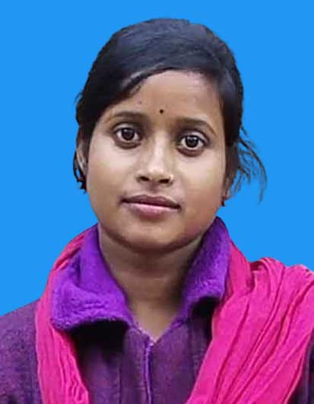
Curriculum Vitae
RIMA HALDER
Address:
Village & Post Sutabecha
P.S. – Mandirbazar
District – South 24 Parganas, Mob: 7601881012
Pin - 743395, West Bengal Email ID: rimahalder7699@gmail.com

ACADEMIC QUALIFICATION

Examination Passed | Board/University | Year
B.A(Honours) | C.U | Pursuing
Higher Secondary | W.B.C.H.S.E. | 2023
Madhyamik | W.B.B.S.E. | 2021

COMPUTER KNOWLEDGE
- Basic Knowledge in Computer Application.
WORKING EXPERIENCE
- Fresher.
PERSONAL PROFILE
- Father’s Name : Dinobandhu Halder
- Date of Birth : 19th May, 2004
- Gender : Female
- Marital Status : Single
- Religion : Hinduism
- Nationality : Indian
- Languages Known : Bengali

CAREER OBJECTIVES
- I am driven in all endeavors by a commitment to excellence. I have attitude to learn and work in terms. Facing challenges and meeting deadlines are my strength. I am looking forward to work in creative, challenging and learning atmosphere which provide ample opportunities for growth in any field.

Date: ____ / ____ / ______
Place: NAIHATI Signature

