Professional Experience
- Internship

Name of Company | Duration | Project Title | Deliverables
NA | NA | NA | NA
NA | NA | NA | NA

- Projects
NA

- Computer Proficiency
1.MICROSOFT OFFICE
2.MICROSOFT EXCEL
3.EMAIL- MARKETING
4.QGIS

- Interests and Hobbies

1. SWIMMING
2.PAINTING
3.READING

- Activities and Achievements

- MICROSOFT OFFICE COURSE FROM BRAINWARE ACADEMY KOLKATA

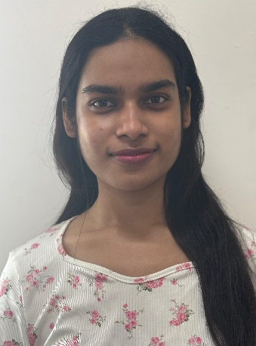
Cell: +(91)8336986510
Email: oisheemitra2004@gmail.com
Personal Details
Father’s name – SUJAY KUMAR MITRA
Date of Birth – 17.12.2004
Gender – FEMALE
Languages known – ENGLISH, HINDI, BENGALI

Address – RAJARHAT ROAD, KOLKATA 700136

Career Objective
Enthusiastic BSC GEOGRAPHY (HONOURS+ RESEARCH) pursuing in Amity university Kolkata, student with humanities background, eager to apply geographic knowledge to real life world challenges. Interested in spatial analysis, environmental studies.
Seeking an internship to gain practical experience and enhance problem solving skills.

ABOUT ME
ABOUT ME
OISHEE MITRA
Date 10.04.2025
Place KOLKATA
Signature 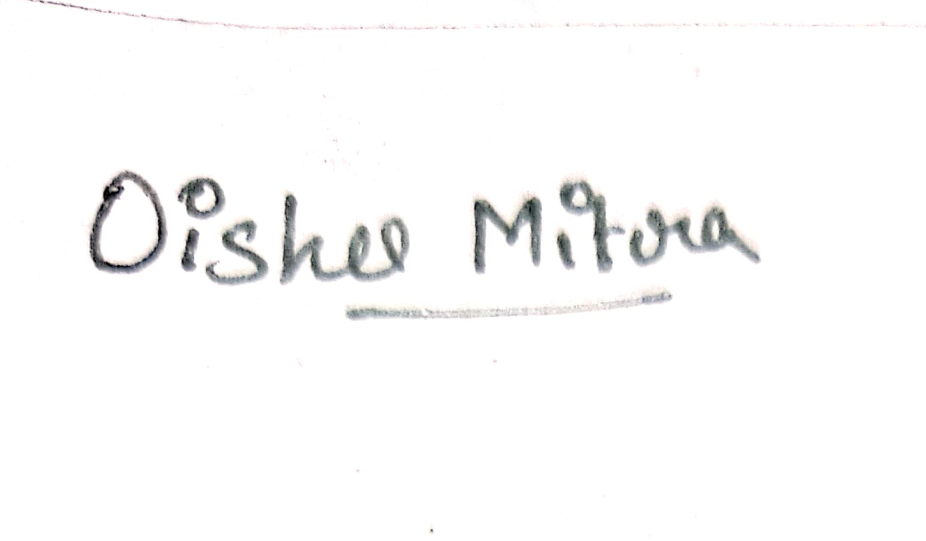

I ,OISHEE MITRA student of Amity University Kolkata, hereby solemnly affirm and declare that what is stated is true to the best of my knowledge.
Academic Qualifications
Qualification | Name of School / College | Board / University | Year of Passing | Marks (in %) / CGPA
Graduation  (write name of degree/diploma) | AMITY UNIVERSITY KOLKATA  BSC GEOGRAPHY HONOURS | AMITY UNIVERSITY | 2023-2027 | 6.71
12th | INDIRA GANDHI MEMORIAL SCHOOL | CBSE | 2023 | 75%
10th | INDIRA GANDHI MEMORIAL SCHOOL | CBSE | 2021 | 84%

