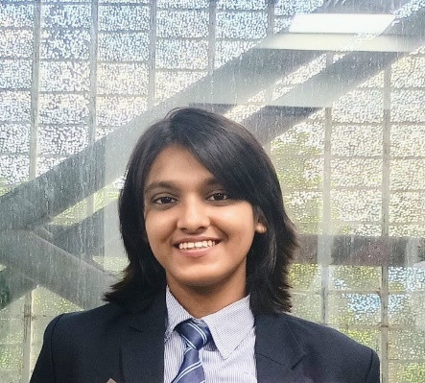
Radhika Jhunjhunwala
Contact
Phone no. - 7003000576
Email- jhunradhikajhun576@gmail.com
Address - 1/1a Nanda Mullick Lane, Kolkata-6

Education qualification
Pursuing BcomLLB(Hons.) from Saint Xavier's University, Kolkata 2024-2029
Qualification | Board | Marks Obtained | Year of passing
Class 12 | ISC | 94% | 2024
Class 10 | ICSE | 96.6% | 2022

Participation
Participated in XAVMUN'24 (in COP) in Saint Xavier’s University
Participated in XITAC'2024 as witness in Saint Xavier’s University
Participated in XVERSE'2024(Finance management) in Saint Xavier’s University
Participated in Inter-College debate competitions.
Participated in Inter-College Dance Competitions

Achievements
Awarded 2nd position in Inter-School Debate Competition
Awarded 1st position in Intra School Hindi Extempore Competition
Awarded 2nd position in Intra School English Elocution Competition
Awarded Best Speaker in Intra School Hindi Debate Competition
Awarded 2nd position in Intra School Dance Competition
Posts Hold
Served as the School Captain of Maheshwari Girls' School for the year 2023-2024
Served as the Secretary of Interact Club of Maheshwari Girls' School for the year 2023-2024

Languages Known
English
Hindi

Skills
Working knowledge in MS Word and MS PowerPoint
Communication skills
Quick learner
Go getter

