Professional Experience
- Internship

Name of Company | Duration | Project Title | Deliverables
Adamas International School, Belghoria | 3 months | Teaching Experience
Adamas World School, Barasat | 3 days | Inspection

- Projects
- NTCC: Socio-Cultural life of Santhals

- Computer Proficiency
- MS WORD
- MS EXCEL
- MS POWERPOINT
- BASICS OF GIS AND REMOTE SENSING

- Interests and Hobbies
- Drawing
- Script writing
- Dancing

- Activities and Achievements
- B.Ed graduate from Adamas university

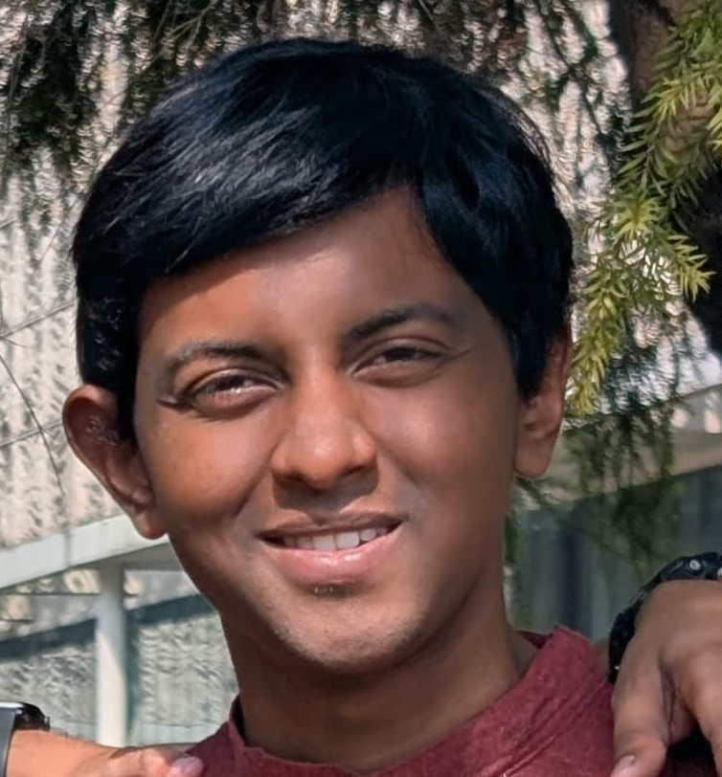
Upal Nino Soren
Cell: +(91)6290675016
Email: upalninosoren1999@gmail.com
ABOUT ME
Career Objective
Pursue a career in teaching or be a government official
Personal Details
Father’s name – Innocent Soren
Date of Birth – 17/03/1999
Gender – Male
Languages known – Hindi, English

Address - ROYAL UNIMARK, RAJARHAT NEAR ST. JONES SCHOOL, NARAYANPUR, KOLKATA

ABOUT ME
Academic Qualifications
Qualification | Name of School / College | Board / University | Year of Passing | Marks (in %) / CGPA
Graduation  (write name of degree/diploma) | St. Xaviers College, Burdwan | Burdwan University | 2022 | 6.65
12th | St. Thomas School | ISC | 2018 | 51
10th | St. Thomas School | ICSE | 2016 | 65

I, Upal Nino Soren, student of Amity University Kolkata, hereby solemnly affirm and declare that what is stated is true to the best of my knowledge.
Date 17.03.2025
Place Kolkata
Signature _____________________________

