Professional Experience
- Internship

Name of Company | Duration | Project Title | Deliverables
CHILD RIGHTS AND YOU | 6 WEEKS | CLOUD SECURITY AND IT’S IMPLICATIONS ON POLITICAL PROCESSES: A CASE STUDY OF KOLKATA

- Projects
- An examination of the role of international organizations in promoting peace, security in the middle east
- CLOUD SECURITY AND IT’S IMPLICATIONS ON POLITICAL PROCESSES: A CASE STUDY OF KOLKATA

- Computer Proficiency
- HTML
- MICROSOFT EXCEL
- POSTER MAKING
- VIDEO EDITING
- MICROSOFT WORD
- MICROSOFT POWERPOINT
- Interests and Hobbies
- READING BOOKS
- PLAYING FOOTBALL
- Activities and Achievements
- RECEIVED SHRI BALJIT SHASTRI AWARD FROM AMITY UNIVERSITY IN BACHELOR’S
- WON GOLD IN SANGATHAN EVENT IN THE CATEGORY OF FOOTBALL


Personal Details
Father’s name – Mridul Ghosh
Date of Birth – 02.03.2004
Gender – Male
Languages known – English, Bengali, Hindi

Address – D2/6 Purbasha housing estate 161 Maniktala main road

Career Objective
Highly motivated and detail-oriented recent graduate
My objective is to make the most out of it while doing a research.

ABOUT ME
ABOUT ME
Cell:+916290633953
Pritamghosh2304@gmail.com
Pritam Ghosh
Date ______08.04.2025_______________________
Place ______kolkata _______________________
Signature 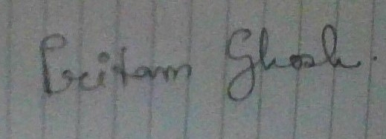

I, Pritam Ghosh student of Amity University Kolkata, hereby solemnly affirm and declare that what is stated is true to the best of my knowledge.
Academic Qualifications
Qualification | Name of School / College | Board / University | Year of Passing | Marks (in %) / CGPA
Graduation  (write name of degree/diploma) | AMITY INSTITUTE OF SOCIAL SCIENCES | AMITY UNIVERSITY KOLKATA | 2024 | 8.26
12th | BHAVANS GANGABUX KANORIA VIDYAMANDIR | CBSE | 2021 | 85.4%
10th | BHAVANS GANGABUX KANORIA VIDYAMANDIR | CBSE | 2019 | 78.4%

