Professional Experience
- Internship

Name of Company | Duration | Project Title | Deliverables
Radhanath Sikdar Institute of Geospatial Science and Technology  (RSIGST) | Six weeks | Designing Geospatial Database of Sundarban | Research Intern

- Projects
- Designing Geospatial Database of Sundarban
- Impact of climate change on Sundarbans Mangrove Ecosystem
- History of Map Making
- Titan; The Moon of Saturn

- Computer Proficiency
- Digitisation
- Microsoft Word
- Microsoft Power Point
- Microsoft Excel
- Interests and Hobbies
- Painting
- Travelling
- Listening pocket FM
- Cooking
- Listening Music
- Activities and Achievements
• Certificate of Participation for Participating Murshidabad District Yoga Competition (10th august 2014) securing 2nd position with silver medal
• Certificate of Participation for Participating in the Kathak dance (28/05/ 2011, 12/07/2012, 04/07/2013 held in SARBABHAARATIYA SANGEET -O- SANSKRITI PARISHAD.
• Certificate of Participation for Participating in the Rabindra nritya (28/ 05/2011, 12/07/2012, 04/07/2013, 06/07/2014, 31/07/2015 held in SARBABHAARATIYA SANGEET -O- SANSKRITI PARISHAD
• Certificate of Participation for participating in creative dance (06/07/2014) held in SARBABHAARATIYA SANGEET -O- SANSKRITI PARISHAD.
• Certificate of Participation for participating in the Rabindra nritya (2010_2011, 2011-2012, 2012- 2013, 2013-2014, 2014 -2015) securing 1st division distinction in junior diploma part II and 1st division (2015 – 2016) in senior diploma part II
• Certificate of Participation for participating in creative and kathak dance (2014- 2015) and (2015- 2016) securing 1st position distinction on 30th September 2015 and 31st September 2016 held in Pracheen Kala Kendra
• Certificate of Participation for participating in painting (2010-2011, 2011-2012, 2012-2013, 2013-2014, 2014-2015) securing 1sr division distinction held in BANGIYA SANGEET PARISHAD

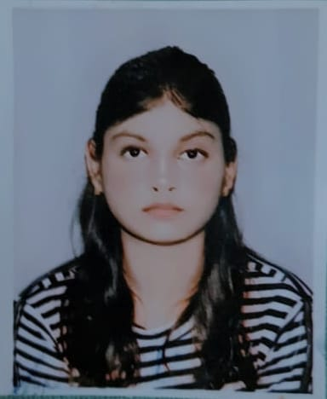
SUHRITA SINHA
Cell: +(91) 7718386446
Email: snhasuhrita@gmail.com
ABOUT ME
Career Objective
The career objective or the Target in my life is to complete my masters in GIS and remote sensing and work for either as a GIS analyst or engineer.

Personal Details
Father’s name – Soumitra Prasad Sinha
Date of Birth – 26/07/2003
Gender –Female
Languages known –English, Hindi, Bengali
Address – Ramdhenu Complex Block A Flat- B/3 Mohisgote , Newtown , Kolkata , Action Area I[700102]

ABOUT ME
Academic Qualifications
Qualification | Name of School / College | Board / University | Year of Passing | Marks (in %) / CGPA
Graduation  (write name of degree/diploma) | Amity University Kolkata  (BSC. GEOGRAPHY) |  | 2024 | 6.05
12th | Kendriya Vidyalaya Berhampur | CBSE | 2021 | 7.25
10th | Kendriya Vidyalaya Berhampore | CBSE | 2019 | 60

I, Suhrita Sinha student of Amity University Kolkata, hereby solemnly affirm and declare that what is stated is true to the best of my knowledge.
Date 17/03/2025
Place Kolkata
Signature 