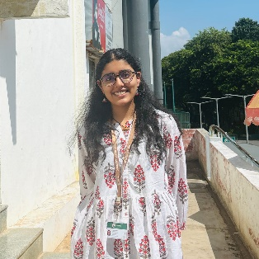
DEVIKA MADHU
Email: nairdevika953@gmail.com | Phone: +91 9589566945
Location: Raipur, Chhattisgarh

Objective
Motivated and detail-oriented BA LLB (Hons.) student with strong analytical skills and a passion for legal research. Seeking to leverage academic knowledge, legal writing abilities, and dedication to continuous learning to contribute effectively to a reputable legal organization.

Education
BA LLB (Hons.)
GITAM (Deemed to be University), Visakhapatnam, Andhra Pradesh
2024 – 2029 | Current SGPA: 8.5
XII – Humanities Stream
Holy Cross Senior Secondary School, Byron Bazar, Raipur, Chhattisgarh
2023 – 2024 | Percentage: 80.6%
X – CBSE
Holy Cross Senior Secondary School, Byron Bazar, Raipur, Chhattisgarh
2021 – 2022 | Percentage: 86%

Certifications
- Legal Research & Writing Course, MyCaptain (2025)
- Principles of Creative Writing, Alison (June 2024)
- Speech Reading Hearing & Multi Training Rehabilitation Centre Raipur (CG) – Completed 3 weeks of Internship (2025)

Skills
- Legal Research & Writing
- Analytical Reasoning
- Communication & Presentation Skills
- Creative Writing
- Designing Posters & Pamphlets
- Time Management
- Leadership
- Documentation

Projects & Experience
- Served as Deputy head girl (2022-2023) - Holy Cross Senior Secondary School, Byron Bazar, Raipur, Chhattisgarh
- Conducted legal research and drafted reports as part of the Legal Research & Writing Course (MyCaptain).
- Developed creative content and articles through Principles of Creative Writing Course (Alison).
- Completed 3 weeks of internship at Speech Reading Hearing & Multi Training Rehabilitation Centre Raipur (CG).
- General body member at Rotaract club of GITAM (2024-)

Hobbies & Interests
- Dancing
- Reading
- Writing
- Travelling
- Designing

Languages
- English
- Hindi
- Malayalam

Personal Information
Date of Birth: 29th June 2006
Father’s Name: Madhu C Nair
Mother’s Name: Vijayalakshmi Nair
Nationality: Indian
Permanent Address: H.NO 52, Shreeji V3, Balaji Greens, Deopuri Road, Amlidih, Raipur, Chhattisgarh – 492001

I hereby declare that the information provided is true and correct to the best of my knowledge.
Date: 06/03/2025
Place: Visakhapatnam
Devika Madhu

