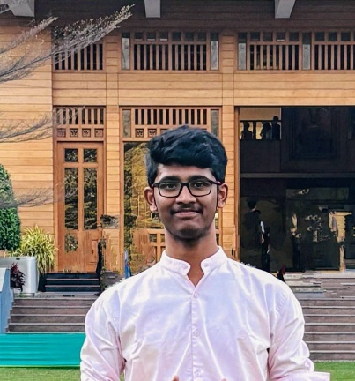
Education____________________________________
2014 – 2022 | Sri Venkateswara Children’s High School  I’ve completed my schooling from Tirupati, and secured 9.61 GPA in my 10 board exams. And I got prizes in school level events pertaining to sports, calligraphy, and quizzes.
2022 - 2024 | Sri Chaitanya Junior College  I’ve completed my higher secondary education in MPC stream and secured 9.92 GPA in my 11th & 12th boards.
2024 – present | Presidency University  Currently, I’m pursuing my BBA LL.B. (Hons) programme in the aforementioned respective university. And secured 8.58 CGPA in my 1st semester, and engaged in a lot of intra events, which was conducted by the university.

Skills_________________________________________
- Researching work;
- Management skills;
- Creativity;
- Motivating others;
- Badminton player.
Awards_______________________________________
- 2021 | Runner up in districts,
- 2023 | Winner up in state selections.
Participations__________________________________
- Participated in debate conducted by KJC.
- Participated in national moot court (as liaison).
Current status_________________________________
- Currently, working on a research paper, about Indian Educational system.
- Learning new skills which is important to exist in this world.

Contact_____________
Phone:
8328611516

Email:
thandlamkundankaushik@gmail.com

Address:
2-1-114, kola street, behind traffic police station, Tirupati, Andhra Pradesh, India.

Languages__________
Telugu
Hindi
English

Hobbies____________
Cooking
Reading books and newspaper
Writing journal
Watching spiritual talks; and debatable topics
Cycling
Collecting old currencies
Travelling in bike

Thandlam Kundan Kaushik
Law student

