J. D. BIRLA INSTITUTE
Departments of Science and Commerce
11 Lower Rawdon Street, Kolkata- 700020

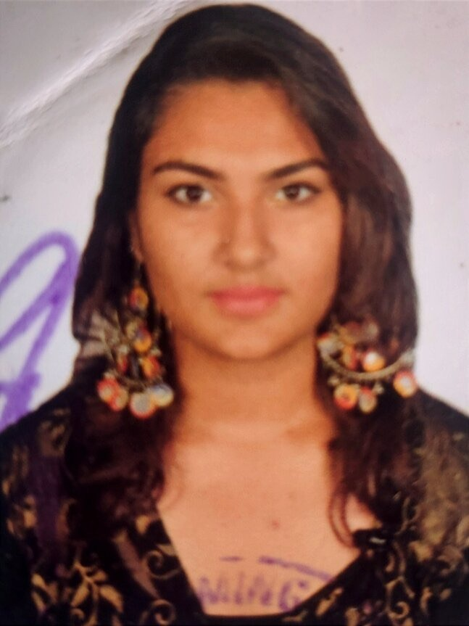
RESUME

PERSONAL INFORMATION

Name- Nilanjana Mukherjee
Date of Birth- 24/11/2003
Father’s Name- Indranil Mukherjee
Marital Status- Unmarried
Postal Address- 26 Convent Road, near Moulali.
City- Kolkata Pin Code- 700014

CAREER OBJECTIVE

My goal is to build a meaningful and impactful career in counselling, drawing from my academic foundation in B.Sc. (Hons) in Human Development and a deep-seated passion for supporting individuals in need. I am particularly dedicated to working with children with special needs, where I aim to create a nurturing and empowering environment that fosters their holistic growth and development.
As a student, I am eager to learn and grow under the guidance of experienced counselling psychologists, gaining valuable insights and practical knowledge about effective counselling practices. I believe my academic background, hands-on experience through internships, and enthusiasm for making a difference will help me contribute meaningfully to the field. I am committed to developing my skills further and using them to help individuals overcome challenges and thrive.

EDUCATIONAL QUALIFICATIONS

 | DEGREE/  EXAMINATION | UNIVERSITY/BOARD INSTITUTE | YEAR OF PASSING | PERCENTAGE
Class-X | ICSE | Pratt Memorial School | 2019 | 82%
Class-XII | ISC | Pratt Memorial School | 2021 | 86%
Graduation | CBCS | J.D. Birla Institute | 2025  (estimated) | 9.2 S.G.P.A (up to Sem IV)

SKILLS

- Leadership skills
- Empathetic approach
- Problem-solving ability
- Creativity
- Friendly
- Effective communication
- Negotiation capabilities
- Ambitious
- Reliability
- Public speaking

CAREER SUMMARY

I am a passionate and driven individual with a strong background in Human Development and a deep interest in Psychology. Since my first year of college, I have been working as a private tutor, helping school students excel academically while fostering confidence and discipline. I have actively contributed to NGOs such as Rainbow in Loreto and Teresa Girls, teaching children life skills, art therapy, and basic grammar to support their holistic growth. My internships at Deepani Encore, a counselling centre, and Apollo Hospital under Dr Anjan Bhattacharya, a senior child development paediatrician, have enhanced my understanding of counselling strategies and child development practices.

I further enriched my knowledge by attending a three-week mental health and stress healing workshop at Fortis Hospital. My experience in the BPO sector and as a customer service executive at Deltron Equipment and Systems sharpened my communication, active listening, and interpersonal skills, which are invaluable for a career in counselling. During my school years, I held leadership roles, such as in sports clubs, and was an active member of the Interact and Nature Clubs, participating in numerous workshops and events organized by my school and college. These diverse experiences have strengthened my problem-solving skills, empathy, and ability to connect with people. I am committed to advancing research in child psychology and supporting children in building resilience and achieving positive outcomes.

EXPERIENCE

- Private Tutor (Since First Year of College)
Taught school students academic subjects while fostering discipline, confidence, and essential skills.

- NGO Volunteer (Rainbow in Loreto & Teresa Girls)
Taught children life skills, art therapy, and basic grammar to promote their holistic development.

- Internship at Deepani Encore Counselling Centre
Gained hands-on experience in counselling and understanding diverse emotional needs.

- Internship at Apollo Hospital
- Worked under Dr. Anjan Bhattacharya, a senior child development paediatrician, to deepen knowledge of child development practices.

- Internship at Nabajatak Child Development Centre

- Mental Health Workshop (Fortis Hospital)
Attended a three-week workshop on mental health and stress healing, gaining valuable insights into mental health care strategies.

- Customer Service Executive (Deltron Equipment and Systems)
Strengthened communication, active listening, and interpersonal skills through client interactions.

- BPO Experience in Voxient Solutions
Developed patience, empathy, and effective communication skills essential for counseling through client service.

- Leadership and Clubs (School Life)
Held the role of Sports Vice Captain and actively participated in Interact and Nature Clubs.
Contributed to various workshops and events organized by the school and college.

- National Service Scheme (NSS) Volunteer
Actively participated in NSS initiatives, contributing to community welfare and events as a volunteer.

- Public Speaking and Event Participation
Engaged in several public speaking events, workshops, and activities to enhance communication and leadership skills. I have taken part in Muns and debate, recitation competition in school life so it has enhanced my communication skills.
- Did an internship at Disha Counselling center in Mumbai. I observed Career counseling, Aptitude Tests, and Career vocational Training, later I was also assisting the Aptitude testing there along with doing the scoring of the same. I also had the opportunity to observe counselling sessions and also made notes and reports of the same.
- Also had the opportunity to go to Bhaktivedanta School, it was basically related to my internship at Disha. Had observed and assisted the primary school teachers, attended brain exercise workshop for pre-primary students, observed inclusive ducation system, observed the roles of a special educator and a school counsellor too.

ADDITIONAL INFORMATION

I am a person with diverse interests and a strong desire to make a difference. I aspire to open a preschool in the future and actively contribute to the inclusive education system, helping children with special needs integrate into mainstream education. I am passionate about sports, having played tennis at the club level (CCFC Club), basketball in school competitions, and participating in tug-of-war. As a second-level cleared classical singer, I have a deep love for music. I also want to work with NGOs that focus on helping women in red-light areas, supporting them in building better lives. Additionally, my love for animals has led me to work with NGOs that care for street animals, and I have successfully rehomed two kittens through social media. I am a fun-loving, energetic person who loves life and strives to give back to society in as many ways as possible.

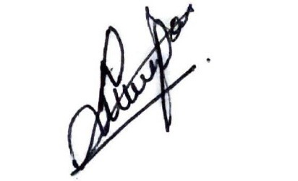

Nilanjana Mukherjee
Kolkata
18.11.2024

