


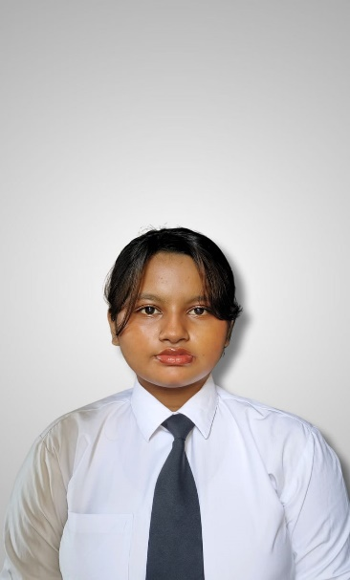

Education

BA.LLB
Calcutta University
2024-2029

Class XII
B.S.F Sen. Sec. Resi. School
2024 [Achieved 80%]

Class X
Alphonsa School
2022 {Achieved 66%]

Skills

- Communication
- Teamwork
- Project Management
- Critical thinking
- Leadership

Achievements

Head Girl
B.S.F Sen. Sec. Resi. School
2024

Youth Parliament
I.I.L.S
2023

+91-9883242905
rainamratarai5@gmail
Kolkata, West Bengal

Contact

NAMRATA RAI
legal intern

Professional overview

I am a first-year BA.LLB (Hons) student at Kolkata Police Law Institute, seeking to gain practical exposure in legal research and writing. With proven leadership as Head Girl and active participation in debates and youth parliaments, I have developed strong communication and analytical skills. My experience in content management and product design has strengthened my discipline and adaptability, which I’m keen to apply in academic and research initiatives.

Work experience

Social Media Manger

Yellow Town India 2024- 2025
Created engaging reels and daily stories to promote the business on Instagram and Facebook. Managed content posting and kept the page active with regular updates and interactions. Helped increase visibility by sharing promotions, offers, and customer shoutouts through stories.
- Managed branding, campaigns, and digital engagement for a student-led business.
- Designed and launched aesthetic products including posters
- Built skills in creativity, communication, and project management.
- Collaborated with team members to develop marketing strategies and improve customer engagement.

Freelancer

Content & Creative Services 2023
Wrote SEO-friendly articles and web content for various clients, including travel and lifestyle websites. Crafted engaging travel blog posts, destination guides, and itinerary-style content to inform and inspire readers. Adapted tone and style to match different brand voices while meeting deadlines and content briefs.
- Assisted clients with content writing, editing, and branding projects
- Delivered projects within deadlines, ensuring quality and client satisfaction.
- Developed strong research, communication, and adaptability skills applicable to diverse professional settings.

