KASVI SHARMA

✉24jspc-ksharma@jgu.edu.in +91 9830034637

EDUCATION
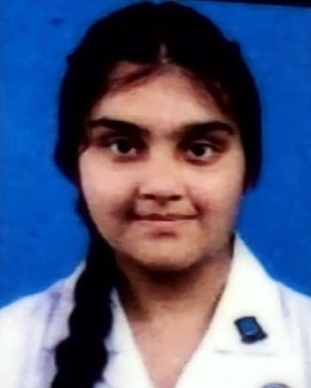

O.P. Jindal Global University Sonipat, Haryana, India | Jindal SchoolOf Psychology and Counselling.
(ExpectedGraduation: August 2028)
La Martiniere for Girls, West Bengal, India |Scored 85% in Class XII, ISC (Commerce) 2024
La Martiniere for Girls, West Bengal, India |Secured 70% in Class X, ICSE2022

INTERNSHIPS

Assisted in research on behavioral science under the Fortis School Mental Health Program, focusing on data collection, analysis, and intervention strategies. Gained practical experience in promoting mental health awareness in school settings.“Department of Mental Health and Behavioural Science Fortis School Mental Health Program”- Offline Internship In Psychology.

Interned at the Unmish Foundation from December 2024 to January 2025, where I actively contributed to child-centered community welfare programs. My role involved direct interaction with children during educational workshops and outreach sessions, helping to foster a supportive and engaging environment. I also assisted in planning and organizing awareness drives, managing data entry and documentation tasks, and supporting CSR initiatives through coordination and fieldwork. This experience strengthened my interpersonal, communication, and organizational skills while deepening my understanding of grassroots-level social work and child development.

Certificate Course in Applied Forensic Psychology and Criminology (July 1 – October 1, 2025). Conducted intensive, 3-month online study focused on the core principles of Forensic Psychology and Criminology, successfully completing all certification requirements. This rigorous program required deep engagement in complex topics, including criminal profiling and investigative analysis, resulting in specific commendation for demonstrating insightful questions and a high level of commitment to applied learning within the field.

RESEARCH CONTRIBUTIONS

- Led research on how dogs recognize human and canine emotions in the study "Paws and Feelings: Exploring the Emotional World of Our Canine Companions." Gained insights into animal behavior and emotional recognition through data analysis and behavioral observations.

POSITIONS OF RESPONSIBILITY

- Assistant Captain, Girl Guides, La Martiniere for Girls (2023–2024). Served as a leader and mentor to a team, guiding members through various activities and projects that promoted teamwork, community service, and personal development. Organized and coordinated events, collaborated with peers and supervisors to achieve group goals.This role has developed my problem-solving, communication, and organizational skills through regular training and hands-on leadership experiences. | 2024-2028|Sonipat

VOLUNTEER EXPERIENCE
2024 -2028|Sonipat
- Assisted in distributing sanitary pads and food to promote awareness and hygiene as part of an NGO initiative.
- Contributed to a transgender support program, focusing on emotional upliftment and awareness campaigns.
- Volunteered at an animal shelter, feeding dogs and cows to support animal welfare.
- Organized and participated in food distribution drives for underprivileged individuals, including orphanages, on personal milestones like birthdays.

COMPETITIONS

- Participated in a public speaking show, showcasing strong communication skills and the ability to engage with diverse audiences.
2024-2028|Sonipat

EXTRA-CURRICULAR

- Played basketball, demonstrating teamwork, strategic thinking, and physical endurance.
- Experienced swimming with sharks, showcasing courage, adaptability, and a willingness to embrace challenges.
- Fed fish underwater, highlighting interest in aquatic life and adventurous, hands-on experiences.
. 2024-2028|Sonipat

LANGUAGES: English, Hindi, and Spanish (Limited Speaking Proficiency)

INTERESTS: Creative Interests: Reading, Dancing, Singing, Music

Travel & Adventure: Travelling, Swimming, Underwater Experiences

