


BBA
-
MBA Integrated

1
^{st}

Year

Final Report of

Summer Internship Programme (2025)

at

Submitted to

Prof. Bhajan Lal

On

(
16
/
06
/2024)

Submitted by

Roll No.

Name

Section

214
24
BBA

Divyangsu Chatterjee

B

Author of the Report
Name: Divyangsu Chatterjee
Email: 24bba214@nirmauni.ac.in

Date: 16th June 2025

Name of the Organization
Child Rights and You (CRY)
152, New No. 8, 2nd St, Gitanjali Park, Kalikapur, Haltu,
Kolkata, West Bengal-700099

Organization’s Mentor
Name: Ms. Rubina Haque
Email: rubina.haque@crymail.org

Purpose of the report
To understand how a non-profit organization with multiple layers of operation function to
make a positive impact on the society.

Submitted to
Name: Prof. Bhajan Lal
Email: bhajanlal@nirmauni.ac.in

TABLE OF CONTENTS

S NO. | TITLE | PAGE NO.
1. | Acknowledgment | 5
2. | Executive Summary | 6
3. | Part A: Profile of the Organization  A.1: History  A.2: Vision and Mission  A.3: Geographical Spread  A.4: Corporate Partners  A.5: The Management | 7 – 13
4. | Part B: Project Work  B.1 Research based Project [Type - I]  B.1.1 Introduction  B.1.2 Objectives  B.1.3 Utility  B.1.4 Methodology  B.1.5 Context of Industry Problems  B.1.6 Presentation of Data  B.1.7 Analysis & Discussion  B.2 Experiential Learning Project [Type – III]  B.2.1 Introduction  B.2.2 Objectives  B.2.3 Methodology / Approach Adopted  B.2.4 Execution | 14-29  14-21  22-26
5. | Part C: Learnings from the Summer Training | 27

ACKNOWLEDGEMENT

With great pleasure, I would like to express my sincere gratitude to my parents for being my constant pillars of support and being with me through thick and thin. I would also like to thank Ms. Zeel Patel for constantly helping me throughout the procedure of my internship.
I would also like to thank our program chair Prof. Mumukshu Trivedi and additional director Dr. Hrudanand Misra for providing me with such a wonderful opportunity of working with the top NGO of the country. I would also like to extend gratitude to my faculty mentor, Prof.Bhajan Lal without whose constant support it wouldn’t have been possible for me to complete this internship.
I would also like to take this opportunity to thank our intern coordinator Ms. Rubina Haque for her guidance and constant support. I would also like to express my sincere gratitude to the frame makers of this programme to include NGO Internship in the very first year of our college. I would also like to thank the CRC Department for providing me with such an amazing opportunity to intern at the best NGO in the country.

EXECUTIVE SUMMARY

The report covers every aspect of the internship period. There are three sections in the report: A, B, and C. The Part A of the report contains information about the organisation including history and details of the NGO, details of the office Bearers, Geographical spread of the NGO, Vision and Mission of the organisation and corporate partners of the organisation.
Part B contains the details of the organisation that includes introduction, methodology, context of industry problems, presentations of data and analysis and discussions.
Part C contains a brief description of my learnings which I gained during my internship period and the references used to constructing this report.

PART A: PROFILE OF THE ORGANIZATION

A.1 History

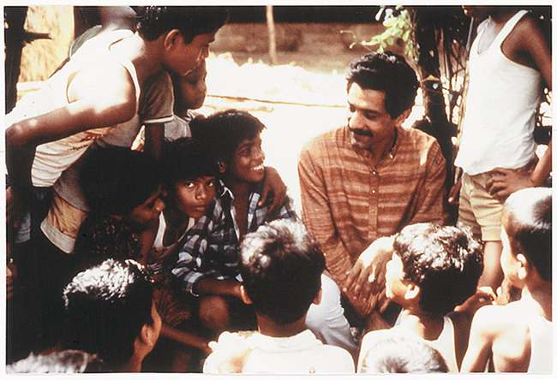
On 28th January, 1979 Rippan Kapur along with his six other friends founded Child Rights and You (CRY) with the goal of helping children from socially and economically deprived backgrounds to sustain and grow in their lives to become individuals who can be both independent and can be depended on by others. Rippan realized that these children were the future of the country and had a spark but not a direction with them. Therefore, to bring these children into the mainstream life, he built an institution which would inspire the citizens to come forward and contribute whatever resources they have so that a Significant societal shift created. In 1994, the visionary founder, Rippan Kapur passed away.
CRY started out by helping children with basic needs like food, shelter, and care. Over time, it has grown into an organization that now speaks up for children's rights, making sure their voices are heard and their rights are protected.
CRY is part of two important national groups: a sub-committee on ‘Child Rights and Child Protection’ under NITI Aayog, and the Central Advisory Board on Child and Adolescent Labour, which is part of the Ministry of Labour and Employment.

A.2 Vision and Mission

Vision
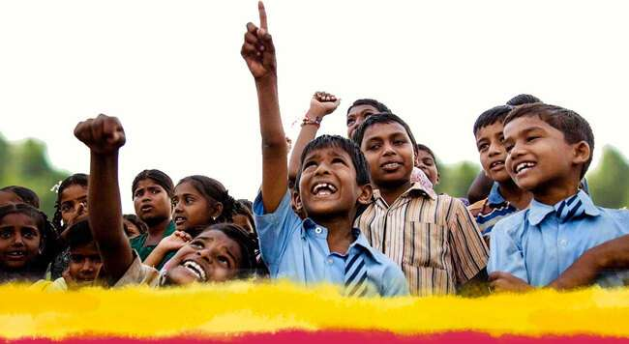
The vision of the organization aims is to provide maximum care and resources to make the children from the underprivileged part of the society knowledgeable, physically fit and creative enough to think beyond themselves and provide enough assurance to make sure that no child has to go through any phase where their rights are at danger and make a society where each child is provided with an equal number of opportunities.

Mission
- Enabling Responsibility: To encourage individuals and communities to recognize the challenges faced by underprivileged children and take meaningful steps to address them.
- Mobilizing Potential: To inspire people to realize their power to make a difference and actively contribute to a better future for children.
- Inspiring Collective Action: To build partnerships and foster unity among diverse groups in securing and upholding every child's rights.

A.3 Geographical Spread
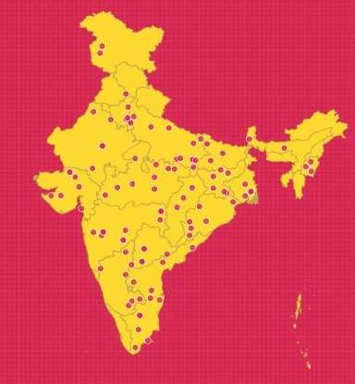
Source: https://www.cry.org/our-approach/
CRY helps children across India through over 100 local projects in 19 states. They also work internationally, with teams in the UK and US. CRY teams up with local groups and organisations to make sure children receive education, healthcare if required, stay in a safe place and grow up with the care they deserve. They do this by working closely with regional communities, spreading awareness, and advocating for more detailed and structured government policies and initiatives that protect children's rights.

A.4 Corporate Partners



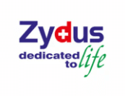



A.5 The Management
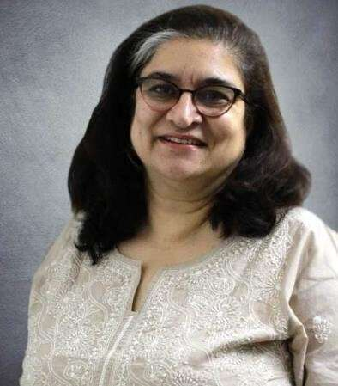

Puja Marwaha- CHIEF EXECUTIVE
Puja made the transition from the corporate to the social sector as she joined CRY in 1994. Today, she is the CEO at CRY, India’s leading child rights organization. The awardee of Olga Alexeeva Memorial Prize in 2018 for social innovation, Puja currently serves on the Academic Advisory Board for Masters in Human Resources at XISS, Ranchi; the Advisory Board for School of Sustainability at Xavier Institute of Management (XIM), Bhubaneswar; and the Advisory Board of Centre for Data Science and Social Impact (CDSSI) at Indian School of Development Management (ISDM), Noida. She is also a Member of the Expert Advisory Group of the Bengal Chamber of Commerce and Industry CSR Committee (BCC&), Kolkata.
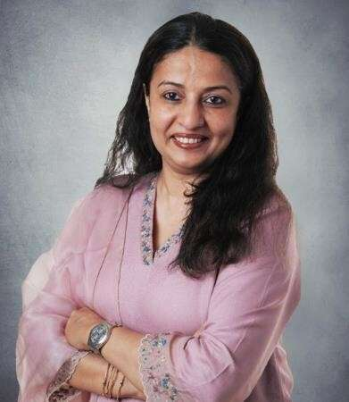

Yamini Kapoor - DIRECTOR – RESOURCE GENERATION
A graduate in Economics and a diploma holder in travel and tourism, Yamini’s professional journey began in the telecom industry. Over the past two decades, she’s contributed her expertise to companies like Koshika, Essar, Hutchison, and Vodafone, excelling in roles related to Customer Service, Revenue Assurance, and Marketing. Yamini firmly believes in the limitless potential within every person, a belief that drives her passion for making a
positive impact on the lives of children and creating happier childhoods.

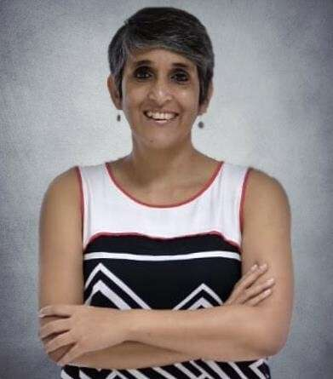

Vatsala Mamgain - DIRECTOR – COMMUNICATIONS
Vatsala has worked in advertising for close to two decades on clients like J&J, Unilever, LG and Maruti. She is an award-winning columnist who has also set up a design portal, run a successful home catering business and worked as a textile consultant. Vatsala believes that every single person has limitless potential and she hopes that her work at CRY will help India’s children realize theirs.
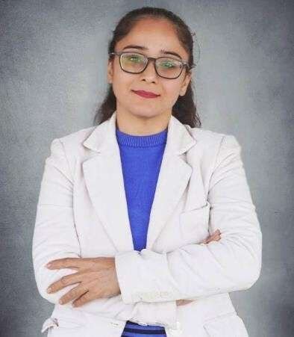

Rashmi Arora - DIRECTOR – FINANCE
Brings 22 years of expertise in team leadership, policy, governance, audits, credit management, and compliance. With a Chartered Accountant qualification and a B.Com (H) from Delhi University, Rashmi’s strategic acumen and dedication to excellence promise to drive CRY’s financial stewardship to new heights. Her career embodies a relentless pursuit of excellence, making her a valuable asset to CRY’s mission.

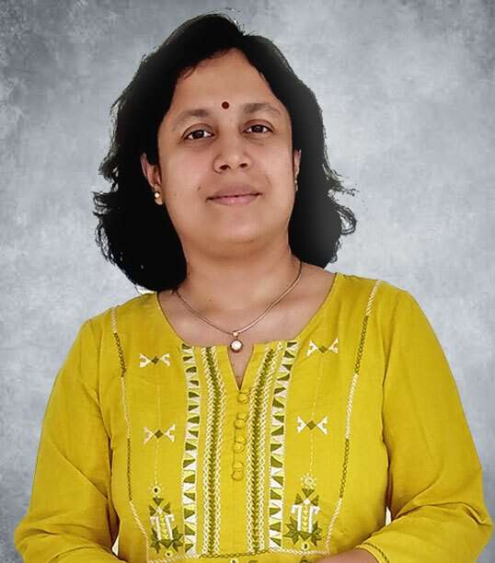
Trina Chakrabarti - DIRECTOR – East,
DIRECTOR – Volunteer Engagement & Information Technology
Masters in the Theory and Practice of Human Rights, Trina graduated from the Tata Institute of Social Sciences and started her career in CSR with the Tata Group and CARE India. She joined CRY in 2002 as a part of the Development Support team and went on to lead Volunteer Action before taking on the Director role for the East. She currently also anchors the Volunteer Engagement and Information Technology functions at CRY. Trina believes that children can change the world and hopes to make a difference in children’s lives through her work with CRY.
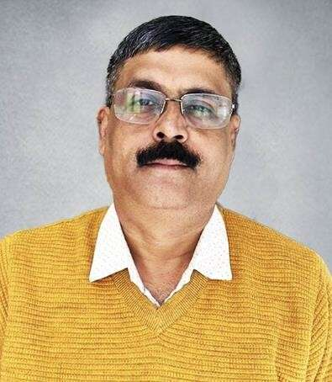

Subhendu Bhattacharjee - DIRECTOR – RESEARCH AND KNOWLEDGE EXCHANGE
Subhendu comes with more than 22 years of experience in human rights and child rights in the arena of research, policy analysis, media advocacy, and Child Rights programming. He admired CRY’s work early on during his secondary school days through CRY cards and their messages for upholding children’s rights. Through CRY he wishes to
create an enabling environment for them so that they can enjoy their rights to their fullest potential.

PART B: PROJECT WORK

B.1 Research based Project [Type - 1]

B.1.1 Introduction
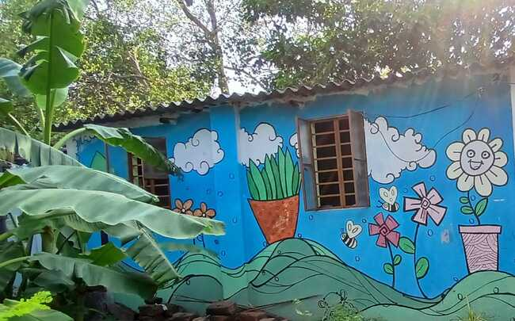
CRY is aimed only at expanding at their network all across the country so that all children belonging to the underprivileged section of the society are guaranteed the same quality and amount of resources that their counterparts of the privileged section receive. CRY has been doing so by reaching to the most basic level such as rural areas to not only educate children but the whole population of that respective area that might be foreign to them but are highly beneficial to both the children and adults of that respective area.
Thus, to check that how their resources have been helpful in implementing a shift in the mindset of people, first, concrete and highly organised data of the utilisation of the resources is to be made. This data would not only when analysed and cross examined would help see the gaps in implementation and help to rectify the issues and will clearly display the extent of the issue.
The government and various other organisations have certain dynamic standards made which help identify how much part of the population is still deprived of basic facilities such as washroom, existence of a primary health centre near them, access to hygienic drinking water, electricity and are they properly nourished. Therefore, I was assigned the task to analyse an excel spreadsheet which contained the information of different facilities under CRY, what resource have been given to them and what is the level of impact which has been generated by them.

B.1.2 Objectives
- To understand that which parameters were to be used in analysing the impact of the organisation.
- Understanding how were those parameters responded to understand its impact on the root level.
- To see if two parameters were highly correlated and find how one depends on the other so that the analysis is simple and to the point.
- Prioritising which areas needed immediate intervention and till what extent.

B.1.3 Utility
As previously mentioned, this project was of critical importance to the NGO as it helped identify the places where their resources were not being utilised properly, whether they were being able to lay the foundation for various practices which are foreign to people living in rural areas but are not easily accepted by them, whether they were able to ensure that a child is in a safe environment by identifying if child marriage and child labour are being practiced in that respective region. This data when collected, would be utilized by the members in the senior management to scrap, change or make a new sequence of execution so that the new plan maximises the positive impact being created on the children.

B.1.4 Methodology
Approach (Quantitative vs. Qualitative):
Since the parameters were of diverse characteristics where both numerical and textual data were used in responses, I had to take a mixed approach which involved the usage of both quantitative and qualitative methods to analyse the data. While qualitative approach helped me to assess the areas which needed the attention of the organisation, the quantitative tools helped me state the extent of help needed in an area. A combination of both these tools helped me draw a more precise analysis.

Sources of Data:
The raw data was provided to me by my mentor who had then asked me to structure it and provide a comprehensive analysis on the areas which needed the organisation’s attention. Therefore, my mentor was the source of my data.
Size of Samples and Methods of Sampling:
The excel document given to me had 5 worksheets whose size of samples and information it entailed are as follows-
- Worksheet 1(Child Baseline) – This worksheet contained the records of 2753 children on the basis of 46 parameters.
- Worksheet 2(Hamlet Baseline) – This worksheet contained the records of 48 hamlets on the basis of 26 parameters.
- Worksheet 3(Household Baseline) – This worksheet contained the records 1379 households with 47 parameters.
- Worksheet 4(AWC Baseline Data) – This worksheet contained the records of 31 Anganwadi centres under CRY with 33 parameters.
- Worksheet 5(Health Centres data) – This worksheet contained the records of 7 health centres with 41 parameters.

Method of Data Analysis:
The first task for me to analyse the data was to remove any irregularity in responses such as for the parameter “Any Comments”, both NO and NA were written as responses which when analysed would give a wrong inference and graphical representation according to my needs. Therefore, after removing all irregularities across all 5 worksheets, I converted the 5 worksheets individually into csv and then into json files. I used AI to prepare a downloadable html link where I would be able to upload the worksheet file in json format which in turn would provide me with an interactive dashboard based on the rough structure of the worksheet provided to AI. I used this html downloadable link to upload my worksheets individually so that it can provide me with a dashboard containing graphical representation of the data entered as a response to the parameters asked. Next, I copied the graphical representations and followed it up with my inference on that particular parameter based on the responses I received against it on a word document so that I could draw the attention of the concerned authorities to the matters of utmost concern.

B.1.5 Context of Industry Problems
One of the biggest flaws that any organisation irrespective of its orientation faces is the assurance that all its resources have been implemented at the most minute level efficiently. For CRY, these resources mainly include human support, educational support and provision of basic healthcare and infrastructural support. For example, hamlets of CRY which are spread across the district of Koraput in Odisha have responded that only 10 of the 48 hamlets enjoy the availability of drinking water supply whereas the rest of the 38 hamlets either have irregular or no availability of drinking water supply.
Another problem arises when the construction of these facilities faces resistance from the local population who do not want the influence of foreign ideologies or aspects in that particular region. Other than this, corruption in the implementation of government projects are also a factor which does not let the resources released by the state or central government to be properly implemented at the most grassroot level. Also, these resources which are released by the concerned authorities have to go through an extensive list of procedures even before an initial foundation of it is laid on the ground which increases the time of implementation in the areas of immediate concern such as availability of drinking water.

B.1.6 Presentation of Data
The representation of the 5 worksheets I was tasked with analysing are as follows:
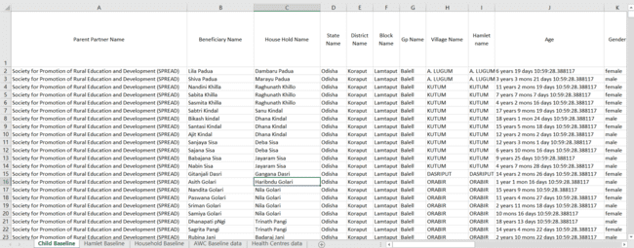
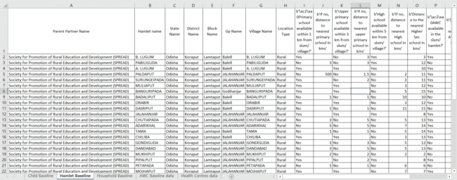
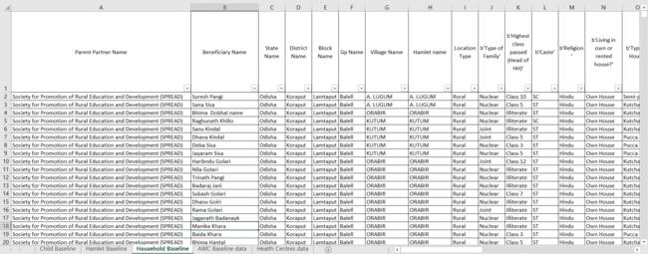
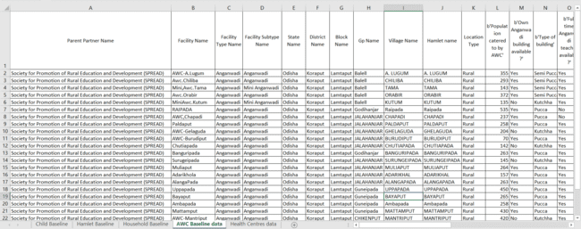
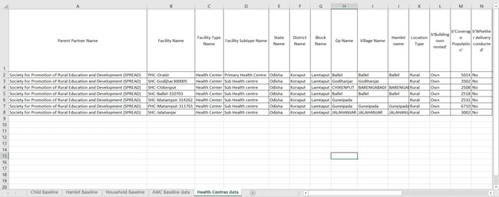

B.1.7 Analysis & Discussion
My research spanned only over the infrastructural facilities and services provided by CRY in Koraput in Odisha. Out of these numerous parameters, a significant portion of them needed the attention of the concerned authorities. Other parameters were either responded to be completely working or other parameters had no correlation with what the main objective of CRY was.
Conclusions:
Among the many inferences which I gathered throughout the analysis, few are as follows:
- 90.7% of the fathers in rural areas were agricultural labours indicating that agricultural sector still continues to provide to the most number of livelihoods in the rural areas.
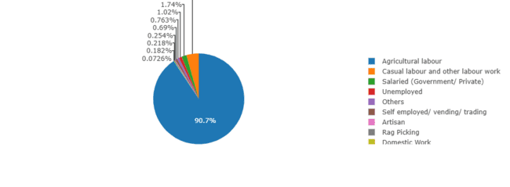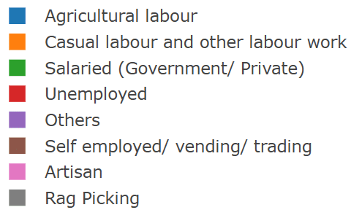
- Majority The data gathered while studying the gender distribution pattern in the rural areas indicate a nearly balanced ratio, with females comprising 50.6% and males comprising 49.4% of the total child population.
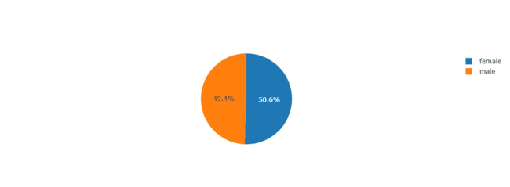
- The parameter of “Toilet Access” clearly indicated that most(686) of the households in rural areas sill practice open defecation followed by another 530 households which use a flush or pour-flush system discharging into open drains and only 110 households were able to use the facility of closed drains.
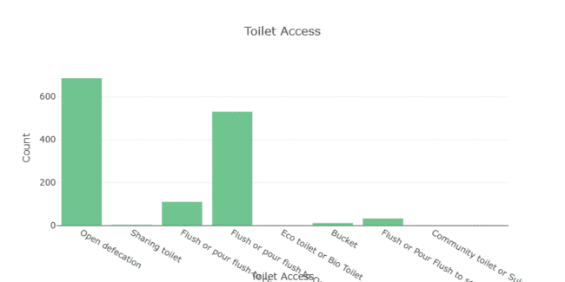
- While analysing the “Missing Child Indicator”, it clearly displayed that out of 1379 households, only 6 households reported at least one child to be missing and the remaining two households gave an unclear response. Though the number of children to be missing are low but they are a matter of concern which should be followed up on an urgent basis.
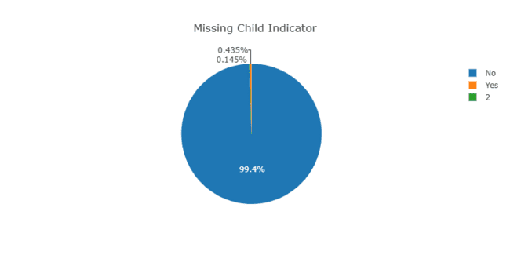

Challenges and my Solutions for them:
- When the data is being entered, it should be kept in mind that if there is no surety to the parameter which is to be responded then something which indicates it for further follow up should be maintained so that when the data is collected again, these places should be given the first priority.
- Few cells had unclear responses given therefore they might not give the proper view of what the situation is on the ground. Therefore, when data is being entered, any type of typing error must be avoided. For example, in the above given inference of missing child indicator, two households have responded “2” whereas it clearly asked for a “Yes” or “No”.

B.2 Experiential Learning Project [Type – III]

B.2.1 Introduction
CRY, is highly focused in providing children with their very basic rights such as education, safety, healthcare and a hygienic place to live in. CRY strives to spread awareness to the section of the society who have become so habituated with misinformation that they are completely resistant towards any correct information given to them.
Thus, as my second project/task, I was tasked to visit the neighbourhood with my onsite coordinator and invite both the children and their mothers to the site’s operational area to celebrate World Environment Day on 5th June, 2025.
This was being done so that they could be more aware of the existing problem of hygienic conditions which were mainly due to the land and water pollution caused by dumping of plastic and other harmful elements which were being left in common spaces just for the sake of disposing them from their houses.
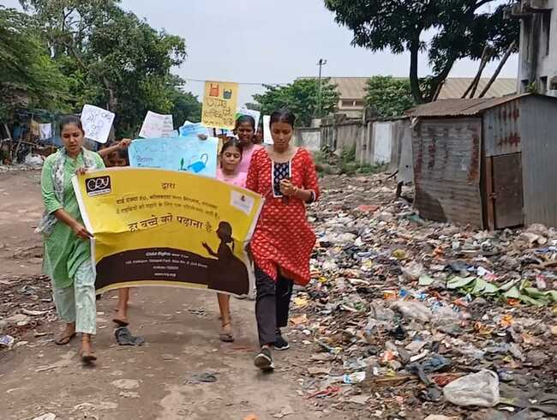
B.2.2 Objectives:
- To invite all the households with children for the event.
- To convey the children what their tasks were during the event.
- To make sure that a majority of the mothers who were invited would also turn up with their children.
- To decide which route is to be used for the march so that maximum amount of awareness is spread about the environmental problems and their implications in the region.
- To gather stationary supplies to create different posters which would be used during the march to spread awareness.

B.2.3 Methodology / Approach Adopted
We were not sure of the turnout on the day of the event because there had been many such events in the past for people from the neighbourhood did show the same amount of initiative to learn anything new and correct. Therefore, we had to use different means such as distribution of refreshment pack which contained boiled egg, banana and cake and spreading a news that “something” very much interesting would be shown in the projector.
So, we did spread these two highlights of the event so that maximum participation was ensured in this event which was aimed at educating them about the various actions that they could take to prevent environmental harm.

B.2.4 Execution
- Poster Making
We were instructed by our field coordinator to find various pictures and slogans which can be used to demonstrate the Environmental harm while we carry them around in the form of posters and slogans written on paper during the march so that we can capture the attention of passers-by. Therefore, the day before the event children were given relief from their daily classes to prepare posters and placards which would be used during the march. Somewhere, I think this was the only moment when I saw children enjoying themselves the most because they were given a relief from their daily supplementary classes which were held by CRY. The other aspect which shocked me the most was the team spirit which they exhibited while making these posters.
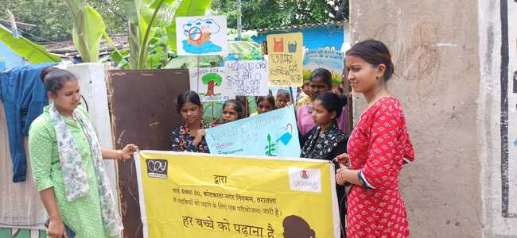

- The event Day
We initially thought that our plan to attract a significant portion of children and adults by offering them the things mentioned before had failed miserably but just before the first event of the day, the march was to be started, a large number of children turned up. That very moment I realised that people can work up to any extent to fight against their weaknesses which in this situation was hunger for them. If we had not offered the refreshment pack then there never might have been a turnover of this extent.
After tallying the attendance sheet, the children were asked who among them wanted to voice the different slogans which were written on the placards and the posters so that while we were walking in the neighbourhood, everyone around us had their attention fixed on us. Ultimately, 4 such children were chosen who would shout out the slogans individually and others would also shout after them. Here, I got to saw what jealousy was like for them because when out of numerous children, few are given opportunity to create a name for themselves in the neighbourhood, the rest feel the anguish and need to show somehow that they are better than them. This was clearly evident as a fight broke amongst the group which had to be then stopped by forcefully accepting them to agree to shake hands with each other which neither of them wanted to and to my surprise that handshake was just like a sudden inflow of water into mountain spurting volcano. This showed me how simple things are for them while we struggle to make amends for the silliest mistakes done by us.

After the truce was made, we started for our march across the neighbourhood and the voices did grab everyone’s attention but somewhere I knew that this either had minimal or no impact on the majority of the people whom we encountered during our march. But, I realised that this might be a “big” incident enough for these children to strive for a world where the environment is cared and not polluted.
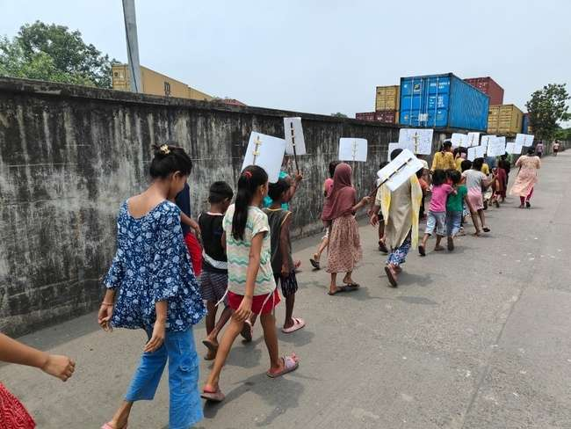
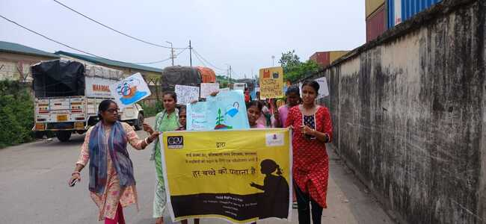

After the march, an event was held to plant a few plants in the compound by the children so that they can emotionally connect to the environment when they will be proud of the big trees which the small plants had grown into. Through this event, they were also encouraged to plant more plants which would give them enough amount of fruits for “free” provided they do not litter the soil with anymore plastic and other harmful elements.
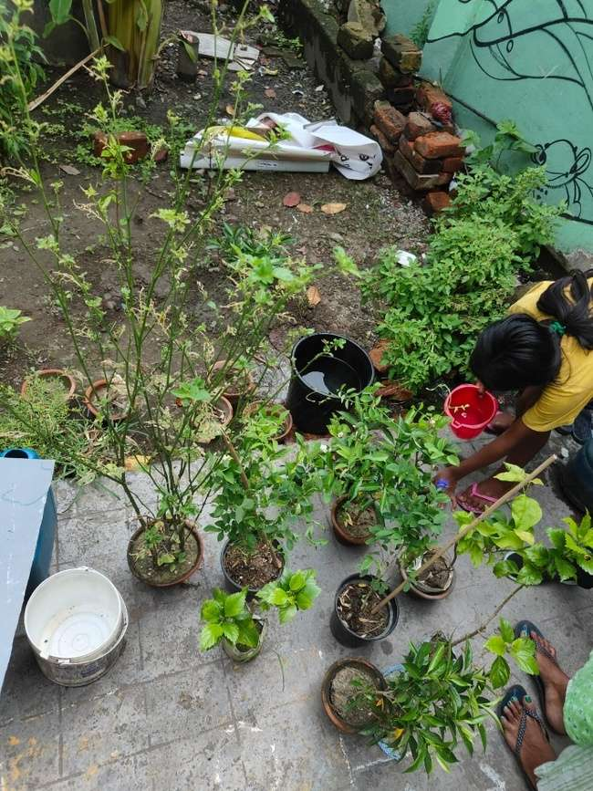
The next event was considered to be the highlight of the day as “something interesting” was going to be shown on the projector. This was the only event where the mothers could participate but then also there was a significant representation of the community of the mothers in that particular neighbourhood. Sadly, the children and their mothers who expected their favourite form of entertainment to be displayed on the projector had to console themselves with the animated video on environmental awareness. Though there were a few sad faces initially, by the end of the video everybody had their attention affixed on the projector. This provided a way to gather the attention of the people present in the room for the ending request from our coordinator’s end to practice environmentally friendly actions so that our future generations can live in a world where pollution is an history. At the end of the event, refreshment packages were distributed to the children after tallying with the first attendance sheet. This showed the amount of structural procedures which the organisation ensured to deliver those who were deserving.

PART C: LEARNINGS FROM THE SUMMER TRAINING
This whole period of One Month which I had a lot of questions about ended up becoming the month where I learned about the “Education for Life”. The major learnings which I was able to experience myself and will continue to remember and practice are as follows:
- Realities of Life: If anyone were to ask me what hardship and survival look like, I would have responded the effort to wake up in the morning and go to work or study but today I can proudly say that my reality had been wrong. Reality of life is that there are numerous children who continue to work odd jobs every day just so that they can sustain another day in this tough world.
- Gratitude: In these preceding 4 weeks, I realised that other than gratitude, there exists no other emotion of a human being which would keep him humble enough to keep on working towards his final goal and not get swallowed by the pleasures of intermediary success or goals.
- Consistency: No matter how you feel things might turn out, you must keep on performing your own duty because greater things do take time to shape into reality.
- Perspective: Perspective can transform your views on an aspect to an absolutely contradictory direction because the sorrow which we gain by comparing what we don’t have can easily be transformed into gratitude when we start to realize what we have.
- Happiness is a choice: Even though the people in the area did not have high exposure or access to various resources but they were still able to be happy. This when I asked myself, the only answer I got is that you would continue to be happy and spread happiness as long as you continue to enjoy the nuances of human relationship rather than prioritizing momentary materialistic pleasures.

References:
https://www.cry.org/ (CRY NGO’s Official website)

