BAT Grant project Utilisation – Broad trends and patterns
Basic details:
- Addendum [Contract variation letter] dtd 07/05/2024. Original grant of the 01/04/2022 contract was extended up to 31/03/2025.
  - Additional grant amount: Rs 36,20,085/-
  - Grant period: 01/04/2024 to 31/03/2025.
  - Location: Jalpaiguri, Block- Nagrakata, Panchayat: Looksan, Total Sansad – 28.

- Addendum [Contract variation letter] dtd 07/05/2024. Original grant of the 19/04/2023 contract was extended up to 31/03/2025.
  - Additional grant amount: Rs 64,99,265/-
  - Grant period: 01/04/2024 to 31/03/2025.
  - Location: Jalpaiguri & Alipurduar, Block – Banarhat & Kalchini, Panchayat: Banarhat-II, Chamorchi, Malangi & GaroPara, Total Gram Sansad – 107.

Utilisation summary:
BAT 1:
Based on the files and information received from Programs and finance teams, we looked through the BAT 1 project details, for the year 2024-25 only, to understand the pattern of utilisation vis-à-vis program implementation. The documents referred for this include –
- BAT 1 project financials for the period April 2024 to May 2025 – shared by Finance;
- BAT 1 project annual report for the period April 2024 to May 2025 – shared by Programs.
Table 1: Sector-wise grant utilisation in ‘000.
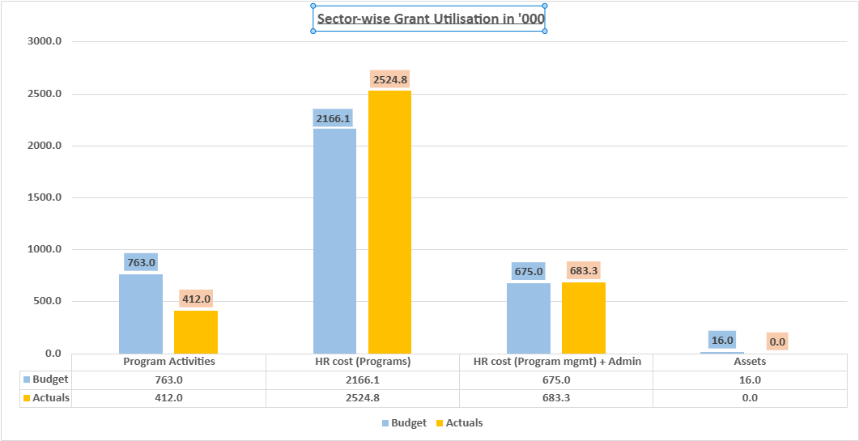

- Overall utilisation touched 100% but there were differences in utilisation % within the buckets.
  - Budget utilisation of HR cost for Program team (117%) and of HR cost for Program management (101%) crossed 100%;
  - Budget utilisation of program activities by the end of the grant period was 54%.
  - The budget for assets remained unutilised.

Table 2: Pattern of utilisation sector-wise and quarter-wise (‘000).

Value in '000 | Program Activities | HR cost (Programs) | HR cost (Program mgmt) + Admin | Assets
Q1 budget | 117.8 | 541.5 | 168.8 | 16.0
Q1 actuals | 0.0 | 526.5 | 79.6 | 0.0
% utilisation | 0% | 97% | 47% | 0%
Q2 budget | 317.4 | 541.5 | 168.8 | 0.0
Q2 actuals | 84.7 | 547.5 | 167.4 | 0.0
% utilisation | 27% | 101% | 99% | 0%
Q3 budget | 171.6 | 541.5 | 168.8 | 0.0
Q3 actuals | 100.9 | 541.8 | 164.1 | 0.0
% utilisation | 59% | 100% | 97% | 0%
Q4 budget | 156.3 | 541.5 | 168.8 | 0.0
Q4 actuals | 208.2 | 557.9 | 161.7 | 0.0
% utilisation | 133% | 103% | 96% | 0%

- Q1 had no program activity or asset procurement – most presumably because of delayed MoU finalisation and grant disbursal.
- HR cost of Program team was booked almost entirely and uniformly, every quarter, through Apr’24 to Mar’25, ranging between 97% and 103% across the quarters.
- HR cost of Program management (CRY cost) – 1 role was booked uniformly in all quarters while the other role was booked Q2 onwards. Hence Q1 utilisation was only 47% while utilisation in the other 3 quarters ranged between 96% and 99%.
- Program expenses started getting booked through Q2 and picked up only in Q3 and Q4. Bulk of the program expense bookings happened in Q4, towards the end of the grant tenure.
- At the end of the originally approved grant tenure, 31st March 2025, ₹ 4.80L (13% of total grant of ₹ 36.20L) remained unutilised. No-cost extension was approved by BAT and subsequently, the entire balance amount of ₹ 4.80L was utilised fully by the end of 31st May 2025.
  - ₹ 3.51L was utilised towards HR cost (Program team);
  - ₹ 1.10L was utilised towards administrative expenses; and
  - ₹ 0.18L was utilised towards expenses of program activities.

Table 3: Budget vs Actuals, outcome-wise
- A look through the budget vs actuals data for the different program outcomes, as per the budget, revealed the following pattern.
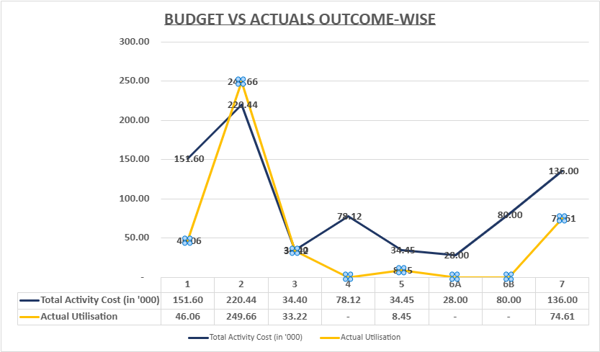
  - Outcome 2 [% Increase in action taken by child protection bodies (e.g., CPCs, DCPU, etc.) to prevent child labour, sexual abuse, and trafficking] – 6% of the total budget bottomline – achieved 113% utilisation.
  - Outcome 3 [% Increase in action taken by child protection bodies (e.g., CPCs, DCPU, etc.) to prevent Child Marriage] – 1% of the total budget – achieved 97% utilisation.
  - Outcomes 4 [% increase in schools that are safe spaces for children], 6A [% increase in survivors who are re-integrated into families and communities & have access to trauma informed health support] and 6B [% increase in survivors who are re-integrated into families and communities & have access to trauma informed health support, plus any other service such as (i) Enrolment in formal schools (ii) Age- appropriate skilling and livelihood opportunities] – 5% of total budget for 3 outcomes taken together – reported zero utilisation.

- There were a few outcomes where the actual utilisation significantly differed over the budgets.

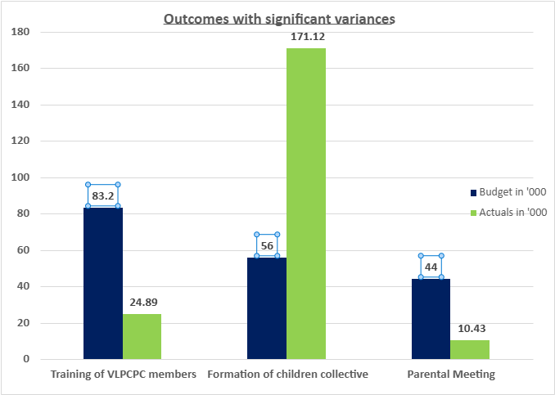
  - Training of VLCPC members – only 30% budget was utilised [₹ 0.25L/ ₹ 0.83L].
    - However, in terms of the program activity, the planned outcome was fully achieved.
      - 100% reference villages had fully operational and functional CPCs.
      - All the 28 Gram Sansads completed its vulnerability mapping and village level action plan and those were submitted to the Panchayat under GPDP plan.
      - 313 members of the CPC were trained on child rights, child right to protection and social security schemes. 173 CPC meetings were organised. 75% of the members maintained a regular attendance regular in all Monthly meetings.
      - All the 28 Gram Sansads of the Looksan Panchayat of Nagrakata Block are now maintaining the records of monthly meetings, case management, migration register, vulnerable children and village level action plan.
  - Parental meeting – only 24% budget was utilised [₹ 0.10L/ ₹ 0.44L]. However, in terms of the program activity.
    - However, in terms of the program activity, the planned outcome was fully achieved.
      - 2343 meetings were held with parents against 2200 planned meetings.
      - 726 trainings were also held for effective parenting against a target of 400 planned trainings.
  - Formation of children’s collective – utilisation was more than 3 times the annual budget [₹ 1.71L/ ₹ 0.56L].
    - 28 children’s collectives were formed in the operational Gram Sansads.
    - 1199 meetings were conducted with these children’s collectives.

BAT 2:

BAT 2 grant project followed a similar trend –
- Program activities – 64% utilisation;
- HR costs (Program team) – 116% and
- Program management team – 109%; and
- Admin cost – 88%.
Since the points are similar, hence we used BAT 1 project data only for the reflections.

Reflections:

- The planned outcomes appear to have been achieved fully most likely because of CRY’s programming approach centred around building the agency of children and engaging with their parents, local community collectives, service delivery system and all other connected stakeholders so as to build a safety net and an enabling system around children.
- However, budget utilisation for program activities appears to be a matter of concern. As mentioned earlier in this document, program expense bookings began only by middle of Q2 and picked up only by Q3. Even the no-cost extension was more about HR costs of program team and program management than about program activity expenses. Clearly, there were challenges faced by the team, presumably at multiple levels, for booking program expenses in FMS, month-on-month, in a timely manner.

For a deeper understand of this pattern, we may need to look into the following points, over time, with data from verified sources. The points enlisted below are based on learnings gathered from other grants governed by the GM team.

- Whether the challenges were internal to CRY or external and thus, beyond control of our teams.
- Whether there were any enablers at ground level, like accessing government or community spaces pro bono, for meetings of collectives and therefore funds were not even required for the meetings held.
- Whether there were any challenges in program implementation, at the ground level, that may have caused delayed start of program expense booking and resulted in a significant variance from approved budget.
- Whether there were any logistical or operational issues at the ground level, that may have affected program budget utilisation.
- Whether there were any process/ norm related or other operational challenges internally within CRY, that affected budget utilisation.
- Any other reason that may have affected the booking and utilisation of program expenses.
- Any specific reason why the budget for asset procurement was left totally unutilised? Was it not needed anymore or was it related to any other operational factor?

Learnings for budgeting:

- Knowing that the signing of MoU and the disbursement of funds by the donor takes time, we may want to budget for program activities, mostly from Q2.
- The new proposal is more about system strengthening. So, we may assume there may be more of workshops, meetings and conferences, most of which may not be month-on-month expenses. We may thus need to do the program activity gantt keeping the externalities in mind.
- We would be entering new districts and forming/ working with new teams. So, we may need to provision time, keeping these factors in perspective.
- For challenges that the team may have faced internally, we might want to raise/ escalate them to concerned functional HO’s for iteration on ways forward.
- The learnings emanating from DI workshops being organised by GRM and PAC teams jointly, may provide a platform to discuss some of the challenges and get ideas on addressing/ solutioning them.

BAT 2:
Based on the files and information received from Programs and finance teams, we looked through the BAT 2 project details, for the year 2024-25 only, to understand the pattern of utilisation vis-à-vis program implementation. The documents referred for this include –
- BAT 2 project financials for the period April 2024 to May 2025 – shared by Finance;
- BAT 2 project annual report for the period April 2024 to May 2025 – shared by Programs.

Table 1: Sector-wise grant utilisation in ‘000.

- Overall utilisation touched 100% but there were differences in utilisation % within the buckets.

  - Budget utilisation of HR cost for Program team (100%) and of HR cost for Program management (69%) which was heavily underutilized.
  - Budget utilisation of program activities by the end of the grant period was 41%.
  - There was no budget allocated for the assets and such there was no movement in this sector.

Table 2: Pattern of utilisation sector-wise and quarter-wise (‘000).

Value in ,000 | Program Activities | HR cost (Programs) | HR cost (Program mgmt) + Admin | Assets
Q1 budget | 665.8 | 1144.9 | 100.5 | 0.0
Q1 actuals | 0.0 | 840.8 | 41.9 | 0.0
% Utilisation | 0% | 73% | 42% | 0%
Q2 budget | 407.3 | 1114.9 | 103.5 | 0.0
Q2 actuals | 105.1 | 1166.8 | 125.2 | 0.0
% Utilisation | 26% | 105% | 121% | 0%
Q3 budget | 384.5 | 1114.9 | 103.5 | 0.0
Q3 actuals | 284.2 | 1222.9 | 54.4 | 0.0
% Utilisation | 74% | 110% | 53% | 0%
Q4 budget | 141.1 | 1114.9 | 103.5 | 0.0
Q4 actuals | 244.9 | 1253.8 | 58.4 | 0.0
% Utilisation | 174% | 112% | 56% | 0%

- Q1 had no program activity or asset procurement – most presumably because of delayed MoU finalisation and grant disbursal.
- HR cost of Program team had a slight underutilisation of 73% in the first quarter and slight over utilization in second, third and the fourth quarter ranging from 105% to 112%.
- HR cost of Program management (CRY cost) – 1 role was booked uniformly in all quarters while the other role was booked Q2 onwards. Hence Q1 utilisation was only 42% while utilisation in the other 3 quarters ranged between 53% to 121%. There was a major spike in utilisation in quarter 2 mainly because of the delayed start of the initiative.
- Program expenses started getting booked through Q2 and picked up only in Q3 and Q4. Bulk of the program expense bookings happened in Q4, towards the end of the grant tenure.
- At the end of the originally approved grant tenure, 31st March 2025, 7.35L (11% of total grant of 69L ) remained unutilised. No-cost extension was approved by BAT and subsequently, the entire balance amount of 7.35L was utilised fully by the end of 31st May 2025.
  - ₹ 1.61L was utilised for program activities;
  - ₹ 7.64L was utilised towards HR cost (Program team);
  - ₹ 1.2L was utilised towards administrative expenses.

Table 3: Budget vs Actuals, outcome-wise :

- Outcome 1 which was 10% of the entire budget, the highest allocation among all the other outcomes had an utilisation of 63%.
- Outcome 2 which was only 6% of the total budget saw an utilisation of 74%. The goal of this outcome was to measure the “%Increase in action taken by child protection bodies to prevent child labour, sexual abuse, and trafficking”.
- Outcome 6A which was to measure ” % increase in survivors who are re-integrated into families and communities & have access to trauma informed health support, plus any other service such as (i) Enrolment in formal schools (ii) Age- appropriate skilling and livelihood opportunities” which had 0.4% of the budget allocated saw 29% utilisation.
- Outcome 6B which was to measure the “% increase in survivors who are re-integrated into families and communities & have access to trauma informed health support, plus any other service such as (i) Enrolment in formal schools (ii) Age- appropriate skilling and livelihood opportunities” was only 1% of the entire budget saw the lowest percentage utilisation of 6%.
- Outcome 7 (Monthly, quarterly and annual meeting and Capacity building) which is 3% of the entire budget saw a 125% of budget utilization, the highest utilisation among all the other outcomes.

- There were a few outcomes where the actual utilisation significantly differed over the budgets.

  - Formation of VLAP– only 8% of the budget was utilised [₹ 4.45L/ ₹ 55L].
    - However, in terms of the program activity, the planned outcome was fully achieved.
      - All the 30 Gram Sansads completed its village level action plan and vulnerability mapping and and those were submitted to the Panchayat under GPDP plan.
      - 270 CPC meetings were organised to develop the VLAP by the 940 VCPC members, children and the parents at the community level. 75% of the members maintained a regular attendance regular in all Monthly meetings.
      - All the 30 Gram Sansads of the Looksan Panchayat of Nagrakata Block are now closely following the VLAP and maintaining the records of monthly meetings, case management, migration register, vulnerable children and village level action plan.

  - Awareness Campaign – 148% of the budget was utilised [₹ 64.3L/₹ 43.5L]
    - The overutilisation of the funds took place in the third and the fourth quarter but the outcome was fulfilled as per the requirements.
      - 4500 participants including VLCPC members successfully took part in the awareness campaign
      - The perpetrators rampant in the area were reported by the VLCPC for action against them.

  - Creation of child safe corners – 0% of the entire budget was utilised [₹ 0.0L/₹ 0.72L]
    - However, in terms of the program activity, the planned outcome was fully achieved.
      - Child safe corners were successfully setup in 50 government schools that agreed to take part in the initiative to increase safe places for children.
      - It included setting up of suggestions box and help box in the school and regularisation in school.
  - Capacity building – 146% of the entire budget was utilised [₹ 150.5L/₹ 103L]
    - The second and the third quarter saw an overutilisation. However, in terms of the program activity, the planned outcome was fully achieved.
      - 940 VLCPC members along with several other stake holders including community parents and local panchayat members were trained on child rights, child right to protection and social security schemes.

