PART I-
- ABOUT THE TRAINEE:
As a passionate social work student in the 4th semester of the MSW program at Assam University, the trainee had the opportunity to be placed with CRY (Child Rights and You), Kolkata for the block fieldwork for the period of 45 days. The trainee worked under the supervision of Miss Rubina Haque Laskar (Associate-Volunteer Engagement).CRY, a well-known organization dedicated to upholding the rights and well-being of children, provided a meaningful platform for the trainee to apply classroom learning to real-world situations. Coming from a background deeply rooted in social work values, the trainee had the opportunity to work in child-centered initiatives, community outreach, and advocacy efforts. This experience not only deepened trainee’s understanding of child rights but also strengthened the commitment to creating a positive impact in the lives of children.
- ABOUT THE ORGANIIZATION:
The trainee had been placed in an organization named as CRY (Child Rights and You). Its regional office in Kolkata is located at 13, Regent Estate, Kolkata – 700092, West Bengal. Their contact number +91-33-2412-0059 and email id: kolkata@crymail.org. While CRY's head office is based in Mumbai, it works actively across different regions of India, including Kolkata.
Child Rights & You (CRY) in a non-governmental organization (NGO) in India that is working to promote the rights of the children in four key areas: education, health and nutrition, safety and protection & child participation. Children are one among the most vulnerable groups in our society who are easily affected and thus they are at risk groups. Various issues can be seen such as child labour, child trafficking, child marriage, and other forms of child abuse etc. CRY, being one of the top NGOs working in the sectors of children works in collaboration with the parents, schools, community members, volunteers, interns, community resource persons, local-self-governments and most importantly with the children in order to improve and transform their lives. The goal is to support the healthy and holistic development of the children for getting empowered and to envision the change in long run.

- History of the Organization: Child rights and You (CRY) was started in the year 1979 by Rippan Kapur, who began the journey with just Rs. 50 and a few friends. Since then, CRY has touched the lives of millions of children across our country.
The beginning: CRY was founded in 1979 by Rippan Kapur, who worked as a purser with Indian Airlines. He and six friends started CRY with a simple goal: to bring joy and better lives to children in need. Gradually, CRY moved from just helping children through welfare to focusing on the rights of children’s rights. It began collaborating with local organizations and communities to bring long-lasting change.
Today, CRY works across India with the aim to fix the deeper problems that hinders children from living healthy and happy lives.
Major Achievements of CRY:
- Voice of India Campaign: CRY played a key role in pushing for free and compulsory education, which helped lead to the Right to Education Act in 2009.
- Global Participation: CRY is part of important international networks like: ‘Girls Not Brides’, ‘National Action and Coordination Group for Ending Violence Against Children (NACG-EVAC)’
- Work at the Ground Level: CRY supports communities in tackling issues like: - Children being out of school, Child labor, Child marriage and other social problems harming children.
- Institutional Objectives:
Vision: CRY's vision is a society built on respect for dignity, justice, and equity, where all children can grow up with their rights fulfilled. This includes:
- Happy, healthy, and creative children: ensuring children have access to basic necessities and opportunities for holistic development.
- Protected rights: Upholding children's rights to survival, development, protection, and participation.
- A society of justice and equity: Creating an environment where every child is treated with respect and dignity, regardless of background or circumstance.
Mission: CRY's mission is to:
- Empower individuals by motivating people to take action and contribute to positive change for children.
- Secure children's rights: Partner with communities, local institutions, and governments to protect and promote children's rights.
- Address root causes: Work towards long-term solutions to issues like poverty, lack of education, and child exploitation.
- Ensure sustainable impact: Focus on sustainable development initiatives that address the needs of children and their communities.
Key Goals: The organization has key goals focused on ensuring children's rights to education, healthcare, safety, and participation. They aim to improve access to quality education and healthcare, prevent child labor and child marriage, empower girls, and create a safer future for all children. CRY also works towards reducing child malnutrition and ensuring children's voices are heard on issues affecting them.
- ADMINISTRATIVE STRUCTURE
Table 1: Executive Body Members with their Designations
Executive Body Members | Designations
Puja Marwaha | Chief Executive
Yamini Kapoor | Director – Resource Generation
Vatsala Mamgain | Director – Communications
Rashmi Arora | Director – Finance
Kreeanne Rabadi | Director – West & Director – People and Culture
Soha Moitra | Director – North & Director – Programme
Trina Chakrabarti | Director – East, Director – Volunteer Engagement & Information Technology
John Roberts | Director – South & Director – Business Support
Subhendu Bhattacharjee | Director – Research and Knowledge Exchange

- Table 2: Body Members with their Designations
Body Members | Designations
Ratan J. Batliboi | Board Chair & Hon. Trustee
Pervin Varma | Trustee
Bahram N. Vakil | Trustee
Rajni Bakshi | Trustee
Dr. Ritu Priya | Trustee
Rajesh Patel | Trustee
Sandeep Batra | Trustee & Hon. Treasurer

- LEGAL STATUS: The legal status of CRY is that of a registered trust under the Bombay Public Trusts Act, 1950. It is also registered under Section 12A and 80G of the Income Tax Act and is eligible for receiving foreign donations under the Foreign Contribution (Regulation) Act (FCRA), 2010.

- REGISTRATION DETAILS: The registration details for the Kolkata office follow the parent organization’s legal framework and were formalized in the early 2000s.

- TYPE OF WORK

CRY Kolkata works to improve the lives of children by focusing on four main areas: protection, education, health and nutrition, and child participation. They team up with local grassroots organizations to run projects in different parts of West Bengal, Jharkhand, Odisha, and some areas of Bihar. Their aim is to build safe and supportive communities where children are not forced into child labor, early marriage, or trafficking. In education, they help children get enrolled in school, stay in school, and learn in a safe and friendly environment. Health programs focus on improving nutrition for mothers and children, raising awareness about health issues, and connecting families with local health services. They also pay special attention to supporting adolescent girls and children from tribal and disadvantaged backgrounds, helping them feel confident, included, and empowered.
- Funding Sources:
The major funding source of the organization comes from the major donors companies like HDFC, ITC, and Cognizant Foundation, along with long-time individual patrons and supporters. Also supported through individual donations, corporate social responsibility (CSR) contributions, and international funding agencies. The organization also conducts annual fundraising campaigns and receives support from philanthropic institutions and grant-making bodies both in India and abroad.

- Number and Target group of beneficiaries:
CRY Kolkata mainly works with children from birth up to 18 years old, especially those living in difficult situations—like children from poor rural areas, urban slums, or communities such as Scheduled Castes, Scheduled Tribes, and other backward groups. Every year, with the help of partner organizations, CRY supports over 25,000 children in Kolkata and nearby districts. These children get help with things like going to school, staying healthy, getting proper food, and being protected from harm and exploitation.
Children aged 0-18: CRY's work encompasses a broad spectrum of child rights, including health, education, and protection from various forms of exploitation.
Children under 5: CRY focuses on preventing undernourishment and ensuring access to healthcare services.
Children aged 6-18: CRY works to ensure school enrolment and retention, particularly for the 15-18 age groups, where they have seen better results than the all-India average.
Adolescent girls: CRY works to protect adolescent girls from child marriage.
Children at risk of child labor: CRY strives to protect children from child labor and trafficking.

- Organizational Structure:

Regional Director
↓
Senior Program Managers
↓
Program Managers
↓
Field Coordinators
↓
Community Mobilizers
↓
Field Staff (Community-Level Engagement
Figure No. 1: Organizational Structure

Volunteers & Interns
↳ Assigned based on:
• Area of Interest
• Skill Set

↳

Contribute to:
• Field Visits
• Documentation
• Child Engagement Activities
Communication Team Fundraising Team
↘ ↙

Operations and Outreach Support

- Infrastructure Facilities:
The CRY Kolkata office is well-equipped to support its operational needs. It includes administrative workspaces, meeting rooms and a resource center with books and reports related to child rights and development. The office is digitally connected, with access to internet, computing systems, printers, and project management tools. While CRY does not have its own training halls or transport fleet in Kolkata, it partners with local schools and community centers to conduct outreach programs and awareness events. Interns and staff are supported with digital tools and mobility expenses for fieldwork.

- Success Stories and Limitations:
Success Story 1- Rupali’s Story: A Fighter’s Spirit
Rupali, a 13-year-old girl from a Kolkata slum, lives in a one-room hut with her parents and four siblings. After her father became bedridden, her mother became the sole earner, making just Rs. 2500 a month.
Despite poverty and criticism, Rupali joined CRY’s Sports for Change program and found her passion in Karate. With limited food and resources, she trained hard, won local and national medals, and even bagged gold at the 6th International Karate Championship and West Bengal State Wushu Championship.
Now a green belt, Rupali dreams of earning a black belt, winning Olympic gold, and coaching other underprivileged girls.
Success Story 2: From Danger to Safety – Saving Children from Trafficking
In July 2025, over 90 young girls and women were rescued from human trafficking in West Bengal. Many of them were stopped at railway stations, where traffickers often try to move them. This rescue was possible because of the hard work of CRY Kolkata and its local partners, who have been raising awareness in areas where trafficking is common.
CRY ran awareness programs in communities, trained frontline workers, and educated school children about trafficking. In one case, a field worker saw a young girl acting strangely at a railway station. Because of CRY's earlier training, the Railway Protection Force acted fast and rescued the girl before anything bad happened.
This story shows that with awareness, training, and strong community support, we can stop trafficking and protect children. CRY works with families, local authorities, and children to help them stay safe and stop trafficking before it starts

- LIMITATIONS:
However, the organization also faces some challenges. One major issue is the strong social stigma and resistance to changing traditional mindsets in some rural communities. Even with awareness programs, problems like child labor and school dropouts still exist because of poverty and poor infrastructure. Another challenge is relying on donor funding, which can limit how freely the organization can run its programs, as the funds often come with specific conditions.

- FUTURE PLAN:
Over the next 2 to 5 years, CRY Kolkata plans to grow its work by teaming up with more local NGOs in remote areas. The organization will put more focus on adolescent health and providing digital education to children in rural regions. It also plans to set up urban child rights watch groups, working with municipal bodies to track and report cases of child protection violations.

CRY aims to partner closely with local governments to help implement policies effectively and ensure better funding for children's welfare. Their future plans also include training community leaders, encouraging youth to become child rights advocates, and using technology to monitor progress in real time.
CRY further is looking forward to extend their education program in Barak Valley in collaboration with Assam University Silchar, with the support of young volunteers which was offered to the trainees during the placement.

PART-II Student’s Field Work Report:
Work done by the Student’s:
As part of the MSW 4th semester block placement, the trainee was placed at Child Rights and You (CRY), Kolkata, a well-known child-focused organization that works to protect and promote children’s rights, especially those from underprivileged communities. The placement period lasted for 45 days.

- Orientation and Initial Work
The trainee's journey began with a detailed orientation conducted by CRY team members. During this session, the trainee learned about the history of CRY, its mission, and the four major thematic areas it works on — education, health & nutrition, protection, and child participation. The orientation helped the trainee understand the structure of the organization and its partnerships with grassroots NGOs.
Initially, the trainee was assigned office-based documentation work. This included maintaining project reports, updating case files, and organizing educational materials. This task gave the trainee a basic understanding of how NGOs function and how documentation plays a vital role in tracking the progress of field-level interventions.

Fieldwork and Community Visits

Soon after the initial days, the trainee was given the opportunity to participate in fieldwork. Under supervision, the trainee visited urban slum communities in and around Kolkata where CRY runs its programs. These visits were part of the education project, which focuses on reducing dropout rates, increasing school enrollment, and creating awareness about the Right to Education (RTE).
The trainee observed learning centers set up for children who are either out of school or irregular in their attendance. Interaction with children, community volunteers, and local teachers helped the trainee understand the challenges faced by children in slum areas — such as poverty, lack of parental awareness, and gender discrimination.

Initial Observations and Expectations
In the early phase, the trainee felt a mix of curiosity and concern. It was the first time witnessing ground realities of Urban Slum such as poor living conditions, health issues, and educational barriers faced by children. Despite initial nervousness, the trainee gradually adapted and became more confident in interacting with communities and contributing to ongoing projects.

The field visits gave me an opportunity to interact with children, parents, and local volunteers. I observed the challenges these children face — such as irregular school attendance, poor learning levels, gender discrimination, and lack of parental awareness. I also got a chance to visit informal learning centers supported by CRY, where community volunteers engage children through child-friendly learning approaches.

One of the important realizations during this phase was the gap between school enrolment and actual learning. Many children, even though enrolled in school, lacked foundational skills in reading and mathematics. This gap, if unaddressed, could lead to long-term academic failure and dropouts.

Participation in the Public Action Group (PAG) Project

A key highlight of my placement was being part of CRY’s PAG (Public Action Group) project. This initiative involved community volunteers working with children in both informal slum-based learning setups and government schools. The goal was to support children who had learning gaps — especially in English and Mathematics.

As part of this project, I accompanied volunteers during their school visits, where they worked alongside schoolteachers to help struggling students. The volunteers used simple tools like storytelling, picture cards, drawing, and activity-based games to make learning easier and more engaging. In slum areas, informal education sessions were conducted to help out-of-school children or those irregular in attendance to gradually reintegrate into formal schooling.

I personally engaged with small groups of children, helping them with basic alphabets, reading practice, and number recognition. The informal and interactive setting made the children more open, confident, and eager to learn.

b) Application of Social Work Method in the Field
1. Social Group Work
Social Group Work is a method where individuals are helped through group activities to learn, grow, and solve problems together. The group setting encourages sharing, cooperation, and mutual support, especially helpful for children or youth who learn better when they feel included and supported.

Target Group
Children from urban slums who were either irregular in school, weak in basic subjects like English and Math, or had dropped out.

Techniques Used
- Small group learning sessions in schools and slum areas
- Interactive storytelling, drawing, and games
- Group reading and basic writing exercises
- Encouraging peer support
- Consistent engagement with the same group of children
Outcomes Observed
- Children became more confident in reading and speaking
- Better participation and interest in learning
- Reduced fear of school among weak learners
- Safe and friendly learning environment

2. Social Work Research
Social Work Research involves the systematic investigation and study of problems to develop knowledge that guides social work practice. It helps understand the root causes of social issues and evaluate the impact of interventions.
The trainees were engaged in CRY’s research on PAG, the success of PAG, Razabazar and what role PAG played for those vulnerable slum children, where data were collected by the volunteers. Later, trainees were involved in data analysis process including both quantitative and qualitative set of data which were further interpreted and has provided the necessary findings.
Target Group: Children participating in the PAG project, volunteers working in schools, PAG Centre and engaged in informal education.
Techniques Used
- Observation of group learning sessions (by the volunteers)
- Informal interviews and conversations with children, volunteers, parents and school staff were used for data collection process by the volunteers.
Later, for the analysis and interpretation purpose, trainees were involved in reviewing previous progress reports and records.
Outcomes Observed
- Better understanding of the academic and social challenges faced by children
- Identification of patterns in dropout, irregular attendance and improvement in performance of the children.
- Insight into how volunteer participation impacts classroom learning
- Practical understanding of applying research tools like observation and interview in a community setting.

Key Learning’s from the Field
- Children feel free to learn when they are in a space where they are safe, supported, and not judged. It doesn’t matter what challenges children face but if they are provided a supportive environment they will definitely shine.
- Group activities help build children's confidence. Especially for those who are shy or weak in studies, learning in a small group with friends makes them feel comfortable and motivated.
- When the local community—like parents, volunteers, and teachers—get involved, real change happens. They understand the issues better and come forward to support the children in their own ways.
- Social work is more than just helping someone. It means giving people the power to stand on their own, make decisions, and improve their lives.
  - Critical Reflections:
Working with CRY Kolkata was a truly eye-opening experience for me. Being a social work trainee, I had the chance to interact closely with slum children, observe their daily struggles, and understand the deep-rooted challenges they face—like poverty, irregular schooling, and lack of guidance. At the same time, I also got to work on important tasks like documentation, assisting volunteers, and participating in informal education programs and various awareness sessions.
One of the biggest challenges I faced was connecting with children who were shy or irregular in learning. Many of them had little interest in studies due to past failures or lack of support at home. It took time and patience to build trust and make them feel safe.
Building Emotional Bonds with Children: As a trainee, I became attached to some children and felt emotionally responsible. But I had to maintain professional boundaries and avoid giving false hope about what I could offer in the long run. Balancing empathy with professionalism was emotionally challenging.
Limited Resources and Prioritization: CRY worked with many children, but resources (volunteers, time, and materials) were limited. I often had to choose whom to give more attention to. This raised ethical concerns—was I unintentionally neglecting others by focusing on only a few?
Through this journey, I experienced personal growth. I became more empathetic, patient, and aware of the realities that many children live in. Sometimes, we can’t blame person as situation are responsible to them. I also improved my communication skills and learned how to work with a team in real community settings. The placement helped me connect theory with real practice—understanding how methods like group work, community engagement, and research can bring real impact when applied well.
This experience made me realize that being a social worker is not just about helping—it's about standing beside people, understanding them, and working with them to bring lasting change.
  - Skills Developed:
During my 45-day placement at CRY, I developed several important skills that have strengthened my professional and personal growth:
- Communication Skills: I learned how to talk effectively with children, community members, and team members. I became more confident in explaining ideas in simple language and listening with empathy.
- Teamwork and Collaboration: Working alongside CRY staff, volunteers, and parents helped me understand the value of working together and supporting each other toward a common goal.
- Documentation and Reporting: I improved my ability to organize information, maintain records, and prepare short reports on field visits and activities. This helped me appreciate the importance of proper documentation in social work.
- Adaptability and Patience: Fieldwork in slum communities taught me to be flexible and patient, especially when dealing with challenging situations or delays.
- Empathy and Ethical Awareness: I became more sensitive to the struggles of children and their families, and more careful about respecting their dignity and rights while working with them.
- Basic Facilitation and Teaching Skills: Through informal education sessions, I developed basic teaching skills like storytelling, engaging group activities, and simplifying concepts for better understanding.

  - Conclusion
My time at CRY, Kolkata, was a special and eye-opening journey. Working with children in slum areas and being part of different activities helped me understand the real meaning of social work. I faced challenges, but I also learned a lot — not just about others, but also about myself. These experiences made me more confident, caring, and clear about why I want to help people. It showed me that even small efforts can make a big difference in a child’s life. It doesn’t matter what challenges children face but if they are provided a supportive environment they will definitely shine.

Annexures:

Certificate of Completion

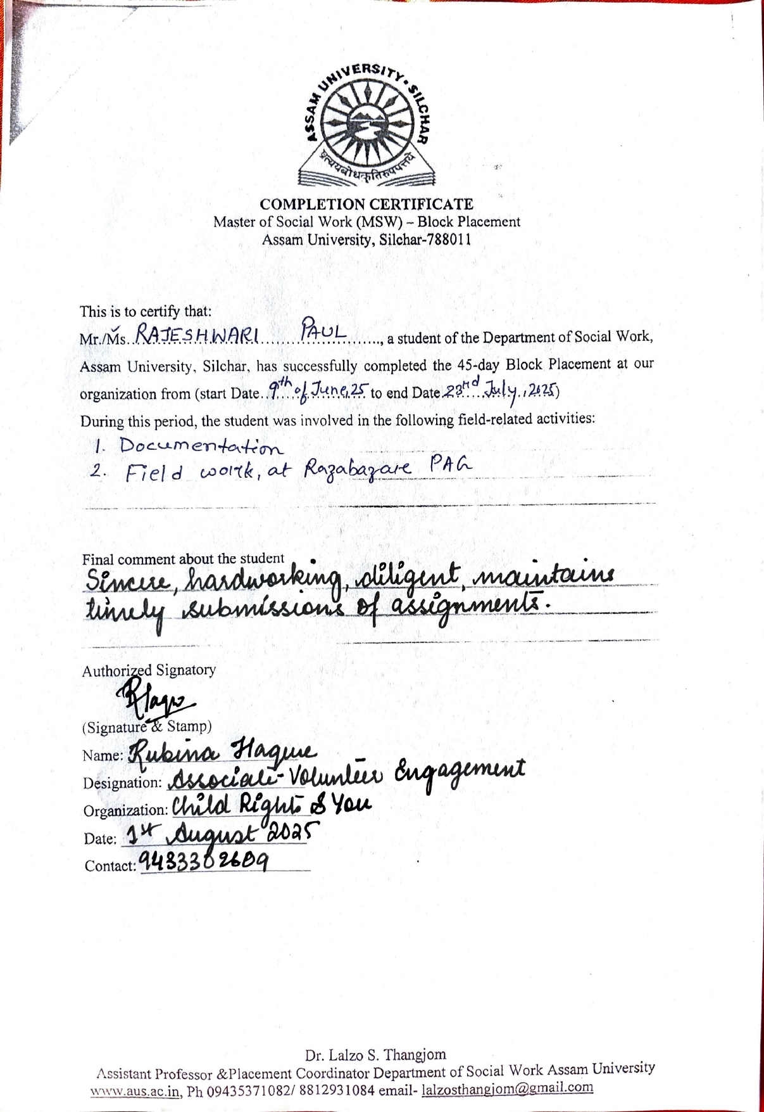
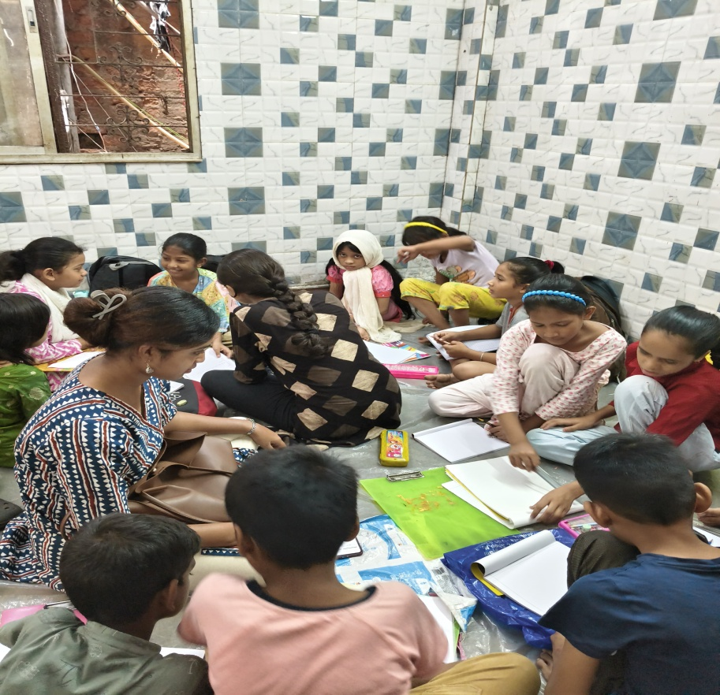
Picture 1: Trainee while teaching the children in PAG
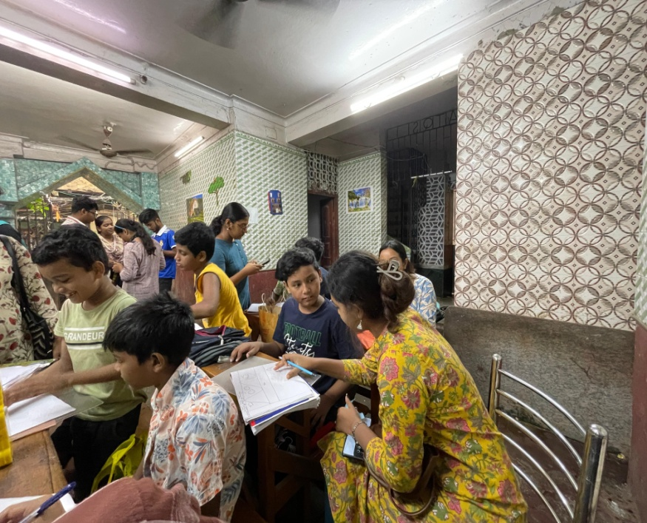
Picture 02: Trainee while helping the children

