A) Theme : Education
B) Title of story : Story of Bondana Nagbonshi - Determination leads to success.
C) Organization : CRY Foundation
D) Place : Digboi
E) Name of the child : Bondana Nagbonshi
F) Age : 13 year
G) Sex : Female
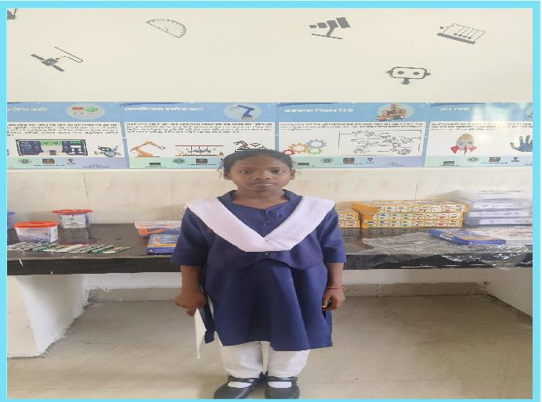
H) Community : Tea tribe
I) Access to school : Sowmar Vidyapith Higher Secondary School which is at 1 km distance from her home.
J) About family : Bondana's family consists of 5 members. She is the middle child in her family. Her father is engaged in earning money by driving.
K) Background : Bondana comes from a family of limited income, despite this she is good at her studies. She has an excellent academic record where she scored 85.5% in Science and 54.5% in Maths. She has participated in various school programs related to science, showing her profound interest in the subject.
L) Problem identification : Though Bondana is a bright student the lack of resources at her school hindered the utilisation of her potential.
M) Problem Intervention : With the introduction of STEM lab in her school her enthusiasm has grown. Hands-on learning and access to resources has increased her understanding of science and it's practical application. She is now engaged in science exhibition and working in collaboration with her project partner.
N) Overall impact of the project : This project has impacted her academic progress positively. Her active participation and dedication show promise for future academic and personal growth.

