Feed Back

The 1month internship with CRY is the one of the best internships I have earned. Now is the time to say Bye from the organization first if all Thanks to Monish Ma'am and Team CRY giving such wonderful opportunity in the field of Social Work

The first time I thought and googled these Organizations I thought I didn't get these Organizations but God Grace I got an opportunity to do an internship. This is the first time I am doing an internship with an NGO

On 13th June is the first Filed with Subha ma'am Harsha at Haralur School it was a nice opportunity to do with there We do lots of Indoor & Outdoor activity with the children they all are engaged with all these activities. After that i joined for the summer camp with Yeswanthpur Team Aww it was the one of Awesome experience we teach lots of activities Crafts, Life Skill & different areas.
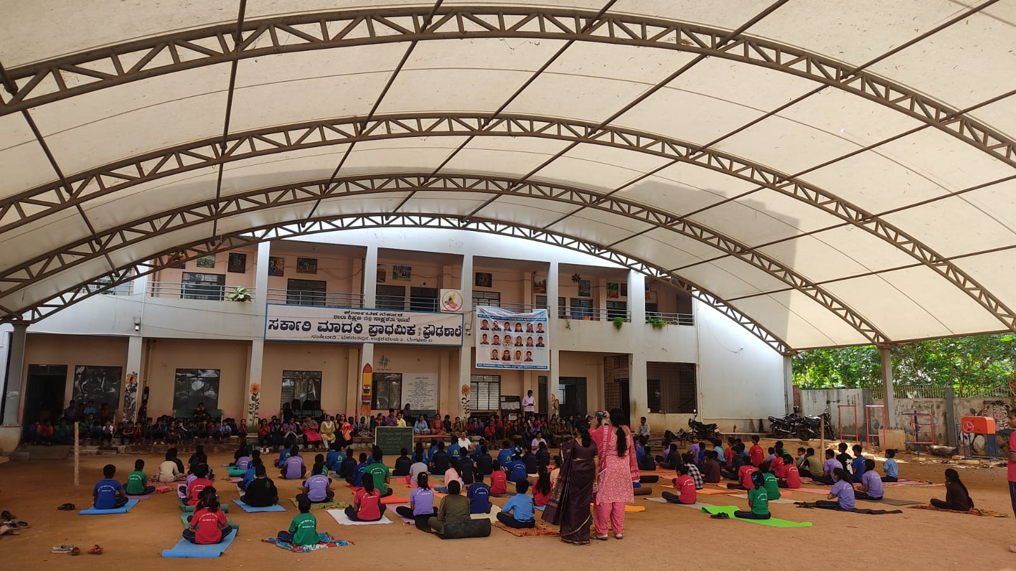

At the first time we feel very difficulties to handle the children’s they all are very little children's they didn't have any attention to us they all are run way I know a little bit Kannada and one of our team member Navy's Handle the children’s very calm and quietly they suddenly become silent and they are enjoying the section. But next Saturday we see a dramatic change because we entered the school the children came to us and they are called "Akka & Anna" please come to our class. They all are welcoming us so on that time we feel Happy they are remembering us. On the last day we conclude the session they say that "Don't go please come next day we all enjoying the session they all are very Happy" this kind of emotions we can see in the last day

Children Side: Their response was very genuine Say that they all are very Happy they Enjoyed Craft Session, Hello Hai Round Playing.
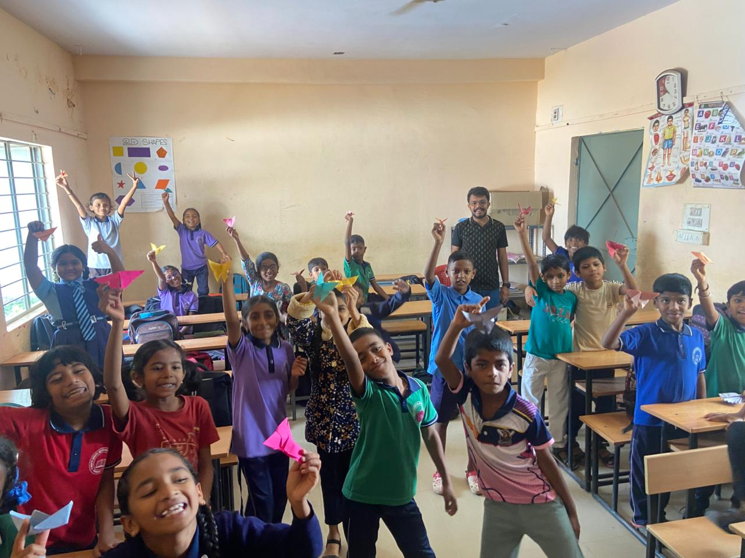
My Side: As earlier i said one of the great opportunities i learned a lot of things from this How I can handle the situation very Calm & Quietly because children are very Small. Learned not to get angry as my opinion, I am a quick-tempered person, but I have learned to control it now. Thanks to CRY to help this I improve my language styles also

Again, thank you CRY and My Yeswanthpur Team for this wonderful opportunity we all wishing a wonderful journey for CRY in the future.

Thankyou Thankyou a Lot

