CSR TRENDS IN INDIA – RESEARCH
By Himanshi Sharma

Corporate Social Responsibility (CSR) in India has seen tremendous growth, particularly with the implementation of the Companies Act, 2013. This act brought about a mandatory requirement for the eligible companies—those whose net worth is ₹500 crore or more, turnover is ₹1,000 crore or more, or whose net profits are over ₹5 crore—to utilize a minimum of 2% of their average net profits of the last three financial years on CSR activities. The enactment of this mandate heralded a change in the way CSR was viewed and practiced in India: from spontaneous acts of philanthropy to purposeful, legally regulated obligations toward social progress. In order to grasp how CSR has evolved since this shift, I investigated three various scholarly studies that collectively present an overview of CSR trends in India—ranging from spending habits to industry focus, regional distribution, company conduct, and reconciliation with country and global development targets.
The initial study, "CSR in India: A Comprehensive Analysis of Sectoral and Regional Spending Patterns" by Rishikesh Nalawade and Kandarp Singh, provides a complete analysis of CSR spending from FY 2014–15 to FY 2021–22. It shows education and healthcare as the most regularly funded sectors, where the companies consider these as core to bringing long-term positive change to society. Education expenditure had its peak in 2019–20 at more than ₹7,100 crore. Health expenditure, on the other hand, increased exponentially in the years since 2020 largely as a result of the COVID-19 pandemic, resulting in emergency funding to the Prime Minister's Relief Fund and other public health measures. Other sectors like rural development, sanitation, and empowerment of women also received significant, albeit relatively lower, allocations. Technology incubation and environmental segments, however, were underfunded, which reflected selective priorities.
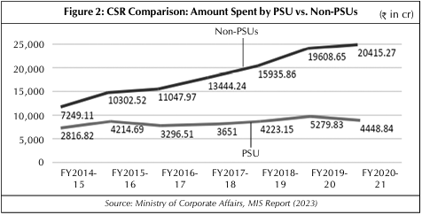
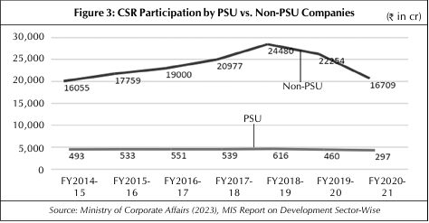
An important focus of the research is regional disparity in CSR expenditure. Industrial and corporate high-density states—especially Maharashtra (₹24,114 crore aggregate), Karnataka, Gujarat, and Delhi—accrued the lion's share of CSR funds. Northeastern states like Mizoram, Nagaland, and Tripura, on the other hand, received disproportionately lower expenditures, although they have some of the highest developmental arrears in the nation. The imbalance is mainly because of the provision under the CSR rules that induces the companies to incur expenditure in areas they have operations. Although this benefits people in the vicinity of industrial areas, it again increases the gap between developed and underdeveloped states. The research also differentiates between PSUs and private firms and finds that non-PSUs (private sector entities) have continued to outstrip PSUs in their expenditure and are more likely to adopt strategic impact-oriented CSR. PSUs, while significant contributors, tend towards a compliance model with limited long-term integration into the community
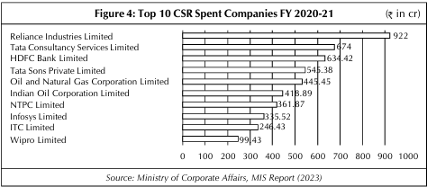

The second report, "Opportunities and Challenges for Corporate Social Responsibility in India" by S. Gouda, S. Parasuraman, and A.G. Khan, takes a qualitative view, examining both best practice CSR and the structural challenges that companies encounter in implementation. The research shows the performance of companies like Tata Group, Infosys Foundation, and Satyam Foundation, as examples like Satyam's 108 emergency ambulance service as a very effective CSR intervention having saved countless lives. Such examples show how well-designed CSR is able to directly contribute to the infrastructure of public services and reach out to target groups.
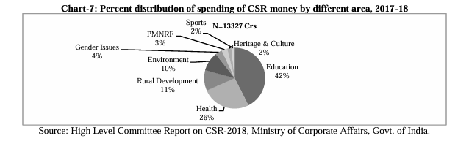
This study highlights that education (42%) and health care (26%) are the CSR funding majors, followed by rural development, environmental programs, and women's empowerment. Again, similar to the earlier study, it emphasizes that CSR is very disproportionately distributed geographically. The developed states receive most of the funds, with underdeveloped parts of the country, especially in the northeastern region and central India, being systematically neglected. The research also indicates that most companies do not utilize the entire 2% required CSR expenditure. A lot only set targets to fulfill the bare minimum legal compliance without measuring impact or customizing programs based on local contexts. Additionally, SMEs neither have the financial nor organizational capacity to engage in CSR despite being a bulk of India's business landscape.
A second critical observation is the over-reliance on implementing agencies. Most companies outsource CSR activities to third-party NGOs or consulting firms, which creates a gap between corporate planning and field implementation. This may result in wasteful expenditure of funds, redundancy of activities in areas that are already saturated, and poor accountability for project results. These observations imply that although the number of CSR activities has grown, their quality, effectiveness, and geographical spread continue to be uneven across industries and regions.

The third research, "Understanding CSR Investment for Sustainable Development: A Five-Year Review in India" by Pushpa Rani and others, also follows a data-driven strategy by reviewing CSR expenditure from FY 2017–18 to FY 2021–22 against the backdrop of the United Nations Sustainable Development Goals (SDGs). The research identifies strong congruence between Indian CSR initiatives and SDGs 1 to 4—poverty elimination, zero hunger, good health and well-being, and quality education. The information indicates sustained growth in CSR spending across these five years, with the total exceeding ₹26,000 crore in 2021–22. Non-PSUs continued to be the largest contributors. For instance, in FY 2021–22 alone, non-PSUs spent approximately ₹21,932 crore, while PSUs contributed around ₹4,345 crore.
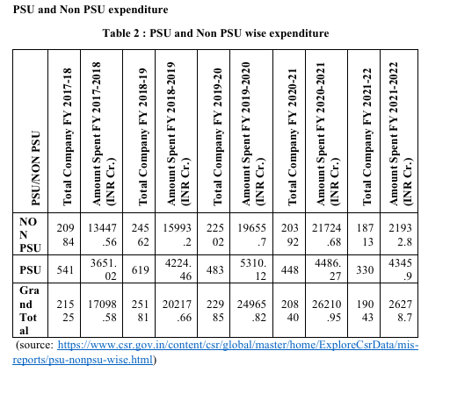
This study presents detailed state-wise, PSU vs. non-PSU, and sectoral breakdowns of CSR spending. It reinforces earlier observations: education and healthcare are the most supported sectors; states like Maharashtra, Karnataka, and Gujarat are the biggest recipients; and smaller, remote states continue to receive less funding. Yet it also highlights significant changes, like stepped-up CSR expenditure in environmental sustainability (₹2,392 crore during 2021–22, a big leap from ₹1,030 crore in the previous year) and climbing spend on sanitation, women empowerment, and livelihood improvement.
The strength of the study is its effort to evaluate the alignment of CSR with national development goals, particularly through the prism of SDGs. It highlights the need for transparency in data and continuous monitoring, observing that even as CSR gets more organized and visible, most firms have not yet established long-term assessment frameworks for measuring true social impact. Additionally, the study raises an issue of research deficiency on discovering the extent to which CSR is embedded in a firm's business strategy, as opposed to being viewed as an external regulatory requirement.

Common to all three studies are some dominant themes. First, CSR spending is highly concentrated on education and health care, which are both viewed as being socially relevant and reputation-building. Second, private sector companies lead CSR both in quantity and in strategic caliber of efforts. Third, there is a clear urban-industrial regional prejudice in fund allocation with scarce focus placed on backward or tribal areas. Fourth, there is a significant gap between CSR spending and CSR performance fueled by inadequate planning, a lack of monitoring, and poor stakeholder engagement.
Collectively, these results paint a complex picture of CSR in India. While corporate India has adopted CSR both in terms and in essence, its financial contribution to national growth has grown many-fold. However, inequality of implementation, regional penetration, and sustainability over time means that much more work needs to be done in making CSR inclusive and effective in the country's very diverse social landscape.

REFERENCES
Nalawade, R., & Singh, K. (2024). CSR in India: A Comprehensive Analysis of Sectoral and Regional Spending Patterns. The IUP Journal of Accounting Research & Audit Practices, 23(4), 377–402.
Gouda, S., Parasuraman, S., & Khan, A. G. (2024). Opportunities and Challenges for Corporate Social Responsibility in India. IOSR Journal of Humanities and Social Science (IOSR-JHSS), 29(3), 36–45.
Rani, P., Sharma, P., Monisha, & Malik, M. (2024). Understanding CSR investment for sustainable development: A five–year review in India. In N. Pathak et al. (Eds.), Proceedings of the 2nd International Conference on Emerging Technologies and Sustainable Business Practices-2024 (ICETSBP 2024) (pp. 579–592). Atlantis Press.

