Summer Internship Report
BBA 2nd Year
Weekly Report of Summer Internship Programme 2025 at
CRY Foundation

Submitted to
MS. Smiriti Rustagi


Submitted By
Name: SHYAM SUNDER
Roll No: 2331292
University Name: IILM University, Greater Noida
Course: BBA (Operations and Supply Chain Management)

Table of Contents
1. About the CRY Foundation 3
1.1 Mission & Vision 3
1.2 Core Focus Areas 3
1.3 Impact and Achievements 3
1.4 Partnership with Nav Srishti NGO 4
2. Introduction 5
3. Weekly Internship Activities (1st week) 6
3.1. Activities 6
3.1.1. Orientation Session 6
3.1.2. Introduction with Nav Shrishti Incharge – Nitu Ma’am 6
3.1.3. Event Planning for New Project Launch (Baghola Village, Faridabad) 6
3.1.4. Event Management & Support at the Project Launch (Baghola Village) 6
3.1.5. Field Work and Direct Engagement with Children 7
3.2. Key Learnings and Takeaways 7
3.3. Challenges 7
4. Weekly Internship Activities (2nd week) 8
4.1. Activities 8
4.1.1. Teaching Hindi, English, Maths, and Science 8
4.1.2. Data Collection for Eye Camp and Health Check-Up 8
4.1.3. Event Organising – Anti-Child Labour Campaign 8
4.2. Key Learnings and Takeaways 8
4.3. Challenges 9
5. Weekly Internship Activities (3rd week) 9
5.1. Activities 9
5.1.1. Teaching Hindi, English, Maths, and Science 9
5.1.2. Annual Report Preparation for Nav Shrishti NGO 9
5.1.3. Interactive Activities to Teach Maths in a New Way 10
5.2. Key Learnings and Takeaways 10
5.3. Challenges 10
6. Weekly Internship Activities (4th week) 10
6.1. Activities 10
6.1.1. Teaching Hindi, English, Maths, and Science 11
6.1.2. Interactive Activities to Teach English & Maths 11
6.1.3. Teaching Microsoft Excel in the Computer Lab 11
6.1.4. Mental Health Session for Girls (13+) 11
6.1.5. Legal Awareness Programme with Sakhi: One Stop Centre 12
6.2. Key Learnings and Takeaways 12
6.3. Challenges 13

1. About the CRY Foundation
Established in 1979 by Rippan Kapur, an Air India purser, CRY began as "Child Relief and You" with the mission to address the challenges faced by marginalised children. Over the years, it has evolved into a rights-based organisation, focusing on systemic changes to create a conducive environment for children's development. Headquartered in Mumbai, CRY operates through branches in Bangalore, Chennai, Delhi, and Kolkata, collaborating with over 100 grassroots NGOs across 19 states in India.

1.1 Mission & Vision
Vision: CRY envisions "a happy, healthy, and creative child whose rights are protected and honoured in a society that is built on respect for dignity, justice, and equity for all."
Mission: CRY's mission is structured around three core objectives:
- Taking Responsibility: Encouraging individuals to acknowledge and address the challenges faced by deprived Indian children, motivating them to seek solutions through personal and collective action.
- Mobilising Potential: Empowering people to recognise their capacity for initiating change.
- Inspiring Collective Action: Facilitating the formation of diverse collectives and movements that collaborate to secure and uphold the rights of India's children.

1.2 Core Focus Areas
CRY's initiatives revolve around four fundamental rights of children:
- Right to Survival: Ensuring access to healthcare, nutrition, and a safe environment.
- Right to Development: Providing quality education and opportunities for personal growth.
- Right to Protection: Safeguarding children from abuse, exploitation, and neglect.
- Right to Participation: Encouraging children to express their views and participate in decisions affecting their lives.

1.3 Impact and Achievements
As of the 2023–24 period, CRY has positively impacted over 2.1 million underprivileged children in India. Notable achievements include: 94% of children aged 6–18 years in CRY project areas are enrolled in schools.
- 92% of children under 5 years are protected from undernourishment.
- 99% of adolescent girls aged 11–18 years are safeguarded against child marriage.
- 88% of children aged 6–18 years are protected from child labour. CRY's efforts have been recognised through various awards, such as the "Most Trusted NGO" in 2018 and inclusion among the "Top 100 Non-profits in the World" the same year.

1.4 Partnership with Nav Srishti NGO
CRY collaborates with various grassroots organisations to amplify its impact, one of which is Nav Srishti, an NGO based in Delhi. Established in 1994, Nav Srishti focuses on child rights, education, health, women's empowerment, and livelihood development.
The partnership between CRY and Nav Srishti aims to address the multifaceted challenges faced by children and women in underserved communities. Through joint initiatives, they work towards creating sustainable change by:
- Educational Programs: Implementing child-centric learning methods to enhance educational outcomes.
- Health & Nutrition: Conducting health camps and awareness sessions to improve community health standards.
- Women's Empowerment: Organising skill development workshops and support groups to promote gender equality and economic independence.
- Child Protection: Establishing child protection committees and mechanisms to safeguard children's rights.
This collaboration exemplifies CRY's strategy of partnering with local organisations to create a broader and more profound impact on child welfare.
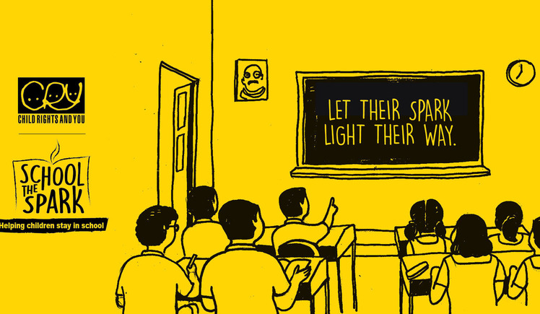
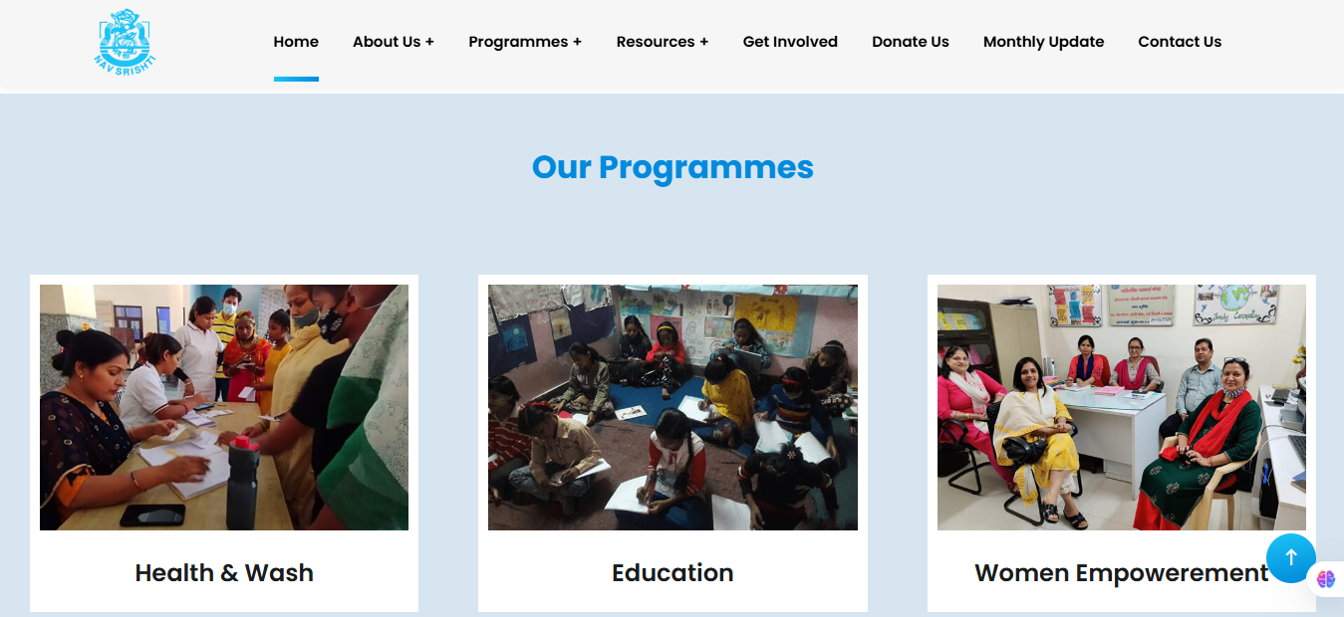

2. Introduction
I am a management student currently pursuing my BBA from IILM University. As a part of my academic journey, I have taken up an internship at CRY (Child Rights and You), a leading NGO working to protect the rights of underprivileged children in India. This opportunity is helping me gain real-world experience and understand how organisations operate beyond the classroom.
The main reason I chose to intern at CRY is to learn about the practical side of the corporate world and to explore the concept of Corporate Social Responsibility (CSR). CSR is a growing part of business today, where companies take responsibility not only for their profits but also for the society and environment around them. At CRY, I am seeing firsthand how organisations can make a positive impact on people's lives through dedicated planning and teamwork.
This internship is helping me develop professional skills like communication, teamwork, and time management. I am also learning how NGOs work in partnership with corporate and community members to bring about real change. I believe this experience will play a big role in shaping my future career and help me become a responsible and socially aware professional.


3. Weekly Internship Activities (1st week)

3.1. Activities

3.1.1. Orientation Session

The internship began with an orientation where I was introduced to the organizational structure, rules, and responsibilities. This session was essential for setting expectations and understanding the code of conduct. I was briefed on the mission of CRY and how Nav Shrishti functions as a partner NGO to implement child-focused projects on the ground. My role, scope of work, reporting protocol, and expected deliverables were clearly defined.

3.1.2. Introduction with Nav Shrishti Incharge – Nitu Ma’am

I had a formal interaction with Nitu Ma’am, the head of Nav Shrishti NGO. This was a significant moment that gave me a deeper understanding of the organization’s grassroots-level work. Nav Shrishti focuses on education, health, and vocational training, especially for underprivileged and disabled children. Nitu Ma’am shared their ongoing initiatives and explained how they align with CRY's mission to ensure children’s rights.

3.1.3. Event Planning for New Project Launch (Baghola Village, Faridabad)

I was involved in planning an event to launch a new community development project in Baghola Village (Faridabad). My tasks included:

- Brainstorming event structure.
- Supporting the core team (Helper).
- Teamwork.
- Time Management.

3.1.4. Event Management & Support at the Project Launch (Baghola Village)

On the day of the event, I took on a supportive role as a helper. I assisted in logistics setup, guiding attendees, ensuring supplies were available, and supporting the core team. My teamwork and time management skills were tested, especially when helping maintain order during activities with children and community members.

3.1.5. Field Work and Direct Engagement with Children

- Special Schools Search: I helped identify and list schools for disabled children near Delhi (especially around Saket and Neb Sarai). This research involved mapping special education institutions, understanding their facilities, and noting their contact information.
- Computer Class Monitoring: I supervised ongoing computer classes to observe how children were engaging with digital learning tools.
- Teaching Hindi to children aged 8–13 to strengthen their language skills.
- Attending a mental health session to better understand the psychological needs of children in difficult circumstances.
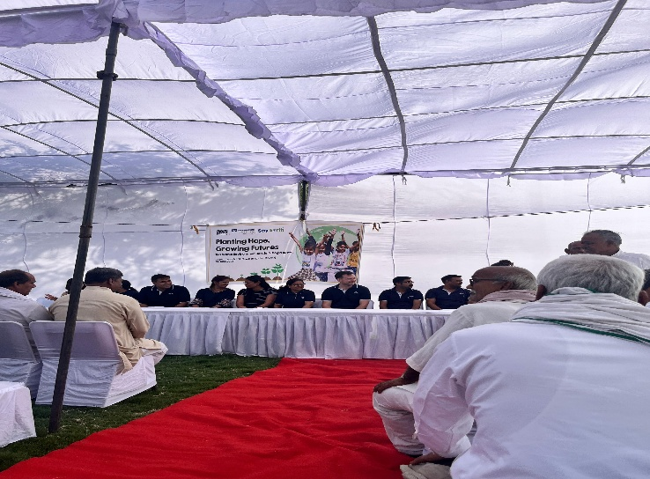

3.2. Key Learnings and Takeaways
- Professional Communication: I learned how to interact formally with team leaders, NGO staff, and community stakeholders.
- Event Planning & Execution: Gained hands-on experience in organizing and executing a community development event.
- Teamwork: Collaborating with peers and NGO staff improved my ability to function effectively in diverse teams.
- Time Management: Balancing multiple tasks in a limited time frame helped me build practical time management skills.
- Learned how to identify and document community needs, especially for children with disabilities.

3.3. Challenges
- Coordination Delays: Sometimes, there were last-minute changes in the event plan due to external conditions (like location issues or limited resources).
- Emotional Sensitivity: Observing the difficult circumstances of disabled or underprivileged children was emotionally intense and required empathy and self-awareness.
- Information Access: Finding detailed data about special schools was time-consuming and required cross-verifying multiple sources.
- Managing children's varied learning levels while teaching Hindi in group sessions.
- Communication barriers due to language differences or unfamiliar local dialects.

4. Weekly Internship Activities (2nd week)

4.1. Activities

4.1.1. Teaching Hindi, English, Maths, and Science

This week, I was actively involved in teaching core subjects — Hindi, English, Mathematics, and Science — to children in the age group of 8–14 years. My work included:

- Preparing simple and engaging lesson plans
- Conducting interactive classroom sessions
- Helping children improve their reading, writing, comprehension, and basic numerical skills
- Using creative techniques (like storytelling, drawing, and oral exercises) to explain science and math concepts

This experience helped me develop classroom management skills and explore how education can be made enjoyable and accessible, especially for underprivileged children.

4.1.2. Data Collection for Eye Camp and Health Check-Up

I was assigned to handle data collection and entry for people attending an Eye Camp and General Health Check-up organised by the NGO. My responsibilities included:

- Collecting basic demographic data (name, age, contact details, etc.)

This task made me realise the importance of accurate data entry and confidentiality in health records, as this data is critical for planning future outreach and follow-ups.

4.1.3. Event Organising – Anti-Child Labour Campaign

As part of the World Day against Child Labour (June 12), I helped to organise a special awareness event for children and community members. My tasks included:

- Coordinating speeches, songs, and small performances.
- Spreading awareness about child rights and the importance of education.

This event aimed to educate the public and empower children to speak out against child labour and advocate for their rights.

4.2. Key Learnings and Takeaways
- Multi-Subject Teaching Experience: Enhanced my ability to simplify and communicate complex topics across various subjects.
- Organisational Skills: Learned how to plan and execute events with attention to both logistics and emotional engagement.
- Data Handling: Understood the role of data management in ensuring the smooth delivery of health services.
- Child Rights Awareness: Gained a deeper understanding of issues like child labour and the role NGOs play in combating them.
- Empathy and Patience: Working with children of different learning abilities taught me to be more adaptable and compassionate.

4.3. Challenges
- Diverse Learning Levels: It was challenging to teach children from different grades and learning paces in the same classroom.
- Time Constraints: Balancing teaching, data entry, and event planning within a limited timeframe required strong multitasking.
- Sensitive Topics: Discussing child labour and related issues required careful communication to ensure children felt safe and empowered

5. Weekly Internship Activities (3rd week)

5.1. Activities

5.1.1. Teaching Hindi, English, Maths, and Science

Throughout this week, I continued teaching core subjects, including:

- Hindi: Focused on reading fluency, grammar, and vocabulary enhancement.
- English: Conducted speaking exercises, basic grammar lessons, and reading comprehension activities.
- Mathematics: Helped students practice fundamental arithmetic and problem-solving.
- Science: Introduced basic science concepts using simple experiments and everyday examples.

By tailoring lessons to the children’s level, I encouraged active participation and helped reinforce classroom learning in a fun, interactive way.

5.1.2. Annual Report Preparation for Nav Shrishti NGO

One of the key responsibilities this week was assisting in the preparation of Nav Shrishti’s Annual Report, which involved:

- Collecting and compiling data from different projects (CACs, Digital & STEM centres)
- Structuring content under sections like project highlights, impact stories, student participation, and special events
- Designing visual elements like charts, photos, infographics, and formatting the document for presentation

Additionally, I supported the creation of a PowerPoint Presentation summarizing the annual report for upcoming meetings or donor engagement.

This task strengthened my understanding of NGO operations, impact reporting, and professional documentation.

5.1.3. Interactive Activities to Teach Maths in a New Way

To improve learning outcomes in Mathematics, I introduced and facilitated interactive math activities such as:

- Math games and puzzles (e.g., number bingo, flashcard challenges).
- Story-based problem solving.
- Group activities using real-life objects (coins, sticks, charts) to explain concepts like measurement, addition, and geometry.

These methods made math more relatable, engaging, and less intimidating for students, especially those who previously struggled with the subject.

5.2. Key Learnings and Takeaways
- Curriculum Adaptation: Learned how to adapt academic content based on student levels and learning styles.
- Reporting Skills: Gained hands-on experience in writing and designing an Annual Report — a key part of NGO accountability and donor engagement.
- Creative Teaching Methods: Discovered that using interactive, play-based methods boosts interest and learning in subjects like mathematics.
- Project Documentation: Understood the importance of structured documentation to reflect year-long impact.

5.3. Challenges

- Time Management: Balancing report-making with teaching sessions required strong time planning and prioritisation.
- Data Gaps in Reporting: Collecting consistent data across projects for the annual report was sometimes difficult due to limited or missing records.
- Student Engagement in Math: A few students had a fear of math or lacked foundational knowledge, which needed extra effort and personalised attention.

6. Weekly Internship Activities (4th week)

6.1. Activities

6.1.1. Teaching Hindi, English, Maths, and Science
This week, I continued teaching the core academic subjects to children in the 6–12 age group. My focus remained on:
- Enhancing reading and writing skills in Hindi and English
- Reinforcing basic math operations through hands-on practice
- Introducing science concepts through real-life examples and discussions.
These sessions helped strengthen foundational learning in a consistent and supportive environment.

6.1.2. Interactive Activities to Teach English & Maths
To make learning more engaging and effective, I introduced interactive games and group activities:
- For English: Vocabulary games, sentence-making puzzles, storytelling.
- For Maths: Real-life problem-solving activities, number games, flashcards.
These techniques increased student participation and made the learning process more fun and relatable.

6.1.3. Teaching Microsoft Excel in the Computer Lab
I conducted a basic Excel session for older students at the Digital Learning Centre. My tasks included:
- Teaching Excel basics (data entry, formatting, simple formulas).
- Helping students practice by creating basic tables and charts.
- Monitoring individual progress and providing support as needed.
This digital literacy training is essential for building future-ready skills in today’s tech-driven world.

6.1.4. Mental Health Session for Girls (13+)
I attended a mental health awareness session designed specifically for adolescent girls (aged 13 and above). Key topics covered were:
- Understanding emotions and stress.
- Building self-esteem.
- Coping with peer pressure.
This session emphasized the importance of emotional well-being, especially during adolescence, and created a safe space for open discussion.
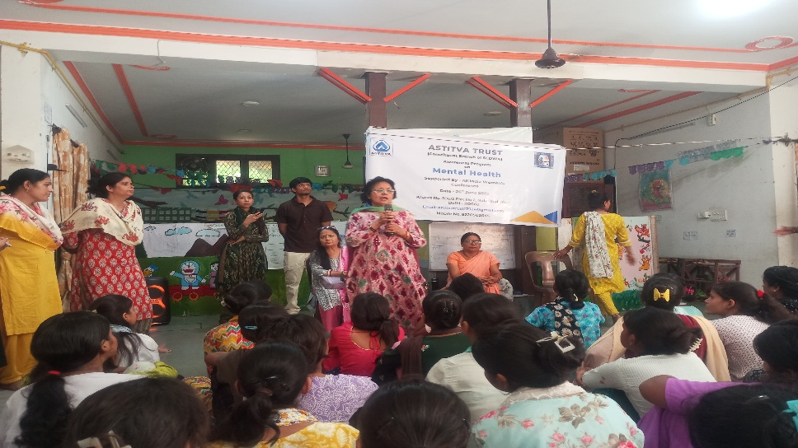

6.1.5. Legal Awareness Programme with Sakhi: One Stop Centre
I also attended a Legal Advice and Awareness Programme conducted in collaboration with Sakhi: One Stop Centre, for individuals aged 15 and above. The session focused on:
- Women's legal rights and protection under Indian law.
- Reporting and responding to abuse or violence.
- Support services are available through the government and NGOs.
This programme was particularly empowering for young girls and women, equipping them with practical legal knowledge and support resources.
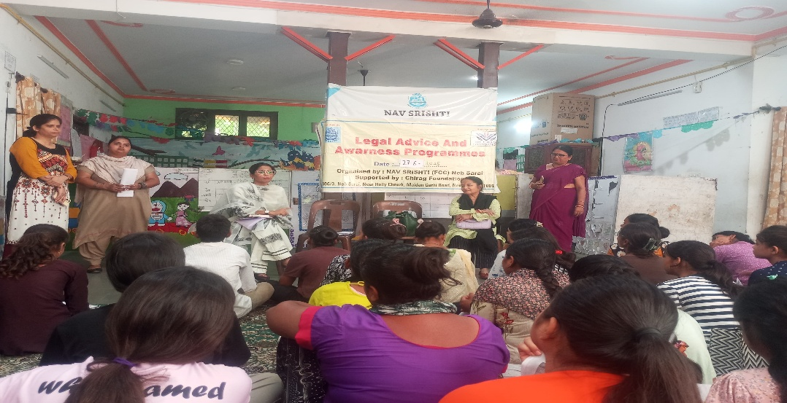

6.2. Key Learnings and Takeaways
- Activity-Based Learning: Reinforced the value of creative, interactive methods in academic instruction.
- Empathy and Sensitivity: Gained a deeper understanding of emotional and mental health needs among adolescent girls.
- Digital Literacy Teaching: Developed the ability to explain technical content (Excel) in a simple and structured way.
- Legal Awareness: Learned about key legal rights and support systems for women and girls, which are crucial for community empowerment.
- Holistic Child Development: Understand the balance between academic learning and recreational or emotional support.

6.3. Challenges
- Managing Mixed Skill Levels: In Excel and academic classes, students had very different learning speeds, requiring extra effort and individualized support.
- Limited Resources: Conducting Art & Craft with minimal materials pushed me to be more creative and resourceful.
- Sensitive Discussions: Topics during mental health and legal sessions needed to be handled delicately, especially for younger participants.
- Time Constraints: Coordinating multiple types of sessions (academic, creative, legal, and emotional) in a single week was challenging but rewarding.

Declaration
I hereby declare that the information furnished above is accurate to the best of my knowledge and reflects my true internship experience for the given week.

Signature:
Date: 03/06/2025 - 30/06/2025
References:
CRY Foundation: https://www.cry.org/
Nav Shrishti NGO: https://navsrishti.org/

