A) Theme : Education
B) Title of story : The Story of Jahnabi Kowar - Steady improvement A key to success.
C) Organization : CRY Foundation
D) Place : Digboi
E) Name of the child : Jahnabi Kowar
F) Age : 14 Years
G) Sex : Female
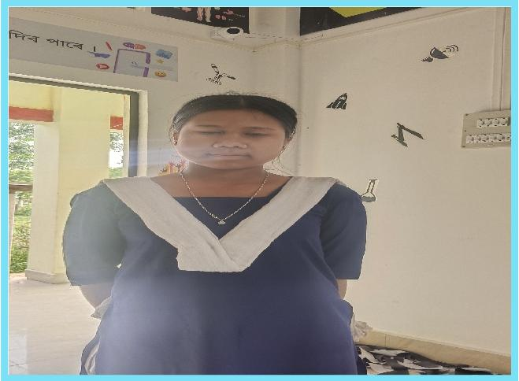
H) Community : Ahom
I) Access to school : Jahnabi studies in class 8 in Sowmar Vidyapith Higher Secondary School which is about 1 km away from her home.
J) About family : Jahnabi Kowar comes from a family of four members. Her father works as a daily wage labourer in pipeline maintenance. She is the eldest of the two siblings, hence she carries a sense of responsibility to do better in her academics.
K) Background : Jahnabi belongs to a hardworking family with limited income. Despite financial hurdles, she strives to do better in her education. She actively participates in class which shows her eagerness to learn. In the subject of Science, she has shown steady progress, with her marks increasing from 32 to 37. This improvement highlights her growing interest and effort in understanding scientific concepts.
L) Problem identification : Limited financial resources and the challenges of a daily wage household pose significant obstacles. Despite this, Jahnabi remains committed to her learning, drawing strength from her teachers and the academic support provided at school.
M) Project Intervention : Jahnabi's improvement in Science can be linked to the influence of hands on learning experience provided by the introduction of STEM initiatives at her school. The practical approaches have helped her understand difficult concepts, overcome and improve in the subject. She is determined to set an example for her younger sibling and to bring positive changes in her family through education.
N) Overall impact of the project : Jahnabi Kowar's story shows that she embraces challenges, is resilient and seeks opportunities to build her knowledge base. She is a young learner determined to grow through education. Her progress in Science and her dedication to studies show that, with the right encouragement, students from challenging backgrounds can steadily move toward a brighter future.

