A) Theme : Education
B) Title of story : The Story of Rita Murah - Aspiring to be Inspiring.
C) Organization : CRY Foundation
D) Place : Habi Charai Chungi
E) Name of the child : Rita Murah
F) Age : 14 years
G) Sex : Female
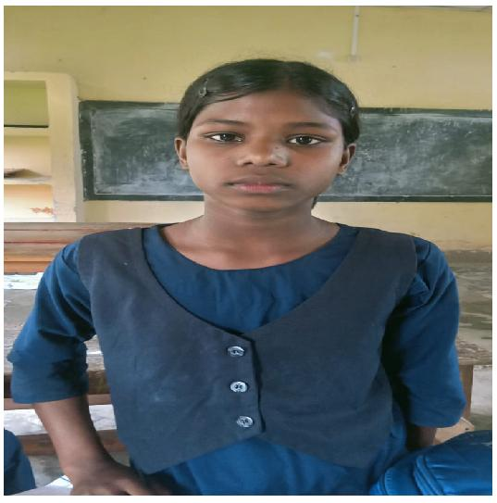
H) Community : Adivasi (ST)
I) Access to school : Rita Murah is a class 9 student in Rongchangi Sowmarpith High School which is about 1.5 km away from her home.
J) About family : Rita Murah's family consists of her parents and siblings. Her father, Jiten Murah is a daily wage labourer and mother Manju Murah is a homemaker. Her siblings are also engaged in school.
K) Background : Rita comes from a modest family with limited resources who have been supportive of her education despite financial hurdles. She is a hardworking student who can overcome challenges with encouragement and support.
L) Problem identification : Rita struggled in Science and Maths, she scored only 30 in the first phase of the school's STEM assessment. Lack of resources and academic support were the reason for such results.
M) Project intervention : The setup of the STEM Lab at Rongchangi Sowmarpith High School changed everything. With hands-on experiments, visual learning, and teacher mentorship, Rita began to enjoy and understand complex concepts. This was reflected in her progress in the second phase of assessment where she scored 72 marks. This improvement led to the upsurge of a newfound confidence in her and now she dreams of becoming a science teacher to inspire and empower other girls of her village.
N) Overall impact of the project : Rita Murah's story shows that STEM initiatives can bring meaningful changes. Her parents are proud of her progress and her siblings take inspiration from her and work hard to become like her. From struggle to success, she utilized the project in the best way to shape her educational journey with excellence.

