A) Theme - Education
B) Title - The story of Sumi Saikia : Choosing Dreams close to home.
C) Organization - CRY Foundation.
D) Place - Kachari Pather
E) Name of the child - Sumi Saikia
F) Age - 13 years
G) Sex - Female
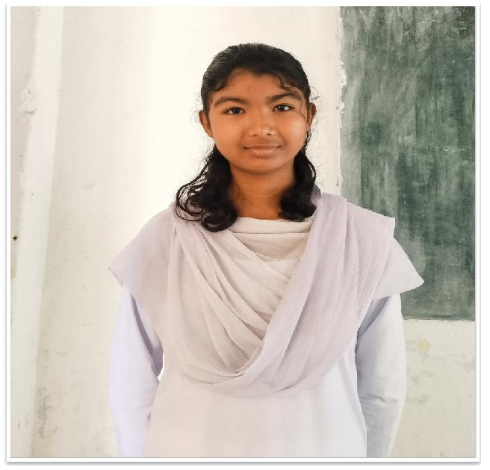
H) Community - Assamese
I) Access to school - Sumi completed her education up to class 8 in Kachari Pather ME school, and then pursued studies in Kachari Pather High school, in Kachari Pather village, which is about 1 km from her home.
J) Family - Sumi belongs to a family of eight members. Her father has a small business with limited income.
K) Background - Sumi comes from family of large number and limited income, despite this she has been a bright student. She studied up to class 8 in Kachari Pather ME school and decided to take admission in Kachari Pather High school.
L) Problem identification - Many of Sumi's classmates considered schools in larger town with better resources and infrastructure for higher studies. While she made a different choice.
M) Project intervention - Her choice to stay back in the village and take admission in Kachari Pather High school was influenced by the establishment of a new STEM (science, technology, engineering and mathematics) lab at the school. This lab was set up under the CSR initiative of Oil India Limited, in collaboration with Child Rights and You (CRY), and implemented by Smart Circuit. The lab brought advanced learning tools and hands-on science opportunities right into her village.
N) Overall impact - This initiative enabled Sumi to stay in her village and still pursue quality STEM education without any additional financial burden on her family. Her story underscores the importance of such initiatives and partnership which can transform rural education, empower students to utilise the available resources and chase their dreams from where they are. This also highlights the importance of bringing better resources and facilities to rural areas for the welfare of all people residing there.

