A) Theme : Education
B) Title of story : The Story of Sweety Borah - Encouragement leads to Improvement.
C) Organization : CRY Foundation
D) Place : Digboi
E) Name of the child : Sweety Borah
F) Age : 15 Years
G) Sex : Female
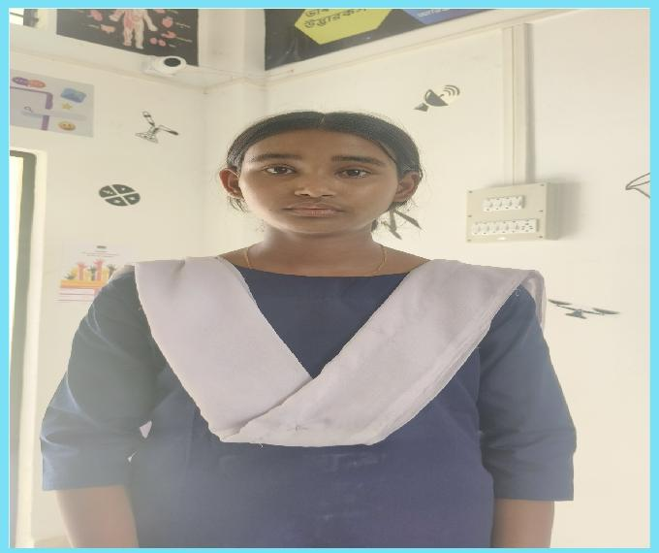
H) Community : Ahom
I) Access to school : Sweety Borah is a class 9 student in Sowmar Vidyapith Higher Secondary School, which is at a distance of 1.5 km from her home.
J) About family : Sweety comes from a modest family. Her father works as an office boy in the Indian Oil Corporation Limited (IOCL) and supports the family through his dedication and hard work.
K) Background : Despite limited resources, her family is very supportive of her academic aspirations and encourages her to turn aspirations into reality. She is a hardworking student and has shown remarkable improvement in her academics. Her Science marks improved from 38 to 44, and her Math marks showed a significant jump from 14 to 32. She participated in a science exhibition for the first time, and it was a milestone in her educational journey.
L) Problem identification : Sweety being a diligent student performs well at school but coming from financially constrained household prevents her from having access to educational resources at home.
M) Project intervention : Access to STEM learning environment plays a key role in Sweety's academic progress and provides motivation to overcome challenges she faces due to lack of educational resources at home. Exposure to practical experiments and real-world applications of scientific concepts helped her understand lessons more deeply and boosted her confidence, particularly in Math and Science. With continued support, she is likely to excel in academic and personal pursuits.
N) Overall impact of the project : Sweety Borah’s story is a powerful example of how a nurturing learning environment and perseverance can lead to meaningful improvement. Sweety’s enthusiasm for learning and her courage to participate in the science exhibition for the first time indicate a growing ambition. Her journey underscores the importance of inclusive education and the transformative power of opportunity.

