BLOCK PLACEMENT REPORT Master of Social Work (MSW)

Student Details
- Name of the Student: Ankita Senapati

- Institution: Assam University, Silchar.

- Semester: MSW 4th semester

- Block Placement Duration: From 9th June, 2025 to 24th July, 2025.
- Name of Agency Supervisor: Miss. Rubina Haque Laskar

- Name o the Placement Coordinator: Dr. Lalzo S Thangzom
- Contact Details of Agency: kolkata@crymail.org
Mail to: vol.kol@crymail.org.

Acknowledgement
I would like to express my heartfelt gratitude to the Department of Social Work, Assam University, Silchar, for granting me the invaluable opportunity to undertake my block placement, which has significantly enriched my academic and professional journey. This placement not only provided practical exposure but also allowed me to apply the theoretical knowledge gained during the course in a real-world setting. I am especially thankful to the Placement Coordinator for their continuous academic guidance, encouragement, and support throughout the placement period. Their insights and timely interventions played a crucial role in shaping my learning experience and helping me stay focused on my objectives.
My sincere thanks and deep appreciation also go to my agency supervisor at CRY Kolkata, whose mentorship and constant support were instrumental in my professional development. Their patient guidance, constructive feedback, and commitment to child rights inspired me greatly and made this placement a truly meaningful experience. The opportunity to work with an organisation like CRY has broadened my understanding of field-based social work practice and deepened my commitment to social justice.
Lastly, I would like to acknowledge the support of my peers, the CRY team, and the communities I engaged with, who have all contributed to my learning in unique and lasting ways.

PART I: ORGANIZATIONAL PROFILE

1. Name of the Agency/Institution:
The full name of the agency is Child Rights and You (CRY). The Kolkata regional office is located at 13, Regent Estate, Kolkata – 700092, West Bengal, India. For communication, the organization can be reached through its official contact number and email: +91-33-2412-0059, kolkata@crymail.org, mail to: kolkata@crymail.org. The CRY headquarters is situated in Mumbai, but it operates regionally across India, including in Kolkata.

2. History of the Agency/Institution:
CRY (Child Rights and You) was founded in 1979 by Rippan Kapur with just ₹50 and six friends, driven by the dream that every child deserves a happy and secure childhood. CRY’s initial work involved supporting other small-scale grassroots initiatives by channelizing funds and resources. However, the organization has evolved into a development enabler and change-maker with a strategic focus on child rights, social justice, and systemic change. Over the decades, CRY has grown into a national movement dedicated to restoring children’s rights. Initially a fundraising initiative for grassroots organizations, CRY today is a nationally recognized development organization that partners with NGOs, communities, and government institutions to ensure systemic change in the lives of children.

3. Institutional Objectives:
- Vision: “A happy, healthy and creative childhood for every child.”
CRY envisions a world where no child is deprived of their rights, regardless of their socio-economic background. This vision reflects CRY’s deep commitment to creating an environment where children not only survive but thrive physically, mentally, and emotionally.
- Mission:
i. Taking Responsibility
To enable people to take responsibility for the situation of the deprived Indian child and so motivate them to seek resolution through individual and collective action thereby enabling children to realise their full potential.
ii. Mobilising Potential
To make people discover their potential for action and change.
iii. Inspiring Collective Action
To enable people’s collectives and movements encompassing diverse segments, to pledge their particular strengths, working in partnership to secure, protect and honour the rights of India’s children.
CRY’s objectives focus on creating sustainable, long-term changes in child rights by addressing root causes such as poverty, lack of education, and social injustice.
- Key Goals & Focus Areas:
CRY focuses on four fundamental child rights:
1. Right to Survival (Health & Nutrition)
Ensuring access to healthcare, immunisation, nutrition support, and sanitation.
2. Right to Development (Education)
Promoting free, quality education and facilitating learning opportunities for children in underserved communities.
3. Right to Protection (Safety & Protection)
Preventing child labour, early marriage, trafficking, and abuse by strengthening child protection mechanisms.
4. Right to Participation (Child Participation)
Empowering children to voice their concerns and participate in decisions that affect their lives.

4. Administrative Structure:
Executive Body Member | Designation(s)
Puja Marwaha | Chief Executive
Yamini Kapoor | Director – Resource Generation
Vatsala Mamgain | Director – Communications
Rashmi Arora | Director – Finance
Kreeanne Rabadi | Director – West & Director – People and Culture
Soha Moitra | Director – North & Director – Programme
Trina Chakrabarti | Director – East, Director – Volunteer Engagement & Information Technology
John Roberts | Director – South & Director – Business Support
Subhendu Bhattacharjee | Director – Research and Knowledge Exchange  Table 1: List of Executive Body Members with their Designations
Table 1: List of Executive Body Members with their Designations
Table 2: List of Body Members with their Designations
Body Members | Designation
Ratan J. Batliboi | Board Chair & Hon. Trustee
Pervin Varma | Trustee
Bahram N. Vakil | Trustee
Rajni Bakshi | Trustee
Dr. Ritu Priya | Trustee
Rajesh Patel | Trustee
Sandeep Batra | Trustee & Hon. Treasurer  Table 2: List of Body Members with their Designations
Table 2: List of Body Members with their Designations
- Legal Status: The legal status of CRY is that of a registered trust under the Bombay Public Trusts Act, 1950. It is also registered under Section 12A and 80G of the Income Tax Act and is eligible for receiving foreign donations under the Foreign Contribution (Regulation) Act (FCRA), 2010.
- Registration Date: The registration details for the Kolkata office follow the parent organization’s legal framework andwere formalized in the early 2000s.

5. Type of Work (Programs/Projects):
CRY works through a rights-based approach focusing on:
- Child Education: CRY promotes enrolment and transition of children from marginalized communities into formal education, conducts mass awareness drives for re-enrolment of dropouts, and works to ensure access to educational entitlements and schemes provided by the government. CRY also helps vulnerable children access government benefits like scholarships and education materials and sets up education centres to support former child labourers complete their studies.
- Child Health & Nutrition: CRY emphasizes timely prenatal and postnatal care for expectant and lactating mothers, ensuring safe deliveries and breastfeeding check-ups. It monitors child growth till the age of 6, promotes infant and young child feeding, immunization, and addresses gender discrimination.
- Stopping Child Labour: CRY intervenes to prevent children from becoming child labourers by connecting parents with MNREGA job opportunities and setting up education centres for rescued child labourers. Awareness rallies are conducted to mobilize the community and re-enrol children who have dropped out.
- Supporting Girl Child Education: CRY works to educate communities and parents about the value of education, creating a positive mind-sets towards education for all children. Girls are empowered through collectives that foster agency and confidence, helping them pursue their aspirations. The organization conducts drives to combat child marriage and child labour by changing mindsets.
- Preventing Child Marriage: CRY focuses on shifting mindsets by raising awareness about the negative consequences of child marriage and educating communities to prioritize girls’ education. Through support networks, it empowers girls to grow in confidence and pursue their dreams. The organization actively tracks potential child marriages and coordinates with police to intervene. It also informs families about government schemes that support girls' education to reduce financial burdens.
- Preventing Child Trafficking: CRY uses a solution-oriented approach to this deep-rooted problem, focusing on connecting with the government mechanism to rescue victims, mobilizing communities against child trafficking through awareness rallies, and reinforcing the importance of education.
- Promoting STEM Education: CRY focuses on STEM (Science, Technology, Engineering, and Mathematics) education as a means to empower underprivileged children with 21st-century skills. It establishes STEM centres and promotes hands-on learning, critical thinking, and problem-solving. CRY's STEM initiatives include:
- STEM Centers providing access to learning resources
- Mini Science Centers for interactive engagement
- Activity-Based Learning to foster curiosity and discovery
- Capacity Building of educators
- Awareness Programs for parents on the value of STEM education
These programs are implemented through partnerships with grassroots NGOs, direct field interventions, and advocacy. There are various ongoing programs by CRY in Kolkata, which include:
- Fundamentalist Program: CRY Collaborates with government schools (Urdu and Bengali medium) to teach children basic English and Mathematics, enabling children to read and write independently.
- Co-curricular Activities: It involves engaging students with science experiments, art and craft to enhance creativity and curiosity.
- Infant Smartness Program: CRY introduces children to basic marketing strategies such as saving and earning money.
- Safe and Unsafe Touch Sessions: CRY aims to educate children about personal safety and bodily autonomy.
- Cyber Security Awareness: It also tries to teach the children to avoid sharing OTPs, how to keep passwords secure, and the importance of online safety.
- "Umeedon Ke Rangmanch": A platform for children to showcase their talents and build confidence through cultural and artistic expression.
- Community Calling: It is another project, where they interact with the parents in the locality so that they can build the trust of the parents and they can also at the same time encourage the parents to send the children in order to have the engagement with the PAG sessions and thus the parents’ consents are also taken and gradually the PAG volunteers develop a good rapport with the children and their parents.

6. Funding Sources:
CRY raises funds through a diverse mix of sources:
- Individual donations from Indian and international supporters
- Corporate Social Responsibility (CSR) contributions
- Institutional grants
- Fundraising campaigns and events
The organisation does not accept foreign funds under FCRA to maintain operational transparency and control.

7. Number and Target Group of Beneficiaries:
- Statistics and Description of Population Served
- CRY East Region (including West Bengal)
According to CRY’s 2021–22 report, the East region served approximately 2,381,564 children (East‑regional projects combined).
However, the most recent CRY Annual Report 2023–24 does not provide state‑level or city‑level disaggregation—only overall indicators for India.

In 2025, awareness camps helped rescue over 90 trafficked women and girls in West Bengal, with targeted efforts in regions like north Bengal, Jalpaiguri, Sundarbans, Barupur, etc.
- Description of the Population Served in West Bengal
Target Beneficiaries
Children across all major age groups: infants (<1 year), young children (<5), school-age children (6–18), and particularly adolescent girls (11–18).
Populations served are primarily drawn from underserved and marginalised communities, including:
Children in urban slums or low-income wards of Kolkata.
Rural areas, including tea‐garden clusters (e.g., Jalpaiguri) known for high vulnerability to trafficking and child labour.
Families are impacted by poverty, lack of access to healthcare, education, and legal services.
The CRY, Kolkata, is also serving the population on a large scale through:
- Direct Reach in Local Events
In a 2016 Rajabazar and Dhakuria health camp, CRY East volunteers reached approximately 600 children and engaged their families with medical screenings and awareness sessions.
In a later Howrah health event, nearly 150 children attended and participated in screenings and hygiene education.
- Education & Community Outreach via PAGs (Public Action Groups)
In areas like Rajabazar, CRY's youth volunteers began with fewer than 10 children per intervention, which scaled up to 60–70 children per week through sustained community outreach and neighbourhood mobilisation.
(Source: Annual Report CRY, 2021-2022 & 2023-2024)

8. Organisational Structure:
The organizational hierarchy includes:
- National Head Office (Mumbai)
- Regional Offices (Kolkata, Delhi, Bengaluru, Chennai)
- Departmental Units: Program, Policy & Advocacy, Fundraising, HR, Finance
- Grassroots Partner Organisations under each regional office

9. Infrastructure Facilities:

The CRY Kolkata office is well-equipped to support its operational needs. It includes administrative workspaces, meeting rooms, and a resource center with books and reports related to child rights and development. The office is digitally connected, with access to the internet, computing systems, printers, and project management tools. While CRY does not have its own training halls or transport fleet in Kolkata, it partners with local schools and community centers to conduct outreach programs and awareness events. Interns and staff are supported with digital tools and mobility expenses for fieldwork.

10. Success Stories and Limitations:
Success Stories: - From Child Bride to Future Doctor – Disha’s Story
In the heart of Tamil Nadu, Disha a bright and determined girl from a marginalized village, stood on the verge of becoming a child bride, just like her elder sister who was married off after completing 11th grade. Her family's limited resources, societal pressure, and the remote location of their village made access to education difficult, especially for girls. But Disha’s story took a different turn when CRY (Child Rights and You) intervened.
The CRY team, recognizing Disha’s potential, reached out to her family and consistently motivated them to support her education instead of pushing for early marriage. Their persistent efforts paid off, and Disha was enrolled in the 11th grade with a focus on Mathematics and Biology. She worked hard and scored an outstanding 91% in her 12th board exams. Though she struggled to crack NEET in her first attempt, CRY didn’t give up. They supported her emotionally and academically, helping her secure admission to a coaching academy.
Disha cleared NEET in her second attempt with an impressive score of 449 and secured admission to Erode Government Medical College. Today, she is not just a medical student but a symbol of resilience and hope for her entire community. Her story is a testament to how consistent support, quality education, and timely intervention can break cycles of poverty and gender-based discrimination.
Limitations: - Funding limitations in remote project areas - Resistance from traditional communities during anti-child marriage campaigns - Difficulties in working in insurgency-affected or conflict zones

11. Future Plans:
CRY plans to:
- Expand its STEM education model in tribal areas
- Scale up digital classrooms and blended learning post-pandemic
- Increase advocacy efforts with state governments
- Build stronger child protection networks in high-risk zones.
Part 2: Field Work Report
12. Detailed Report on the Work Done in CRY, Kolkata:
a. Orientation at CRY:
During the orientation period at CRY Kolkata, the agency supervisor, Ms. Rubina Haque, provided a detailed introduction to the organization, its mission, and the ongoing programs. She explained the structure of the agency, highlighting its child-centric approach and various thematic areas such as education, health, child protection, and participation. As part of the fieldwork assignment, the trainee was assigned to assist the Public Action Group (PAG) project guided by Miss. Aradhana Nasir, Expertise Volunteer at the Rajabazar, PAG Center.
The supervisor clarified that the trainee would engage with school children by conducting activities focused on learning, awareness, and group dynamics. The trainee shall have to visit the PAG center and facilitate interactive sessions with the students, focusing on creative learning and social engagement. These PAG centers have a Majority of the students (22 out of 37) in Classes 3 to 5, representing 59% of the group. It includes only 1 student who is in pre-primary, indicating the focus is more on primary education. Lower representation in classes 6 and 7 (just 6 students), suggesting either dropouts increase after primary level or fewer older children are enrolled in PAG. The distribution reflects a concentration on foundational academic support, especially in middle primary years when learning gaps often widen.
In addition to the field activities, the trainee was involved in documentation of additional reports, recreational activities, impact assessment and work as a guide to help the students in subjects like English and math’s. These tasks also included contributing to the preparation of the organisation’s annual report, writing case success stories and engaging children based on the interventions, guiding the students and supporting the extraction and analysis of case data for internal use.
The orientation enabled the trainee to understand the agency’s field-level operations, the integration of social work principles in practical settings, and the expectations associated with the block placement. This early exposure helped shape a deeper understanding of CRY’s rights-based approach and provided a strong foundation for the subsequent weeks of engagement.
Initial Observations at CRY Kolkata:
- Warm and Welcoming Environment
The office space at CRY Kolkata gave a sense of warmth and purpose. The staff and atmosphere reflected a deep commitment to the well-being of children.
- Professional Yet Friendly Staff
The team members were professional in their behaviour but also very friendly and helpful. This helped create a safe and comfortable space for everyone, especially those from vulnerable backgrounds.
- Focus on Rights, Not Charity
CRY works with a rights-based approach. Instead of giving direct help like charity, the focus is on helping people understand their rights and demand what they deserve from the system.
- Teamwork and Community Involvement
The organisation works together with schools, government departments, health workers, and local NGOs. This shows their belief in collective efforts to bring change.
- Uses Data and Real Stories for Planning
Inside the office, there were reports, case studies, charts, and planning materials. This showed how CRY plans its work based on facts and field experiences.
- Open Discussions and Sharing Ideas
Staff often had discussions about challenges they faced and shared ideas to solve them. This helped in learning from each other and improving the work.
Expectations and Early learning from the Block Placement at CRY Kolkata:
Interning at CRY Kolkata, an organisation committed to advancing child rights, came with a range of expectations that were both academic and practice-oriented. These expectations helped guide the learning process and shaped the overall approach to fieldwork.
- Understanding Child Rights and Legal Frameworks
The Block Placement aimed to provide a deeper understanding of child rights within the Indian context. It was expected that the trainee would learn about national legislations like the Right to Education Act, Juvenile Justice Act, and other child protection mechanisms, along with CRY’s alignment with the principles of the UN Convention on the Rights of the Child (UNCRC).
- Alignment with CRY’s Vision and Mission
The trainee was expected to work in sync with CRY’s broader vision -to ensure that every child enjoys their right to a safe, healthy, and joyful childhood. This required an empathetic and justice-oriented approach while working with children and communities.
- Community Engagement and Sensitivity
During field visits and school interactions, it was expected that the trainee would engage sensitively and respectfully with children, parents, and community members. Listening actively, showing empathy, and respecting cultural and social realities were key expectations.
- Application of Social Work Methods
As a trainee, it was expected that the professional methods of social work including casework, group work, community organisation, and social work research, would be consciously applied during the placement.

- Teamwork and Professional Behaviour
The trainee was expected to collaborate with other staff and interns in a respectful and disciplined manner. Understanding team roles, maintaining professional conduct, and following organisational protocols were part of the expected work ethic.
b. Major Work Done by Trainee at CRY Kolkata:
    - Fieldwork Engagement and group activity at Public Action Group (PAG) Centre, Rajabazar.
Public Action Groups (PAGs) are crucial component functioning under the CRY where the groups of volunteers engage with the children around their own natural setting of residence and design activities with the children in an interactive and participatory manner for the holistic development of the children at the target areas. As part of the Block Placement with CRY, the trainee was placed at the Programme Activity Group (PAG) Centre, Rajabazar Kolkata, where engagement was done directly with children ranging from pre-primary to class 9, and they belonged to families facing severe financial constraints. Many of them could not able to attend regular school due to socio-economic challenges, as they were from urban slums and underprivileged backgrounds. The infrastructure of the community comprises of congested housing patterns with inadequate sanitation facilities like open drainage system, garbage buildup, unregulated street market without maintaining proper hygienic conditions. The improper infrastructure includes broken public staircase increasing the risk for those children. The community is much adjacent to the main road with no traffic regulatory mechanisms increasing risk for children and the streets are also not much safe. The children of this area are engaged in activities like working in leather factory, shoe factories, envelope making, domestic works and so on several challenges are being observed through the study, predominantly child labour, engaging girl children in household chores, early marriage (though reduced now) and lack of access to safe spaces, etc. are found. These children often face multiple barriers to quality education, structured learning, and positive social development. The role of the trainee was to provide them with a safe, nurturing, and interactive environment where both their academic and personal growth could be supported.
A major focus of the work at the PAG Centre was conducting group activities that combined learning with play. Drawing competitions and other creative exercises were organised to help children express themselves freely and build self-confidence. These sessions were not just recreational, but they were also provided a platform to observe the children's interests, learning styles, and emotional expressions.
Strong emphasis was placed on teaching classroom behaviour and etiquette, especially for those who had never attended formal schooling or had dropped out. Children were guided to practice simple, respectful behaviours such as saying “Good morning” to teachers, standing up when a teacher enters the room, listening without interrupting, and participating actively but politely.
In the academic sessions, the trainee actively contributed to teaching core subjects, with a specific focus on English grammar. Children were introduced to basic sentence formation, everyday vocabulary, correct pronunciation, and simple grammar rules like the use of articles, verbs, and prepositions. Interactive methods such as word games, storytelling, and quiz competitions were used to make lessons more engaging. Over time, children began using new English words in their conversations for example- one of the students there told the trainee that “Didi, what did you had in your breakfast today: I had rice along with egg” which showed their improvement in their communication scale
The trainee also facilitated foundational learning in Mathematics and Science, using real-life examples to explain basic concepts.
An important aspect of the engagement involved celebrating special days and encouraging self-expression. For instance, on Father’s Day, children were encouraged to make greeting cards and deliver small speeches about their fathers or father figures. This not only built their communication skills but also helped them to connect emotionally with family values and express gratitude, which is something often overlooked in their day-to-day lives.
Throughout this experience, significant changes were observed, not just in the academic progress of the children, but also in their behaviour, confidence, and willingness to participate. This fieldwork enabled the trainee to develop a practical understanding of how informal education spaces can play a powerful role in shaping the lives of children from marginalised communities. It also improved skills in communication, patience, classroom management, and lesson planning, while deepening sensitivity toward the needs and aspirations of vulnerable children.

    - Engagement in Documentation and Reporting
As part of the Block Placement at CRY, the trainee was also actively engaged in various documentation and reporting-related tasks that played a vital role in supporting the organisation’s ongoing activities. One of the key responsibilities of trainee included the documentation of success stories collected from the field. These stories highlighted positive changes in children’s lives and were used to showcase the impact of CRY’s interventions.
The trainee also contributed to the data analysis and interpretation of field-level findings, this involved helping in organising raw data, identifying patterns, and drawing basic insights, which were later used in internal evaluations and report writing. These tasks deepened the trainee’s understanding of how data informs decision-making in social work practice.
Another key assignment involved preparing the Monthly Volunteer Activity Summary for the Raja Bazar PAG Centre. This involved reviewing session records, summarizing weekly activities, documenting student participation, and mapping volunteer engagement. The trainee also incorporated reflective notes highlighting challenges such as the shortage of teaching materials and difficulty in maintaining consistent contact with children along with actionable suggestions for improvement. The report served as an internal monitoring tool to support ongoing evaluation and strategic planning.
In addition to field-level documentation, the trainee was involved in various office-based tasks such as report writing, maintaining daily records, and assisting in the compilation of the annual report. This helped in developing skills in clear communication, record management, and attention to detail.
    - Impact Assessment and Educational Tools on Cyber Safety for Children:
As part of the placement at CRY, the trainee was involved in developing impact assessment materials on cybersecurity and digital safety, a growing concern given children’s increasing access to smartphones, online classes, and digital media.
The trainee was able to contribute in creating child-friendly educational tools such as handouts and visual slides designed for awareness sessions. These resources covered essential topics like identifying safe vs. unsafe websites, protecting personal information, managing screen time, avoiding online strangers, and reporting cyberbullying. The trainee ensured the content was simple, engaging, and supported by relatable visuals to connect with young learners effectively.
Additionally, the trainee helped design a basic impact assessment sheet to be used after the sessions. This included short quizzes, matching exercises, and scenario-based questions to gauge children's understanding and identify areas that needed further reinforcement.
This experience provided the trainee a meaningful insight into how digital safety is now an integral part of child rights education and the importance of equipping children with the knowledge to navigate the online world safely.
    - Involvement in Recreational Activities and Celebrations
  - Arts and Crafts Sessions:
Children were encouraged to engage in creative expression through drawing, colouring, paper folding, and simple crafts.
  - Dance Activities:
The trainee organised group dance sessions where children learned simple, fun routines. This not only helped in improving their physical coordination but also boosted their confidence and allowed them to experience joy through movement and rhythm.
  - Indoor and Outdoor Games:
Recreational games like musical chairs, passing the ball, and memory games were introduced to promote teamwork, strategic thinking, and physical activity.
  - Father’s Day Celebration:
Children were guided to make handmade greeting cards and share short speeches or stories about their fathers or father figures.
  - International Yoga Day:
Basic yoga postures and breathing exercises were demonstrated and practised.

c. Method of Social Work Practice:
- Use of Research as a Method- Description of the method applied
During the Block Placement at CRY, the trainee had the opportunity to engage with research as a method of social work, particularly through the partial use of already existing data and field-level findings. The trainee actively participated in the interpretation and analysis of data collected by CRY through previous surveys and studies.
One of the key responsibilities was to assist in understanding the findings of field research conducted on issues related to child rights, such as education gaps, child labour, and gender-based vulnerabilities in urban slums. This involved reviewing structured datasets, field notes, and interview summaries to help identify patterns, challenges, and areas that required focused intervention.
With guidance from the CRY team, the trainee contributed to interpreting both qualitative and quantitative data, drawing insights that were used to inform awareness campaigns, community engagement strategies, and internal reporting. This process provided valuable insight into how thoughtfully analysed data can strengthen advocacy efforts, improve programme planning, and support evidence-based decision-making. The trainee also contributed to the analysis of existing secondary data and field-level findings, which informed programme planning and impact assessments. Though the involvement in research was partial, it enhanced the analytical skills.
- Target Group:
During my placement at CRY Kolkata, my primary focus was on working with underprivileged and vulnerable children living in urban and peri-urban areas of Kolkata.
- Technique Used:
- Observation
As a trainee at CRY Kolkata, observation played a vital role in understanding the realities faced by children and their communities. During regular field visits, the trainee had the opportunity to closely observe various aspects of children's lives, including their home environments, school conditions, and the surrounding communities.
- Documentation
Documentation played a vital role throughout the Block Placement. It included writing success stories, maintaining daily field records, and contributing to reports based on data interpretation. This technique not only supported organisational transparency and accountability but also improved the trainee’s skills in structured writing, data organisation, and communicating findings effectively.
- Critical Thinking
Critical thinking was used to assess and respond to complex field situations. This involved analysing child rights issues, interpreting field data, and identifying the root causes of challenges faced by children such as irregular school attendance, lack of access to healthcare, or unsafe living conditions.
- Rapport Building
Establishing trust and rapport with children, caregivers, and community members was a key focus throughout the field engagement. This was especially important while interacting with children at the PAG Centre, where creating a friendly and supportive environment encouraged participation and open communication.
- Active Listening
Active listening was practiced consistently during field visits, classroom sessions, and community meetings. By paying full attention to what was being said both verbally and non-verbally for better understanding was developed of the concerns, needs, and aspirations of the people involved.
- Outcomes and Learnings:
- Understanding Grass-Root Level Work
The trainee understood that social issues are deeply layered and cannot be fully comprehended through theory alone. Direct engagement with communities revealed how poverty, gender, caste, education, and child rights intersect in complex ways in daily life.

- Importance of a Rights-Based Approach
Through CRY’s work, the trainee internalised the concept of viewing children as rights holders rather than mere beneficiaries. Observations showed how community awareness and advocacy play a vital role in securing dignity and services for children.
- Ethical Sensitivity and Self-Awareness
Exposure to real-life ethical dilemmas—such as dealing with sensitive disclosures or ensuring confidentiality—enabled the trainee to understand the importance of ethical responsibility and self-reflection in professional practice.
- Professionalism and Organisational Behaviour
Observations of CRY’s team operations provided insights into balancing fieldwork with planning, coordination, and reporting. The trainee learned the value of punctuality, discipline, teamwork, and functioning within the structure of an NGO.
- Improved Communication and Confidence
Continuous interactions with children, parents, educators, and local leaders enhanced the trainee’s ability to communicate with clarity, confidence, and sensitivity—especially when addressing complex social issues.
- Clarity in Career Goals
The placement experience helped the trainee reaffirm a commitment to social work and clarified a strong interest in child rights, education, and grassroots-level development as future areas of professional engagement.
d. Critical Reflection:
Challenges Faced:
- Emotional Strain in the Field
Witnessing issues like child labour, neglect, and lack of access to basic rights created emotional discomfort and required constant emotional regulation.

- Time Constraints
The internship period was time short in relation to the depth of work required to fully understand and impact community dynamics.
- Balancing Professional Boundaries
Maintaining appropriate boundaries while being empathetic was challenging, especially in emotionally intense situations.
- Navigating Ethical Dilemmas
Situations involving confidentiality, child protection, or community practices often presented ethical dilemmas that required careful judgement and consultation with CRY staff.
Personal Growth:
- Development of Empathy and Emotional Resilience
Encountering children and families facing hardship was emotionally intense, but it gradually led to building inner strength to respond with compassion and purposeful reflection.
- Improved Communication and Interpersonal Skills
Interacting with children, families, and professionals helped build confidence in communication. It encouraged clarity, sensitivity, and respect—especially in delicate conversations.
- Greater Cultural Understanding
Exposure to diverse socio-economic and cultural backgrounds broadened perspectives and improved cultural sensitivity.
- Growth in Ethical Sensitivity and Responsibility
The internship deepened awareness of ethical responsibilities such as maintaining confidentiality, setting boundaries, and respecting cultural diversity while working with vulnerable groups.
- Strengthened Critical Thinking and Adaptability
Navigating complex field situations required active problem-solving, flexibility, and a willingness to learn from both challenges and mistakes as part of the learning process.
Ethical Dilemmas:
- Balancing Confidentiality and Advocacy
Struggled at times with how much information to share in meetings while protecting the dignity and privacy of beneficiaries.
- Emotional Attachment vs. Professional Boundaries
Felt emotionally connected to some children’s stories, which made it difficult to maintain professional distance and objectivity.
- Informed Consent and Participation
Ensuring that the voices of children and parents were included ethically in programme feedback required careful consent and explanation.
Professional Insights Gained:
- Importance of Documentation
Understood the power of accurate reporting in shaping program decisions and influencing stakeholders and funders.
- Team Collaboration and Coordination
Realised how effective teamwork and inter-departmental coordination are crucial for the success of child rights programmes.
- Monitoring and Evaluation
Learned how field observations and follow-ups feed into larger programme evaluation and planning mechanisms.
e. Skills Developed:
- Field Observation and Situational Analysis
Gained the ability to observe, document, and analyse on-ground realities such as children’s living conditions, school infrastructure, and family dynamics. This sharpened critical thinking and enhanced understanding of the socio-economic and cultural contexts affecting child rights.

- Communication and Interpersonal Skills
Developed effective communication with diverse groups of children, parents, community leaders, and government officials through regular community interactions. Sensitivity and empathy were applied while approaching vulnerable populations, ensuring respectful and clear engagement.
- Teamwork and Collaboration
Contributed meaningfully in collaboration with CRY staff and fellow interns, especially during group discussions, planning meetings, and awareness campaigns. Learned the value of cooperation, shared responsibility, and mutual support in achieving social work goals.
- Problem Solving and Initiative Taking
Adapted quickly and took initiative while addressing challenges such as school dropouts, healthcare inaccessibility, or resistance from community members. Applied practical thinking while respecting local dynamics.
- Cultural Sensitivity and Ethical Practice
Approached communities with humility and respect, acknowledging local customs, languages, and beliefs. Maintained ethical standards in all aspects of fieldwork and community engagement.

f. Conclusion:
The trainees' block placement experience at CRY Kolkata has been a transformative learning experience that bridged the classroom knowledge with the complexities of field realities. It provided the trainee with a unique opportunity to immerse in the grassroots-level social work, focusing on child rights, education, and the broader socio-economic issues affecting vulnerable communities. The field exposure allowed the trainee to experience first-hand the challenges faced by children in underprivileged settings, ranging from poverty, neglect, and lack of access to services, to cultural and systemic barriers that hinder their overall development.
Throughout the block placement, the trainee was able to apply theoretical concepts in real-world settings, deepening the understanding of participatory development, rights-based approaches, and the importance of community involvement in sustainable change. It has helped the trainee to became more aware of the power dynamics, ethical dilemmas, and emotional demands involved in working with children and their families. Whether it was through PAG Centre visits, group activities, documentations of success stories, each activity helped the trainee to shape skills in observation, participation, critical thinking, report writing and analysis, communication, and professional responsibility.
More importantly, the experience guided the trainee that social work is not only about delivering services or raising awareness it is about building trust, respecting the dignity of individuals, and working collaboratively to empower communities. The trainee also recognised the importance of self-reflection and critical thinking in navigating complex situations and making ethical decisions in the field.
In the conclusion, trainees' block placement at CRY Kolkata has strengthened commitment to the values and goals of social work. It has inspired the trainee to continue working with empathy, patience, and persistence toward creating a more just and inclusive society for children and other marginalised groups. The learnings for trainee from this block placement will remain a foundational part of trainees professional identity as moving forward in this field.

Annexure
Photographs were Clicked with Due Permission from the Expertise PAG Volunteer at Rajabazar, PAG Center.
Art and Craft by the Students at PAG Center

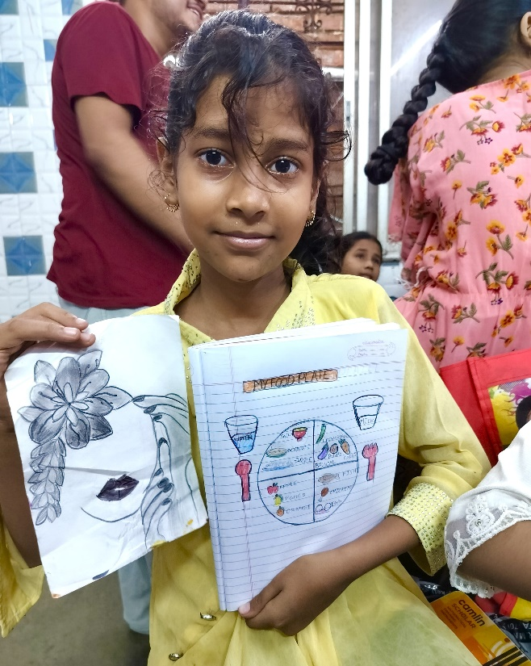
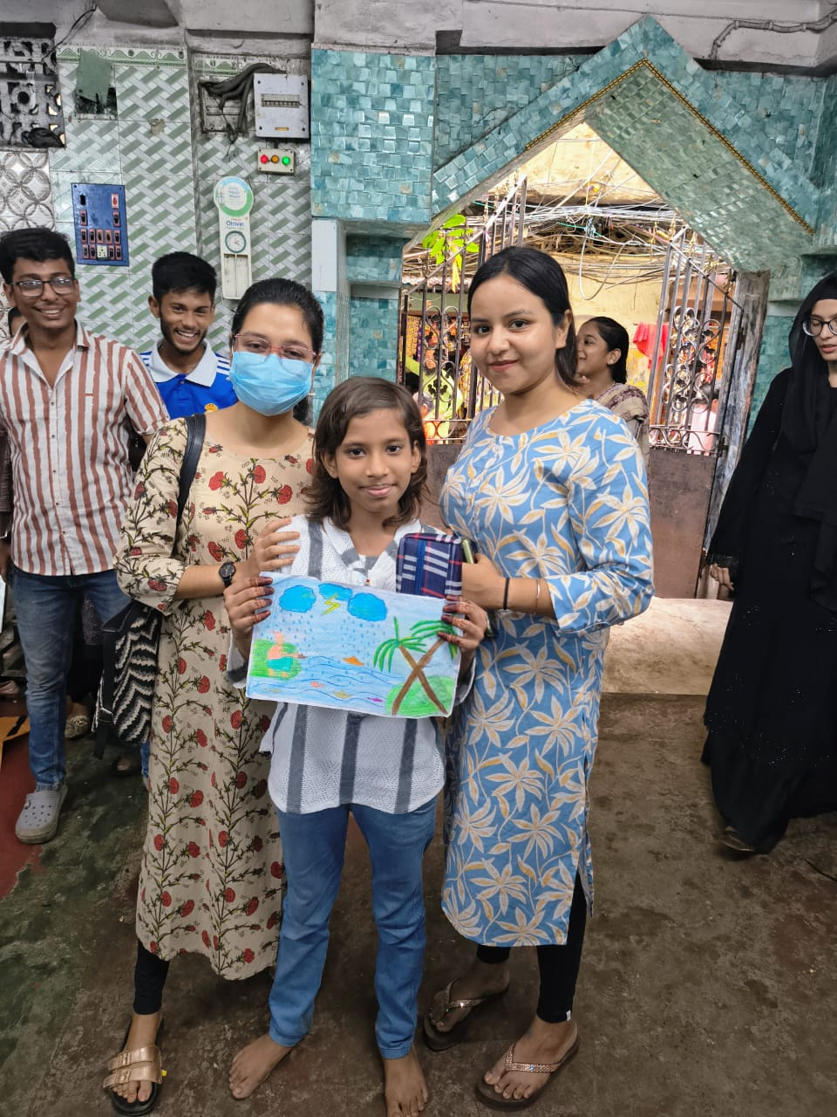

Description: This picture shows creative work by children at the PAG Centre. Through art and craft, they expressed their thoughts and emotions while developing focus, confidence, and creativity as a key elements in CRY’s child-friendly learning approach.

Teaching English at PAG Center

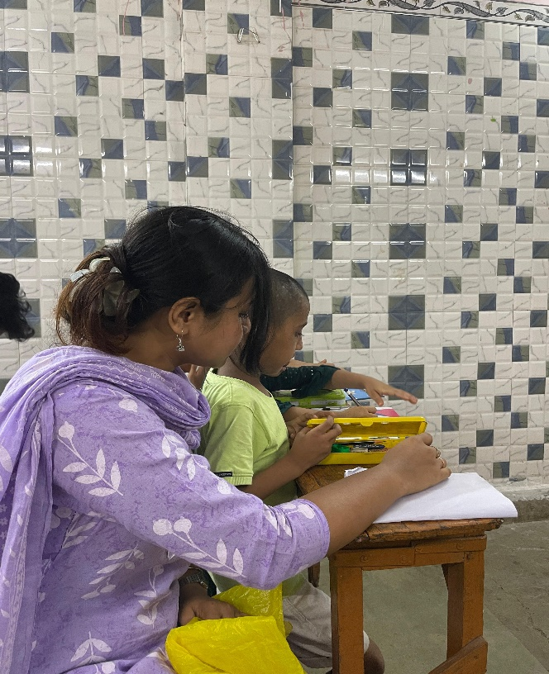
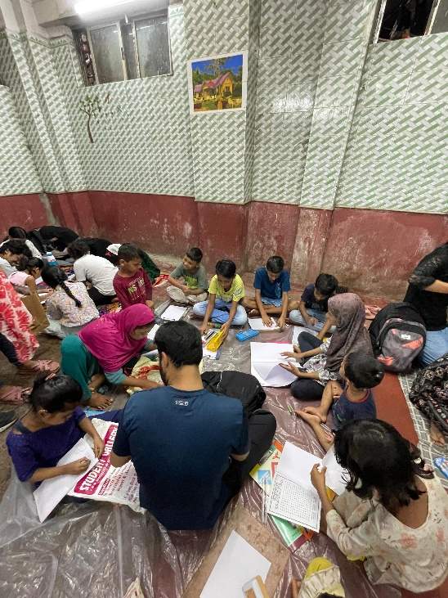

Description: This image shows an interactive English teaching session with children at the PAG Centre. The focus was on building basic vocabulary and communication skills through engaging and child-friendly methods.

Engaging Children with the knowledge of good food habits.
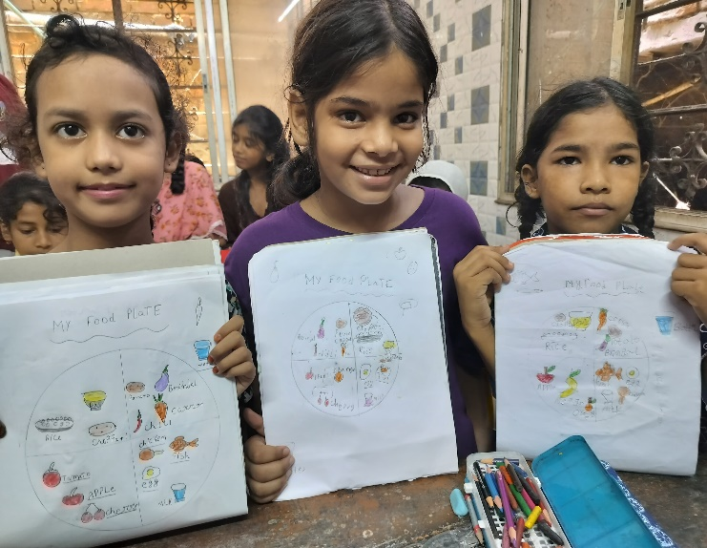
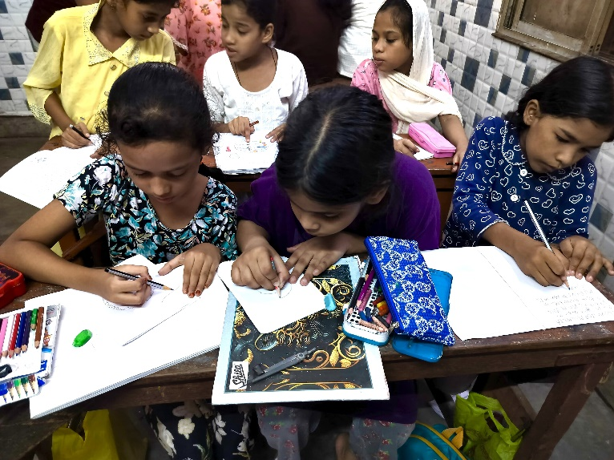

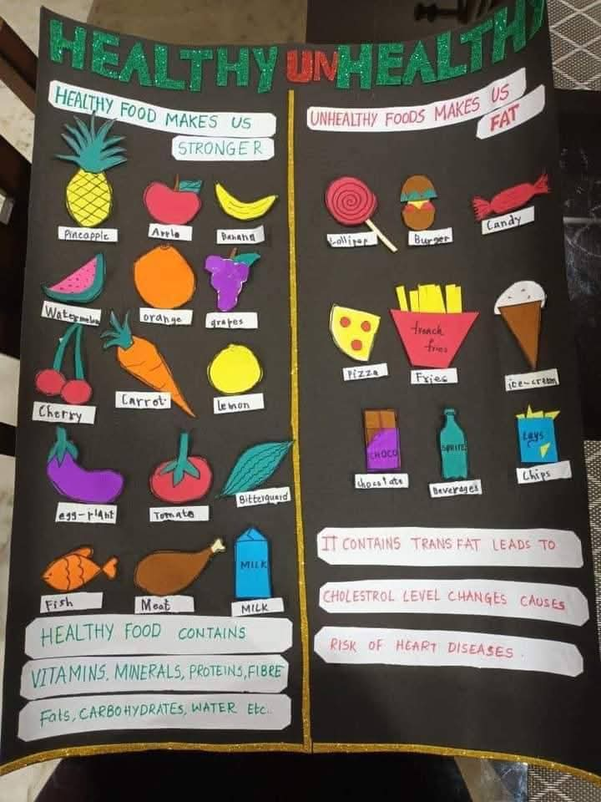

Description: This picture showcases an interactive session with children, focusing on promoting healthy eating habits. The activity aimed to raise awareness about nutritious food choices through fun and simple learning methods.

