Chapter 3

System design
AERA is a digital twin of the LRT Kelana Jaya Line. It runs every train on the published timetable at real Kuala Lumpur time and predicts how crowded each train, and each car, will be. Predictions come from twelve weeks of origin-destination ridership published on data.gov.my, shaped by hour of day.

3.1 Crowding model
Each train's load is the passenger flow on its track segment multiplied by the scheduled headway and divided by the train's capacity of 800 riders. The result is shown as one of five crowding levels, always with a label and an icon so it never relies on colour alone.
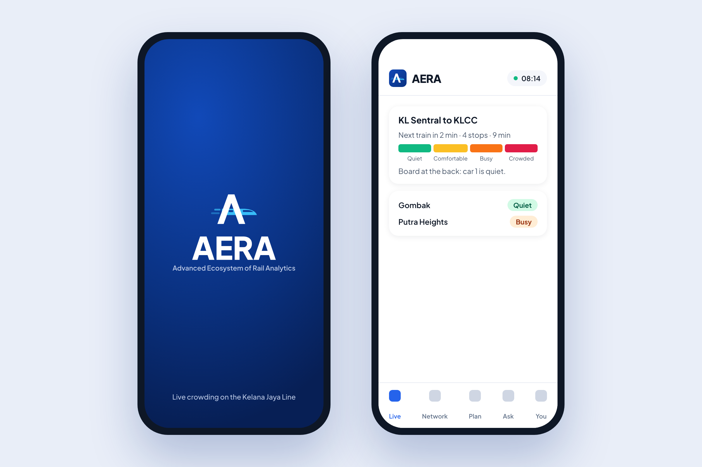
Figure 3.1: Splash screen and app bar in the AERA rider app.
Level | Load | What riders see
Quiet | under 20% | Plenty of seats
Comfortable | 20 to 50% | Some seats, easy standing
Busy | 50 to 75% | Standing, room to move
Crowded | 75 to 95% | Tight standing
Packed | 95% and over | Consider the next train
Table 3.1: Crowding levels and what riders see.

3.2 Data sources
The twin combines three kinds of data:
- Prasarana's published timetable (GTFS Static) for every train and station.
- Daily origin-destination ridership from data.gov.my, over a twelve-week window.
- Rider reports and in-train sensors where they exist, weighted by age and reliability.

3.3 Validation
A back-test against held-out days gives a median daily error of 4.7%. Peaks are shaped by KTM Komuter's hourly pattern, smoothed over three hours, which may overstate LRT peaks.
Riders choose a quieter car when they can see one.

