**Midterm Review**

**Recitation 6 (Fall 2018)**

**CS1520**

Q.1) Consider the following code:

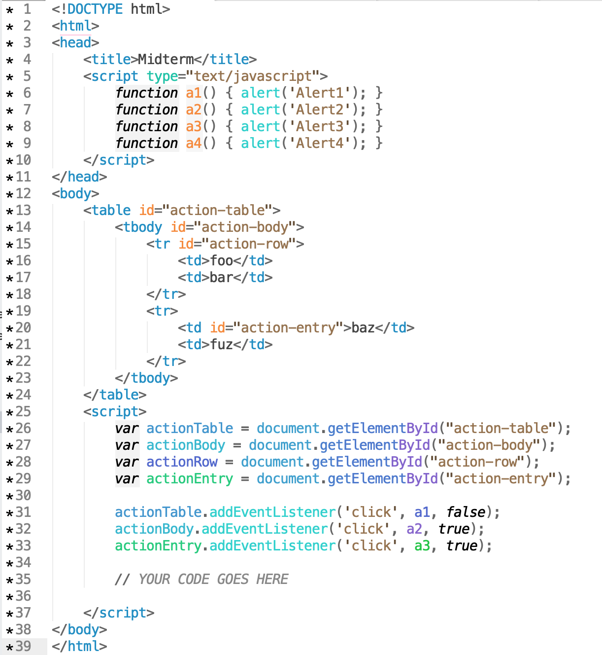

1. What alerts will be produced (and in what order) if a user clicks on `fuz`? What is the `target` and `currentTarget` of each alert?

1. What alerts will be produced (and in what order) if a user clicks on `baz`? What is the `target` and `currentTarget` of each alert?

1. If possible, write Javascript to replace the comment in the source code (`// YOUR CODE GOES HERE`) such that clicking on `foo` will cause `Alert4` to be produced as the first alert. If this is not possible, explain why not.

Q.2) Consider the following JS code:

10 == "10ne" - "0ne";

Write down the final evaluation on each side of “==” and the final result.

Q.3) What is the value of z after executing the following code:

#### if (4=="4") {z="zebra";} else {z="ziggy";}

Q.4) What is the value of z after executing the following code:

#### if (4==="4") {z="zebra";} else {z="ziggy";}

Q. 5) Check all of the following that are evaluate to "true" in JavaScript

* null
* 3
* "Ouch!"
* 0
* NaN
* {shape: "round"}
* -1
* "" // i.e. the empty string

Q.6) What is the value of x after executing the following JavaScript?

#### var a = 4;

#### var b = NaN;

#### var x = a+b;

Q.7) What is the result of the following in JS:

1. 3=="3"
2. 3==3
3. 3==="3"
4. 3===3
5. 3!="3"
6. 3!=="3"

Q.8) What is the result of the following in JS:

1. 433+1
2. "433"+1
3. “433” + “1”
4. Number("443") + 1
5. “hello” + “bye”

Q.9) Take the following function, make it a method named "inc" of an object named "z" so that "z.inc(4)" would return 5.

#### function(y) {return ++y};

Q.10) Consider the following code. What is the final value of y?

#### function makeAdder(amount) {

#### return function(number) {

#### return number + amount;

#### };

#### }

#### var x = makeAdder(5)

#### var y = x(3)

#### y = x(2)