Beirut ReRoute / Lebanon ReConnect
An AI-Designed, Simulated, and Regionally-Envisioned Public Transport System for Lebanon
LebNet Tech Fellows · AI for Lebanon · Final Project Write-Up · Maher Bekdash · maherbekdash05@gmail.com · August 2026

1. Problem Definition
Lebanon's transport system relies overwhelmingly on private cars. The World Bank estimates 650,000 vehicles enter the Greater Beirut Area (GBA) daily, and congestion costs roughly 5% of national GDP; Lebanon has the highest per-capita transport CO₂ emissions in the Levant. A naïve walk-accessibility measure shows 92.2% of the GBA population within reach of some stop today — but the remaining 7.8% is roughly 235,000 people with no practical access. The deeper structural problem is that Beirut's transit is a patchwork: informal vans fill gaps organically, and the new (2024) formal OCFTC/ACTC bus network (11 lines) runs in the same mixed traffic as private cars — no dedicated lanes, no signal priority, and no feeder network connecting underserved neighborhoods to the trunk lines that already exist.
This project asks: what would it concretely take to fix that, with a method that is provable rather than merely descriptive — and how far could the same ambition scale, from one Beirut neighborhood to the entire region?

2. Aim
Design, and prove in simulation, an AI-driven path from Beirut's fragmented transit to a regionally-reconnected Lebanon. Concretely: an optimization algorithm that actually designs a route network (not a model that only flags problems), a simulation that tests that network against today's system on real road data, and real regional data quantifying what reconnecting Lebanon could mean for Beirut's role in the wider region.

3. Approach: Two Honestly-Scoped Layers
The project's scope evolved substantially over its development (see §9, Reflection). A nationwide, fully-simulated multimodal system — ports, rail, ferries — is not buildable solo within the project timeline. Rather than either abandoning that ambition or overreaching on it, the project is split into two layers connected by a single phased action plan (§7):
- Layer B — Beirut ReRoute (AI-designed, simulated pilot). Scope: one region, fully executable and tested end-to-end.
- Layer A — Lebanon ReConnect (national/regional vision). Scope: days not weeks; a topological network analysis, explicitly not engineering-grade.

4. Execution

Layer B — four stages
- Data acquisition: real OpenStreetMap road/walk networks, WorldPop population density, the crowdsourced Lebanese Bus Routes dataset, and OCFTC's 9 formal lines (hand-transcribed from transitapp.com, geocoded via Nominatim — 191 stops, 157 resolved).
- Accessibility scoring: an H3 hex grid scores walk-time to the nearest stop today — status-quo baseline 92.2% population-weighted coverage.
- AI network design: a Maximal Covering Location Problem (MCLP), solved with PuLP/OR-Tools, chooses feeder stops maximizing newly-covered underserved population per trunk line — the core “AI designs a network” step.
- Signal-priority simulation: a SimPy discrete-event simulation runs status-quo vs. proposed (feeder network + rule-based transit signal priority, representing V2X/802.11p) on real roads with real traffic-signal locations.

Layer A — four stages
- 18 sourced nodes (coastal hubs, inland hubs/junctions, border crossings, regional cities, ferry destinations) — each tied to a real historic route, signed agreement, or dated 2026 launch.
- 18 sourced edges across two graph states: status quo (today's formal + informal links, 7 edges) vs. proposed (+ historic-dormant rail, the Arab Mashreq Railway, the Hejaz Railway revival, the 2026 Jounieh ferry — 18 edges).
- Betweenness and closeness centrality computed with NetworkX, weighted by great-circle distance, on each graph.
- Every reported number is a real before/after delta from the computed graphs, including a negative, counter-intuitive result kept and explained rather than dropped (§5).

Technical stack
GeoPandas / Shapely (geospatial wrangling) · OSMnx (real road/walk networks) · H3 (hex-grid spatial index) · PuLP / OR-Tools (MCLP solvers) · NetworkX (graph algorithms, centrality) · SimPy (discrete-event simulation) · Folium (interactive maps) · Matplotlib (static charts) · Nominatim/OSM (geocoding). Python 3.14, pytest (16/16 passing), one-command reproducible pipeline (run_pipeline.py).

5. Results (real, reproducible — not estimated)
Every number below comes directly from running the pipeline against real data; none are hand-picked or rounded for effect. Full derivations and caveats are in the repository README.
Metric | Result
GBA-wide accessibility (walk-only → + feeder network) | 92.2% → 97.4% (+156,594 people)
Simulated trip completion, previously-uncovered riders | 0% → 91.9%
Avg. simulated door-to-door time (feeder-served riders) | ~162 min (incl. one genuine ~4.4hr long-haul trunk, ML1)
MCLP feeder network | 22 stops / 7 lines; 68.4% (156,594 / 228,965) of underserved population newly covered
Trunk speed gain from signal priority | Small, real gains on corridors with OSM-tagged signals (B3, B4); unchanged where none exist (B6-ML2, ML1) — an honest null result
Beirut betweenness centrality (status quo → proposed) | 0.132 → 0.662 (+400%)
Beirut closeness centrality (status quo → proposed) | 0.0082 → 0.0046 (−44%) — explained in §5.1, not hidden

5.1 A result kept, not hidden
Beirut's closeness centrality falls under the proposed regional network. This is not a bug: closeness measures average distance to every reachable node, and the proposed network makes genuinely distant places (Riyadh, Mersin, Larnaca — hundreds to ~1,500km away) reachable for the first time. Adding far-but-newly-reachable nodes raises average distance faster than it raises reach. The honest reading: reconnecting Lebanon regionally is a bridging/gateway role, not a “closer to everything” one — a real finding worth reporting, not an artifact worth dropping because it complicates the thesis.
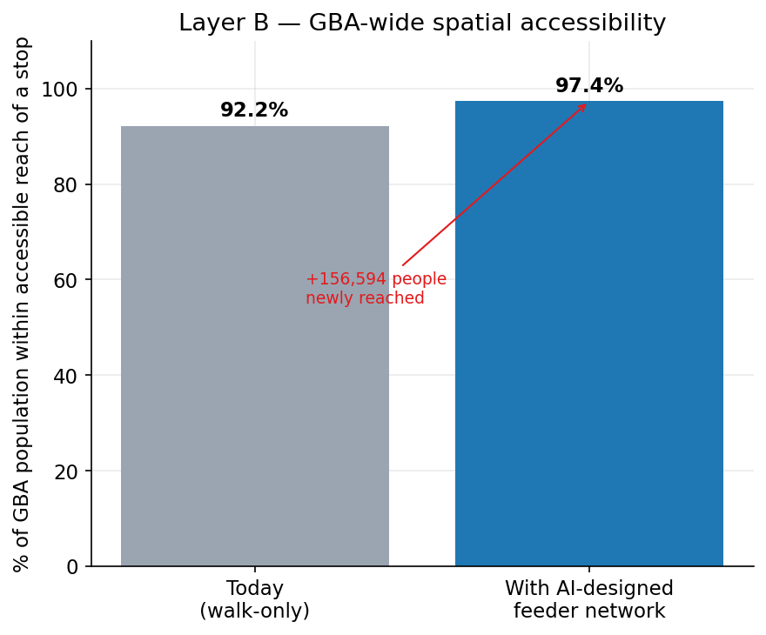
Figure 1. GBA-wide spatial accessibility, status quo vs. proposed feeder network.
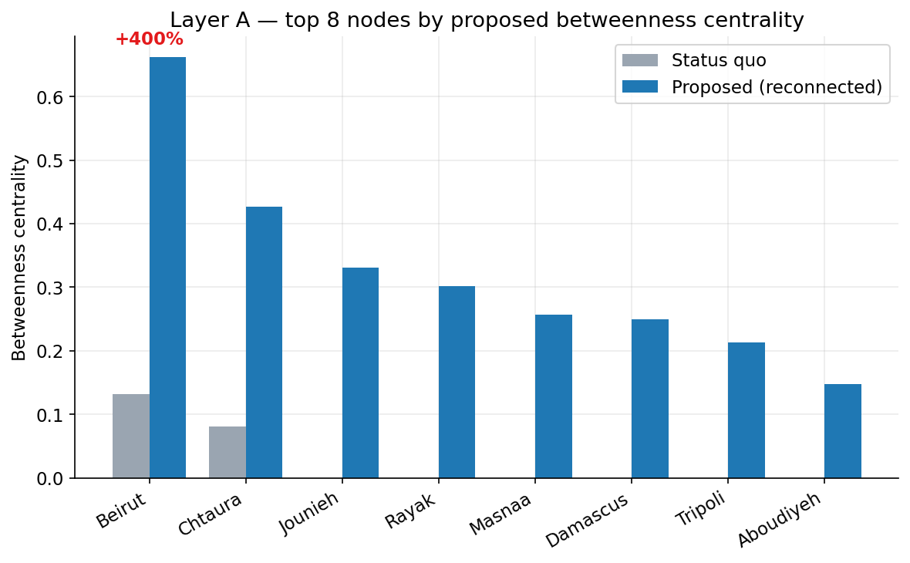
Figure 2. Top-8 nodes by proposed betweenness centrality, status quo vs. proposed regional network.

6. Contributions
- Design, not diagnosis: an optimization algorithm (MCLP) that proposes an actual route network, not a model that only flags problems.
- Two honestly-different scales, reconciled by a shared action plan, instead of one project overreaching on everything.
- Grounded in live regional history: the Hejaz Railway revival and the Jounieh ferry are real 2025–2026 developments — the project is timed with the region, not speculating about it.
- Full reproducibility: one command (run_pipeline.py) rebuilds every number and figure in this document from source data; 16/16 tests passing.
- Five real data bugs found and fixed during actual pipeline runs — documented, not erased (README, “Bugs found and fixed”).
- Explicit honesty about limits throughout (§7) rather than only in a closing caveat.

7. Limitations — Honesty About Scope

Layer B
- Origin-destination demand is representative hub-based flow, not a full four-step travel demand model.
- Feeder route geometry is heuristic stop-chaining, not full vehicle routing.
- The congestion multiplier on OSM free-flow speeds is a documented, unvalidated placeholder pending a better public source.

Layer A
- Edge weight is great-circle distance — a topological abstraction, not a costed or routing-grade network.
- Node coordinates were pre-seeded (the dev sandbox had no live route to the geocoding service) with known-accurate values for well-documented places; flagged for live re-verification.
- 3 of Layer B's real trunk lines (ML1, ML4, B6-ML2) have unconfirmed regular-operation status per the project's own earlier QA — carried through honestly rather than smoothed over.

8. Phased Action Plan
Phase | Focus | Description
1 | This project's Beirut pilot | Feeder network + signal priority, one region, proven in simulation.
2 | Replicate the method | Run the same AI network-design approach around Tripoli, Saida, Tyre, Jounieh.
3 | Domestic rail revival | Beirut–Bekaa–Damascus and Tripoli–Homs, tied to OCFTC/ACTC and the Ministry of Public Works.
4 | Regional integration | Plug into the Arab Mashreq Railway and the Hejaz Railway revival already being negotiated.

9. Learning Takeaways & Reflection

How the project's scope evolved
The project began as a narrow wish to fix Beirut's buses — congestion hotspots and a V2X-style signal controller on one corridor. Direct feedback (“congestion prediction is a subtopic, used as a black box”) restructured it around AI network design instead — the MCLP feeder-network optimizer became the core, with congestion prediction demoted to a supporting utility. A subsequent wish to envision “all of Lebanon” — ports, rail, trams, international lines — was scope-checked against a solo, multi-week timeline and reconciled into the two-layer structure described above, rather than either dropped or overbuilt. Both descoping decisions preserved the original ambition by relocating it into an appropriately-scoped layer instead of cutting it.

Rewarding
- Seeing real numbers come out of real code (92.2%→97.4%, +400% centrality) rather than estimates.
- The discipline of descoping three times without losing the original ambition.
- Finding that the region's own history (Hejaz Railway, Arab Mashreq Railway) already pointed the same direction as the project.

Challenging
- Balancing genuine national-scale ambition against a solo, short timeline without abandoning or overbuilding.
- A sandboxed dev environment with no live route to geocoding — solved via a documented, pre-seeded cache flagged for re-verification.
- Reporting a counter-intuitive result (falling closeness centrality) honestly instead of dropping the metric that didn't confirm the thesis.

10. Documentation & Reproducibility
The full pipeline reproduces every number and figure in this document with one command (run_pipeline.py), backed by a 16/16-passing pytest suite. The repository README documents every pipeline stage, all real result numbers, known limitations, and every bug found and fixed while running the pipeline on real (not synthetic) data. Three interactive maps (outputs/maps/) and six static charts (outputs/figures/) are included in the repository alongside the source code so results are visible without re-running the pipeline. Full source, data, and documentation: see the linked GitHub repository.

11. Next Steps
- Live re-verification of the pre-seeded Layer A geocoding against live Nominatim on an unrestricted network.
- Continue validating Layer B's absolute travel-time calibration against more real reference trip times.
- Phase 2 of the action plan: replicate the MCLP methodology for Tripoli, Saida, Tyre, and Jounieh.

