Data Crunching Report: Data_quality- Draft not for distribution.

Generated with [Koboloader](https://unhcr.github.io/koboloadeR/docs)

26 June 2019

Table of Contents

# Introduction

This data crunching report allows to quickly explore the results of the survey that can be regenerated as needed. You can:

* adjust the configuration in the xlsform to break it into chapter;
* configure disaggregation & correlation for each questions;
* revise the data cleansing based on the cleaning log;
* add weight to each observation in order to account for a specific sampling plan;
* append calculated indicators to your data frame.

The objective of this report is to allow to quickly identify potential patterns in your dataset. A quick screening of this initial report should allow to select the most meaningful graphs. A data digest from this initial report can be then reviewed through a **data analysis workshop** where subject matter experts can contribute with qualitative components. When analyzing those representations in a collective setting, you may:

* **Reflect**: question data quality and/or make suggestions to change questions;
* **Interpret**: develop qualitative interpretations of data patterns;
* **Recommend**: develop recommendation in terms of programmatic adjustment;
* **Classify**: order the level of sensitivity for the information;

# Compilation of questions results

## Is the case reachable?

For audit purpose, it’s important to have record of all attempt to reach cases selected in the sample

Single choice question

### Tabulation

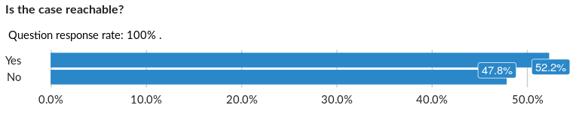

### Cross-tabulations

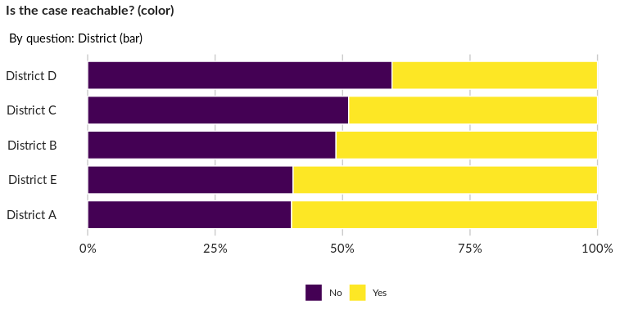

### Significant Associations (chi-square with p value < 5%)

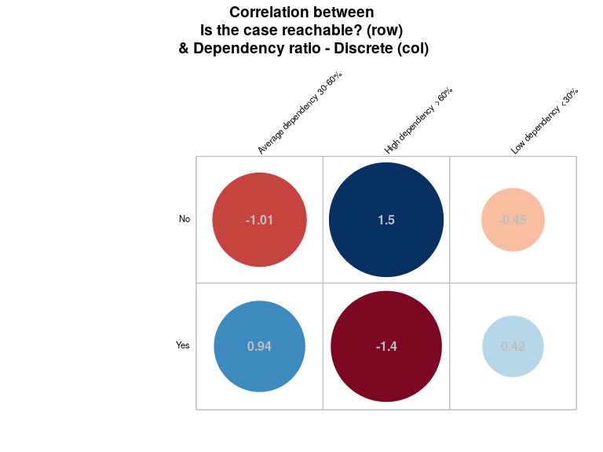

## Select the reason case is unreachable:

For audit purpose, it’s important to have record of reasons why cases selected in the sample could not be reached

Single choice question

### Tabulation

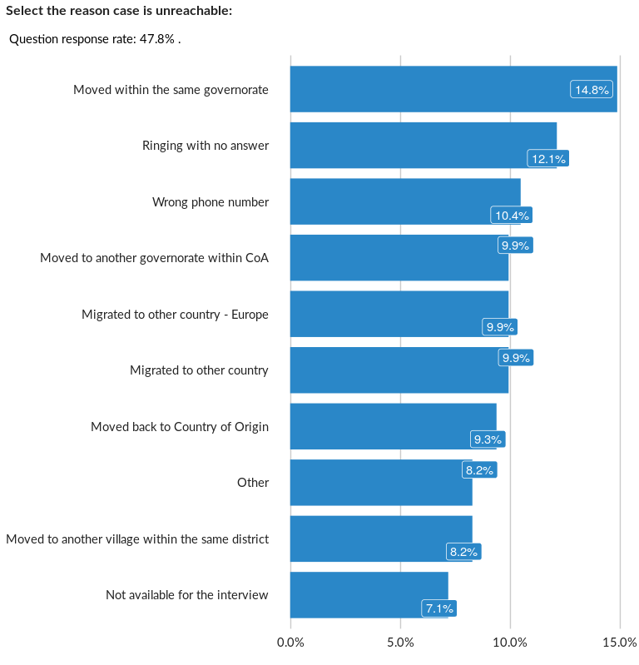

### Cross-tabulations

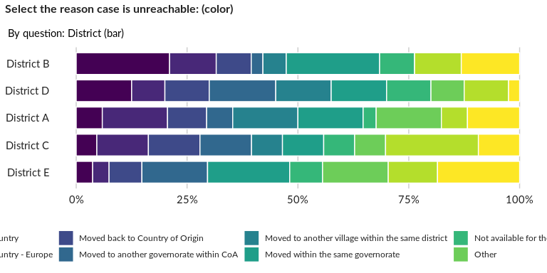

### Significant Associations (chi-square with p value < 5%)

No significant association found for this question…

## Organization of enumerator:

NA

Single choice question

### Tabulation

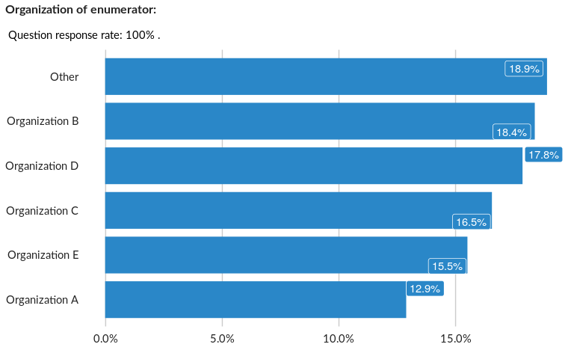

### Cross-tabulations

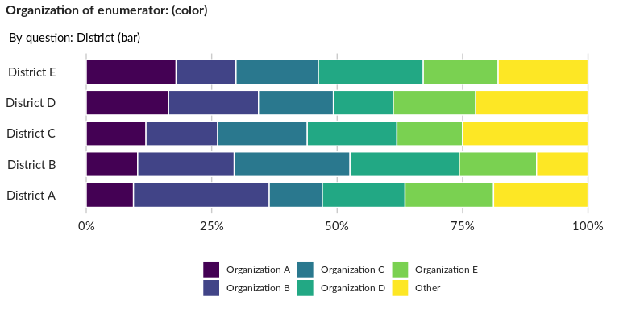

### Significant Associations (chi-square with p value < 5%)

No significant association found for this question…

## District

Optional as a fallback

Single choice question

### Tabulation

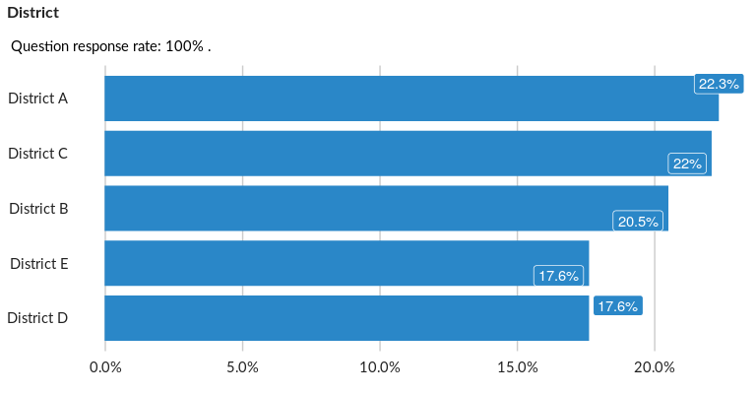

### Cross-tabulations

### Significant Associations (chi-square with p value < 5%)

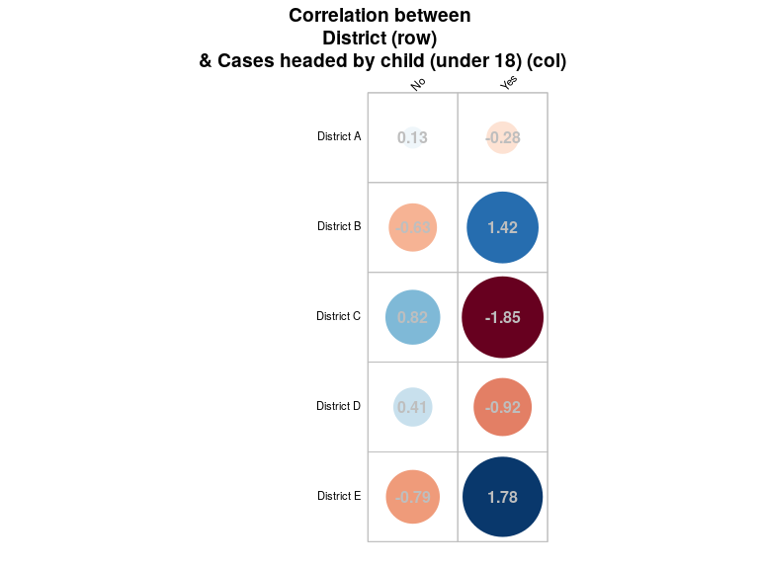

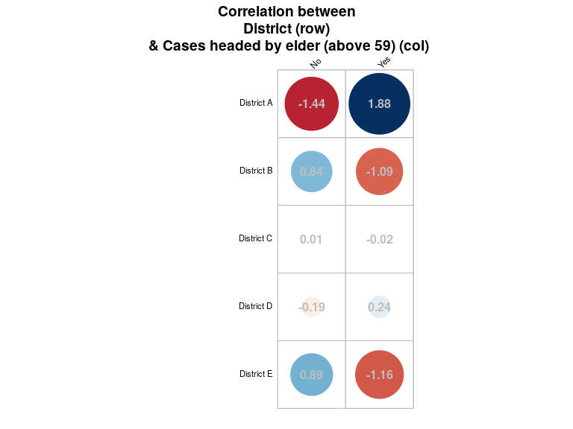

## Area

Optional as a fallback

Single choice question

### Tabulation

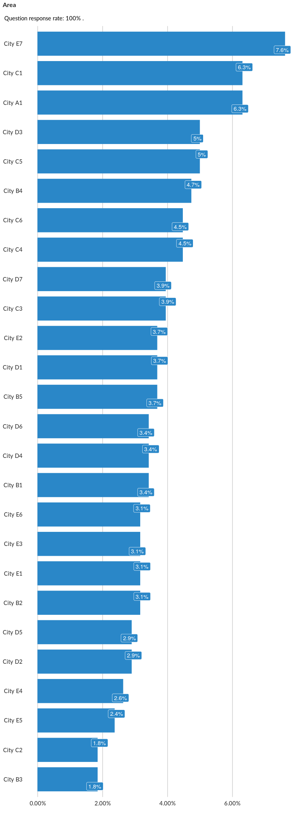

### Cross-tabulations

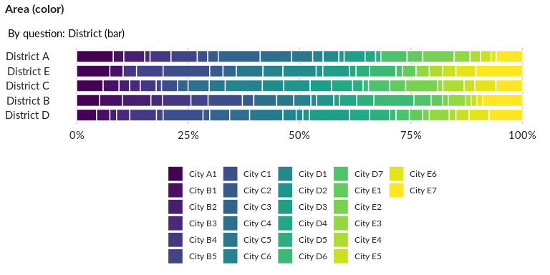

### Significant Associations (chi-square with p value < 5%)

No significant association found for this question…

##### Page Break