Data Crunching Report: Food_Security- Draft not for distribution.

Generated with [Koboloader](https://unhcr.github.io/koboloadeR/docs)

26 June 2019

Table of Contents

# Introduction

This data crunching report allows to quickly explore the results of the survey that can be regenerated as needed. You can:

* adjust the configuration in the xlsform to break it into chapter;
* configure disaggregation & correlation for each questions;
* revise the data cleansing based on the cleaning log;
* add weight to each observation in order to account for a specific sampling plan;
* append calculated indicators to your data frame.

The objective of this report is to allow to quickly identify potential patterns in your dataset. A quick screening of this initial report should allow to select the most meaningful graphs. A data digest from this initial report can be then reviewed through a **data analysis workshop** where subject matter experts can contribute with qualitative components. When analyzing those representations in a collective setting, you may:

* **Reflect**: question data quality and/or make suggestions to change questions;
* **Interpret**: develop qualitative interpretations of data patterns;
* **Recommend**: develop recommendation in terms of programmatic adjustment;
* **Classify**: order the level of sensitivity for the information;

# Compilation of questions results

## How many meals (warm and cooked or prepared) did the adults of this household ea

NA

Numeric question

### Tabulation

No responses recorded for this question...

No responses recorded for this question...

## How many meals (warm and cooked or prepared) did the children under 5 of this ho

NA

Numeric question

### Tabulation

No responses recorded for this question...

No responses recorded for this question...

## Over the past 7 days, how many days did members of your household eat: Tubers (p

NA

Numeric question

### Tabulation

Based on the sample design, the average weighted mean response for this question is 3.51

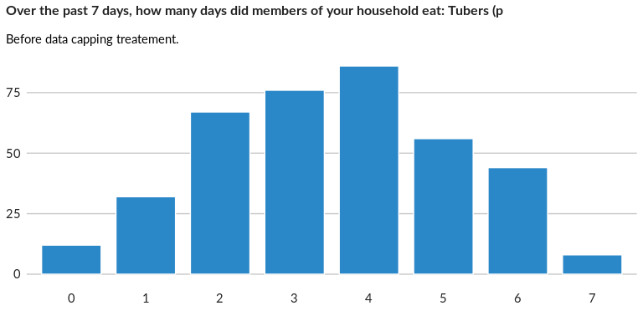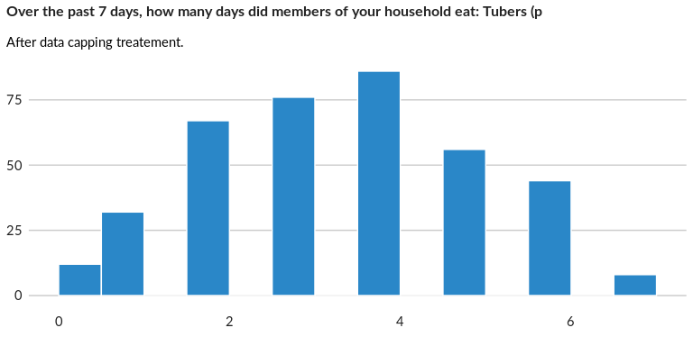

### Analysis of relationship

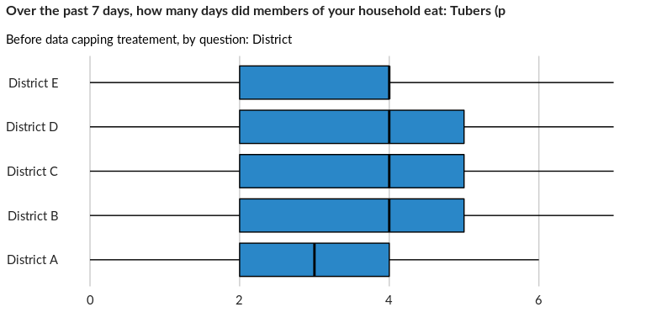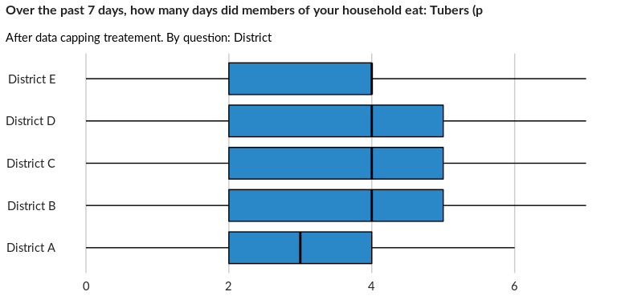

## Over the past 7 days, how many days did members of your household eat:  Legumes

NA

Numeric question

### Tabulation

Based on the sample design, the average weighted mean response for this question is 3.48

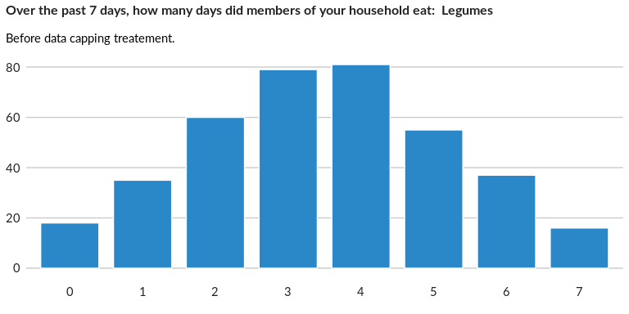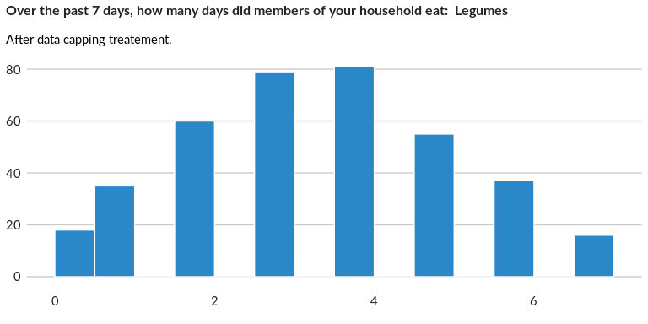

### Analysis of relationship

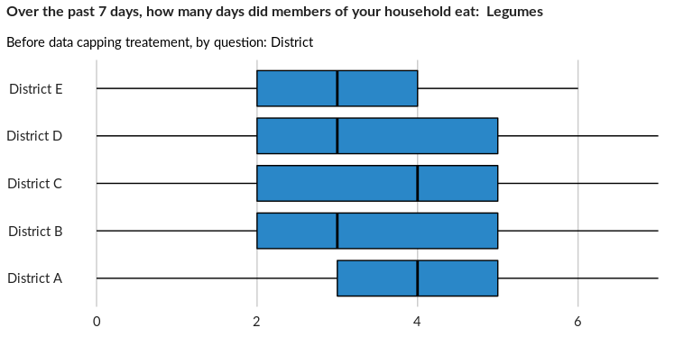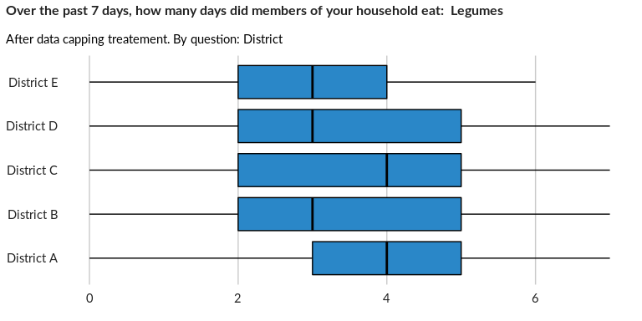

## Over the past 7 days, how many days did members of your household eat: Milk and

NA

Numeric question

### Tabulation

Based on the sample design, the average weighted mean response for this question is 3.45

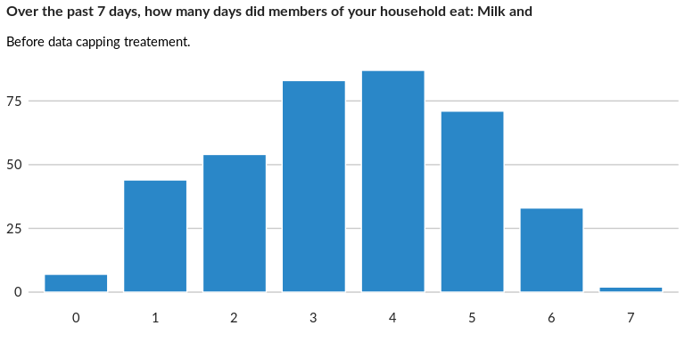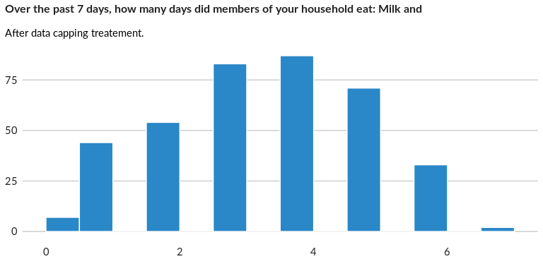

### Analysis of relationship

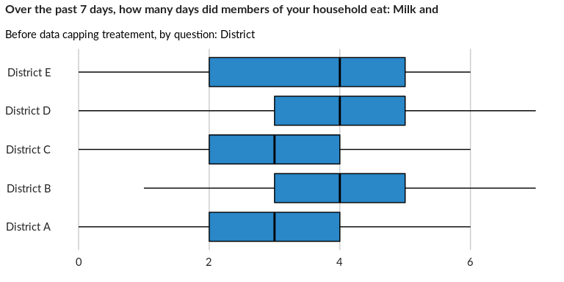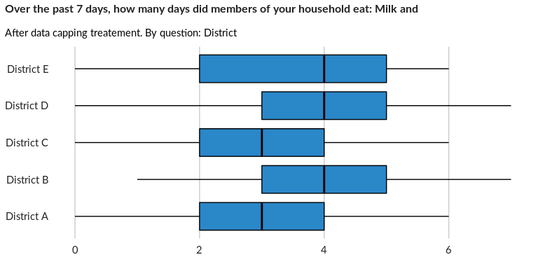

## Over the past 7 days, how many days did members of your household eat: Flesh mea

NA

Numeric question

### Tabulation

Based on the sample design, the average weighted mean response for this question is 3.45

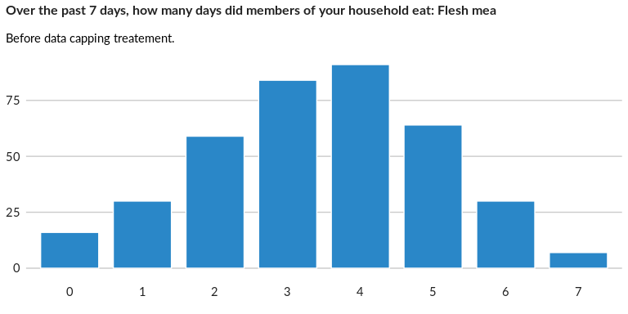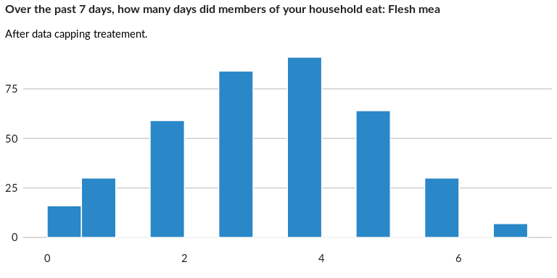

### Analysis of relationship

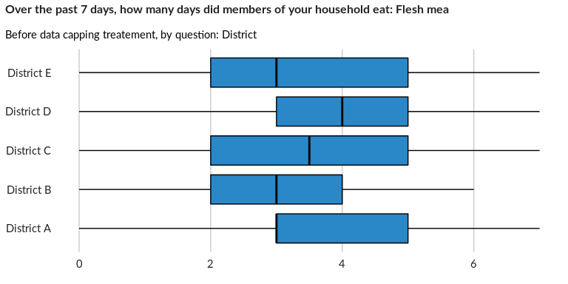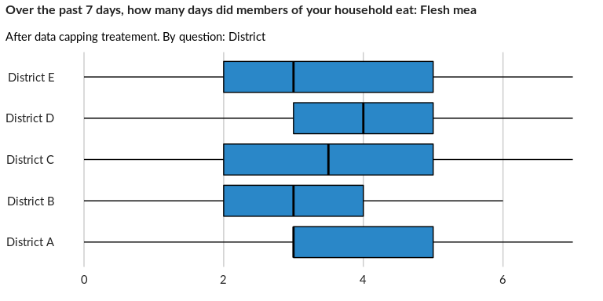

## Over the past 7 days, how many days did members of your household eat: Organ mea

NA

Numeric question

### Tabulation

Based on the sample design, the average weighted mean response for this question is 3.6

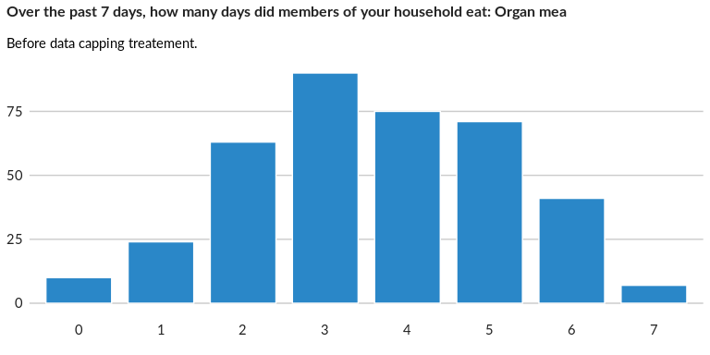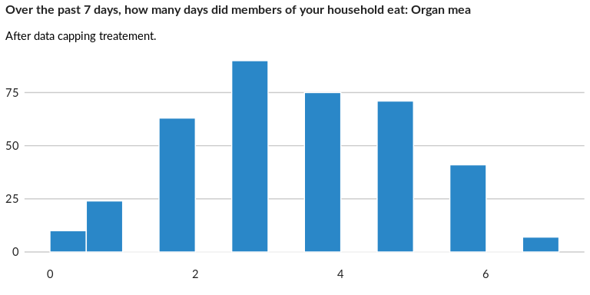

### Analysis of relationship

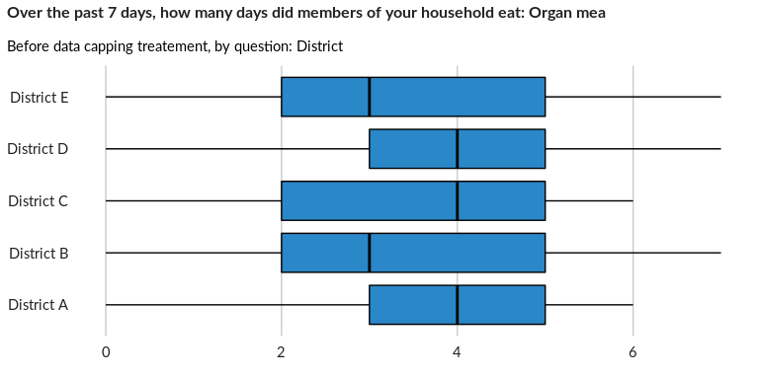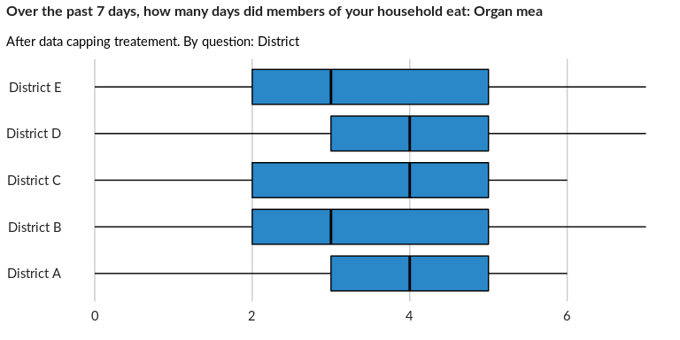

## Over the past 7 days, how many days did members of your household eat: Fish/shel

NA

Numeric question

### Tabulation

Based on the sample design, the average weighted mean response for this question is 3.6

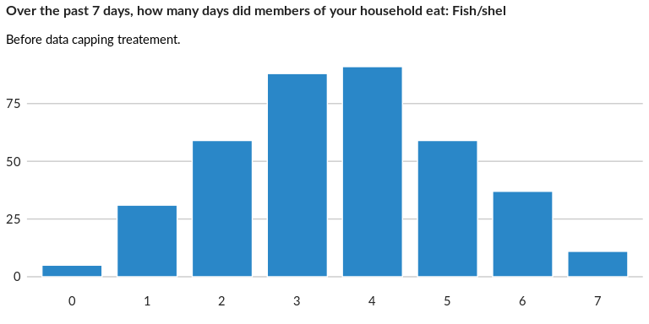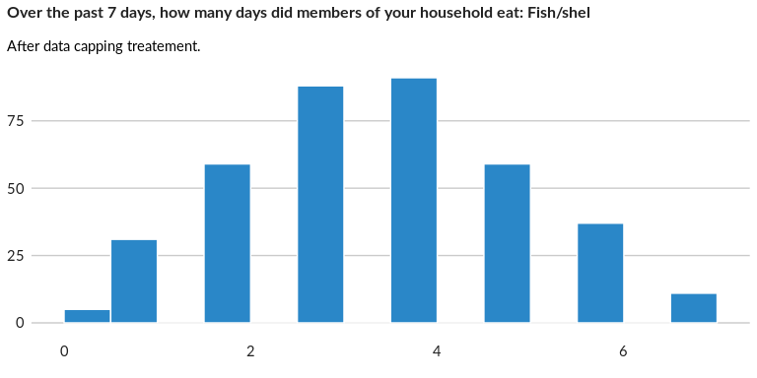

### Analysis of relationship

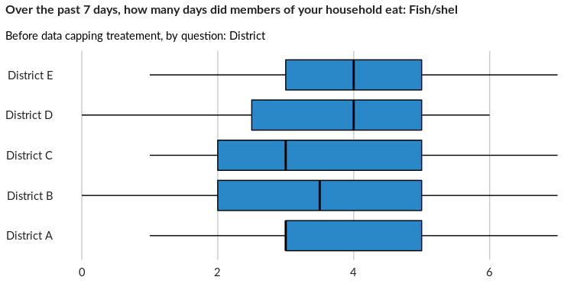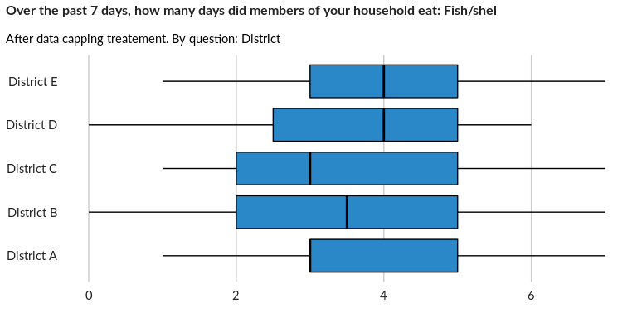

## Over the past 7 days, how many days did members of your household eat: Eggs

NA

Numeric question

### Tabulation

Based on the sample design, the average weighted mean response for this question is 3.53

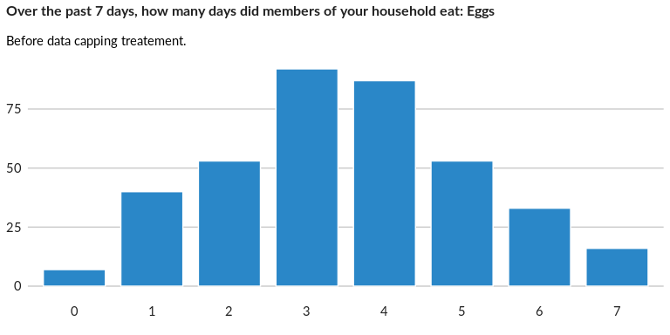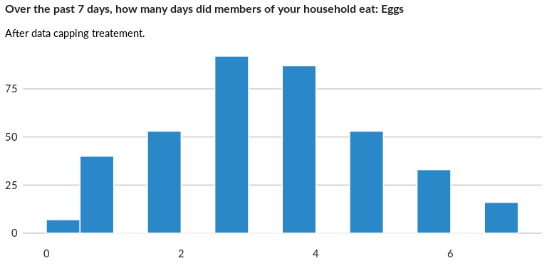

### Analysis of relationship

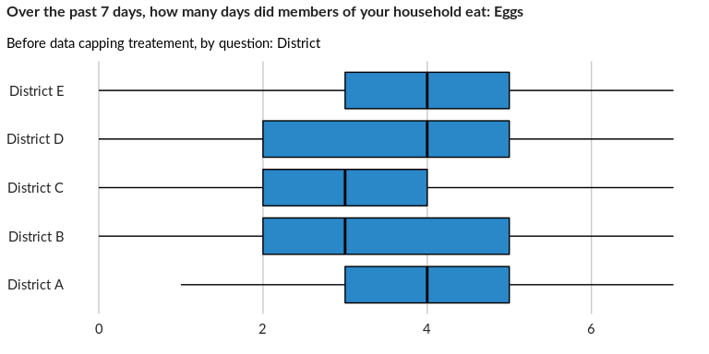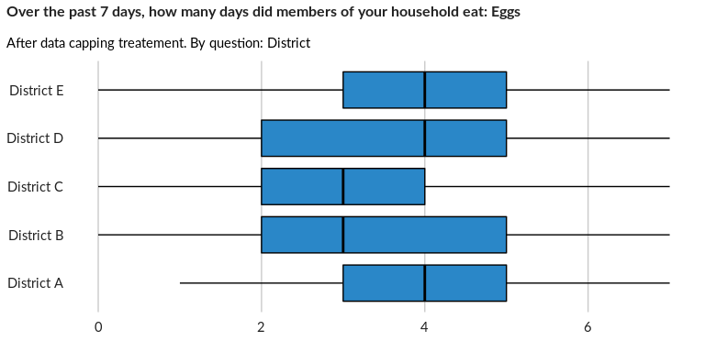

## How many days over the past 7 days, did members of your household eat: Orange ve

NA

Numeric question

### Tabulation

Based on the sample design, the average weighted mean response for this question is 3.37

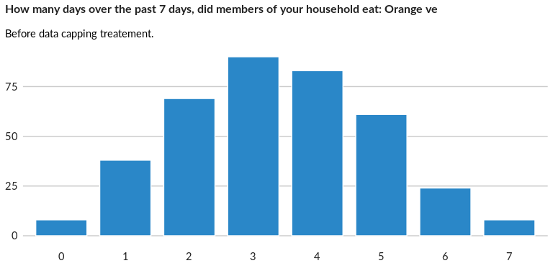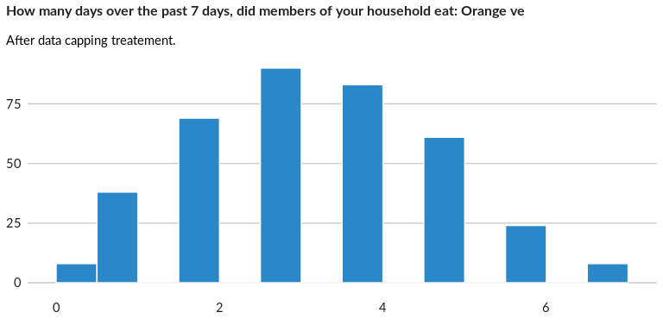

### Analysis of relationship

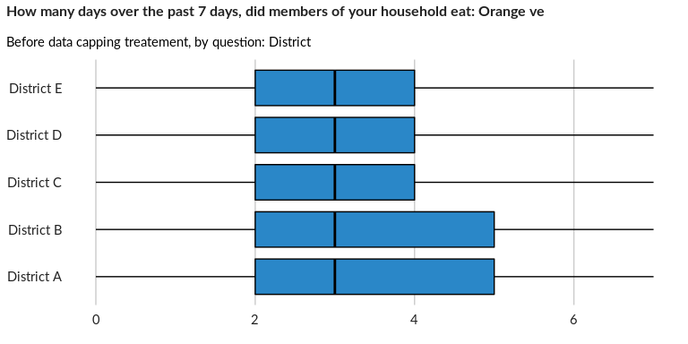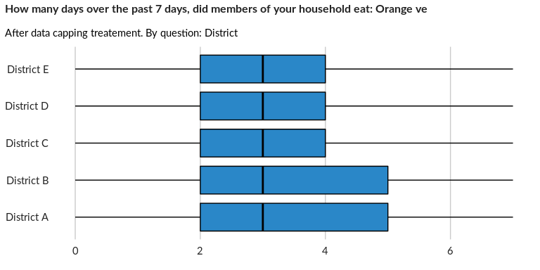

## Over the past 7 days, how many days did members of your household eat: Green lea

NA

Numeric question

### Tabulation

Based on the sample design, the average weighted mean response for this question is 3.46

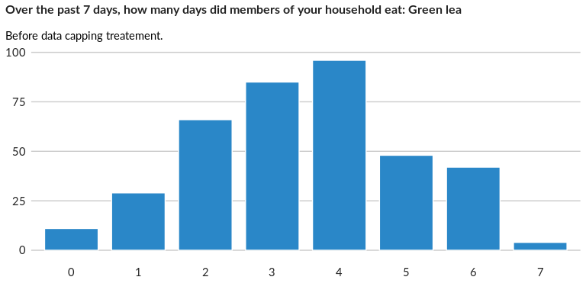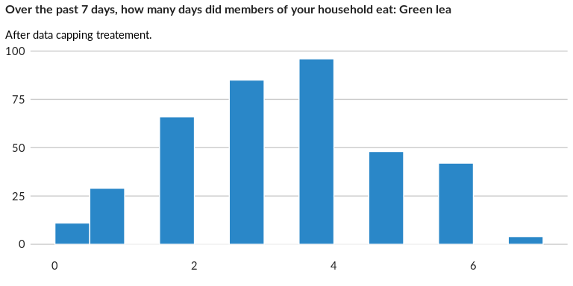

### Analysis of relationship

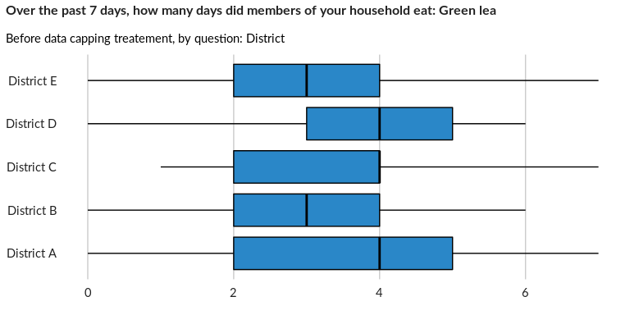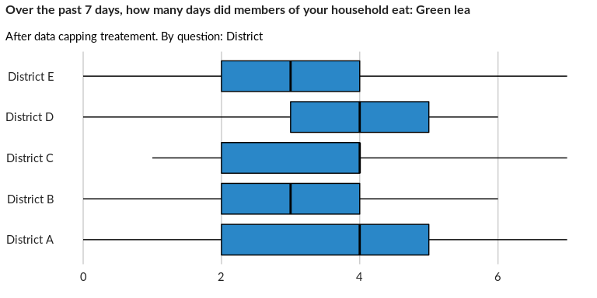

## Over the past 7 days, how many days did members of your household eat: Other veg

NA

Numeric question

### Tabulation

Based on the sample design, the average weighted mean response for this question is 3.35

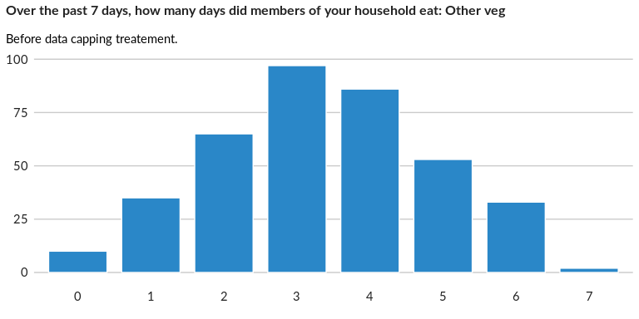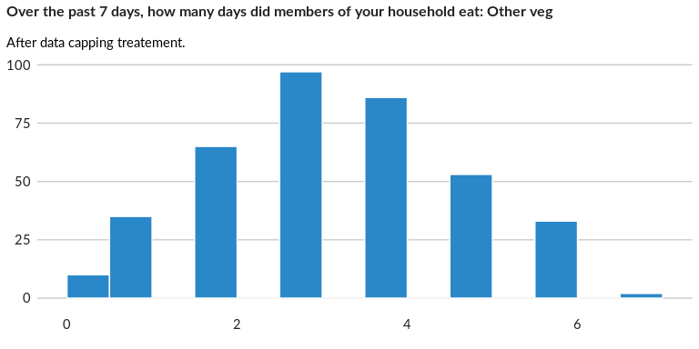

### Analysis of relationship

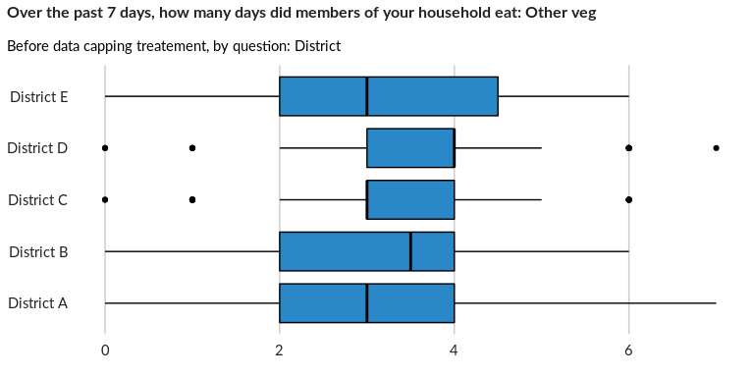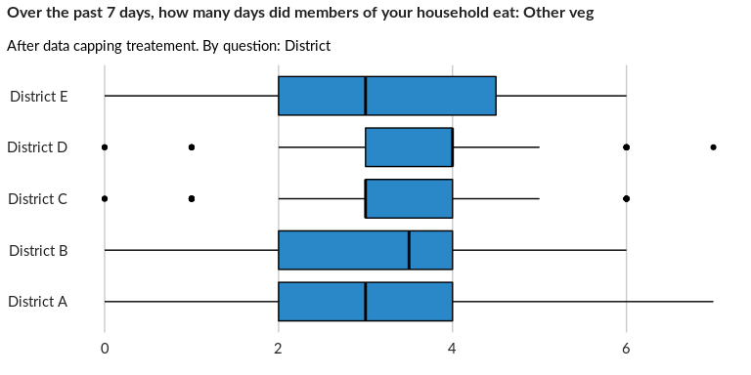

## Over the past 7 days, how many days did members of your household eat: Fruits: b

NA

Numeric question

### Tabulation

Based on the sample design, the average weighted mean response for this question is 3.66

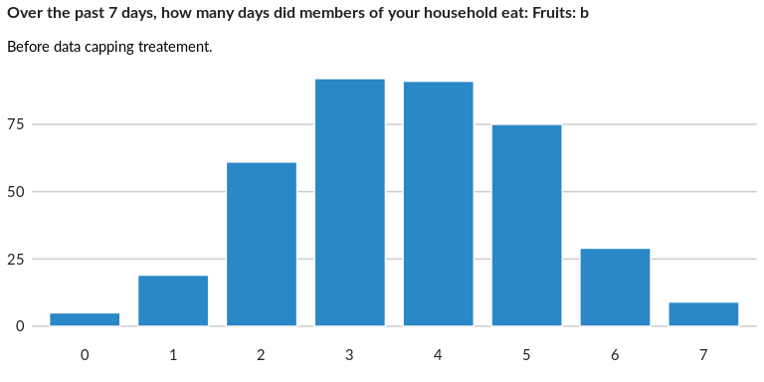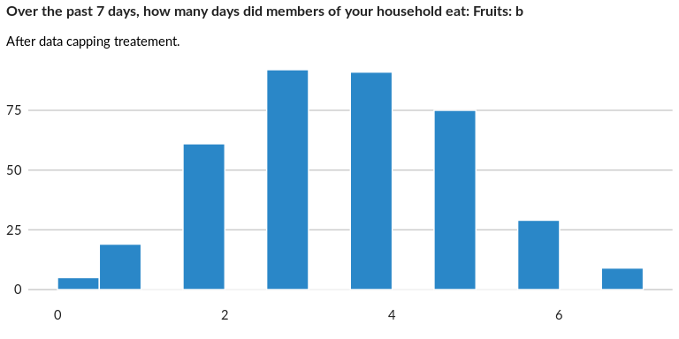

### Analysis of relationship

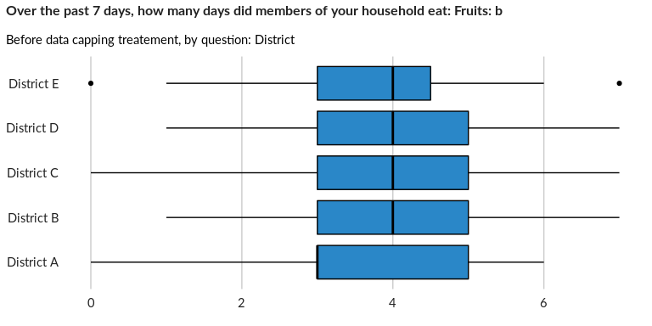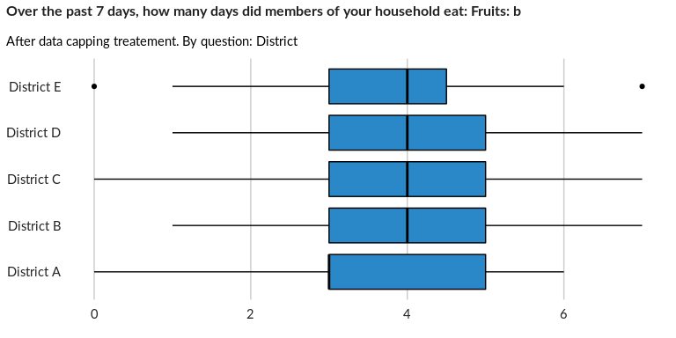

## Over the past 7 days, how many days did members of your household eat: Oil / fat

NA

Numeric question

### Tabulation

Based on the sample design, the average weighted mean response for this question is 3.54

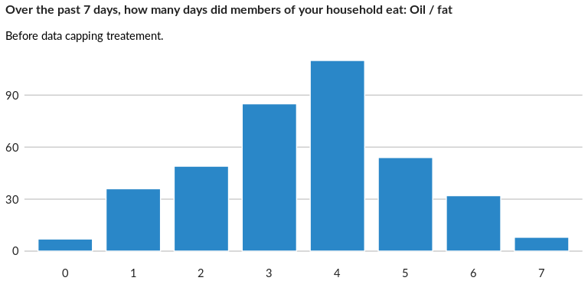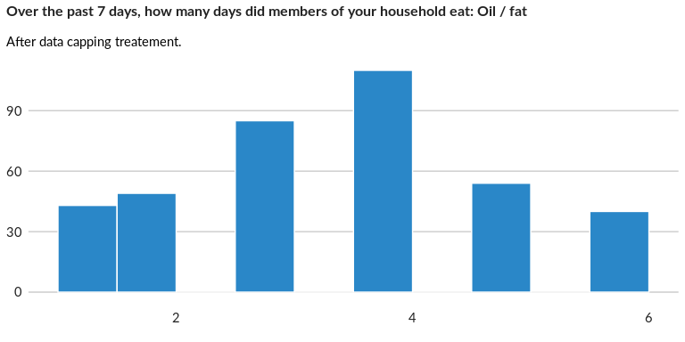

### Analysis of relationship

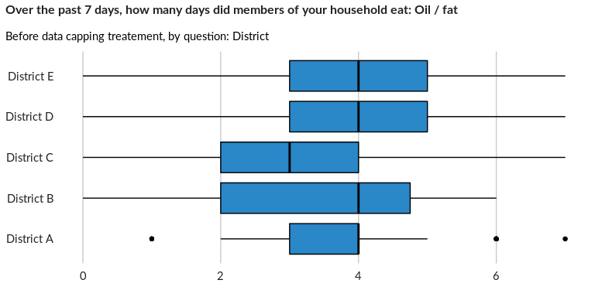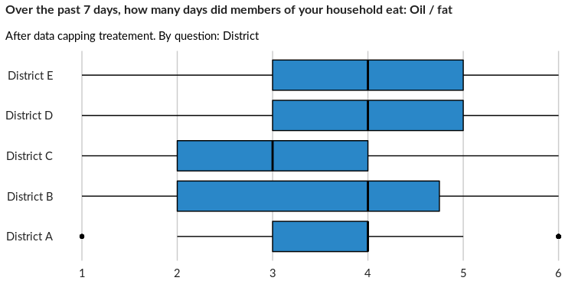

## Over the past 7 days, how many days did members of your household eat: Sugar, or

NA

Numeric question

### Tabulation

Based on the sample design, the average weighted mean response for this question is 3.45

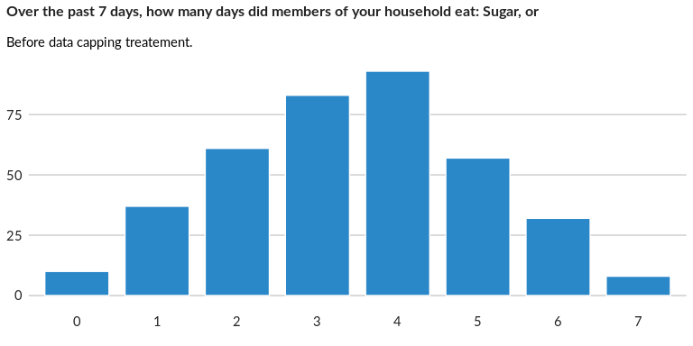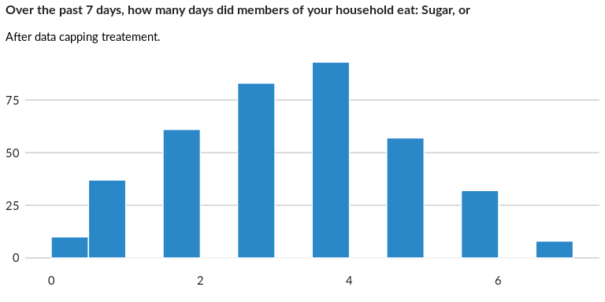

### Analysis of relationship

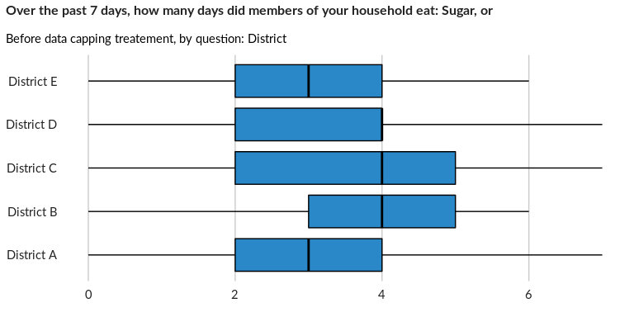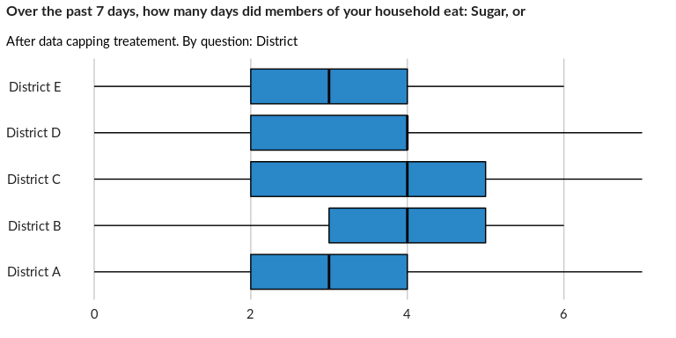

## Over the past 7 days, how many days did members of your household eat: Condiment

NA

Numeric question

### Tabulation

Based on the sample design, the average weighted mean response for this question is 3.38

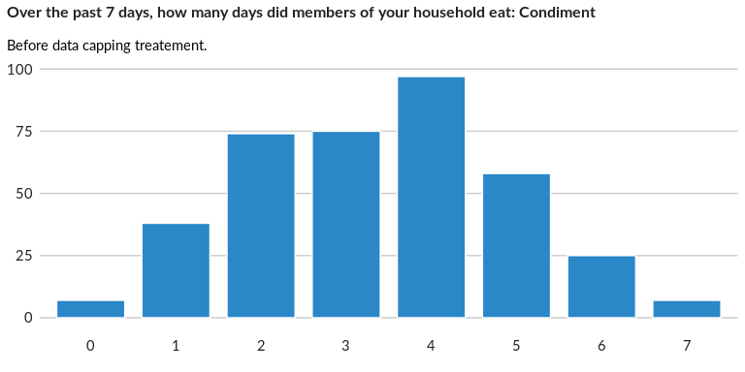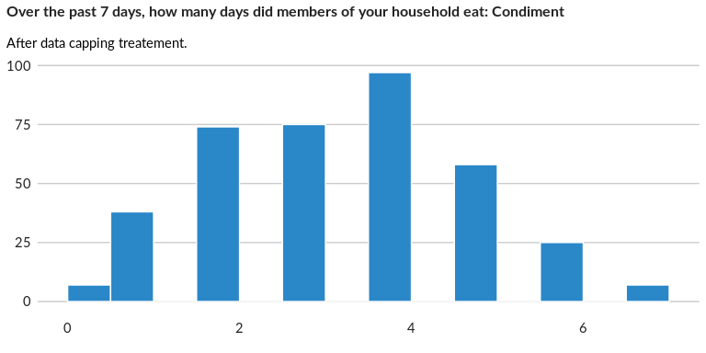

### Analysis of relationship

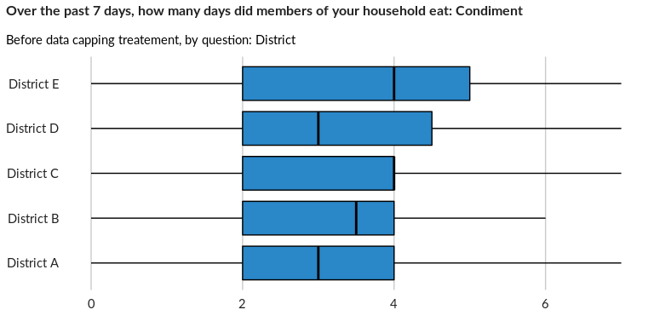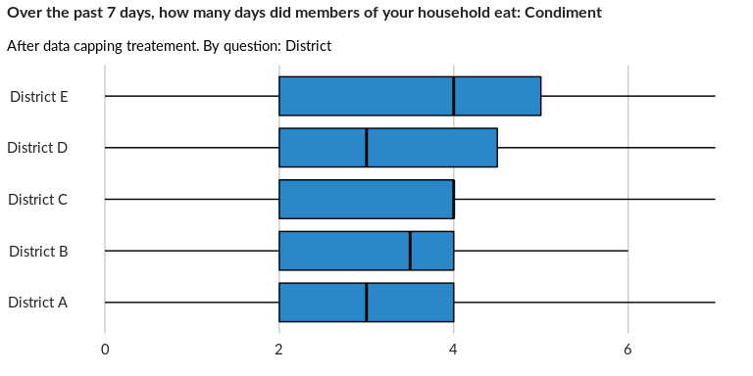

## Rely on less expensive/less preferred food

NA

Numeric question

### Tabulation

Based on the sample design, the average weighted mean response for this question is 3.66

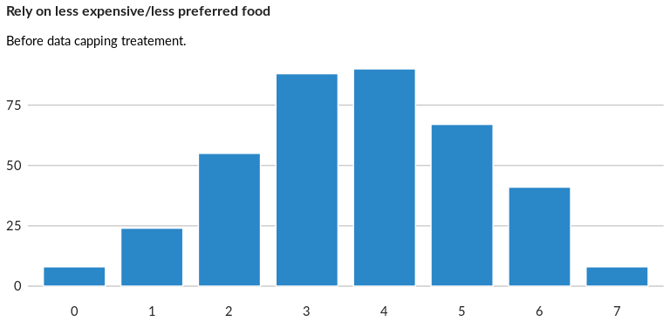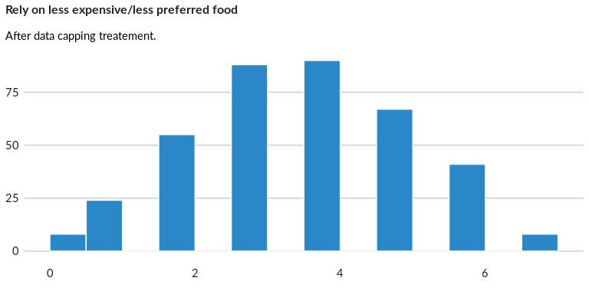

### Analysis of relationship

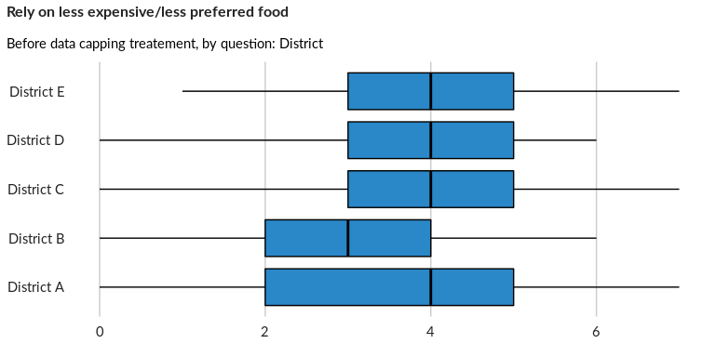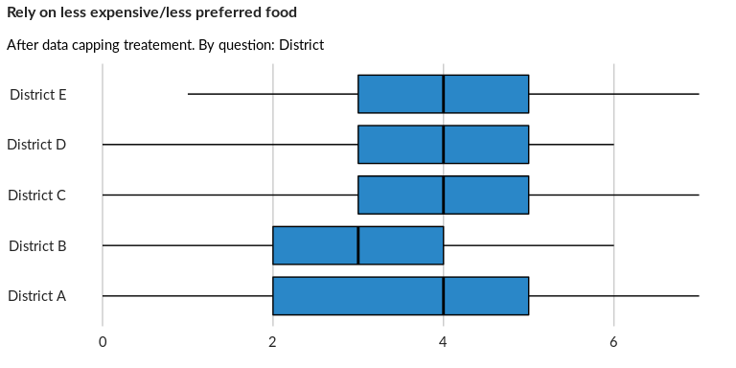

## Borrow food and/or relied on help from friends/relatives

NA

Numeric question

### Tabulation

Based on the sample design, the average weighted mean response for this question is 3.43

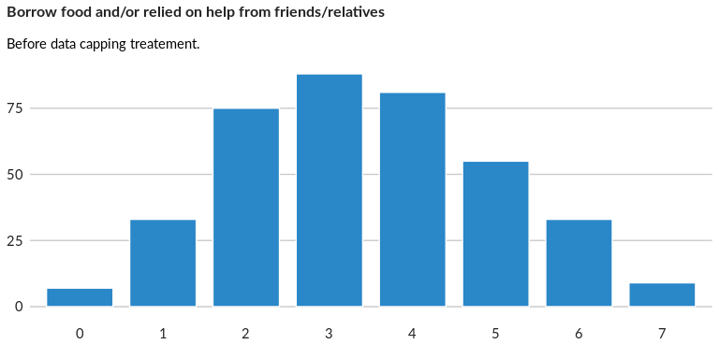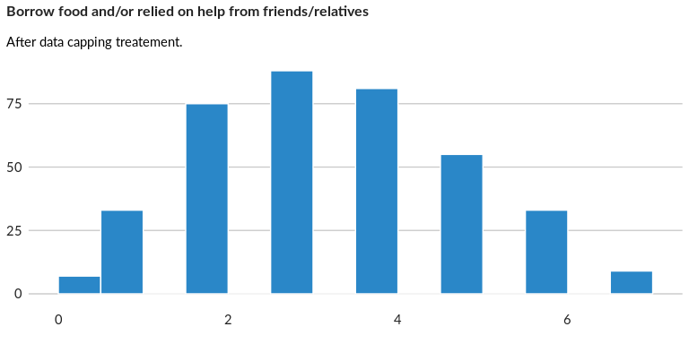

### Analysis of relationship

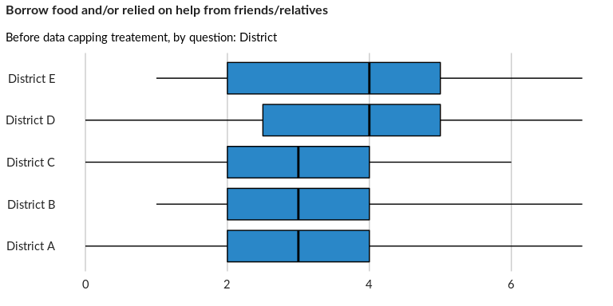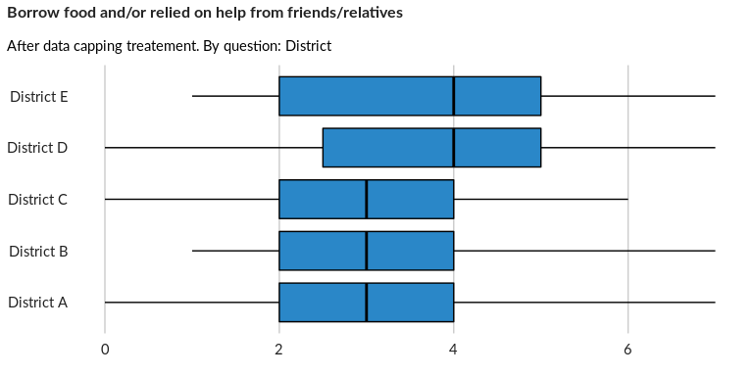

## Reduce the number of meals eaten per day

NA

Numeric question

### Tabulation

Based on the sample design, the average weighted mean response for this question is 3.4

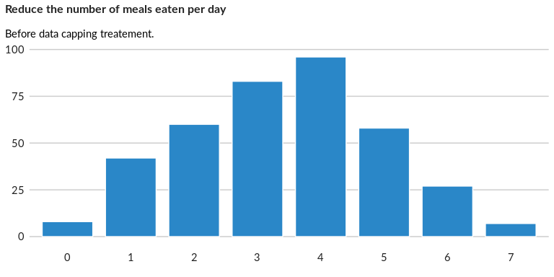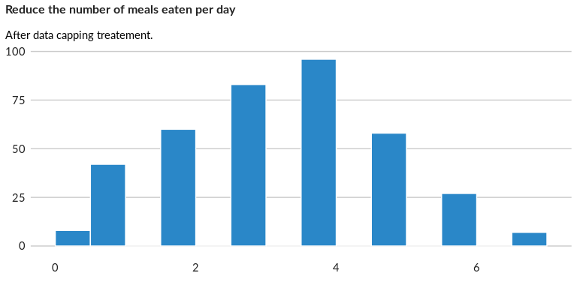

### Analysis of relationship

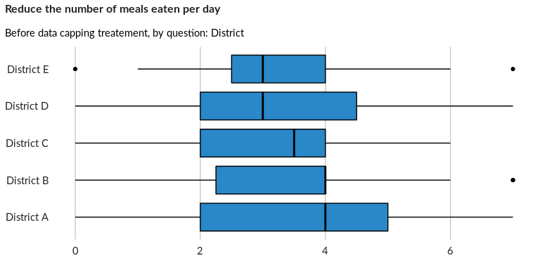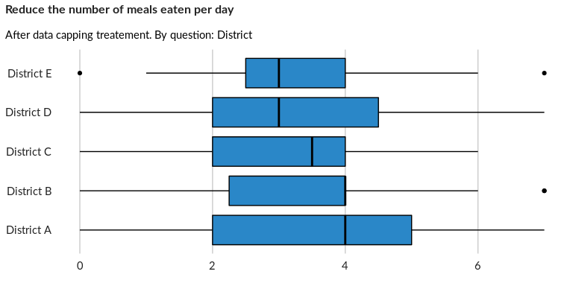

## Reduce portion size of meals

NA

Numeric question

### Tabulation

Based on the sample design, the average weighted mean response for this question is 3.48

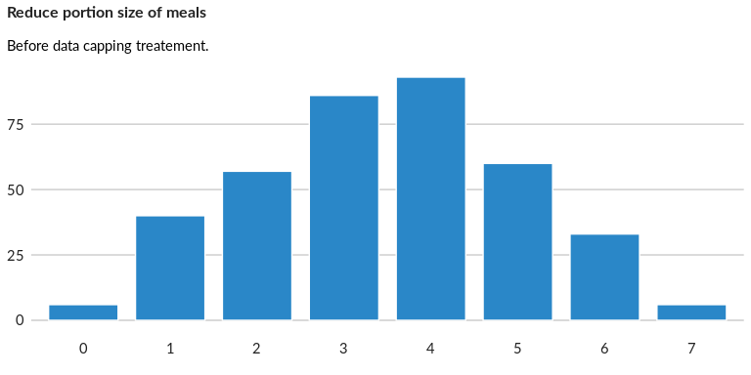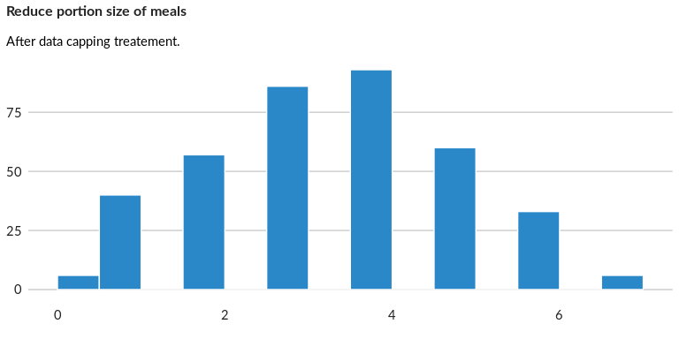

### Analysis of relationship

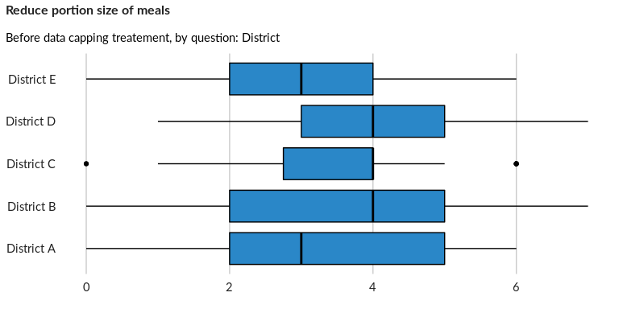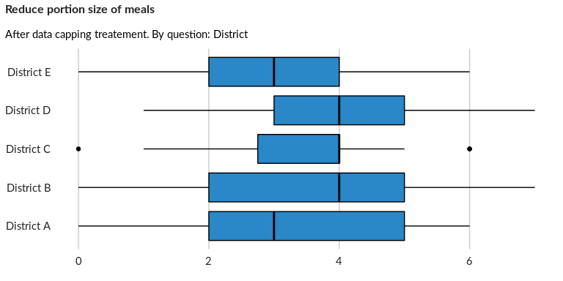

## Go an entire day without eating

NA

Numeric question

### Tabulation

Based on the sample design, the average weighted mean response for this question is 3.49

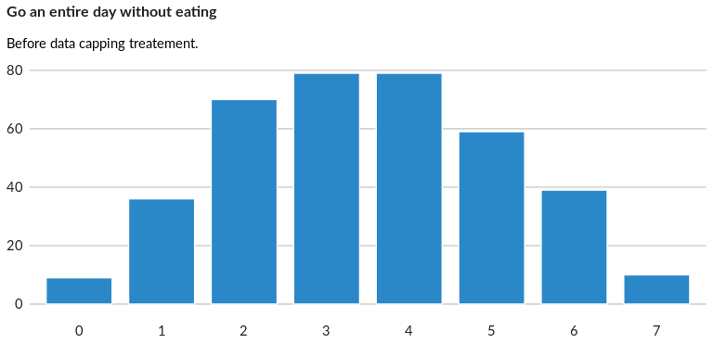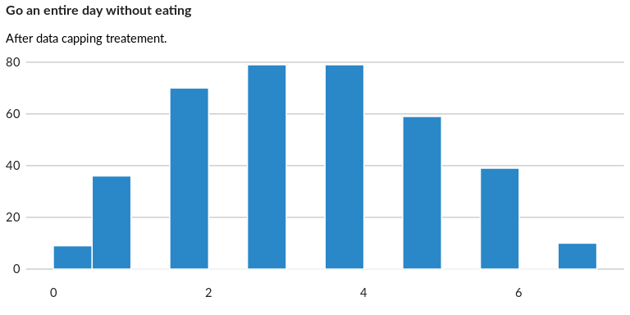

### Analysis of relationship

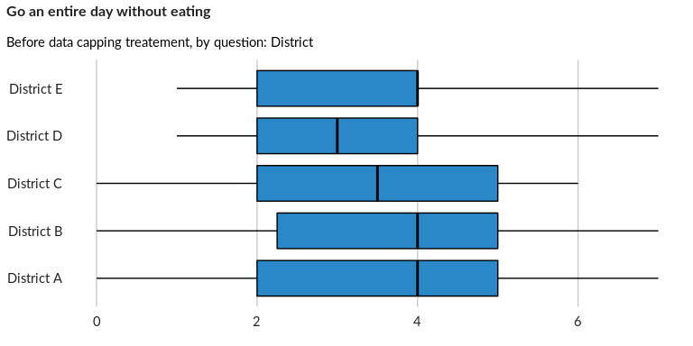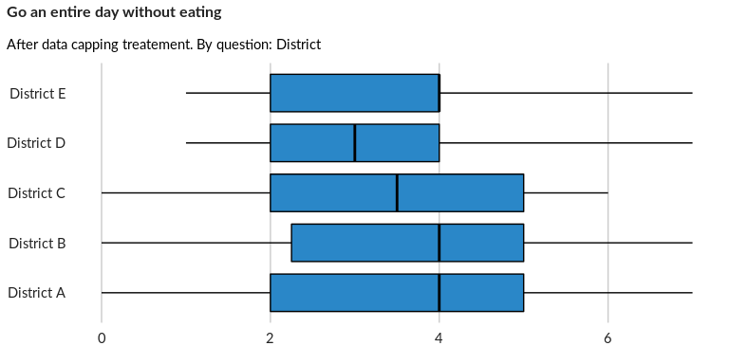

## Restrict consumption of adults in order for young children to eat

NA

Numeric question

### Tabulation

Based on the sample design, the average weighted mean response for this question is 3.45

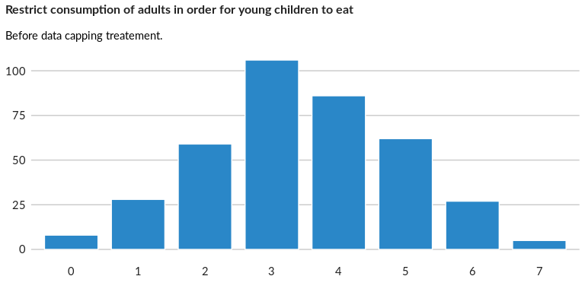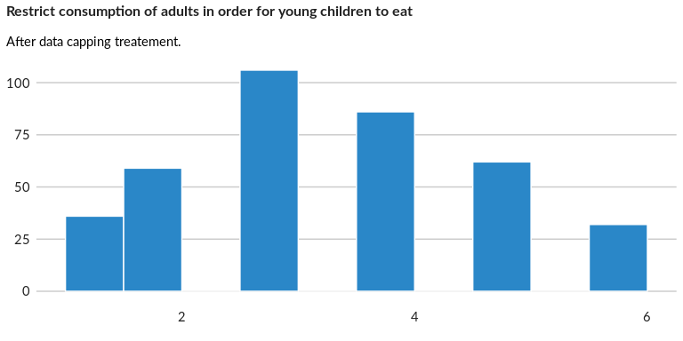

### Analysis of relationship

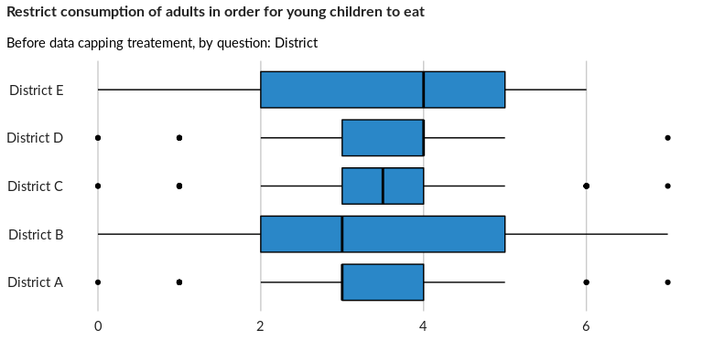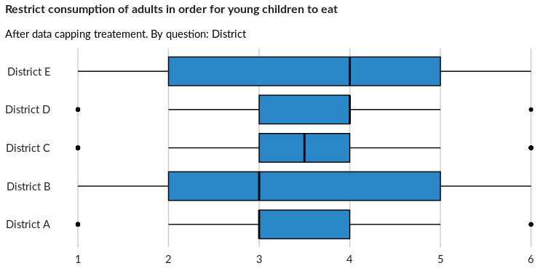

## Send household members to eat elsewhere

NA

Numeric question

### Tabulation

Based on the sample design, the average weighted mean response for this question is 3.47

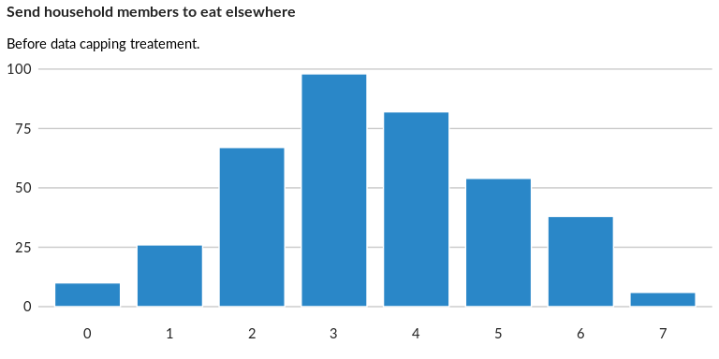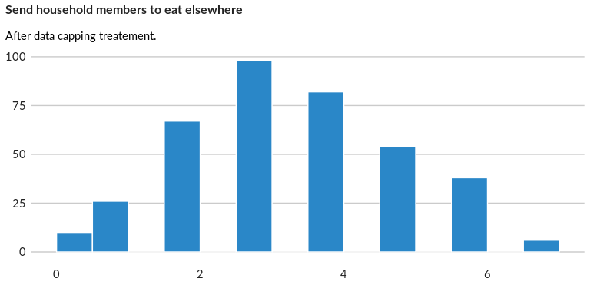

### Analysis of relationship

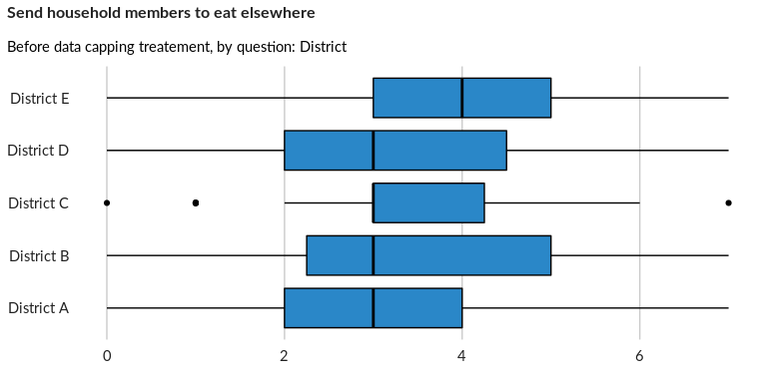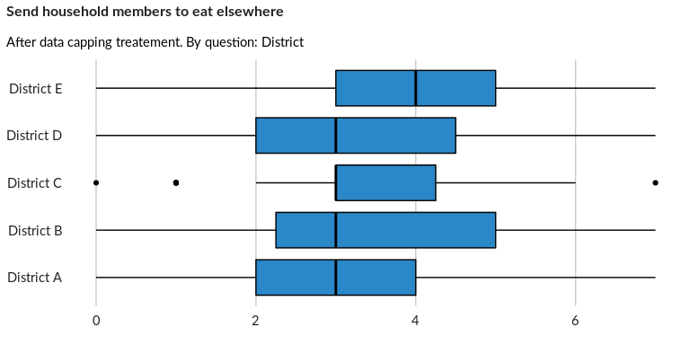

## Restrict consumption of female household members

NA

Numeric question

### Tabulation

Based on the sample design, the average weighted mean response for this question is 3.49

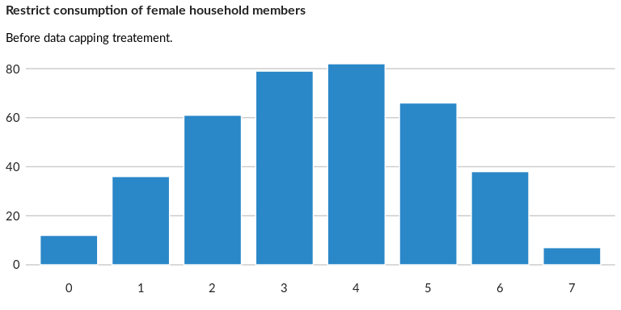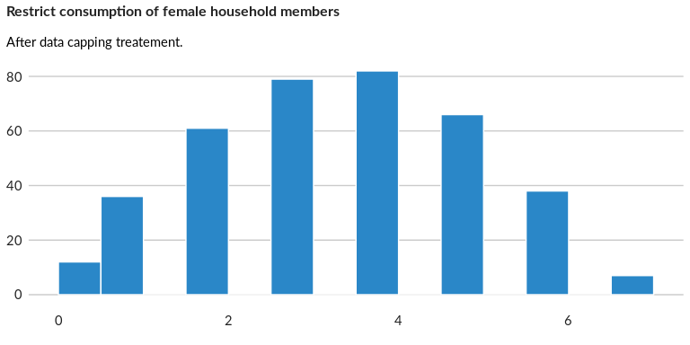

### Analysis of relationship

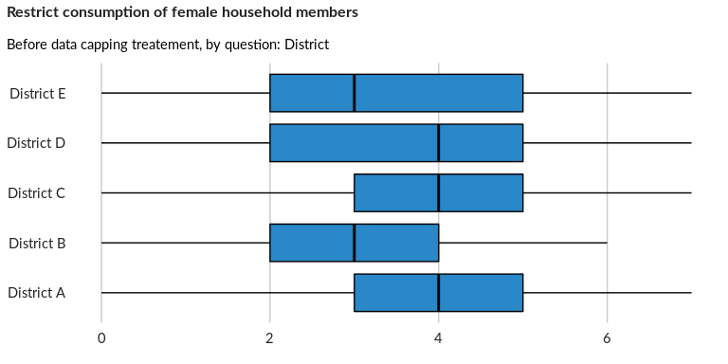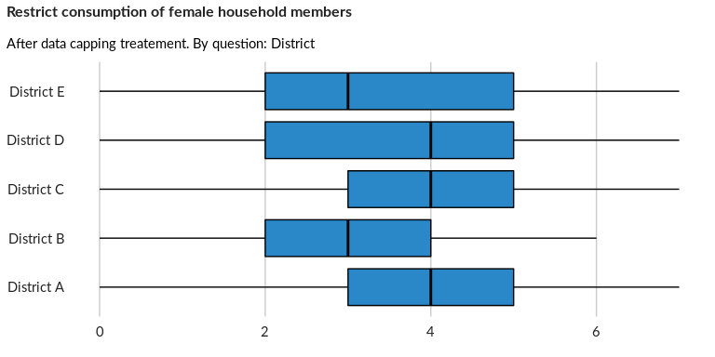

## Does the household currently receive food assistance (cash-based)?

NA

Single choice question

### Tabulation

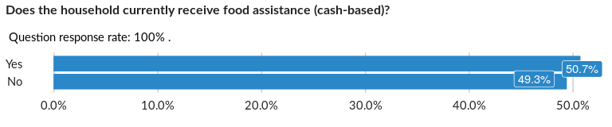

### Cross-tabulations

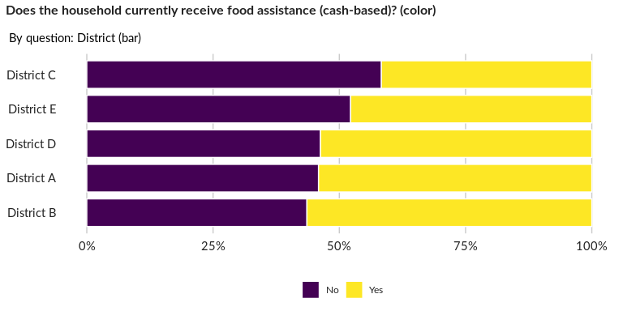

### Significant Associations (chi-square with p value < 5%)

No significant association found for this question…

## Has the household received any food assistance (in-kind) over the past three mon

NA

Single choice question

### Tabulation

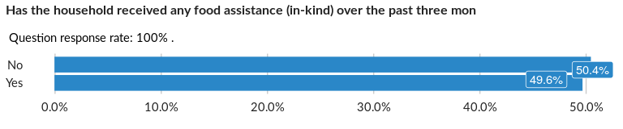

### Cross-tabulations

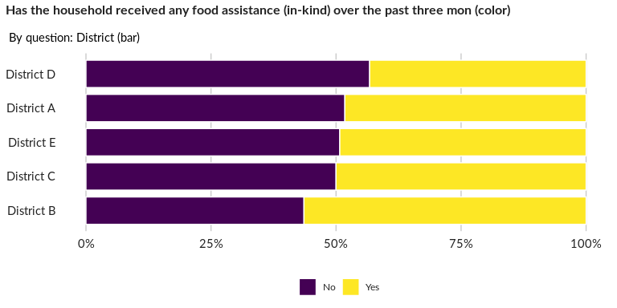

### Significant Associations (chi-square with p value < 5%)

No significant association found for this question…

## Does the household receive food assistance (in-kind) regularly?

NA

Single choice question

### Tabulation

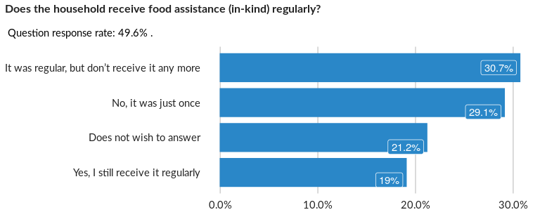

### Cross-tabulations

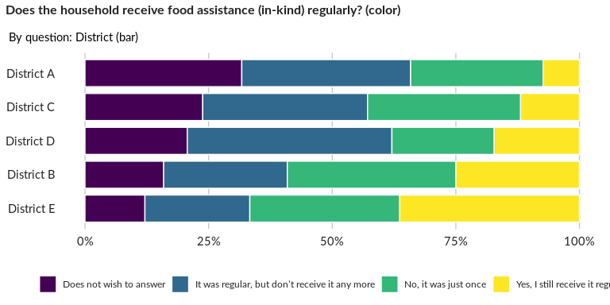

### Significant Associations (chi-square with p value < 5%)

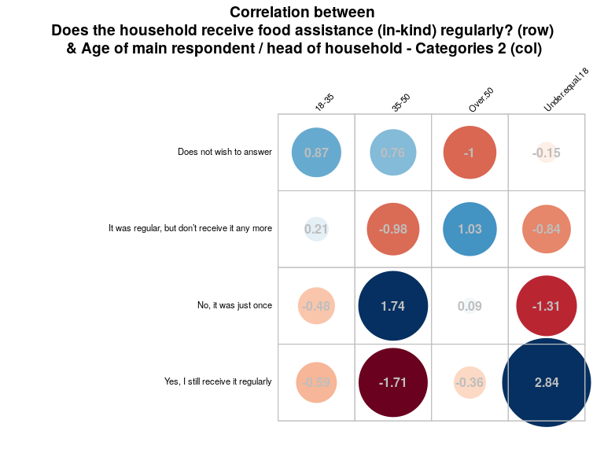

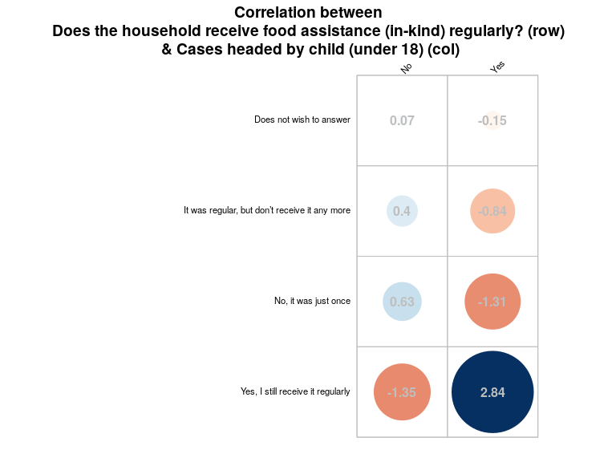

##### Page Break