Data Crunching Report: Coping_Strategies- Draft not for distribution.

Generated with [Koboloader](https://unhcr.github.io/koboloadeR/docs)

26 June 2019

Table of Contents

# Introduction

This data crunching report allows to quickly explore the results of the survey that can be regenerated as needed. You can:

* adjust the configuration in the xlsform to break it into chapter;
* configure disaggregation & correlation for each questions;
* revise the data cleansing based on the cleaning log;
* add weight to each observation in order to account for a specific sampling plan;
* append calculated indicators to your data frame.

The objective of this report is to allow to quickly identify potential patterns in your dataset. A quick screening of this initial report should allow to select the most meaningful graphs. A data digest from this initial report can be then reviewed through a **data analysis workshop** where subject matter experts can contribute with qualitative components. When analyzing those representations in a collective setting, you may:

* **Reflect**: question data quality and/or make suggestions to change questions;
* **Interpret**: develop qualitative interpretations of data patterns;
* **Recommend**: develop recommendation in terms of programmatic adjustment;
* **Classify**: order the level of sensitivity for the information;

# Compilation of questions results

## Sell household goods (radio, furniture, television, jewellery etc)

NA

Single choice question

### Tabulation

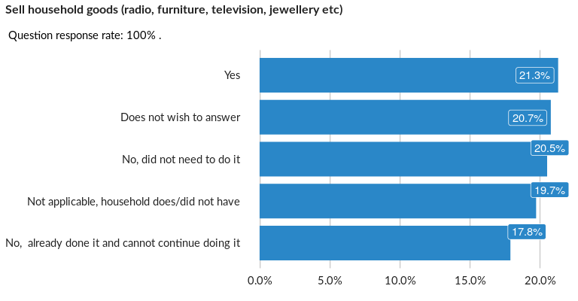

### Cross-tabulations

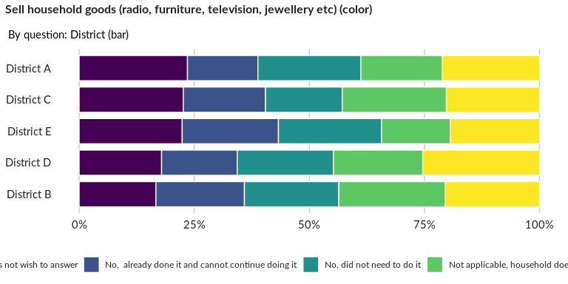

### Significant Associations (chi-square with p value < 5%)

No significant association found for this question…

## Sell productive assets and/or means of transport (sewing machine, wheelbarrow, b

NA

Single choice question

### Tabulation

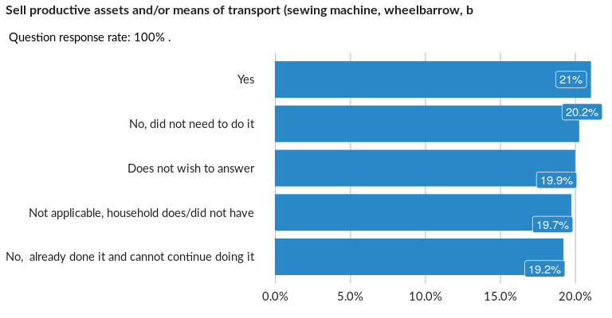

### Cross-tabulations

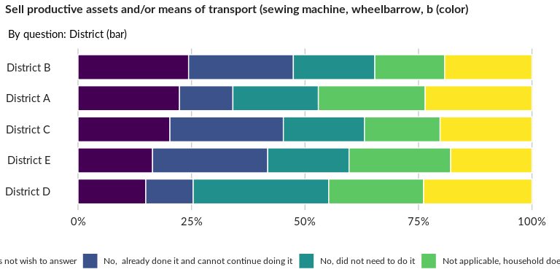

### Significant Associations (chi-square with p value < 5%)

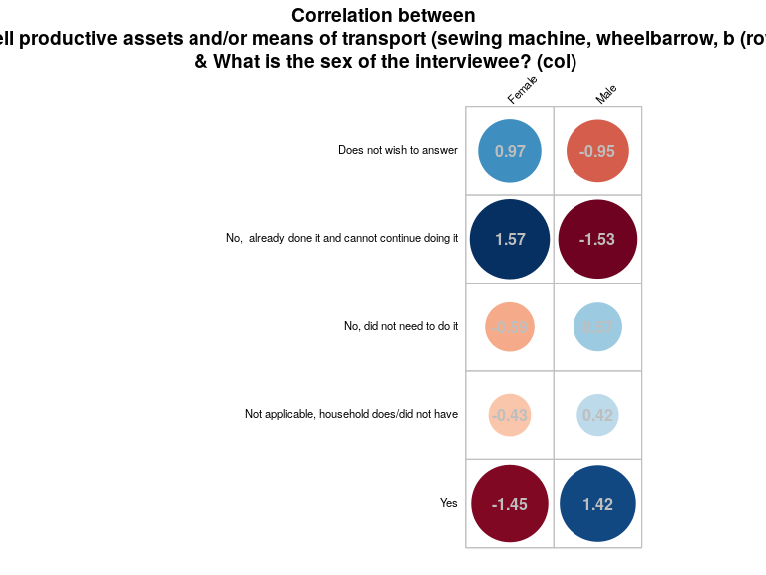

## Reduce food expenditure

NA

Single choice question

### Tabulation

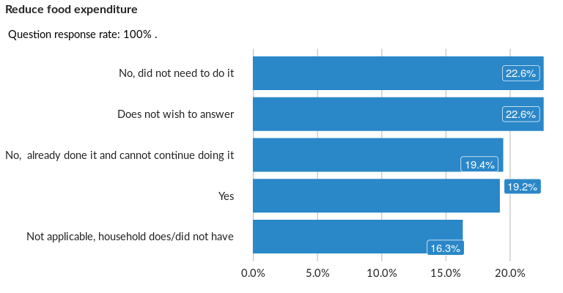

### Cross-tabulations

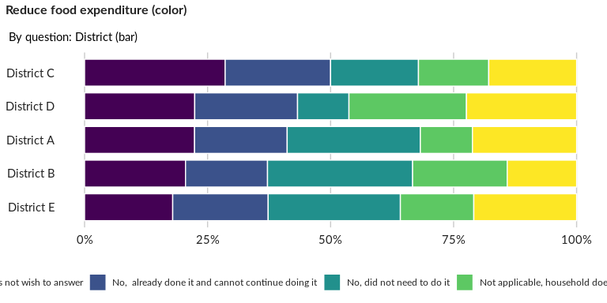

### Significant Associations (chi-square with p value < 5%)

No significant association found for this question…

## Reduce non-food expenses on health (including medicines)

NA

Single choice question

### Tabulation

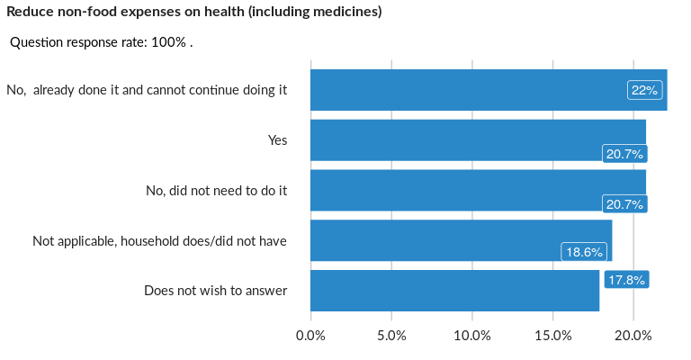

### Cross-tabulations

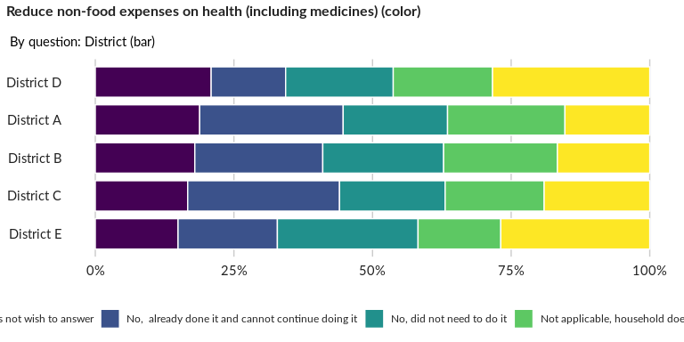

### Significant Associations (chi-square with p value < 5%)

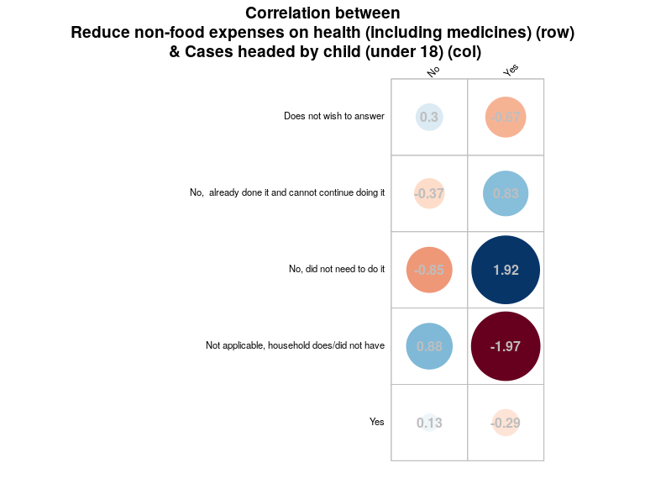

## Reduce non-food expenses on education

NA

Single choice question

### Tabulation

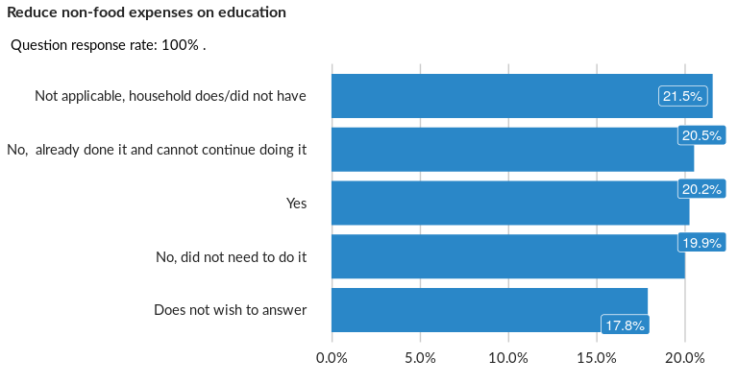

### Cross-tabulations

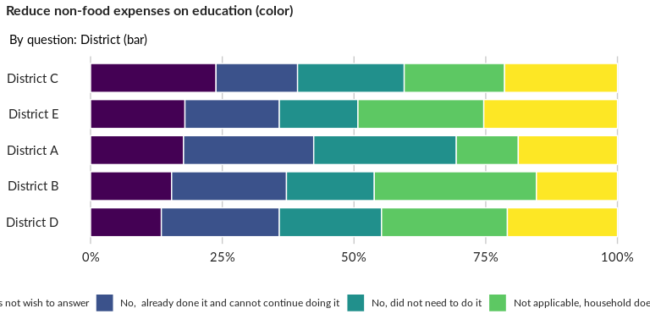

### Significant Associations (chi-square with p value < 5%)

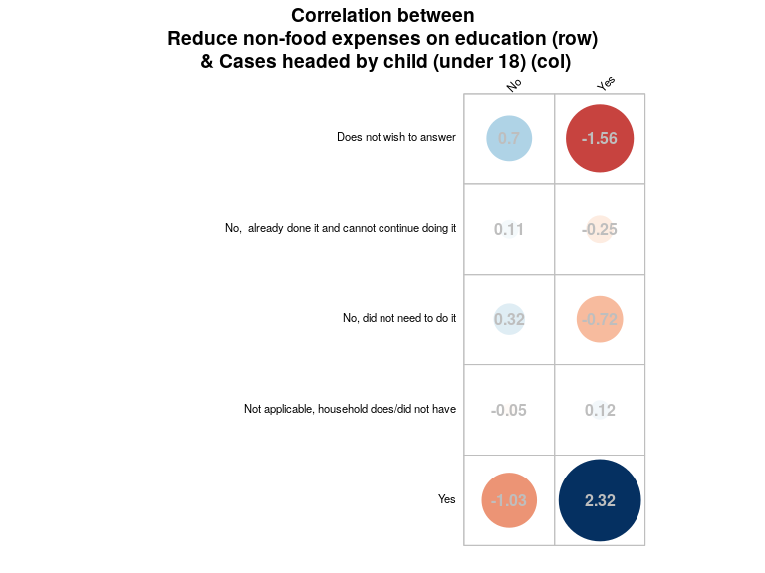

## Spend some or all of the household savings

NA

Single choice question

### Tabulation

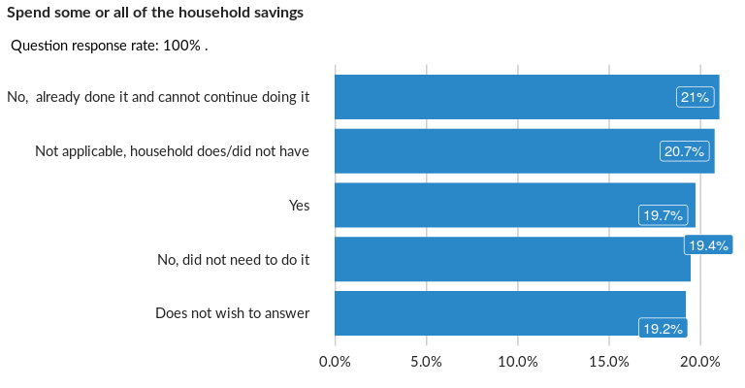

### Cross-tabulations

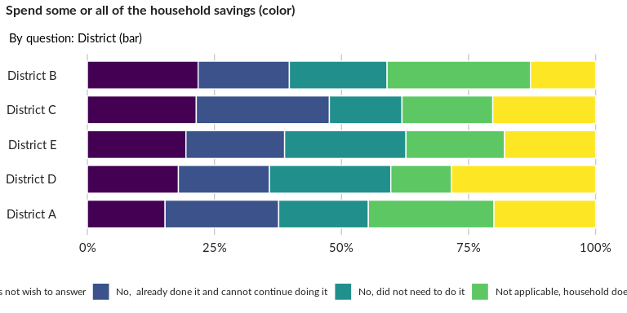

### Significant Associations (chi-square with p value < 5%)

No significant association found for this question…

## Buy food on credit and/or borrowed money to purchase food

NA

Single choice question

### Tabulation

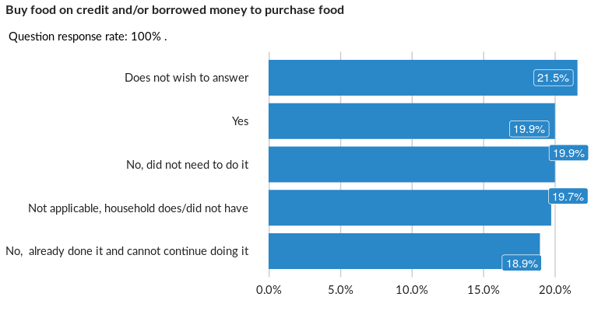

### Cross-tabulations

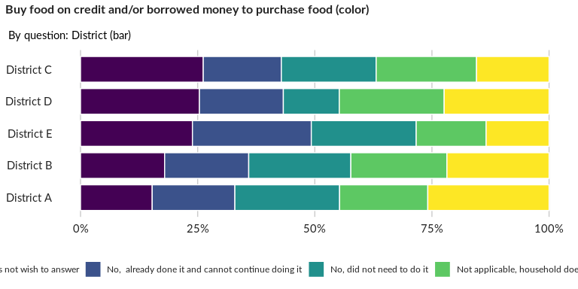

### Significant Associations (chi-square with p value < 5%)

No significant association found for this question…

## Sell house and/or land

NA

Single choice question

### Tabulation

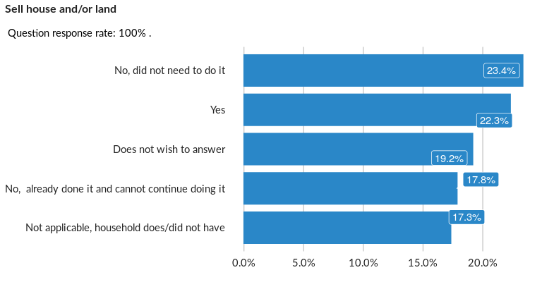

### Cross-tabulations

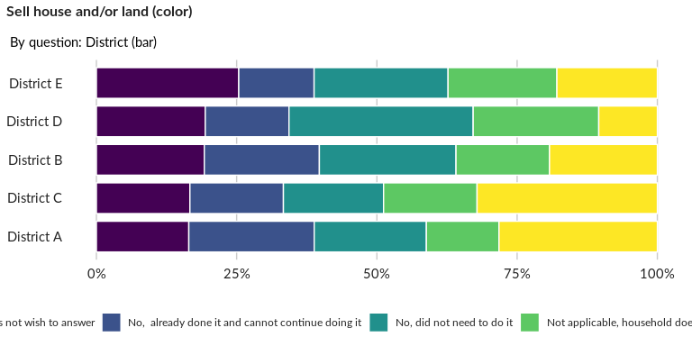

### Significant Associations (chi-square with p value < 5%)

No significant association found for this question…

## Move to a cheaper rental place/live on the street

NA

Single choice question

### Tabulation

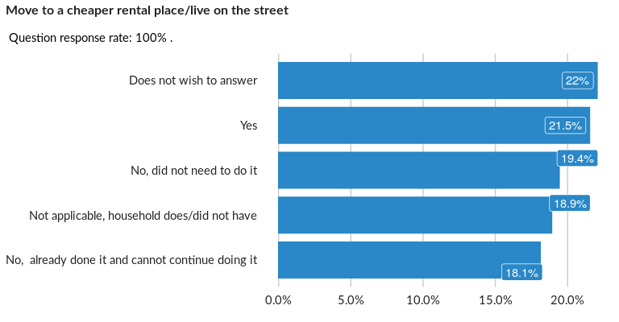

### Cross-tabulations

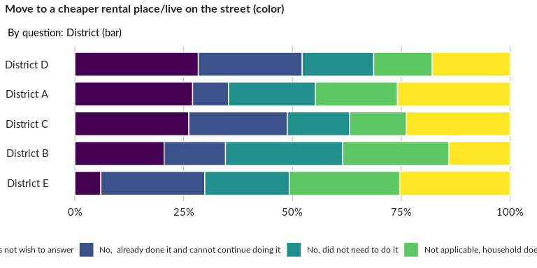

### Significant Associations (chi-square with p value < 5%)

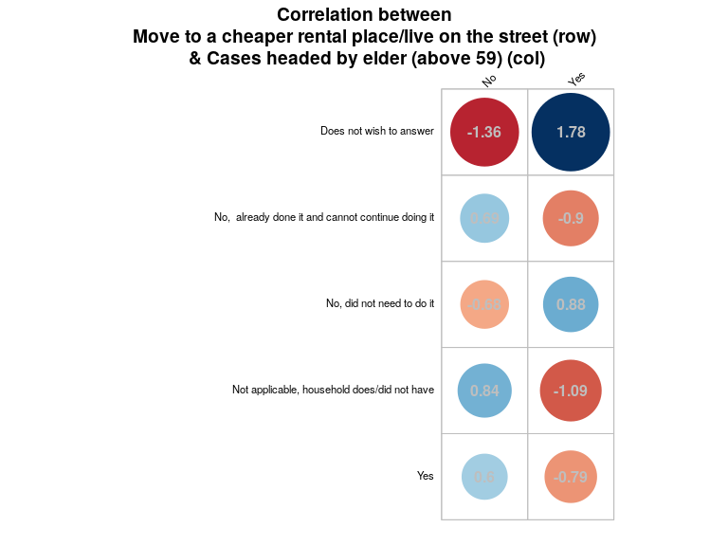

## Withdraw children from school

NA

Single choice question

### Tabulation

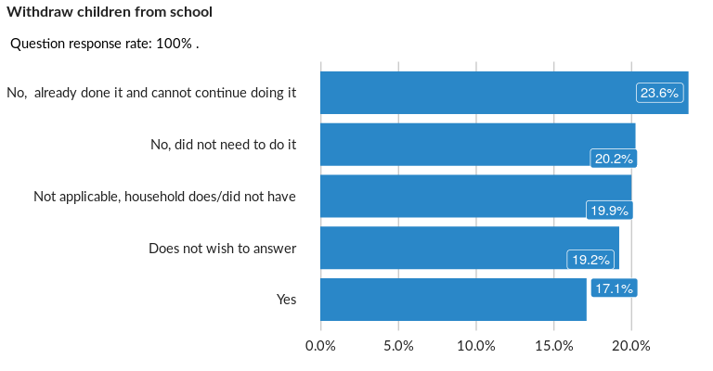

### Cross-tabulations

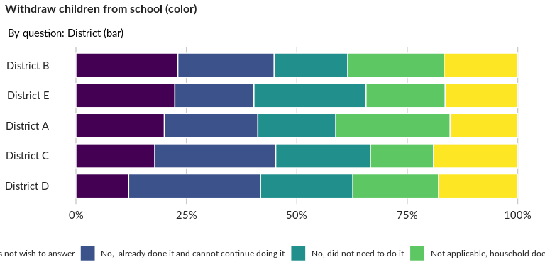

### Significant Associations (chi-square with p value < 5%)

No significant association found for this question…

## Involve school children (6 -15 years old) in income generation

NA

Single choice question

### Tabulation

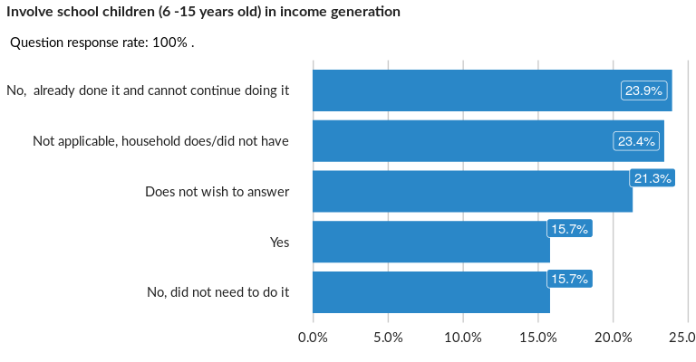

### Cross-tabulations

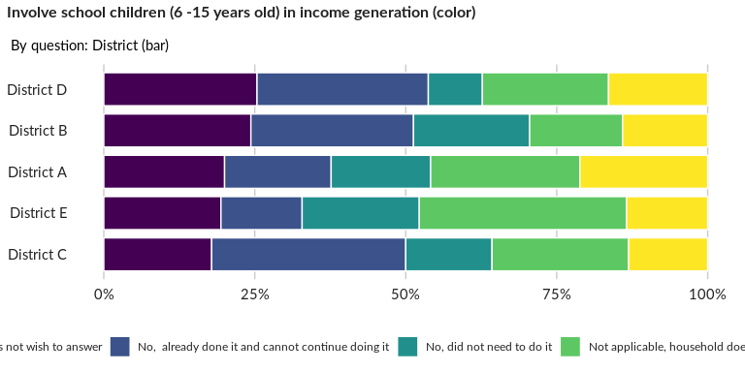

### Significant Associations (chi-square with p value < 5%)

No significant association found for this question…

## Ask for money from strangers (begging)

NA

Single choice question

### Tabulation

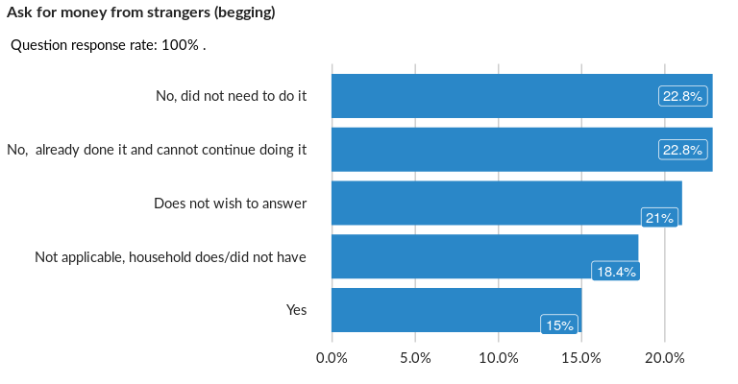

### Cross-tabulations

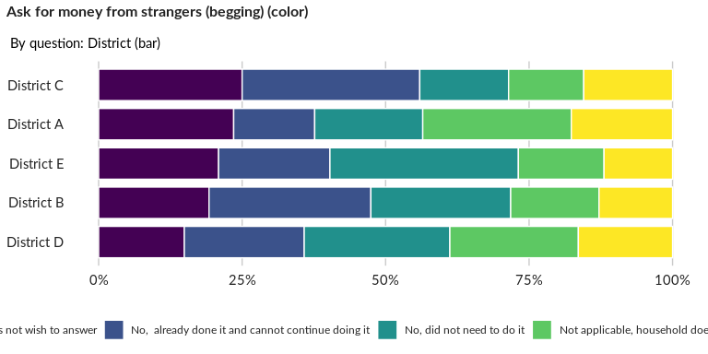

### Significant Associations (chi-square with p value < 5%)

No significant association found for this question…

## Have household members 18 years and over accept high risk, dangerous, or exploit

NA

Single choice question

### Tabulation

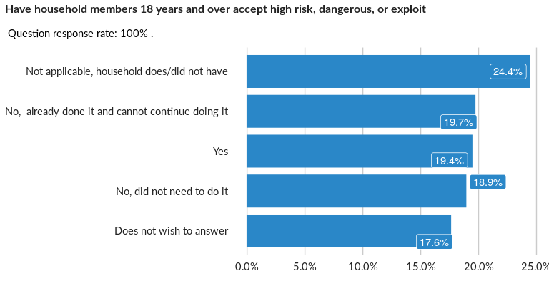

### Cross-tabulations

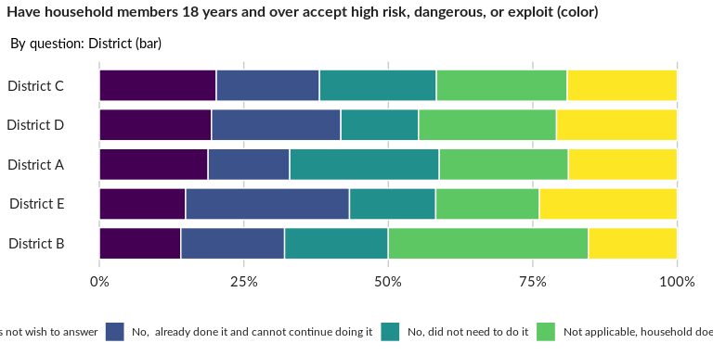

### Significant Associations (chi-square with p value < 5%)

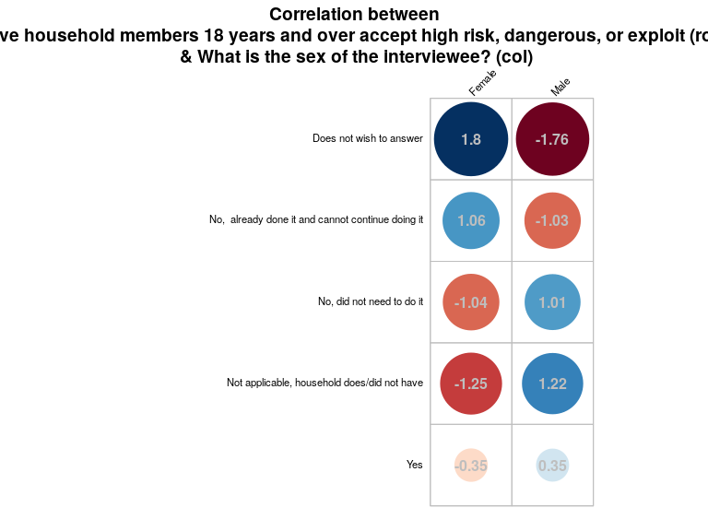

## Have household members under the age of 18 accept high risk, dangerous, or explo

NA

Single choice question

### Tabulation

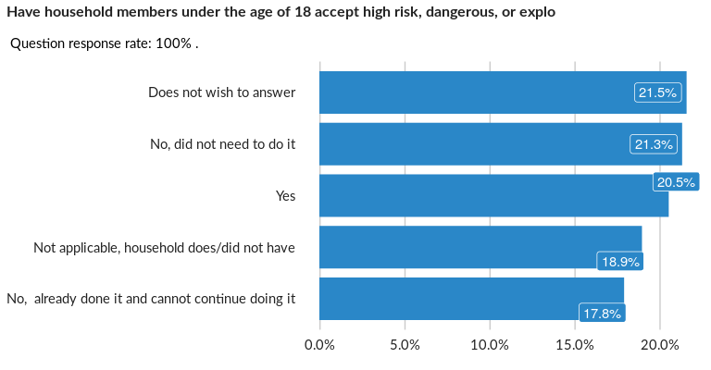

### Cross-tabulations

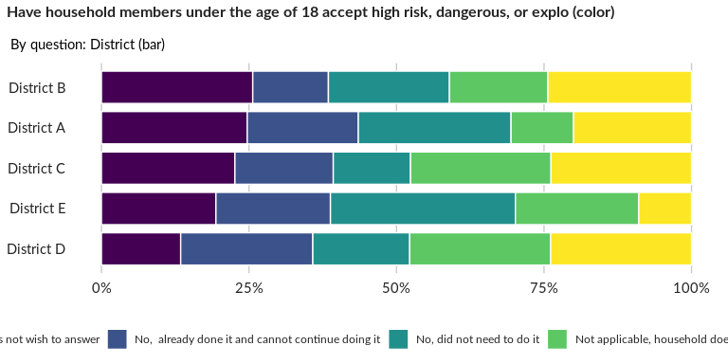

### Significant Associations (chi-square with p value < 5%)

No significant association found for this question…

## Send an adult household member to work elsewhere (not related to usual seasonal

NA

Single choice question

### Tabulation

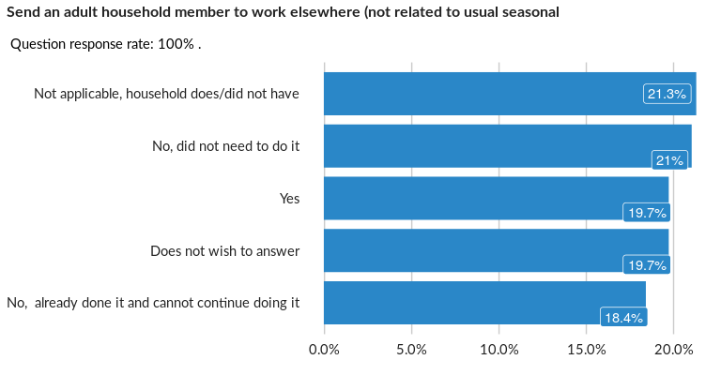

### Cross-tabulations

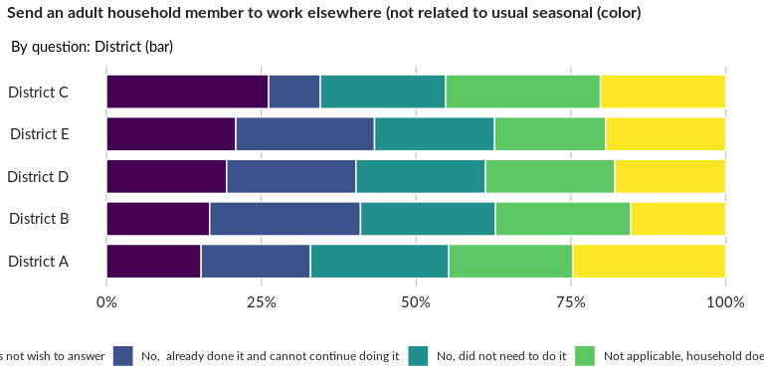

### Significant Associations (chi-square with p value < 5%)

No significant association found for this question…

## Send a child household member to work elsewhere (not related to usual seasonal m

NA

Single choice question

### Tabulation

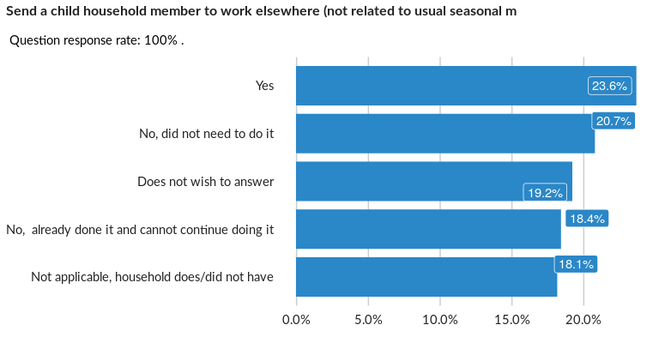

### Cross-tabulations

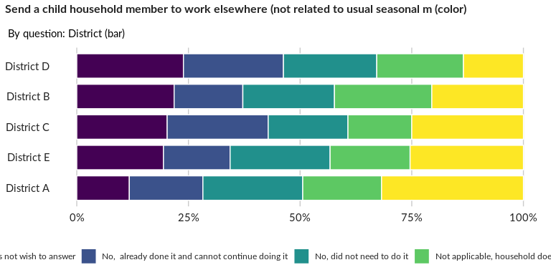

### Significant Associations (chi-square with p value < 5%)

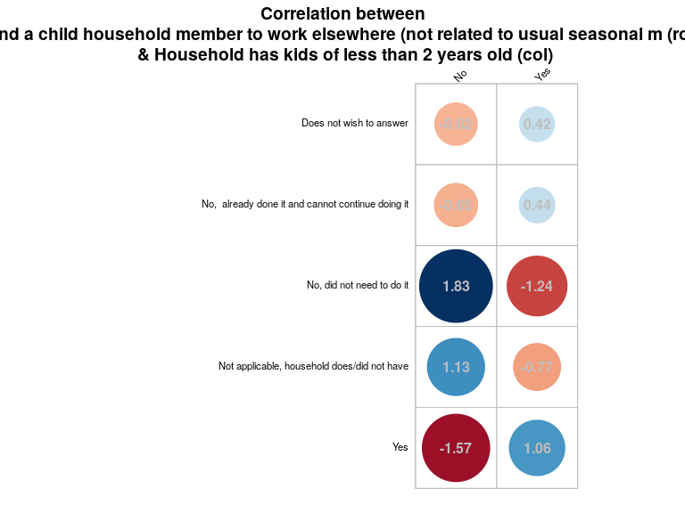

## Marry children under 18

NA

Single choice question

### Tabulation

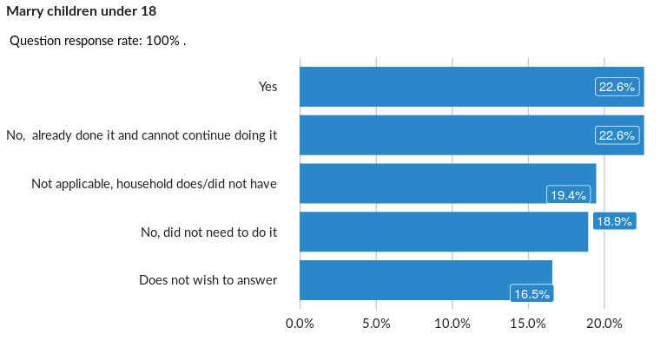

### Cross-tabulations

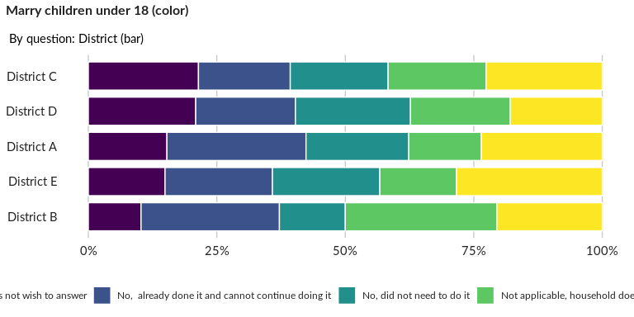

### Significant Associations (chi-square with p value < 5%)

No significant association found for this question…

## What do you consider to be your community’s MOST important need?

NA

Single choice question

### Tabulation

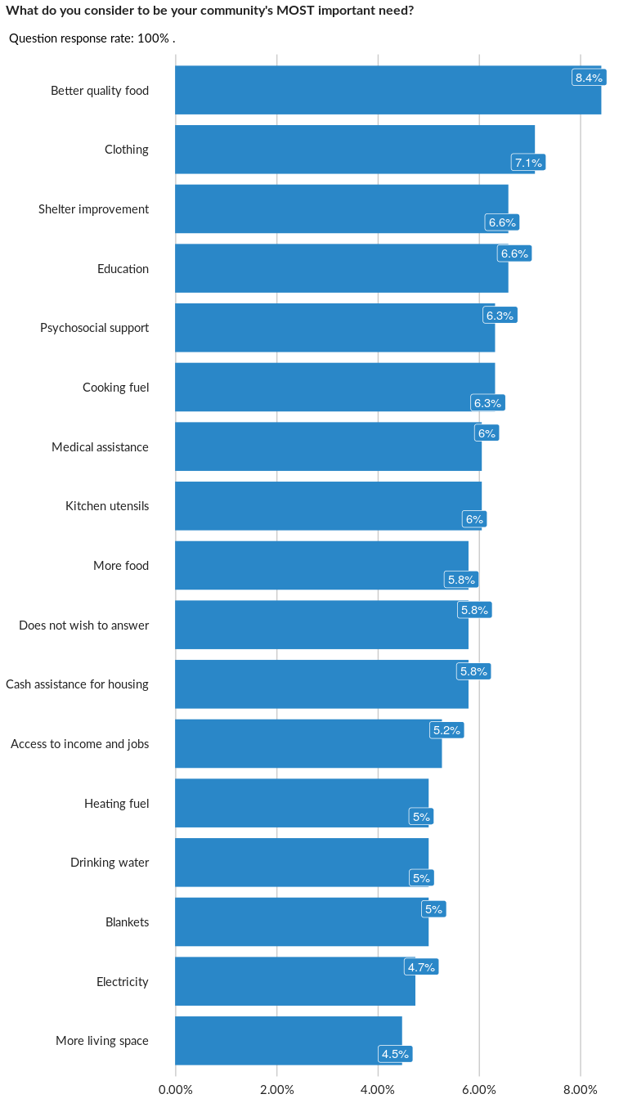

### Cross-tabulations

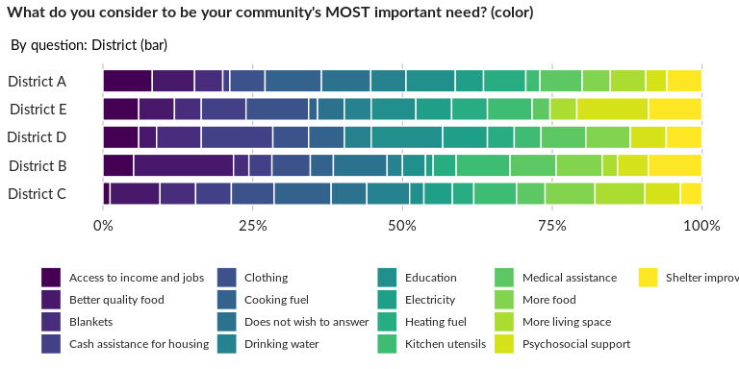

### Significant Associations (chi-square with p value < 5%)

No significant association found for this question…

## What are two or three other needs you consider your community has?

NA

Multiple choice question

### Tabulation

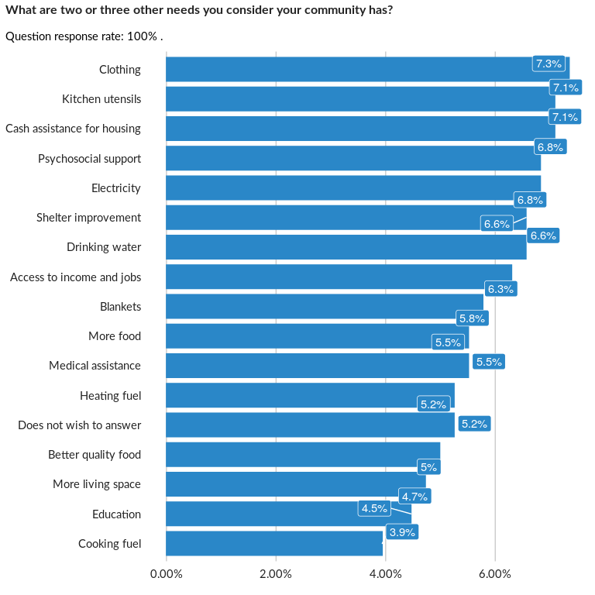

### Analysis of relationship

## What do you consider to be your household’s MOST important need?

NA

Single choice question

### Tabulation

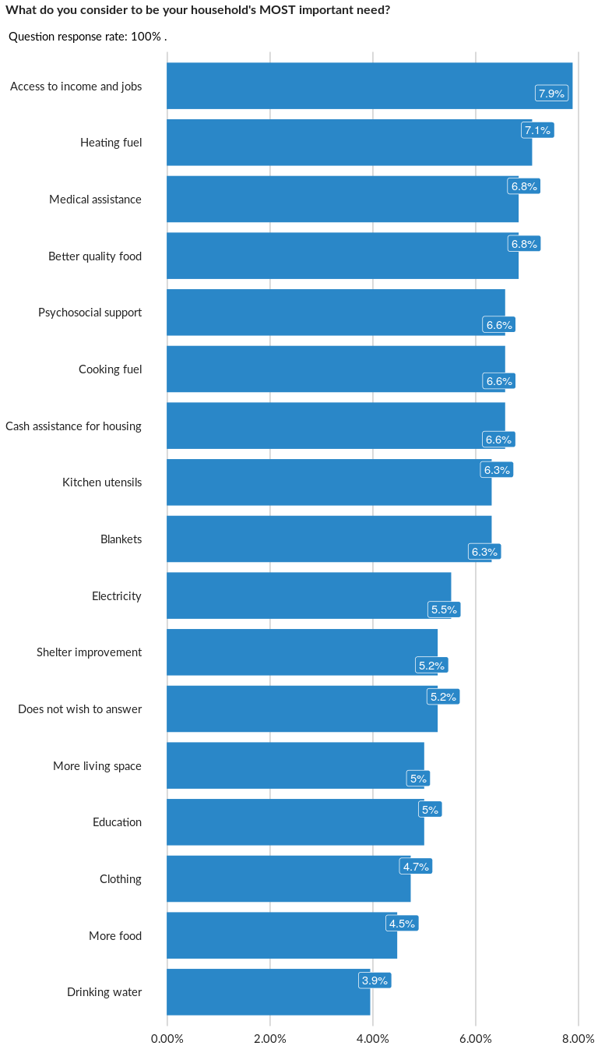

### Cross-tabulations

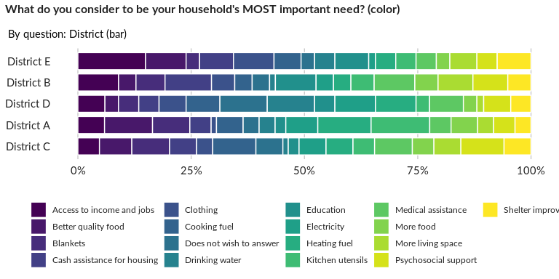

### Significant Associations (chi-square with p value < 5%)

No significant association found for this question…

## What are three other important needs you household has?

NA

Multiple choice question

### Tabulation

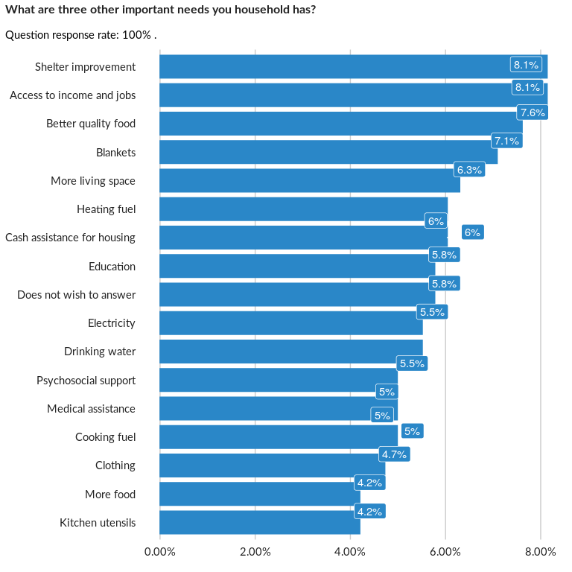

### Analysis of relationship

##### Page Break