Data Crunching Report: Inclusion- Draft not for distribution.

Generated with [Koboloader](https://unhcr.github.io/koboloadeR/docs)

26 June 2019

Table of Contents

# Introduction

This data crunching report allows to quickly explore the results of the survey that can be regenerated as needed. You can:

* adjust the configuration in the xlsform to break it into chapter;
* configure disaggregation & correlation for each questions;
* revise the data cleansing based on the cleaning log;
* add weight to each observation in order to account for a specific sampling plan;
* append calculated indicators to your data frame.

The objective of this report is to allow to quickly identify potential patterns in your dataset. A quick screening of this initial report should allow to select the most meaningful graphs. A data digest from this initial report can be then reviewed through a **data analysis workshop** where subject matter experts can contribute with qualitative components. When analyzing those representations in a collective setting, you may:

* **Reflect**: question data quality and/or make suggestions to change questions;
* **Interpret**: develop qualitative interpretations of data patterns;
* **Recommend**: develop recommendation in terms of programmatic adjustment;
* **Classify**: order the level of sensitivity for the information;

# Compilation of questions results

## Have any household members experienced any kind of issue related with their safe

NA

Single choice question

### Tabulation

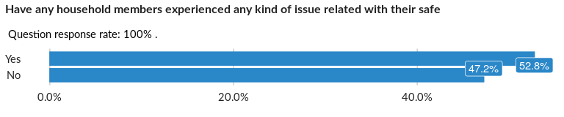

### Cross-tabulations

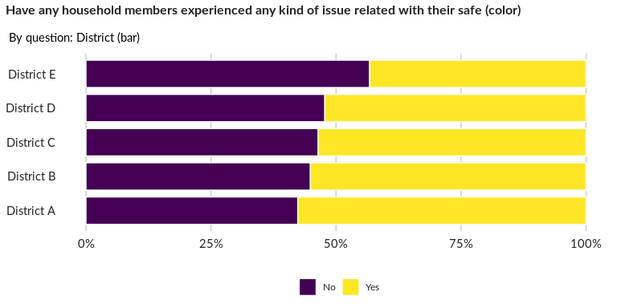

### Significant Associations (chi-square with p value < 5%)

No significant association found for this question…

## What kind of safety issue?

NA

Multiple choice question

### Tabulation

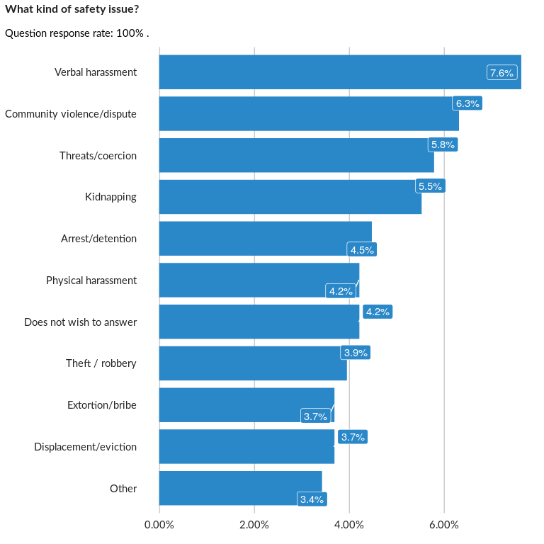

### Analysis of relationship

## Who or what is the cause of the safety issues?

NA

Multiple choice question

### Tabulation

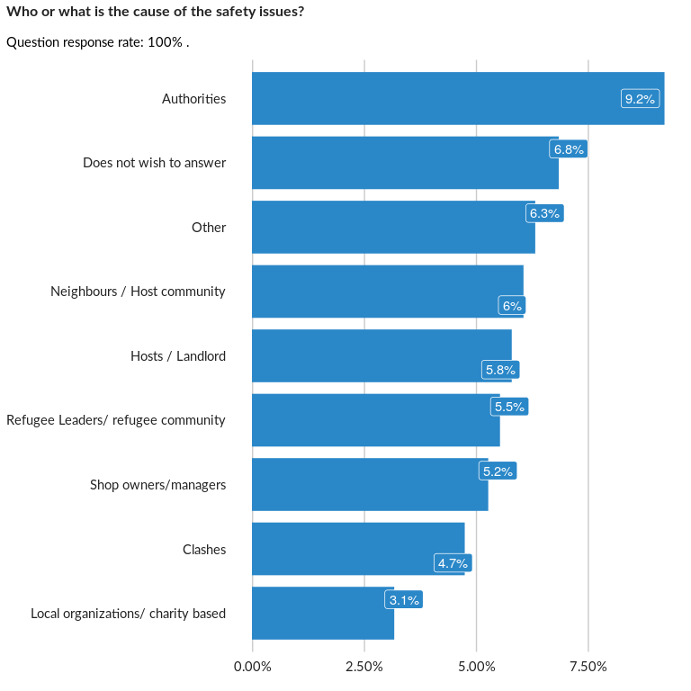

### Analysis of relationship

## Does unsafety reduce the free movement of any household member?

NA

Single choice question

### Tabulation

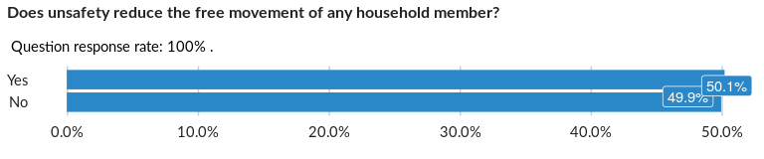

### Cross-tabulations

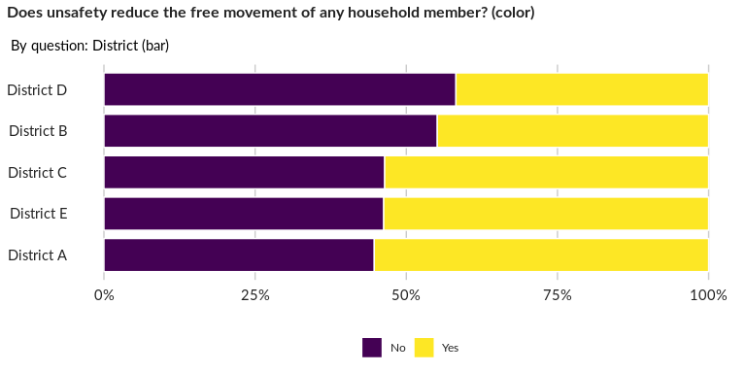

### Significant Associations (chi-square with p value < 5%)

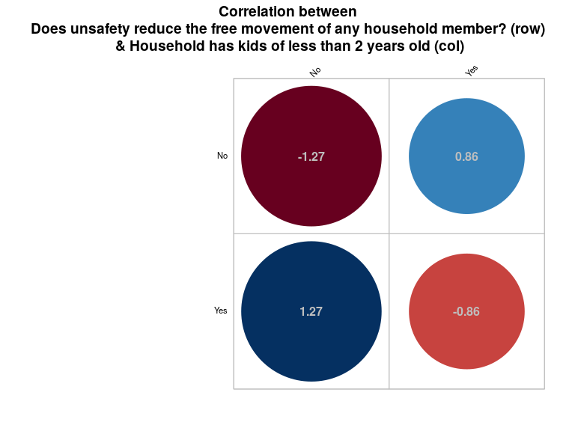

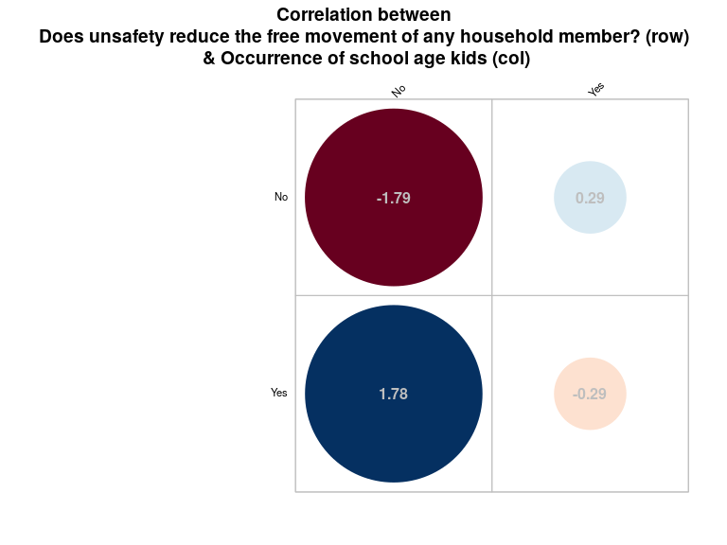

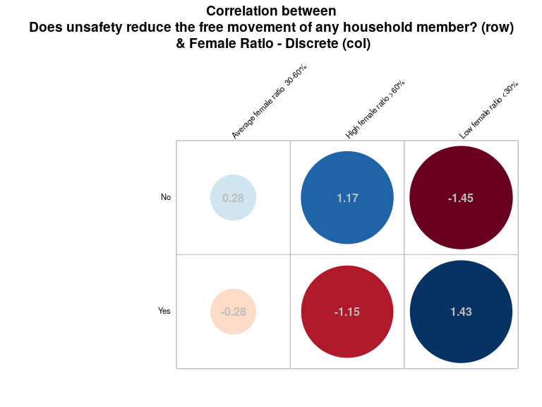

## At which level of the ladder would you place Fatima’s family?

NA

Single choice question

### Tabulation

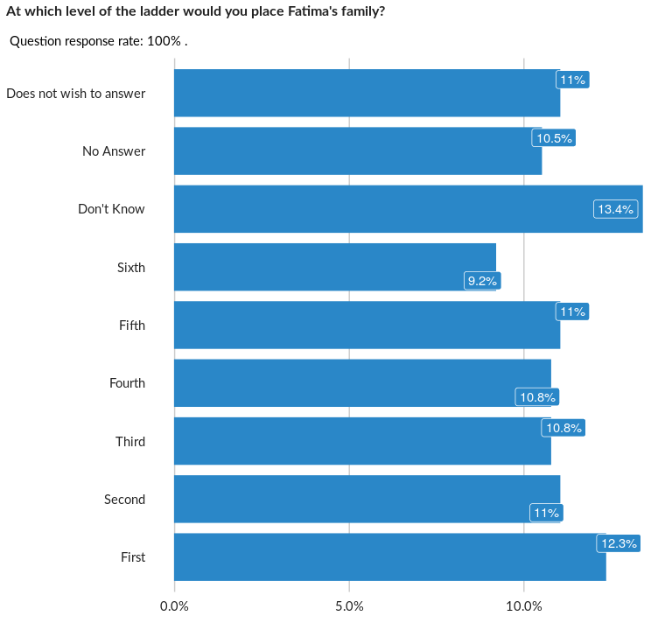

### Cross-tabulations

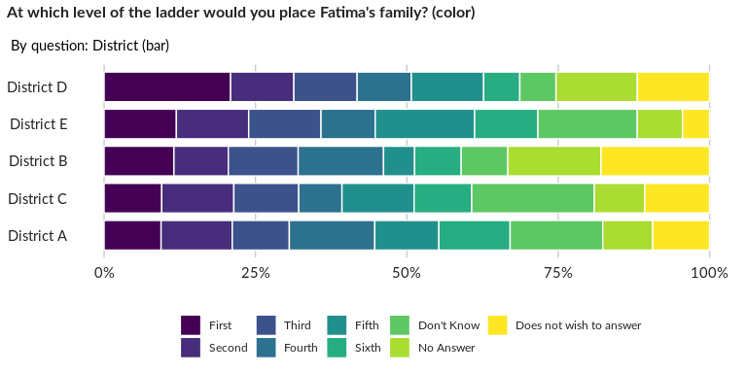

### Significant Associations (chi-square with p value < 5%)

No significant association found for this question…

## At which level of the ladder would you place Miriam’s family?

NA

Single choice question

### Tabulation

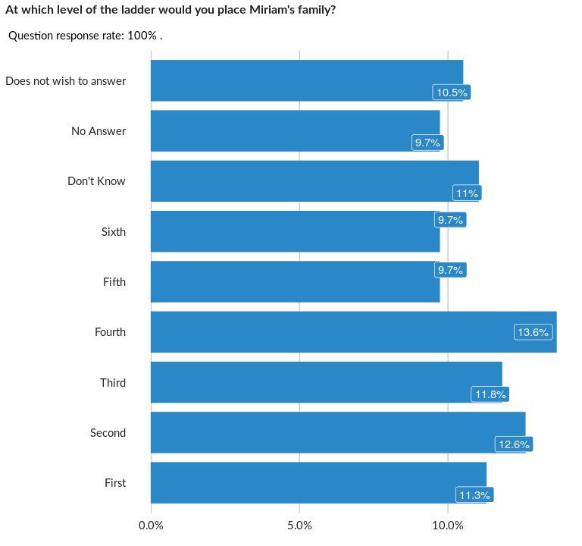

### Cross-tabulations

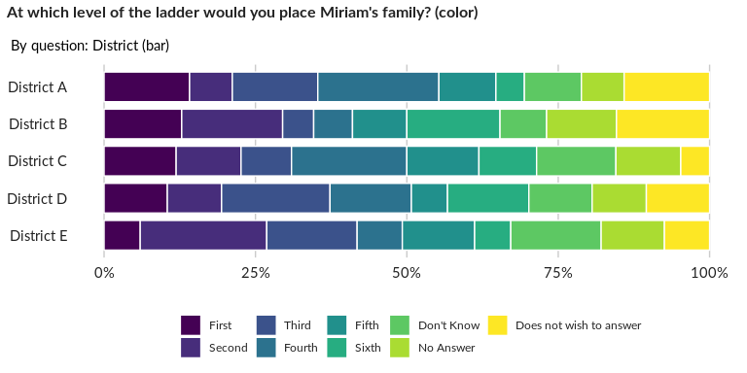

### Significant Associations (chi-square with p value < 5%)

No significant association found for this question…

## At which level of the ladder would you place Ahmed’s family?

NA

Single choice question

### Tabulation

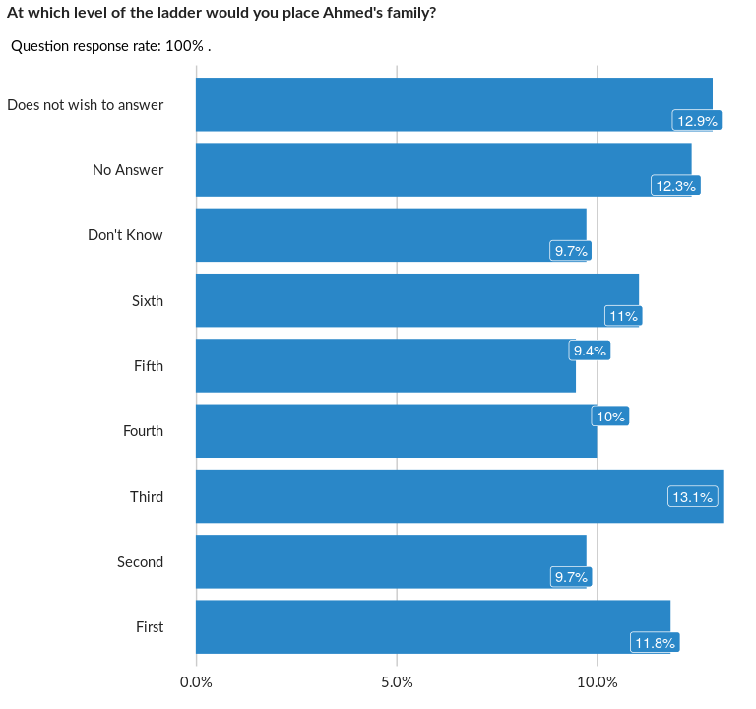

### Cross-tabulations

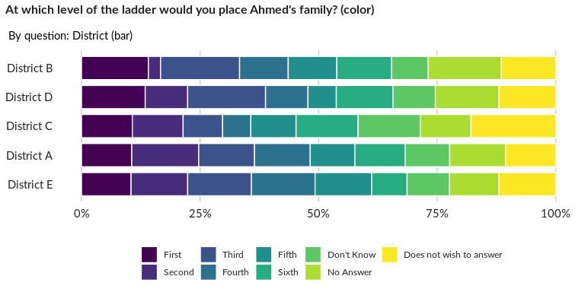

### Significant Associations (chi-square with p value < 5%)

No significant association found for this question…

## At which level of the ladder would you place Abdullah’s family?

NA

Single choice question

### Tabulation

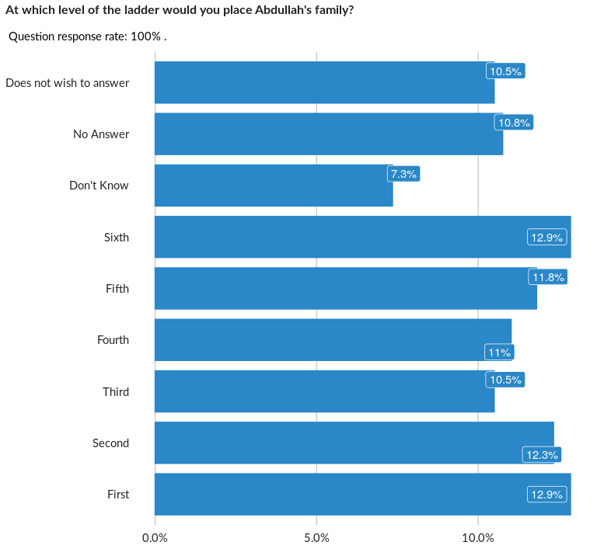

### Cross-tabulations

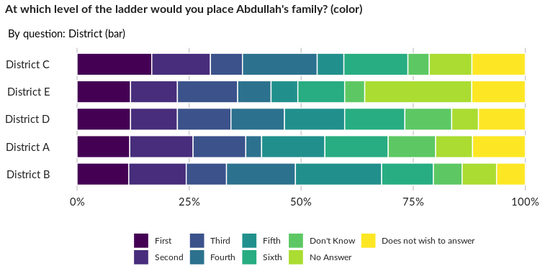

### Significant Associations (chi-square with p value < 5%)

No significant association found for this question…

## At which level of the ladder would you place your own household?

NA

Single choice question

### Tabulation

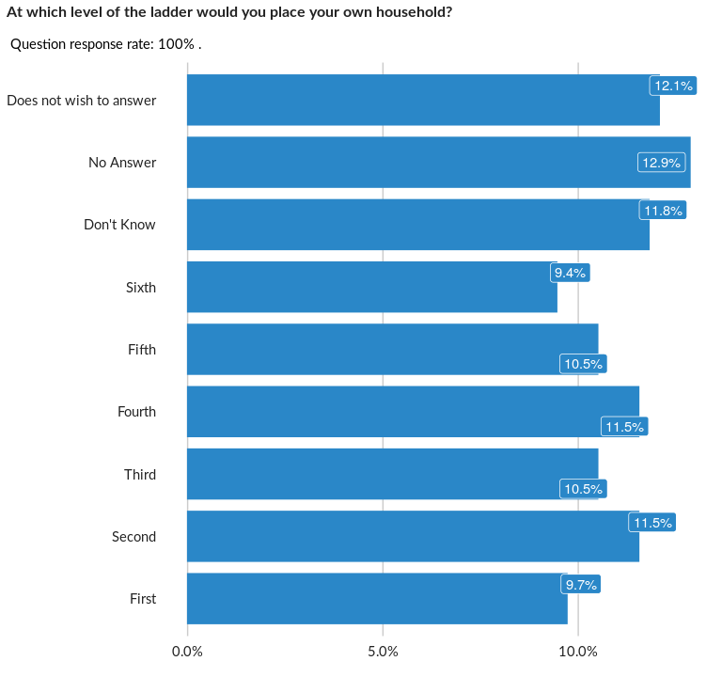

### Cross-tabulations

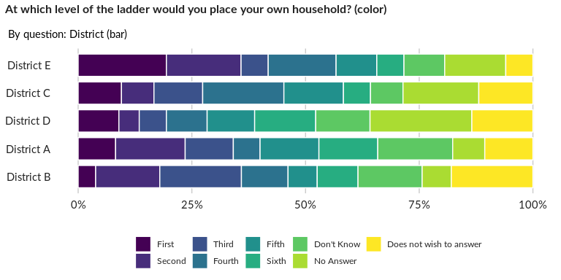

### Significant Associations (chi-square with p value < 5%)

No significant association found for this question…

## I am isolated from my fellow refugees

NA

Single choice question

### Tabulation

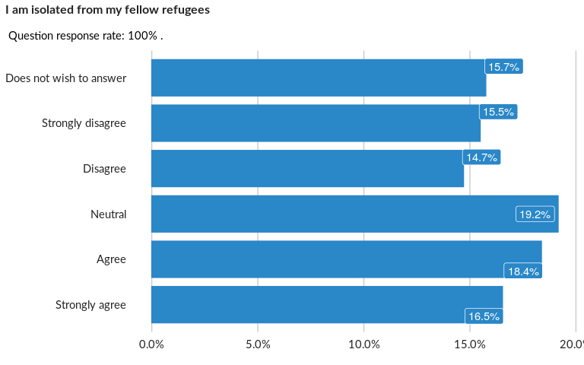

### Cross-tabulations

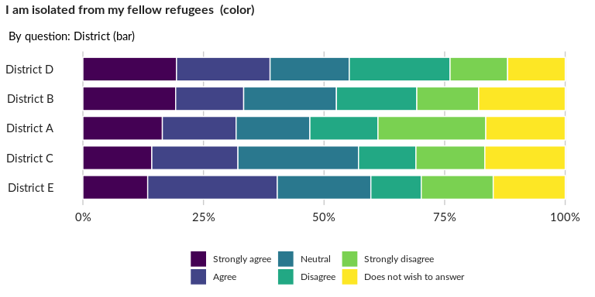

### Significant Associations (chi-square with p value < 5%)

No significant association found for this question…

## My local neighbours are concerned about me

NA

Single choice question

### Tabulation

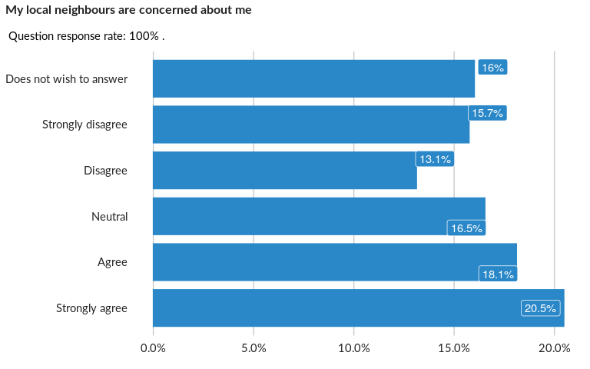

### Cross-tabulations

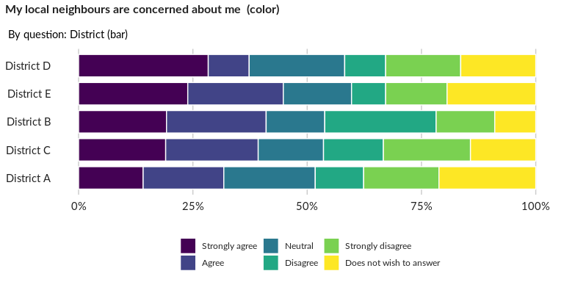

### Significant Associations (chi-square with p value < 5%)

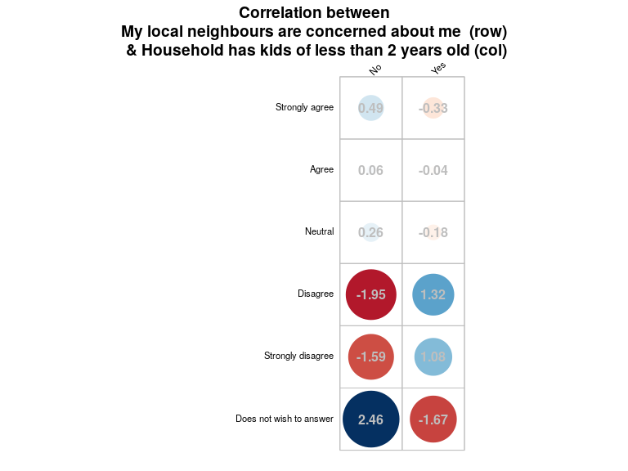

## I often attend community meetings, sports or other similar events, with a mix of

NA

Single choice question

### Tabulation

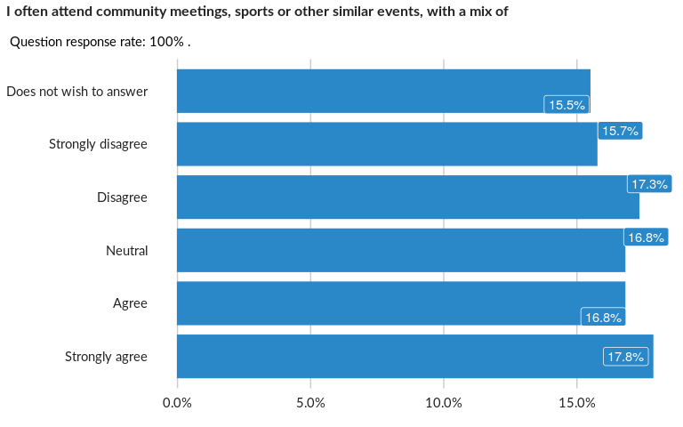

### Cross-tabulations

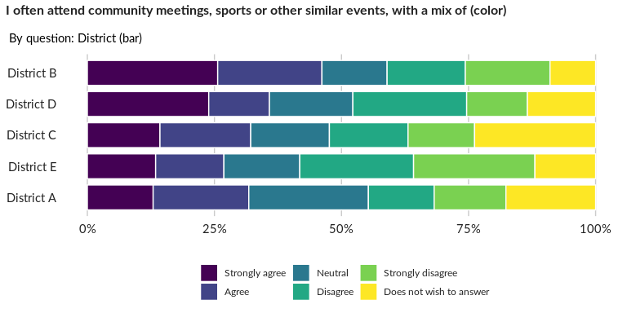

### Significant Associations (chi-square with p value < 5%)

No significant association found for this question…

## My local neighbours and I help each other out if needed

NA

Single choice question

### Tabulation

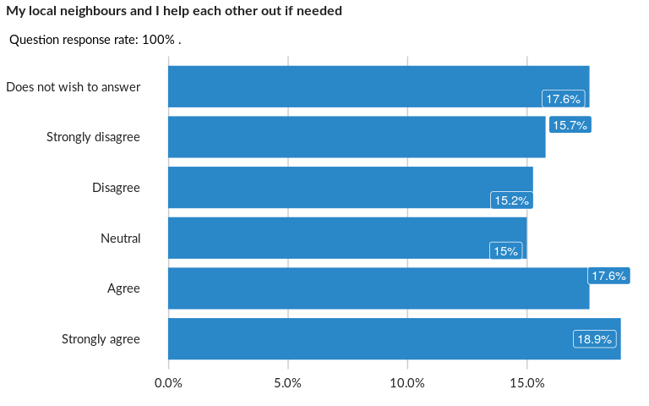

### Cross-tabulations

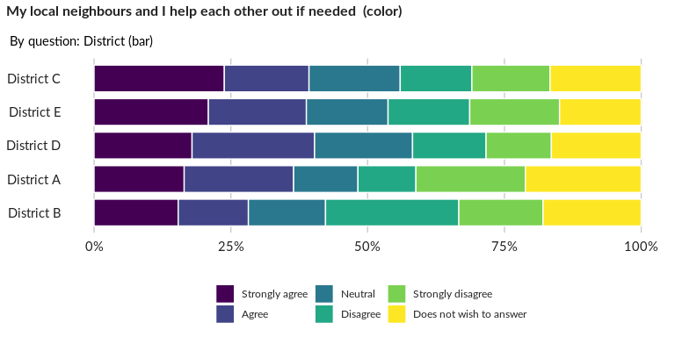

### Significant Associations (chi-square with p value < 5%)

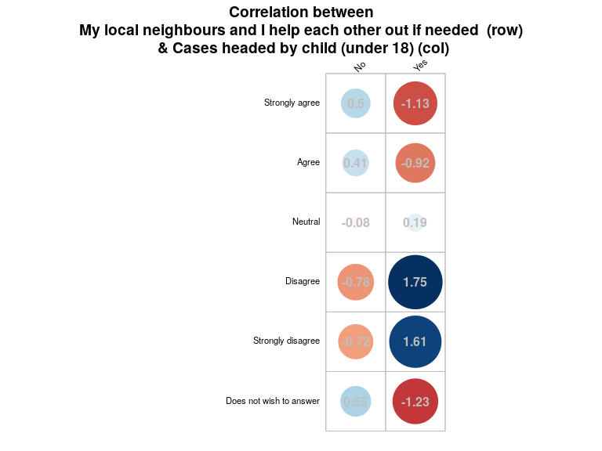

## How frequently do refugees in this town/village interact with host communities?

NA

Single choice question

### Tabulation

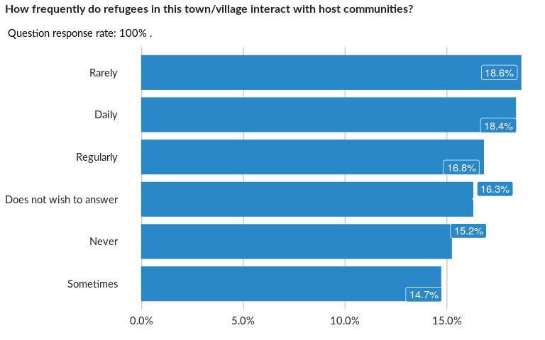

### Cross-tabulations

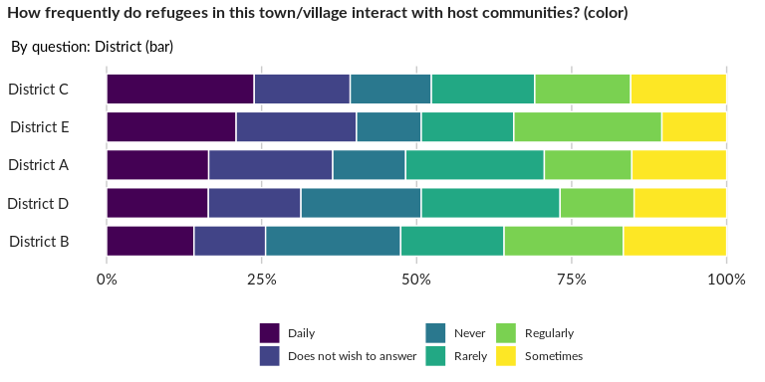

### Significant Associations (chi-square with p value < 5%)

No significant association found for this question…

## How frequently do you interact with members of the host community?

NA

Single choice question

### Tabulation

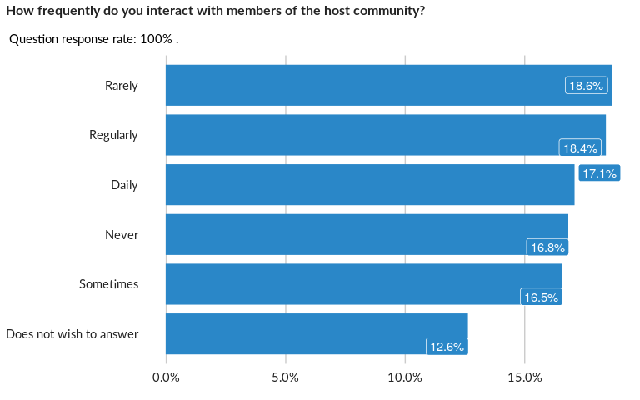

### Cross-tabulations

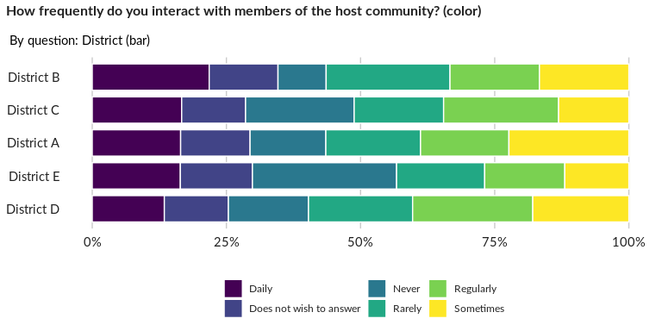

### Significant Associations (chi-square with p value < 5%)

No significant association found for this question…

## What is the key issue or issues that drive host community - refugee community te

NA

Multiple choice question

### Tabulation

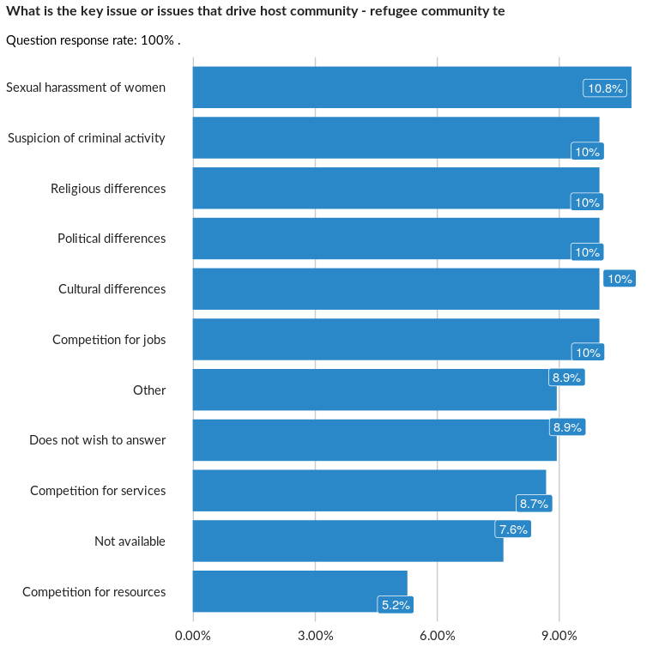

### Analysis of relationship

## What do you think would improve refugee host community relations in this area?

NA

Multiple choice question

### Tabulation

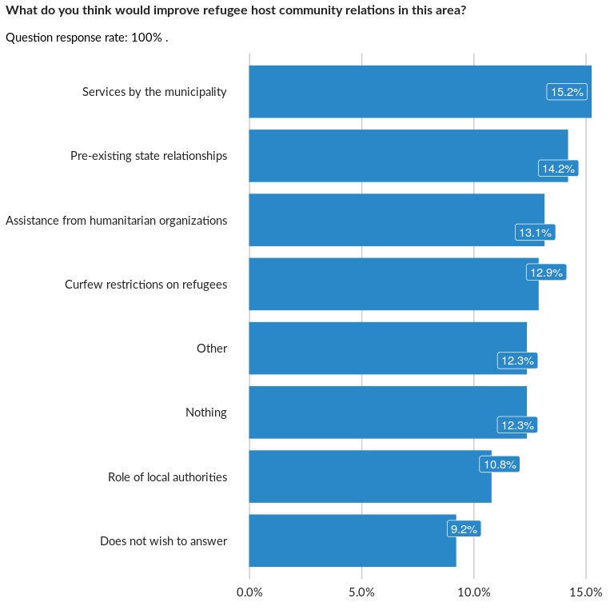

### Analysis of relationship

##### Page Break