Data Crunching Report: Demographics- Draft not for distribution.

Generated with [Koboloader](https://unhcr.github.io/koboloadeR/docs)

26 June 2019

Table of Contents

# Introduction

This data crunching report allows to quickly explore the results of the survey that can be regenerated as needed. You can:

* adjust the configuration in the xlsform to break it into chapter;
* configure disaggregation & correlation for each questions;
* revise the data cleansing based on the cleaning log;
* add weight to each observation in order to account for a specific sampling plan;
* append calculated indicators to your data frame.

The objective of this report is to allow to quickly identify potential patterns in your dataset. A quick screening of this initial report should allow to select the most meaningful graphs. A data digest from this initial report can be then reviewed through a **data analysis workshop** where subject matter experts can contribute with qualitative components. When analyzing those representations in a collective setting, you may:

* **Reflect**: question data quality and/or make suggestions to change questions;
* **Interpret**: develop qualitative interpretations of data patterns;
* **Recommend**: develop recommendation in terms of programmatic adjustment;
* **Classify**: order the level of sensitivity for the information;

# Compilation of questions results

## What is the relationship of the interviewee with the PA?

NA

Single choice question

### Tabulation

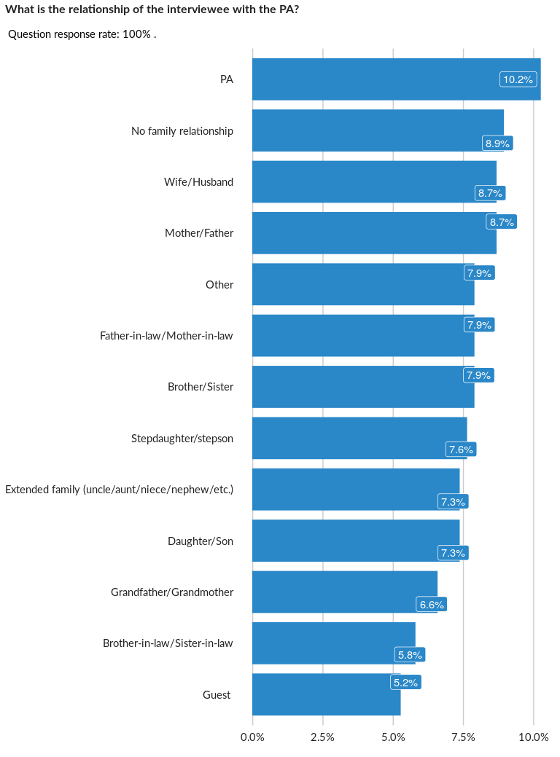

### Cross-tabulations

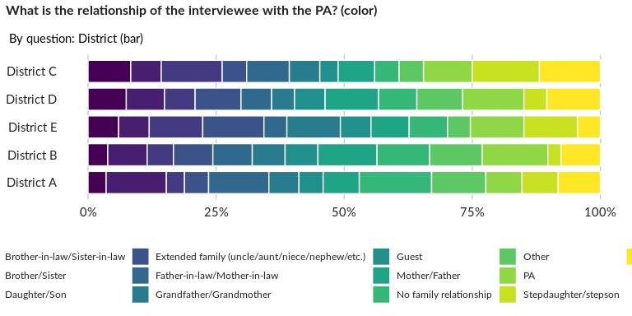

### Significant Associations (chi-square with p value < 5%)

No significant association found for this question…

## What is the sex of the interviewee?

NA

Single choice question

### Tabulation

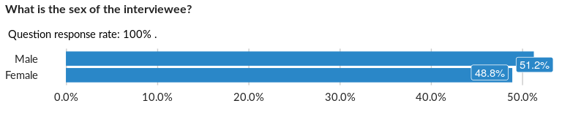

### Cross-tabulations

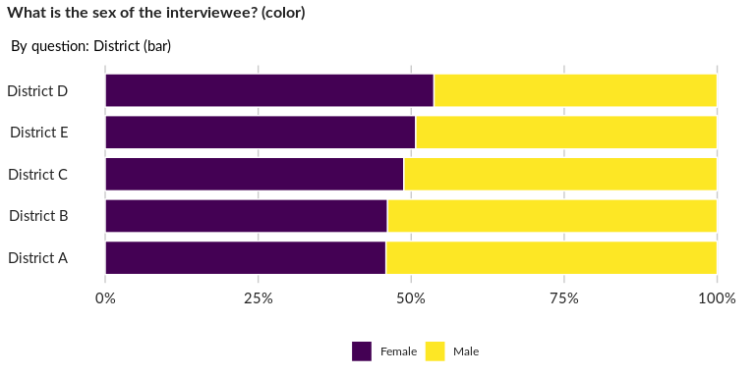

### Significant Associations (chi-square with p value < 5%)

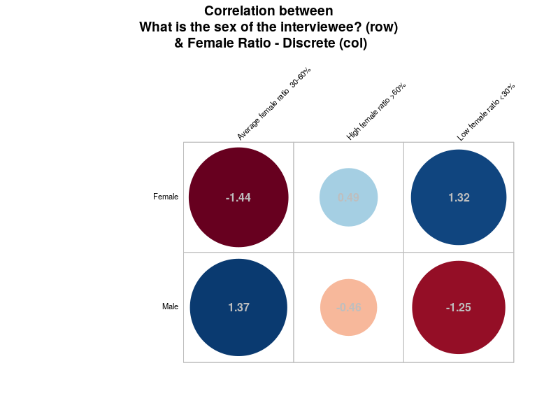

## Please select a statement that is true about the PA

NA

Single choice question

### Tabulation

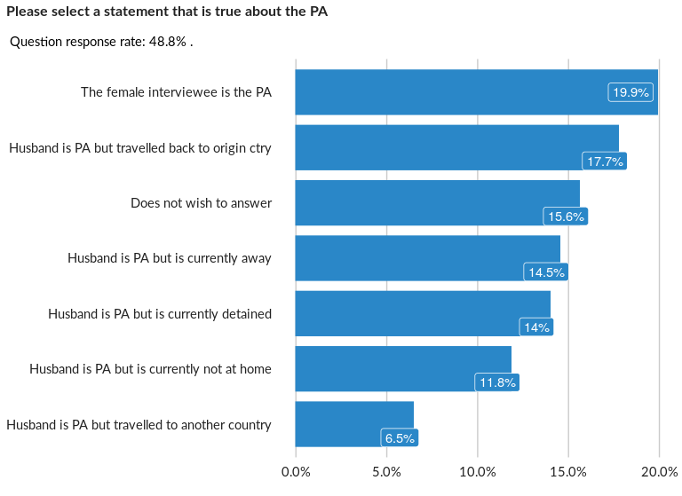

### Cross-tabulations

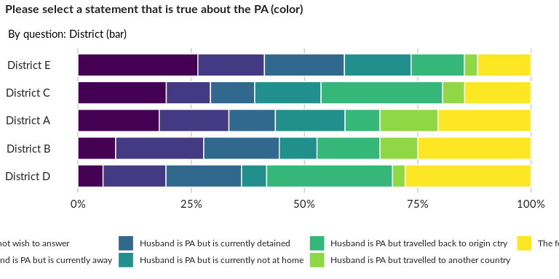

### Significant Associations (chi-square with p value < 5%)

No significant association found for this question…

## What is the date of birth of the interviewee?

NA

Date question in data frame: MainDataFrame

## What is the nationality of the interviewee?

NA

Single choice question

### Tabulation

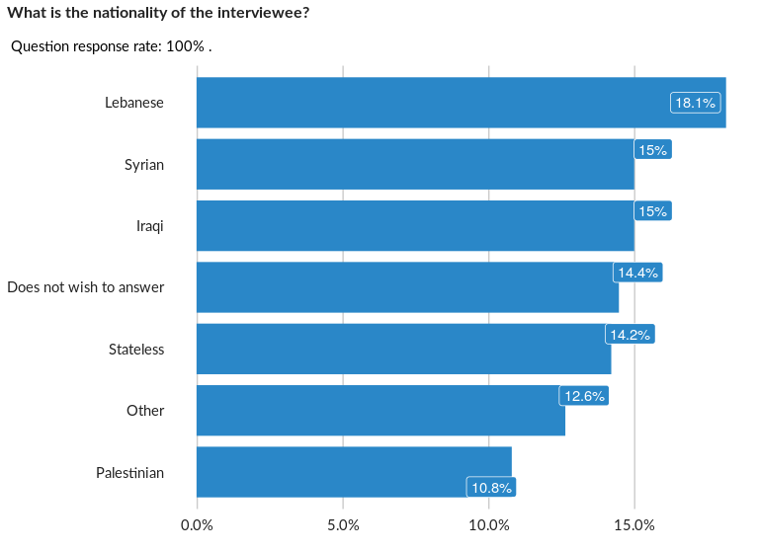

### Cross-tabulations

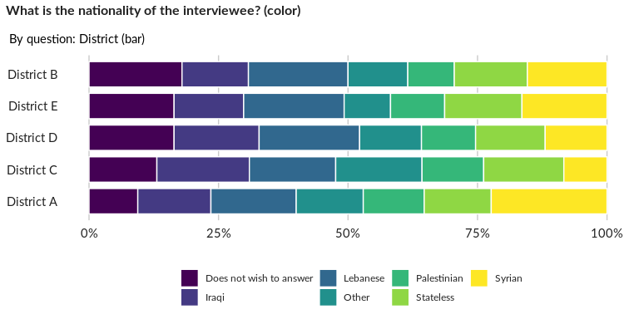

### Significant Associations (chi-square with p value < 5%)

No significant association found for this question…

## How many people are registered under the same case number?

This refers to UNHCR Registration process - which is the sampling universe for the survey

Numeric question

### Tabulation

Based on the sample design, the average weighted mean response for this question is 24.89

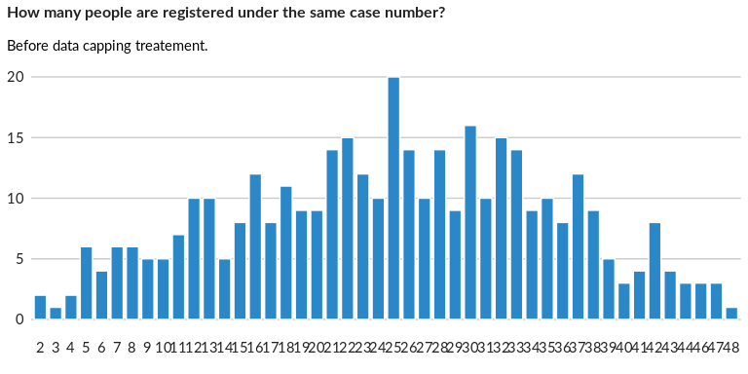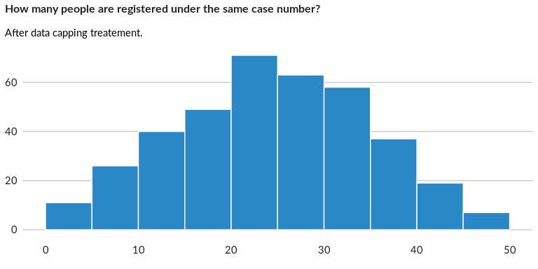

### Analysis of relationship

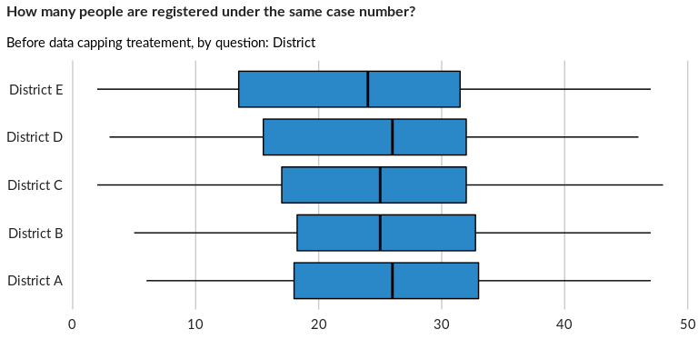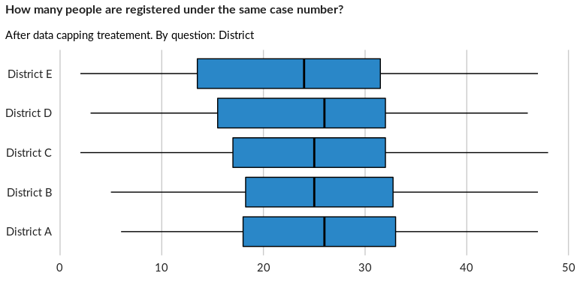

## Are all those registered living with you?

NA

Single choice question

### Tabulation

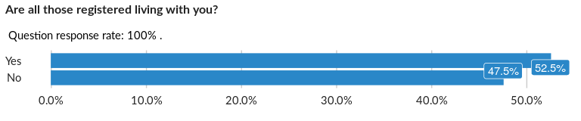

### Cross-tabulations

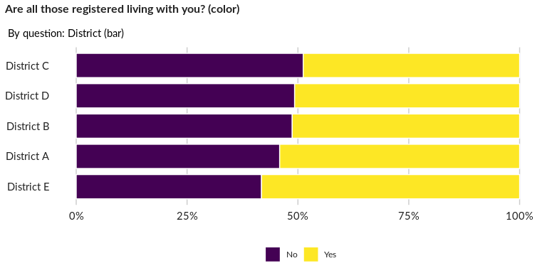

### Significant Associations (chi-square with p value < 5%)

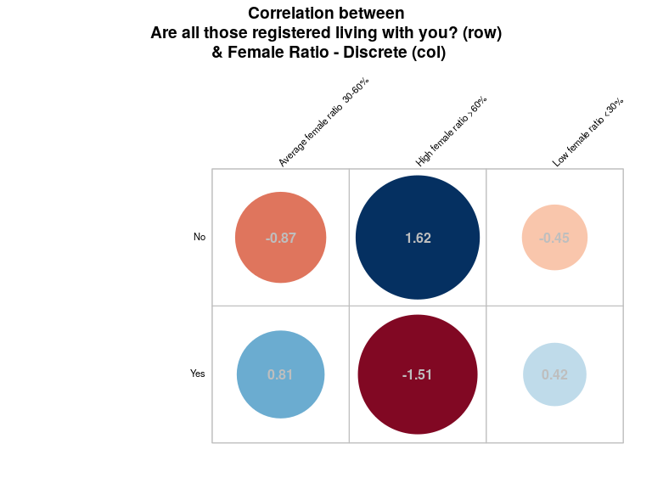

## If not, why not?

NA

Multiple choice question

### Tabulation

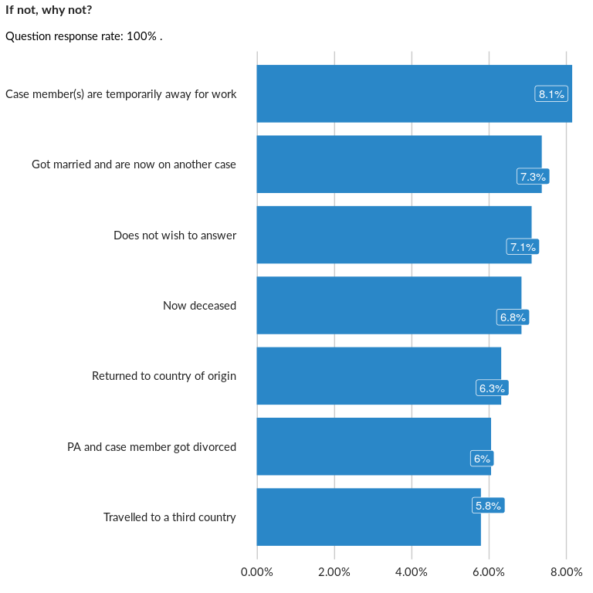

### Analysis of relationship

## Are there other people living with you, who are not registered under the same ca

This question may trigger some registration referals

Single choice question

### Tabulation

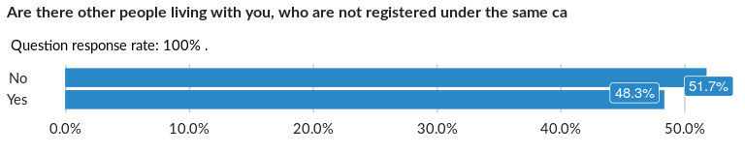

### Cross-tabulations

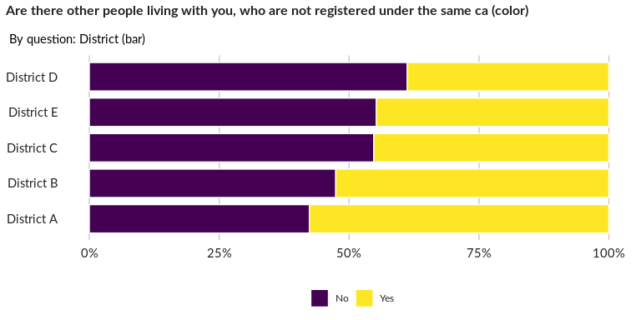

### Significant Associations (chi-square with p value < 5%)

No significant association found for this question…

## If yes, how many?

NA

Numeric question

### Tabulation

Based on the sample design, the average weighted mean response for this question is 51.01

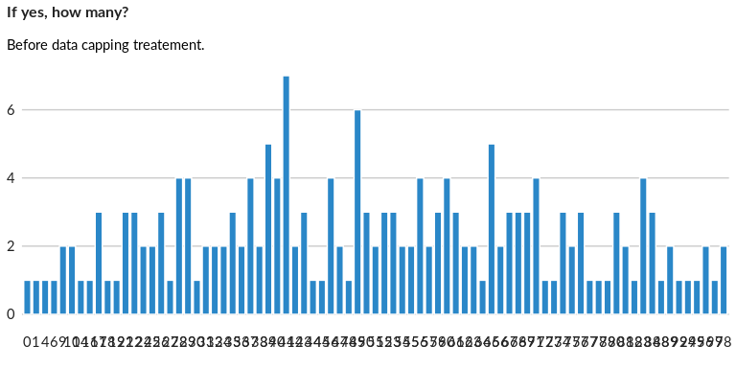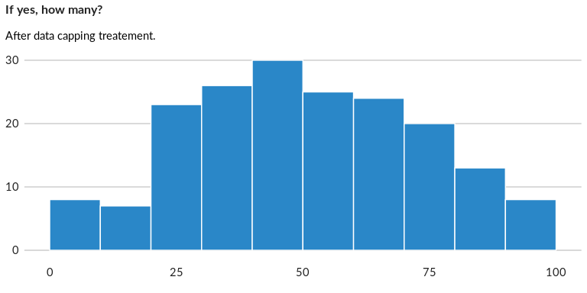

### Analysis of relationship

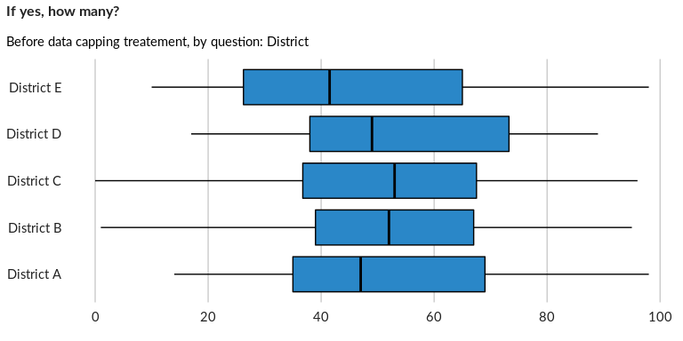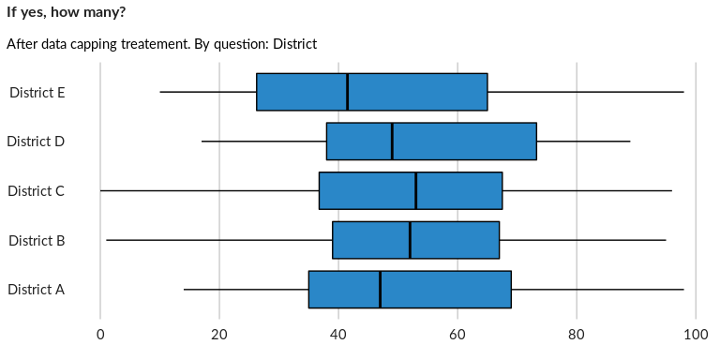

## Are they refugees?

NA

Single choice question

### Tabulation

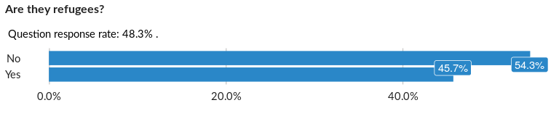

### Cross-tabulations

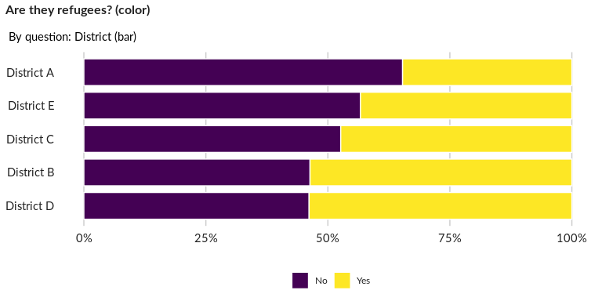

### Significant Associations (chi-square with p value < 5%)

No significant association found for this question…

## If yes, how many additional case numbers are there?

This question provides way to establish relation between different case established together as an household

Numeric question

### Tabulation

Based on the sample design, the average weighted mean response for this question is 48.12

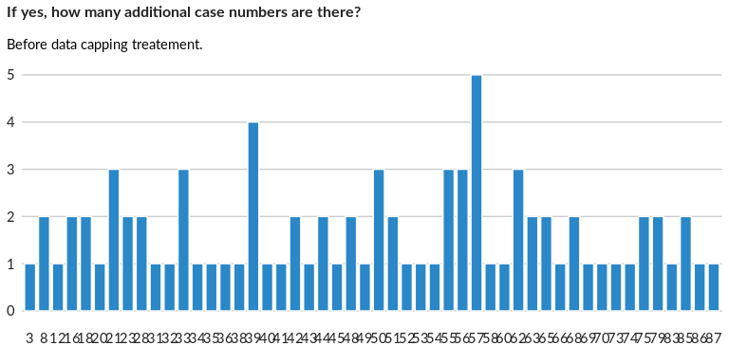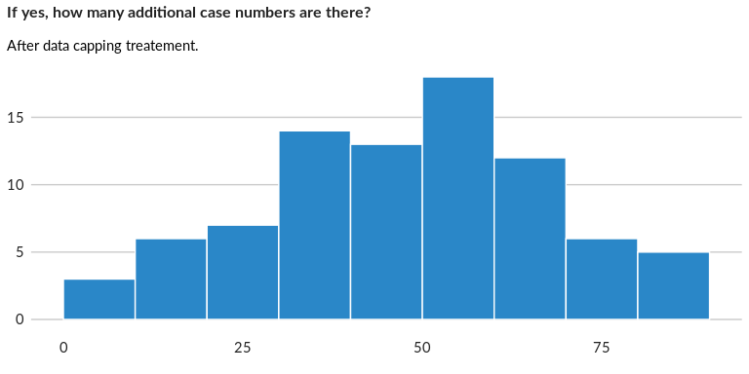

### Analysis of relationship

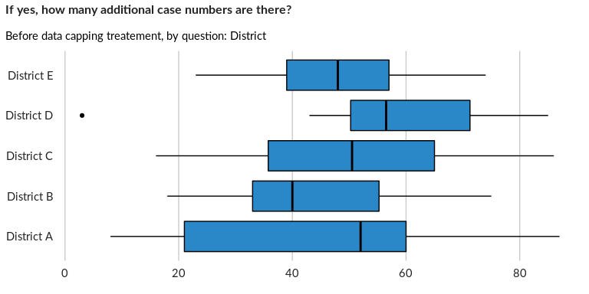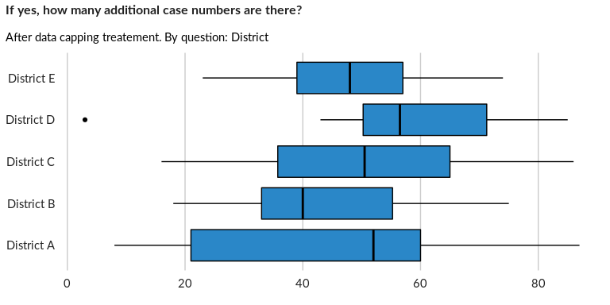

## If no, why are they living with you?

NA

Multiple choice question

### Tabulation

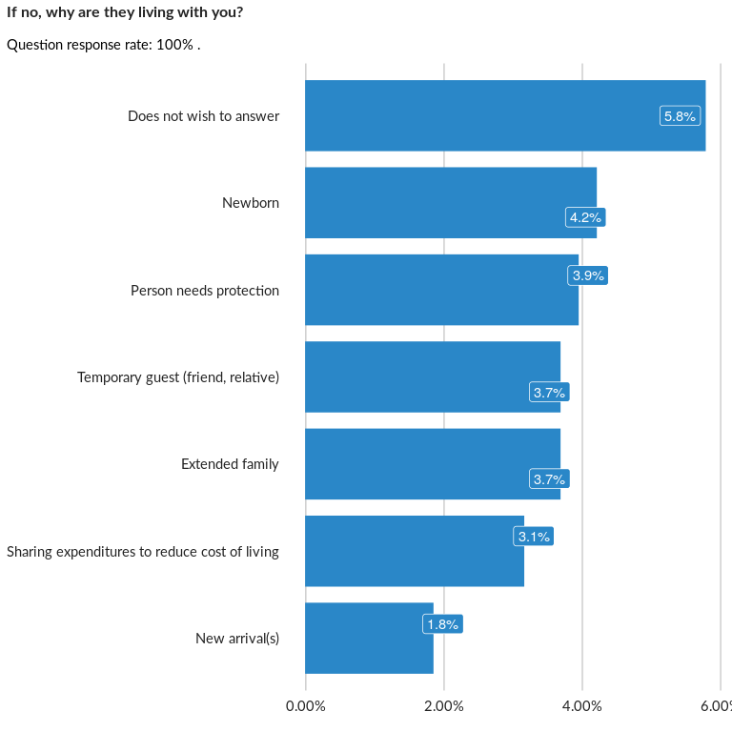

### Analysis of relationship

## Did all household members arrive in CoA at the same time?

NA

Single choice question

### Tabulation

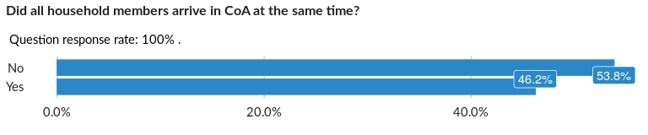

### Cross-tabulations

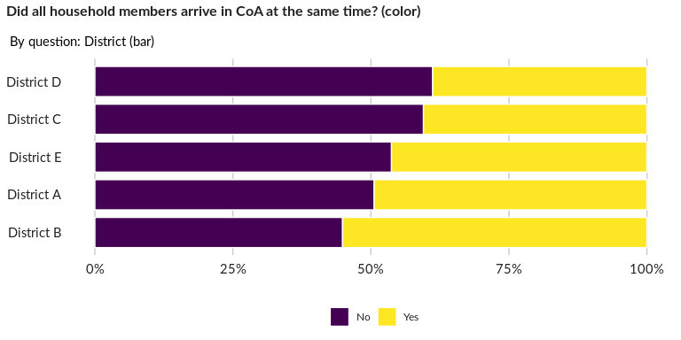

### Significant Associations (chi-square with p value < 5%)

No significant association found for this question…

## When did all household members arrive in CoA?

NA

Date question in data frame: MainDataFrame

## When did the FIRST household members arrive in CoA?

NA

Date question in data frame: MainDataFrame

## When did the LAST household members arrive in CoA?

NA

Date question in data frame: MainDataFrame

## Sex:

NA

Single choice question

### Tabulation

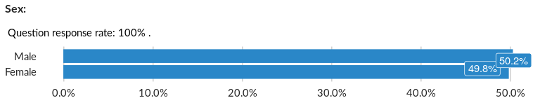

### Cross-tabulations

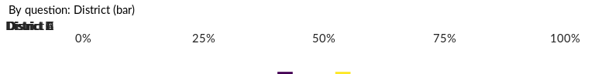

No correlation requested for this question…

## Date of birth:

NA

Date question in data frame: IndBiodata

## Nationality:

NA

Single choice question

### Tabulation

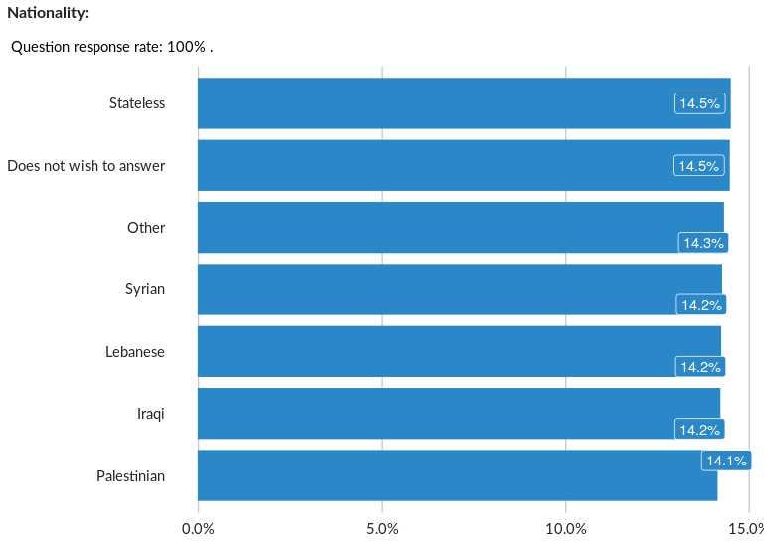

### Cross-tabulations

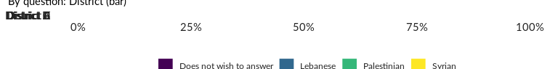

No correlation requested for this question…

## Relationship to PA:

NA

Single choice question

### Tabulation

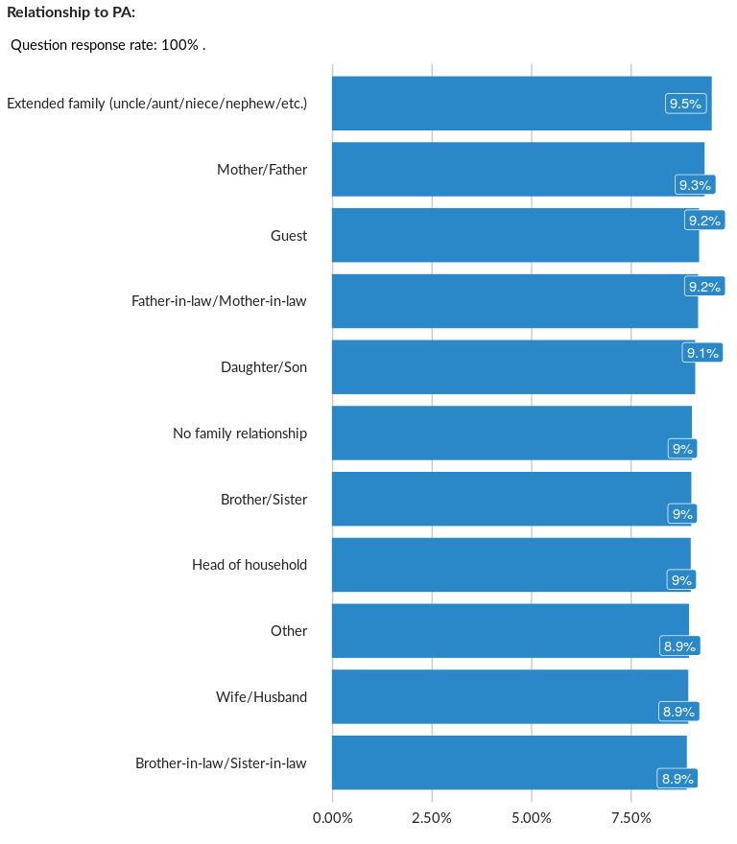

### Cross-tabulations

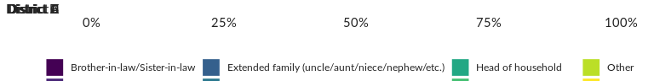

No correlation requested for this question…

## Is someone in this case the child’s legal guardian?

NA

Single choice question

### Tabulation

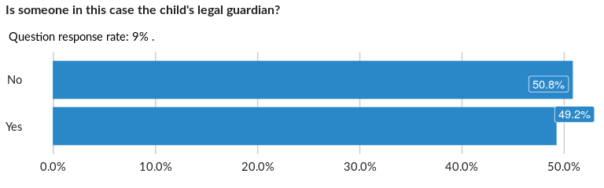

### Cross-tabulations

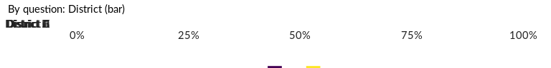

No correlation requested for this question…

## Are any members of the household currently in detention?

Referral notice/hint

Single choice question

### Tabulation

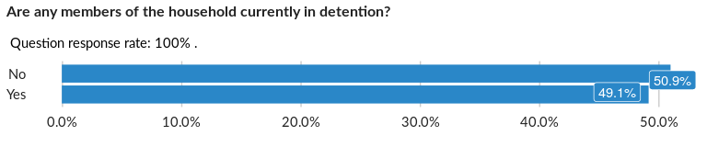

### Cross-tabulations

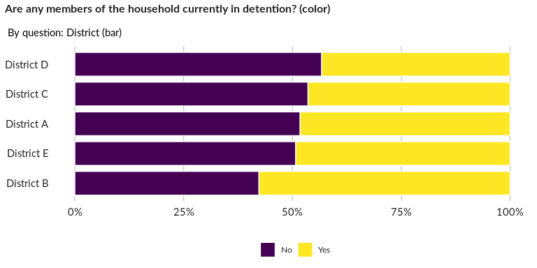

### Significant Associations (chi-square with p value < 5%)

No significant association found for this question…

## Number of minors within household

NA

Numeric question

### Tabulation

Based on the sample design, the average weighted mean response for this question is 9.47

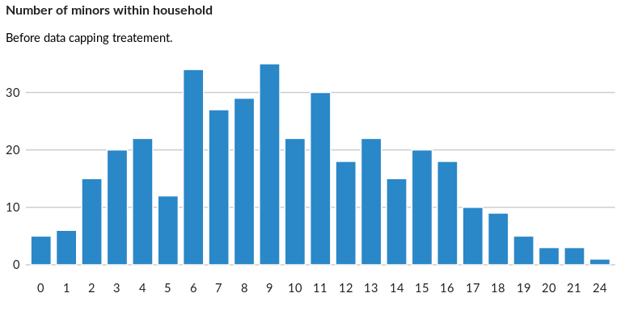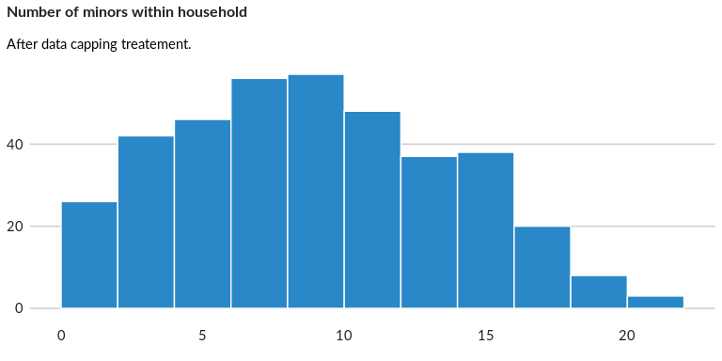

### Analysis of relationship

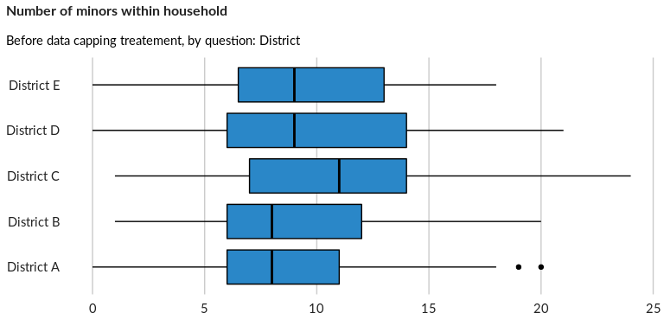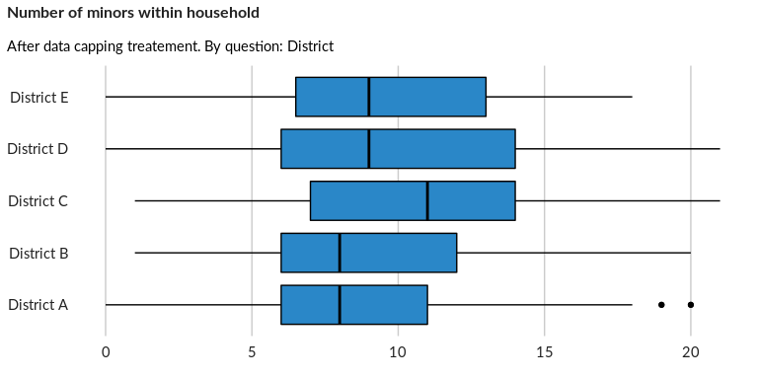

## Number of less than 2 years old kids within household

NA

Numeric question

### Tabulation

Based on the sample design, the average weighted mean response for this question is 1.39

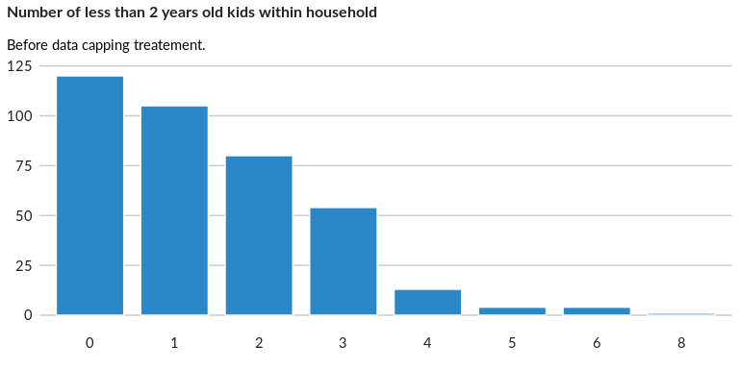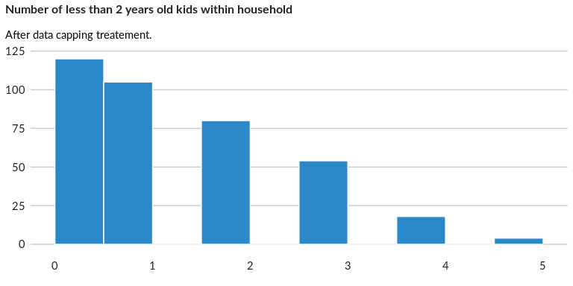

### Analysis of relationship

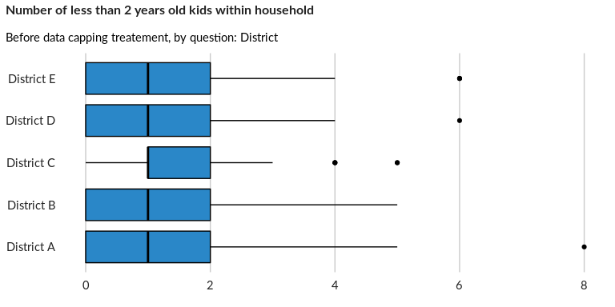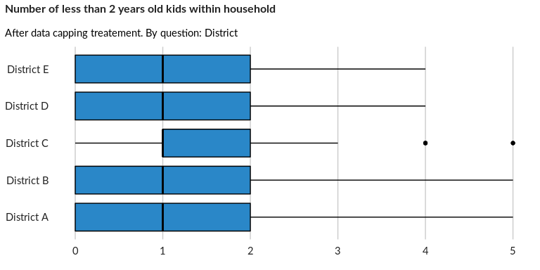

## Number of girls within household - 5-12

NA

Numeric question

### Tabulation

Based on the sample design, the average weighted mean response for this question is 2

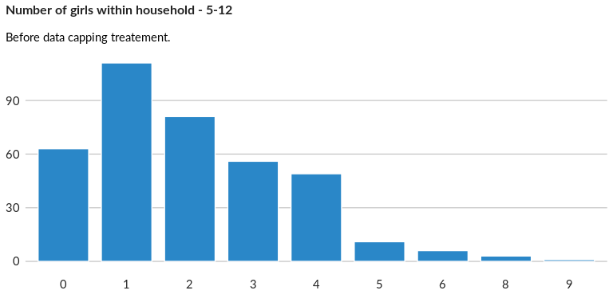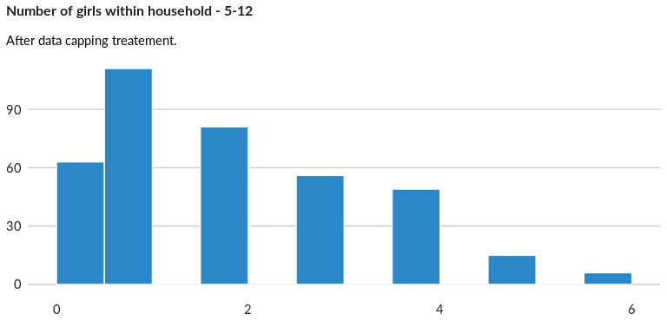

### Analysis of relationship

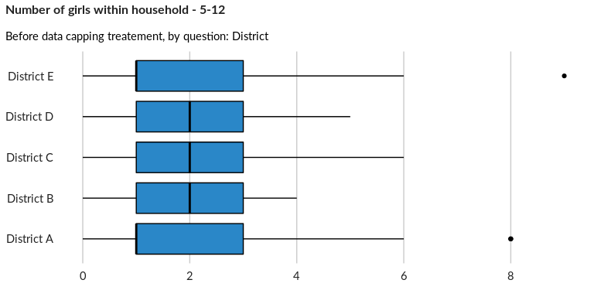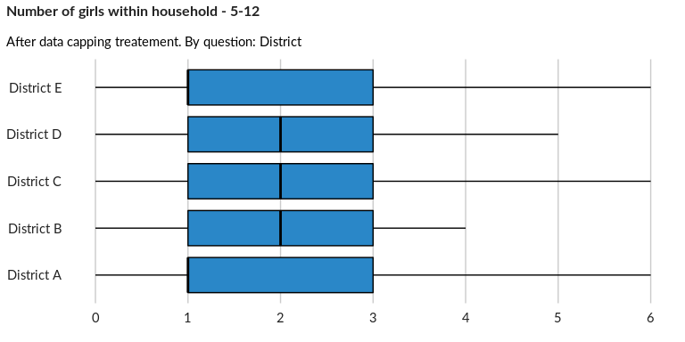

## Number of boys within household - 5-12

NA

Numeric question

### Tabulation

Based on the sample design, the average weighted mean response for this question is 1.88

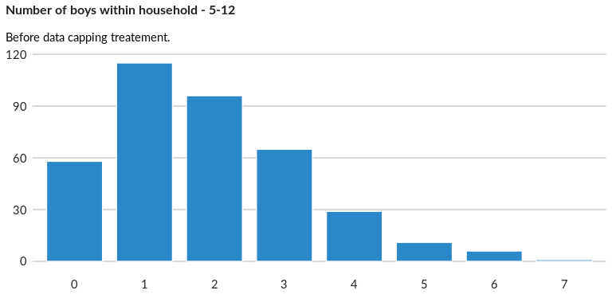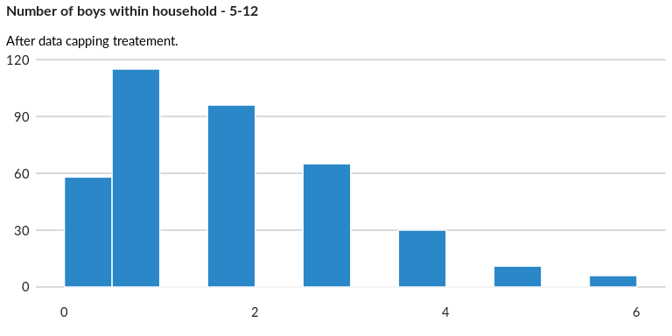

### Analysis of relationship

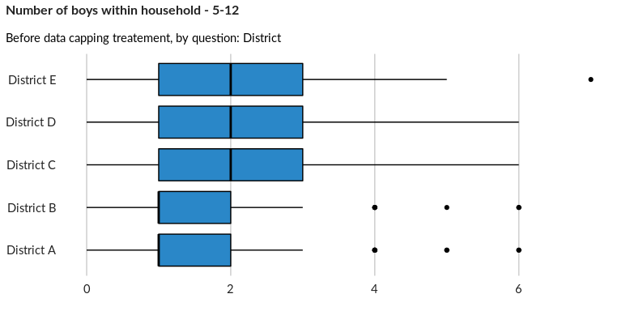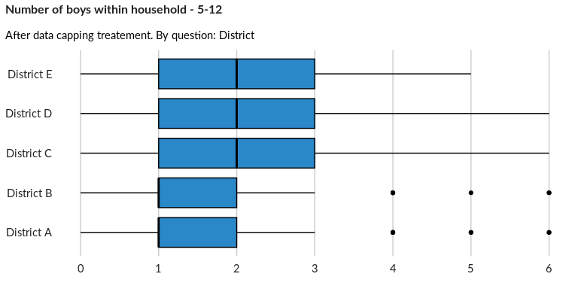

## Number of girls within household - 13-18

NA

Numeric question

### Tabulation

Based on the sample design, the average weighted mean response for this question is 1.55

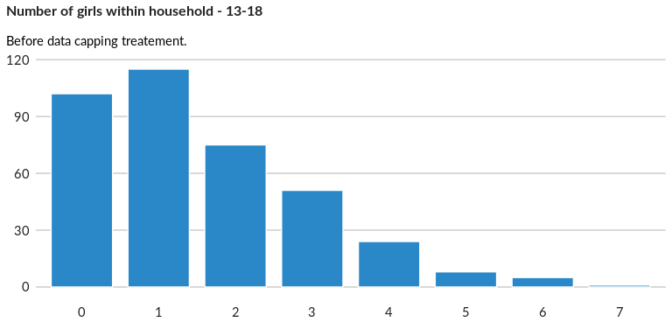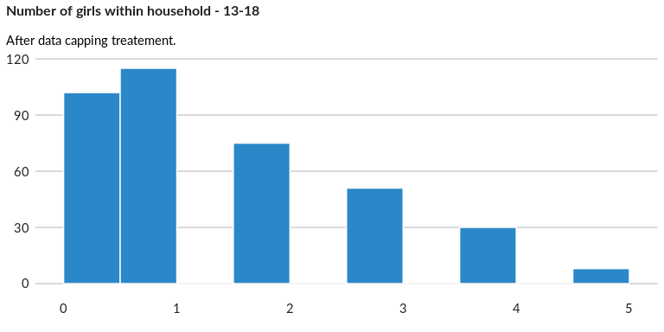

### Analysis of relationship

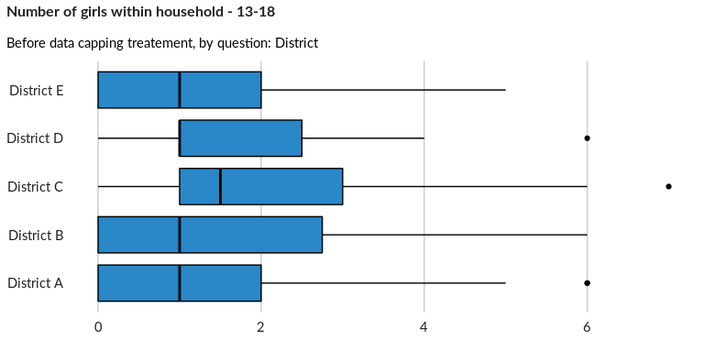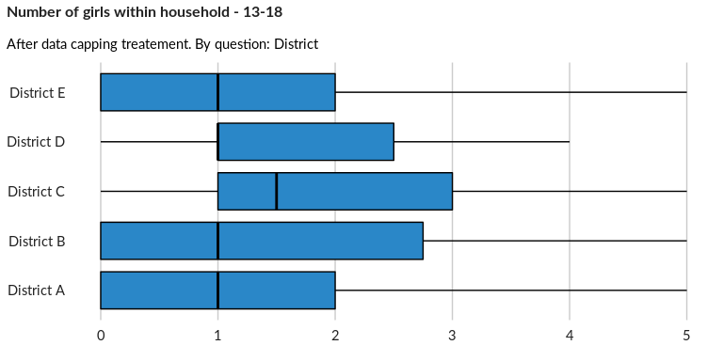

## Number of boys within household - 13-18

NA

Numeric question

### Tabulation

Based on the sample design, the average weighted mean response for this question is 1.55

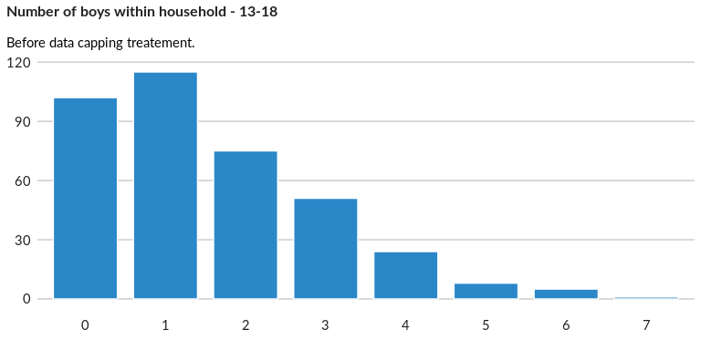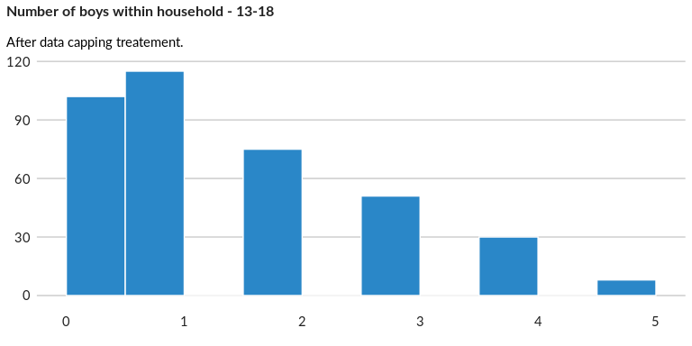

### Analysis of relationship

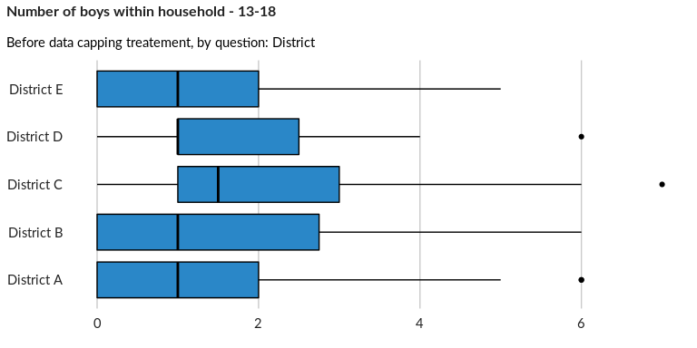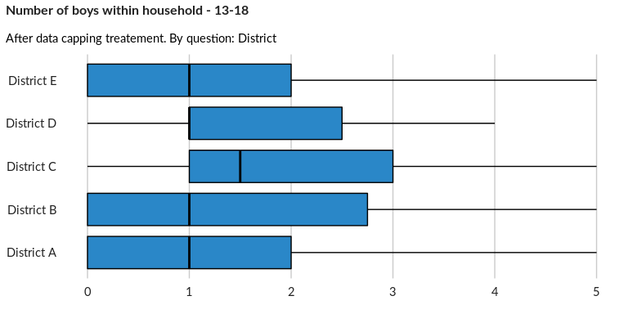

## Household has kids of less than 2 years old

NA

Single choice question

### Tabulation

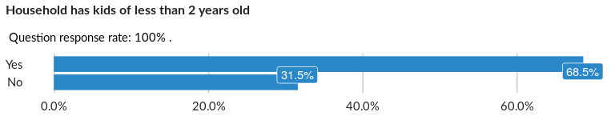

### Cross-tabulations

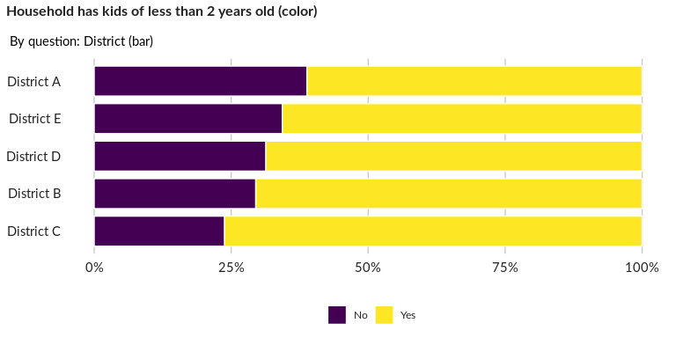

### Significant Associations (chi-square with p value < 5%)

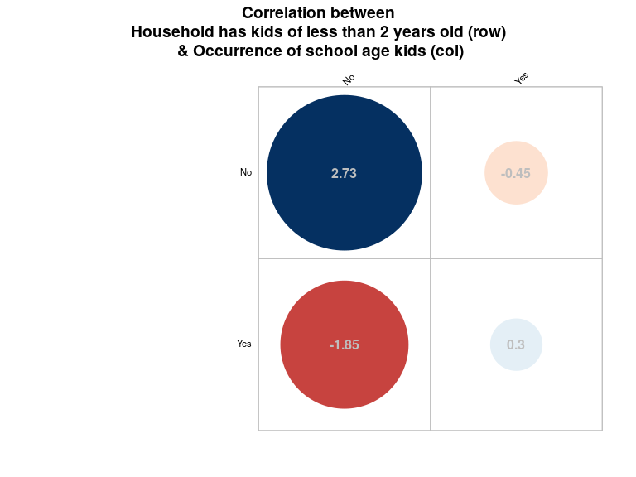

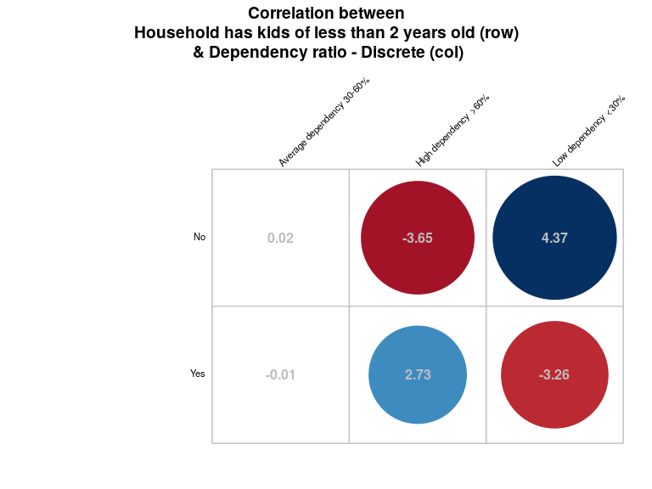

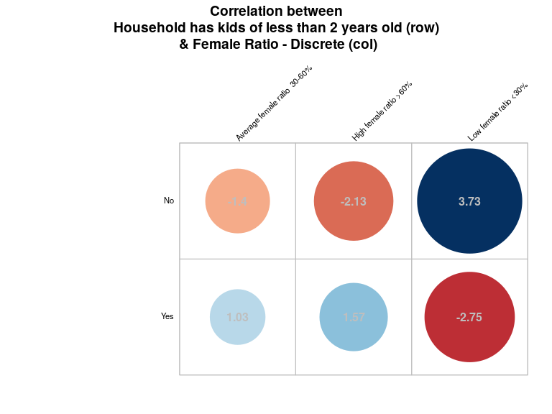

## Number of kids 2-5 years within household

NA

Numeric question

### Tabulation

Based on the sample design, the average weighted mean response for this question is 1.03

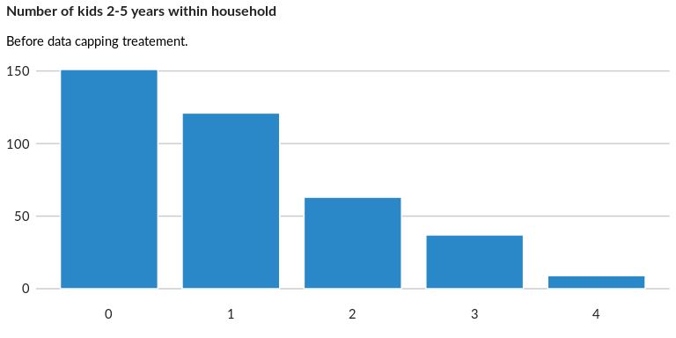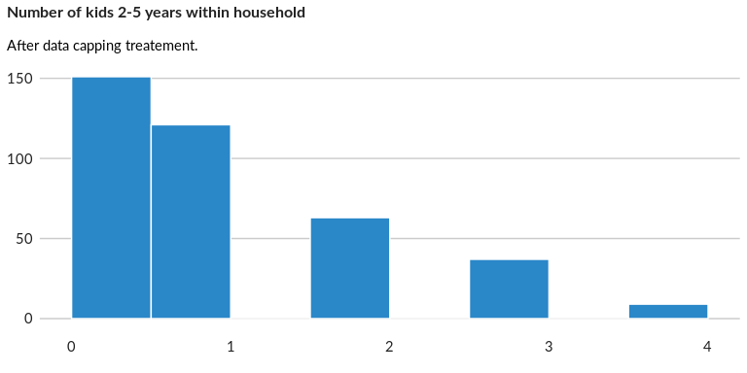

### Analysis of relationship

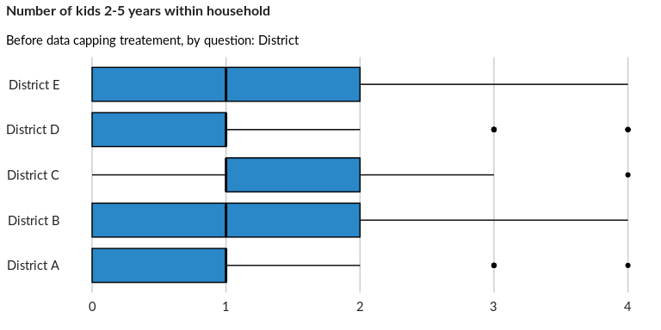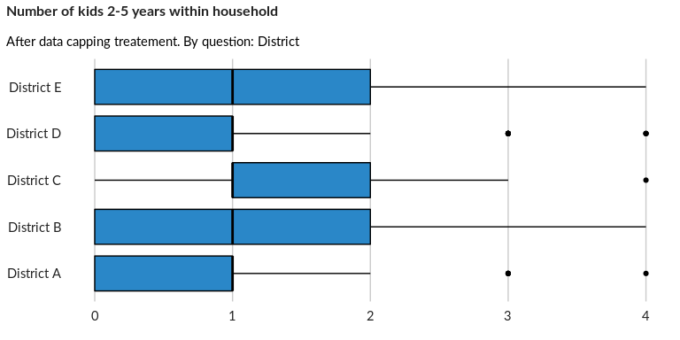

## Number of kids 5-11 years within household

NA

Numeric question

### Tabulation

Based on the sample design, the average weighted mean response for this question is 3.31

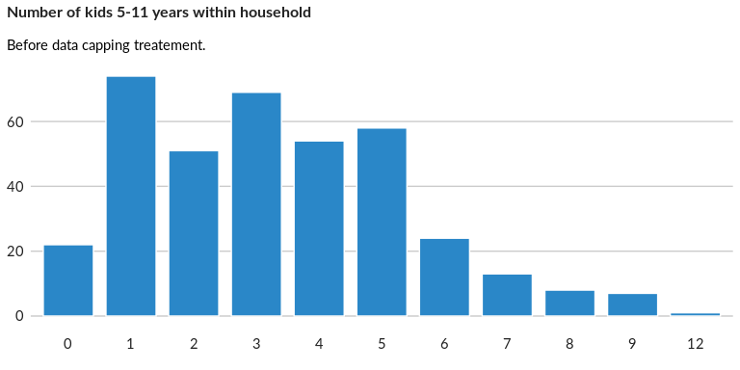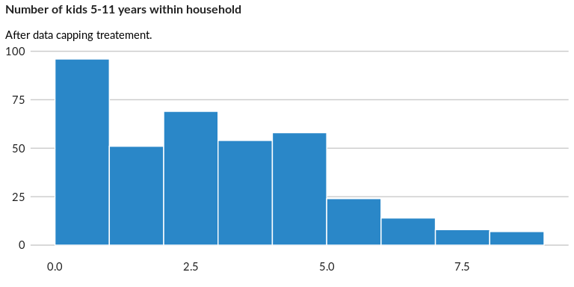

### Analysis of relationship

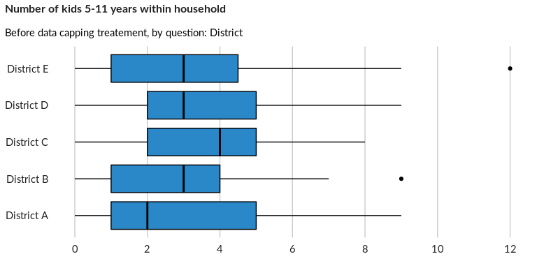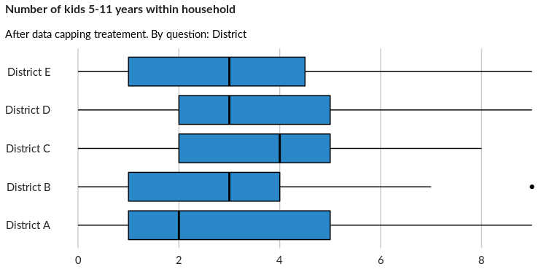

## Number of kids 12-17 years within household

NA

Numeric question

### Tabulation

Based on the sample design, the average weighted mean response for this question is 3.23

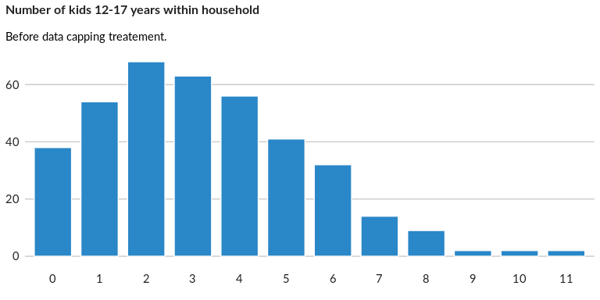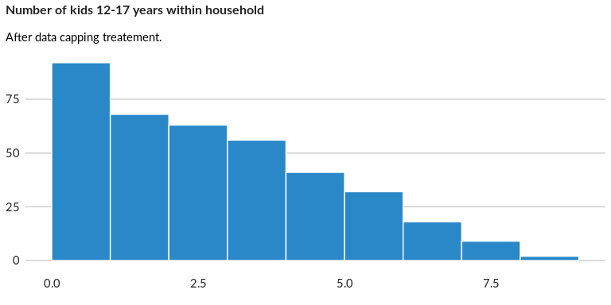

### Analysis of relationship

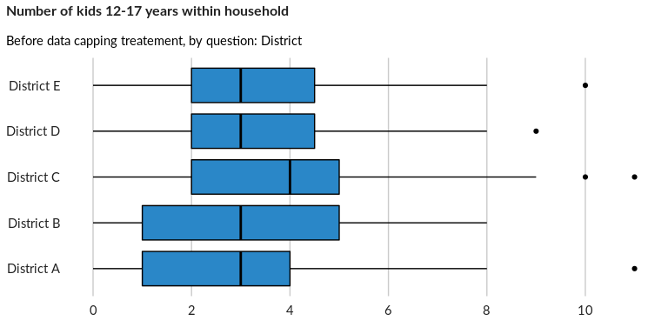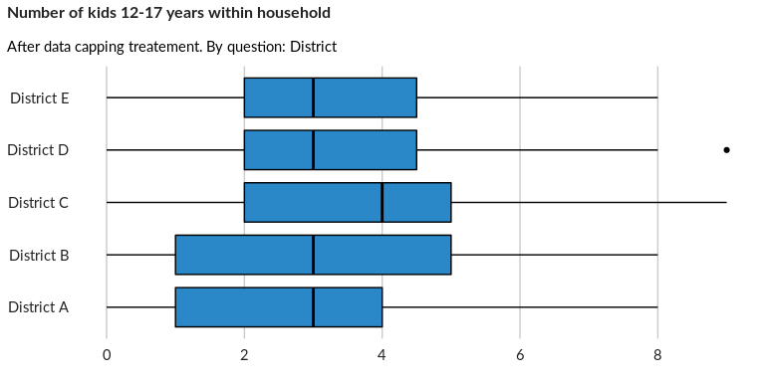

## Number of adults 18-35 years within household

NA

Numeric question

### Tabulation

Based on the sample design, the average weighted mean response for this question is 8.9

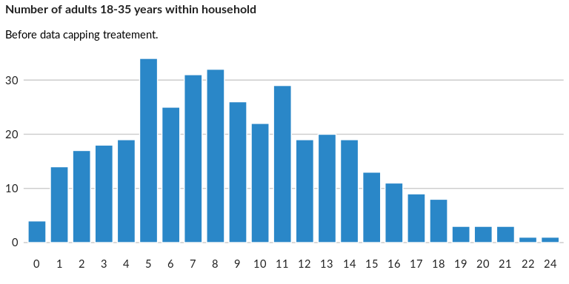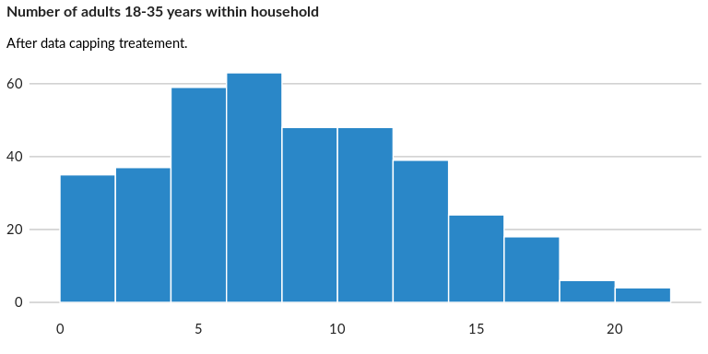

### Analysis of relationship

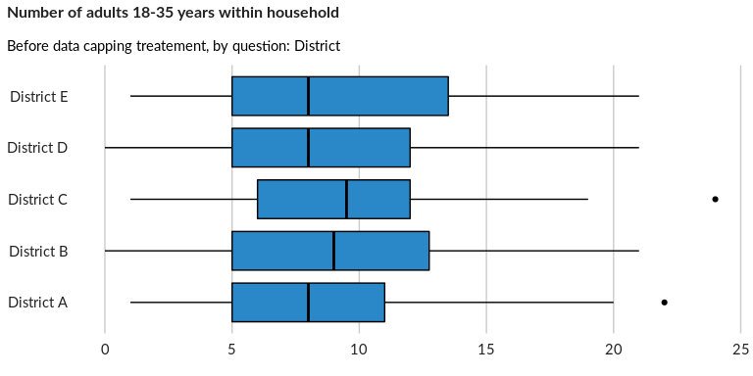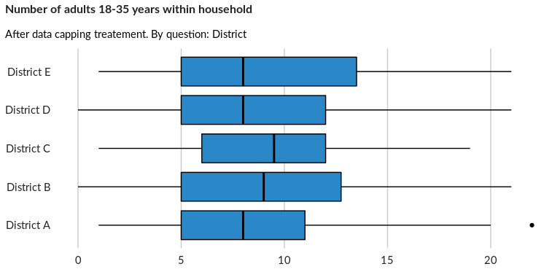

## Number of adults 35-59 years within household

NA

Numeric question

### Tabulation

Based on the sample design, the average weighted mean response for this question is 12.54

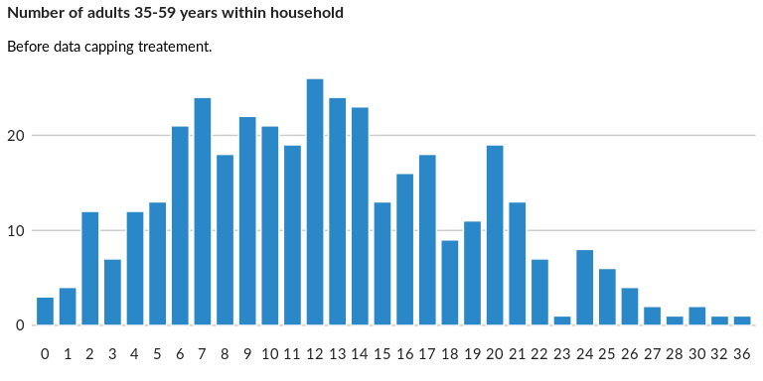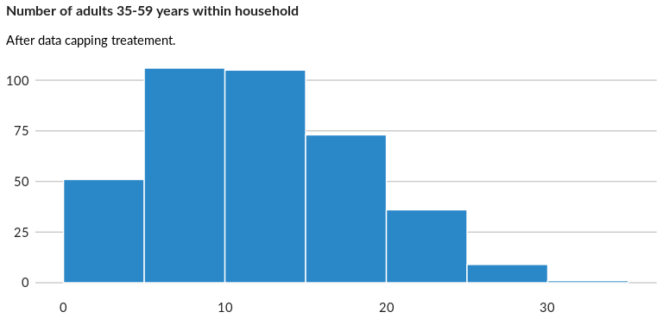

### Analysis of relationship

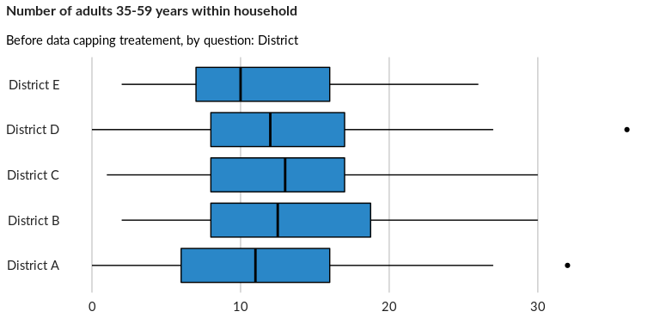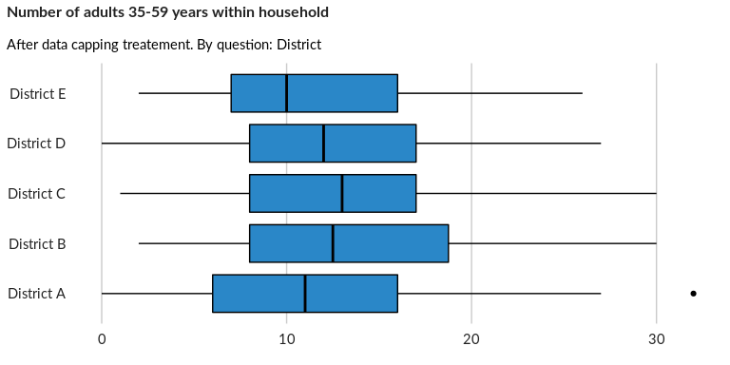

## Number of adults plus de 60 years within household

NA

Numeric question

### Tabulation

Based on the sample design, the average weighted mean response for this question is 20.3

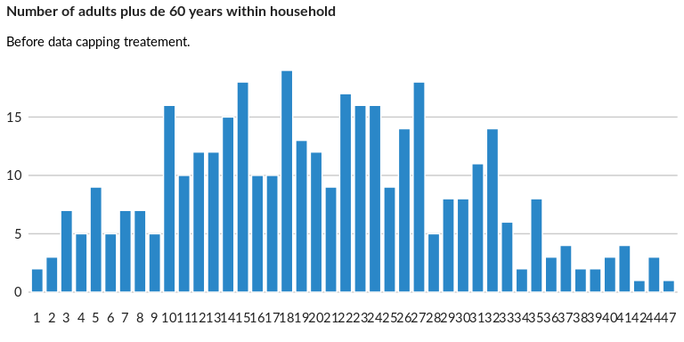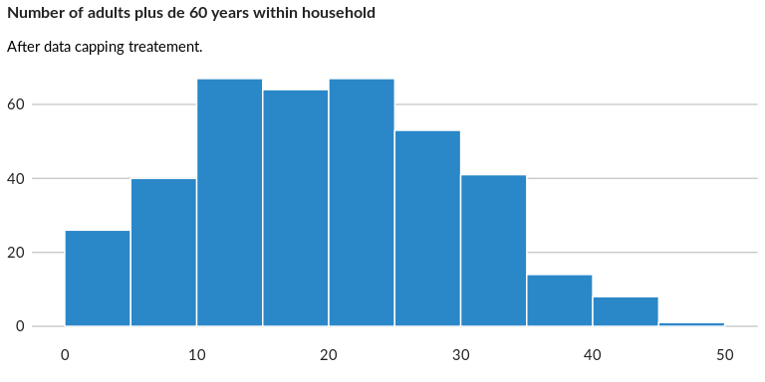

### Analysis of relationship

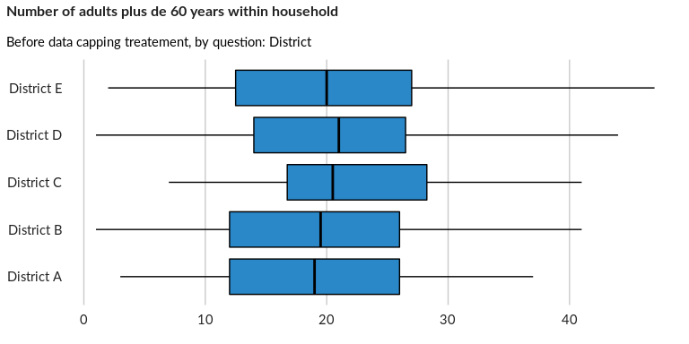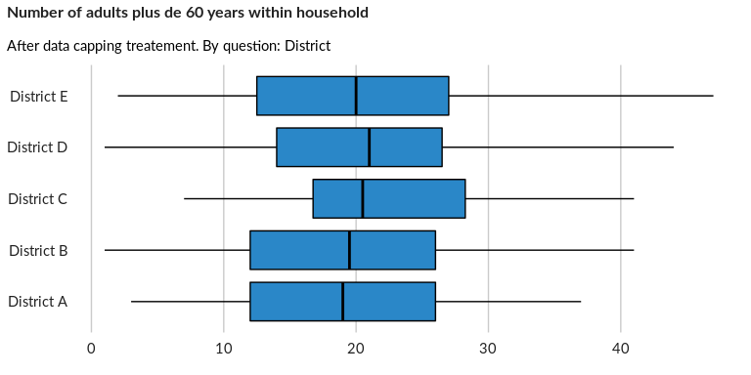

## Occurrence of school age kids

NA

Single choice question

### Tabulation

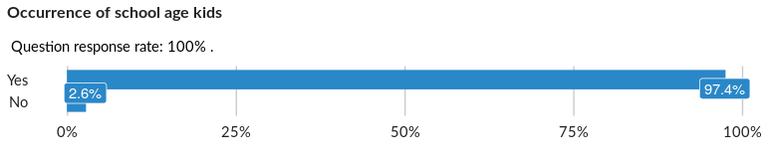

### Cross-tabulations

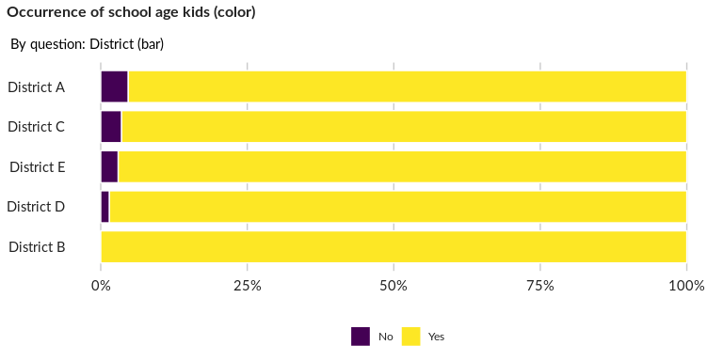

### Significant Associations (chi-square with p value < 5%)

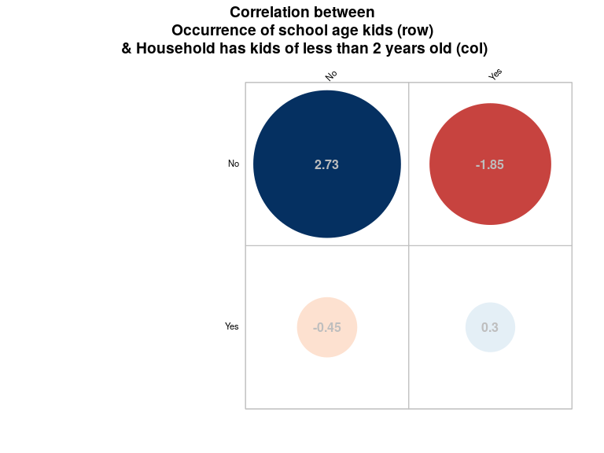

## Dependency ratio

NA

Numeric question

### Tabulation

Based on the sample design, the average weighted mean response for this question is 0.8

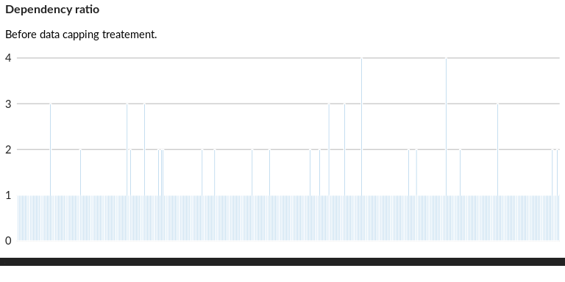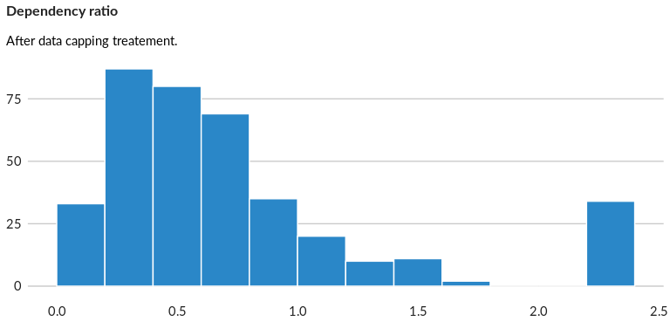

### Analysis of relationship

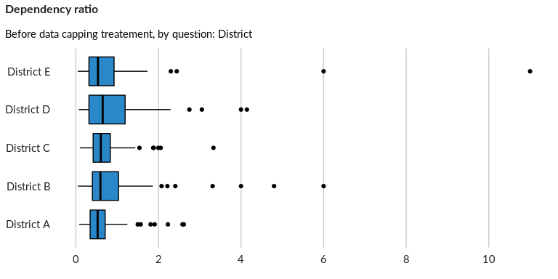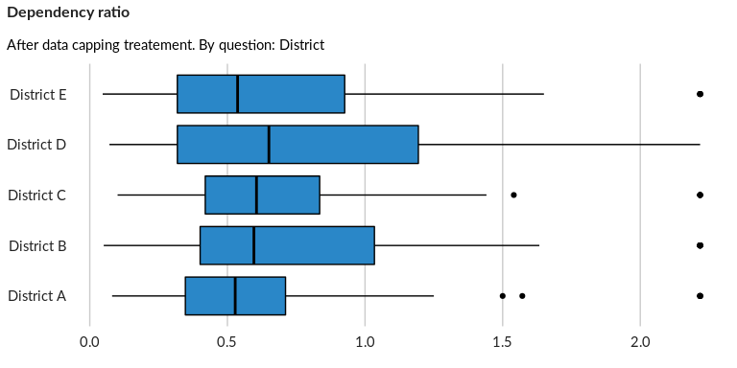

## Dependency ratio - Discrete

NA

Single choice question

### Tabulation

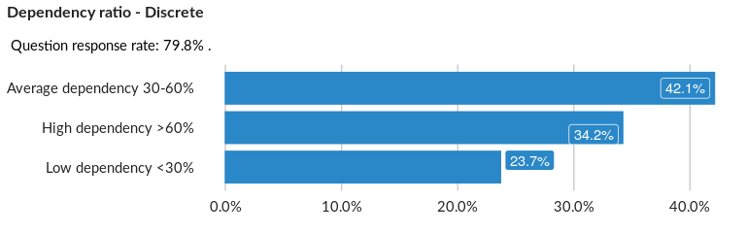

### Cross-tabulations

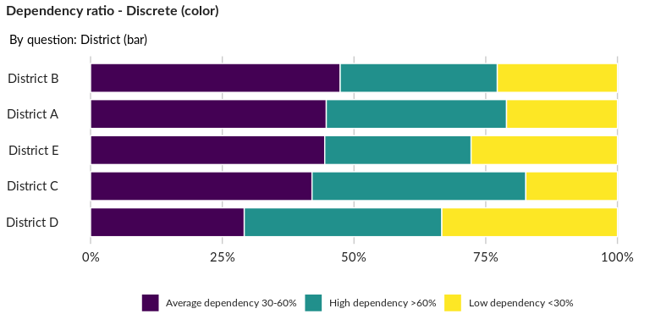

### Significant Associations (chi-square with p value < 5%)

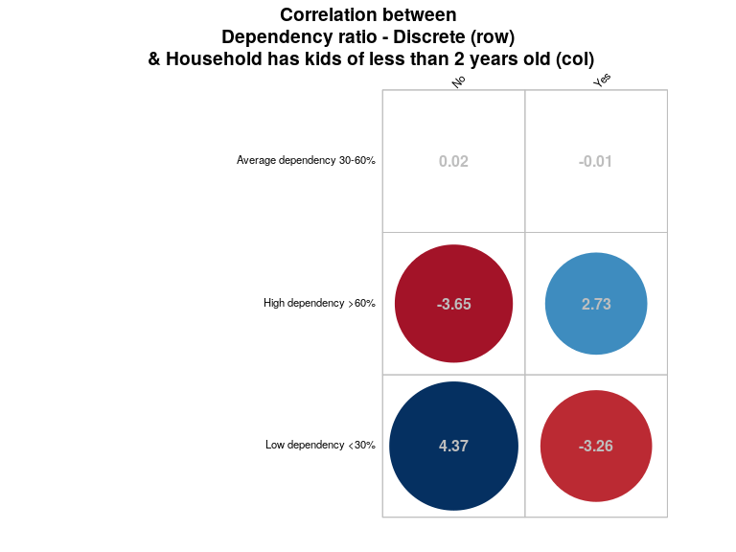

## Female Ratio

NA

Numeric question

### Tabulation

Based on the sample design, the average weighted mean response for this question is 0.7

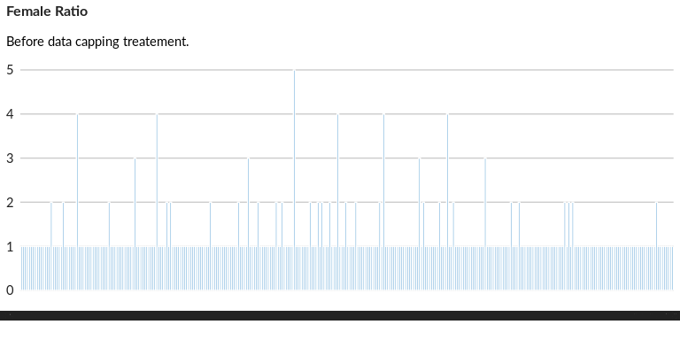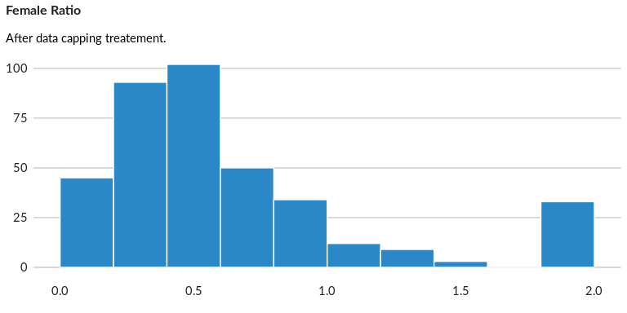

### Analysis of relationship

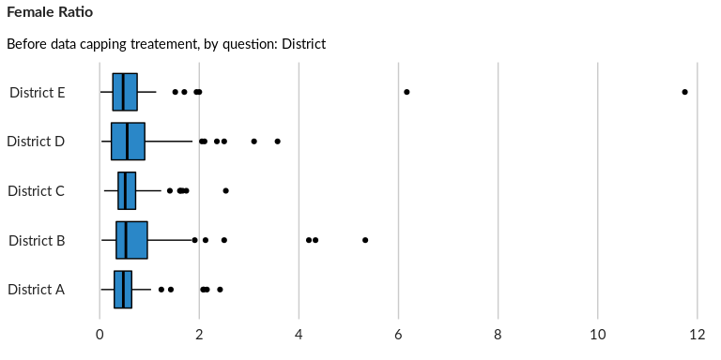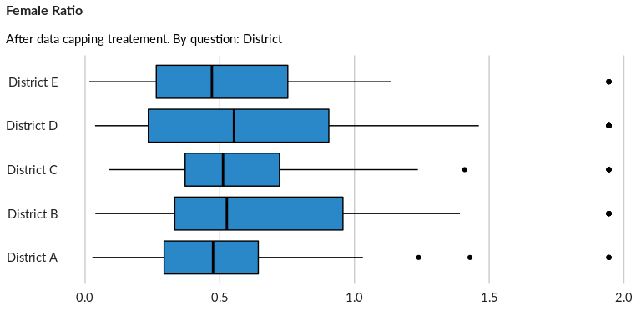

## Female Ratio - Discrete

NA

Single choice question

### Tabulation

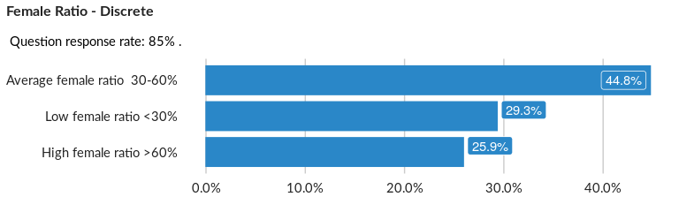

### Cross-tabulations

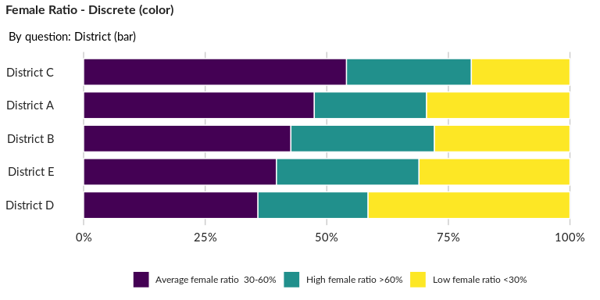

### Significant Associations (chi-square with p value < 5%)

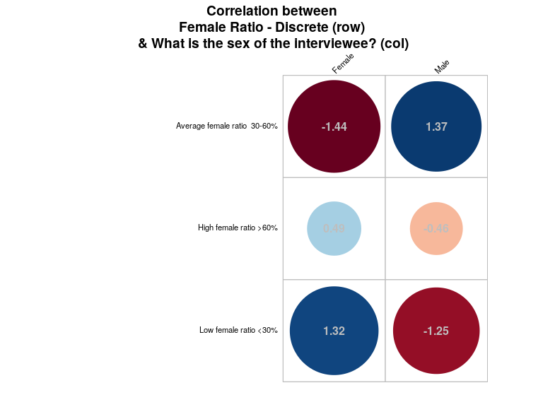

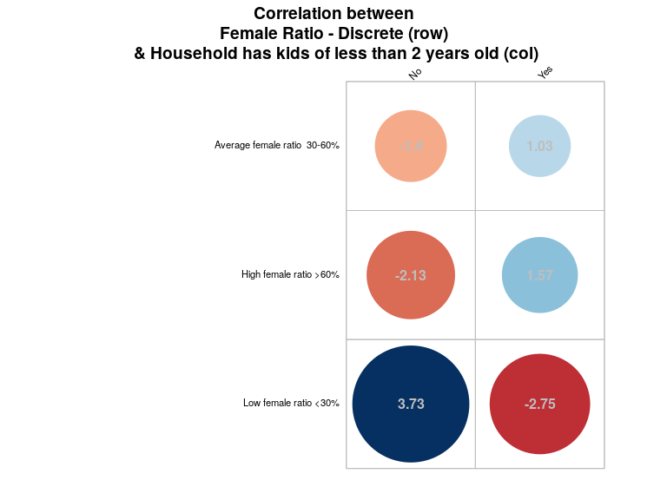

##### Page Break