Data Crunching Report: Documentation- Draft not for distribution.

Generated with [Koboloader](https://unhcr.github.io/koboloadeR/docs)

26 June 2019

Table of Contents

# Introduction

This data crunching report allows to quickly explore the results of the survey that can be regenerated as needed. You can:

* adjust the configuration in the xlsform to break it into chapter;
* configure disaggregation & correlation for each questions;
* revise the data cleansing based on the cleaning log;
* add weight to each observation in order to account for a specific sampling plan;
* append calculated indicators to your data frame.

The objective of this report is to allow to quickly identify potential patterns in your dataset. A quick screening of this initial report should allow to select the most meaningful graphs. A data digest from this initial report can be then reviewed through a **data analysis workshop** where subject matter experts can contribute with qualitative components. When analyzing those representations in a collective setting, you may:

* **Reflect**: question data quality and/or make suggestions to change questions;
* **Interpret**: develop qualitative interpretations of data patterns;
* **Recommend**: develop recommendation in terms of programmatic adjustment;
* **Classify**: order the level of sensitivity for the information;

# Compilation of questions results

## Has anyone in the household experienced difficulties and/or been unable to regis

NA

Single choice question

### Tabulation

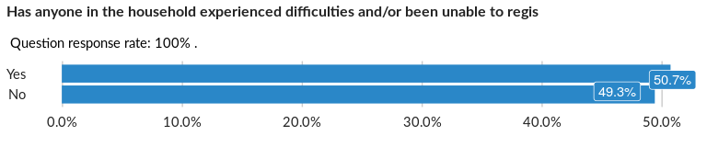

### Cross-tabulations

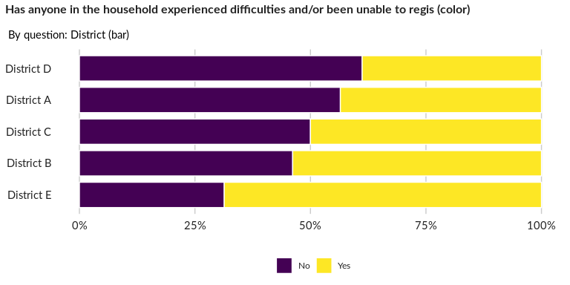

### Significant Associations (chi-square with p value < 5%)

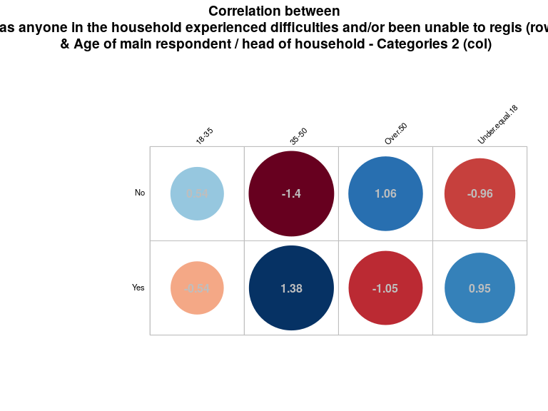

## What difficulties were experienced?

NA

Multiple choice question

### Tabulation

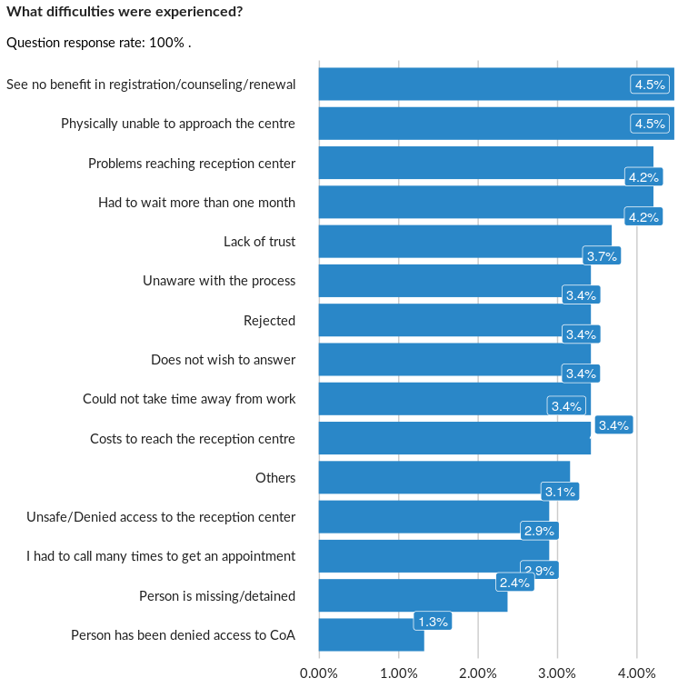

### Analysis of relationship

## Have these difficulties been resolved?

NA

Single choice question

### Tabulation

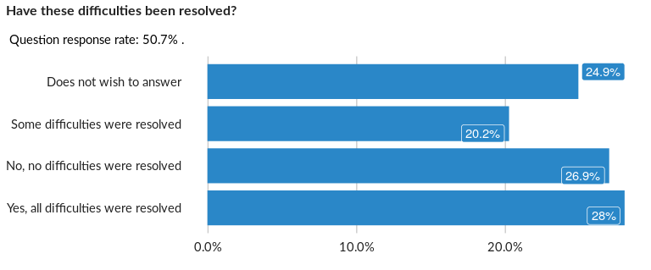

### Cross-tabulations

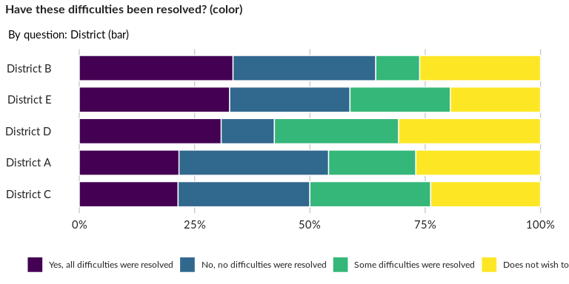

### Significant Associations (chi-square with p value < 5%)

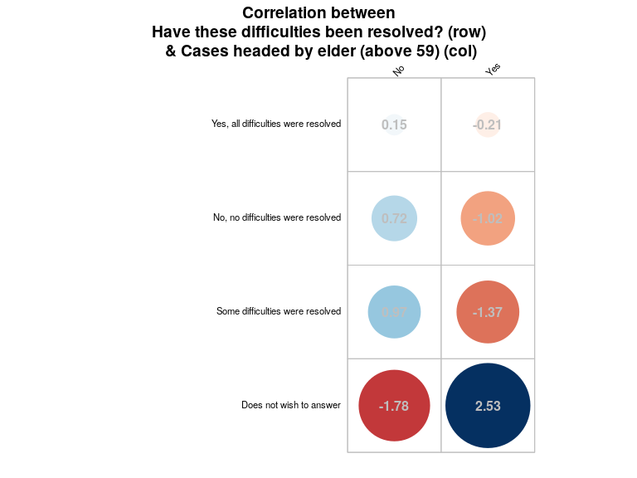

## Are there any household members without regularized legal residency in this coun

NA

Single choice question

### Tabulation

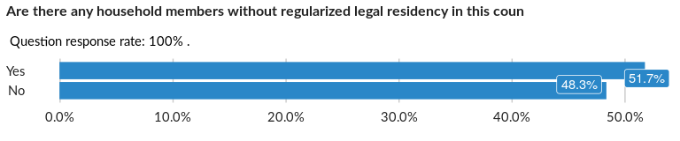

### Cross-tabulations

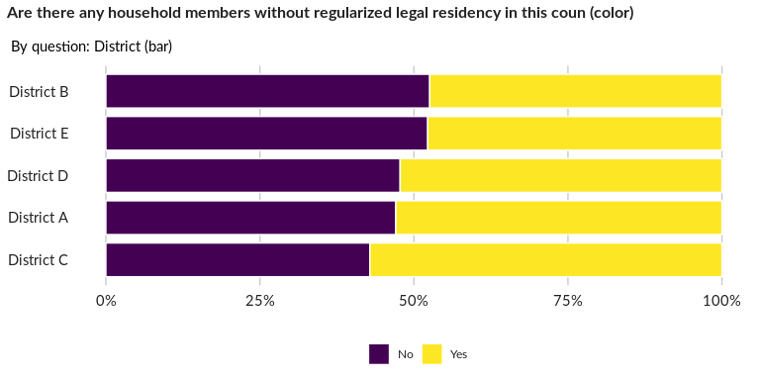

### Significant Associations (chi-square with p value < 5%)

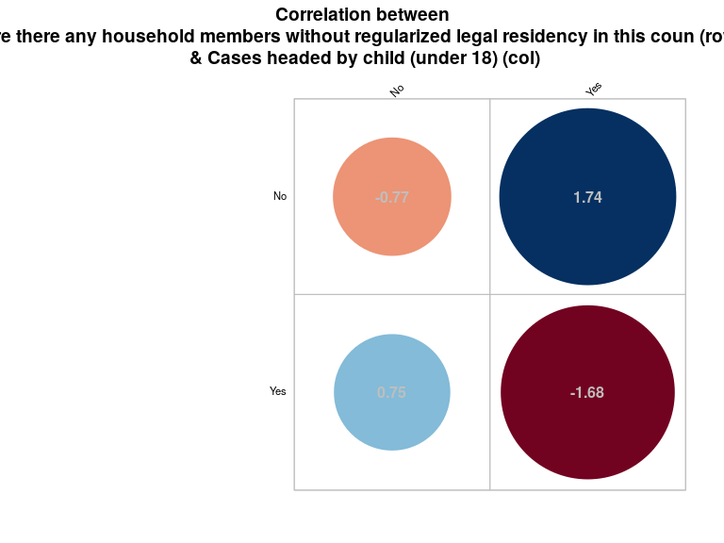

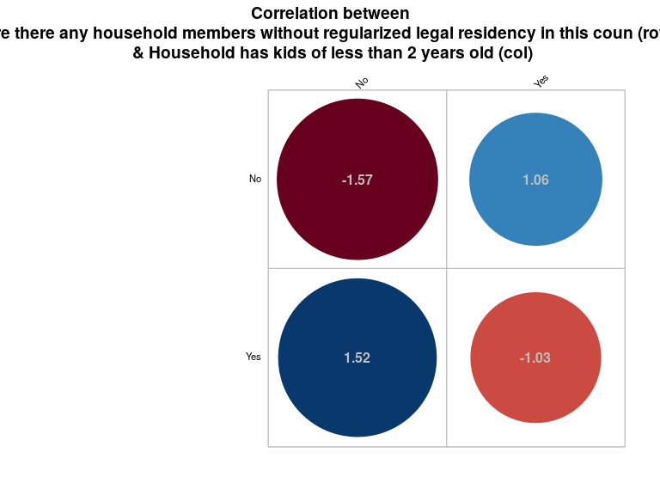

## Reasons for illegal residence:

NA

Multiple choice question

### Tabulation

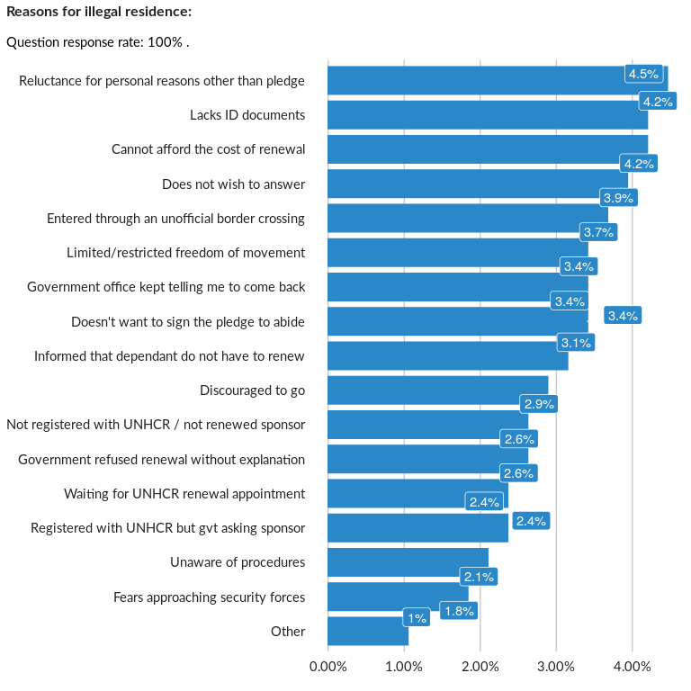

### Analysis of relationship

## Were any children in the household born after leaving CoO?

NA

Single choice question

### Tabulation

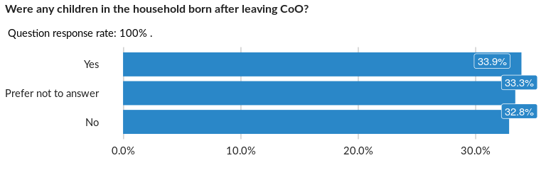

### Cross-tabulations

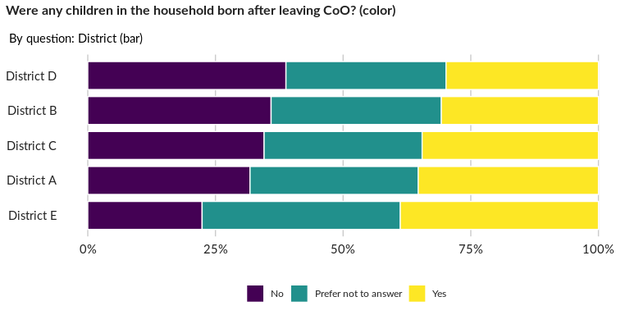

### Significant Associations (chi-square with p value < 5%)

No significant association found for this question…

## If so, how many?

NA

Numeric question

### Tabulation

No responses recorded for this question...

No responses recorded for this question...

## How many of them have birth certificates?

NA

Numeric question

### Tabulation

No responses recorded for this question...

No responses recorded for this question...

## What document do you have to prove the birth of your child? (select only the hig

NA

Single choice question

cat(“No responses or only one modality recorded for this question…”)

```

## Do any members of the household own property in CoA?

NA

Single choice question

### Tabulation

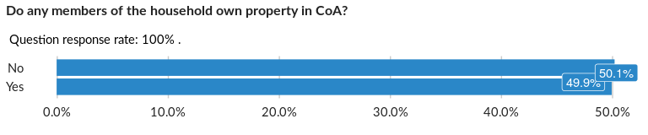

### Cross-tabulations

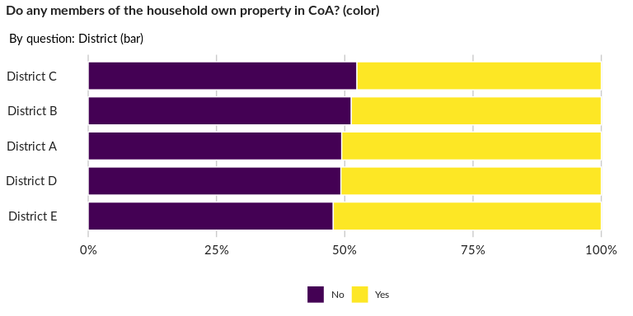

### Significant Associations (chi-square with p value < 5%)

No significant association found for this question…

## What is the status of the land on which you resided in Syria?

NA

Single choice question

### Tabulation

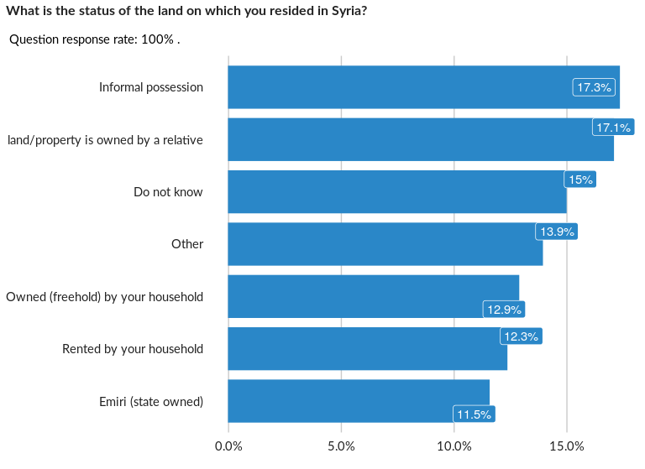

### Cross-tabulations

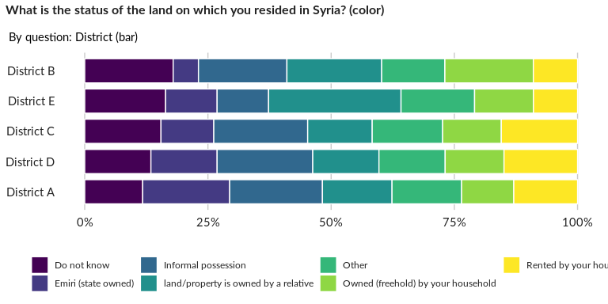

### Significant Associations (chi-square with p value < 5%)

No significant association found for this question…

## What type of documentation did you have proving ownership or right of usage of t

NA

Single choice question

### Tabulation

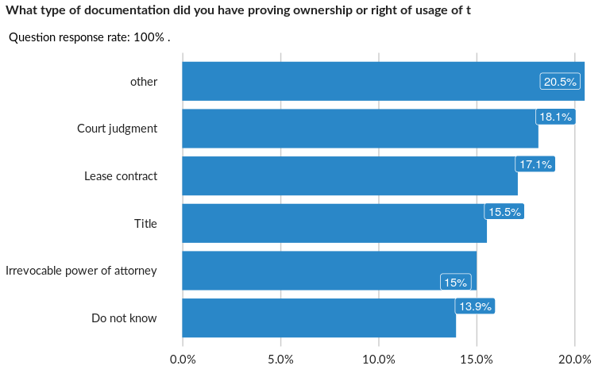

### Cross-tabulations

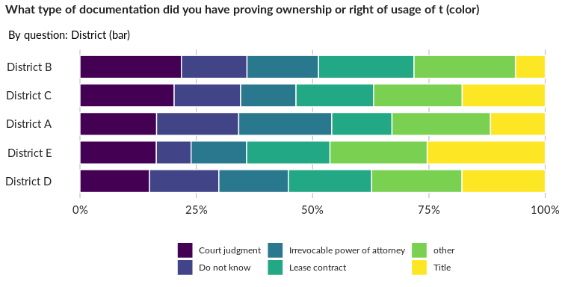

### Significant Associations (chi-square with p value < 5%)

No significant association found for this question…

## What is the current status of this land?

NA

Single choice question

### Tabulation

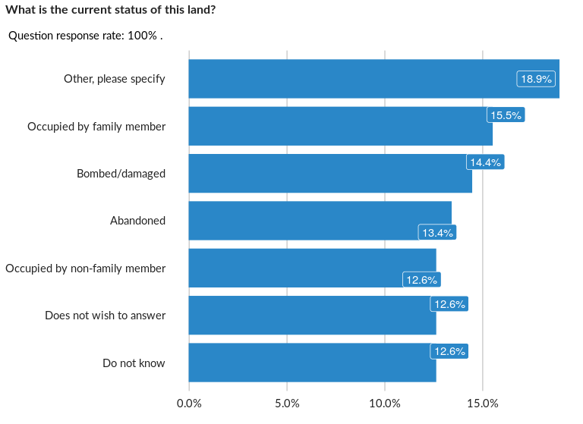

### Cross-tabulations

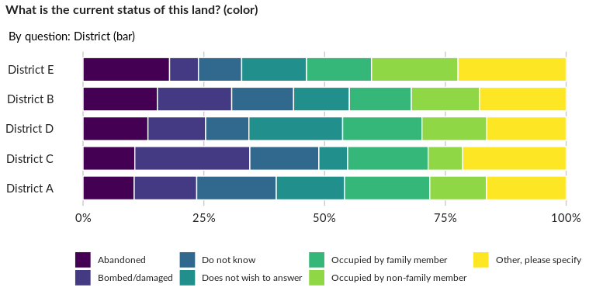

### Significant Associations (chi-square with p value < 5%)

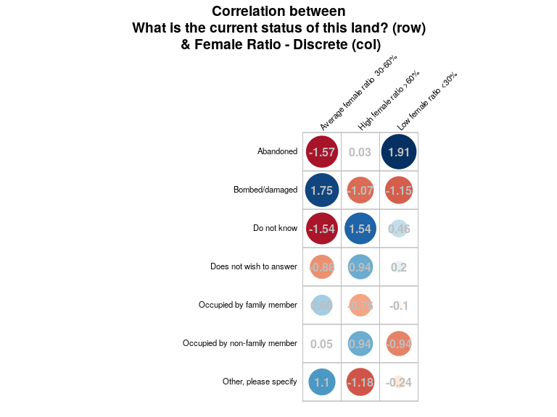

##### Page Break