Data Crunching Report: Education- Draft not for distribution.

Generated with [Koboloader](https://unhcr.github.io/koboloadeR/docs)

26 June 2019

Table of Contents

# Introduction

This data crunching report allows to quickly explore the results of the survey that can be regenerated as needed. You can:

* adjust the configuration in the xlsform to break it into chapter;
* configure disaggregation & correlation for each questions;
* revise the data cleansing based on the cleaning log;
* add weight to each observation in order to account for a specific sampling plan;
* append calculated indicators to your data frame.

The objective of this report is to allow to quickly identify potential patterns in your dataset. A quick screening of this initial report should allow to select the most meaningful graphs. A data digest from this initial report can be then reviewed through a **data analysis workshop** where subject matter experts can contribute with qualitative components. When analyzing those representations in a collective setting, you may:

* **Reflect**: question data quality and/or make suggestions to change questions;
* **Interpret**: develop qualitative interpretations of data patterns;
* **Recommend**: develop recommendation in terms of programmatic adjustment;
* **Classify**: order the level of sensitivity for the information;

# Compilation of questions results

## During the current school year (201x-xx), did Individual attend any formal/pub

NA

Single choice question

### Tabulation

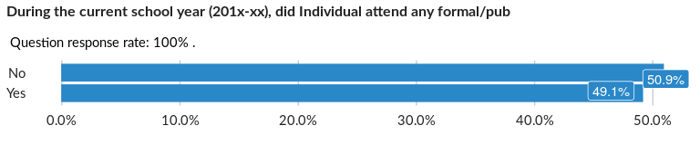

### Cross-tabulations

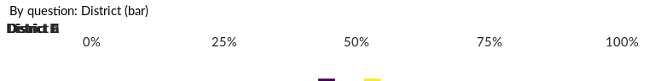

No correlation requested for this question…

## If Individual did not attend any school, what are the reasons?

NA

Multiple choice question

### Tabulation

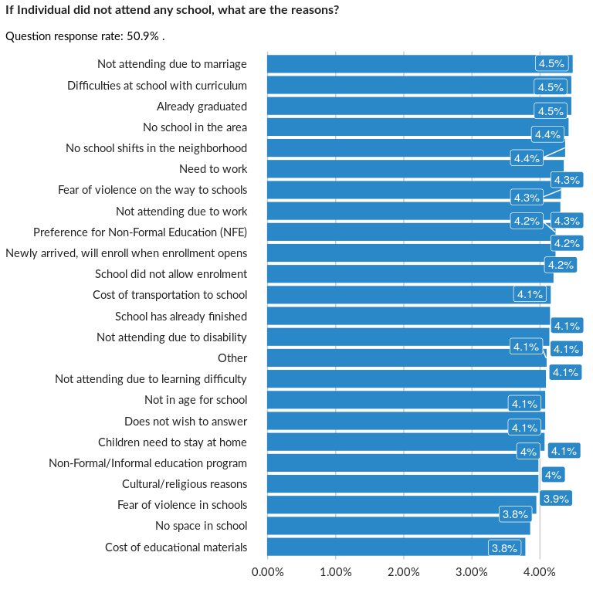

### Analysis of relationship

## During the current school year (2017/18), which level and grade was/is ${FirstNa

NA

Single choice question

### Tabulation

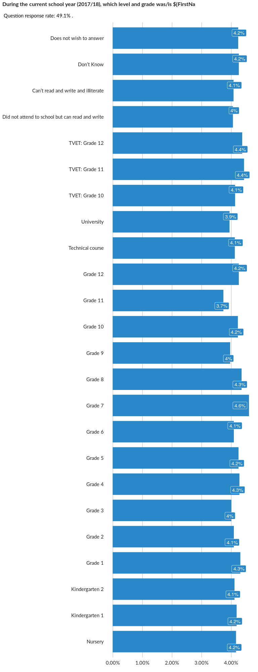

### Cross-tabulations

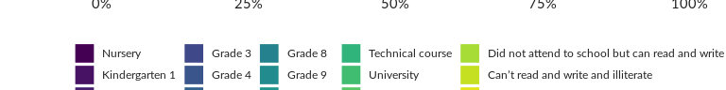

No correlation requested for this question…

## If out of school, please specify number of years out of school:

NA

Single choice question

### Tabulation

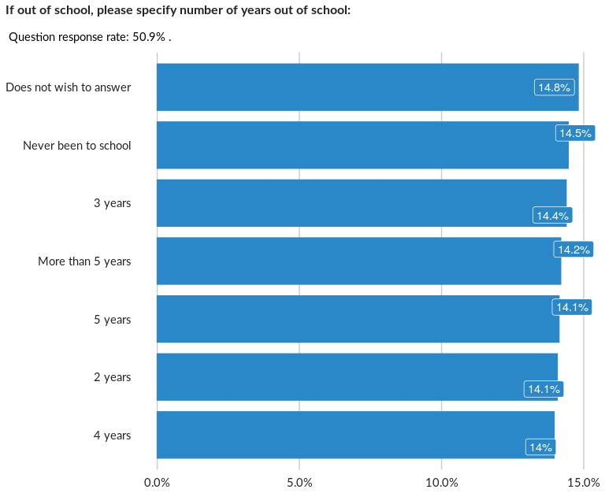

### Cross-tabulations

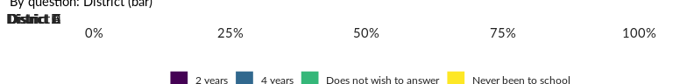

No correlation requested for this question…

## Have any housebold members received any education or training on hygiene over th

NA

Single choice question

### Tabulation

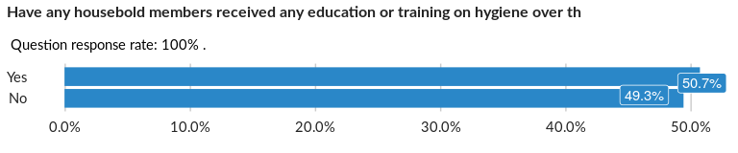

### Cross-tabulations

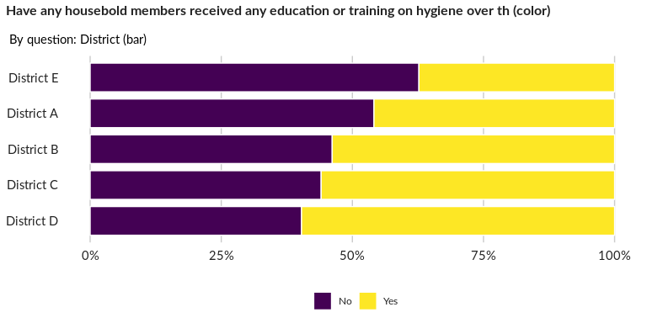

### Significant Associations (chi-square with p value < 5%)

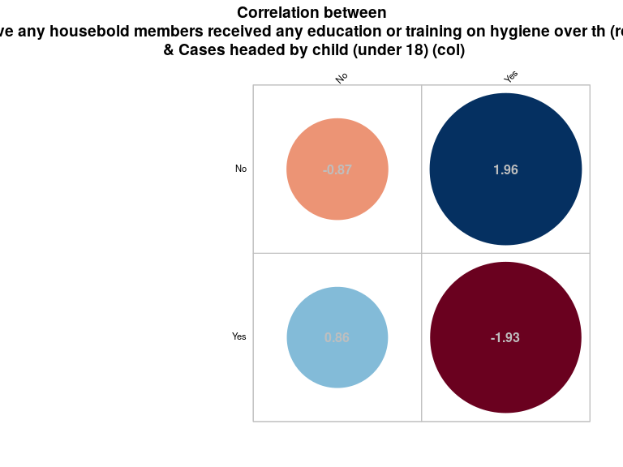

##### Page Break