Data Crunching Report: Employment_and_livelihood- Draft not for distribution.

Generated with [Koboloader](https://unhcr.github.io/koboloadeR/docs)

26 June 2019

Table of Contents

# Introduction

This data crunching report allows to quickly explore the results of the survey that can be regenerated as needed. You can:

* adjust the configuration in the xlsform to break it into chapter;
* configure disaggregation & correlation for each questions;
* revise the data cleansing based on the cleaning log;
* add weight to each observation in order to account for a specific sampling plan;
* append calculated indicators to your data frame.

The objective of this report is to allow to quickly identify potential patterns in your dataset. A quick screening of this initial report should allow to select the most meaningful graphs. A data digest from this initial report can be then reviewed through a **data analysis workshop** where subject matter experts can contribute with qualitative components. When analyzing those representations in a collective setting, you may:

* **Reflect**: question data quality and/or make suggestions to change questions;
* **Interpret**: develop qualitative interpretations of data patterns;
* **Recommend**: develop recommendation in terms of programmatic adjustment;
* **Classify**: order the level of sensitivity for the information;

# Compilation of questions results

## In the past 30 days, did Individual work?

If yes, did you get paid? What did you receive? pay or profit (including in-kind payments, rent, or other profit)

Single choice question

### Tabulation

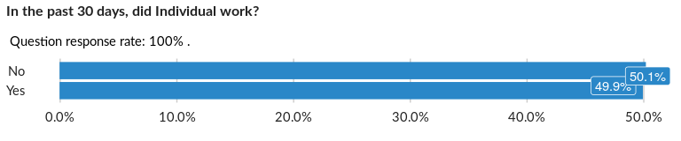

### Cross-tabulations

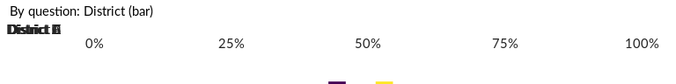

No correlation requested for this question…

## Was this work regular?

NA

Single choice question

### Tabulation

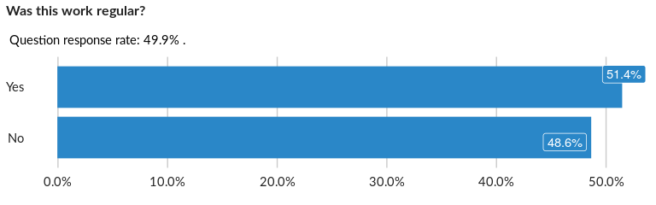

### Cross-tabulations

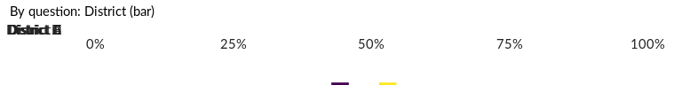

No correlation requested for this question…

## Does Individual usually work in more than one job?

NA

Single choice question

### Tabulation

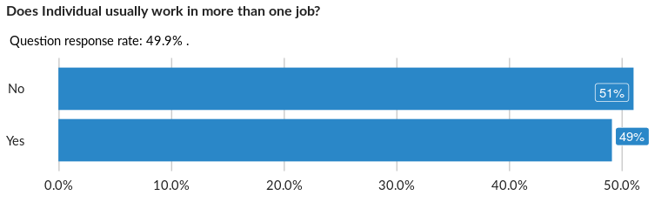

### Cross-tabulations

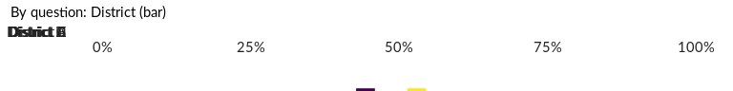

No correlation requested for this question…

## How many days did Individual work during the past 30 days for all jobs?

NA

Numeric question

### Tabulation

Based on the sample design, the average weighted mean response for this question is 14.96

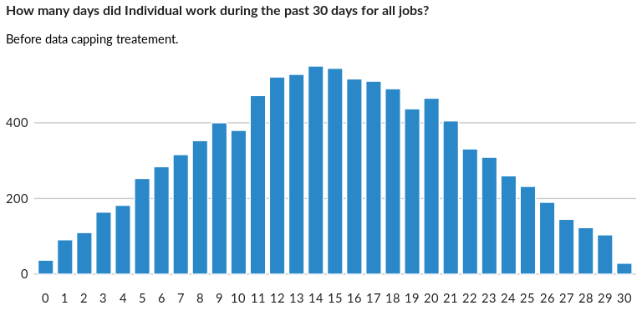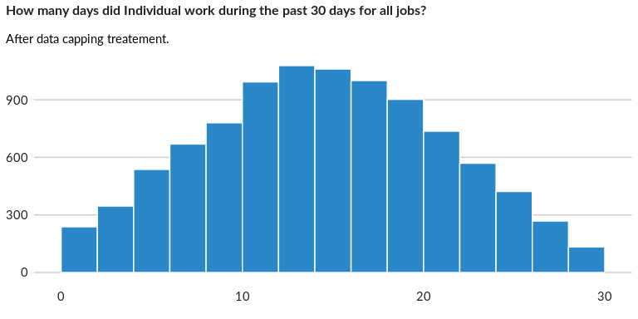

### Analysis of relationship

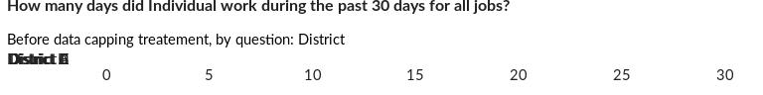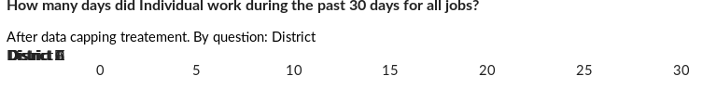

## During the past seven days, did Individual work in return for pay or profit f

NA

Single choice question

### Tabulation

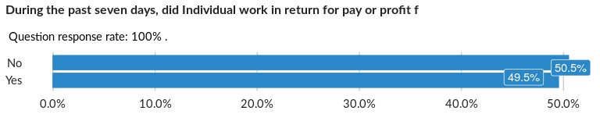

### Cross-tabulations

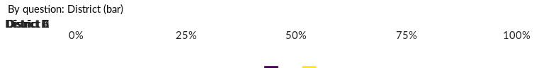

No correlation requested for this question…

## How many hours per week does Individual usually work for all jobs?

NA

Numeric question

### Tabulation

Based on the sample design, the average weighted mean response for this question is 83.39

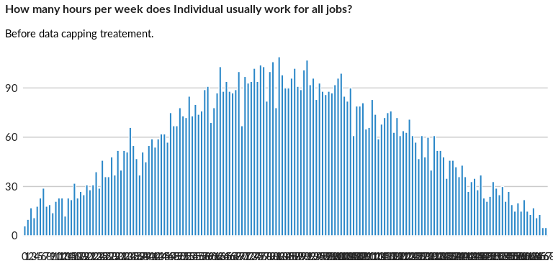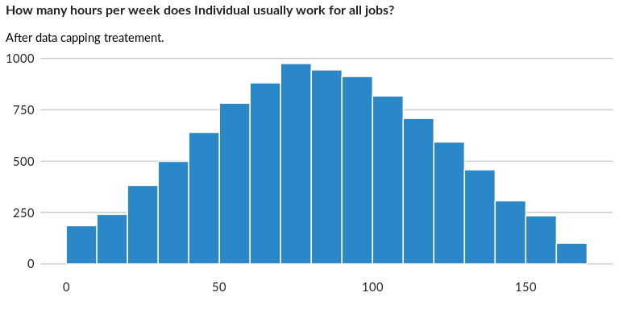

### Analysis of relationship

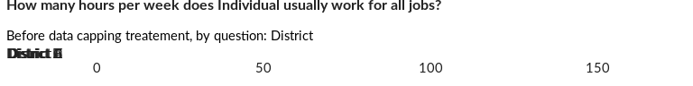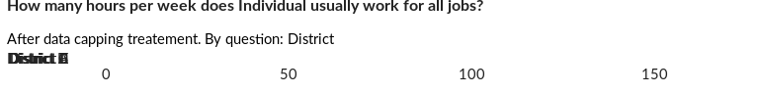

## Is Individual temporarily absent from his/her job with the intention to retur

NA

Single choice question

### Tabulation

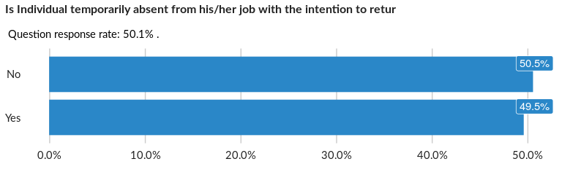

### Cross-tabulations

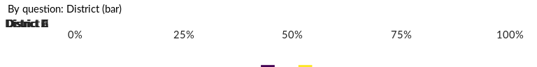

No correlation requested for this question…

## For how long has Individual been not working? (number of weeks)

NA

Numeric question

### Tabulation

Based on the sample design, the average weighted mean response for this question is 23.51

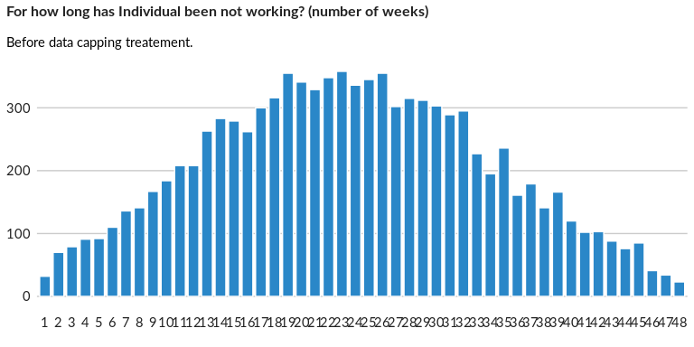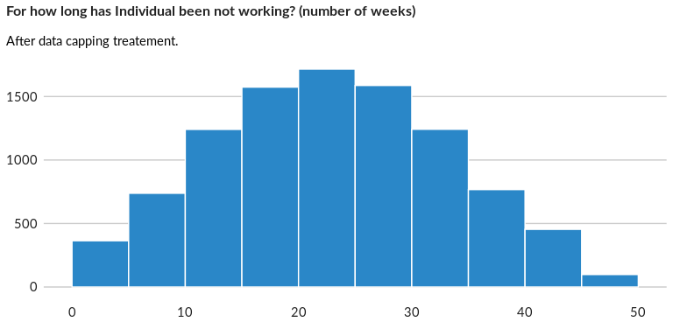

### Analysis of relationship

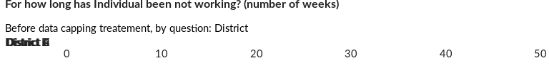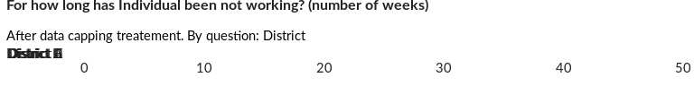

## Has Individual actively searched for work during the past 30 days (asking frie

NA

Single choice question

### Tabulation

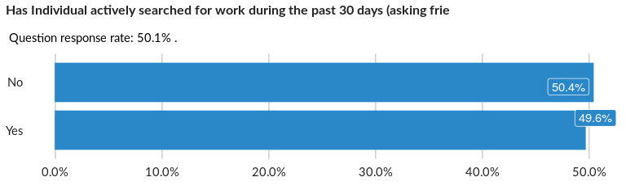

### Cross-tabulations

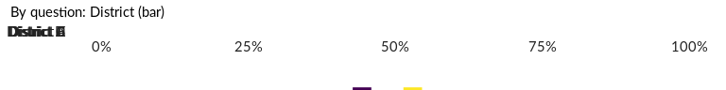

No correlation requested for this question…

## What are the reasons Individual has not been working in the past 30 days?

NA

Multiple choice question

### Tabulation

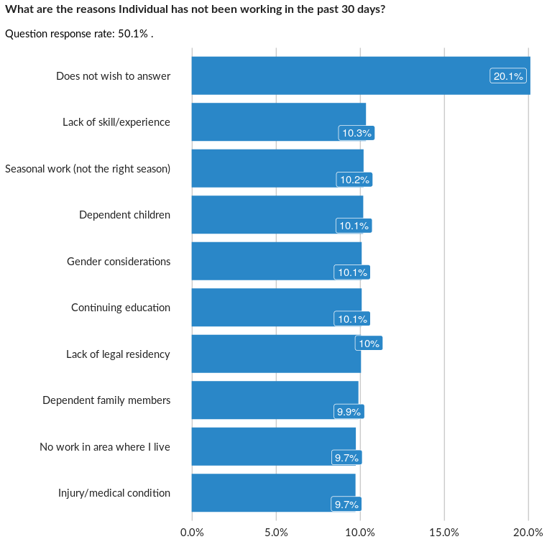

### Analysis of relationship

## Category of Individual that has not been working in the past 30 days

NA

Single choice question

### Tabulation

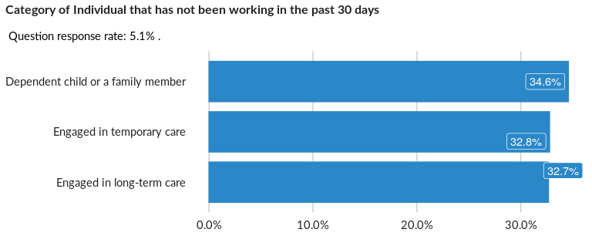

### Cross-tabulations

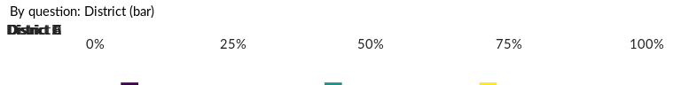

No correlation requested for this question…

## If a paid job or business opportunity became available with the possibility to b

NA

Single choice question

### Tabulation

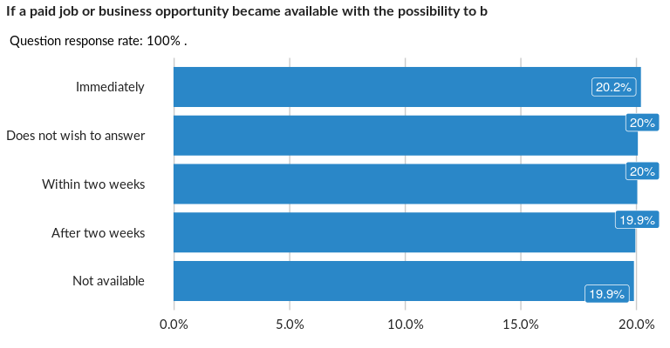

### Cross-tabulations

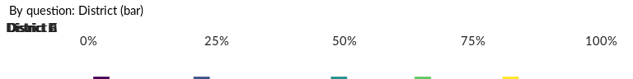

No correlation requested for this question…

## Is Individual considered to be the main family’s breadwinner?

NA

Single choice question

### Tabulation

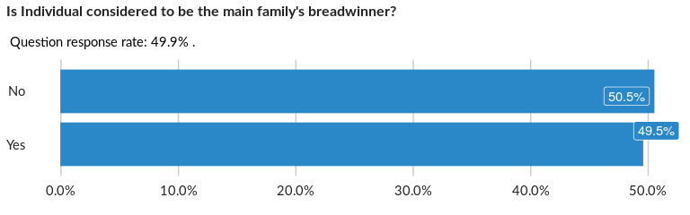

### Cross-tabulations

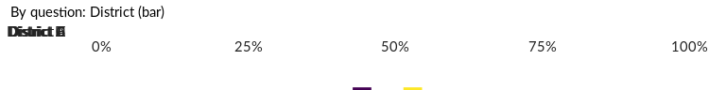

No correlation requested for this question…

## What sectors did Individual work in during the past 30 days?

NA

Multiple choice question

### Tabulation

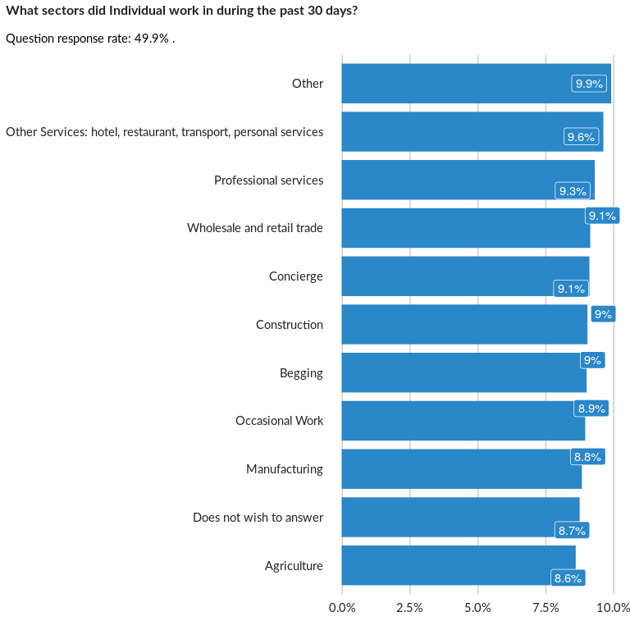

### Analysis of relationship

## Was this work during the past 30 days during school hours?

NA

Single choice question

### Tabulation

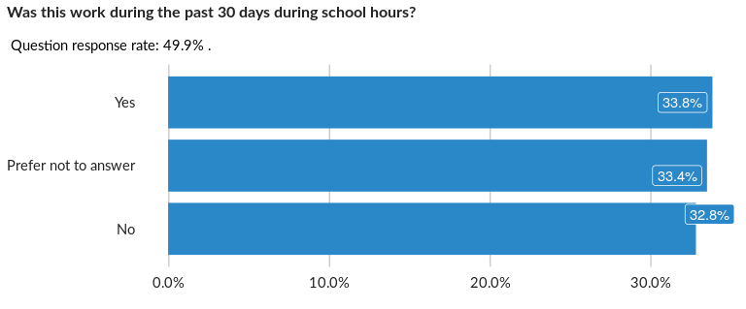

### Cross-tabulations

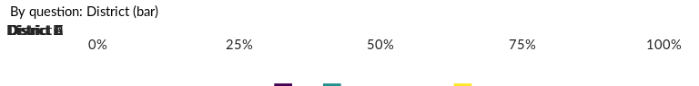

No correlation requested for this question…

## How many hours per week is Individual engaged in unpaid household chores?

NA

Numeric question

### Tabulation

Based on the sample design, the average weighted mean response for this question is 84.38

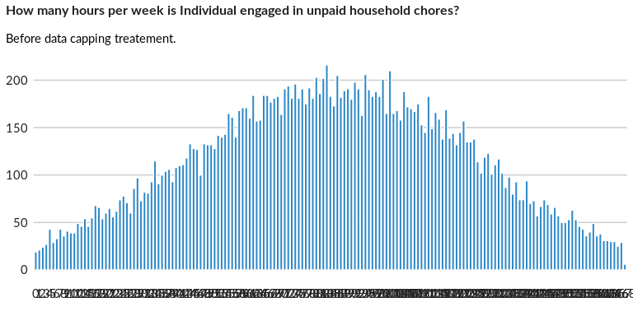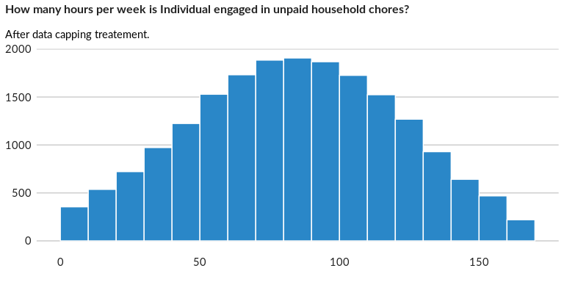

### Analysis of relationship

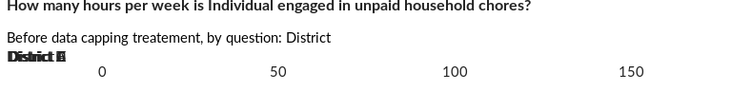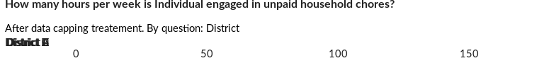

## Have any household members received any technical assistance (capacity building,

NA

Single choice question

### Tabulation

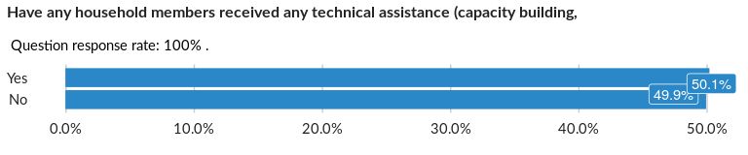

### Cross-tabulations

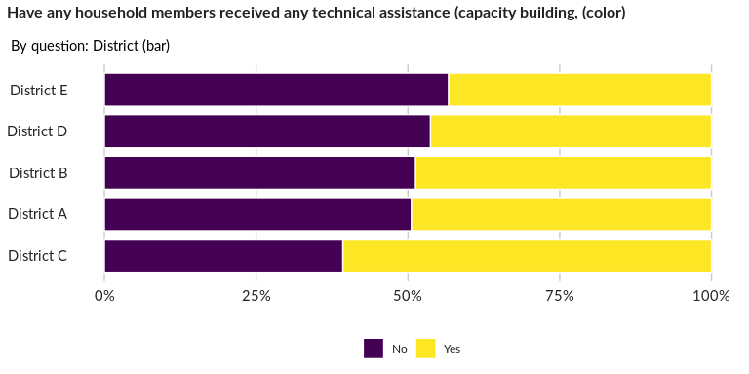

### Significant Associations (chi-square with p value < 5%)

No significant association found for this question…

## Do household member(s) receive technical assistance (capacity building,vocationa

NA

Single choice question

### Tabulation

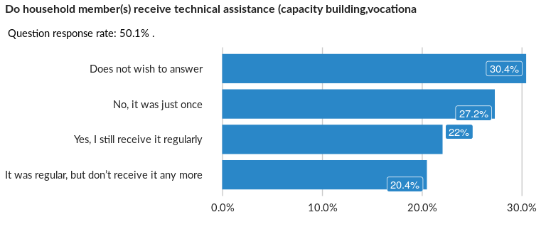

### Cross-tabulations

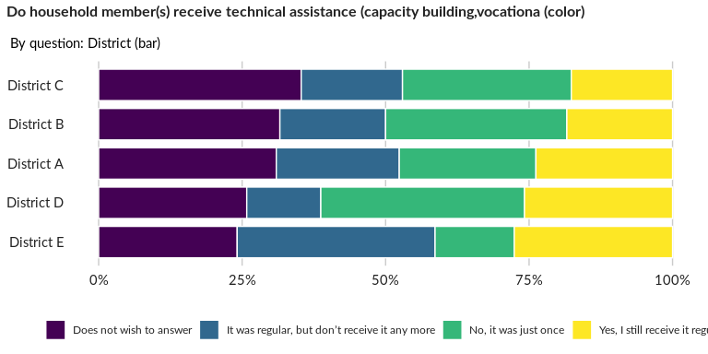

### Significant Associations (chi-square with p value < 5%)

No significant association found for this question…

##### Page Break