Data Crunching Report: Health- Draft not for distribution.

Generated with [Koboloader](https://unhcr.github.io/koboloadeR/docs)

26 June 2019

Table of Contents

# Introduction

This data crunching report allows to quickly explore the results of the survey that can be regenerated as needed. You can:

* adjust the configuration in the xlsform to break it into chapter;
* configure disaggregation & correlation for each questions;
* revise the data cleansing based on the cleaning log;
* add weight to each observation in order to account for a specific sampling plan;
* append calculated indicators to your data frame.

The objective of this report is to allow to quickly identify potential patterns in your dataset. A quick screening of this initial report should allow to select the most meaningful graphs. A data digest from this initial report can be then reviewed through a **data analysis workshop** where subject matter experts can contribute with qualitative components. When analyzing those representations in a collective setting, you may:

* **Reflect**: question data quality and/or make suggestions to change questions;
* **Interpret**: develop qualitative interpretations of data patterns;
* **Recommend**: develop recommendation in terms of programmatic adjustment;
* **Classify**: order the level of sensitivity for the information;

# Compilation of questions results

## Does Individual have any of the following specific needs

Change to serious medical condition or chronic disease

Single choice question

### Tabulation

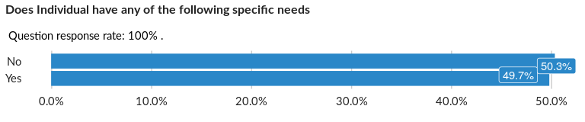

### Cross-tabulations

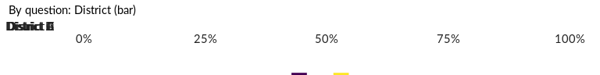

No correlation requested for this question…

## Do you have difficulty seeing, even if wearing glasses?

NA

Single choice question

### Tabulation

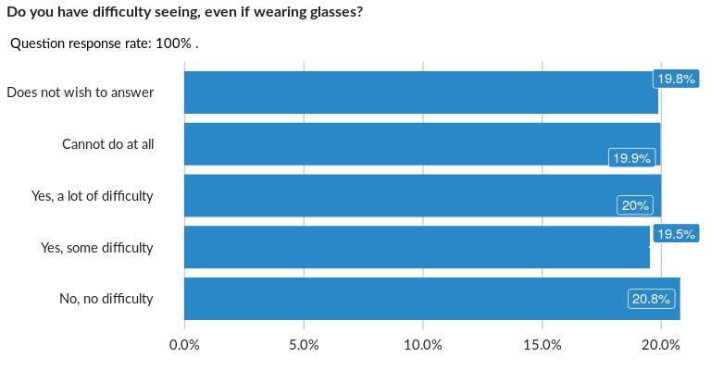

### Cross-tabulations

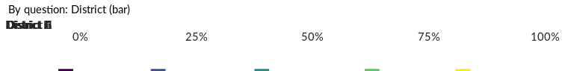

No correlation requested for this question…

## Do you have difficulty hearing, even if wearing a hearing aid?

NA

Single choice question

### Tabulation

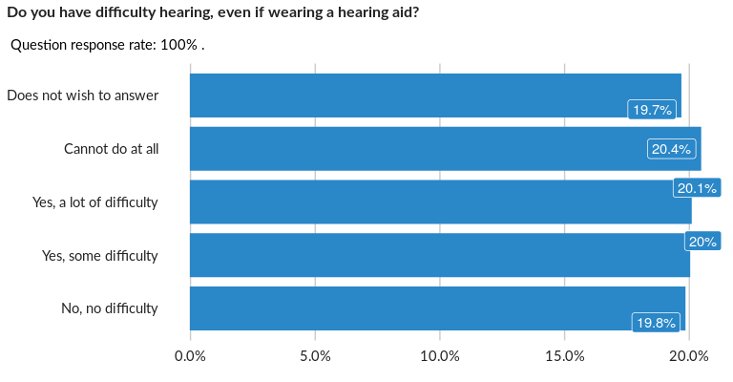

### Cross-tabulations

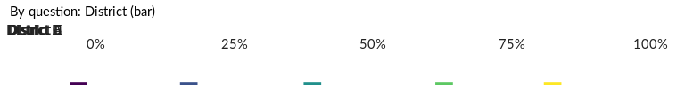

No correlation requested for this question…

## Do you have difficulty walking or climbing steps?

NA

Single choice question

### Tabulation

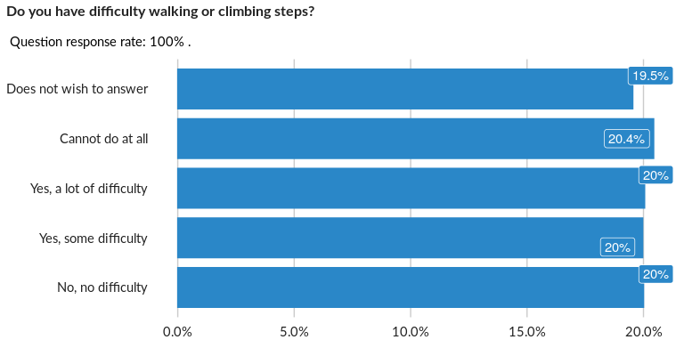

### Cross-tabulations

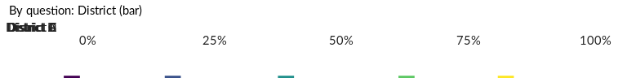

No correlation requested for this question…

## Do you have difficulty remembering or concentrating?

NA

Single choice question

### Tabulation

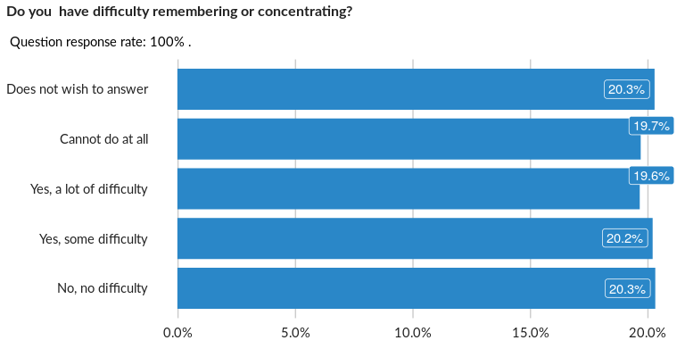

### Cross-tabulations

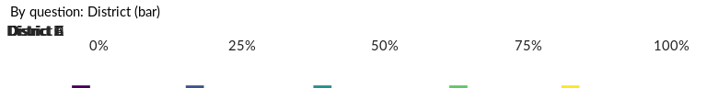

No correlation requested for this question…

## Do you have difficulty (with self-care such as) washing all over or dressing?

NA

Single choice question

### Tabulation

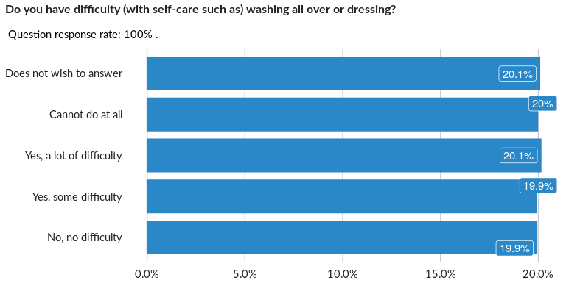

### Cross-tabulations

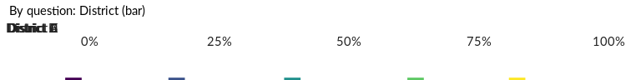

No correlation requested for this question…

## Using your normal customary language, do you have difficulty communicating, for

NA

Single choice question

### Tabulation

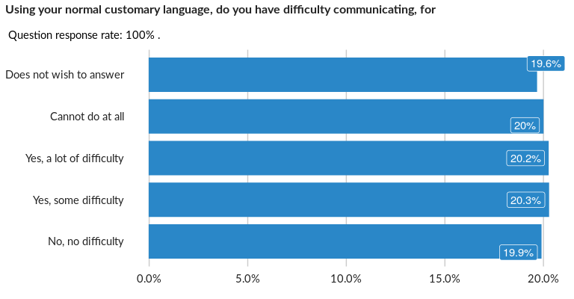

### Cross-tabulations

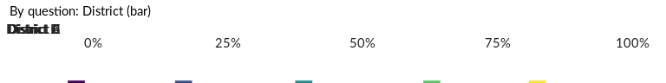

No correlation requested for this question…

## Does Individual need assistance from another person to use the toilet?

NA

Single choice question

### Tabulation

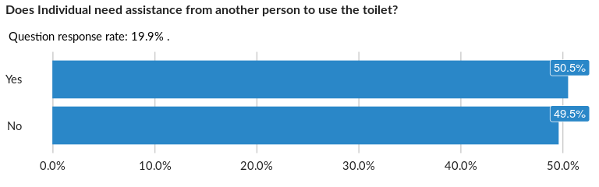

### Cross-tabulations

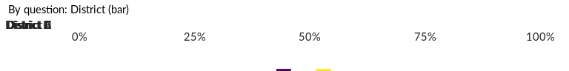

No correlation requested for this question…

## Is there a caregiver available?

NA

Single choice question

### Tabulation

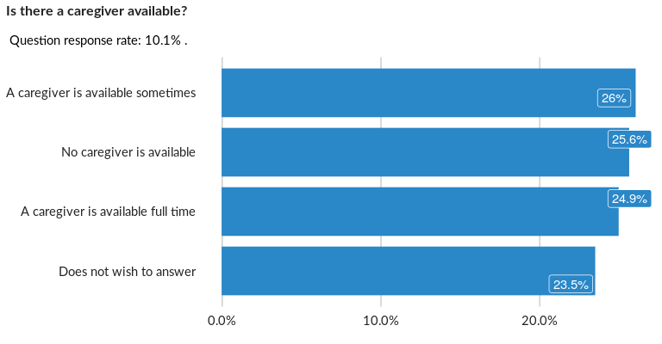

### Cross-tabulations

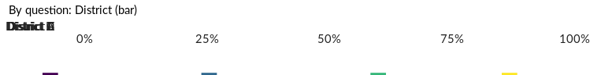

No correlation requested for this question…

## Does Individual have access to a toilet/bathroom adapted to their disability?

NA

Single choice question

### Tabulation

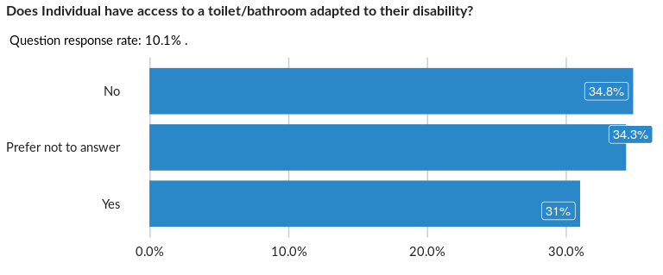

### Cross-tabulations

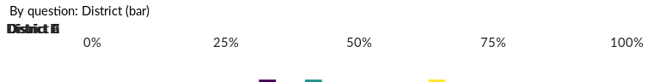

No correlation requested for this question…

## About how often during the last two weeks did you feel so afraid that nothing co

NA

Single choice question

### Tabulation

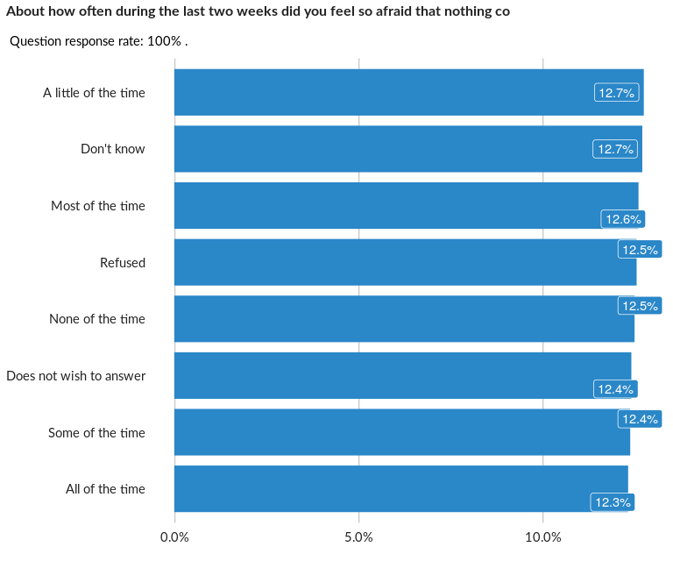

### Cross-tabulations

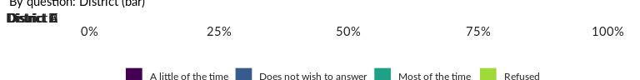

No correlation requested for this question…

## About how often during the last two weeks did you feel so angry that you felt ou

NA

Single choice question

### Tabulation

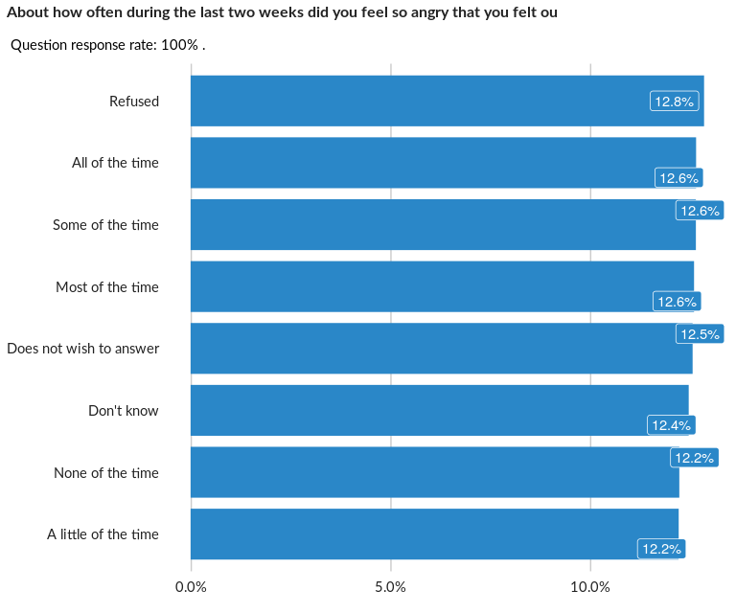

### Cross-tabulations

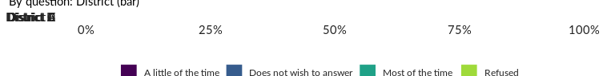

No correlation requested for this question…

## During the last two weeks, about how often did you feel so uninterested in thing

NA

Single choice question

### Tabulation

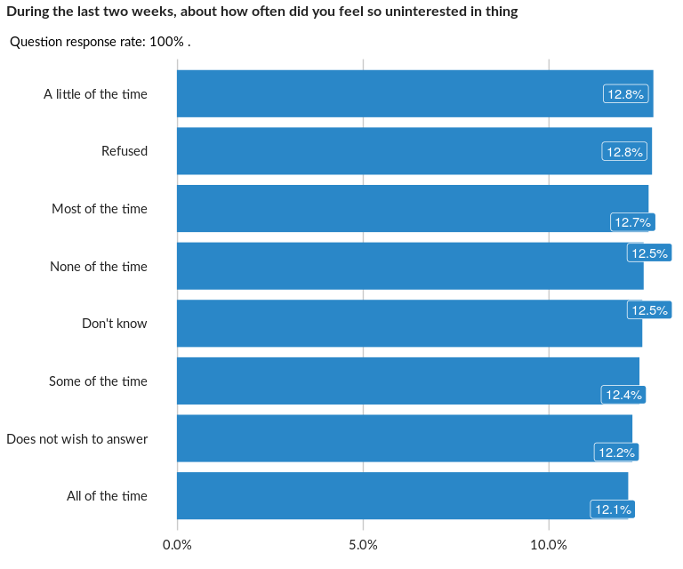

### Cross-tabulations

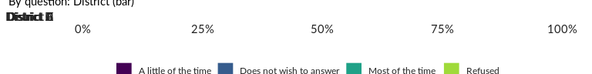

No correlation requested for this question…

## During the last two weeks, about how often did you feel so hopeless that you did

NA

Single choice question

### Tabulation

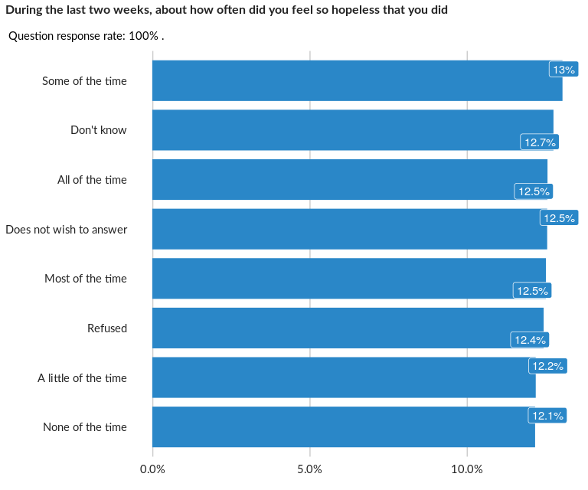

### Cross-tabulations

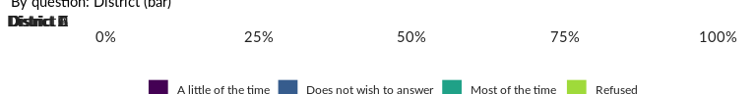

No correlation requested for this question…

## You may have experienced one or more events that have been intensely upsetting t

NA

Single choice question

### Tabulation

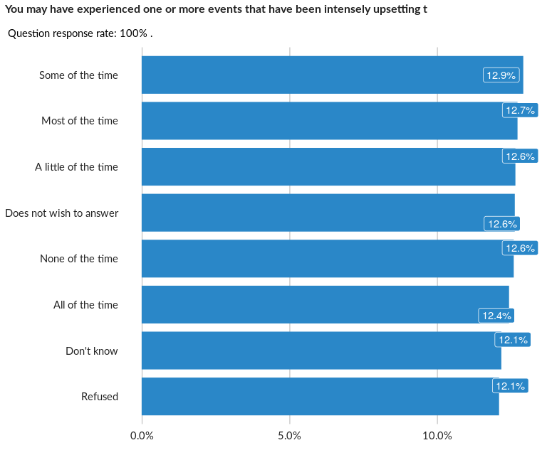

### Cross-tabulations

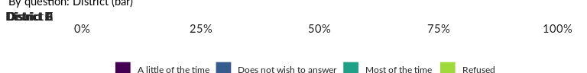

No correlation requested for this question…

## The next question is about how these feelings of fear, anger, fatigue, disintere

NA

Single choice question

### Tabulation

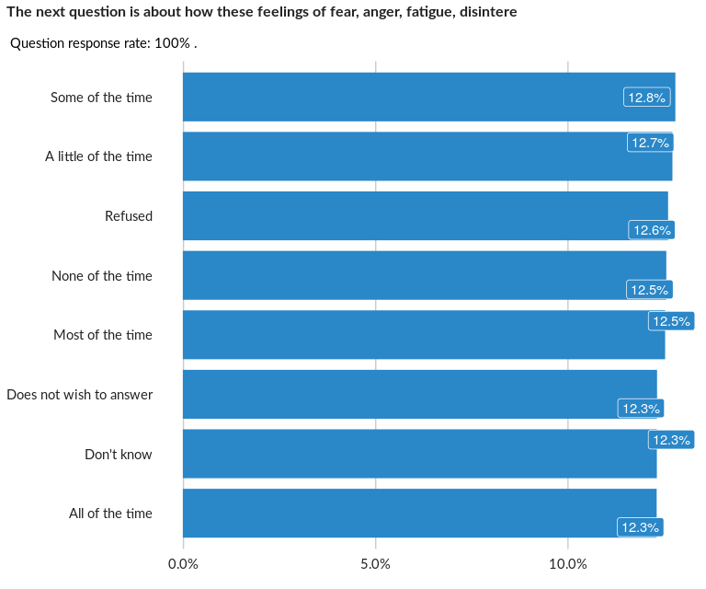

### Cross-tabulations

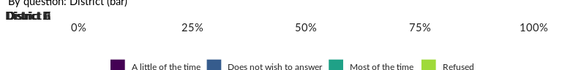

No correlation requested for this question…

## Did any household members require primary health care in the past 6 months?

NA

Single choice question

### Tabulation

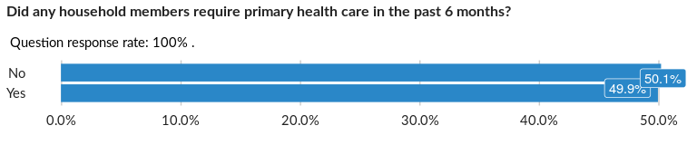

### Cross-tabulations

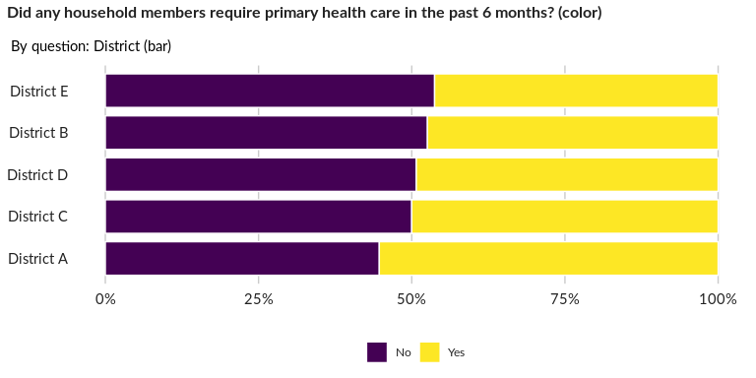

### Significant Associations (chi-square with p value < 5%)

No significant association found for this question…

## Did the household member(s) receive the required primary health care assistance?

NA

Single choice question

### Tabulation

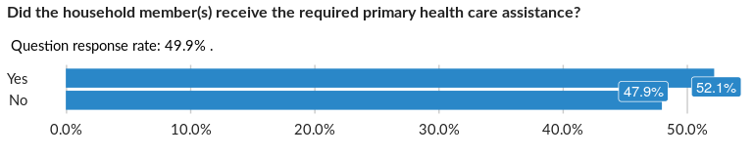

### Cross-tabulations

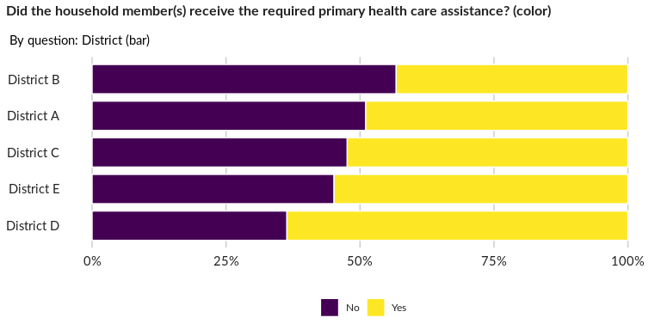

### Significant Associations (chi-square with p value < 5%)

No significant association found for this question…

## Why were household members unable to receive the required primary health assista

NA

Multiple choice question

### Tabulation

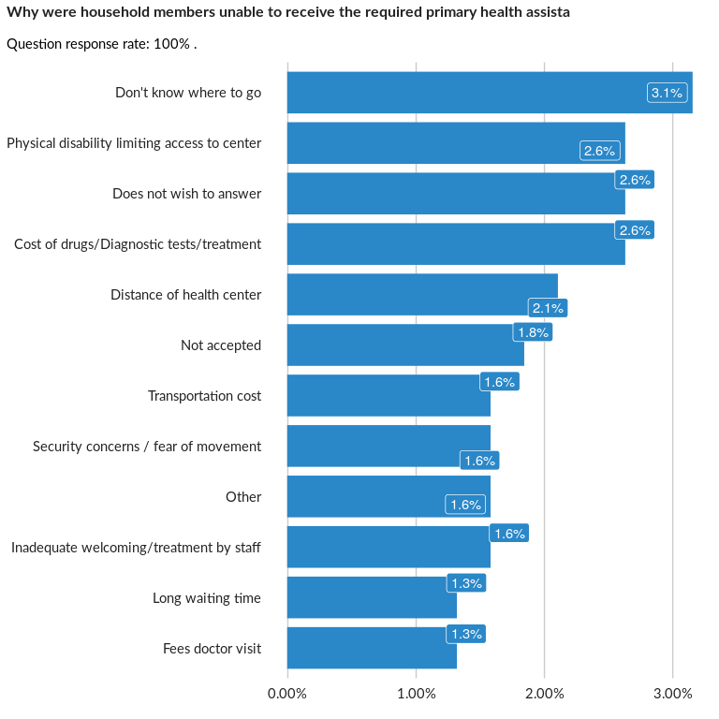

### Analysis of relationship

## Where did the household member(s) access primary healthcare?

NA

Single choice question

### Tabulation

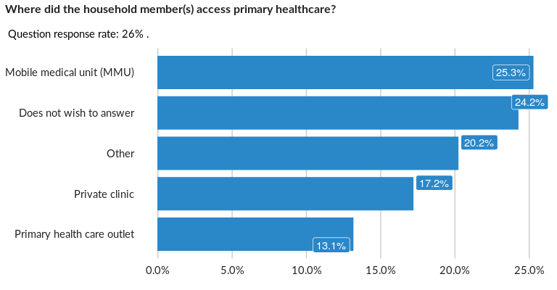

### Cross-tabulations

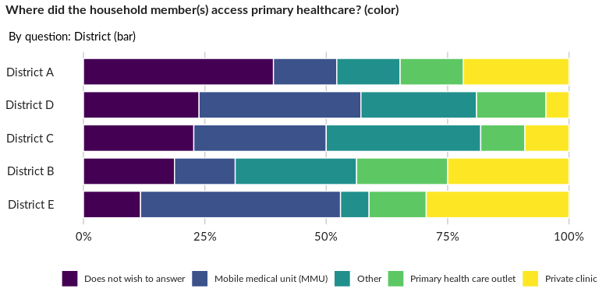

### Significant Associations (chi-square with p value < 5%)

No significant association found for this question…

## Why did the household member(s) seek a private clinic?

NA

Single choice question

### Tabulation

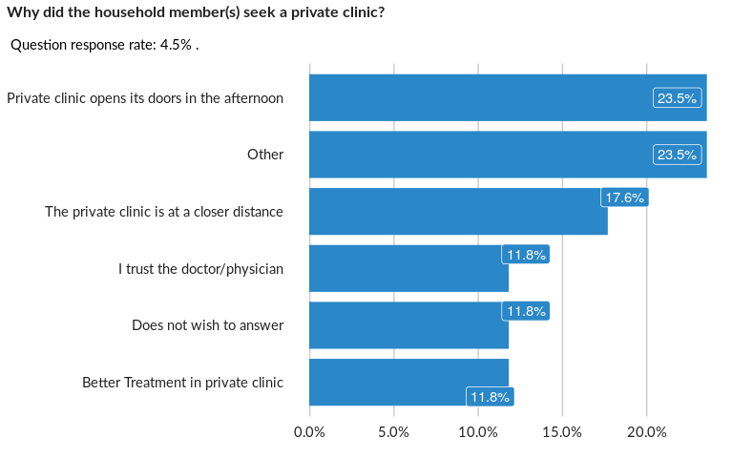

### Cross-tabulations

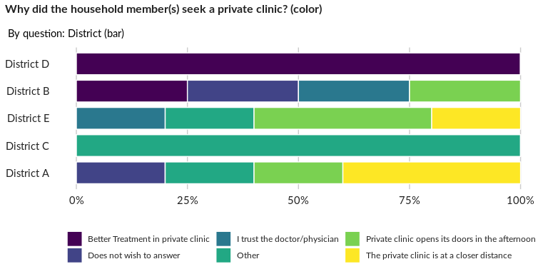

### Significant Associations (chi-square with p value < 5%)

No significant association found for this question…

## Did any of your household members require hospitalization in the past 6 months?

NA

Single choice question

### Tabulation

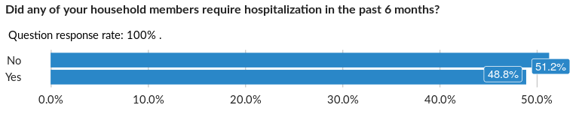

### Cross-tabulations

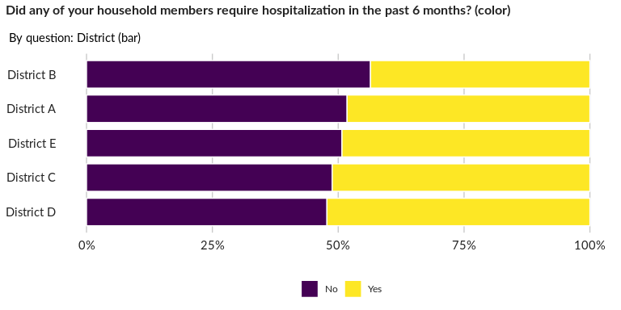

### Significant Associations (chi-square with p value < 5%)

No significant association found for this question…

## Did the household member(s) receive the required hospital care?

NA

Single choice question

### Tabulation

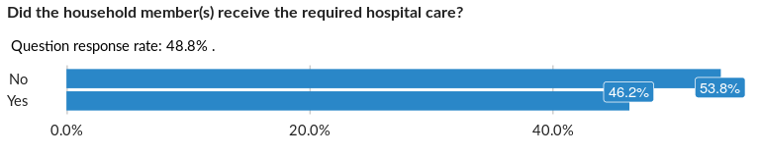

### Cross-tabulations

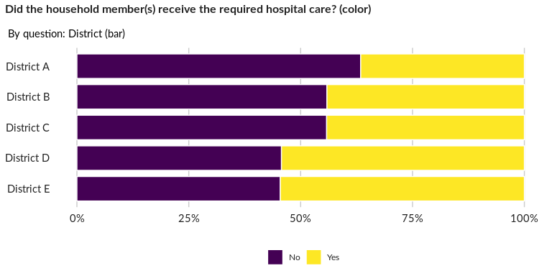

### Significant Associations (chi-square with p value < 5%)

No significant association found for this question…

## Why were household member(s) unable to receive the required hospital care?

NA

Multiple choice question

### Tabulation

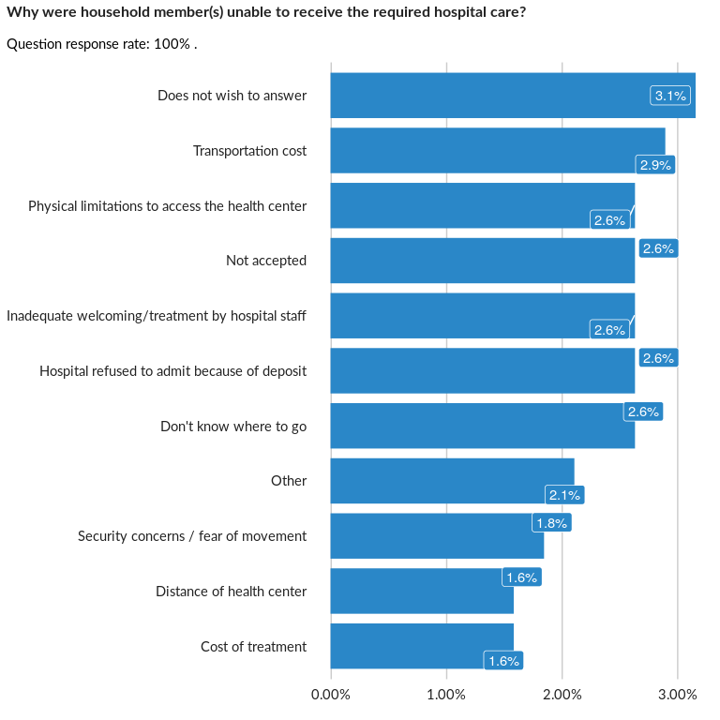

### Analysis of relationship

## Where did the household member(s) access hospitalization?

NA

Single choice question

### Tabulation

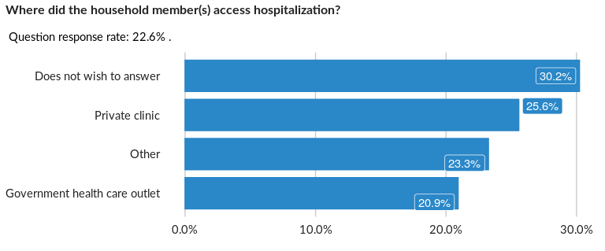

### Cross-tabulations

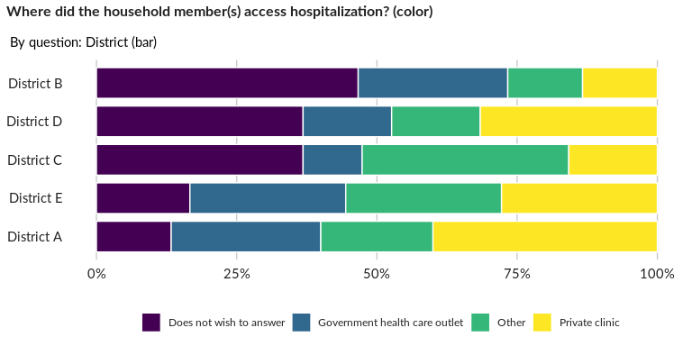

### Significant Associations (chi-square with p value < 5%)

No significant association found for this question…

## Why did the household member(s) seek a private clinic?

NA

Single choice question

### Tabulation

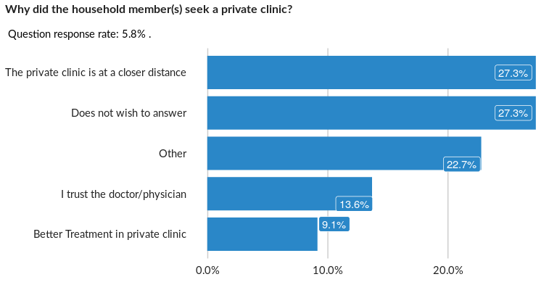

### Cross-tabulations

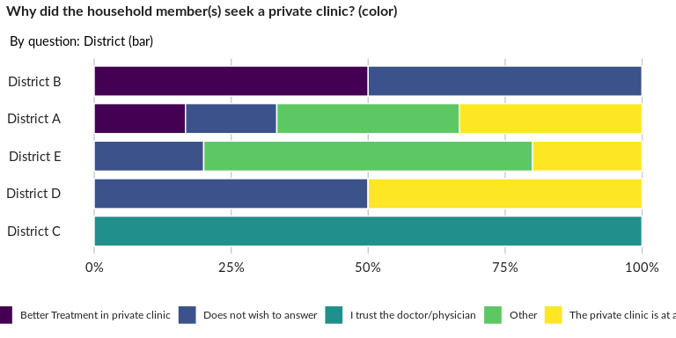

### Significant Associations (chi-square with p value < 5%)

No significant association found for this question…

## If anyone in the household requires urgent medical attention, do you know how to

NA

Single choice question

### Tabulation

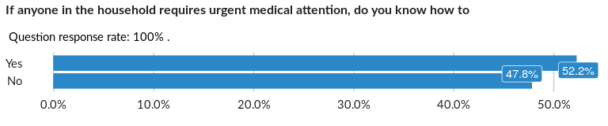

### Cross-tabulations

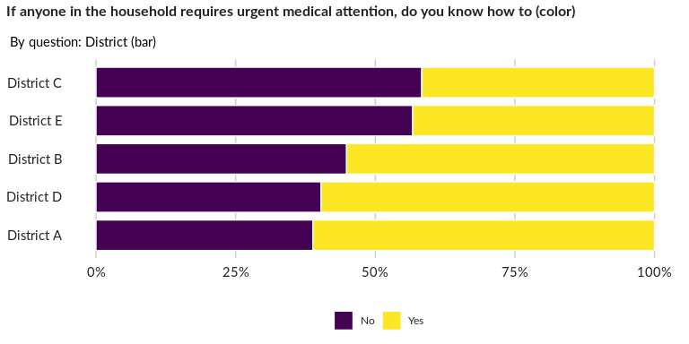

### Significant Associations (chi-square with p value < 5%)

No significant association found for this question…

##### Page Break