Data Crunching Report: Shelter- Draft not for distribution.

Generated with [Koboloader](https://unhcr.github.io/koboloadeR/docs)

26 June 2019

Table of Contents

# Introduction

This data crunching report allows to quickly explore the results of the survey that can be regenerated as needed. You can:

* adjust the configuration in the xlsform to break it into chapter;
* configure disaggregation & correlation for each questions;
* revise the data cleansing based on the cleaning log;
* add weight to each observation in order to account for a specific sampling plan;
* append calculated indicators to your data frame.

The objective of this report is to allow to quickly identify potential patterns in your dataset. A quick screening of this initial report should allow to select the most meaningful graphs. A data digest from this initial report can be then reviewed through a **data analysis workshop** where subject matter experts can contribute with qualitative components. When analyzing those representations in a collective setting, you may:

* **Reflect**: question data quality and/or make suggestions to change questions;
* **Interpret**: develop qualitative interpretations of data patterns;
* **Recommend**: develop recommendation in terms of programmatic adjustment;
* **Classify**: order the level of sensitivity for the information;

# Compilation of questions results

## What type of housing does the household live in?

NA

Single choice question

### Tabulation

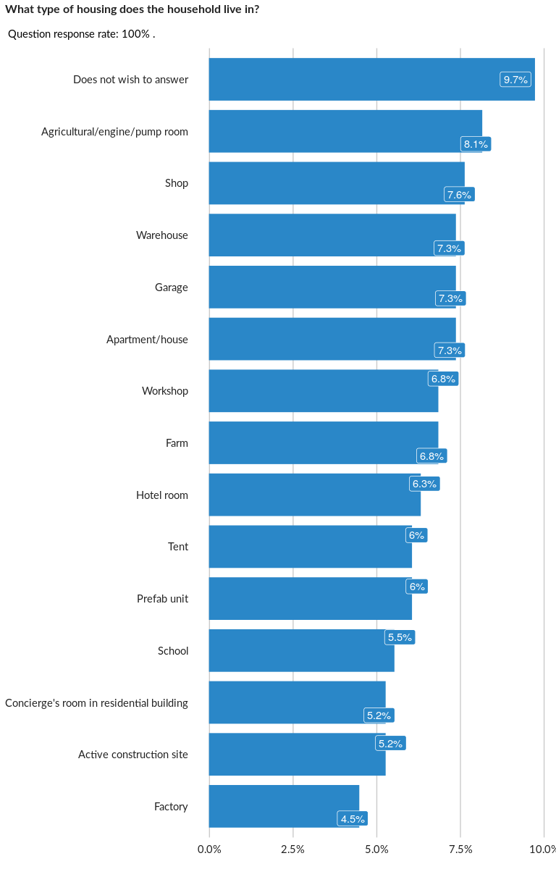

### Cross-tabulations

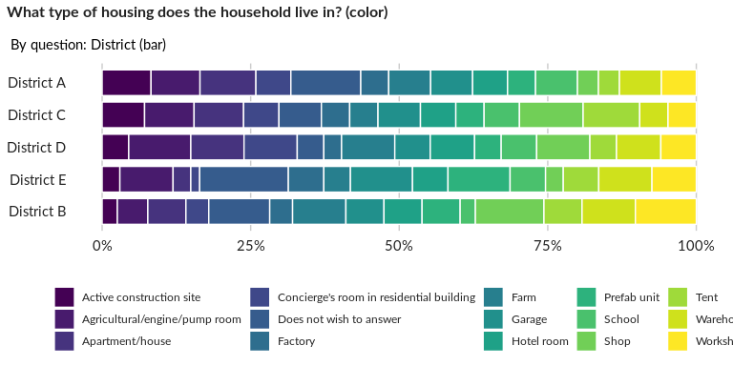

### Significant Associations (chi-square with p value < 5%)

No significant association found for this question…

## What type of occupancy does the household have?

NA

Single choice question

### Tabulation

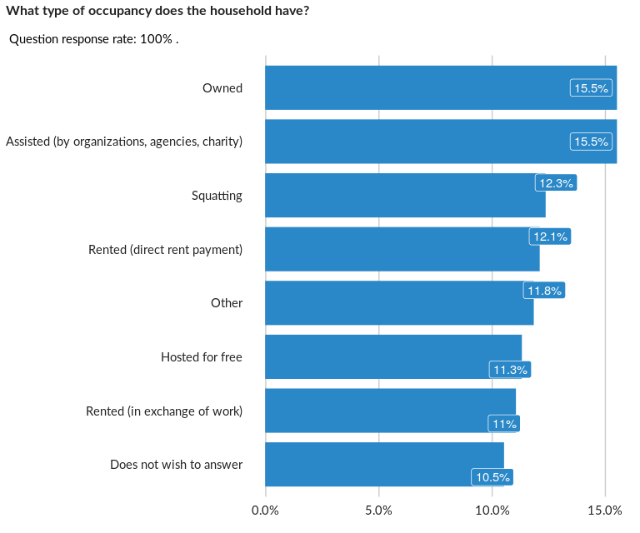

### Cross-tabulations

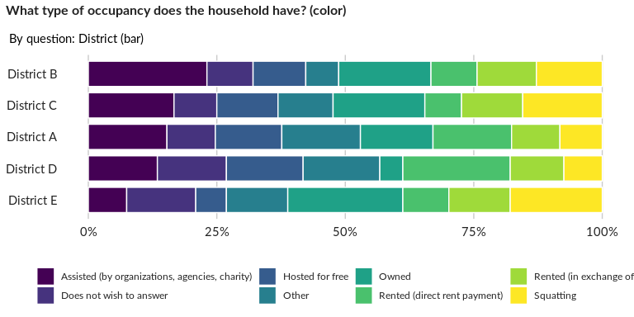

### Significant Associations (chi-square with p value < 5%)

No significant association found for this question…

## Who works in exchange for rent?

NA

Multiple choice question

### Tabulation

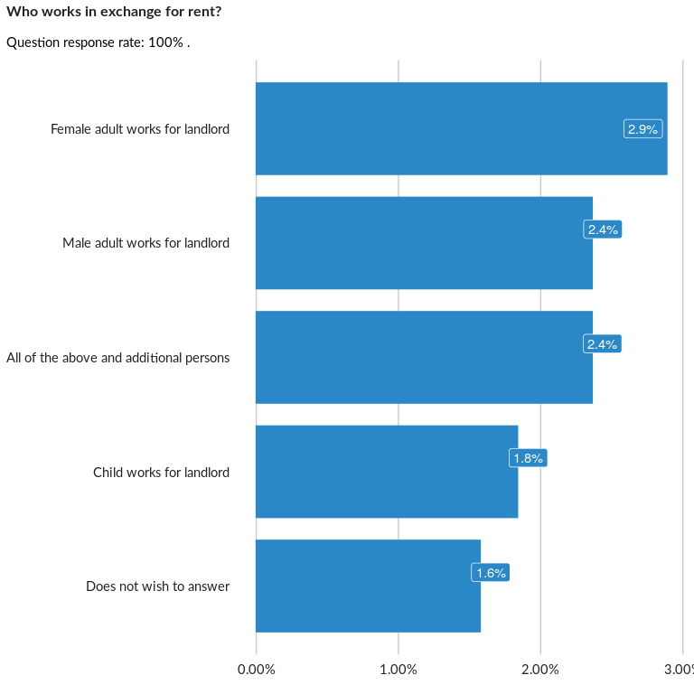

### Analysis of relationship

## What services are included in the rent?

NA

Multiple choice question

### Tabulation

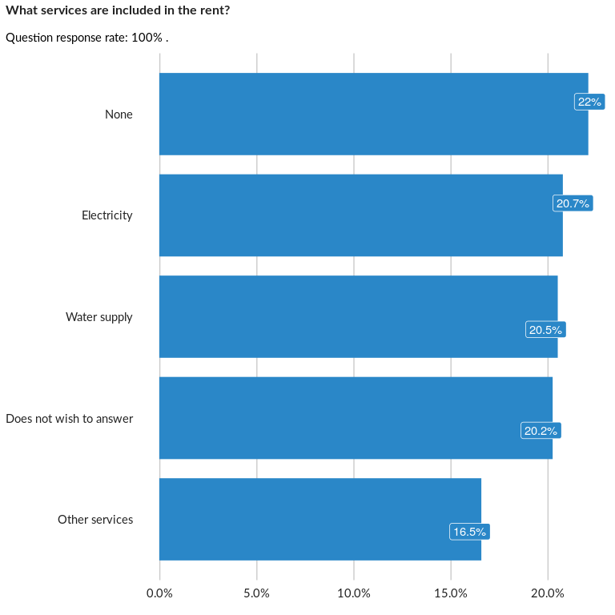

### Analysis of relationship

## How many rooms (excluding bathrooms and toilets) are occupied by the household?

NA

Numeric question

### Tabulation

Based on the sample design, the average weighted mean response for this question is 50.65

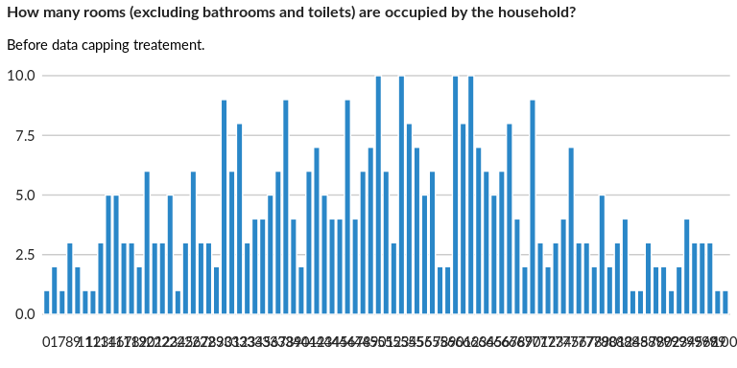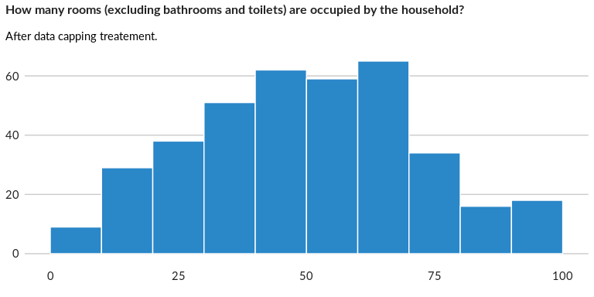

### Analysis of relationship

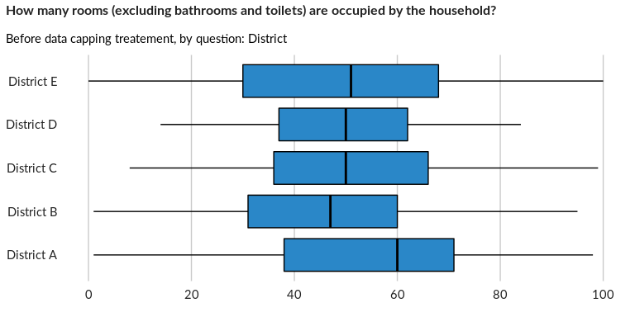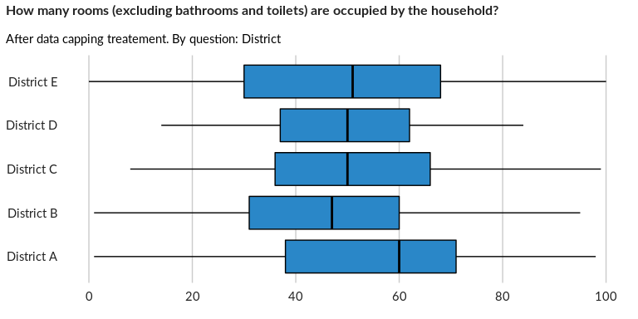

## How many people are sharing this living space?

NA

Numeric question

### Tabulation

Based on the sample design, the average weighted mean response for this question is 47.93

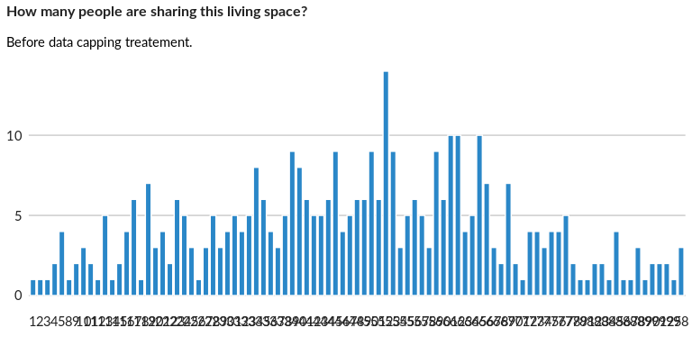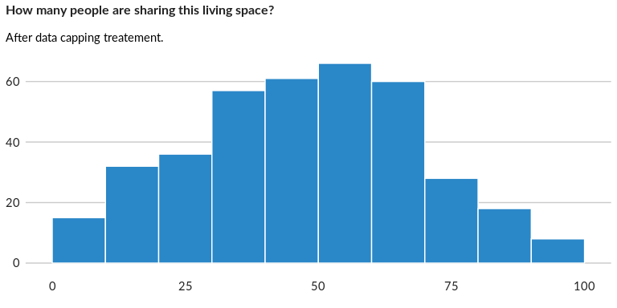

### Analysis of relationship

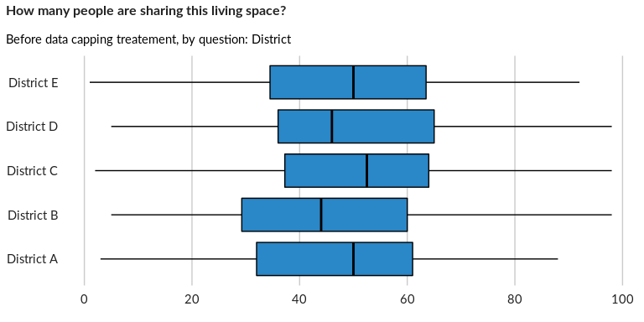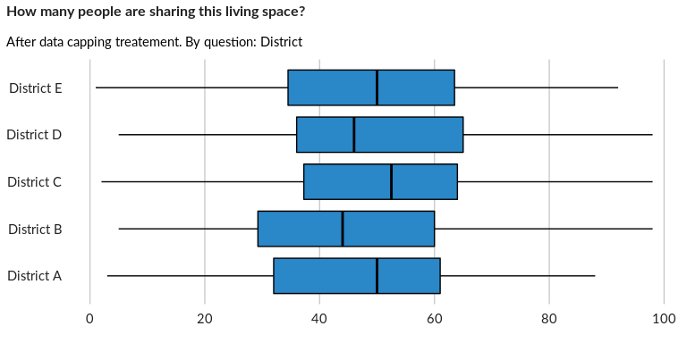

## What type of agreement does the household have with the property landlord?

NA

Single choice question

### Tabulation

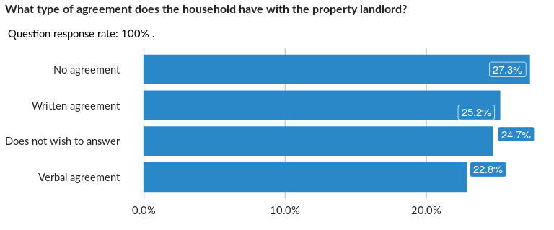

### Cross-tabulations

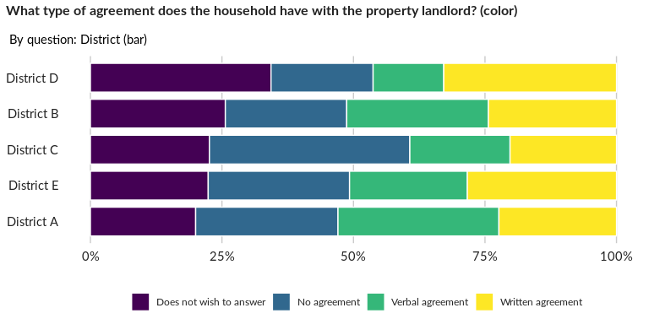

### Significant Associations (chi-square with p value < 5%)

No significant association found for this question…

## Has the household received an eviction notice and/or any other threat of removal

NA

Single choice question

### Tabulation

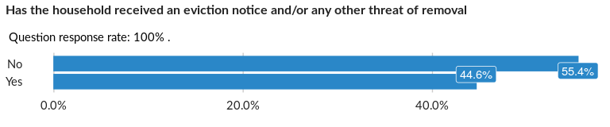

### Cross-tabulations

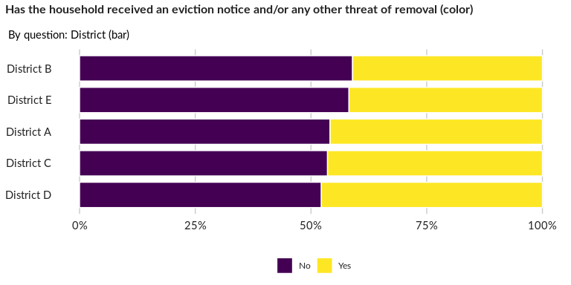

### Significant Associations (chi-square with p value < 5%)

No significant association found for this question…

## If the household received an eviction notice, when are they expected/demanded to

NA

Date question in data frame: MainDataFrame

## If the household received an eviction notice, who issued it?

NA

Single choice question

### Tabulation

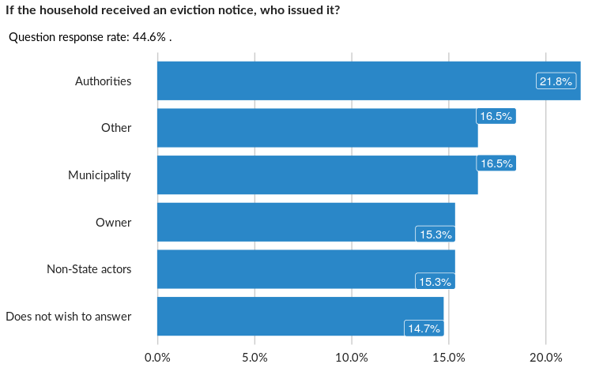

### Cross-tabulations

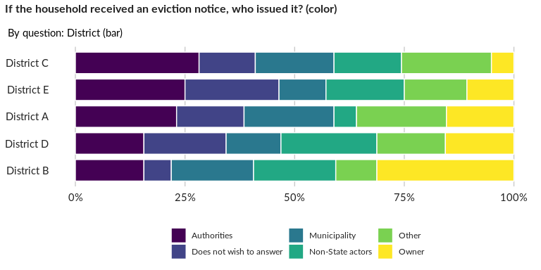

### Significant Associations (chi-square with p value < 5%)

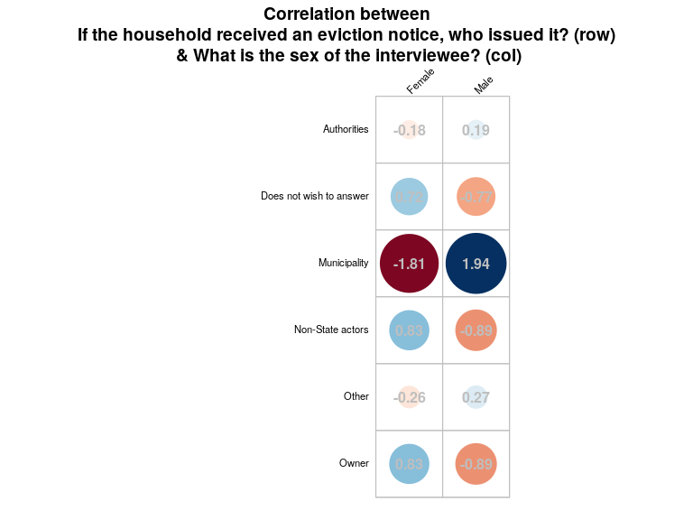

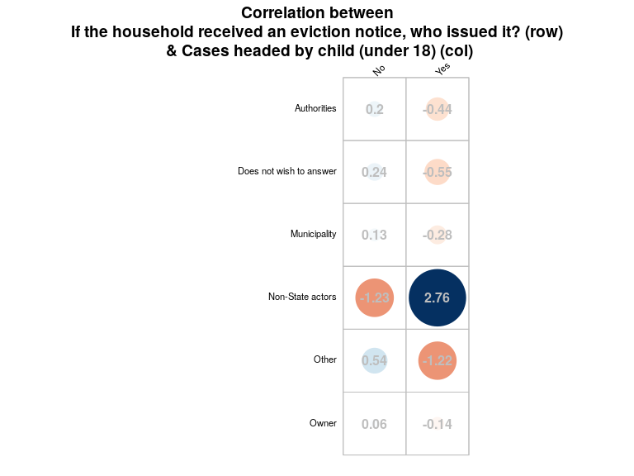

## Has the household moved and/or changed accommodation in the past six months?

NA

Single choice question

### Tabulation

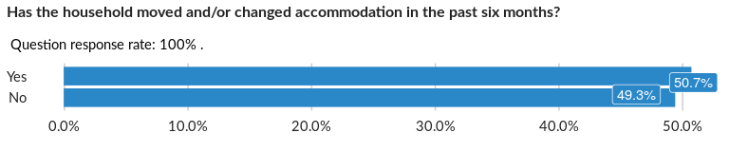

### Cross-tabulations

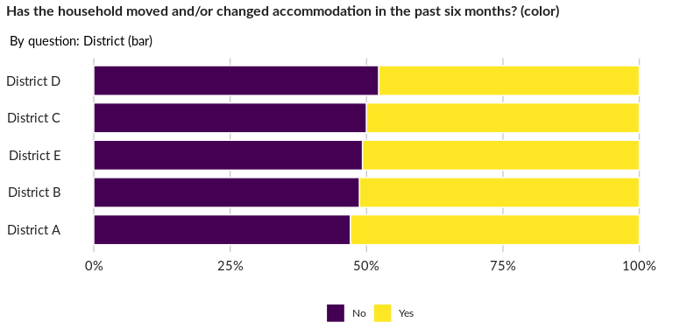

### Significant Associations (chi-square with p value < 5%)

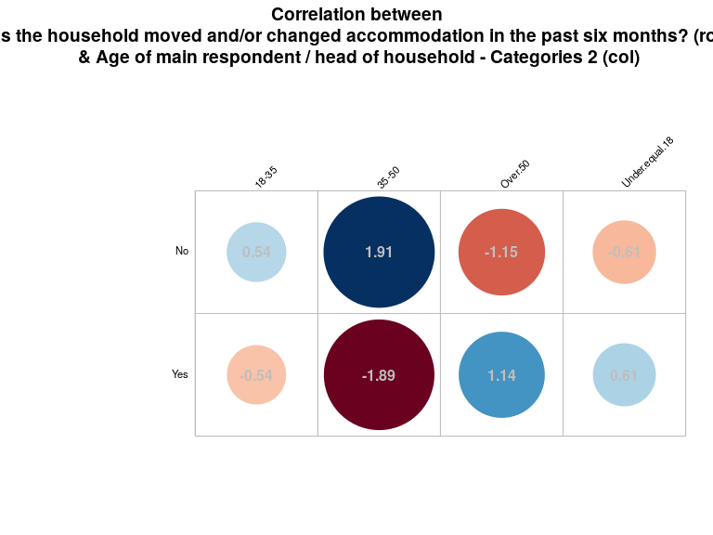

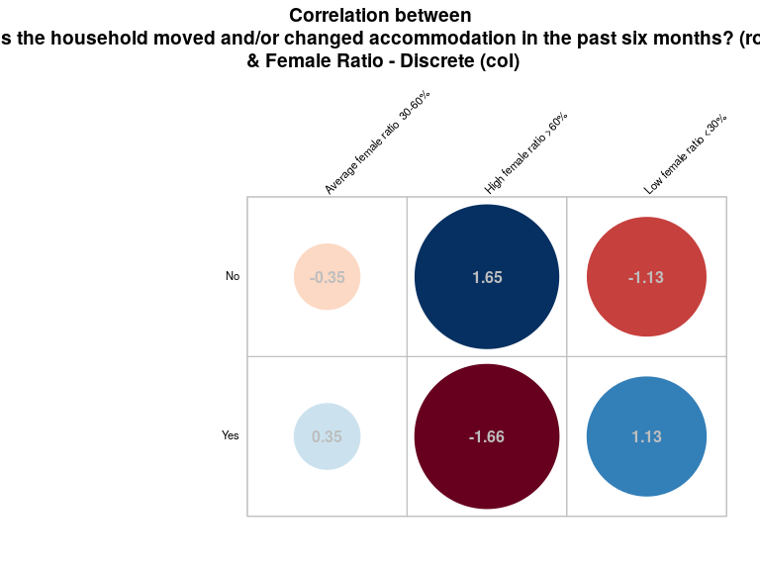

## What is the main reason for moving/changing accommodation?

NA

Single choice question

### Tabulation

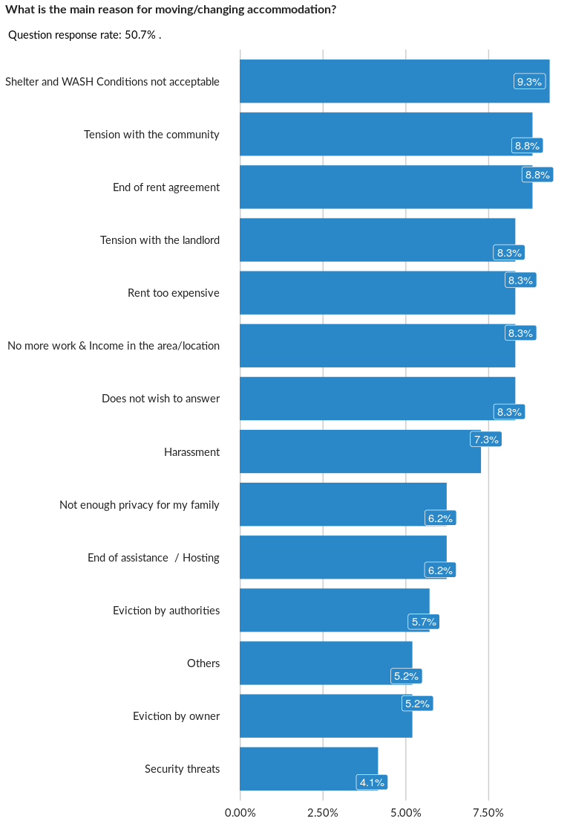

### Cross-tabulations

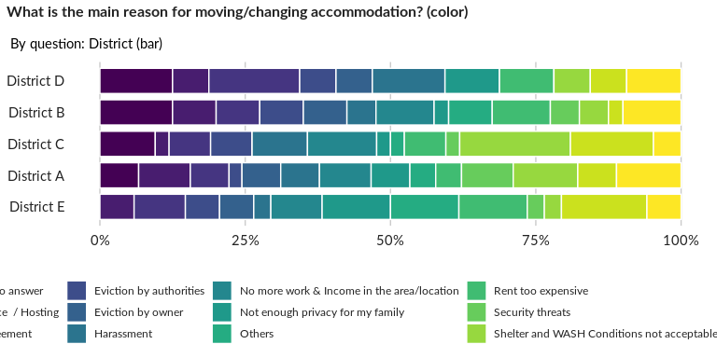

### Significant Associations (chi-square with p value < 5%)

No significant association found for this question…

## How long has the household been living in this shelter? (Number of months - hint

NA

Numeric question

### Tabulation

Based on the sample design, the average weighted mean response for this question is 48.45

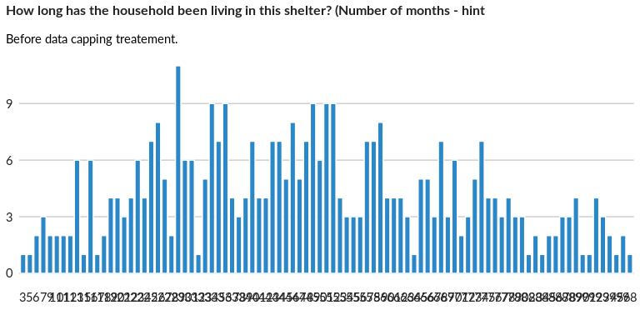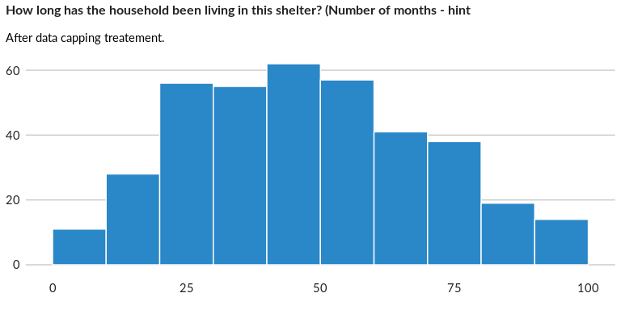

### Analysis of relationship

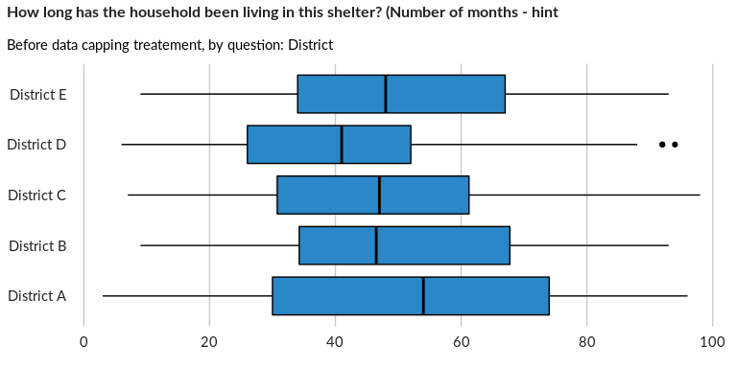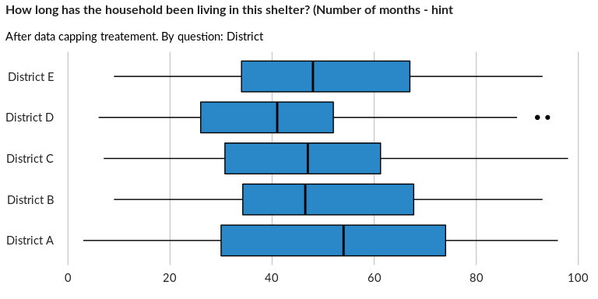

## What was the previous type of accommodation the household lived in?

NA

Single choice question

### Tabulation

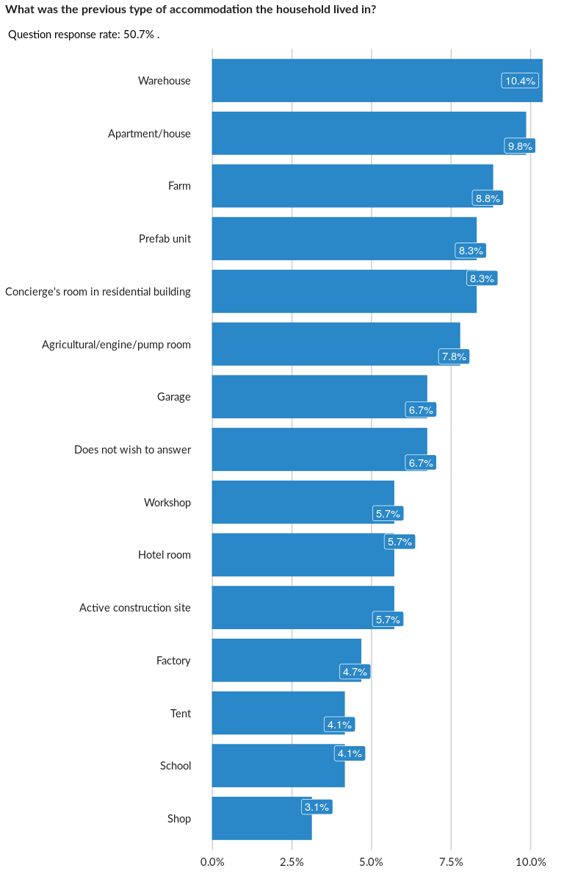

### Cross-tabulations

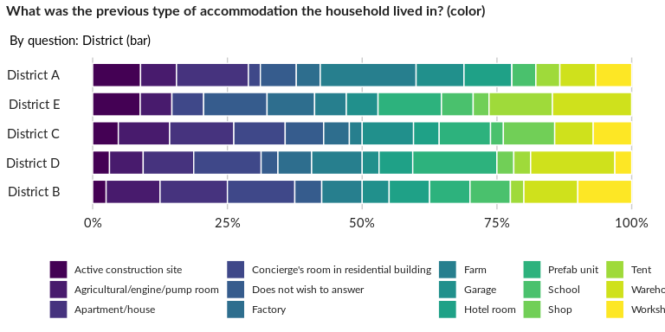

### Significant Associations (chi-square with p value < 5%)

No significant association found for this question…

## Does the household plan to stay in the same accommodation in the coming six mont

NA

Single choice question

### Tabulation

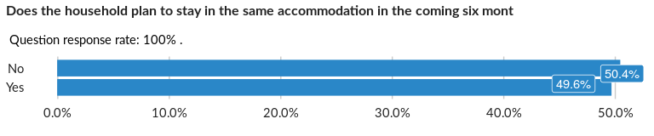

### Cross-tabulations

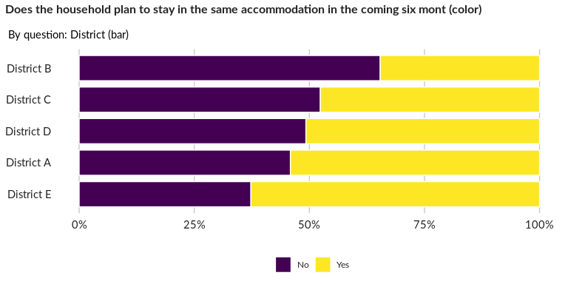

### Significant Associations (chi-square with p value < 5%)

No significant association found for this question…

## If the household is planning to move/change accommodation, what is the main reas

NA

Single choice question

### Tabulation

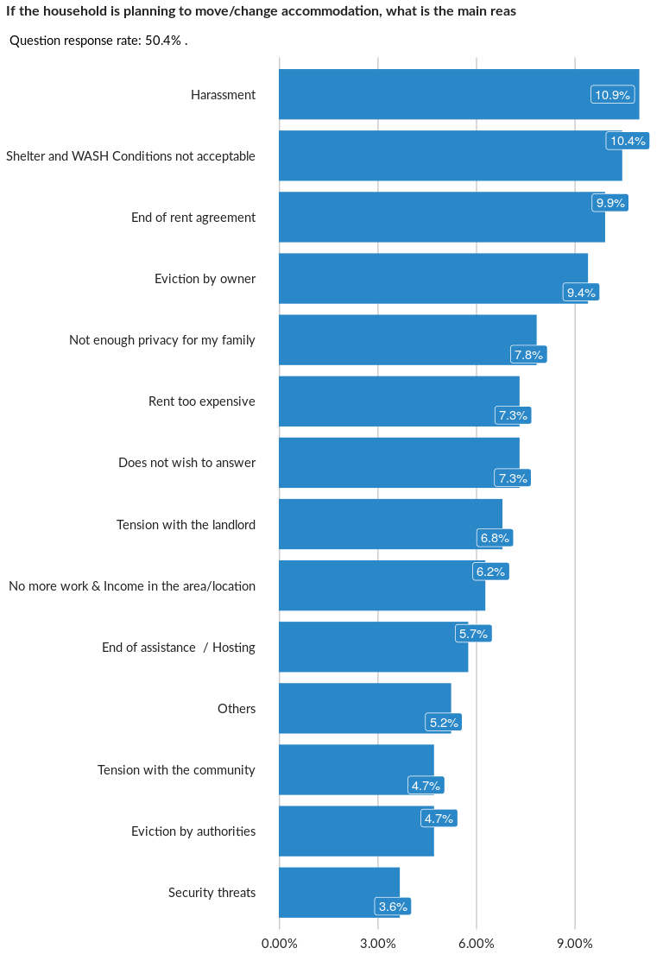

### Cross-tabulations

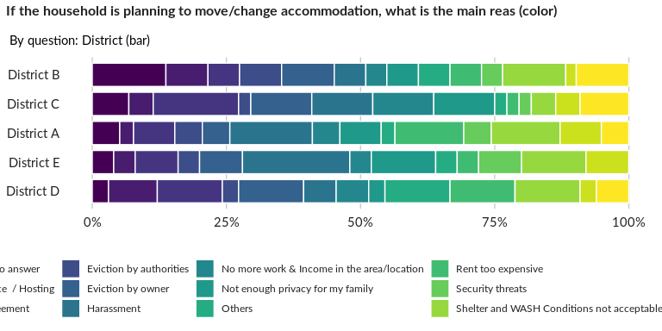

### Significant Associations (chi-square with p value < 5%)

No significant association found for this question…

## Has the household been ever been evicted their stay in this country?

NA

Single choice question

### Tabulation

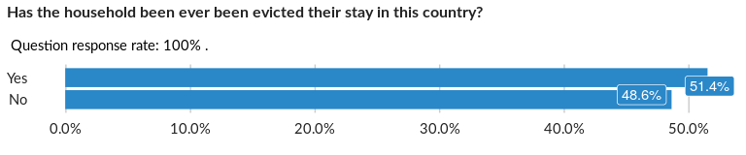

### Cross-tabulations

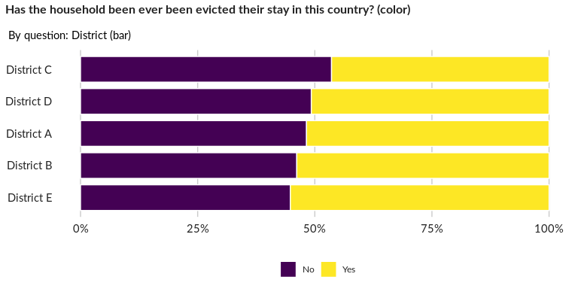

### Significant Associations (chi-square with p value < 5%)

No significant association found for this question…

## How many hours per day, on average, do you get power from the grid (legal or inf

NA

Numeric question

### Tabulation

Based on the sample design, the average weighted mean response for this question is 12.28

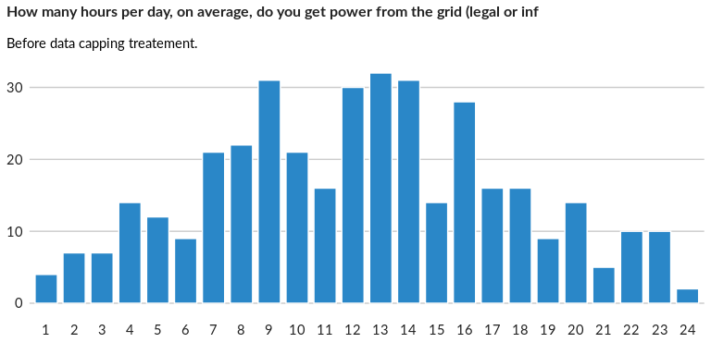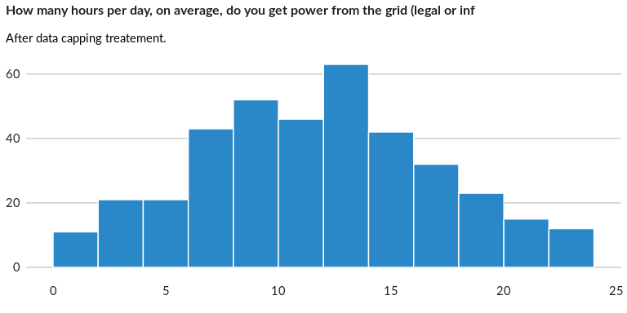

### Analysis of relationship

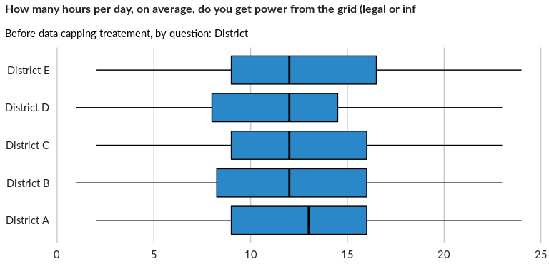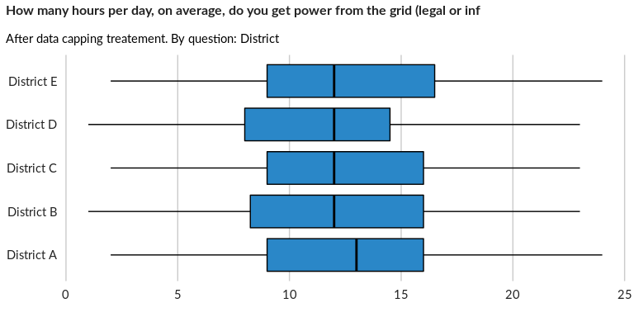

## What are your energy sources for heating/cooking?

NA

Multiple choice question

### Tabulation

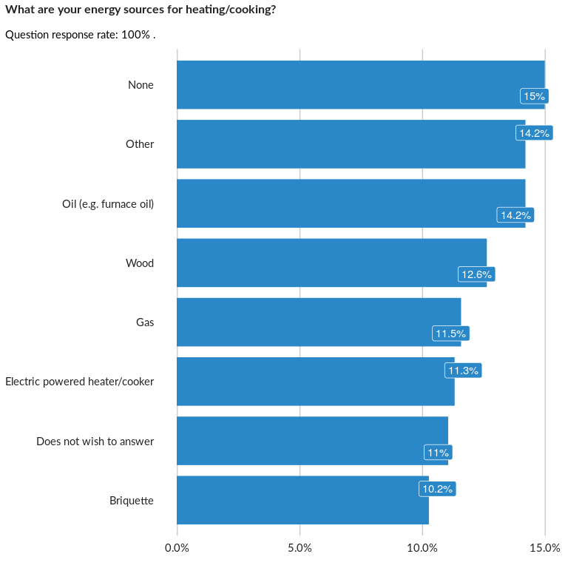

### Analysis of relationship

## Observable Inside/outside the household shelter/property: Shelter structure in d

NA

Single choice question

### Tabulation

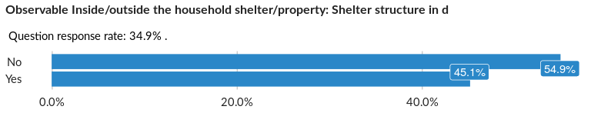

### Cross-tabulations

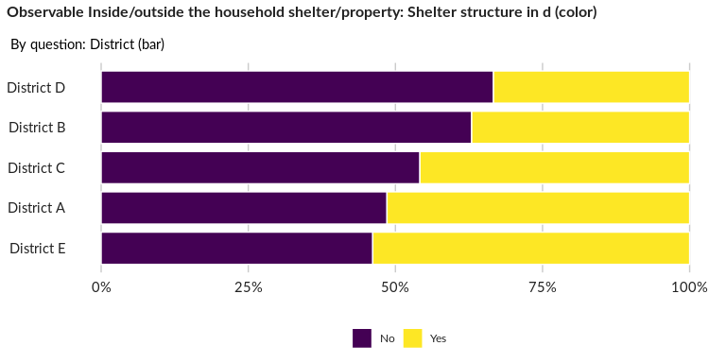

### Significant Associations (chi-square with p value < 5%)

No significant association found for this question…

## Observable Inside/outside the household shelter/property: Damaged roof

NA

Single choice question

### Tabulation

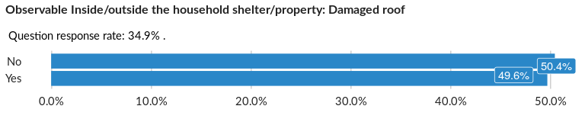

### Cross-tabulations

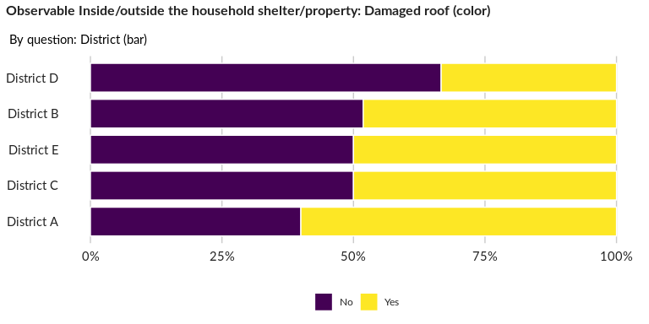

### Significant Associations (chi-square with p value < 5%)

No significant association found for this question…

## Observable Inside/outside the household shelter/property: Damaged columns

NA

Single choice question

### Tabulation

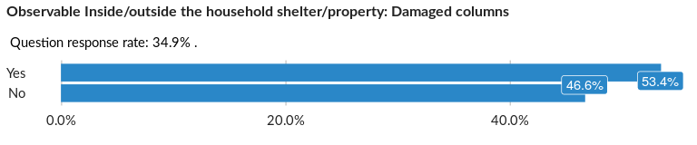

### Cross-tabulations

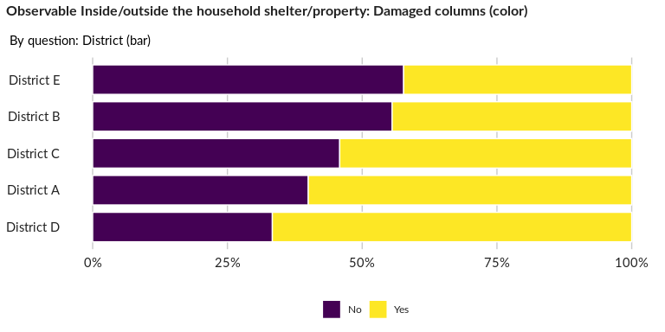

### Significant Associations (chi-square with p value < 5%)

No significant association found for this question…

## Observable Inside/outside the household shelter/property: Windows/doors are not

NA

Single choice question

### Tabulation

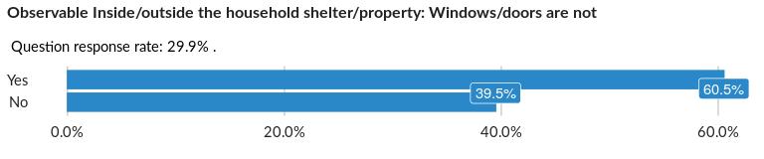

### Cross-tabulations

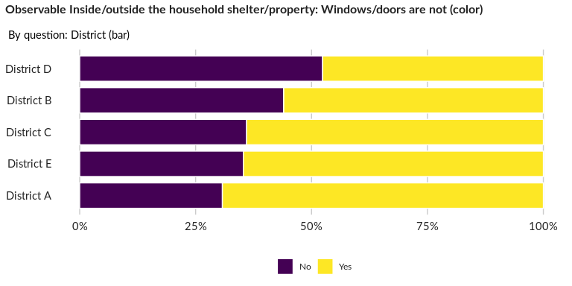

### Significant Associations (chi-square with p value < 5%)

No significant association found for this question…

## Observable Inside/outside the household shelter/property: Leaking roof

NA

Single choice question

### Tabulation

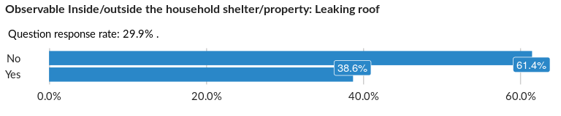

### Cross-tabulations

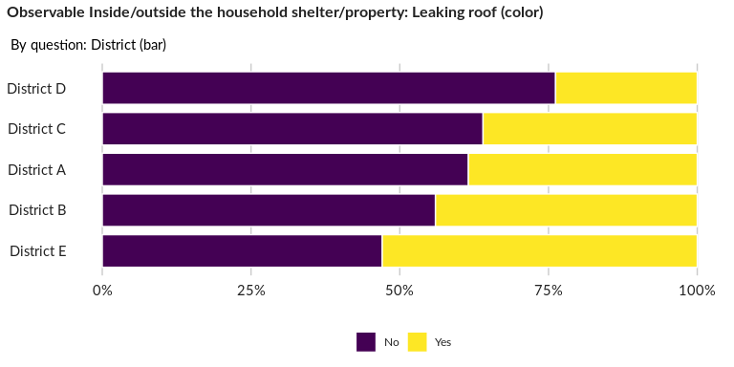

### Significant Associations (chi-square with p value < 5%)

No significant association found for this question…

## Observable Inside/outside the household shelter/property: Leakage / mould in the

NA

Single choice question

### Tabulation

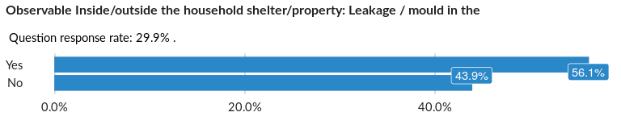

### Cross-tabulations

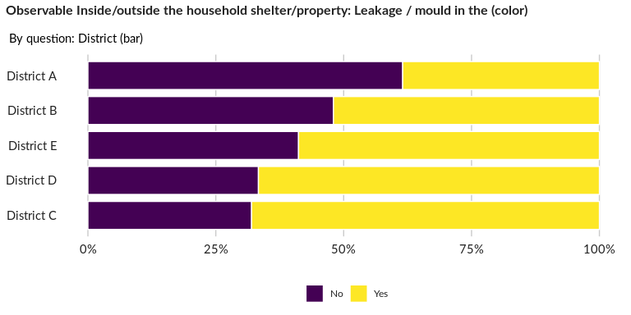

### Significant Associations (chi-square with p value < 5%)

No significant association found for this question…

## Observable Inside/outside the household shelter/property: Damaged walls

NA

Single choice question

### Tabulation

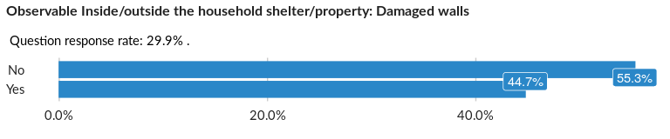

### Cross-tabulations

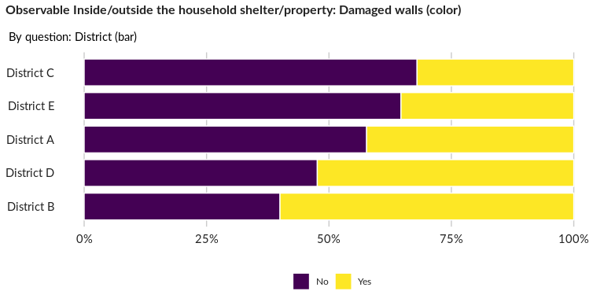

### Significant Associations (chi-square with p value < 5%)

No significant association found for this question…

## Observable Inside/outside the household shelter/property: Water networking not f

NA

Single choice question

### Tabulation

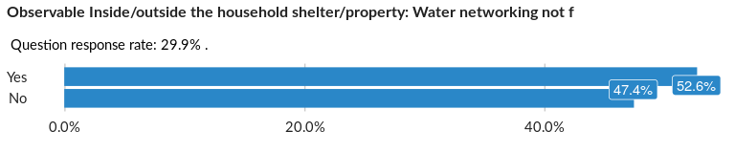

### Cross-tabulations

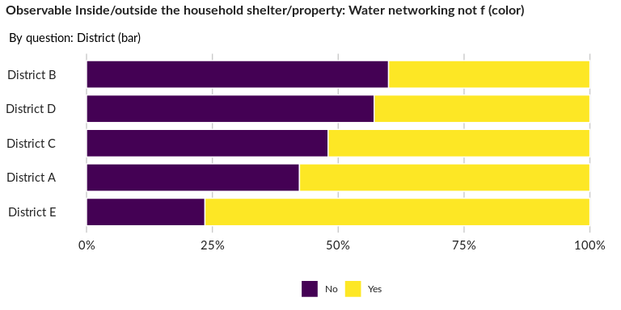

### Significant Associations (chi-square with p value < 5%)

No significant association found for this question…

## Observable Inside/outside the household shelter/property: Latrine/toilet is not

NA

Single choice question

### Tabulation

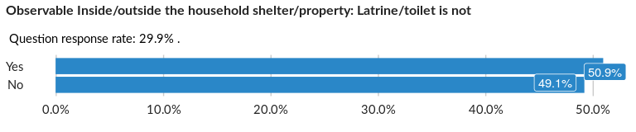

### Cross-tabulations

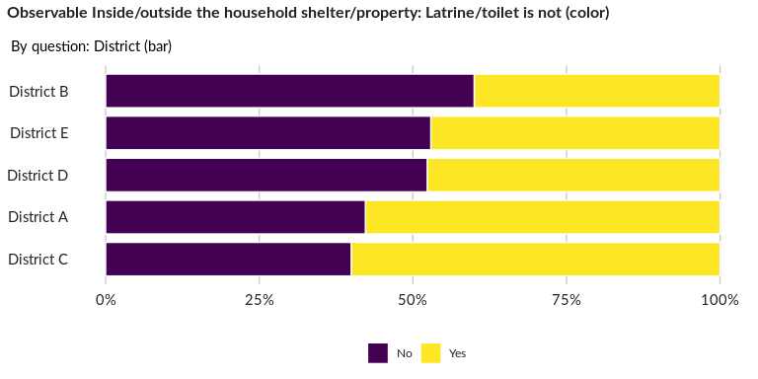

### Significant Associations (chi-square with p value < 5%)

No significant association found for this question…

## Observable Inside/outside the household shelter/property: Bathing/washing facili

NA

Single choice question

### Tabulation

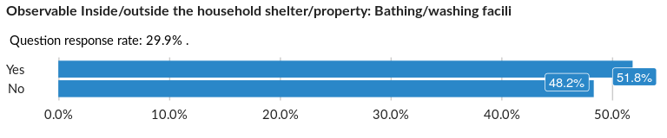

### Cross-tabulations

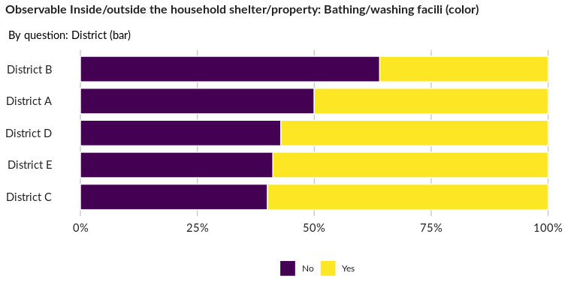

### Significant Associations (chi-square with p value < 5%)

No significant association found for this question…

## Observable Inside/outside the household shelter/property: Electricity installati

NA

Single choice question

### Tabulation

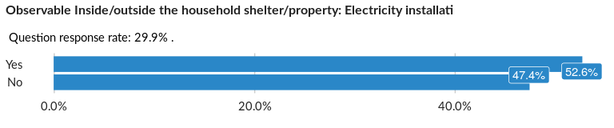

### Cross-tabulations

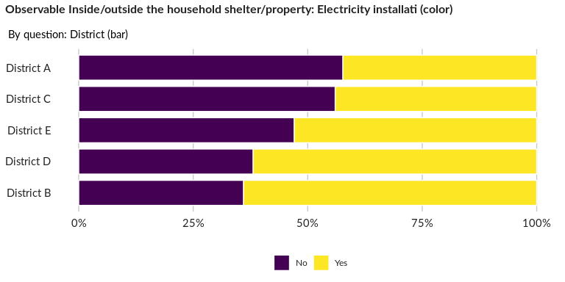

### Significant Associations (chi-square with p value < 5%)

No significant association found for this question…

##### Page Break