Data Crunching Report: WASH- Draft not for distribution.

Generated with [Koboloader](https://unhcr.github.io/koboloadeR/docs)

26 June 2019

Table of Contents

# Introduction

This data crunching report allows to quickly explore the results of the survey that can be regenerated as needed. You can:

* adjust the configuration in the xlsform to break it into chapter;
* configure disaggregation & correlation for each questions;
* revise the data cleansing based on the cleaning log;
* add weight to each observation in order to account for a specific sampling plan;
* append calculated indicators to your data frame.

The objective of this report is to allow to quickly identify potential patterns in your dataset. A quick screening of this initial report should allow to select the most meaningful graphs. A data digest from this initial report can be then reviewed through a **data analysis workshop** where subject matter experts can contribute with qualitative components. When analyzing those representations in a collective setting, you may:

* **Reflect**: question data quality and/or make suggestions to change questions;
* **Interpret**: develop qualitative interpretations of data patterns;
* **Recommend**: develop recommendation in terms of programmatic adjustment;
* **Classify**: order the level of sensitivity for the information;

# Compilation of questions results

## What is the main source of water for cooking?

NA

Single choice question

### Tabulation

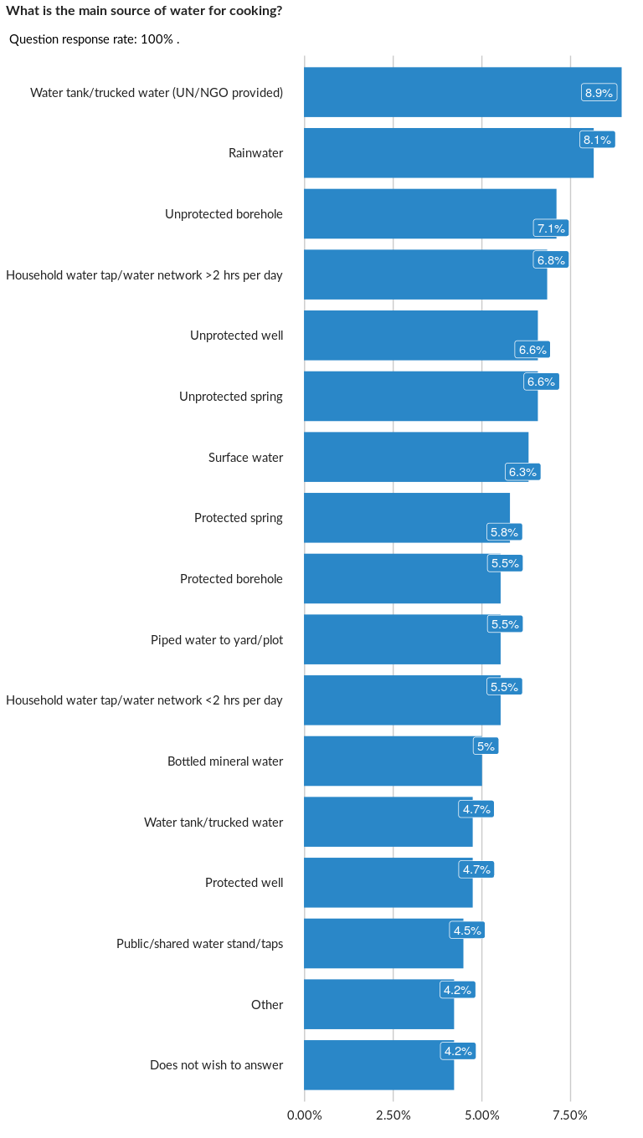

### Cross-tabulations

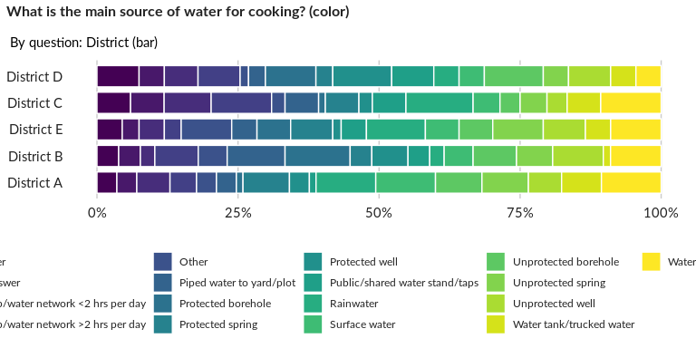

### Significant Associations (chi-square with p value < 5%)

No significant association found for this question…

## Do you use the same water for drinking?

NA

Single choice question

### Tabulation

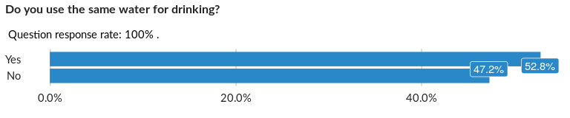

### Cross-tabulations

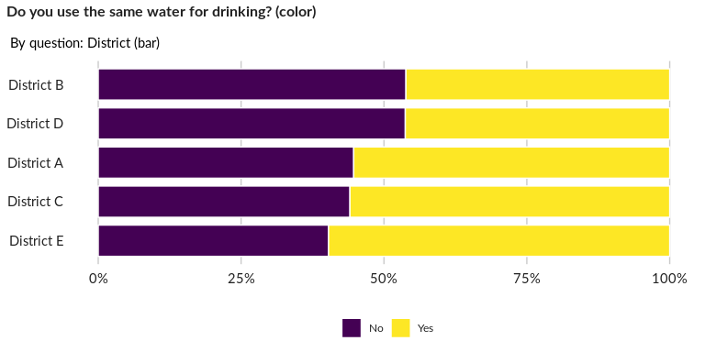

### Significant Associations (chi-square with p value < 5%)

No significant association found for this question…

## If not, what is the main source of water for drinking?

NA

Single choice question

### Tabulation

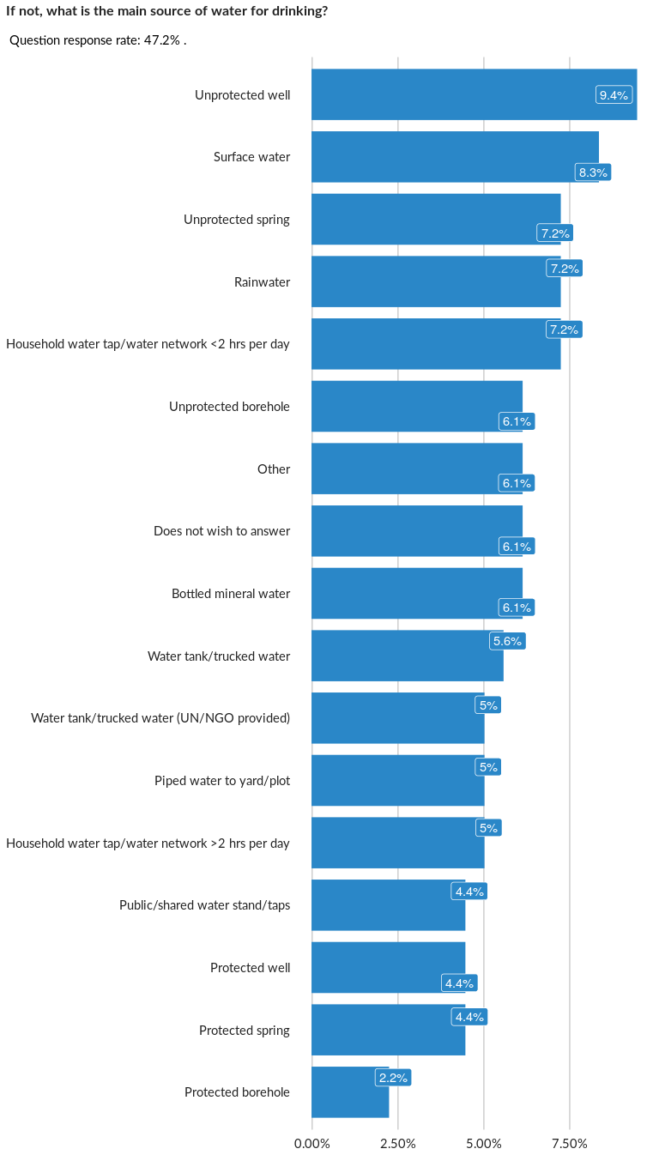

### Cross-tabulations

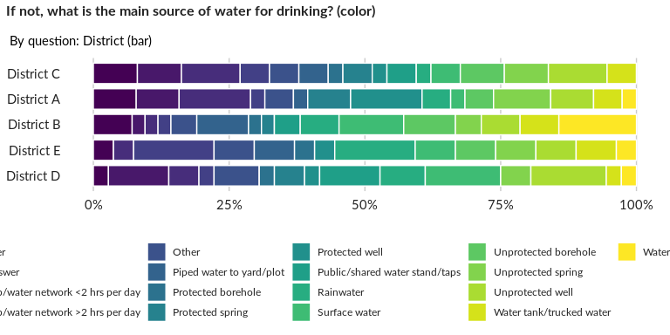

### Significant Associations (chi-square with p value < 5%)

No significant association found for this question…

## What is the main source of water for washing and domestic purposes?

NA

Single choice question

### Tabulation

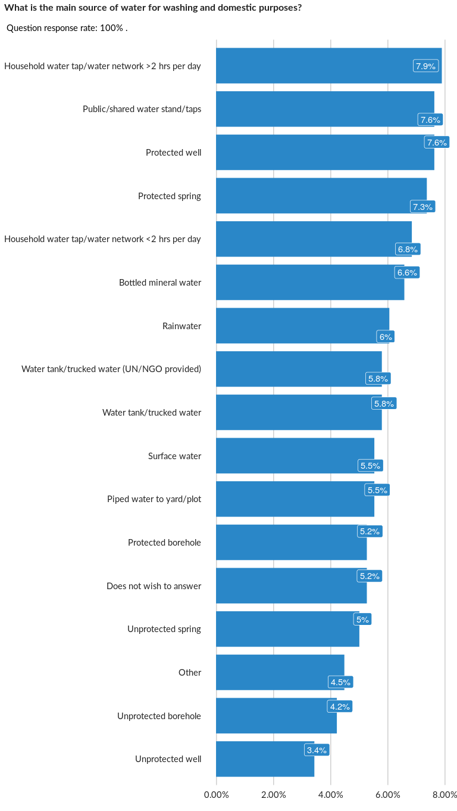

### Cross-tabulations

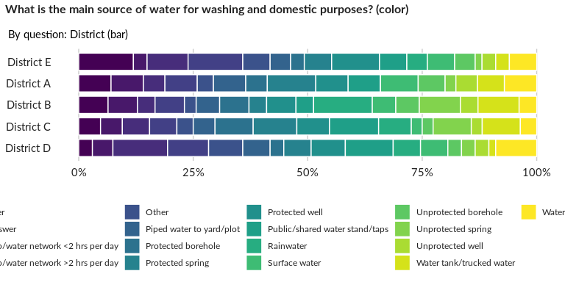

### Significant Associations (chi-square with p value < 5%)

No significant association found for this question…

## How many bathrooms (or washrooms) does your household have access to?

NA

Numeric question

### Tabulation

Based on the sample design, the average weighted mean response for this question is 50.21

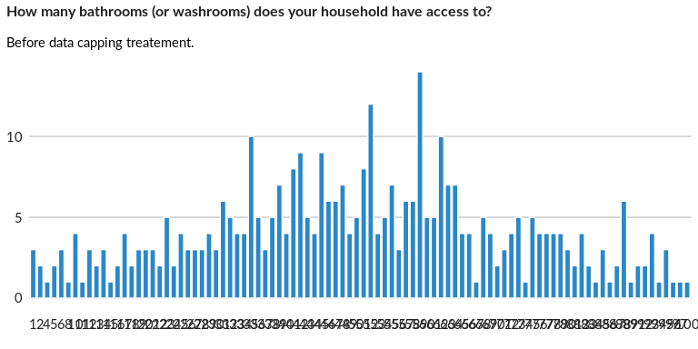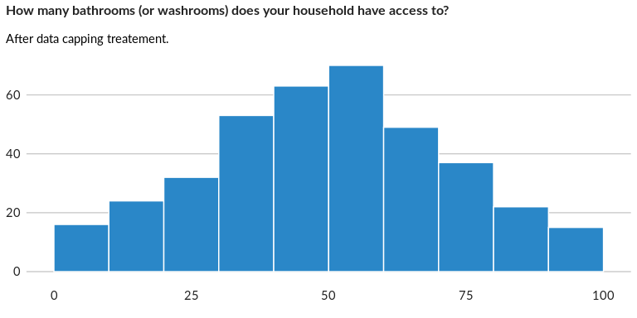

### Analysis of relationship

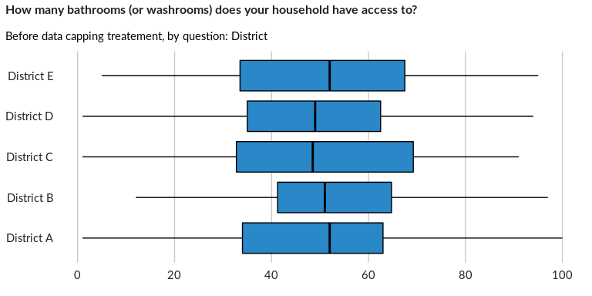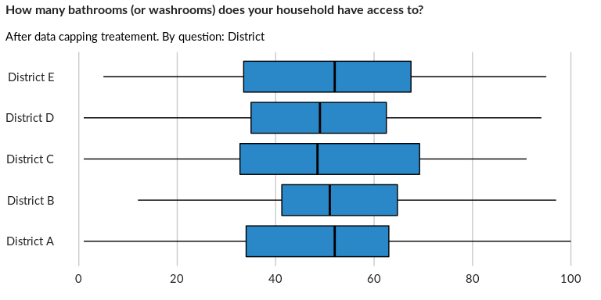

## How many people share the/these bathroom/s?

NA

Numeric question

### Tabulation

Based on the sample design, the average weighted mean response for this question is 49.06

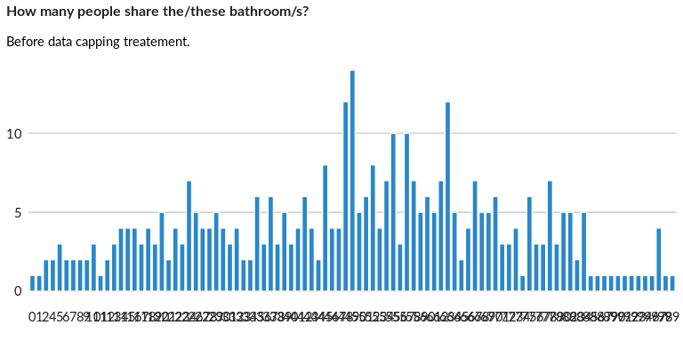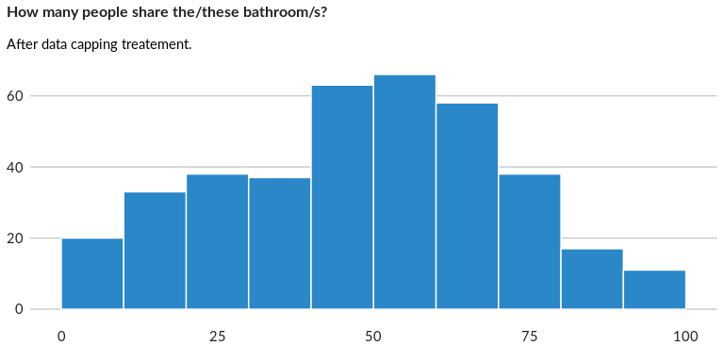

### Analysis of relationship

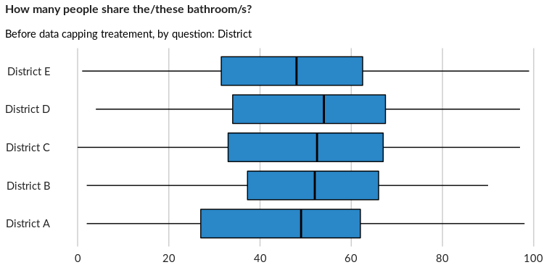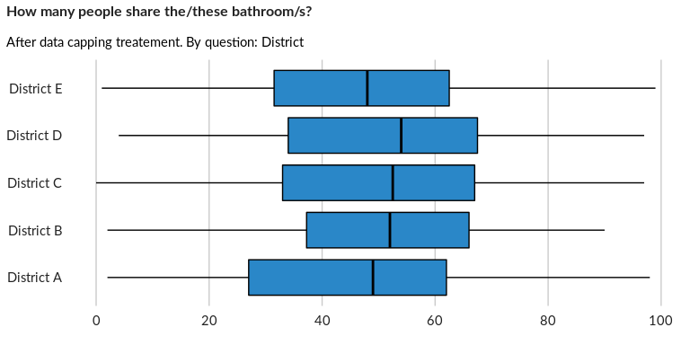

## How many toilets/latrines does your household have access to?

NA

Numeric question

### Tabulation

Based on the sample design, the average weighted mean response for this question is 50.49

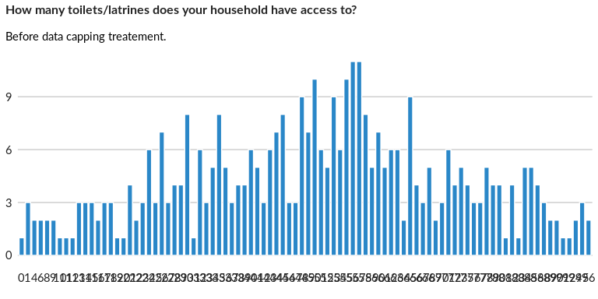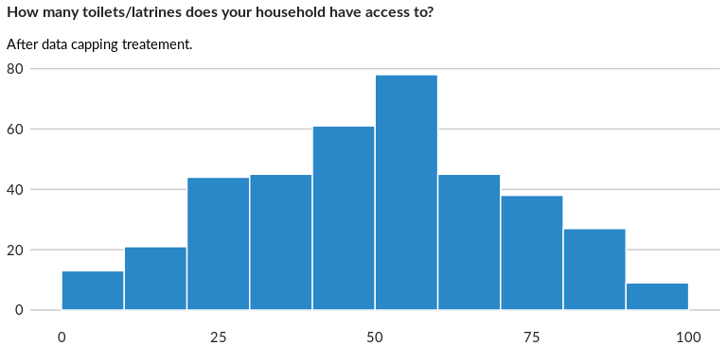

### Analysis of relationship

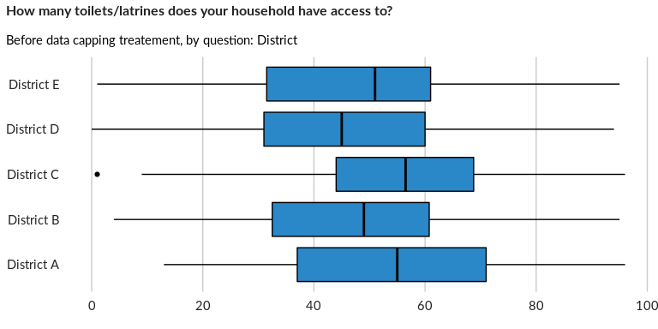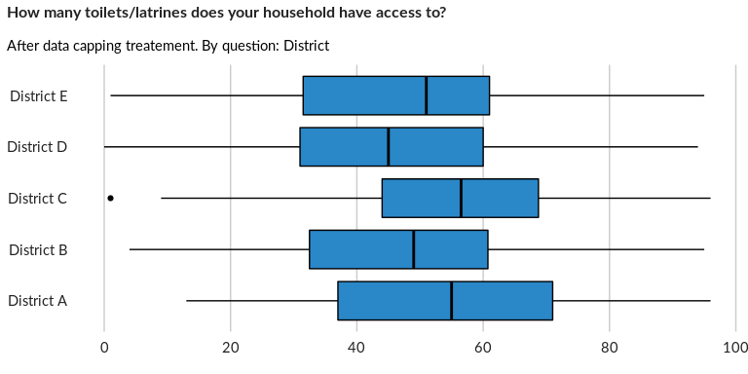

## Do you share this/these toilets/latrines with another household?

NA

Single choice question

### Tabulation

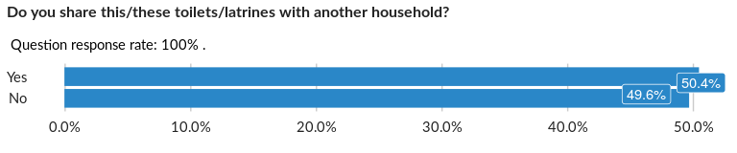

### Cross-tabulations

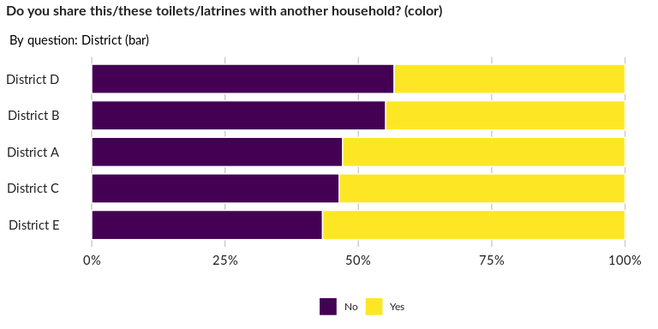

### Significant Associations (chi-square with p value < 5%)

No significant association found for this question…

## How many people share the/these toilets/latrines?

NA

Numeric question

### Tabulation

Based on the sample design, the average weighted mean response for this question is 47.73

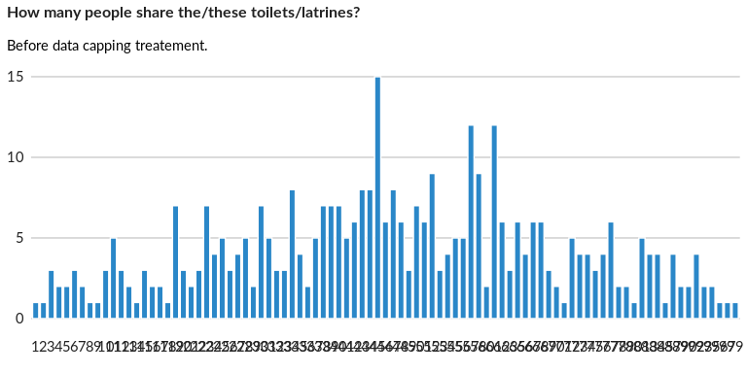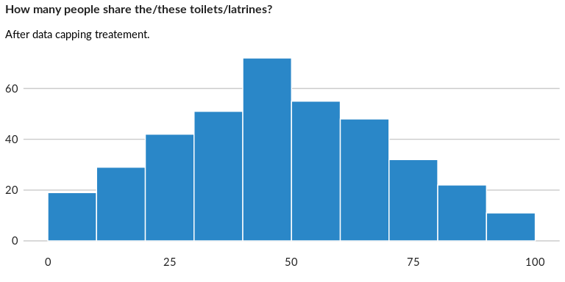

### Analysis of relationship

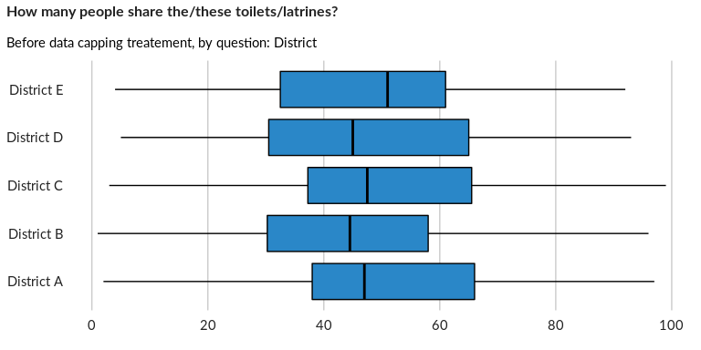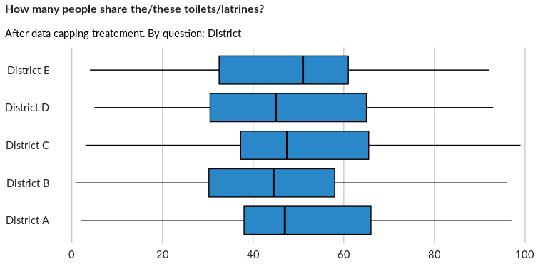

## What kind of toilet/latrine does the household use?

NA

Multiple choice question

### Tabulation

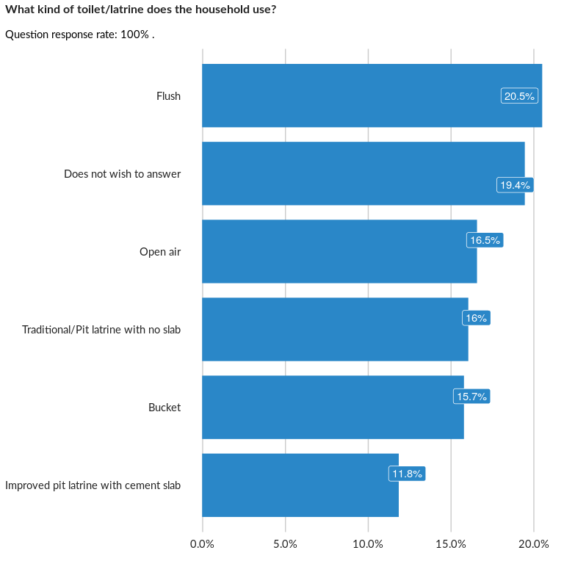

### Analysis of relationship

## Where is the latrine’s wastewater disposed?

NA

Multiple choice question

### Tabulation

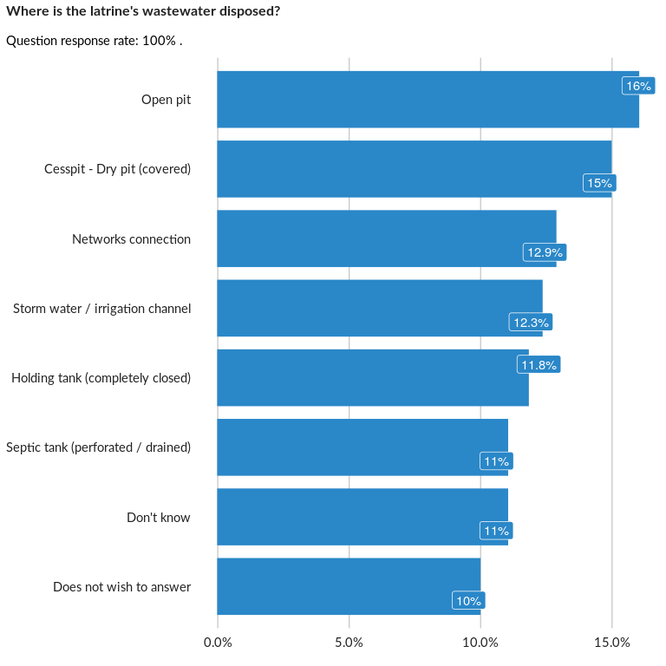

### Analysis of relationship

## Have you received any desludging services (removal of wastewater from septic tan

NA

Single choice question

### Tabulation

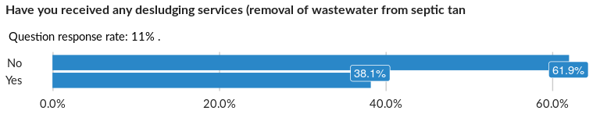

### Cross-tabulations

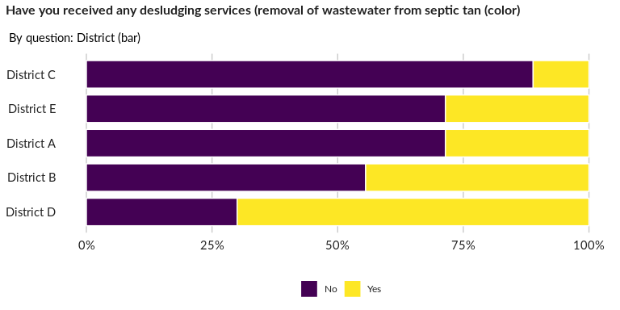

### Significant Associations (chi-square with p value < 5%)

No significant association found for this question…

## Personal hygiene items (soap, toothbrush/paste, other personal hygiene items) -

NA

Single choice question

### Tabulation

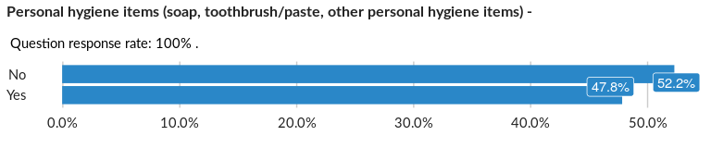

### Cross-tabulations

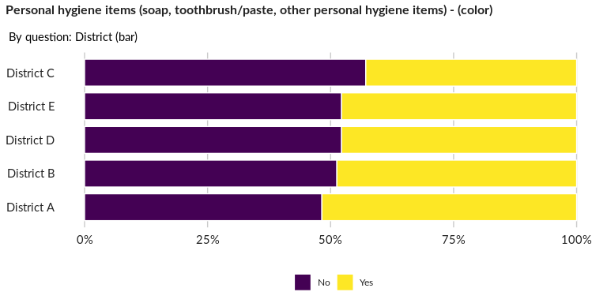

### Significant Associations (chi-square with p value < 5%)

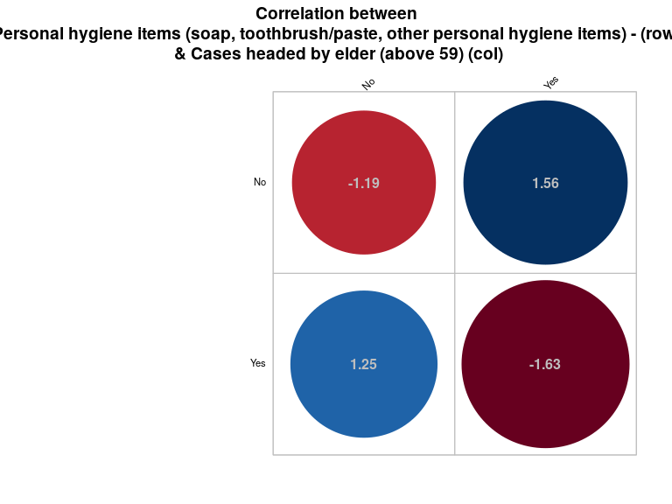

## Cleaning/hygiene items (laundry detergent, cleaning products etc)

NA

Single choice question

### Tabulation

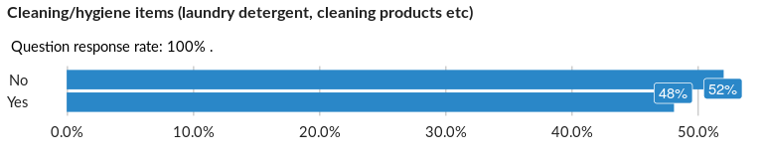

### Cross-tabulations

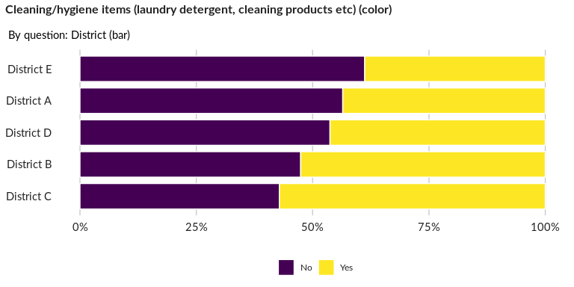

### Significant Associations (chi-square with p value < 5%)

No significant association found for this question…

## Female hygiene/dignity items

NA

Single choice question

### Tabulation

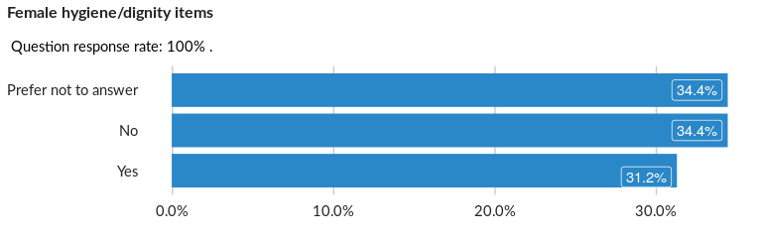

### Cross-tabulations

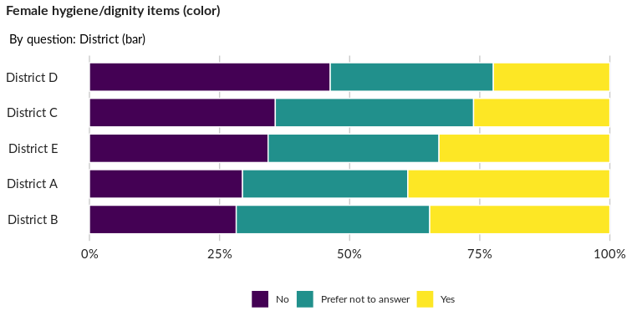

### Significant Associations (chi-square with p value < 5%)

No significant association found for this question…

## Baby care items (diapers, etc.)

NA

Single choice question

### Tabulation

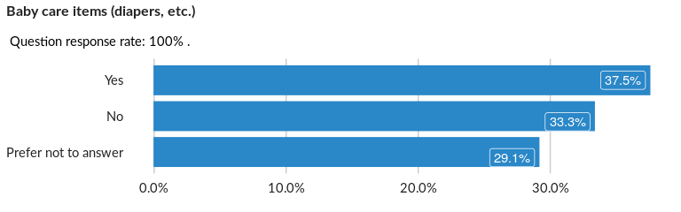

### Cross-tabulations

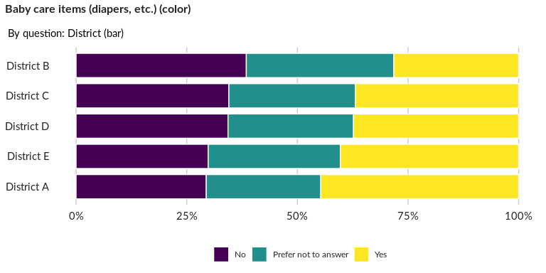

### Significant Associations (chi-square with p value < 5%)

No significant association found for this question…

##### Page Break