Data Crunching Report: Budget_analysis- Draft not for distribution.

Generated with [Koboloader](https://unhcr.github.io/koboloadeR/docs)

26 June 2019

Table of Contents

# Introduction

This data crunching report allows to quickly explore the results of the survey that can be regenerated as needed. You can:

* adjust the configuration in the xlsform to break it into chapter;
* configure disaggregation & correlation for each questions;
* revise the data cleansing based on the cleaning log;
* add weight to each observation in order to account for a specific sampling plan;
* append calculated indicators to your data frame.

The objective of this report is to allow to quickly identify potential patterns in your dataset. A quick screening of this initial report should allow to select the most meaningful graphs. A data digest from this initial report can be then reviewed through a **data analysis workshop** where subject matter experts can contribute with qualitative components. When analyzing those representations in a collective setting, you may:

* **Reflect**: question data quality and/or make suggestions to change questions;
* **Interpret**: develop qualitative interpretations of data patterns;
* **Recommend**: develop recommendation in terms of programmatic adjustment;
* **Classify**: order the level of sensitivity for the information;

# Compilation of questions results

## Does your household currently have access to the following items to cover househ

NA

Multiple choice question

### Tabulation

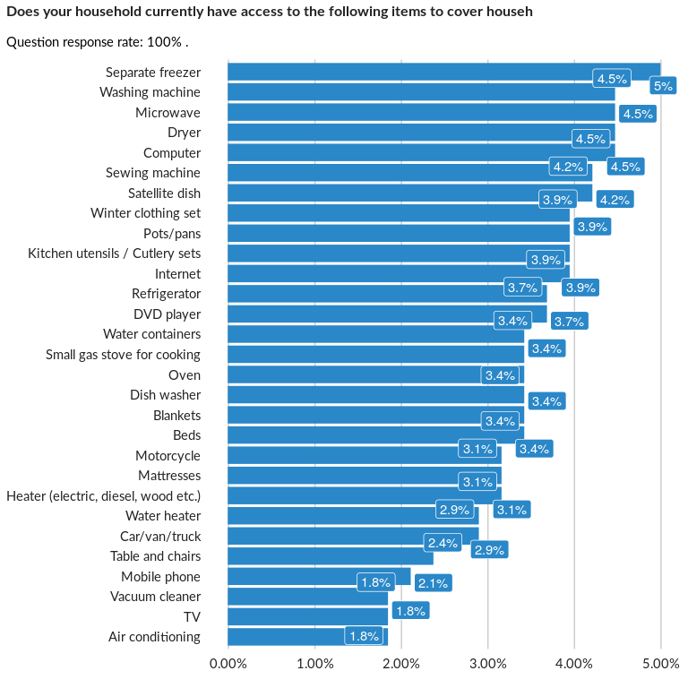

### Analysis of relationship

## During the past 3 months (90 days), did any member of the household borrow money

NA

Single choice question

### Tabulation

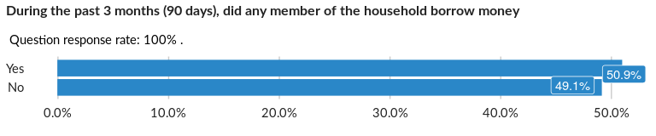

### Cross-tabulations

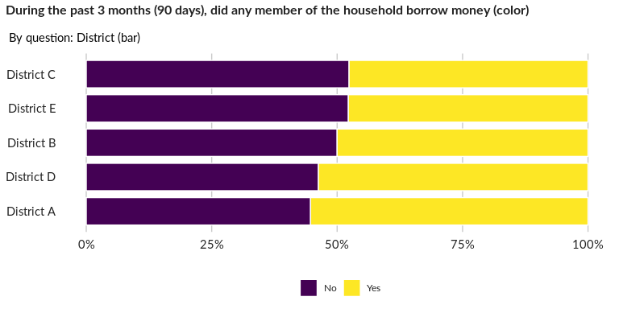

### Significant Associations (chi-square with p value < 5%)

No significant association found for this question…

## Please specify - member of the household borrowed money and/or received credit

NA

Multiple choice question

### Tabulation

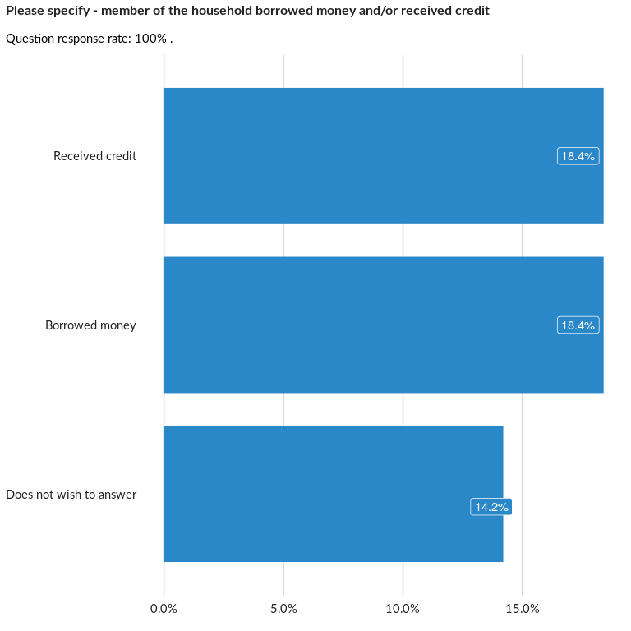

### Analysis of relationship

## What were the primary reasons for borrowing?

NA

Multiple choice question

### Tabulation

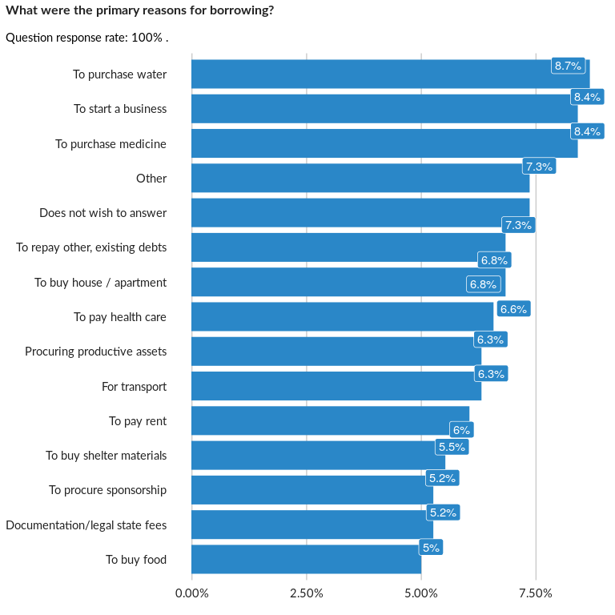

### Analysis of relationship

## From whom did you get the credit or borrow the money?

NA

Multiple choice question

### Tabulation

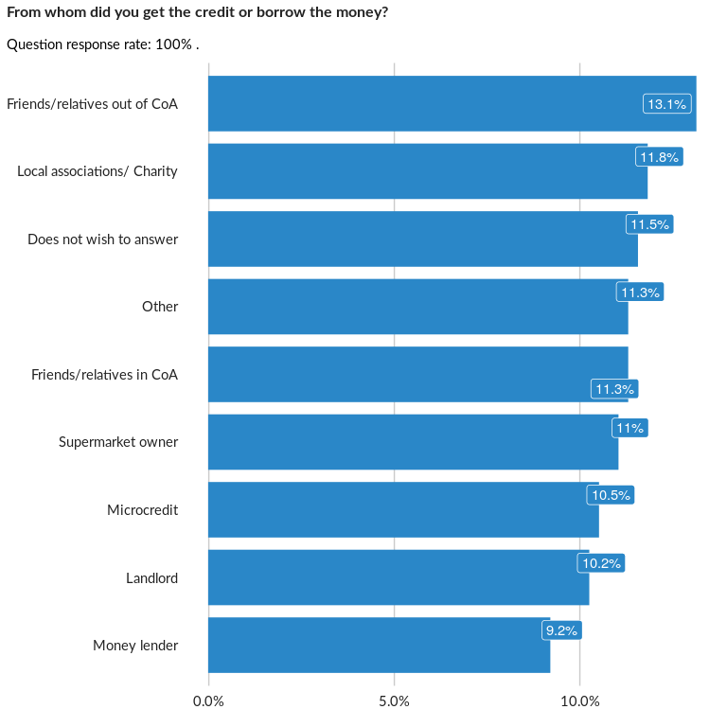

### Analysis of relationship

## What is the current total debt up to now from borrowing money that has not yet b

NA

Numeric question

### Tabulation

Based on the sample design, the average weighted mean response for this question is 23957.8

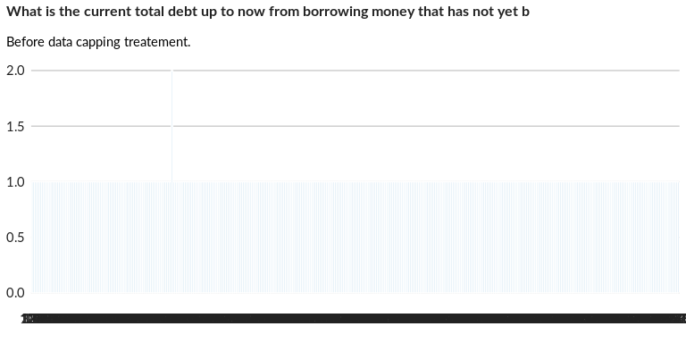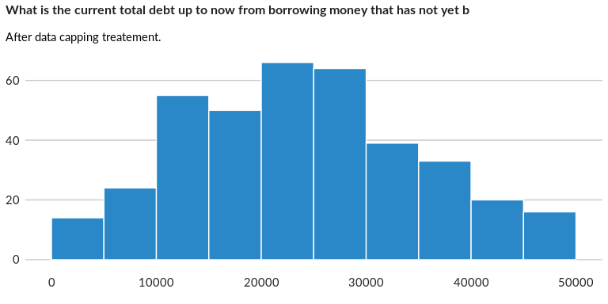

### Analysis of relationship

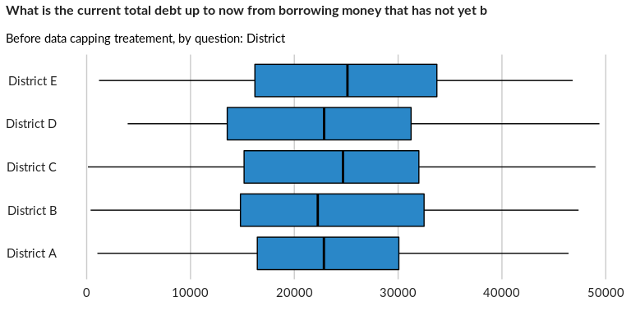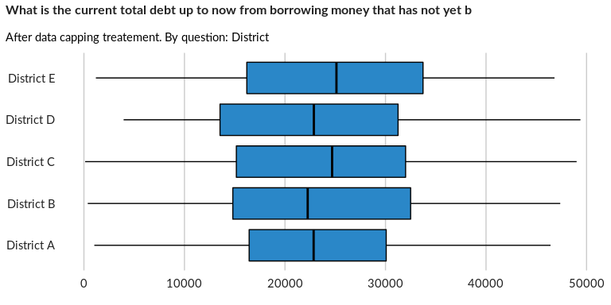

## What is the current total debt up to now from receiving credit that has not yet

NA

Numeric question

### Tabulation

Based on the sample design, the average weighted mean response for this question is 25654.95

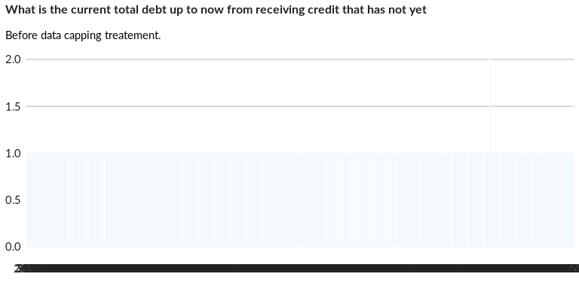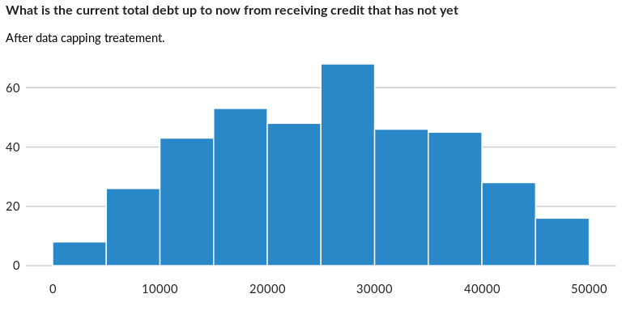

### Analysis of relationship

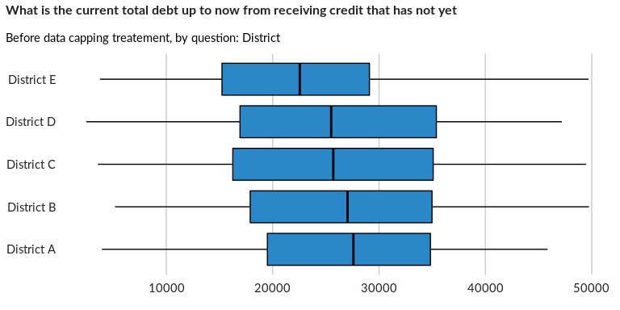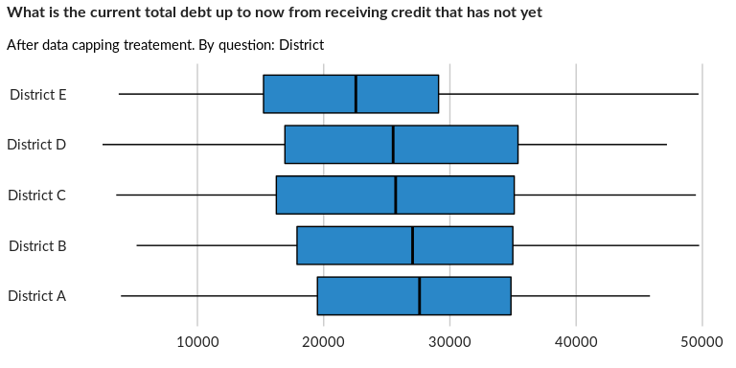

## In the past 30 days, what was the MAIN source of cash/income used to sustain you

NA

Single choice question

### Tabulation

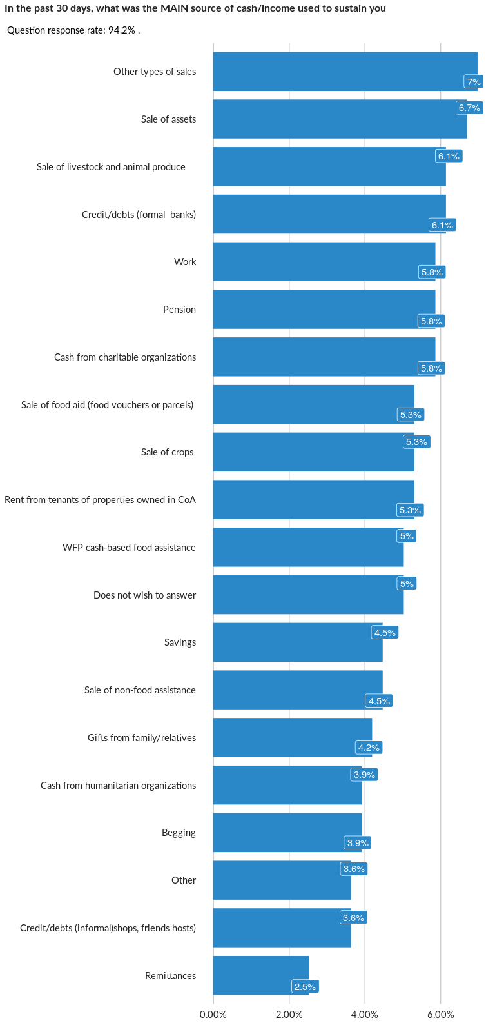

### Cross-tabulations

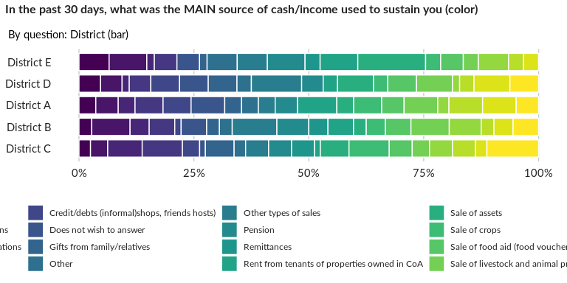

### Significant Associations (chi-square with p value < 5%)

No significant association found for this question…

## In the past 30 days, what would you say were other main sources of cash/income u

NA

Multiple choice question

### Tabulation

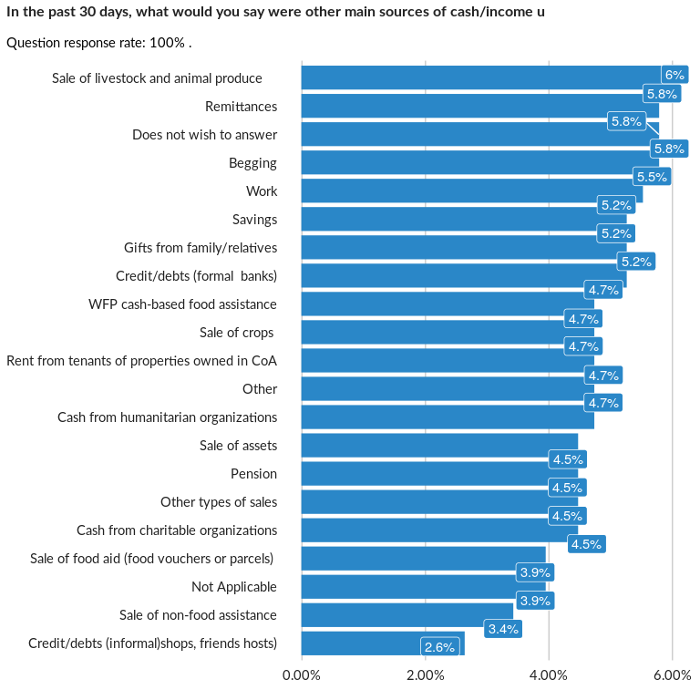

### Analysis of relationship

## What is the total amount of remittances from friends and family outside the coun

Add comment that constraint has to be changed according to local currency norms

Numeric question

### Tabulation

Based on the sample design, the average weighted mean response for this question is 24955.35

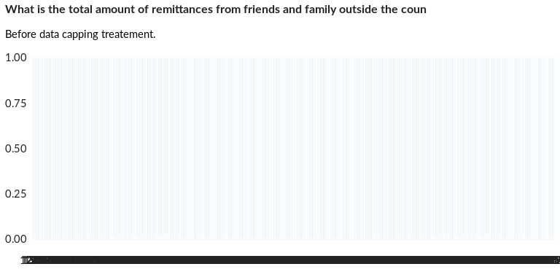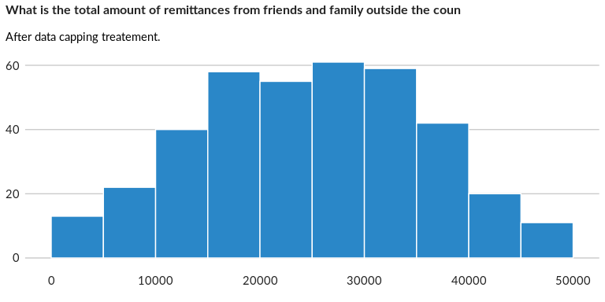

### Analysis of relationship

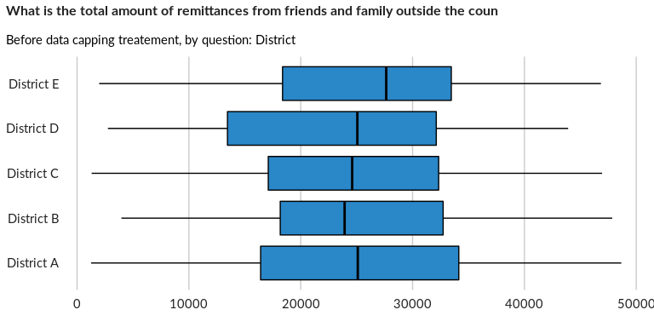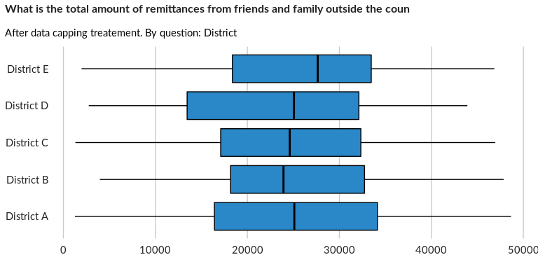

## In the past 30 days, what was the total income (from employment) of all the hous

NA

Numeric question

### Tabulation

Based on the sample design, the average weighted mean response for this question is 25157.77

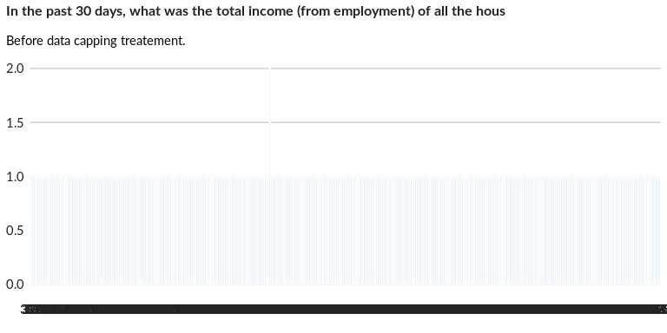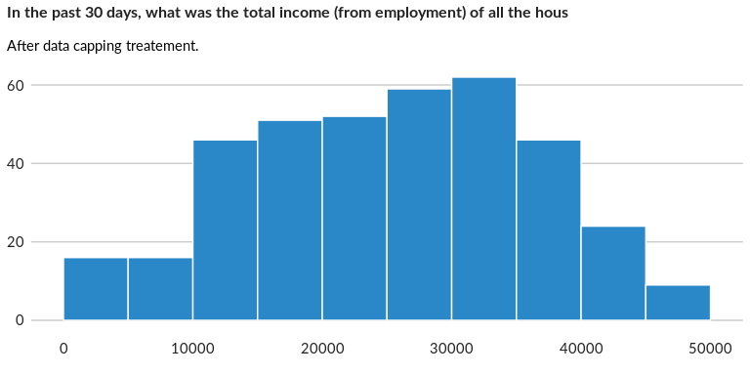

### Analysis of relationship

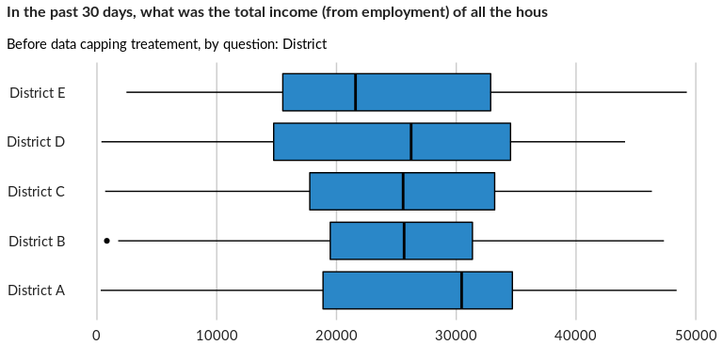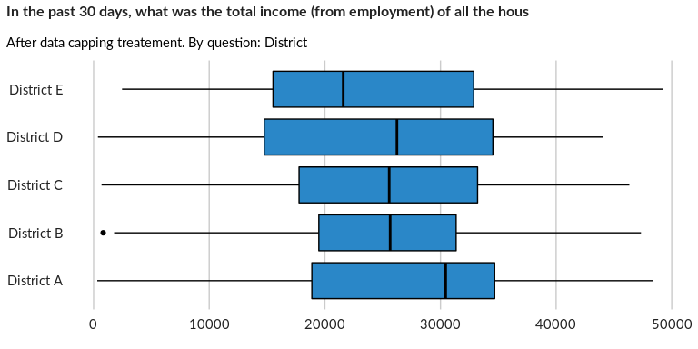

## Over the past 30 days, what was the total household expenditure? (In local curre

NA

Numeric question

### Tabulation

Based on the sample design, the average weighted mean response for this question is 24852.84

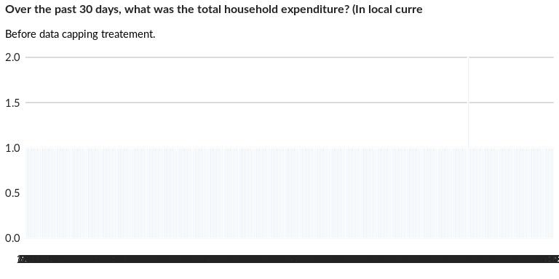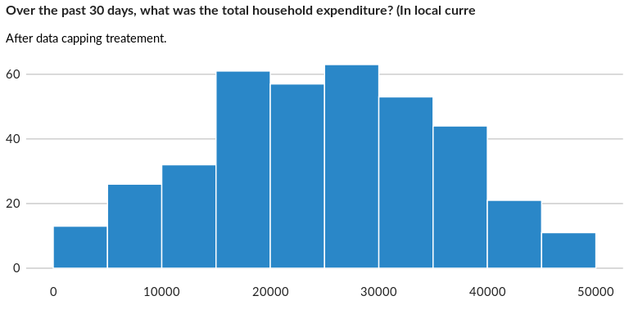

### Analysis of relationship

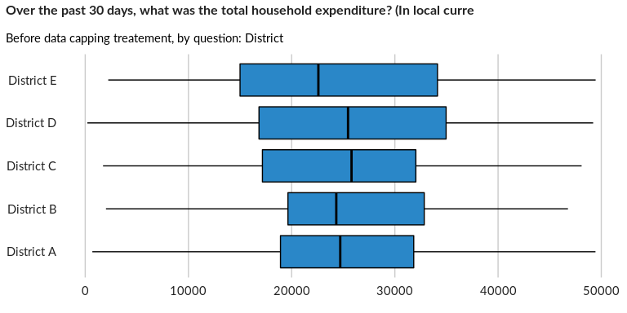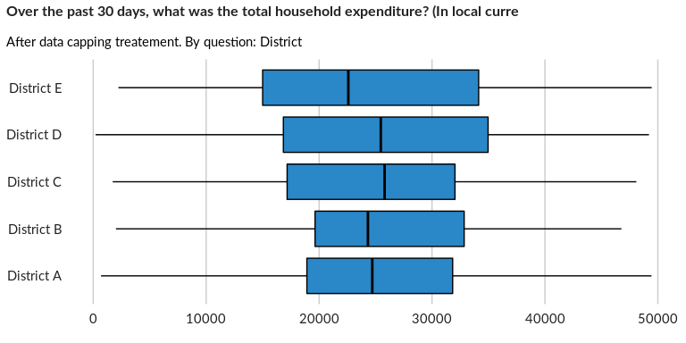

## Amount spent by the household during the past 30 days on food

Do you share this with anyone who is not registered on the same case as you? Ask Paolo how to deal with situation where our sample unit does not live on their own and how do we record expenditure

Numeric question

### Tabulation

Based on the sample design, the average weighted mean response for this question is 5127.82

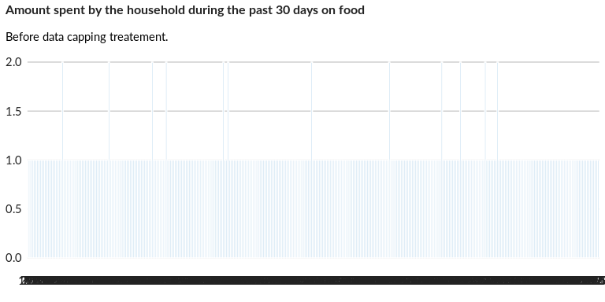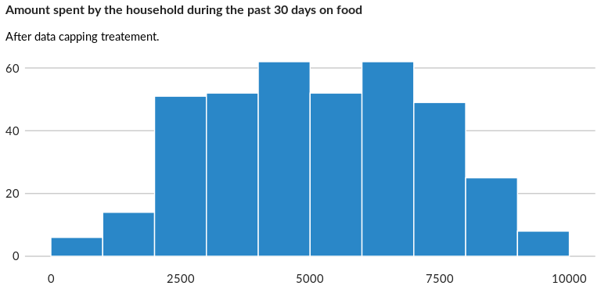

### Analysis of relationship

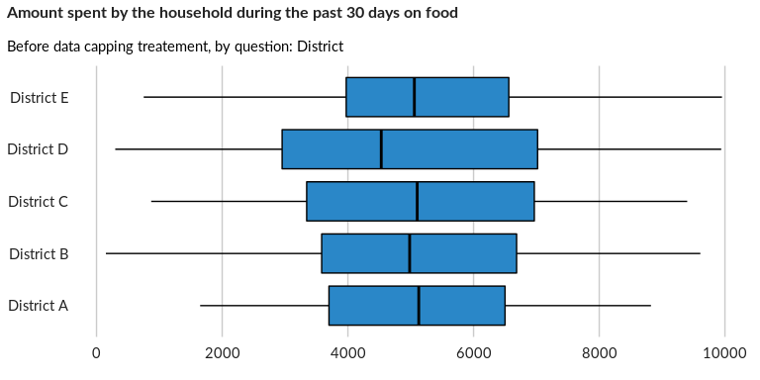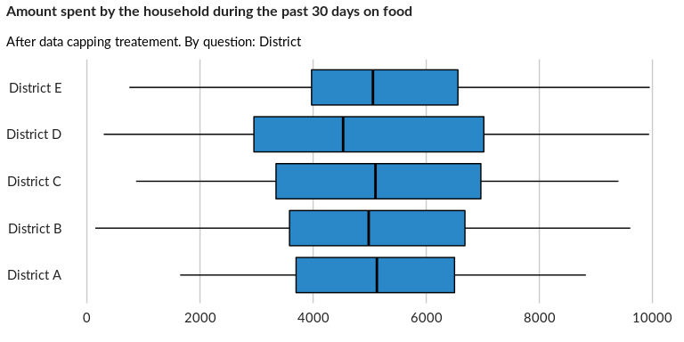

## Amount spent by the household during the past 30 days on health and medical cost

NA

Numeric question

### Tabulation

Based on the sample design, the average weighted mean response for this question is 4887.95

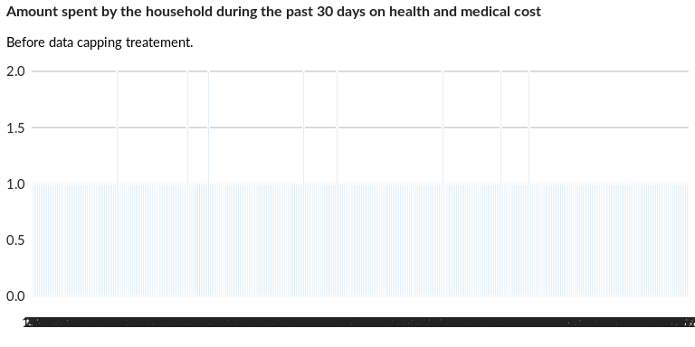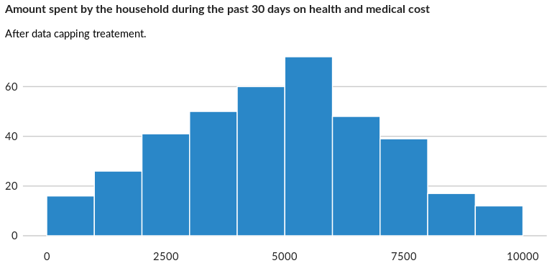

### Analysis of relationship

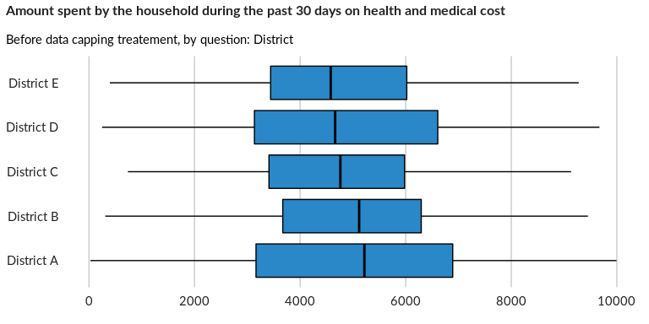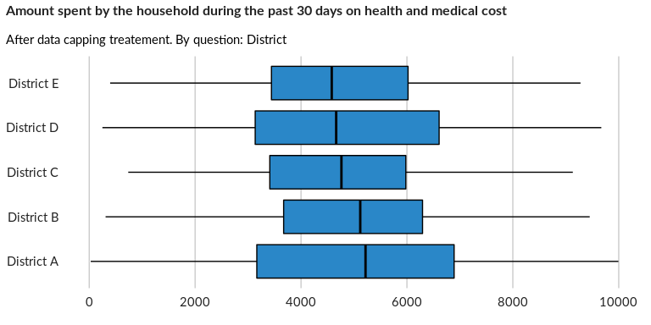

## Amount spent by the household during the past 30 days on education costs (includ

NA

Numeric question

### Tabulation

Based on the sample design, the average weighted mean response for this question is 5004.86

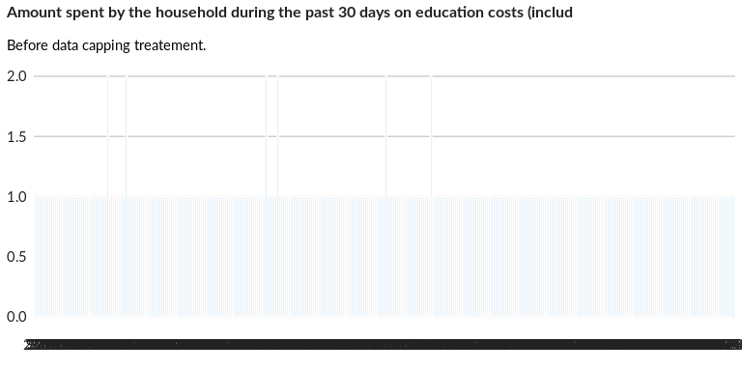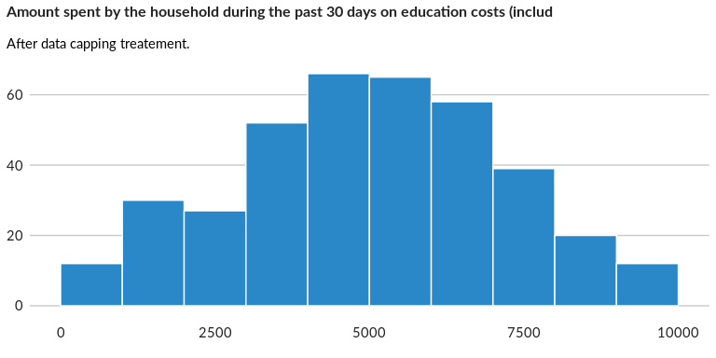

### Analysis of relationship

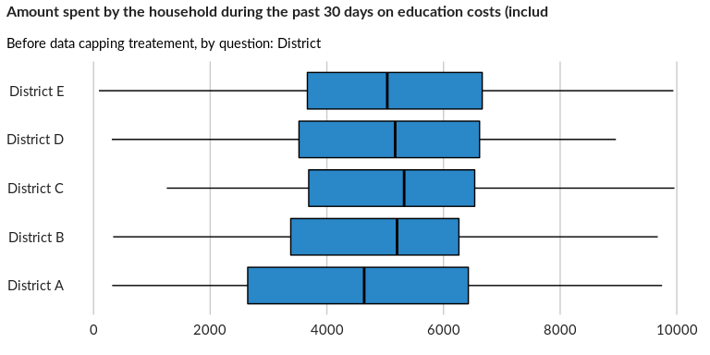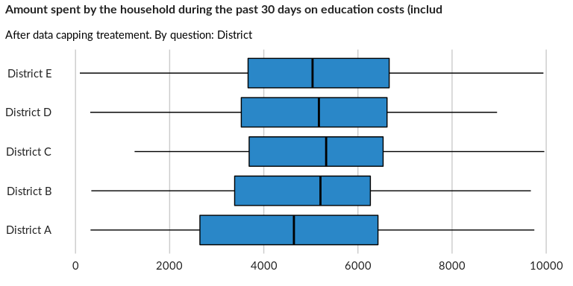

## Amount spent by the household during the past 30 days on rent

NA

Numeric question

### Tabulation

Based on the sample design, the average weighted mean response for this question is 5029.67

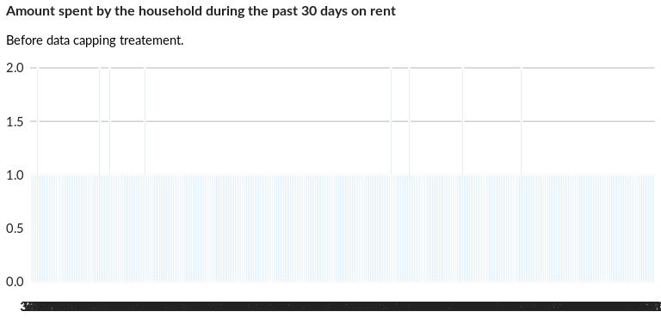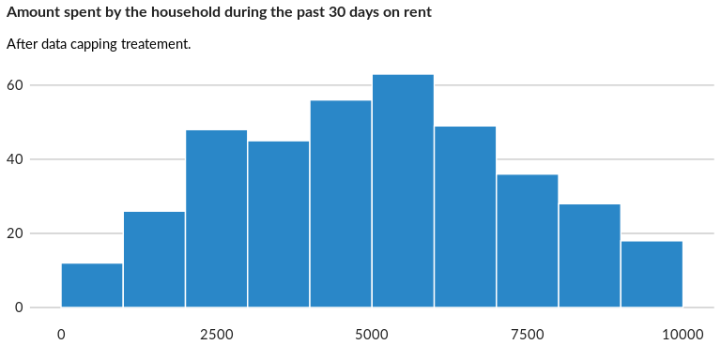

### Analysis of relationship

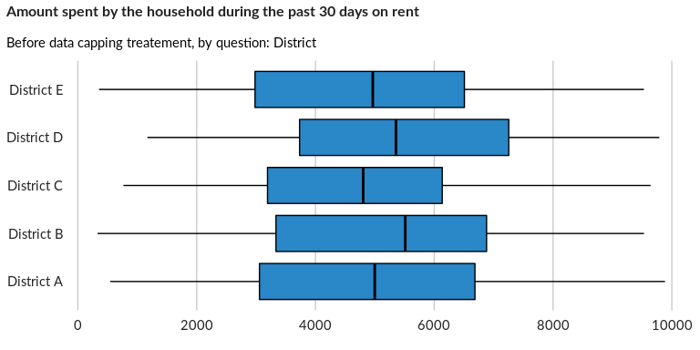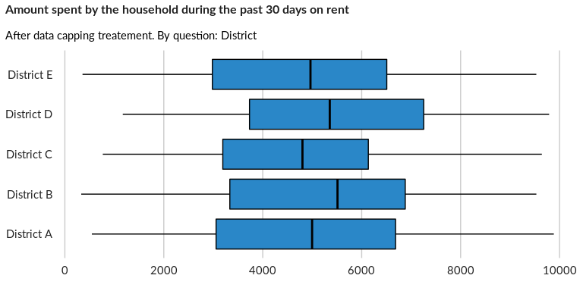

## Amount spent by the household during the past 30 days on shelter materials

NA

Numeric question

### Tabulation

Based on the sample design, the average weighted mean response for this question is 4925.95

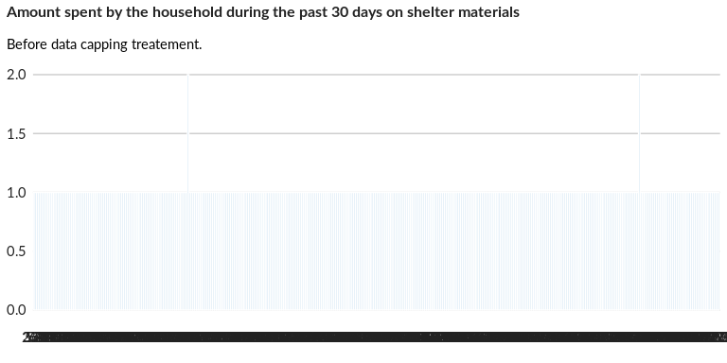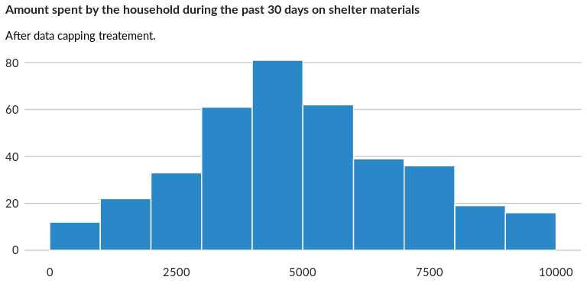

### Analysis of relationship

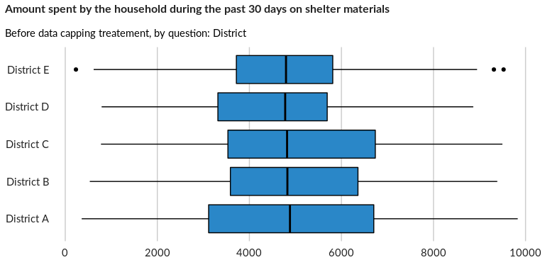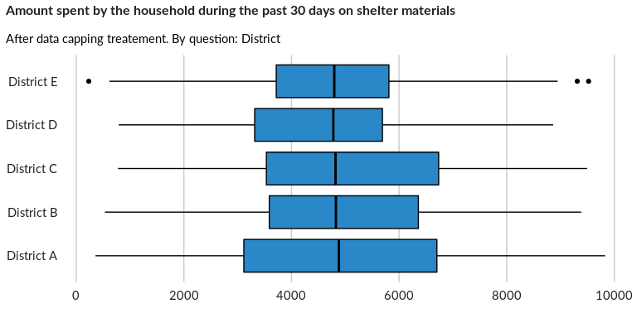

## Amount spent by the household during the past 30 days on water

NA

Numeric question

### Tabulation

Based on the sample design, the average weighted mean response for this question is 5104.64

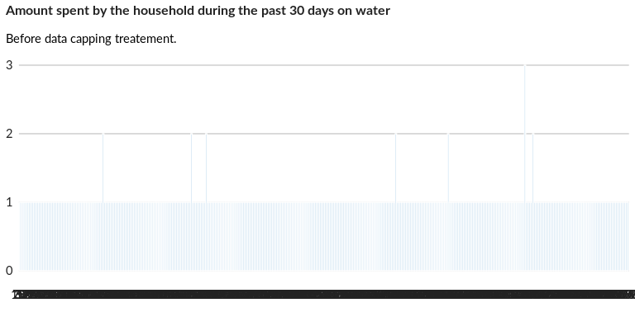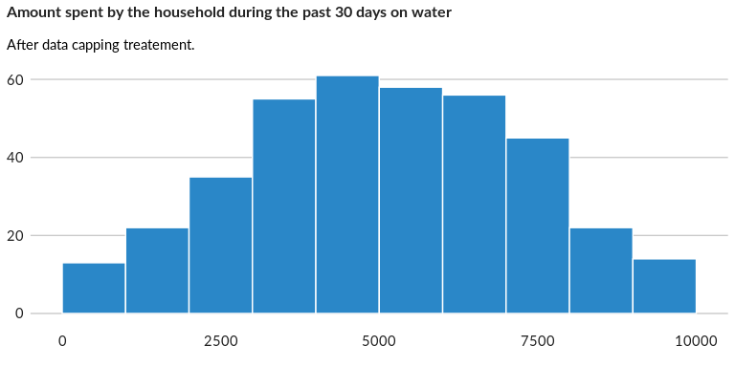

### Analysis of relationship

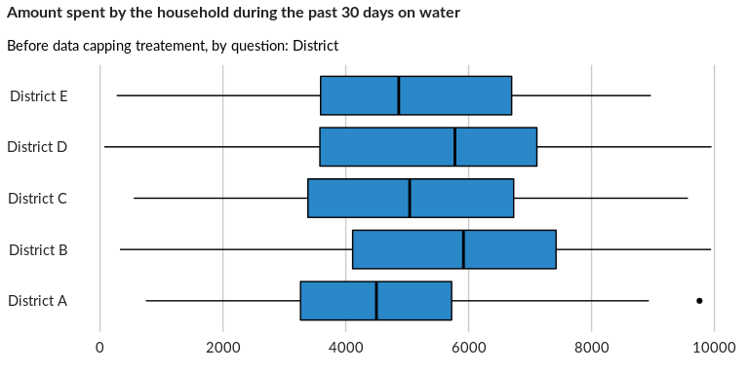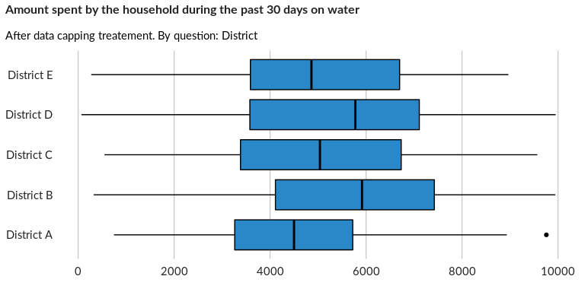

## Amount spent by the household during the past 30 days on gas

NA

Numeric question

### Tabulation

Based on the sample design, the average weighted mean response for this question is 4931.14

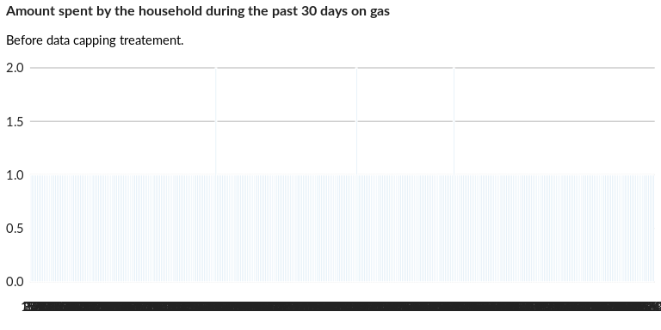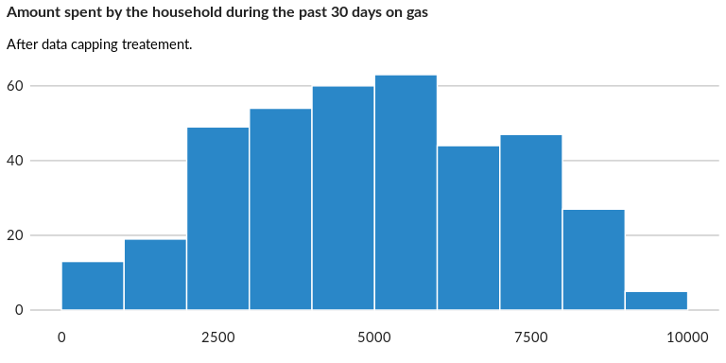

### Analysis of relationship

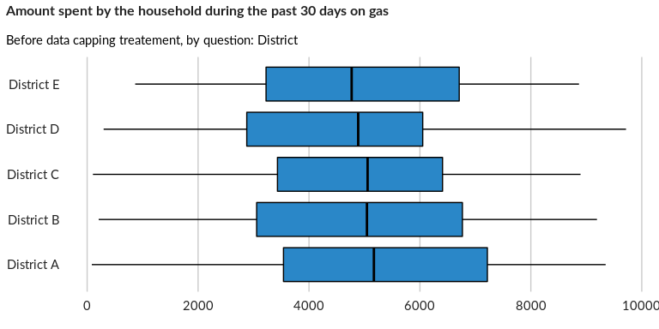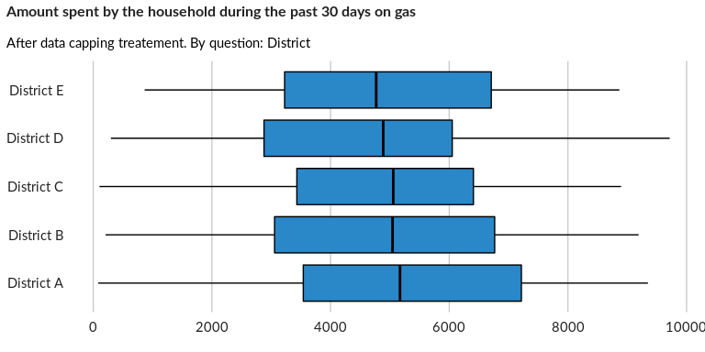

## Amount spent by the household during the past 30 days on fuel (do not include fu

NA

Numeric question

### Tabulation

Based on the sample design, the average weighted mean response for this question is 5033.04

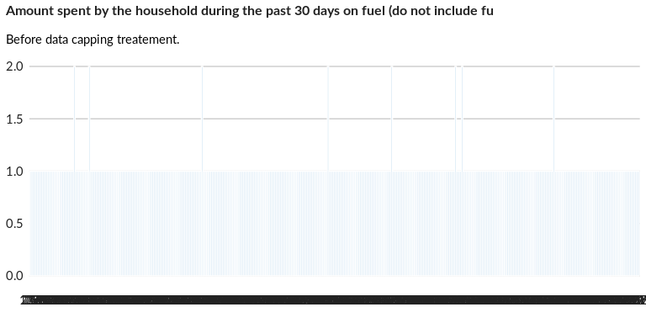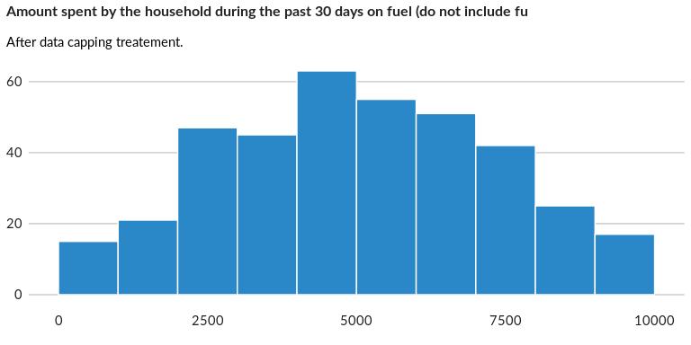

### Analysis of relationship

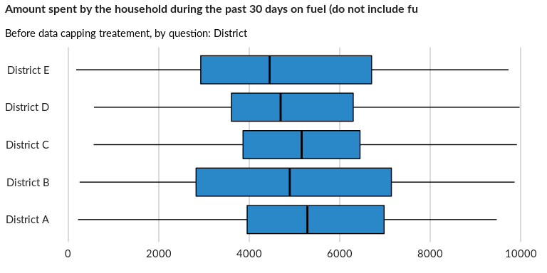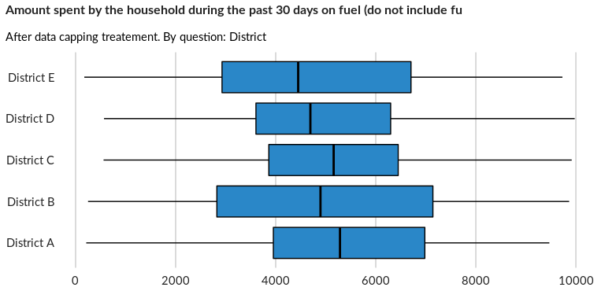

## Amount spent by the household during the past 30 days on transport (including fu

NA

Numeric question

### Tabulation

Based on the sample design, the average weighted mean response for this question is 4953.2

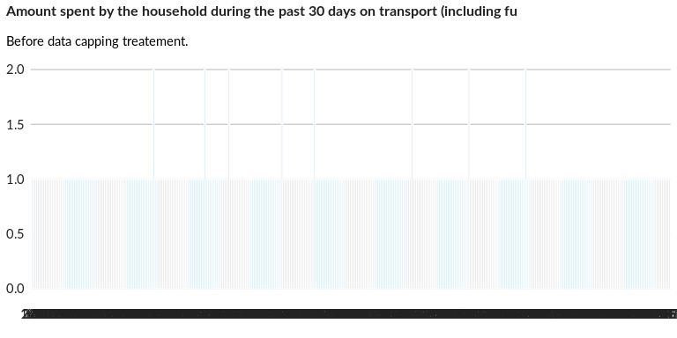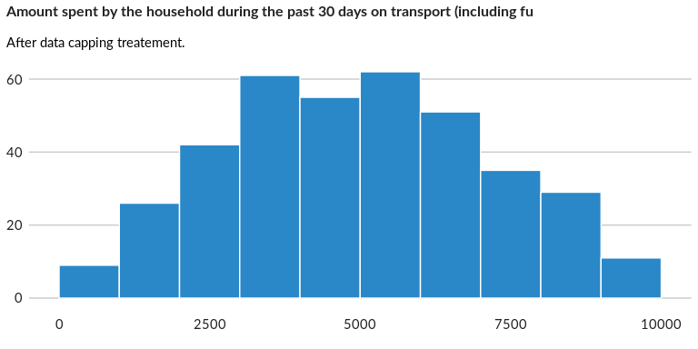

### Analysis of relationship

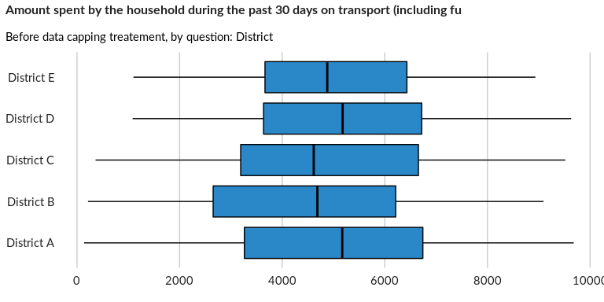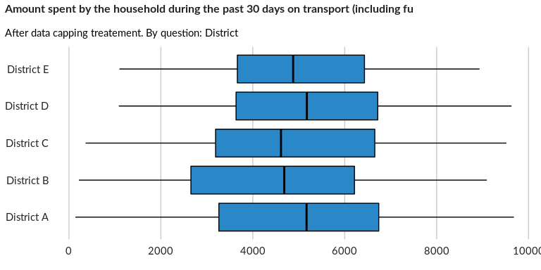

## Amount spent by the household during the past 30 days on electricity

NA

Numeric question

### Tabulation

Based on the sample design, the average weighted mean response for this question is 4982.62

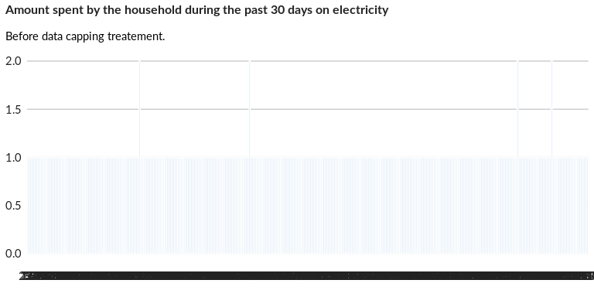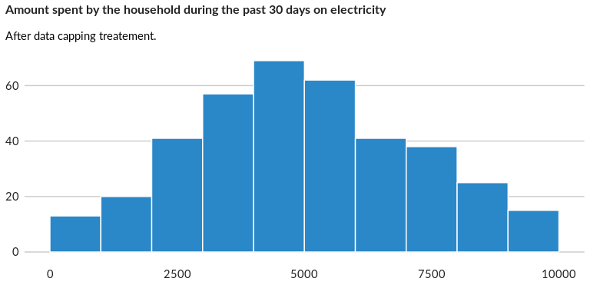

### Analysis of relationship

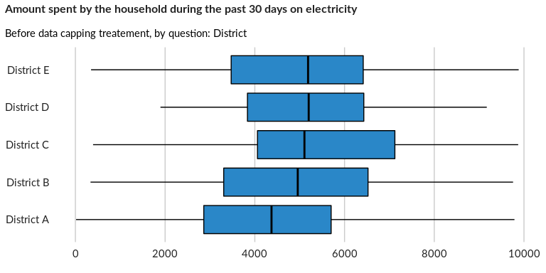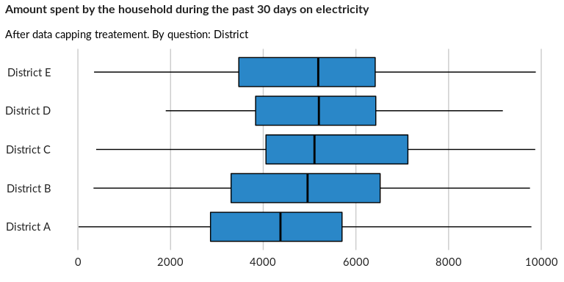

## Amount spent by the household during the past 30 days on clothing

NA

Numeric question

### Tabulation

Based on the sample design, the average weighted mean response for this question is 5315.44

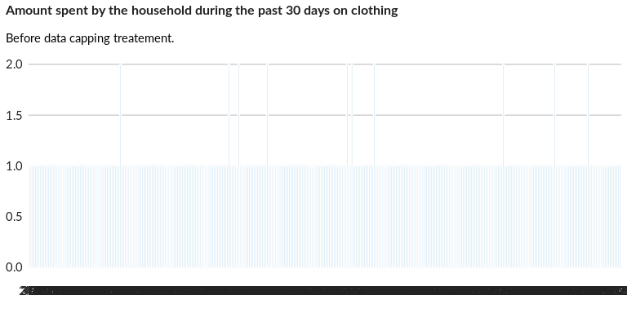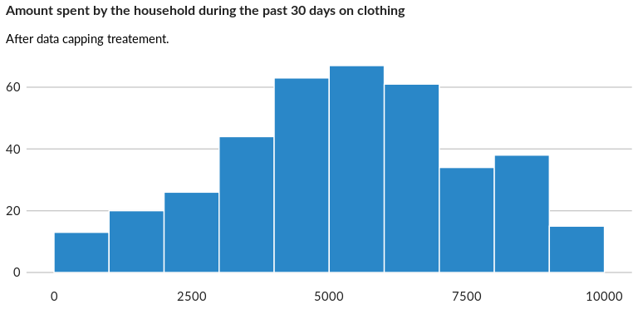

### Analysis of relationship

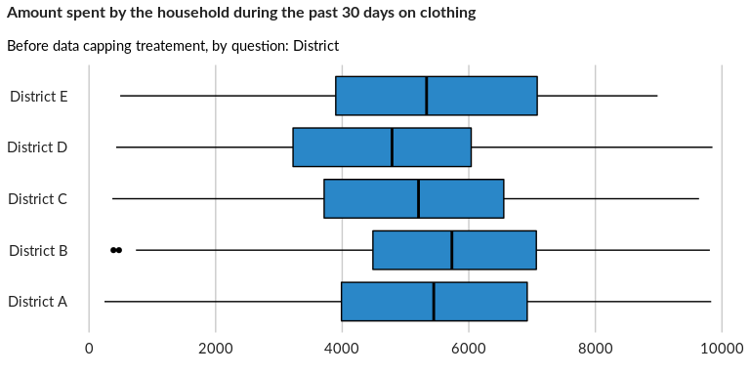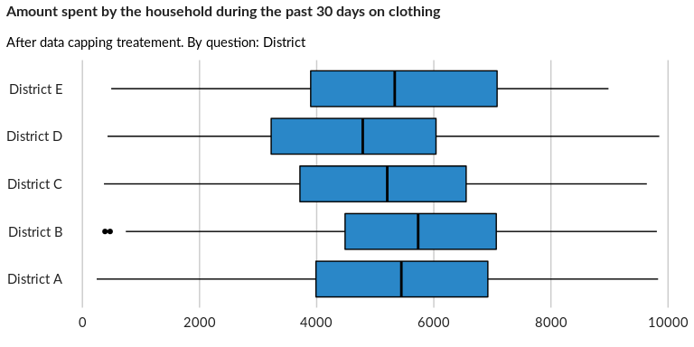

## Amount spent by the household during the past 30 days on communications (mobile,

NA

Numeric question

### Tabulation

Based on the sample design, the average weighted mean response for this question is 5020.37

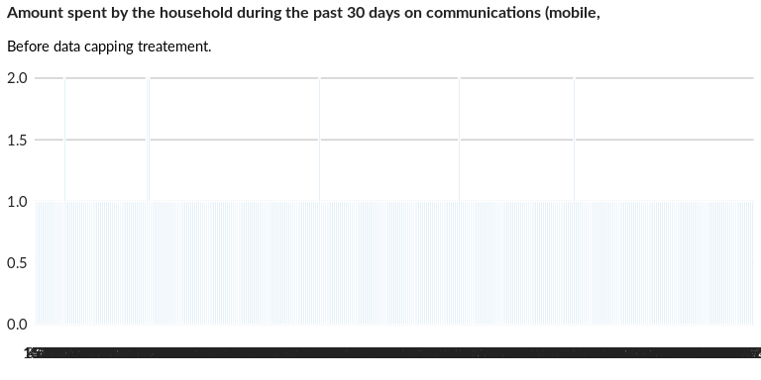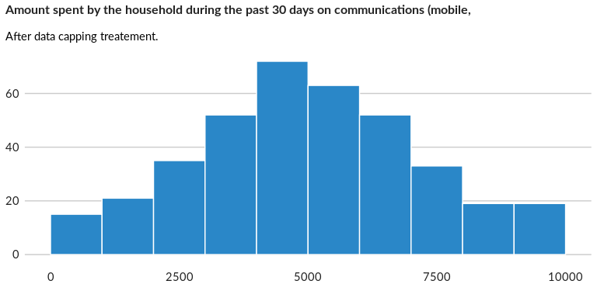

### Analysis of relationship

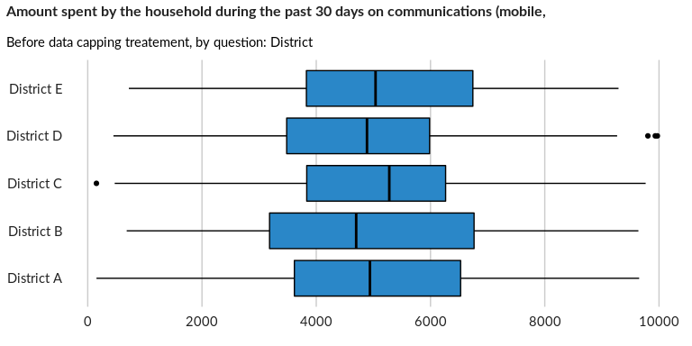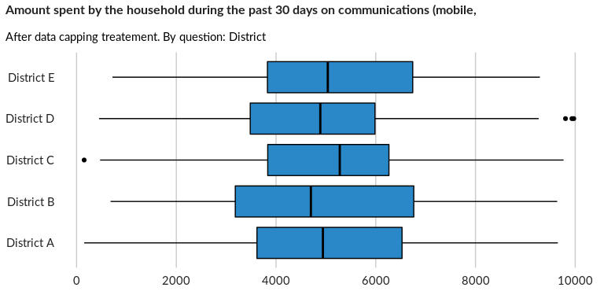

## Amount spent by the household during the past 30 days on soap and other househol

NA

Numeric question

### Tabulation

Based on the sample design, the average weighted mean response for this question is 4789.43

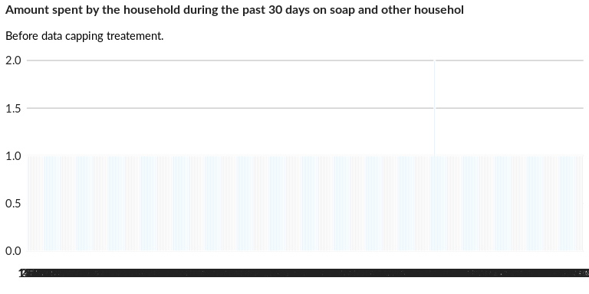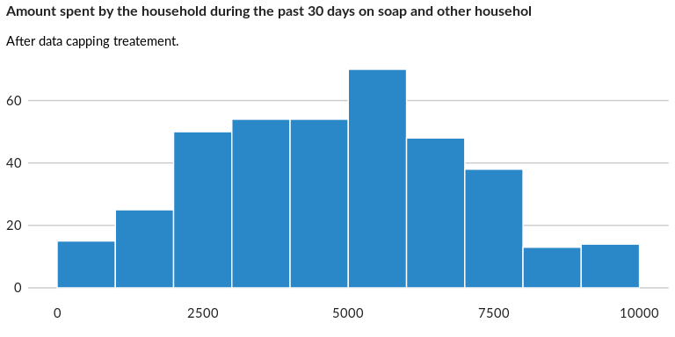

### Analysis of relationship

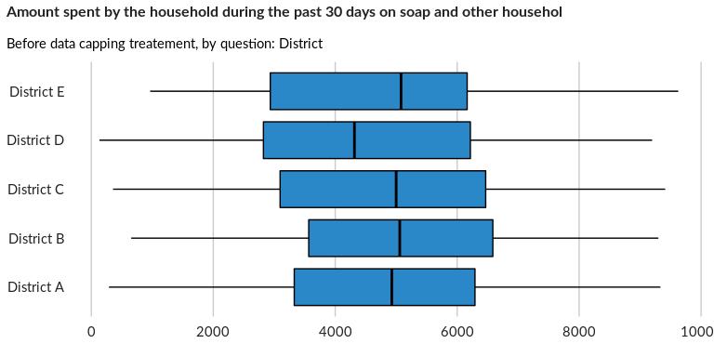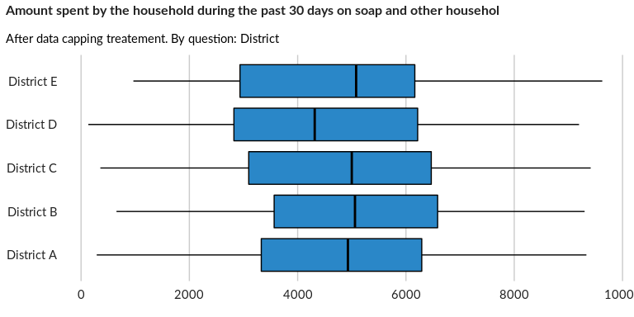

## Amount spent by the household during the past 30 days on household items or asse

NA

Numeric question

### Tabulation

Based on the sample design, the average weighted mean response for this question is 4879.87

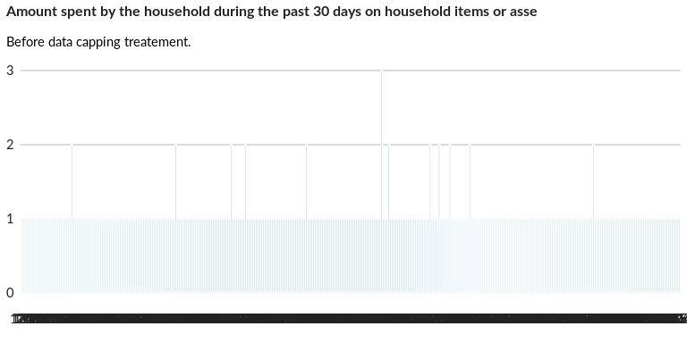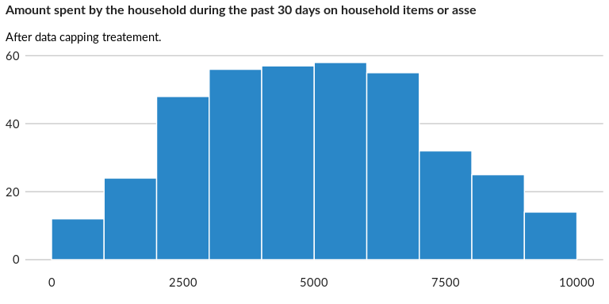

### Analysis of relationship

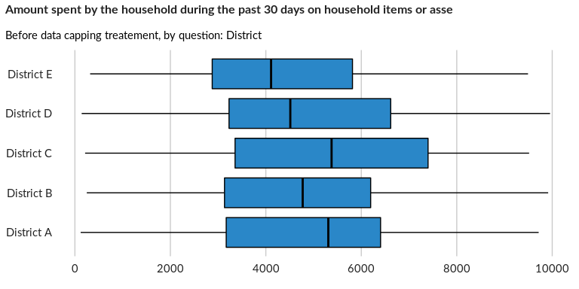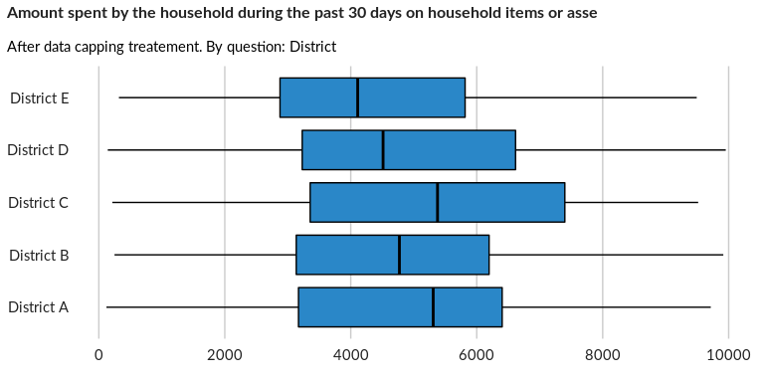

## Amount spent by the household during the past 30 days on entertainment

NA

Numeric question

### Tabulation

Based on the sample design, the average weighted mean response for this question is 5092.86

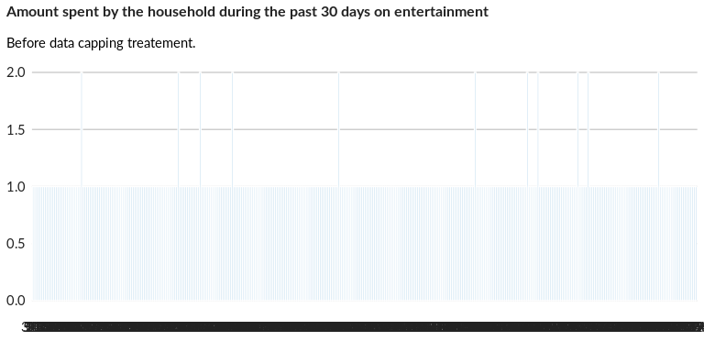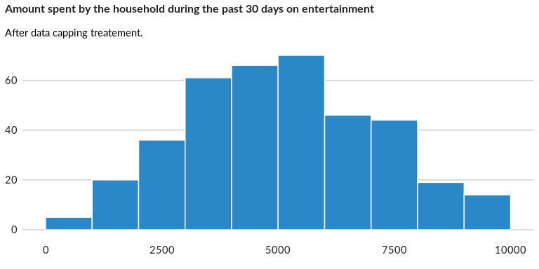

### Analysis of relationship

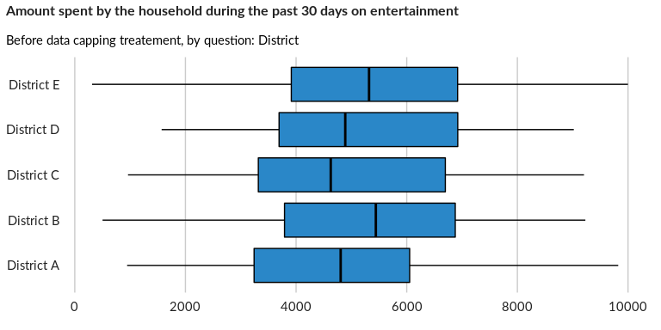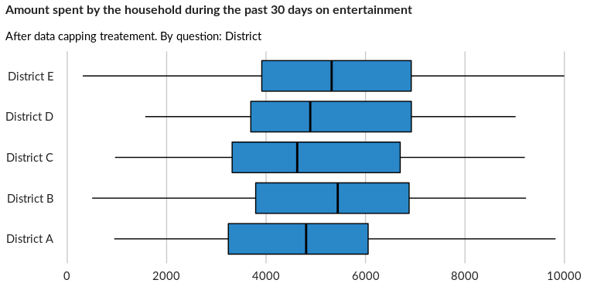

## Amount spent by the household during the past 30 days on alcohol / tobacco / win

NA

Numeric question

### Tabulation

Based on the sample design, the average weighted mean response for this question is 5158.59

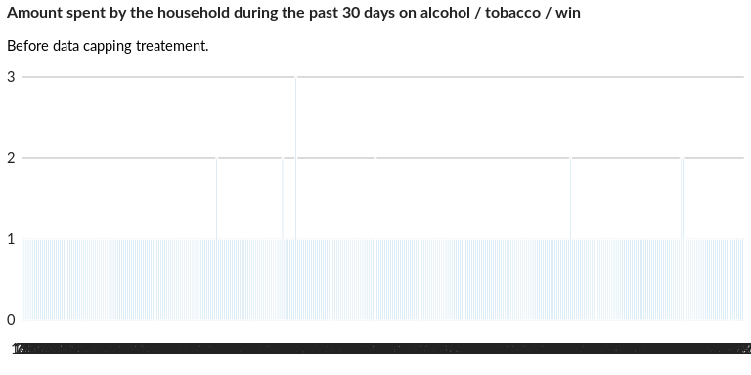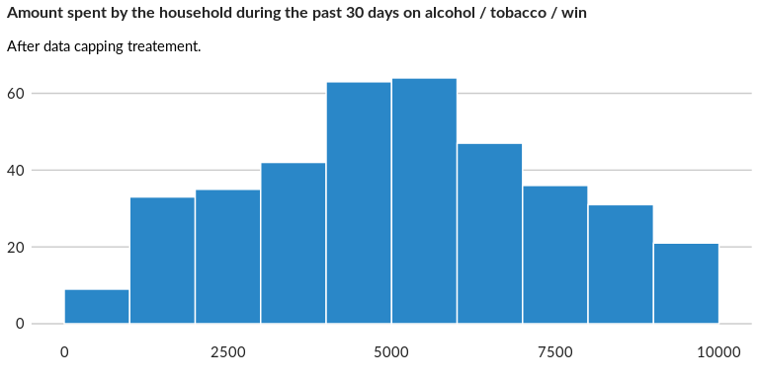

### Analysis of relationship

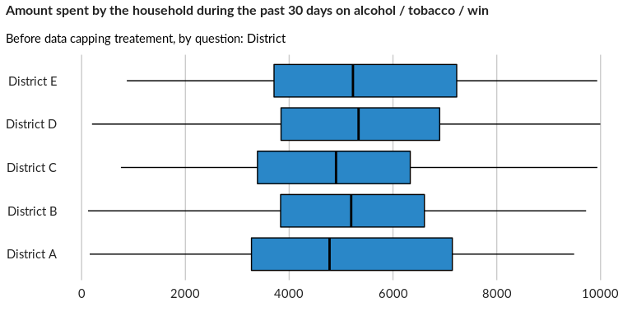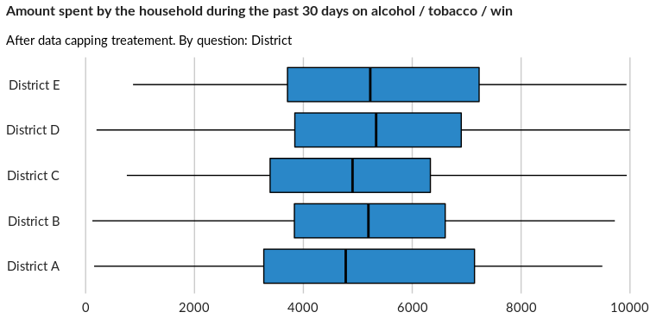

## Amount spent by the household during the past 30 days on debt repayment

NA

Numeric question

### Tabulation

Based on the sample design, the average weighted mean response for this question is 5102.54

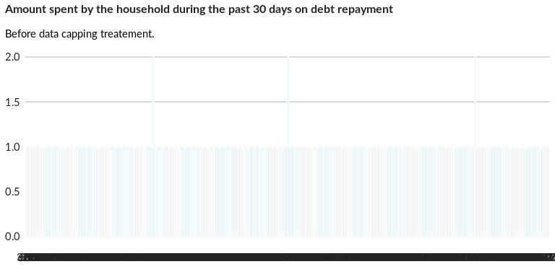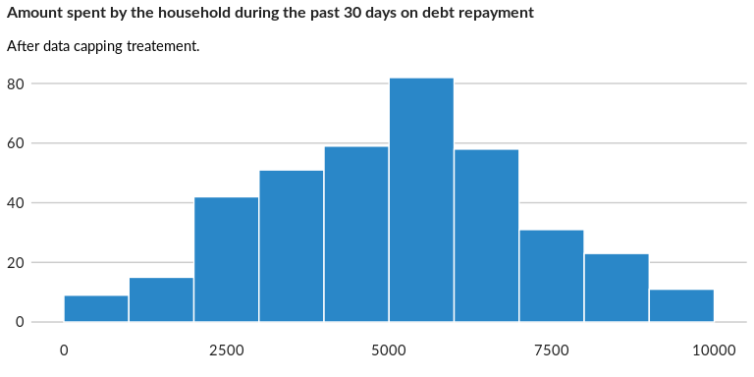

### Analysis of relationship

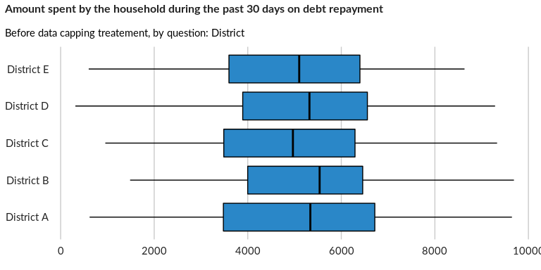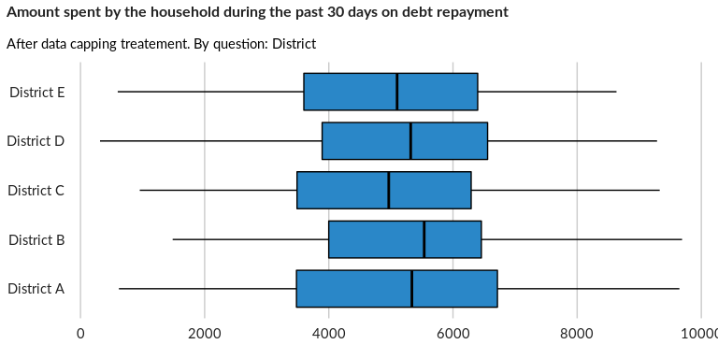

## Amount spent by the household on legal and registration fees (legal residency, b

NA

Numeric question

### Tabulation

Based on the sample design, the average weighted mean response for this question is 5126.61

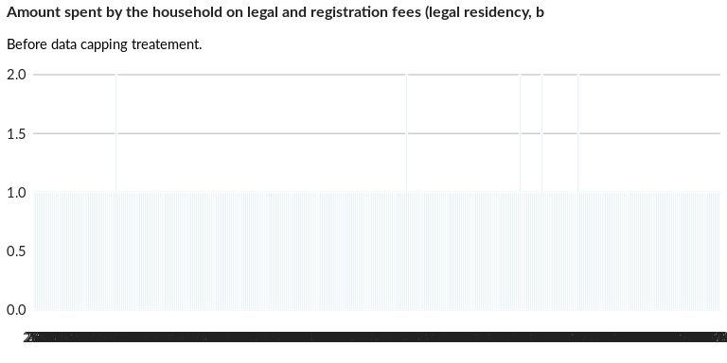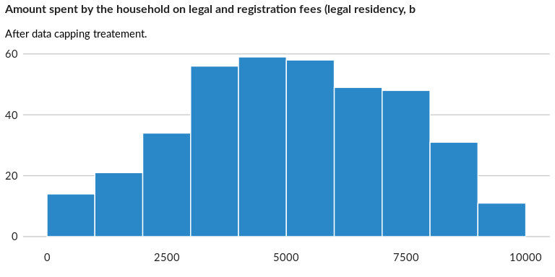

### Analysis of relationship

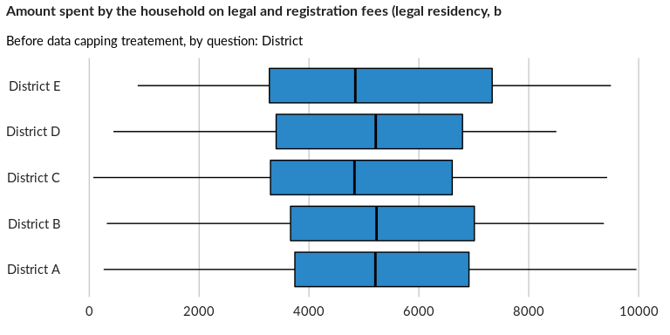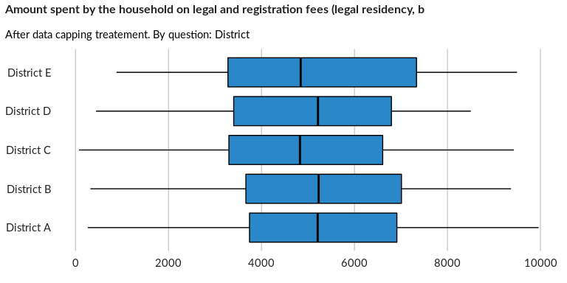

## Amount spent by the household during the past 30 days on all other expenditures,

NA

Numeric question

### Tabulation

Based on the sample design, the average weighted mean response for this question is 5196.58

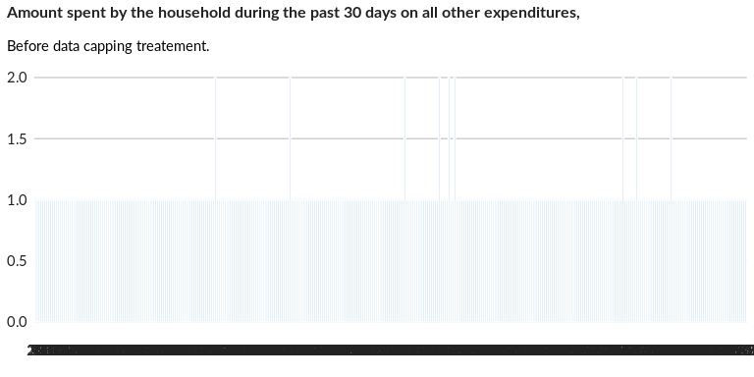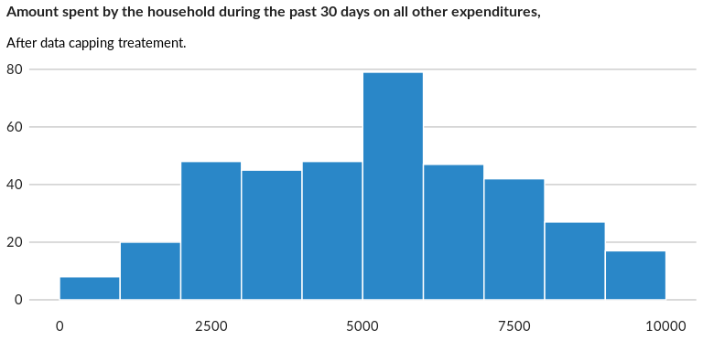

### Analysis of relationship

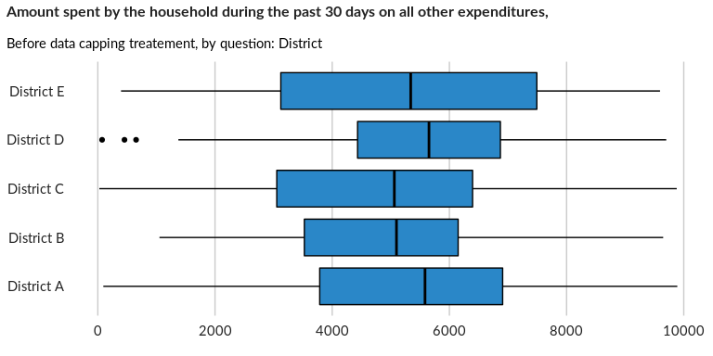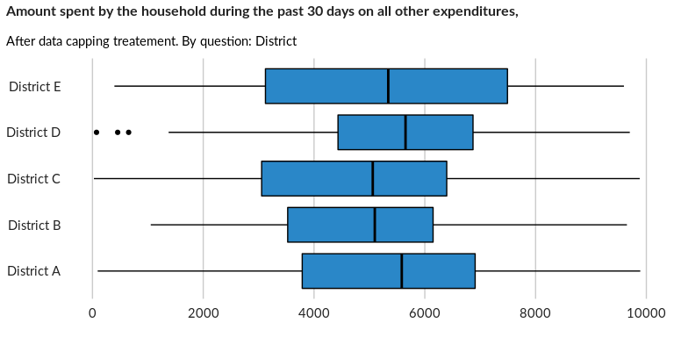

## Does the household currently receive multi-purpose cash assistance?

NA

Single choice question

### Tabulation

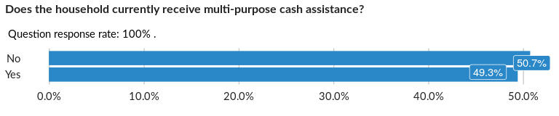

### Cross-tabulations

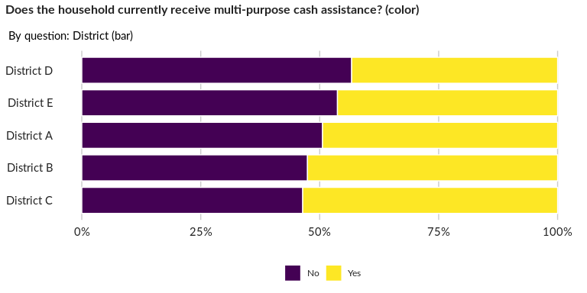

### Significant Associations (chi-square with p value < 5%)

No significant association found for this question…

##### Page Break