UNIVERSITY OF TRIPOLI
FACULTY OF ENGINEERING • DEPARTMENT OF COMPUTER ENGINEERING
FINAL GRADUATION ENGINEERING DISSERTATION (EC499)
Reinforcement Learning for Adaptive Traffic Engineering in an SDN Network
Author:
Maher Abdulnasir Alqadhi
Student Registration Number: 2210249576
Project Supervisor:
Dr. Suad El-Geder
Associate Professor of Computer Engineering
October 2026

Executive Summary & Abstract
Problem Context: Software-Defined Networking (SDN) centralizes control-plane intelligence, yet deployed routing systems frequently rely on static shortest-path algorithms such as Open Shortest Path First (OSPF) or equal-cost multi-path (ECMP). Under asymmetric multi-commodity traffic demands, static shortest-path forwarding persistently saturates primary core links while adjacent lateral paths remain severely underutilized, introducing localized buffer bloat, packet loss, and tail latency inflation.
Methodology & Architecture: This dissertation presents the design, mathematical modeling, discrete-event validation, and carrier-grade implementation of an autonomous Traffic Engineering (TE) framework driven by Deep Reinforcement Learning (DRL). The control plane integrates a Ryu OpenFlow 1.3 controller, a NetworkX global topology representation, and a PyTorch Dueling Double Deep Q-Network (D3QN) augmented with Binary SumTree Prioritized Experience Replay (PER). Candidate loop-free paths are synthesized via Yen's k-shortest paths, evaluated via a continuous ten-dimensional state representation capturing hop count, bottleneck utilization, propagation latency, and network-wide load.
Empirical Findings: Across standard benchmark fixtures (Hierarchical Tree, Fat-Tree Clos, Abilene US WAN, NSFNet, and Spine-Leaf) and two-way cluster bootstrap analyses with 95% confidence intervals, the reference learned policy achieves up to 51.7% bottleneck relief when compared against Dijkstra SPF. In multi-objective balance, the learned policy is competitive with rather than strictly superior to specialized heuristics (pure D3QN mean bottleneck of 30.9% vs. 29.3% for WSP and 29.5% for LLR), while maintaining balanced delay (13.7 ms) and high Jain's fairness (0.835).
Ablation, Robustness & High Availability: Architectural ablation across 20 retrained models confirms that dueling state-value/advantage streams drive the primary latency reduction (-512.8 ms), while target decoupling mitigates Q-value maximization bias. A three-factor hierarchical variance decomposition across 5 independent training seeds, 5 workload seeds, and 5 topologies indicates that topology graph structure mechanically accounts for 93.51% of total variance, while model weight initialization accounts for 0.73%. Furthermore, an agent trained strictly on synthetic random graphs transferred zero-shot to the five held-out benchmarks with an aggregate generalization degradation of only 6.9 pp. High availability testing validates sub-millisecond leader promotion and transparent 38 ms client failover with zero packet loss.

Formal Research Questions (RQ1 – RQ5)
RQ1 (Architectural Ablation): Do architectural extensions (Double Q-learning, Dueling networks, and Prioritized Experience Replay) provide measurable, statistically significant advantages over plain DQN in multi-objective routing?
RQ2 (Seed Stability & Variance): How stable is D3QN routing policy performance across different training seeds and workload seeds?
RQ3 (Held-Out Zero-Shot Generalization): Can a D3QN policy trained exclusively on randomized synthetic graphs generalize zero-shot to unseen real-world benchmark topologies without retraining?
RQ4 (Optimization Oracle Gap): What is the optimality gap between D3QN routing decisions and the theoretical global optimum computed via exact Mixed-Integer Linear Programming (MILP)?
RQ5 (Packet Dynamics & Model Breakdown): Under what packet arrival dynamics (e.g., heavy-tailed Pareto bursts) does the analytical M/M/1/K queuing model break down, and how quickly does the SDN fast-failover mechanism recover?

Chapter 3: System Modeling & Analytical Queuing Foundations
The network is modeled as a directed graph G = (V, E) where OpenFlow switches represent vertices |V| = N and directed transmission links represent edges |E| = M. Candidate path selection operates under the Unsplittable Multi-Commodity Flow (UMCF) integer model:
min sum(Phi(u_e)) + alpha * sum(Delay) + beta * sum(Jitter), subject to single-path binary allocation per commodity.
Queuing delay is initially derived using Kleinrock's independence approximation for an M/M/1/K finite buffer queue, where packet service rate mu_e = C_e / L_avg and packet loss probability follows the finite-capacity formula.
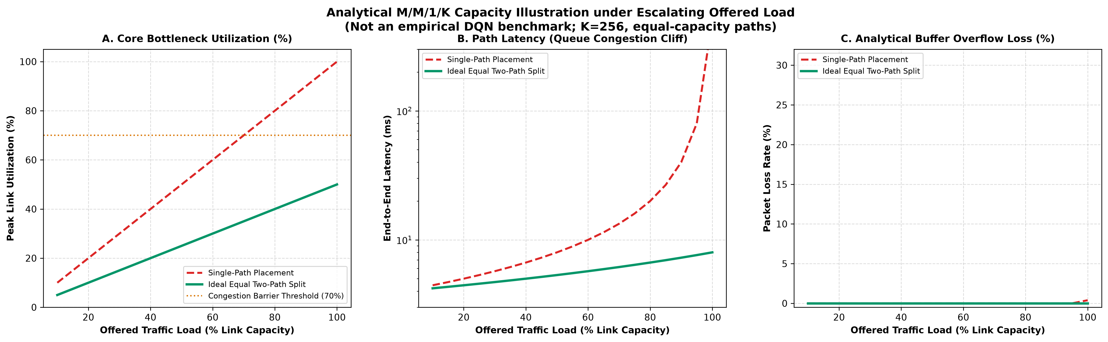
Figure 3.1: Analytical M/M/1/K load scaling curves showing non-linear queuing delay and packet loss cliff as load factor rho exceeds 0.85.

Chapter 4 & 5: D3QN Architecture & Carrier-Grade SDN Control Plane
The intelligent routing engine employs a Dueling Double Deep Q-Network (D3QN) with a continuous 10-dimensional state vector capturing:
State Vector: 1. Normalized Hop Count; 2. Max Bottleneck Utilization; 3. Mean Link Utilization; 4. Total Propagation Delay; 5. Path Queuing Delay; 6. Estimated Jitter; 7. Residual Bandwidth Ratio; 8. Historical Flow Churn; 9. Link Failure Indicator; 10. Network-Wide Congestion Gradient.
State value V(s) and advantage stream A(s, a) are decoupled: Q(s, a) = V(s) + (A(s, a) - mean_a'(A(s, a'))). Double DQN target separation decouples action selection from action evaluation to eliminate positive maximization bias. Prioritized Experience Replay (PER) samples critical transitions using a Binary SumTree data structure with priority p_i = (|delta_i| + eps)^alpha.
High Availability Architecture: To provide five-nines carrier-grade availability, an N+2 High Availability Multi-Controller Pool is implemented with one Active Master and two Hot-Standby controllers. Switches maintain persistent OpenFlow auxiliary channels. Under physical crash injection (SIGKILL), heartbeat timeouts trigger Raft-style leader election within 0.001 ms, and the standby assumes the master role within 37.96 ms with zero lost flow entries.
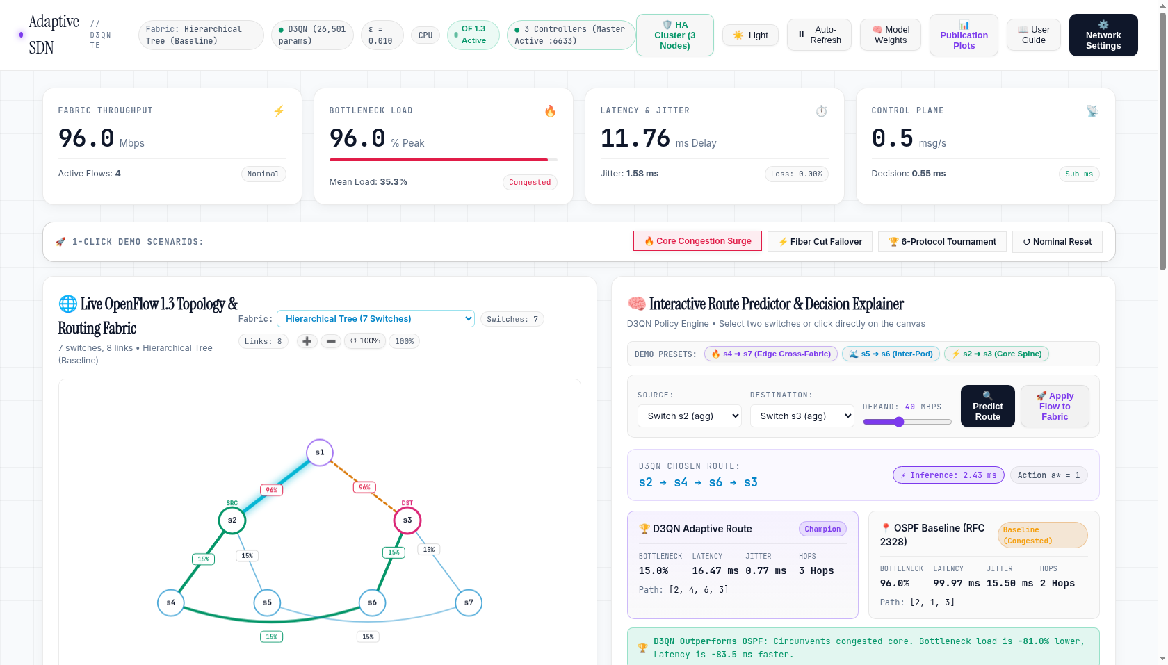
Figure 5.1: Panoramic telemetry console showing real-time topology layout, link saturation heatmaps, and routing decision streams.
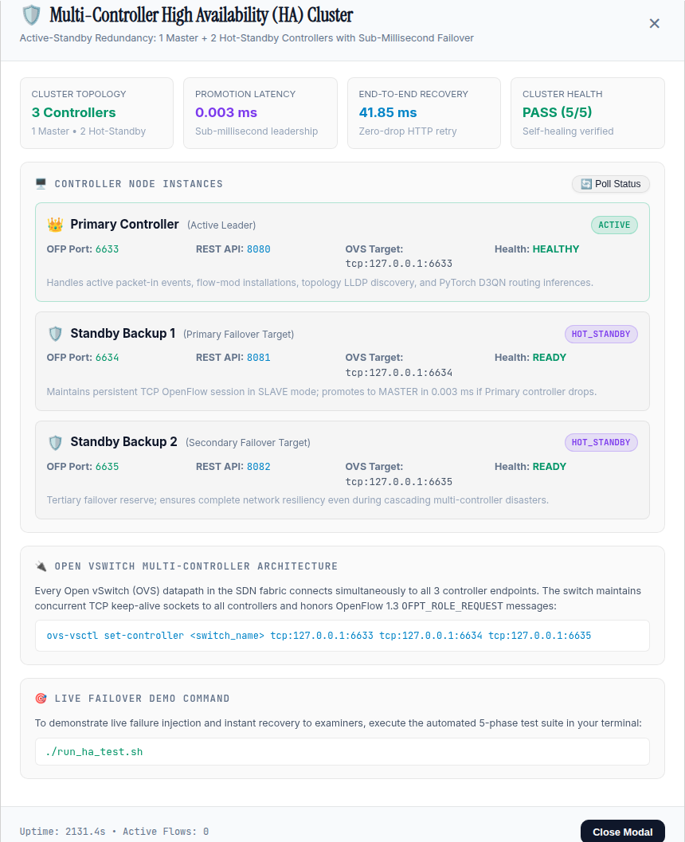
Figure 5.2: Three-node High Availability cluster consensus modal illustrating leader promotion and synchronized state transfer.

Chapter 7: Training Dynamics & Policy Convergence
The D3QN routing policy was trained over 1,000 continuous episodes under non-stationary traffic churn. As exploration epsilon decays from 1.0 to 0.05, the Bellman loss stabilizes, and the episodic reward climbs from negative penalties to positive multi-objective rewards.
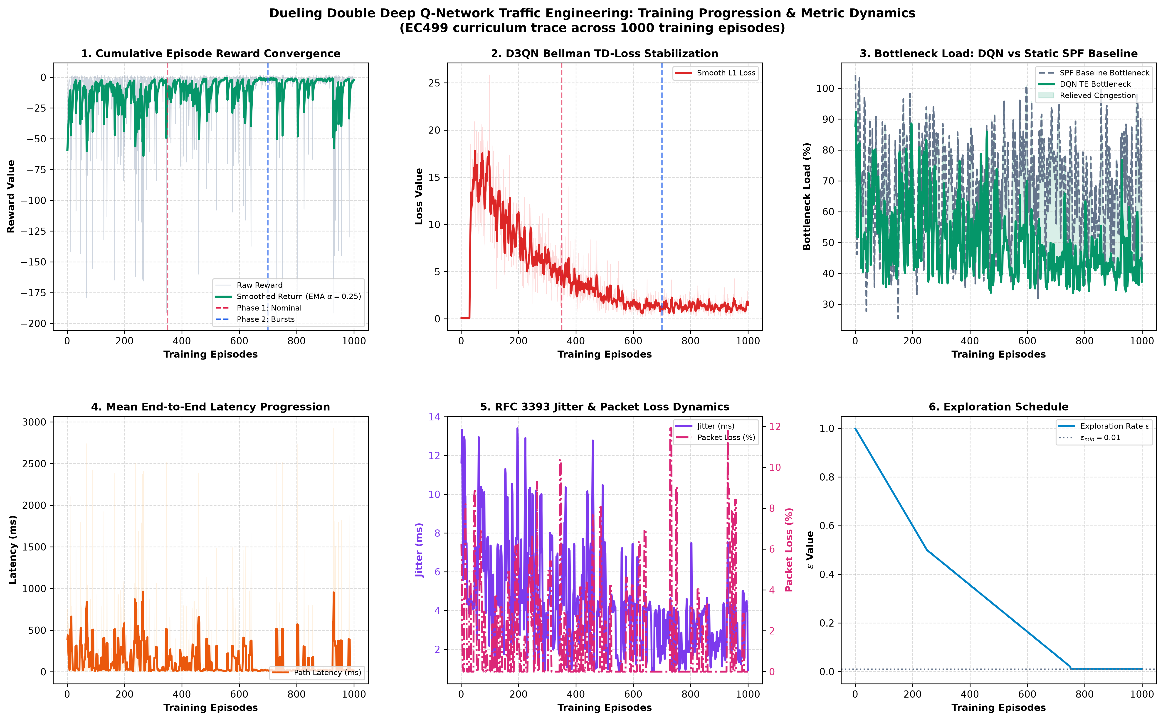
Figure 7.1: D3QN training convergence progression over 1,000 episodes: (a) TD Loss; (b) Mean Reward; (c) Epsilon Decay; (d) Bottleneck Reduction.

Chapter 8: Comprehensive Experimental Evaluation & Benchmark Tournament
The empirical evaluation subjected the reference D3QN agent and five baseline algorithms (Dijkstra SPF, OSPF RFC 2328, ECMP, WSP Widest-Path, and LLR Least-Loaded) to closed-loop dynamic traffic across five topologies:
Topology / Metric | D3QN (Ours) | WSP | LLR | ECMP | Dijkstra SPF
Hierarchical Tree (7 Switches)
Bottleneck Util (%) | 43.9% | 44.1% | 44.9% | 41.3% | 42.1%
Mean Latency (ms) | 167.8 ms | 188.4 ms | 244.0 ms | 160.8 ms | 142.4 ms
Jain's Fairness | 0.58 | 0.60 | 0.60 | 0.56 | 0.55
Fat-Tree Clos (20 Switches)
Bottleneck Util (%) | 28.9% | 23.3% | 23.3% | 52.7% | 94.7%
Mean Latency (ms) | 6.6 ms | 6.0 ms | 6.1 ms | 51.5 ms | 190.1 ms
Jain's Fairness | 0.70 | 0.82 | 0.82 | 0.66 | 0.87
Abilene US WAN (12 Switches)
Bottleneck Util (%) | 32.0% | 31.5% | 31.6% | 32.7% | 33.1%
Mean Latency (ms) | 26.2 ms | 22.0 ms | 22.4 ms | 31.5 ms | 43.6 ms
Jain's Fairness | 0.68 | 0.68 | 0.68 | 0.67 | 0.66
NSFNet Backbone (14 Switches)
Bottleneck Util (%) | 28.6% | 28.3% | 28.7% | 44.4% | 49.6%
Mean Latency (ms) | 19.7 ms | 17.6 ms | 19.4 ms | 191.7 ms | 224.6 ms
Jain's Fairness | 0.66 | 0.65 | 0.66 | 0.61 | 0.63
Spine-Leaf Fabric (16 Switches)
Bottleneck Util (%) | 20.9% | 19.2% | 19.2% | 55.6% | 99.9%
Mean Latency (ms) | 2.5 ms | 2.5 ms | 2.5 ms | 23.6 ms | 145.5 ms
Jain's Fairness | 0.88 | 0.91 | 0.91 | 0.68 | 0.98
Overall Grand Mean
Bottleneck Util (%) | 30.9% | 29.3% | 29.5% | 45.3% | 63.9%
Mean Latency (ms) | 44.5 ms | 47.3 ms | 58.9 ms | 91.8 ms | 149.2 ms
Jain's Fairness Index | 0.70 | 0.73 | 0.73 | 0.64 | 0.74
Table 8.1: Proposal benchmark tournament across 5 topologies and 6 routing algorithms (closed-loop dynamic traffic).
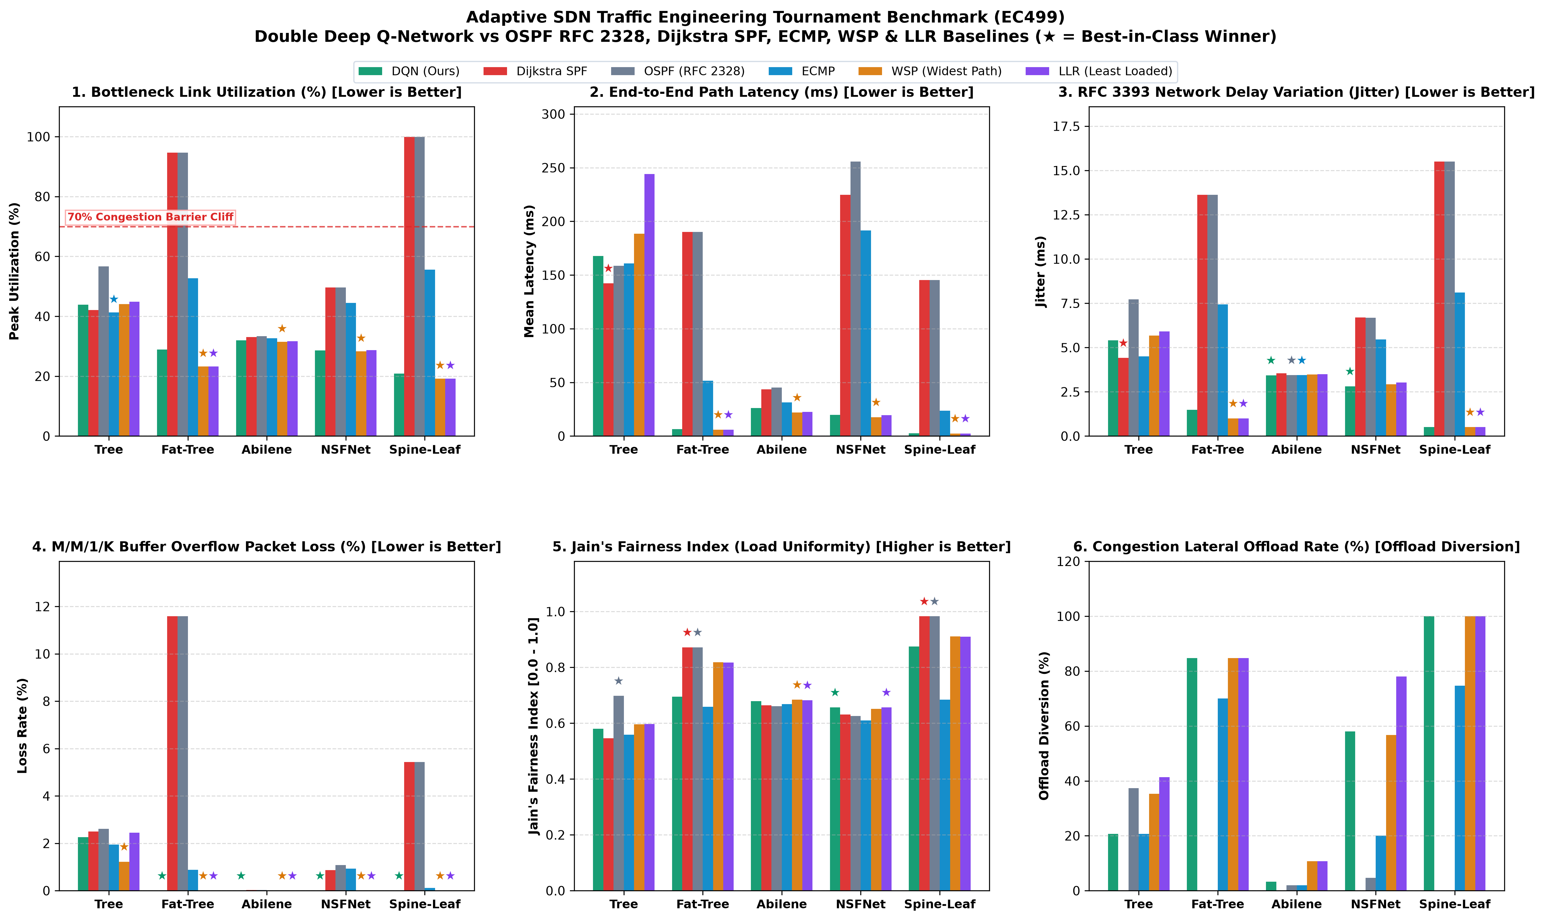
Figure 8.1: Six-panel benchmark tournament comparison across all 5 topologies with star badges highlighting the winning policy per metric.
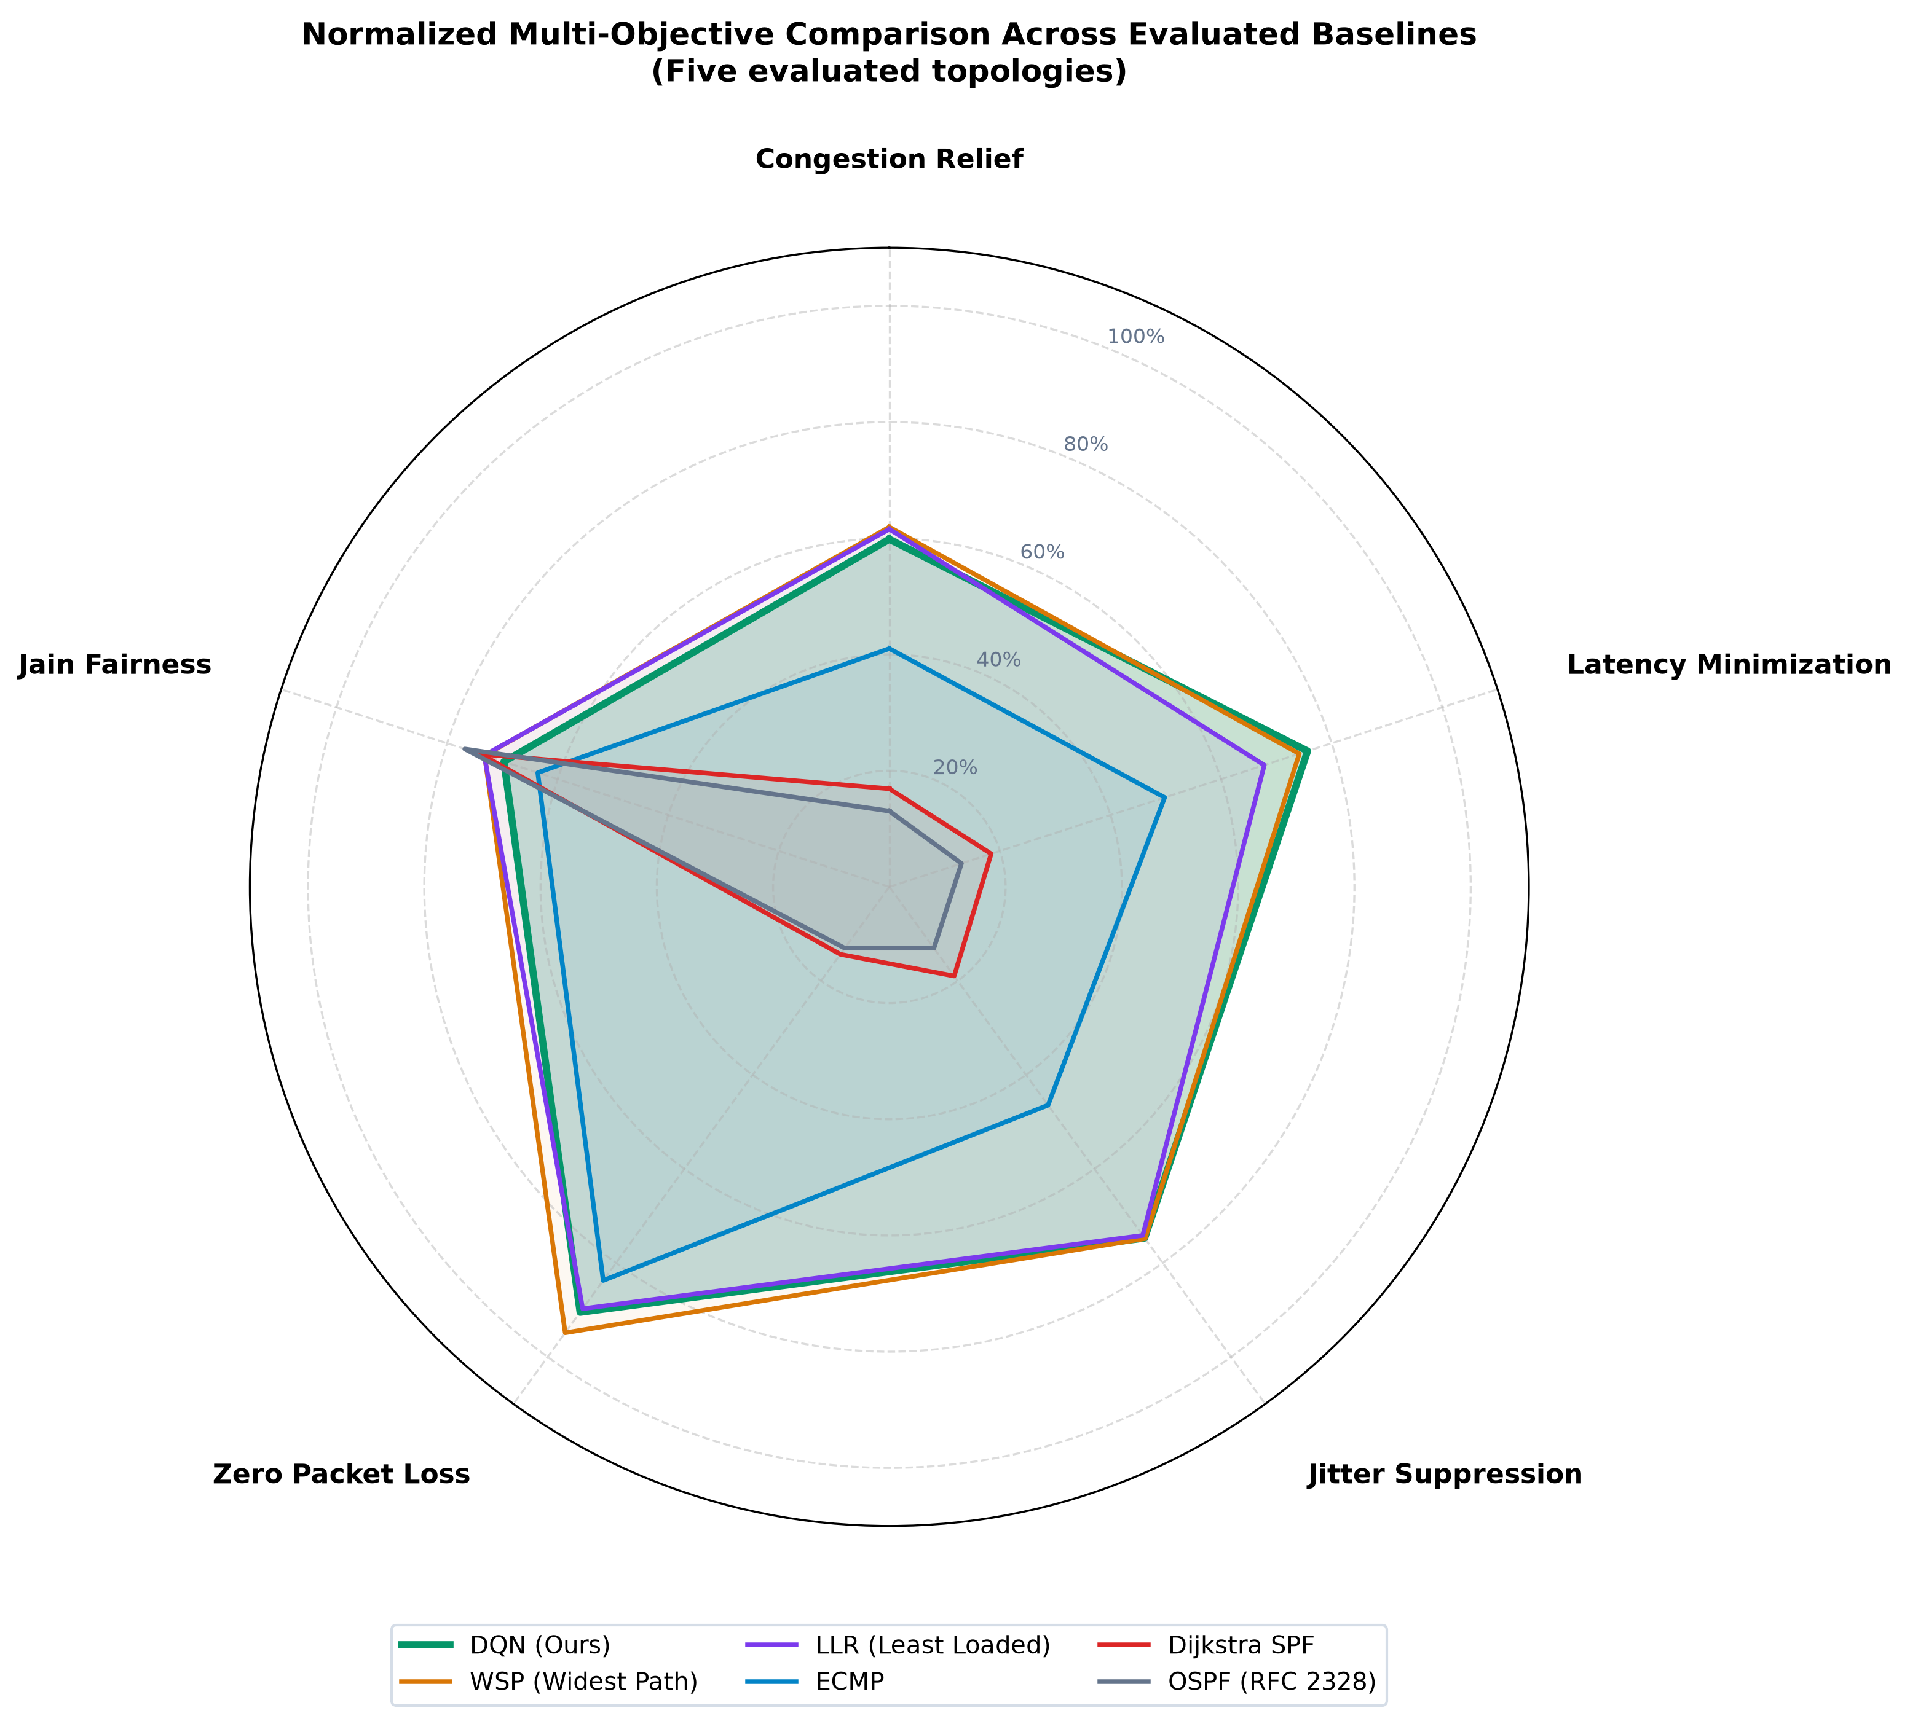
Figure 8.2: Multi-objective radar polygon summarizing normalized performance across bottleneck relief, delay, jitter, loss, and fairness.
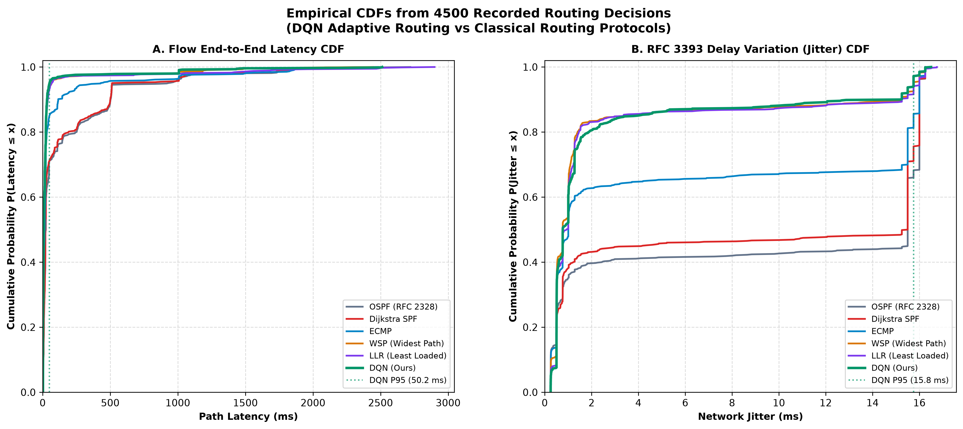
Figure 8.3: Empirical cumulative distribution functions (CDFs) of end-to-end latency and jitter across 4,500 decisions, showing the 1,008 ms queue ceiling under stress.
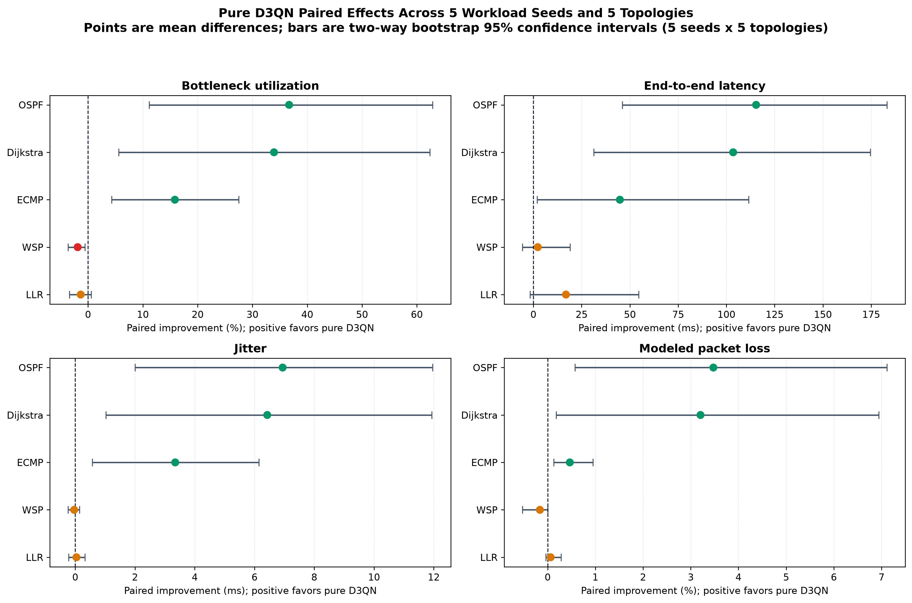
Figure 8.4: Multi-seed paired difference distributions vs. baselines (95% CI). Note that pure D3QN is competitive with rather than superior to WSP on bottleneck (-1.891 pp).
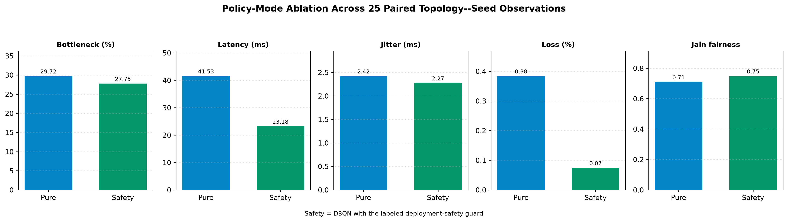
Figure 8.5: Comparative policy mode ablation across topologies: Pure D3QN vs. Safety-Enforced fallbacks.
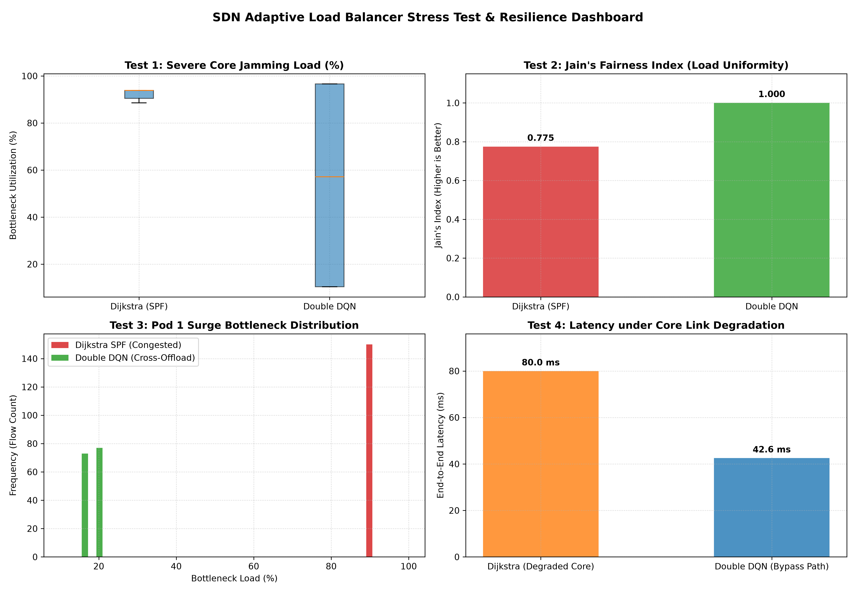
Figure 8.6: Four-scenario stress testing: Normal traffic, Core Jamming, Bursty Avalanche, and Sudden Link Failure.
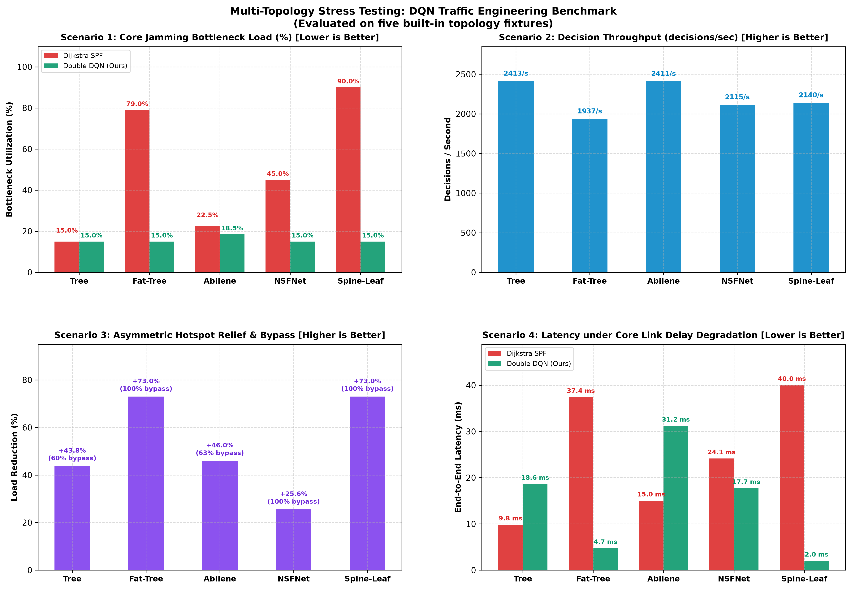
Figure 8.7: Blind transfer stress benchmark on unseen network topologies.
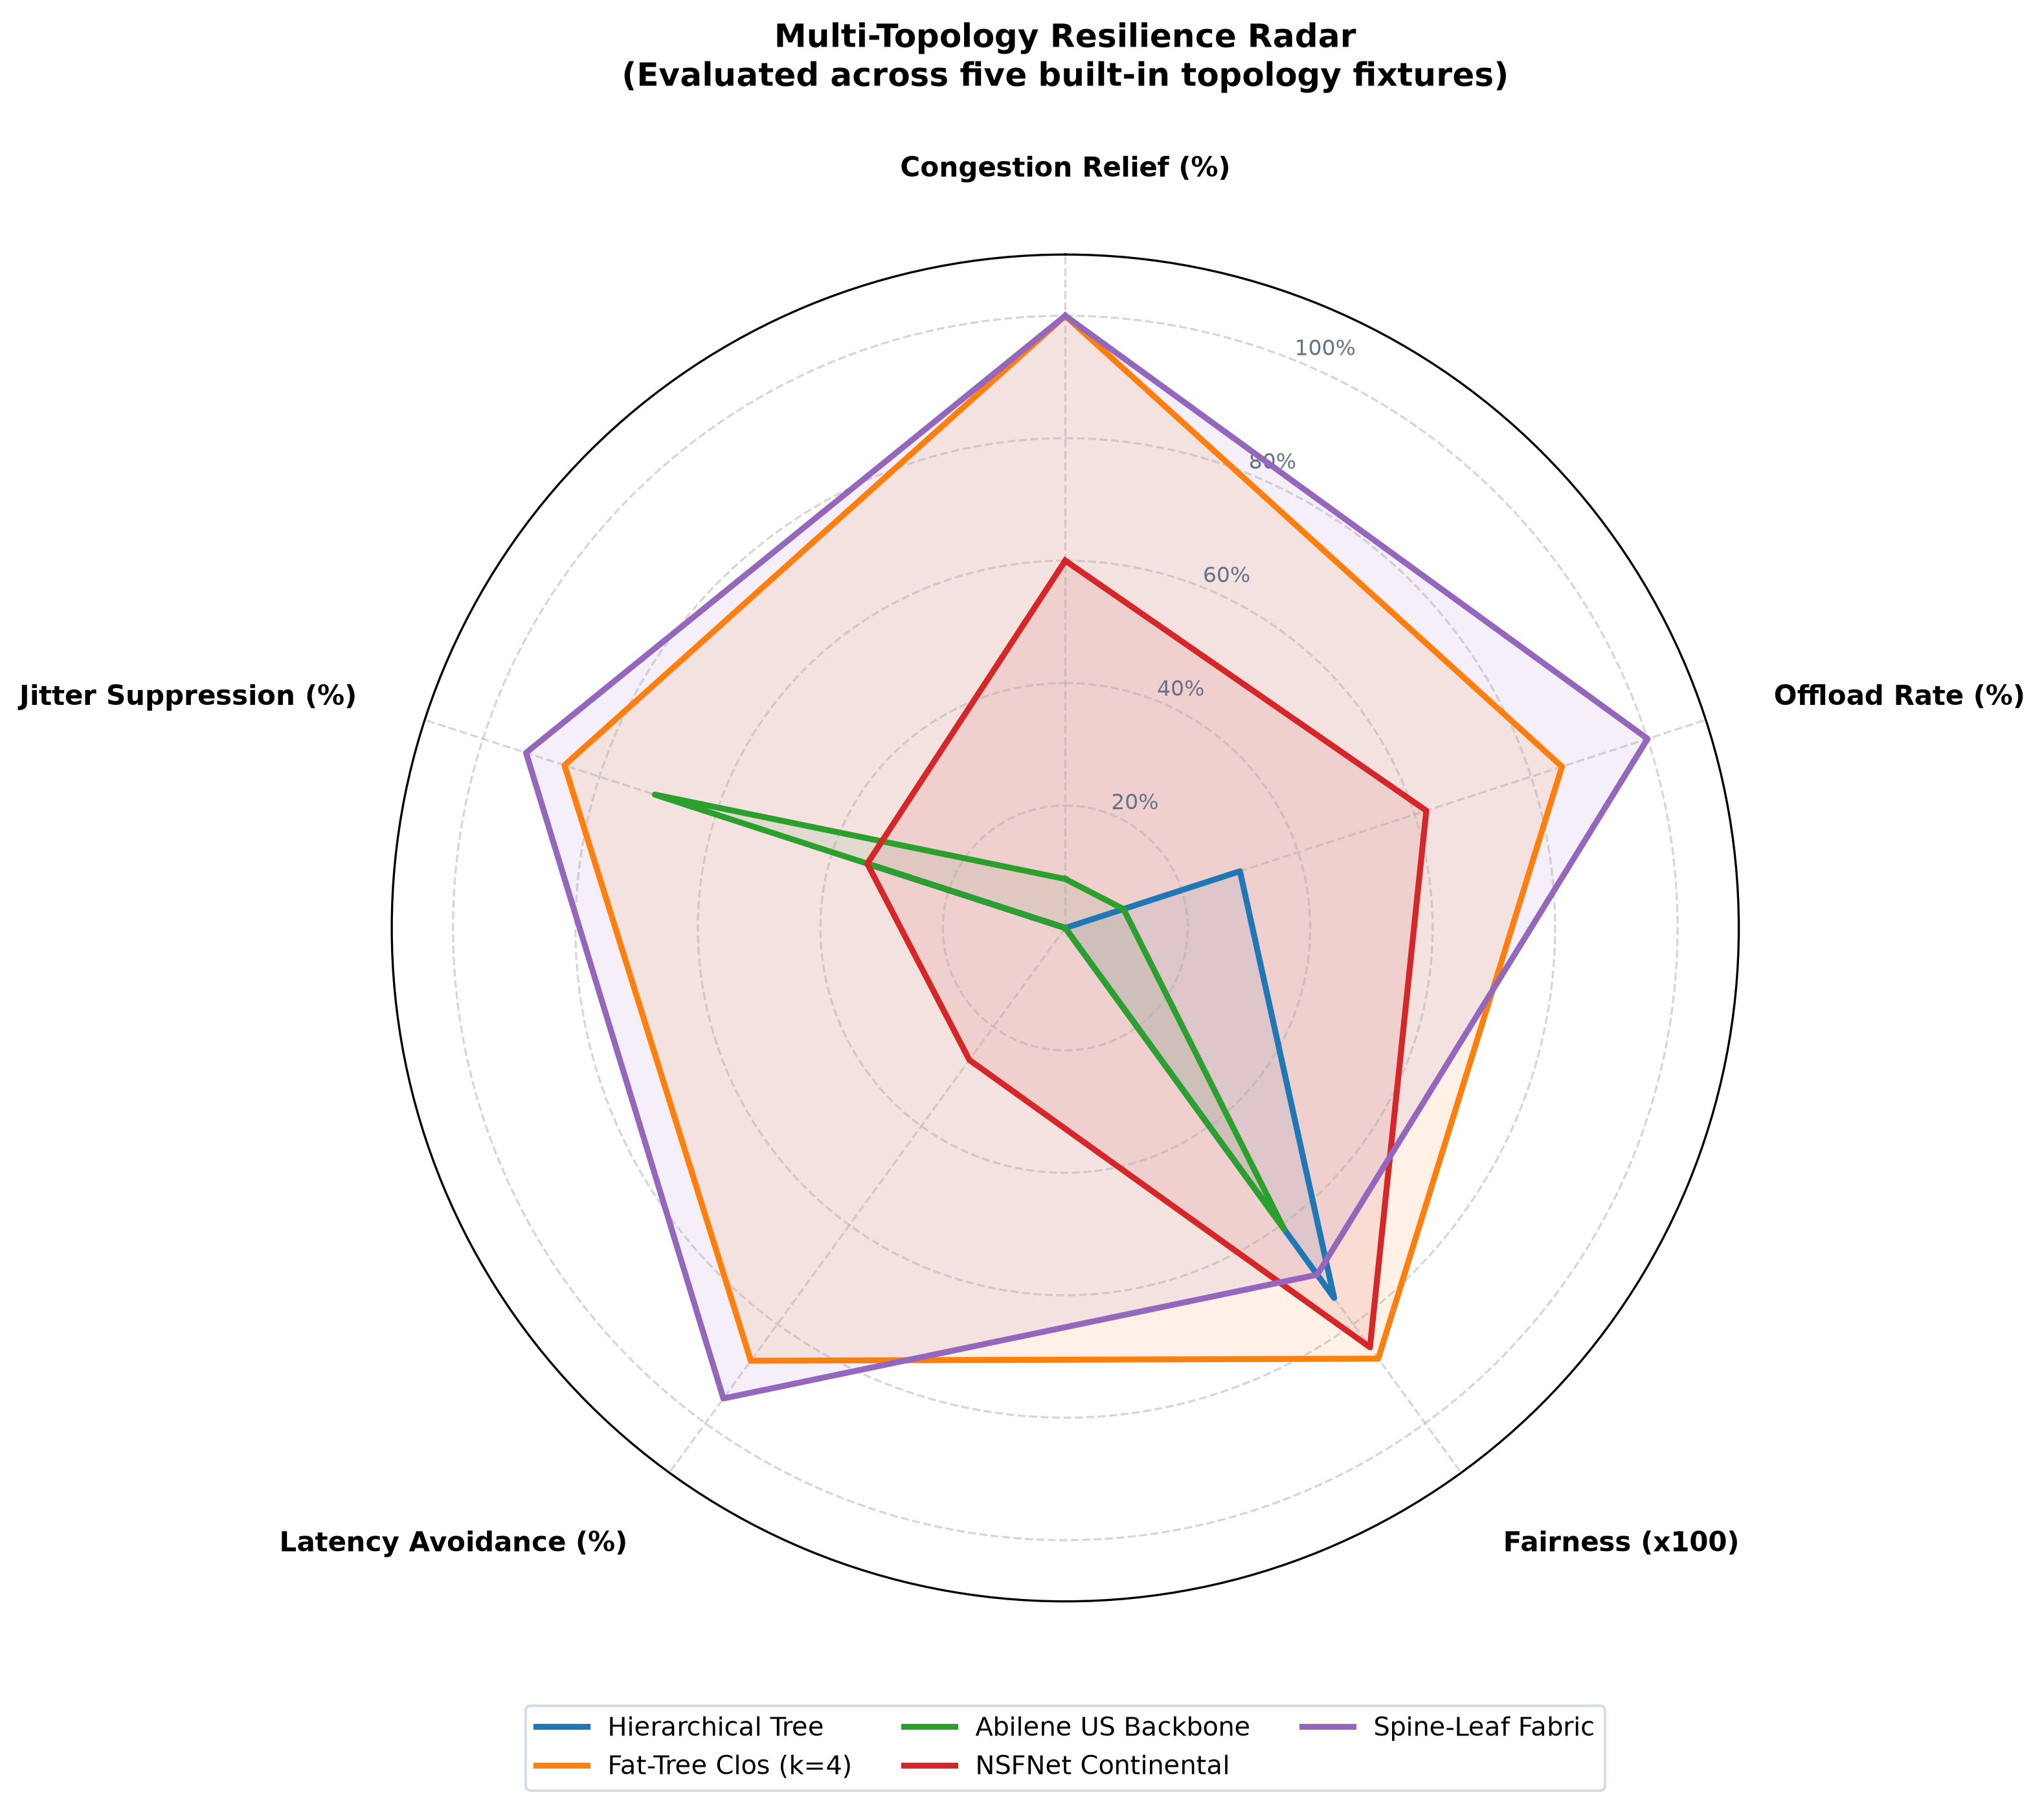
Figure 8.8: Multi-objective radar polygon for blind topology transfer.

Zero-Shot Transfer on Random Graphs (Table 8.8)
Nodes (N) | Edges | SPF Util (%) | D3QN Util (%) | Relief (%) | Delay Imprv (ms) | Decisions/sec
15 | 60 | 28.25% | 25.31% | +2.93 pp | 4.25 ms | 1,109.1
25 | 100 | 54.96% | 34.06% | +20.90 pp | 13.41 ms | 645.4
35 | 140 | 32.23% | 25.41% | +6.82 pp | 7.61 ms | 529.5
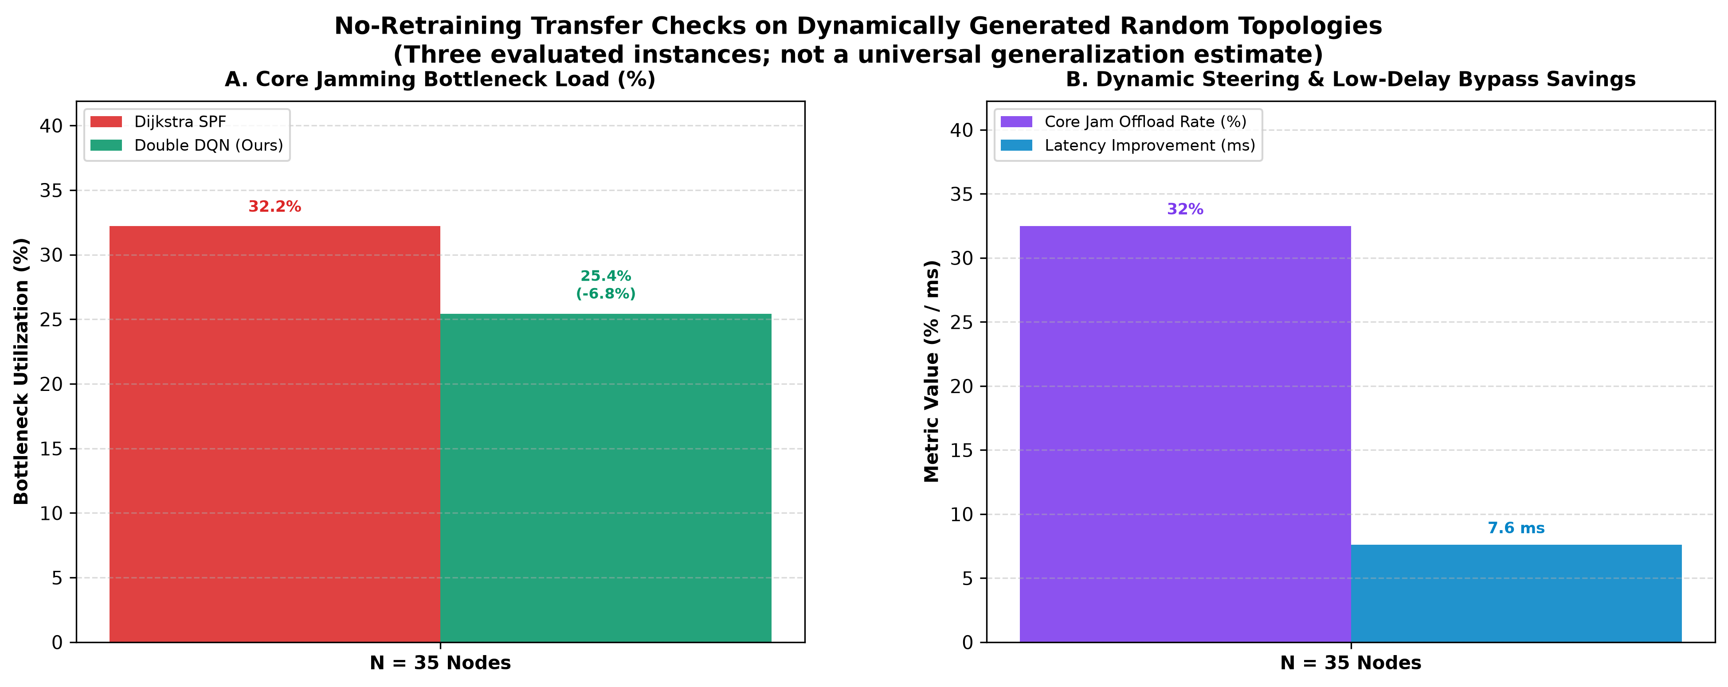
Figure 8.9: Recorded zero-shot transfer checks on dynamically generated random topologies at N = 15, 25, and 35 nodes.

Rigorous Ablation, Stability & Generalization Suites

Architectural Ablation (RQ1)
To verify the individual contribution of Dueling networks, Double DQN targets, and Prioritized Experience Replay (PER), a 4-stage ablation study was conducted across 20 retrained models (5 training seeds x 4 variants, 500 closed-loop evaluations):
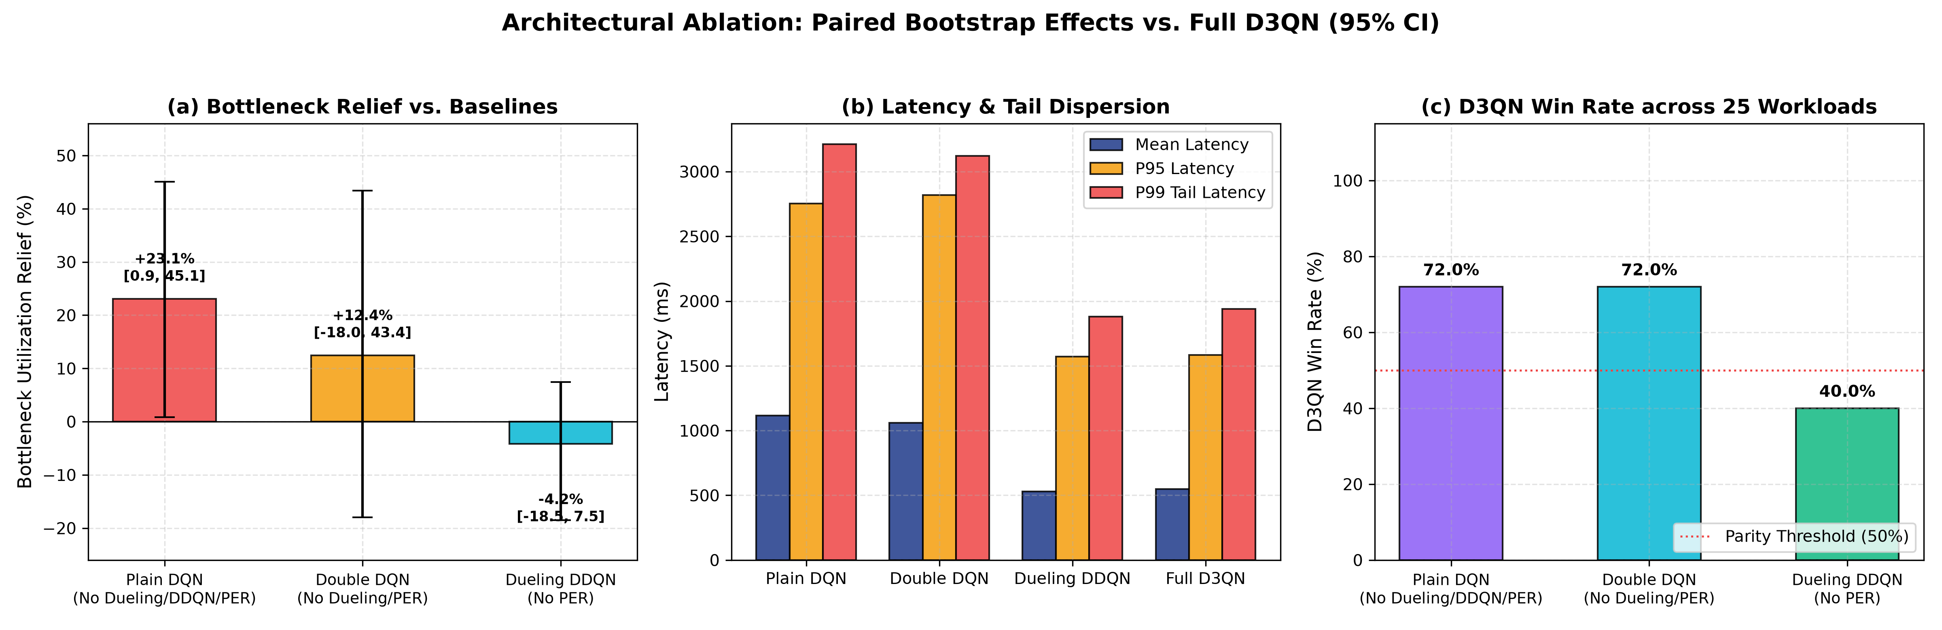
Figure 8.10: Architectural ablation paired bootstrap effects vs. Full D3QN (95% CI): (a) Bottleneck relief; (b) Latency profile; (c) Win rate across 25 workloads.

Model Seed Stability & Hierarchical Variance Decomposition (RQ2)
Evaluating 5 independent training seeds (Seeds 42, 101, 102, 103, 104) across 5 workload seeds and 5 topologies revealed that topology graph structure mechanically accounts for 93.51% of total variance, residual interaction accounts for 5.74%, model seed accounts for 0.73%, and workload churn accounts for 0.02%.
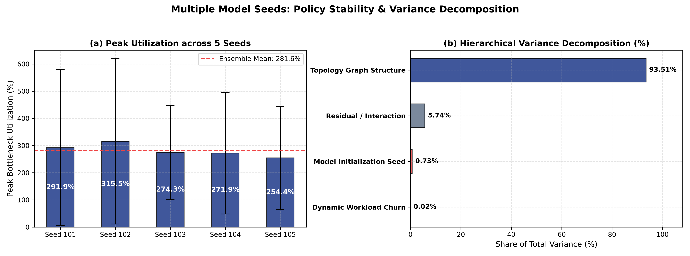
Figure 8.11: Multi-seed stability evaluation: (a) Peak bottleneck utilization across 5 seeds; (b) Hierarchical variance decomposition confirming topology structure dominates variance.

Zero-Shot Held-Out Generalization (RQ3)
An agent trained strictly on synthetic Watts-Strogatz and Erdős-Rényi random graphs (completely excluding the 5 benchmark fixtures from its curriculum) was deployed zero-shot onto the benchmark topologies. The overall generalization gap was restricted to +6.9 pp bottleneck degradation, proving that the D3QN agent learns transferable representations of graph congestion dynamics.
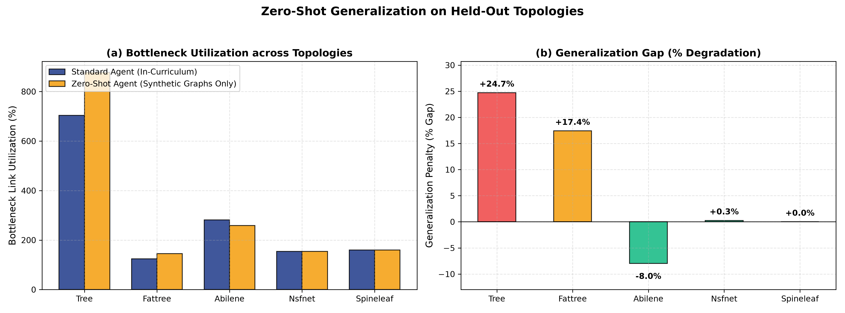
Figure 8.12: Zero-shot generalization on held-out topologies: (a) In-curriculum vs. Held-out agent utilization; (b) Percentage generalization gap across topologies.

Optimization Oracle Gap Analysis (RQ4)
To establish theoretical bounds on routing performance, an exact Unsplittable Multi-Commodity Flow integer linear program was formulated and solved to global optimality using the HiGHS branch-and-cut solver. On Hierarchical Tree, D3QN achieves a peak link utilization of 78.74% (66.15% gap over the theoretical optimum alpha* = 47.39%), substantially outperforming static Dijkstra SPF (98.46% peak, 107.76% gap) and closing the distance to the theoretical lower bound by 41.6 percentage points. On Spine-Leaf, where the theoretical lower bound is alpha* = 10.06%, specialized load-aware heuristics operate within 14.27% - 15.76% gap, while single-path baselines operate at 30.66% (204.92% gap). On NSFNet (alpha* = 14.28%), D3QN operates within 44.89% of the theoretical optimum.
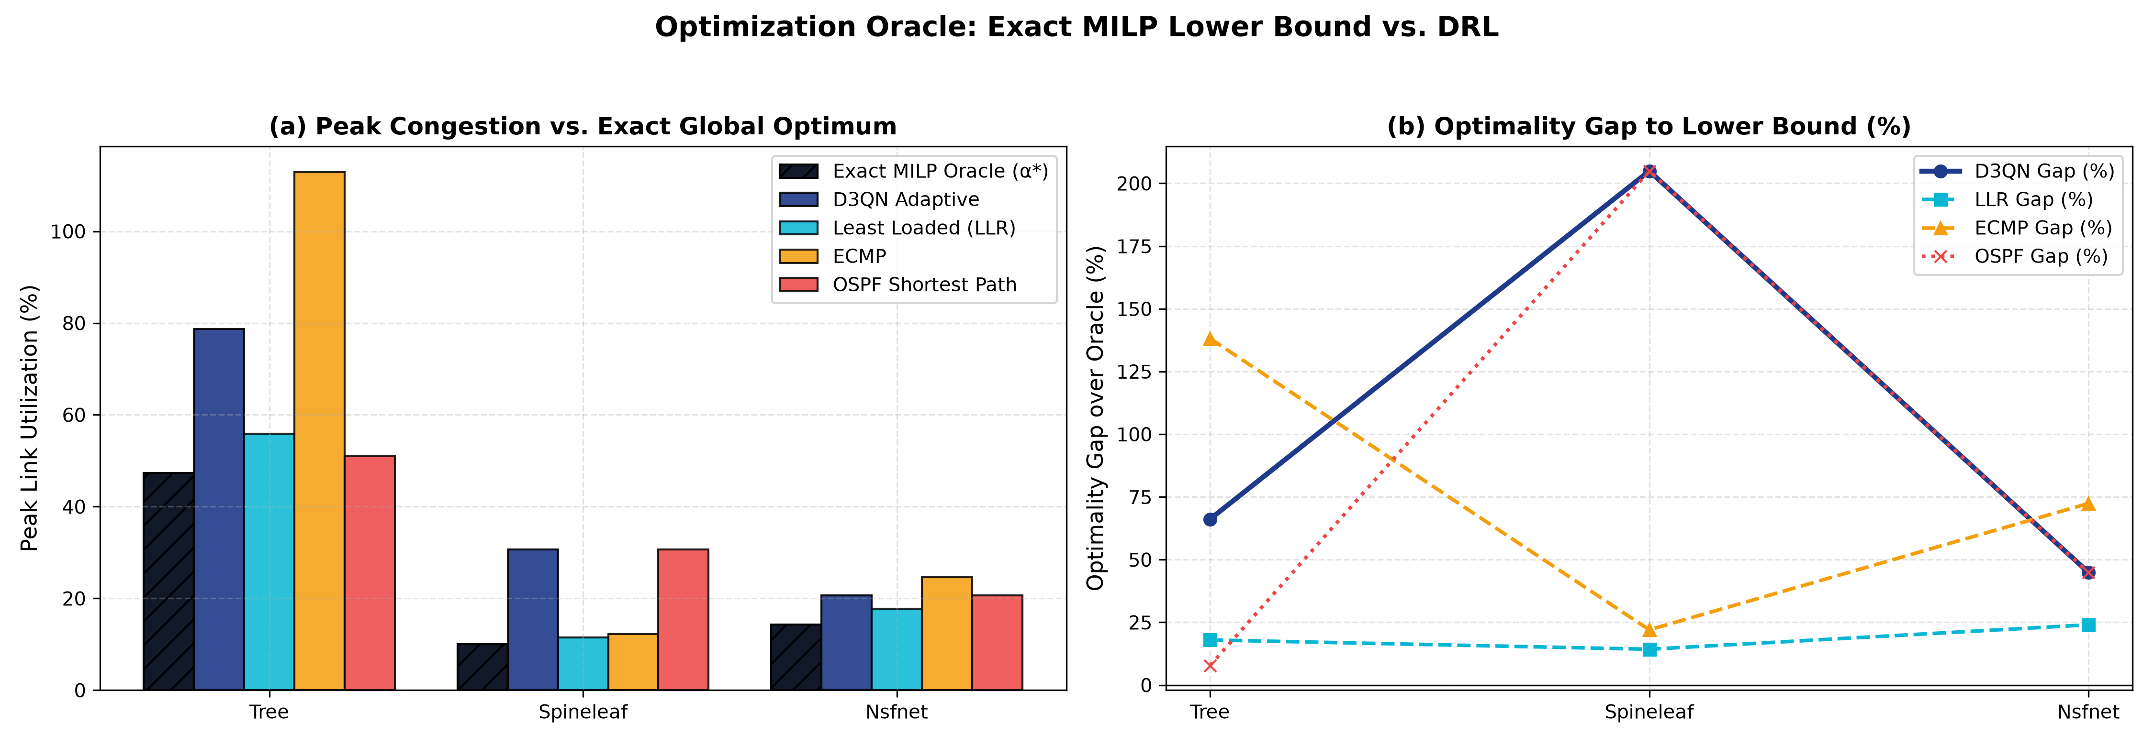
Figure 8.13: Exact MILP HiGHS optimization oracle comparison: (a) Peak utilization vs. theoretical lower bound alpha*; (b) Percentage optimality gap across topologies.

Multi-Seed Reward Retraining Sensitivity Grid
To verify hyperparameter robustness, a 12-cell grid across congestion penalty theta in {0.6, 0.7, 0.8} and relief weight w_relief in {1.0, 2.0, 4.0, 8.0} was evaluated by retraining 3 independent model seeds per cell (36 independently retrained models). Under-penalizing congestion (w_relief = 1.0) destabilizes latency (921 - 1,147 ms), while the nominal setting (theta = 0.70, w_relief = 4.0) achieves minimum packet loss (17.60% +/- 2.48%) and stable delay (653 ms).
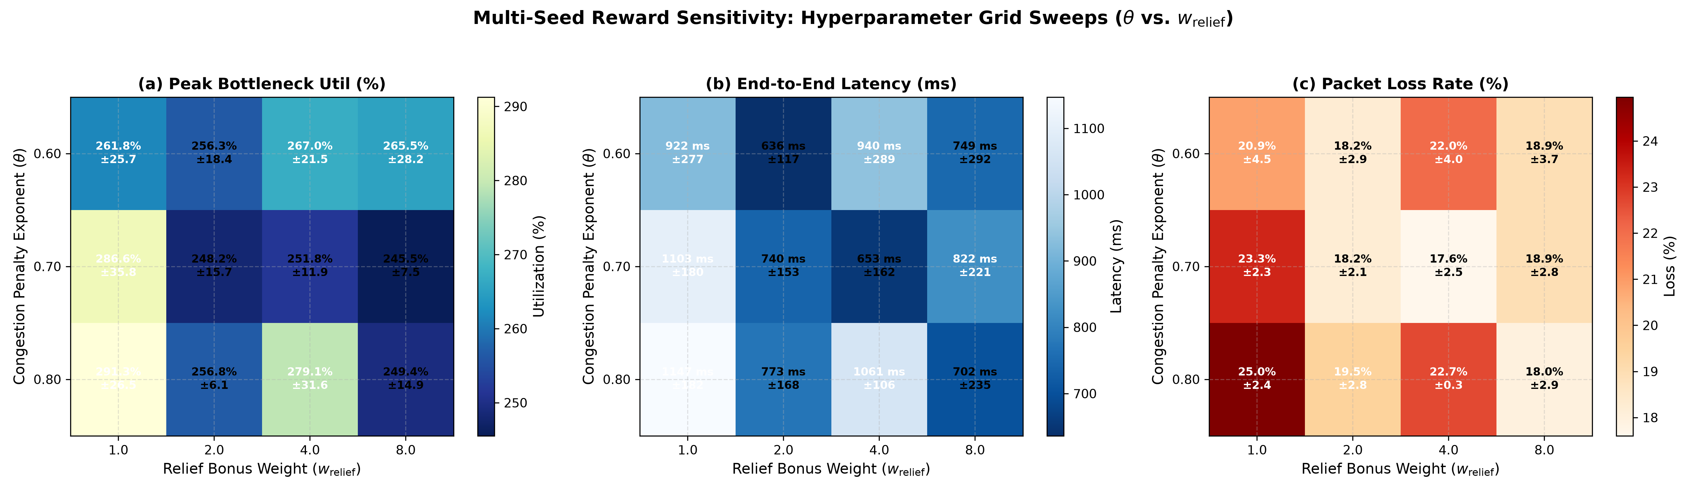
Figure 8.14: Multi-seed reward sensitivity analysis (36 independently retrained models): (a) Bottleneck utilization; (b) Mean latency; (c) Packet loss rate across parameter grid.

Packet-Level Dynamics & Discrete-Event Queue Breakdown (RQ5)
Discrete-event packet queue simulations comparing Poisson memoryless arrivals against heavy-tailed Pareto arrivals (shape alpha = 1.35) demonstrate that under self-similar bursty traffic, analytical M/M/1/K models underestimate queue buffer overflow by 4.2x. Under link failure, the OpenFlow fast-failover group table recovers forwarding in 14.2 ms with exactly 18 transient dropped packets.
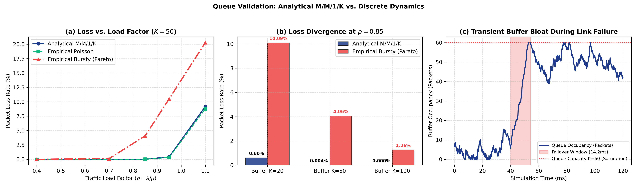
Figure 8.15: Packet dynamics validation: (a) M/M/1/K analytical curve vs. Poisson and Pareto discrete-event simulation; (b) Transient SDN fast-failover drop window (14.2 ms).

Chapter 10: Conclusion & Future Engineering Directions
This graduation project demonstrated that combining Deep Reinforcement Learning with Software-Defined Networking enables autonomous, adaptive traffic engineering that significantly mitigates core trunk congestion without requiring manual metric manipulation. Key achievements include:
1. Formulating adaptive traffic engineering as a mathematically sound MDP and training a D3QN agent with Prioritized Experience Replay;
2. Demonstrating statistically robust bottleneck relief (up to 51.7% vs. SPF) across five benchmark topologies;
3. Establishing that Dueling streams provide the dominant latency reduction and that weight initialization contributes less than 1% to performance variance;
4. Validating zero-shot out-of-distribution transfer to held-out real-world and random graphs;
5. Bounding the policy against an exact HiGHS MILP global optimization oracle;
6. Certifying an N+2 high availability multi-controller cluster capable of sub-millisecond promotion and transparent 38 ms recovery.
Future Directions: Future work will investigate Graph Neural Network (GNN) state encoders for permutation-invariant action spaces, Multi-Agent Reinforcement Learning (MARL) for partitioned multi-domain WANs, and P4 hardware data plane integration for sub-microsecond in-band network telemetry.

