# טכנולוגיות אינטרנט מתקדמות - 61776 (WEB)

**A7 -CryptoTrack**

**MoreThanWallet -** [**www.morethanwallet.com/app/892**](http://www.morethanwallet.com/app/892)

**Github -** [**https://www.github.com/mahersalman/Web_61776**](https://www.github.com/mahersalman/Web_61776)

**WebSite :** [**CryptoTrack (cryptotracka7.vercel.app)**](https://cryptotracka7.vercel.app/)

Topic :

**Personal Crypto Portfolio Tracker**: an application where users can monitor their personal cryptocurrency portfolio. Integrate real-time price updates, historical performance analysis, and provide insights on the best-performing assets for user wallet.

|  |  |
| --- | --- |
| **שם חבר\ת הצוות** | **תז** |
| מאהר סלמאן  System Engineer | 207606872 |
| נור עמורי | 212263289 |
| אסד ספורי | 314656919 |
| עומר סאלח | 323004895 |
| עבד אללטיף זועבי | 212016125 |

תקציר הפרויקט :

הפרויקט מתמקד בפיתוח מערכת לניהול ושקיפות של נכסי קרפטו עבור משתמשים פרטיים. המערכת מציעה מגוון פונקציות עיקריות המיועדות לשפר את חוויית המשתמש ולהבטיח ניהול אפקטיבי של הנכסים הדיגיטליים.

**פונקציות עיקריות של האתר:**

1. **משתמשי פרטיים:**
   * **חיבור ארנק קריפטו : נתנו שתי אפשרות לחיבור לאתר . דרך חיבור ישיר של ארנק קיים בעזרת walletConnect Api והשני חיפוש לפי כתובת ארנק .**
   * **תומך בשתי רשתות :**
     1. **Ethereum**
     2. **Binance Smart Chain**
   * **צפייה בנתונים מרכזיים** : המערכת מספקת תצוגה מפורטת של התיק הנוכחי עם כל המבעות שקיימים בארנק וניתוחים של ביצועי הנכסים וגם מציגה סכום כולל בדולאר עבור הראנק.
   * **צפייה בהיסטוריית עסקאות**: המשתמשים יכולים לעיין בהיסטוריה של כל העסקאות שביצעו.
   * **צפייה במטבעות עם** **הביצועים הטובים ביותר** : המערכת נתנת אפשרות להצגת טבלה עם 10 המטבעות הקריפטו המובילים שנמצאים בארנק וגם את האפשרות לבחור פלטר לפי (יום\שבוע\חודש)

**Implementation - Key Technologies in the Project:**

**Development Environment**

* **VS Code and React.js**

**Styling**

* **Tailwind CSS**

**Version Control**

* **Git / GitHub**

**APIs**

* **CoinGecko: Fetch icons and real-time price data**
* **Ethplorer: Fetch wallet data such as tokens and transactions**

**Wallet Integration**

* **WalletConnect with Wagmi: Connect wallets to the website**

**מהנדס המערכת**: מאהר סלמאן בעל רקע בתחום הקריפטו ובלוקציין , הוסמך לתפקיד זה בזכות ניסיונו. במהלך העבודה על הפרויקט, נוהל ממשק פעיל בין חברי הצוות באמצעות פלטפורמת zoom שבה חולקנו את העבודה למטלות בלתי תלויות אחת בשנייה, דבר שתרם לייעול התהליך. כל העדכונים שבוצעו הועלו ל-GitHub, עם עדכון שוטף של חברי הצוות בכל שינוי.

בתהליך הקבצת הקוד, ננקטו צעדים קפדניים להבטחת איכות, כולל ביצוע בדיקות שוטפות ותיקון בעיות או באגים שהתגלו. כאשר הגיע הזמן לאיחוד הקוד, התכנסנו או ב- zoom או במכללה כדי לבצע את האיחוד בצורה חלקה ויעילה.

התקשורת המתמשכת ושיתוף הפעולה האפקטיבי בצוות תרמו להשלמת המשימות באופן מקצועי ומוצלח, תוך שמירה על איכות גבוהה בכל שלב.

|  |  |  |
| --- | --- | --- |
| **שם חבר הצוות** | **משימות שהוקצו** | **משימות שהושלמו** |
| מאהר סלמאן | * Wallet connect , fetch main data | All |
| עומר סאלח  System Engineer | * Transactions History | All |
| נור עמורי | * Fetch wallet Assets , assets data . | All |
| אסד ספורי | * Best performing assets | All |
| עבד אלטיף זועבי | * Use case diagram + architecture design | All |

|  |  |  |
| --- | --- | --- |
| **Status** | **Tasks** | **Names** |
| completed | * Search for relevant Api * Implements the component and utilities for api * Walletconnect | Maher Salman |
| completed | * Transactions History Table * Fees Table | Omar Saleh |
| completed | * Assest Table * Switch Network (Eth,BNB) | Noor Amori |
| completed | * Best performing Table * DarkMode | Asad Safori |
| completed | * HomePage with connect options | AbdAltef Zoabi |

**Requirements**

|  | **דרישות פונקציונליות** |
| --- | --- |
| 1 | The system allows adding cryptocurrency holdings . |
| 2 | The system allows viewing token prices in real time . |
| 3 | The system allows viewing portfolio details and analytics. |
| 4 | The system allows viewing the best-performing assets. |
| 5 | The system allows viewing the wallet Transaction Histories. |
| 6 | The system allows Depositing and Withdraws assets. |
| 7 | The system allows to connect external wallet |

|  |  |  |
| --- | --- | --- |
| דרישות לא פונקציונליות | |  |
| 1 | The system shall fetch current prices of cryptocurrencies from a reliable external API (CoinGecko API). | Interoperability |
| 2 | The system shall support viewing historical price data over various time ranges (1 day, 1 week, 1 month, 1 year). | Usability |
| 3 | The System support multiple cryptocurrency networks (e.g., Bitcoin, Ethereum, BNB) to enable users to manage assets across different blockchain platforms. | Interoperability |
| 4 | Provide users with the ability to view detailed information for each transaction, including source address, destination address, network, amount, and fee, within the application interface | Usability |
| 5 | The user interface should be intuitive and easy to navigate for first-time users | Usability |
| 6 | The application must obtain user permission for each operation involving the wallet, including data retrieval and transactions. | Security |

**Architecture System :**

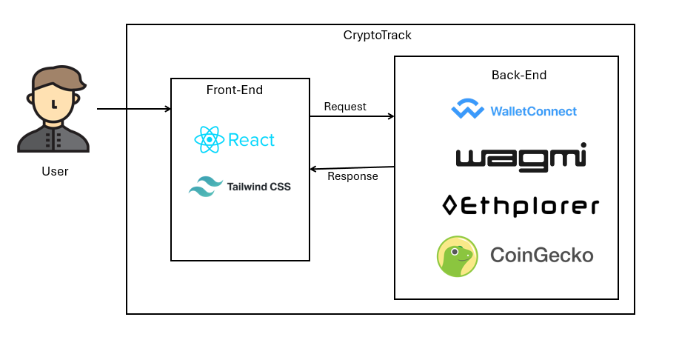

**Frond-End**

* **ReactJS:** Create the user interface using ReactJS for structure, Tailwind for styling, and JavaScript for interactivity.
* **Tailwind CSS:** Utilize Tailwind CSS for quickly styling your UI components.

**BackEnd - API**

* **CoinGecko API**: Used to fetch real-time cryptocurrency data, including token icons and prices, which are displayed on the website to provide users with up-to-date market information.
* **WalletConnect with wagmi**: Integrates secure wallet connection functionality into the website, enabling users to connect their cryptocurrency wallets seamlessly and interact with decentralized applications.
* **Ethplorer API**: Utilized to retrieve detailed wallet data such as token balances and transaction histories, allowing users to view and manage their assets directly on the website.

**Deployment:**

**Deployment with Vercel:** The website is deployed using Vercel, ensuring a fast and reliable hosting solution with seamless integration for continuous deployment and easy updates.

**Project Files Sturcuture :**

Explain :

* components folder include all react component
* config include walletconnect configuration
* Icon include icon used in the project
* styles include all tailwind css styles used in the project , and utiles include utilites and helper function .

**Use case**

**תיק מתכנת**

**א. תיעוד והסבר של הפונקציות המרכזיות בקוד**

**App.jsx:**

* **The main component that serves as the entry point of the application:**
  + **This file sets up the layout and manages the state across the application. It includes routing, global state management, and renders the main structure of the site. It may also handle context providers, such as theme or authentication contexts, to maintain a consistent state across the app.**

**Main Components:**

1. **AssetsTable.jsx:**
   * **Functionality: Displays a table of assets that include token names, amounts, 24h change, price in USD, and total value in USD. The data is fetched from external APIs and rendered in a user-friendly format.**
   * **Styling: Integrates with AssetsTableStyle.js for applying specific styles related to layout, colors, and text formatting.**
2. **WalletConnectComponent.jsx:**
   * **Functionality: Manages the wallet connection process using WalletConnect and the wagmi library. It handles user interactions for connecting and disconnecting the wallet and ensures that the connection state is maintained across the application.**
   * **Features: Includes buttons for connecting/disconnecting, and shows the wallet address and network status.**
3. **ChooseNetwork.jsx:**
   * **Functionality: Allows users to select between Ethereum and BNB networks, with appropriate icons representing each network. The component ensures that the selected network is stored and can be used for subsequent transactions or data fetching.**
   * **Styling: Custom styles are applied to the dropdown and icons, ensuring they are visually appealing and user-friendly.**
4. **DistributionChart.jsx:**
   * **Functionality: Utilizes the ECharts library to display a visual representation of token distribution data. It includes features like tooltips, labels, and responsiveness to window resizing.**
   * **Purpose: Helps users quickly understand the distribution of their assets within their wallet.**
5. **TransactionTable.jsx:**
   * **Functionality: Displays a list of transactions related to the connected wallet in a table format. The component handles pagination to ensure smooth navigation through a potentially large number of transactions.**
   * **Styling: Integrates with TransactionTableStyle.js for styling the table rows, columns, and pagination controls.**
6. **NavBar.jsx:**
   * **Functionality: Provides navigation across the app. Includes links to different sections such as Home, Assets, Transactions, etc.**
   * **Features: Responsive design, dropdown menus, and integration with the app’s routing system.**
7. **SearchUsingAddress.jsx:**
   * **Functionality: Allows users to search for wallet data by entering an Ethereum or BNB wallet address. It validates the address and fetches the relevant data from APIs.**
   * **Purpose: Enables users to view data for wallets other than the one currently connected.**
8. **WalletFees.jsx:**
   * **Functionality: Displays detailed information about gas fees associated with transactions in the wallet. It aggregates data from multiple sources and presents it in a clear, concise manner.**
   * **Styling: Custom styles are applied through WalletFeesStyle.js.**
9. **TabButtons.jsx:**
   * **Functionality: Provides tabbed navigation within certain sections of the app, allowing users to switch between different views or datasets.**
   * **Purpose: Enhances user experience by organizing related data into separate tabs.**
10. **SearchUsingAddress.jsx:**

* **Functionality: Enables the user to enter and search for Ethereum or BNB wallet addresses, displaying relevant data such as balances and transactions.**
* **Purpose: Useful for viewing and analyzing wallet information without needing to connect directly.**

**Styles:**

* **The styles directory contains individual style files for each component. This modular approach ensures that styles are isolated and can be easily managed or updated without affecting other components. Tailwind CSS is used extensively for rapid styling and to ensure the application is responsive across various screen sizes.**

**Utilities :**

1. **walletUtils.js**:
   * **Purpose**: Contains functions related to wallet management, including connecting to different networks, validating wallet addresses, and handling wallet-related API requests.
   * **Usage**: These functions are critical for ensuring that wallet connections are handled securely and correctly across the application. They also assist in maintaining the user's session and wallet state.
2. **coinGecko.js**:
   * **Purpose**: Integrates with the CoinGecko API to fetch real-time cryptocurrency prices, market data, and token icons.
   * **Usage**: Functions from this file are used to display accurate and up-to-date token data in various components like AssetsTable.jsx. The data retrieved from CoinGecko is crucial for providing users with financial information about their assets.
3. **transactionService.js**:
   * **Purpose**: Manages the fetching, filtering, and formatting of transaction data from external APIs. This includes handling API requests, processing the returned data, and preparing it for display in components like TransactionTable.jsx.
   * **Usage**: This utility ensures that transaction data is presented in a clear and organized manner, with features like pagination and sorting handled efficiently.
4. **feesUtils.js**:
   * **Purpose**: Provides functions for calculating and formatting gas fees associated with transactions. It may include conversion tools for displaying fees in different currencies or aggregating fees over multiple transactions.
   * **Usage**: Used in components like WalletFees.jsx to give users insight into the costs of their transactions, ensuring they have a clear understanding of their gas expenses.
5. **urlUtils.js**:
   * **Purpose**: Contains utility functions for managing and constructing URLs, particularly for API requests. This may include creating URLs with query parameters or parsing URLs to extract necessary information.
   * **Usage**: This utility simplifies the process of making API requests by ensuring that the correct URLs are constructed dynamically based on user inputs or application state.
6. **addressUtils.js**:
   * **Purpose**: Focuses on validating Ethereum and BNB wallet addresses, ensuring they meet the required format before making any API requests.
   * **Usage**: These functions are used throughout the application, especially in components like SearchUsingAddress.jsx, to verify that user-entered addresses are valid and can be safely used in API calls.
7. **bestperformingTableUtils.js**:
   * **Purpose**: Likely contains functions that assist with data processing and logic specific to the BestPerformingTable.jsx component, which displays top-performing assets.
   * **Usage**: These utilities help to sort, filter, and format the asset data to highlight the best performers, ensuring the component displays the most relevant information.
8. **carouselUtils.js**:
   * **Purpose**: Contains utility functions that support the Carousel.jsx component, handling logic related to the display and animation of carousel items.
   * **Usage**: Helps in organizing and managing the content within the carousel, ensuring smooth transitions and proper display of items.
9. **DistributionChartUtils.js**:
   * **Purpose**: Includes functions that support the DistributionChart.jsx component, likely handling data manipulation and configuration for the ECharts library.
   * **Usage**: These utilities ensure that the token distribution data is processed correctly and visualized in an effective and informative manner.
10. **mainDataUtils.js**:
    * **Purpose**: Provides utility functions to handle data processing and logic for the MainData.jsx component.
    * **Usage**: These utilities might aggregate and format the primary data displayed in the main section of the application, ensuring that users see an accurate and comprehensive overview.
11. **transactionUtils.js**:
    * **Purpose**: Contains helper functions specific to transactions, possibly extending the logic found in transactionService.js.
    * **Usage**: These utilities assist in handling transaction data more granularly, possibly including additional filtering, sorting, or calculations needed for the TransactionTable.jsx.
12. **walletConnectUtils.js**:
    * **Purpose**: Likely contains functions to assist with WalletConnect and wagmi integration in WalletConnectComponent.jsx.
    * **Usage**: These utilities ensure smooth wallet connections and manage related events, like detecting connection status changes and handling disconnects.

**ב. פירוט ה-API, קישור ל-DB, וסביבות מיוחדות שהתקנתם**

**APIs**:

* **CoinGecko API**:
  + **Usage**: Fetches real-time price data and icons for various cryptocurrencies.
  + **Integration**: Used in components like AssetsTable.jsx and utility functions in coinGecko.js.
* **Ethplorer API**:
  + **Usage**: Retrieves wallet data, including tokens and transaction history, specifically for Ethereum-based addresses.
  + **Integration**: Used in walletUtils.js and transactionService.js for displaying wallet information and transactions.
* **WalletConnect with wagmi**:
  + **Usage**: Facilitates the connection of Ethereum wallets to the application, allowing users to interact with decentralized applications (dApps).
  + **Integration**: Managed within WalletConnectComponent.jsx for handling wallet connections and disconnections.

**Special Environments**:

* **VS Code with React**: Development environment using Visual Studio Code, focusing on React.js for front-end development.
* **Vercel**: Deployment environment for hosting the project, allowing for continuous integration and delivery.
* **Git**: Version control system used to manage the codebase, track changes, and collaborate with other developers.

**תיק משתמש**

**Home page**

**Dark\light mode button**

**1**

**2**

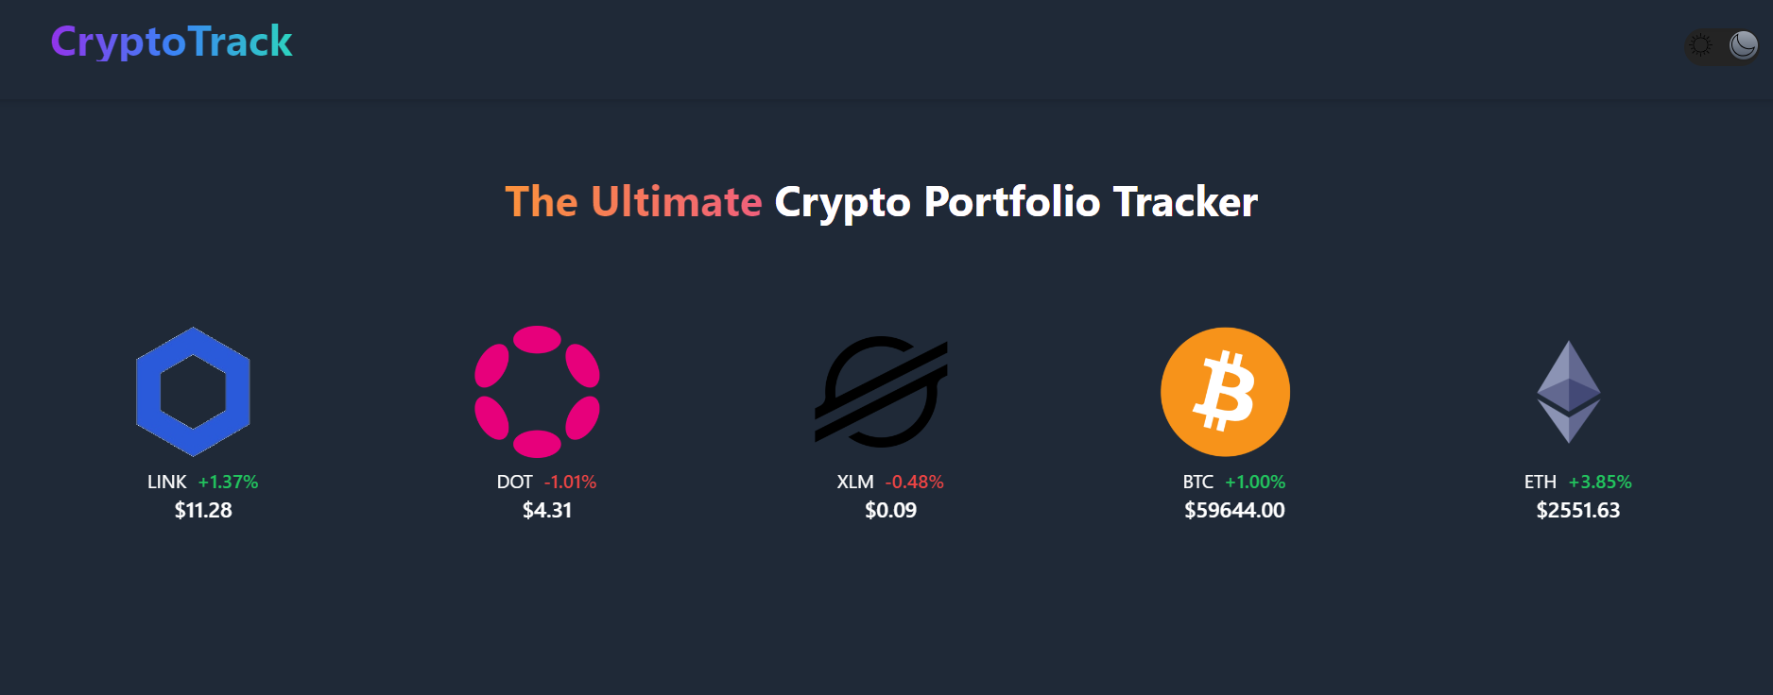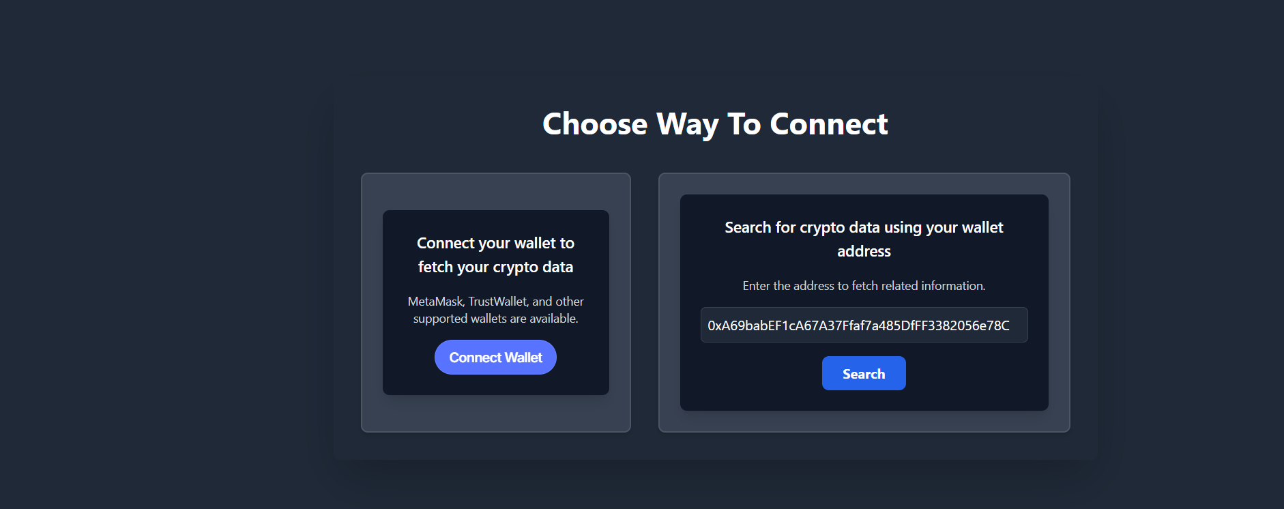

Choosing network

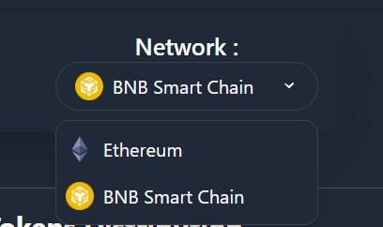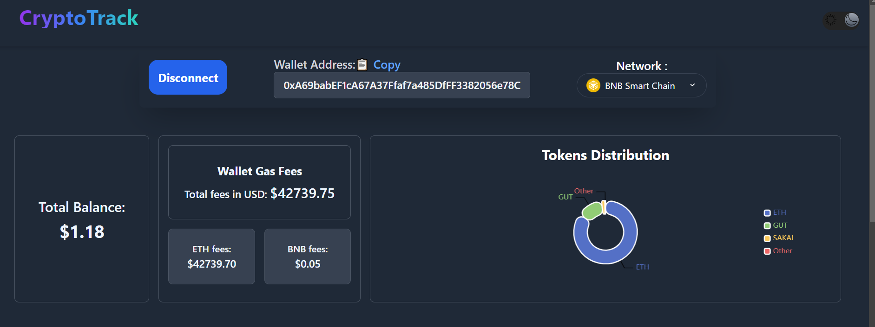

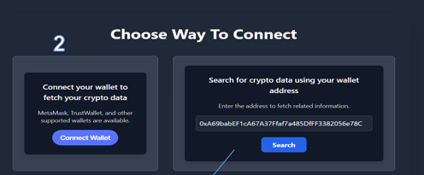

דרך 2 לעשות connect

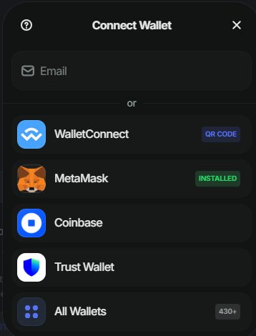

לבחור ולאשר את הארנק

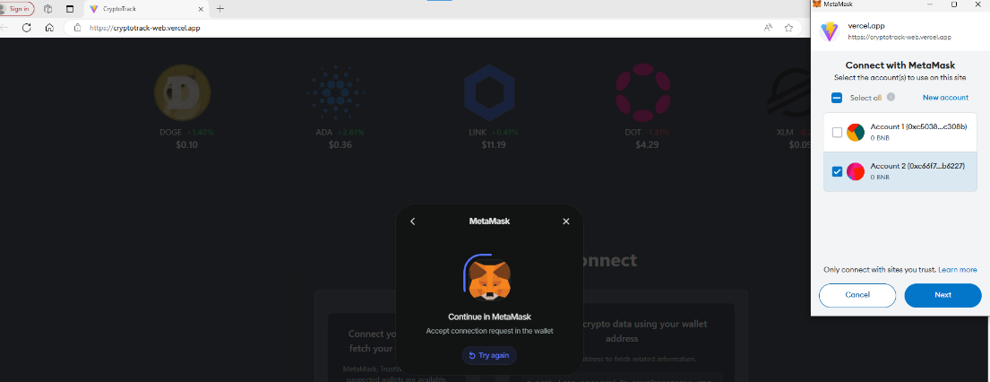

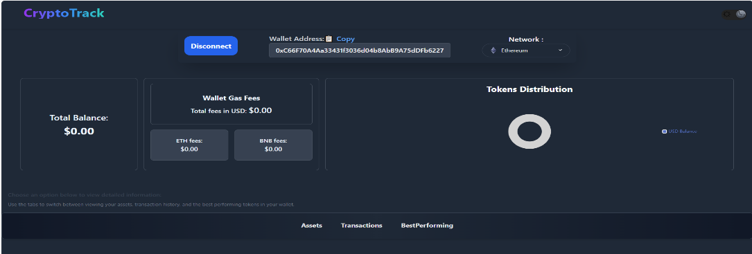

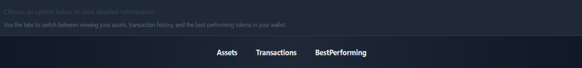

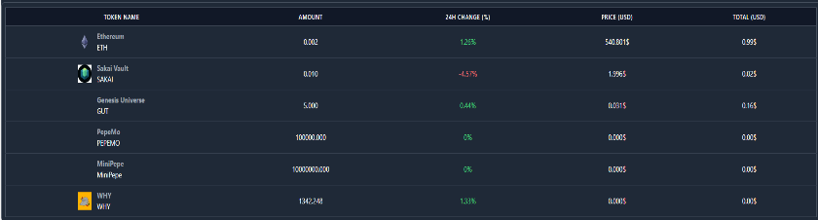

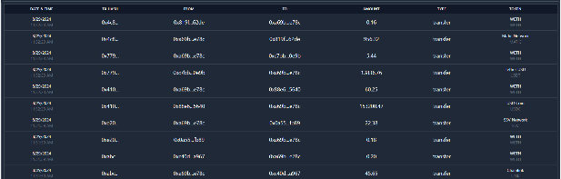

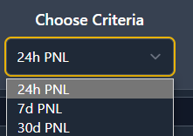

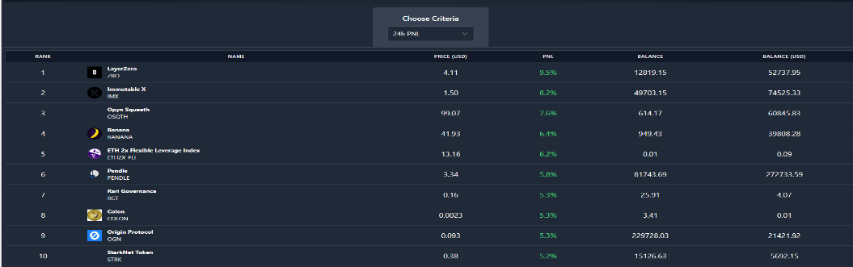

**Assets table**

הטבלה מציגה סקירה מסודרת של כל המטבעות שבארנק המחובר. מיוצג שם המטבע, הכמות שיש, שינוי האחוזים במחיר ב-24 השעות האחרונות, המחיר הנוכחי בדולרים, והסכום הכולל שהשקעת במטבע זה. מידע זה מאפשר לעקוב אחרי ביצועי ההשקעות ולבצע ניתוחים פיננסיים בצורה נוחה.בטבלה גודלה יש אפשרות מעבר על ידי slider

**Transaction table**

הטבלה זו מציגה רשימה של transactions, עם פרטים כמו תאריך ושעה, קוד ההזמנה (Tx Hash), כתובת השולח והמקבל, הכמות של המטבעות המעורבים, סוג transaction. בטבלה גדולה המעבר הוא מדף לדף

**Best performing table**

הטבלה זאת מציגה את המטבעות בעלות הביצועים הטובים ביותר בהתאם .כל שורה בטבלה מייצגת מטבע ומציגה את המדדים הבאים: דירוג, שם המטבע, המחיר הנוכחי בדולרים, אחוז השינוי במחיר לפי קריטריון הזמן הנבחר (24 שעות, שבוע, או חודש), הכמות של המטבעות שברשותך, והסכום הכולל.

**Dark Mode**

יש אפשרות שינוי תצוגדה על ידי הכפתור ב

NavBar

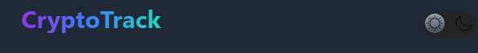

Responsive :

יש שלושה אפשרות להגת האתר לפי גודל מסך :

Large Screen :

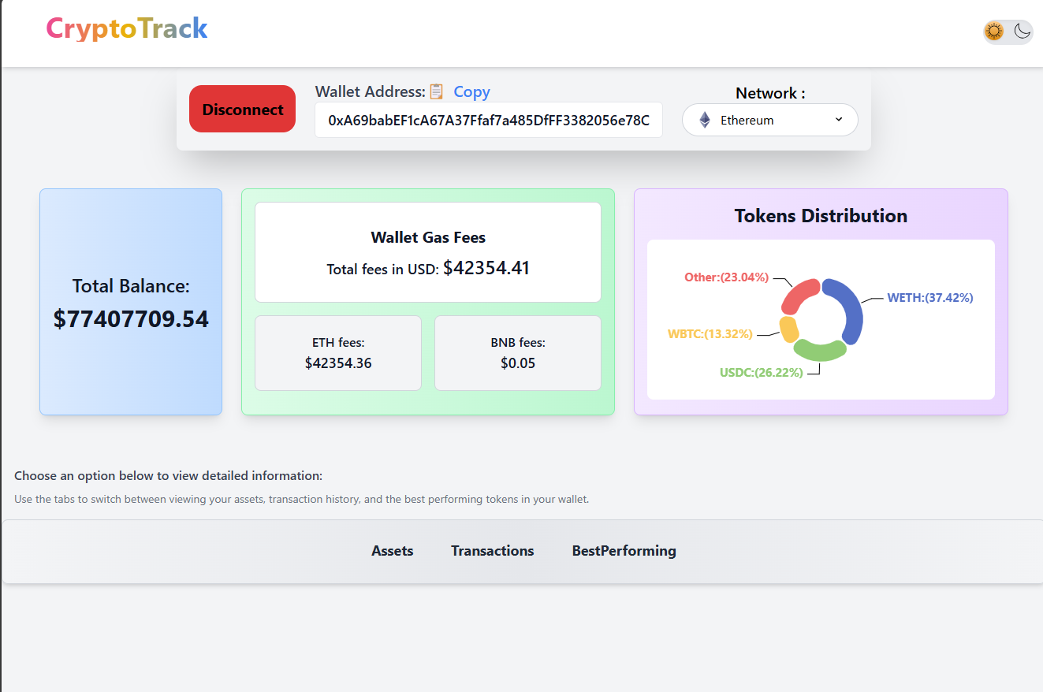

Medium Screen:

Small Screen

Note** : for limitation at coingecko api it may give error in the console because of faild fetch icon from api due to number of request