

Software Engineering Department

Braude College

**Predicting Life Expectancy Based On Personal, Lifestyle, and Medical Indicators Using Machine Learning [25-1-R-12]**

By:

Maher Salman

Adan Butto

Advisors :

Dr. Naomi Unkelos-Shpigel

Dr. Samah Idrees Ghazawi

Website : <https://life-expectancy-pi.vercel.app/>

GitHub: <https://github.com/mahersalman/life-expectancy>

**Table of Contents**

**Abstract 3**

**1. Introduction 3**

**2. Related Work - Literature Review 4**

2.1. Life Expectancy Research: Key Studies and Predictive Models 4

**2.2. Indicators for Life Expectancy 5**

2.2.1. Key Indicators and Their Impact on Life Expectancy 5

2.3. Machine learning in life expectancy 7

**3. Methodology and Research Process 7**

3.1. Data Source And Penalty 7

3.1.1. Personal Key Indicators of Heart Disease Dataset 7

3.1.2. Life Expectancy and Healthy Life Expectancy Dataset 8

3.1.3. Applied Penalty Adjustments 8

3.2. Preprocessing 12

3.2.1. Synthetic Data Generation 12

3.3 Predictive Modeling Approaches for LE 12

3.3.1 XGBoost 13

3.3.1.1 Flow of the XGBoost Model 14

3.3.1.2 Example: Step-by-Step Flow of the XGBoost Model 16

**4. Evaluation 18**

4.2. Metrics in Detail 18

**5. Project Architecture and Deployment 19**

**6. Results 20**

6.1 Synthetic Data Generation 21

6.2 XGBoost Performance 26

7. Documenting Failed Experiences During the Study 30

7.1. Synthetic Dataset Creation Using Averaged Data 30

7.2. Deep Learning on Tabular Data 32

**References: 32**

# Abstract

Life expectancy (LE) is a critical measure of public health and longevity potential, offering valuable insights into societal well-being. This project aims not only to predict life expectancy by leveraging advanced machine learning (ML) techniques but also to construct an individual-level dataset—filling a key gap in existing research where no public, person-level LE dataset currently exists. Such a resource will support this study’s modeling efforts and serve as a foundation for future investigations.

We examine comprehensive lifestyle, behavioral, and socioeconomic indicators using real-world data from reputable sources, including the World Health Organization (WHO) and the National Health and Nutrition Examination Survey (NHANES). Key factors such as Body Mass Index (BMI), physical activity, smoking habits, alcohol consumption, and access to healthcare are analyzed to understand their contributions to LE prediction.

The project employs a comparative analysis of various predictive models, including ensemble methods like XGBoost. These models are rigorously optimized and evaluated using RMSE, MAE, and R² metrics to ensure accuracy and generalizability. By integrating multiple ML approaches, this research seeks to enhance prediction accuracy and provide actionable insights for public health planning. The findings aim to demonstrate the transformative potential of machine learning in life expectancy forecasting and enable personalized healthcare strategies.

# 1. Introduction

Life expectancy (LE) is vital to public health and societal well-being. It offers insights into the average potential longevity of individuals within a population. For individuals at a given age, it estimates the additional years they are likely to live based on prevailing death rates. By summarizing mortality patterns, life expectancy serves as a key indicator of health outcomes, societal progress, and the effectiveness of healthcare systems [1].

Predicting life expectancy is a multifaceted challenge influenced by a wide range of factors. Personal attributes such as body mass index (BMI), physical activity levels, and smoking habits interact with systemic determinants like access to healthcare, socioeconomic status, and environmental conditions[6]. These variables often have complex, non-linear relationships, making life expectancy prediction both complicated and rich in potential insights. Accurate predictions of LE are essential for public health planning, enabling policymakers to identify key determinants and design targeted interventions to improve health and longevity.

While previous research has explored individual indicators of life expectancy, integrating machine learning presents a transformative approach to tackling this problem. Machine learning algorithms allow for the simultaneous analysis of multiple factors, uncovering intricate patterns and relationships with exceptional precision and scalability[1]. By leveraging these capabilities, predictive models can be constructed to estimate life expectancy with greater accuracy than traditional statistical methods.

This project builds on these advancements by utilizing real-world data from diverse sources to ensure a comprehensive representation of indicators. These indicators include behavioral factors like smoking and physical activity, physiological measures such as BMI, and systemic factors like healthcare access and income levels. By testing and comparing machine learning and deep learning models—including neural networks, and ensemble methods—this project aims to identify the most effective approach for predicting life expectancy. Through rigorous model optimization and validation, the results are designed to be both accurate and generalizable, providing valuable tools for improving public health outcomes across diverse populations.

# 2. Related Work - Literature Review

Understanding the factors influencing life expectancy is a critical area of research with profound implications for public health and policy-making. Numerous studies have explored the relationship between health, economic, and social indicators and life expectancy, leveraging both traditional statistical approaches and modern machine learning techniques. These works provide valuable insights into the predictors of longevity and form the foundation for more advanced modeling and analysis. Below, we review key studies that have significantly contributed to this field.

## 2.1. Life Expectancy Research: Key Studies and Predictive Models

1) The project “What Really Drives Higher Life Expectancy?” analyzed global data from the World Health Organization, focusing on identifying key factors that influence life expectancy across countries from 1960 to 2015. Using a regression model, the study aimed to predict life expectancy based on 21 development indicators, achieving a high degree of accuracy. Significant predictors highlighted in the study included access to sanitation facilities, which showed a strong positive correlation (r = 0.88), and gross domestic product (GDP) per capita, which also had a positive correlation (r = 0.698). Other key factors were health expenditure per capita (r = 0.63), percentage of the population in rural areas, which exhibited a strong negative correlation (r = -0.80), and adolescent fertility rate, which had a negative correlation (r = -0.77).

The regression model achieved an accuracy of 89.7% using all 21 indicators. A simplified model that used only access to sanitation and rural population percentage maintained an impressive accuracy of 80.4%. Notably, the study found that a 0.18% increase in access to sanitation corresponded to a one-year increase in life expectancy, while a 0.11% decrease in the rural population percentage resulted in a one-year increase in life expectancy[31].

2) The article **“An Application of a Supervised Machine Learning Model for Predicting Life Expectancy”** investigates the use of machine learning techniques, specifically the Extreme Gradient Boosting (XGBoost) algorithm, to forecast life expectancy across various countries. The study focuses on identifying key determinants influencing life expectancy by analyzing data from the World Health Organization (WHO) and the United Nations (UN).

Key factors examined include:

**Health Indicators**: Adult mortality rate, infant deaths, immunization coverage (e.g., Polio, Hepatitis B), and disease prevalence (e.g., HIV/AIDS).

**Economic Factors**: GDP per capita, total health expenditure, and alcohol consumption.

**Social Factors**: Average years of schooling, population demographics, and country development status.

The XGBoost algorithm demonstrated exceptional performance, surpassing earlier models in accuracy and handling dataset complexity. The results highlighted significant predictors of life expectancy, such as adult mortality rate, GDP per capita, and immunization coverage. These findings emphasize the importance of enhancing healthcare access, economic growth, and disease prevention to positively impact life expectancy [1].

## 2.2. Indicators for Life Expectancy

### 2.2.1. Key Indicators and Their Impact on Life Expectancy

Drawing on established research, we have identified a definitive set of indicators—each shown to correlate strongly with life expectancy—as the sole basis for our analysis. Employing machine learning techniques, we will assess the predictive strength of these chosen factors and quantify their individual contributions. Below, we present each indicator, summarize our findings, and discuss its relevance to life expectancy modeling.

**Table 1. PersonaInfo**

|  | Indicator | Explanation |
| --- | --- | --- |
| 1 | Body Mass Index (BMI) | Measure of body fat based on weight and height; used to categorize health risks. |
| 2 | sex | Biological sex affecting health risks and life expectancy differences. |

**Table 2. Life Style**

|  | Indicator | Explanation |
| --- | --- | --- |
| 1 | Smoking and Vaping | Usage of electronic cigarettes and tobacco, significantly impacting both respiratory and cardiovascular health. |
| 3 | Physical Activities | regular physical exercise, impacting overall health and longevity. |
| 4 | Sleep Hours | Average nightly sleep duration, influencing physical and mental health. |
| 5 | Alcohol Consumption | Frequency and quantity of alcohol intake, affecting liver and overall health. |

**Table 3. Medical History**

|  | Indicator | Explanation |
| --- | --- | --- |
| 1 | HadHeartAttack | History of myocardial infarction, critical for cardiovascular risk assessment. |
| 2 | had Angina | History of chest pain due to reduced blood flow to the heart. |
| 3 | had Stroke | Past incidents of cerebrovascular accidents affecting brain function. |
| 4 | had Asthma | Presence of chronic respiratory disease affecting breathing. |
| 5 | had COPD | Chronic obstructive pulmonary disease, severely affecting respiratory health. |
| 6 | had Depressive Disorder | History of clinical depression impacting mental and physical health. |
| 7 | hadKidney Disease | Chronic kidney disease history, significant for renal function assessment. |
| 8 | had Arthritis | Chronic joint inflammation affecting mobility and quality of life. |
| 9 | had Diabetes | Presence of diabetes mellitus, impacting metabolic and cardiovascular health. |
| 10 | deaf Or Hard Of Hearing | Untreated hearing loss has also been associated with increased rates of anxiety, depression, poor mental health and lower life expectancy. |
| 11 | blind Or Vision Difficulty | the risk of mortality was 29% higher for participants with mild vision impairment, compared to normal vision. The risk increases to 89% among those with severe vision impairment. |
| 12 | difficulty Concentrating | The researchers conclude that, on average, people with an ADHD diagnosis have shorter lives than those without the condition. |
| 13 | difficulty Walking | Mobility impairment significantly affecting independence and health. |
| 14 | difficulty Dressing Bathing | Difficulty in performing personal care activities, indicating severe functional limitation. |
| 15 | difficulty Errands | Difficulty in completing routine tasks outside home, affecting independence. |

**Table 4. Preventive Care**

|  | Indicator | Explanation |
| --- | --- | --- |
| 1 | fluVaxLast12 | Receipt of influenza vaccination in the past year, relevant for infection prevention. |
| 2 | pneumoVaxEver | History of receiving pneumococcal vaccination, important for pneumonia prevention. |
| 3 | tetanusLast10Tdap | Receipt of tetanus vaccine within last ten years, significant for tetanus prevention. |
| 4 | highRiskLastYear | Identification as high-risk individual within the last year, indicating increased vulnerability to health issues. |

## 2.3. Machine learning in life expectancy

In related studies, commonly used machine learning techniques for life expectancy prediction include linear regression and multiple regression models, which are effective for analyzing relationships between indicators and life expectancy. Ensemble methods such as random forests and decision trees are widely employed for feature importance analysis and to enhance predictive performance [6]. Advanced techniques like support vector machines (SVM) are utilized to model complex non-linear relationships, while gradient boosting algorithms, such as XGBoost, are favored for handling large datasets and optimizing predictions [1].

Despite these advancements, existing approaches still face limitations. A key challenge lies in the generalizability of these models, as they often struggle to adapt to diverse datasets from different countries or regions [4]. Additionally, publicly available datasets tend to represent averaged data [2], which weakens the ability to identify precise relationships between life expectancy and specific indicators. Addressing these gaps is crucial for developing more accurate, adaptable, and practical life expectancy prediction models that can offer actionable insights to inform global health policies and strategies.

# 3. Methodology and Research Process

We began by surveying the landscape of life-expectancy research and assembling a set of strongly correlated indicators. In our search for granular, individual-level data, we discovered only aggregate datasets—most notably from the World Health Organization—so, to work around privacy constraints, we generated a realistic synthetic cohort. This involved using a generative adversarial network (GAN) trained on the published averages and variances to produce individual records that faithfully mirror real-world distributions.

With our synthetic tabular dataset in hand, we turned to models proven effective on structured medical data. We selected XGBoost—a gradient-boosting implementation renowned for top Kaggle performances and robust handling of heterogeneous features—and complemented it with a deep-learning architecture tailored to tabular inputs. Each model is rigorously optimized and evaluated on our dataset so we can quantify predictive accuracy, compare strengths and weaknesses, and determine which approach best forecasts life expectancy.

## 3.1. Data Source And Penalty

For this study, two datasets have been employed to enhance analysis accuracy and relevance:

### 3.1.1. Personal Key Indicators of Heart Disease Dataset [45]This dataset includes 2022 annual survey data from over 400,000 adults, provided by the Centers for Disease Control and Prevention (CDC). Originally part of the Behavioral Risk Factor Surveillance System (BRFSS), the dataset has been condensed from nearly 300 variables to the 40 most relevant indicators associated with heart disease, including blood pressure, cholesterol levels, smoking status, diabetes, obesity (BMI), physical activity, and alcohol consumption. The primary variable of interest, "HadHeartAttack," is treated as a binary classification indicating the occurrence of heart disease. Due to class imbalance, special consideration such as undersampling or adjusting model weights is recommended when applying machine learning methods. This dataset is utilized for individual-level health data analysis.

## 3.1.2. Life Expectancy and Healthy Life Expectancy Dataset [46]Provided by the World Health Organization (WHO), this dataset offers comprehensive life expectancy metrics by country and wealth group, covering historical data from 2000 through 2019. It is used to calculate an average life expectancy baseline for each country, serving as a reference to synthetically determine individualized life expectancy for participants from the first dataset.

The two datasets are integrated such that individual health indicators from the heart disease dataset [24] are combined with country-level life expectancy benchmarks from the WHO dataset [25]. Subsequently, individual life expectancies are adjusted using penalty scores based on specific health indicators, as detailed in Table [5] of this research.

### 3.1.3. Applied Penalty Adjustments

To generate our synthetic cohort, we assign evidence-based year-penalties (or gains) for each risk factor—such as smoking, physical activity, sleep duration, and heart attack history—ensuring the simulated data reflect real-world life-expectancy impacts documented in the literature.

**Table 5. Penalty Adjustments for Synthetic Data**

|  | **indicator** | **explanation** | **REF** |
| --- | --- | --- | --- |
| 1 | Smoking and Vaping | Associated with a 6.8 to 8.8 year reduction in life expectancy. | [8] |
| 2 | Physical Activity | Regular activity can increase lifespan by 0.4 to 6.9 years. | [9] |
| 3 | Sleep Duration | Sleeping fewer than 7 hours or more than 9 hours is associated with a reduction of 1–3 years in lifespan. | [10] |
| 4 | Heart Attack | Results in an average reduction of 12 years in life expectancy. | [17] |
| 5 | Stroke | Decreases lifespan by 5.5 to 7.4 years. | [18] |
| 6 | Vaccinations (Influenza, Pneumococcal, Tetanus) | Can collectively increase life expectancy by up to 10 years through disease prevention and immune protection. |  |
| 7 | Body Mass Index (BMI) | * BMI ≥ 30: Reduces life expectancy by 4.2 years in men and 3.5 years in women. * BMI ≤ 18.5: Reduces life expectancy by 4 years | [19] |
| 8 | Asthma | Associated with a reduction in life expectancy by approximately 3.3 years. | [20] |
| 9 | Depression | Found to reduce life expectancy by 12 to 21 years, depending on severity and comorbidities. | [11] |
| 10 | Kidney Disease | Linked to a decrease in life expectancy by 6 years. | [12] |
| 11 | Rheumatoid Arthritis | May reduce life expectancy by up to 10 years. | [21] |
| 12 | Disabilities | Varying degrees of disability can lead to a reduction of up to 10 years in life expectancy. | [13] |
| 13 | Alcohol Consumption | Reduces life expectancy by approximately 0 to 6.9 years, depending on usage patterns. | [14] |
| 14 | Diabetes | Shown to decrease lifespan by around 6 years. | [15] |
| 15 | COPD (Chronic Obstructive Pulmonary Disease) | * Current smokers: 2.2–5.8 years reduction * Former smokers: 1.4–5.6 years reduction * Never smokers: 0.7–1.3 years reduction | [16] |

## 3.2. Preprocessing

Our preprocessing pipeline ingests two primary CSV files—heart_2022_with_nans.csv (individual‐level BRFSS records, many with missing values) and xmart.csv (country-year life-expectancy averages)—and transforms them into a unified, analysis-ready dataset. We begin by harmonizing column names across both sources, dropping irrelevant or redundant fields, and mapping all categorical responses (e.g. “Yes/No,” gender, smoking status, e-cigarette usage, tetanus vaccination) to consistent numeric codes. Continuous variables such as BMI and sleep hours are imputed via group-mean filling, where missing values are replaced by the average within each sex and age cohort. We then clip extreme outliers beyond three standard deviations to reduce undue influence. All numerical columns—including GDP per capita and other continuous indicators—are standardized with z-score normalization to ensure comparable scaling. Finally, the cleaned individual records are split into stratified training (70 %), validation (15 %), and test (15 %) sets, preserving the original distributions of life expectancy and key demographics for robust downstream modeling.

## 3.2.1. Synthetic Data Generation

As part of our preprocessing workflow, we augment the cleaned BRFSS records with a fully synthetic life-expectancy label. From xmart.csv we extract four benchmark columns—LE_birth_male, LE_birth_female, LE_60_male, and LE_60_female—and compute their official minimum, maximum, and mean values. Each preprocessed individual record then receives a synthetic LifeExpectancy via a custom function that (1) selects the appropriate life-table mean (birth or age 60) plus modest Gaussian jitter, (2) applies evidence-based penalties for smoking intensity, alcohol use, sleep deviations, chronic diseases, disabilities, and extreme BMI (capped for plausibility), (3) adds benefits for physical activity and vaccinations, (4) introduces final random noise, and (5) clamps the result within the official min/max bounds. Embedding this step in preprocessing ensures that our downstream ML models train on an individual-level dataset whose marginal and joint distributions faithfully mirror real-world demographics—addressing the critical absence of any public person-level life-expectancy dataset.

## 3.3 Predictive Modeling Approaches for LE

We predict life expectancy using XGBoost, a gradient-boosting ensemble algorithm renowned for its speed, flexibility, and strong performance on structured data. XGBoost builds successive decision-tree learners that iteratively correct the errors of their predecessors, yielding highly accurate and robust models even when complex feature interactions and non-linearities are present. It has demonstrated significant effectiveness in medical applications, handling complex and diverse datasets while meeting accuracy requirements for auxiliary diagnosis [3].

For our implementation, we perform a grid search over key hyperparameters—number of trees, maximum tree depth, learning rate, and subsampling ratios—using five-fold cross-validation on the training set to guard against overfitting. Model performance is then evaluated on held-out validation and test splits using RMSE, MAE, and R² metrics. XGBoost’s proven track record in public-health forecasting makes it an ideal choice for life-expectancy prediction and establishes a strong baseline for future comparative work.

### 3.3.1 XGBoost

XGBoost, or eXtreme Gradient Boosting, is a powerful and efficient machine learning algorithm designed to enhance the performance of gradient boosting models. By leveraging sequential decision trees and optimizing their outputs, XGBoost iteratively refines predictions, making it an essential tool for both research and real-world applications. Its robust features, including scalability, flexibility, and efficiency, have made it a popular choice in machine learning competitions and industry use cases [7] .

As illustrated in Fig. 1, XGBoost represents the evolution of boosting techniques, building on the strengths of decision trees, bagging, and gradient boosting to deliver optimized gradient boosting. This evolutionary process demonstrates how XGBoost refines its approach to achieve greater efficiency and predictive power.

XGBoost’s primary strength lies in its ability to convert weak learners, in our case a decision tree, into a strong predictive model through an iterative boosting process. Each subsequent tree focuses on correcting the residual errors from the previous iterations, allowing the model to capture intricate patterns in the data. This step-by-step refinement ensures that the final ensemble model is both accurate and robust.

In addition to its boosting mechanism, XGBoost is known for its computational efficiency and scalability. It employs parallel processing and memory-efficient techniques, enabling it to handle large datasets with high-dimensional features effectively. Another crucial feature is its ability to automatically handle missing data, allowing users to train models without extensive preprocessing. To prevent overfitting, XGBoost support L1 (lasso) and L2 (ridge) regularization, which penalize overly complex models.

# 

**Fig. 1: Evolution of XGBoost: From Decision Trees to Optimized Gradient Boosting [22]**

#### 3.3.1.1 Flow of the XGBoost Model

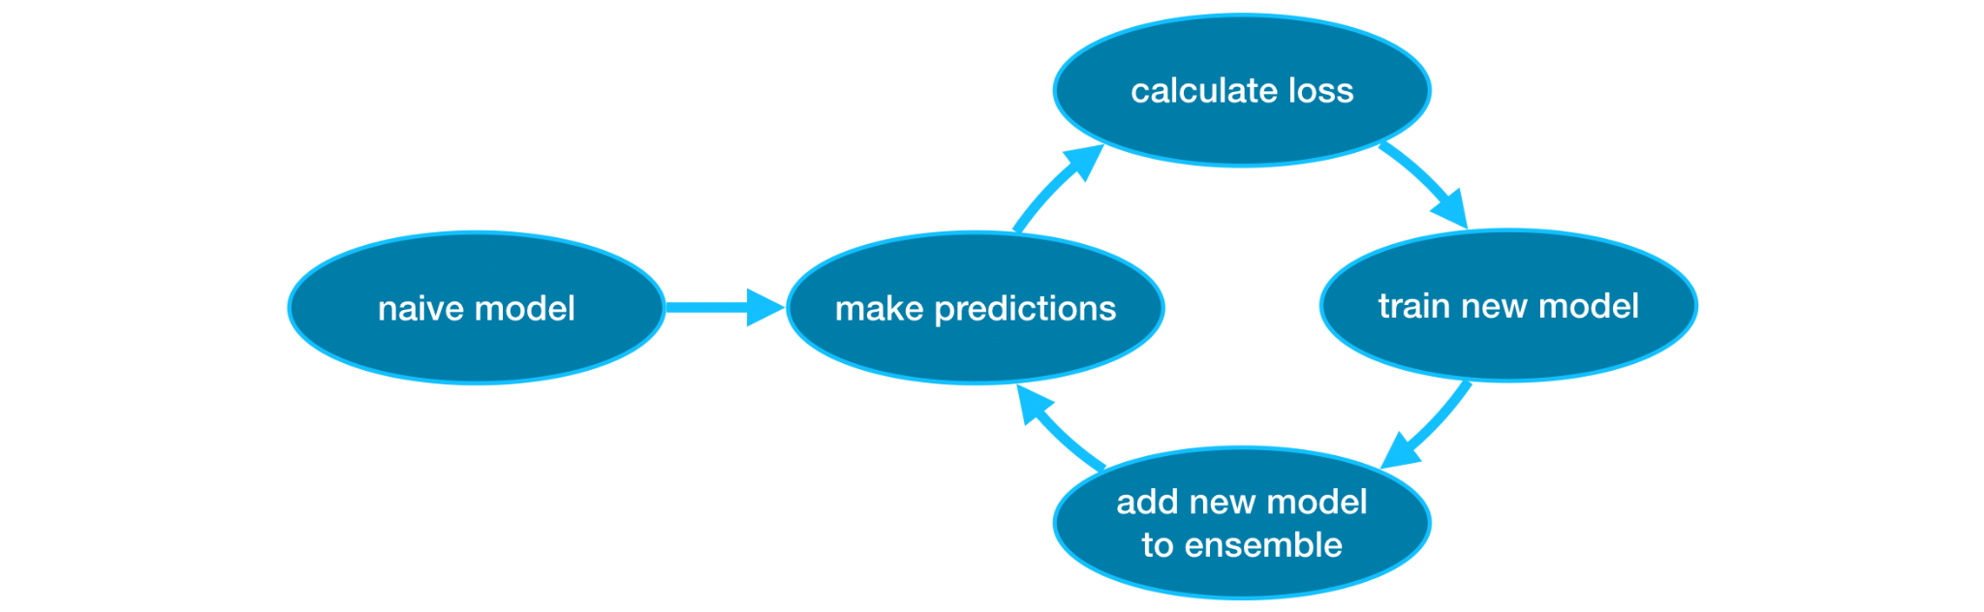

**Fig. 2: Workflow of the XGBoost Model Showing Iterative Training and Loss Minimization [26]**

The flow of the XGBoost model involves several key steps, starting from defining the objective to iteratively building trees that enhance prediction accuracy. **Fig. 2** illustrates the workflow of the XGBoost model, highlighting its iterative process from making initial predictions to adding new models to the ensemble and minimizing loss through repeated refinements. Below is a detailed breakdown of this process:

**Define the Objective Function:** XGBoost minimizes a loss function by adding trees sequentially. For regression tasks, the loss function is typically the **Mean Squared Error (MSE)**, which quantifies the difference between the actual values and the predicted values.

The MSE is expressed as:

Here, is the Actual value and Predicted value, Land is the loss function, specifically the Mean Squared Error in this case.

This formulation ensures that XGBoost iteratively adjusts its predictions to minimize the squared errors between and, improving the accuracy of the model with each additional tree.

**Initialize the Model:** Start with an initial prediction, typically the mean value of the target variable for regression tasks: , this serves as the baseline for subsequent iterations.

**Calculate Residuals:** To improve predictions, XGBoost computes the residuals between the actual values and the current predictions. The residuals represent the direction and magnitude of adjustment needed to minimize the loss. These are calculated as the negative gradient of the loss function with respect to the predicted values:

For regression tasks, such as those using the Mean Squared Error (MSE) as the loss function, the residuals simplify to:

Here, is the loss function, specifically the Mean Squared Error, is the actual target value, is the predicted value at iteration t, and is the residual at iteration t.

The residuals serve as the basis for the next tree in the sequence, allowing the model to iteratively reduce errors and improve its predictions. By incorporating this gradient-based approach, XGBoost systematically refines the model’s accuracy.

**Fit a Tree to the Residuals:** To predict the residuals, a decision tree is constructed. This tree identifies patterns in the data that previous predictions missed, enabling the model to refine its performance. Each leaf node in the tree corresponds to a predicted residual value.

**Compute Leaf Values:** Once the tree is built, the next step is to compute the optimal values for each leaf node that minimize the loss function. This involves calculating the weighted sum of gradients and applying regularization penalties to avoid overfitting and overly complex trees.

**Update Predictions:** Update the model’s predictions by adding the contribution of the new tree:

Here , is the learning rate (controls the contribution of each tree) and is the prediction of the new tree for input .

**Iterate Through Multiple Trees:** The process of calculating residuals, fitting trees, and updating predictions is repeated for a predefined number of iterations (K) or until a stopping criterion is met. This iterative approach enables the model to continuously refine its predictions.

**Generate Final Predictions:** After completing all iterations, the final prediction is obtained by summing the outputs of all trees, weighted by the learning rate:

#### 3.3.1.2 Example: Step-by-Step Flow of the XGBoost Model

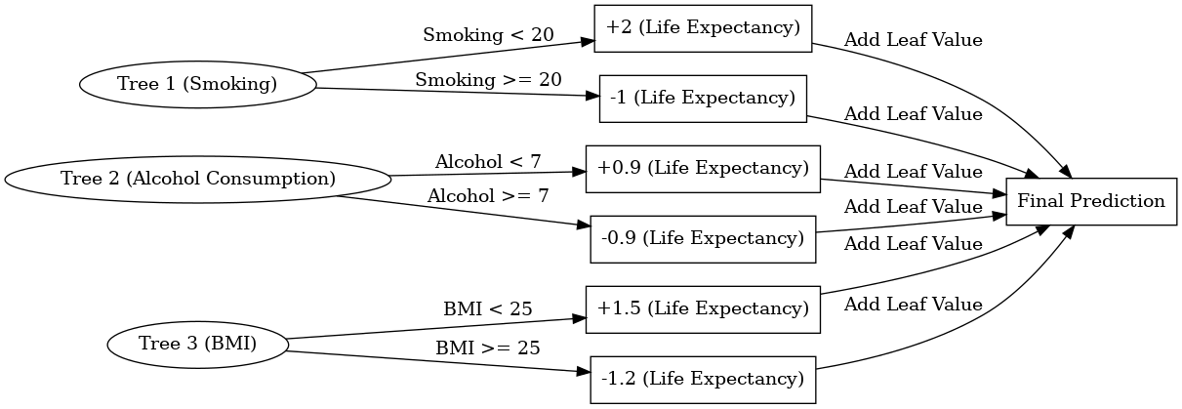

**Fig. 3: Simulation of XGBoost Using Smoking, Alcohol Consumption, and BMI to Predict Life Expectancy**

Here’s a simulation of how XGBoost works using the indicators of **Smoking**, **Alcohol Consumption**, and **BMI** to predict **Life Expectancy**. Each step includes the **formulas** for better understanding.

**Fig. 3** illustrates how XGBoost predicts life expectancy by iteratively refining predictions through a series of decision trees. The process begins with an initial prediction, such as the mean life expectancy in the training data, set at 70 years. Each tree contributes adjustments to this initial prediction based on specific decision rules derived from features like Smoking, Alcohol Consumption, and BMI.

To calculate this step-by-step, consider the following example data:

• **Smoking**: 15 (Smoking < 20, so the tree adds +2 to the prediction)

• **Alcohol Consumption**: 6 (Alcohol < 7, so the tree adds +0.9 to the prediction)

• **BMI**: 24 (BMI < 25, so the tree adds +1.5 to the prediction)

The first step is to calculate the residuals for each observation. Residuals are defined as the difference between the actual observed values and the predicted values. They play a critical role in guiding the corrections made by subsequent trees. For instance, if the actual life expectancy for a data point is 73 years and the initial prediction is 70, the residual is calculated as:

This residual informs the first tree about the error it needs to address.

**In the first iteration**, the model trains a decision tree to minimize the residuals. The first tree uses the feature Smoking and applies the decision rule: if Smoking is less than 20, the tree adds +2 to the prediction; otherwise, it subtracts 1. For the given example, Smoking is 15, so . The updated prediction after this tree is expressed as:

The new residual is then recalculated as:

**In the second iteration**, the model focuses on the residuals left by the first tree. The second tree uses the feature Alcohol Consumption and applies the decision rule: if Alcohol Consumption is less than 7, the tree adds +0.9 to the prediction; otherwise, it subtracts 0.9. For the given example, Alcohol Consumption is 6, so . The updated prediction becomes:

The residual is updated again as:

**Finally**, the third tree addresses the remaining residuals using the feature BMI. The decision rule for this tree is: if BMI is less than 25, the tree adds +1.5 to the prediction; otherwise, it subtracts 1.2. For the given example, BMI is 24, so . The updated prediction becomes:

Equivalently**,** The final prediction is achieved by summing the contributions from all trees, as shown in Fig. 5 :

This iterative process ensures that each tree incrementally reduces the error by focusing on the residuals from the previous step. By combining the initial prediction with the adjustments from all three trees, the model produces a final prediction , which is closer to the actual value of 73. This example demonstrates the effectiveness of XGBoost in refining predictions through its boosting mechanism.

**In conclusion**, by employing machine learning approaches, this research seeks to provide a comprehensive evaluation of the methodologies best suited for predicting life expectancy.

# 4. Evaluation

We begin by validating our synthetic life-expectancy labels against known population benchmarks. First, we examine the overall distribution of generated lifespans: the mean should lie close to 77.5 years [33], with the bulk of values falling between 70 and 80. Next, we compute indicator-specific means to verify realistic relationships—for example, the average life expectancy of smokers must be lower than that of non-smokers, and those reporting regular physical activity should exhibit higher mean lifespans than sedentary individuals. We apply the same comparative checks across all risk and protective factors to ensure that our synthetic data faithfully reflect established epidemiological patterns.

The XGBoost model is evaluated using standard regression metrics—Mean Absolute Error (MAE), Root Mean Squared Error (RMSE), and R-squared (R²) (see Section 4.1)—which together quantify prediction bias, error magnitude, and explained variance. Below, we outline our evaluation protocol and describe each metric in detail.

## 4.1. Metrics in Detail

**Mean Absolute Error (MAE) -** MAE measures the average magnitude of errors between the predicted and actual values, regardless of their direction. It is a straightforward metric that provides a clear understanding of how far predictions deviate from the true values on average. MAE treats all errors equally, making it robust against the influence of large outliers. This simplicity makes it a reliable choice for comparing models, especially when a balanced view of prediction accuracy is desired. The formula used **,** where is the actual value, the predicted value, and the number of observations. The absolute value ensures that the errors are not canceled out by their direction.

**Root Mean Squared Error (RMSE) -** RMSE measures the square root of the average squared differences between the predicted and actual values. Unlike MAE, RMSE gives more weight to larger errors, penalizing them more heavily. This makes RMSE particularly useful when large prediction errors are more concerning than small ones. RMSE provides an intuitive sense of error magnitude, as it is expressed in the same unit as the target variable, making it easy to interpret. The formula used is  , where and represents the actual and predicted values, respectively, and is the total number of observations. The squaring amplifies larger errors, while the square root brings the result back to the same scale as the original data.

**R-squared (R²) -** R² quantifies the proportion of variance in the dependent variable that is explained by the independent variables in the model. It provides a measure of how well the model fits the data, with values ranging from 0 to 1. An R² value close to 1 indicates that the model explains most of the variability in the target variable, while a value near 0 suggests limited explanatory power. R² is particularly useful for comparing models to see which one better captures the underlying patterns in the data. The formula used is , where represents the actual values, the predicted values, and the mean of the actual values. The numerator calculates the residual sum of squares (unexplained variance), while the denominator calculates the total sum of squares (total variance). The resulting value represents the proportion of variance explained by the model, with higher values indicating better performance.

These metrics together provide a comprehensive evaluation framework. While MAE offers a straightforward view of average errors, RMSE highlights significant deviations, and R² indicates the overall explanatory power of the model. XGBoost is rigorously evaluated using these metrics, providing comprehensive insights into their predictive capabilities. XGBoost excels in efficiency and feature importance analysis, The use of these metrics ensures that the models’ predictions are not only accurate but also interpretable and actionable.

# 5. Project Architecture and Deployment

# 

**Fig. 4: Project Architecture and Deployment Workflow**

This project is designed to predict life expectancy based on user-provided information through an interactive web application. Below is a detailed overview of the system architecture, components, and their roles.

**Frontend:**

**Next.js [27]** with **React[29]** and **TypeScript [30]** are used to create an interactive and maintainable web application with fast rendering and dynamic data handling.

**Tailwind CSS [28]**: Simplifies styling with utility-first classes, enabling quick development of responsive and visually appealing designs.

**Backend**

**Flask**: A lightweight and flexible Python web framework for building web applications and APIs. It provides essential tools and libraries while allowing developers to customize components, making it ideal for simple to moderately complex projects[32]

**XGBoost**: A library for gradient boosting, included to handle tabular data problems where tree-based models perform better than deep learning.[23]

**Pandas**: Handles data preprocessing and manipulation and preparing user inputs for ML models.

**Why This Architecture?**

Next.js and React provide a robust structure for building dynamic, interactive UIs, while TypeScript ensures code maintainability by reducing runtime errors. Tailwind CSS accelerates styling workflows.

Flask offers simplicity, flexibility, and ease of integration for deploying machine learning models. TensorFlow and PyTorch provide flexibility and reliability for ML tasks, and Pandas efficiently preprocesses data.

This architecture ensures fast response times, robust data handling, and smooth integration between the frontend and backend.

**Overall Process**

This project predicts life expectancy based on user input through the following steps:

1. User Input: Users submit data via a form on the frontend.
2. Data Transmission: The frontend sends validated data to the backend API.
3. ML Prediction: The backend processes the data, applies preprocessing, and uses machine learning models to predict life expectancy.
4. Response: The backend sends the prediction back to the frontend, where it is displayed to the user interactively and intuitively.

# 6. Results

In this section, we present two primary outcomes: (1) the construction of a fully synthetic, individual-level dataset featuring 27 indicators spanning lifestyle, medical history, and other domains; and (2) the development and evaluation of an XGBoost model that achieves high accuracy in predicting life expectancy.

## 6.1 Synthetic Data Generation

The synthetic cohort yields a lifespan distribution that is highly plausible for an adult population: over 50 percent of simulated individuals fall in the 70–79 age bracket, nearly 20 percent in the 80–89 range, and virtually none below age 40 (Fig. 7). Crucially, these post-penalty “adjusted” lifespans still mirror real-world demographics, demonstrating that our evidence-based penalties and gains did not introduce implausible artifacts.

Next, we quantified each indicator’s effect on these adjusted lifespans. A Pearson correlation analysis (Fig. 5) identifies depressive disorder (r = –0.52), difficulty concentrating (r = –0.31), and smoking status (r = –0.29) as the strongest negative predictors of life expectancy, whereas influenza vaccination (r = +0.21) and regular physical activity (r = +0.20) show the largest positive associations. Category-level bar plots in (Figs. 6.1-6.6) (participant characteristics: Sex, Physical Activities, Heart Attack, Angina, Stroke, Asthma), (Figs. 6.7-6.12) (health conditions: COPD, Depressive Disorder, Kidney Disease, Arthritis, Diabetes, Hearing Difficulty), (Figs. 6.13 - 6.18) (functional limitations & Smoking Status: Vision Difficulty, Concentration, Walking, Dressing/Bathing, Errands, Smoker Status), and (Figs.6.19-6.24) )(preventive behaviors: E-cigarette Usage, Alcohol Consumption, Influenza & Pneumococcal Vaccination, Tetanus Booster, High-Risk Condition) further illustrate—for example—that smokers lose roughly 6–9 years compared to never-smokers and that physically active individuals gain about 4–7 years over inactive peers, validating that our penalty adjustments faithfully reproduce documented epidemiological effects.

In the next section, we leverage these insights to inform feature selection and weighting in our predictive modeling pipeline. We then describe the design, training, and evaluation of an XGBoost regressor whose performance underscores the value of incorporating these empirically grounded penalties and gains.

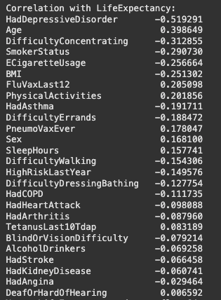

* **Fig. 5.** Correlation of Each Indicator with Synthetic Life Expectancy

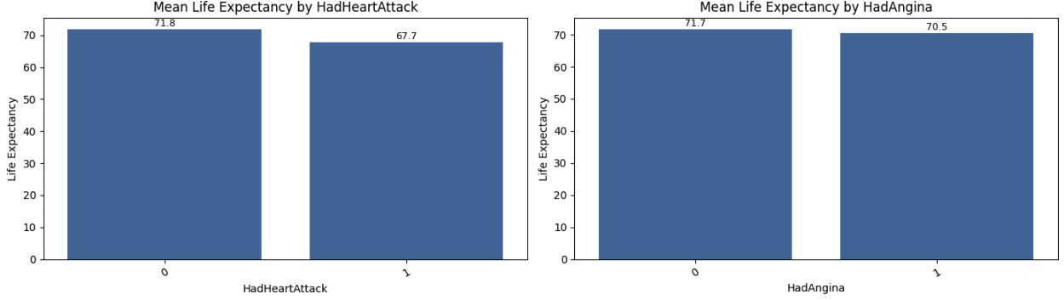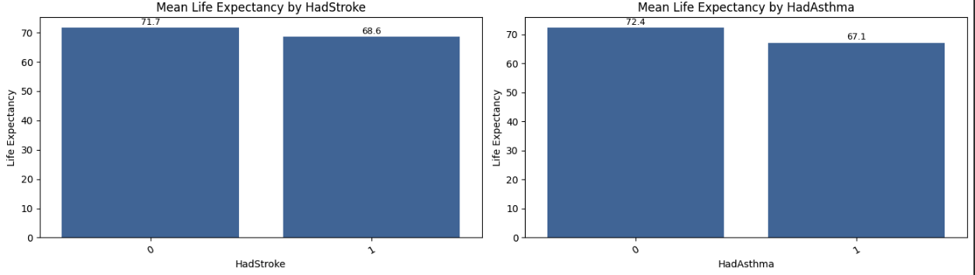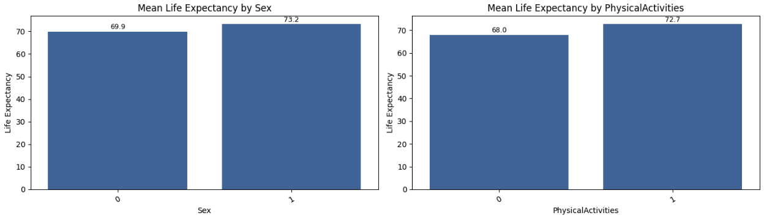

* **Fig. 6.1 - 6.6.** Mean life expectancy by participant characteristics: Sex; Physical Activities; history of Heart Attack; history of Angina; history of Stroke; and history of Asthma.

**Fig. 6.7- 6.12.** Mean life expectancy by participant health conditions: history of COPD; history of depressive disorder; history of kidney disease; history of arthritis; history of diabetes; and deafness or hearing difficulty.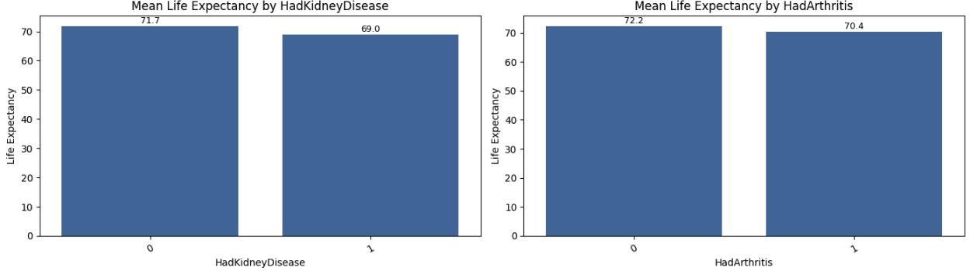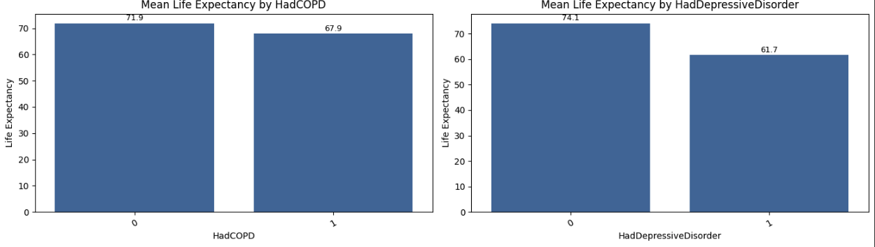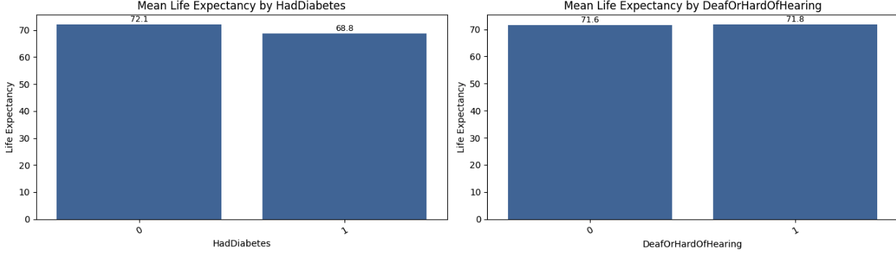

**Fig. 6.13-6.18.** Mean life expectancy by functional limitations and smoking status: blind or vision difficulty; difficulty concentrating; difficulty walking; difficulty dressing/bathing; difficulty running errands; and smoker status.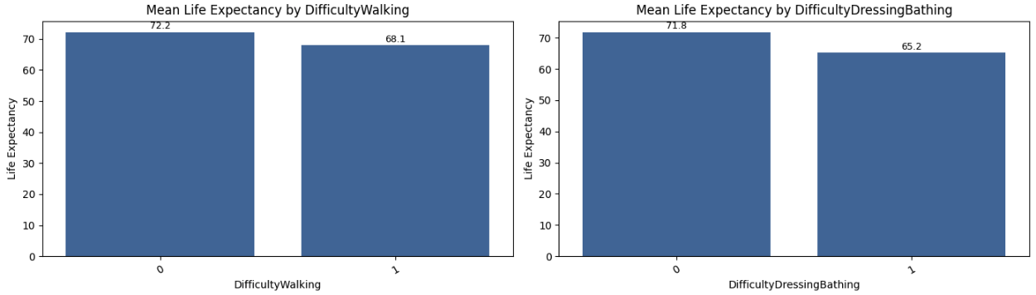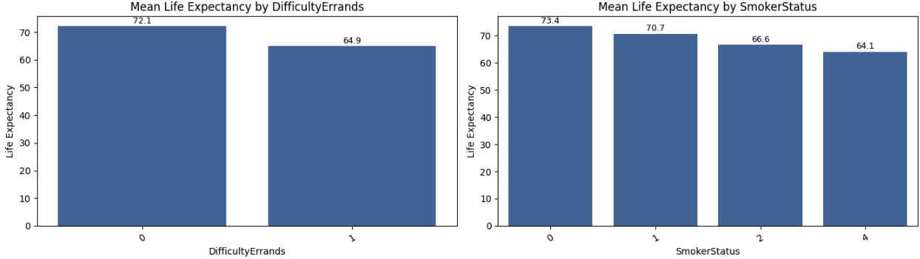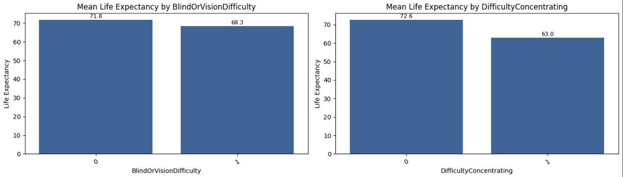

**Fig. 6.19-6.24.** Mean life expectancy by e-cigarette usage; alcohol consumption; influenza vaccination in the past 12 months; pneumococcal vaccination ever; tetanus vaccination within the last 10 years; and high-risk health condition in the past year.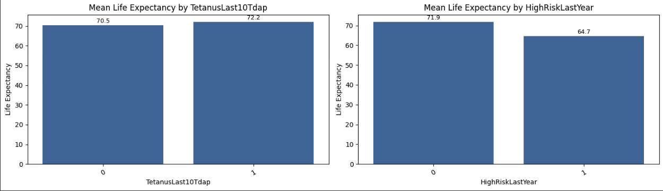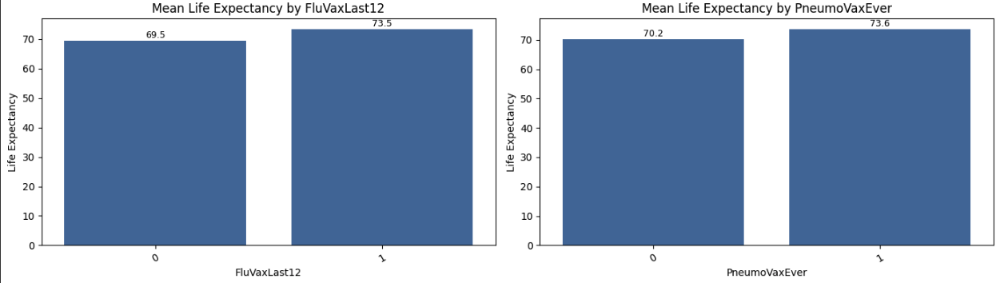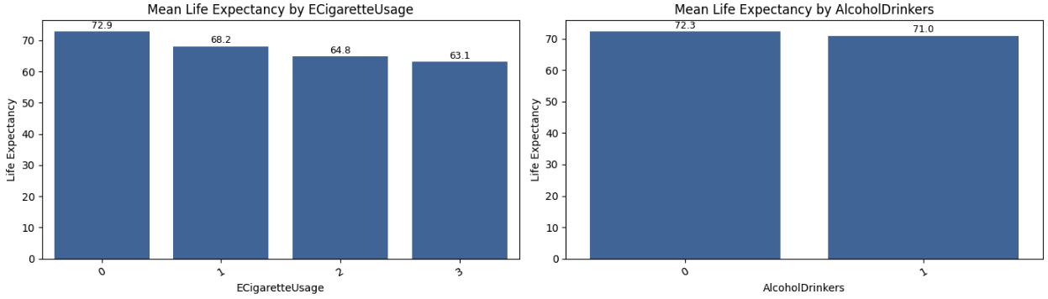

**Fig. 7.** Distribution of Synthetic Life Expectancy in 10-Year Buckets  
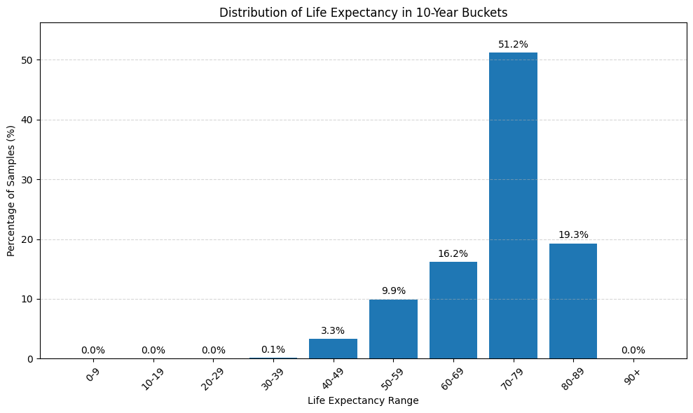

## 6.2 XGBoost Performance

We trained our XGBoost regressor using a grid-search over key hyperparameters and selected the following best configuration to minimize validation error:

Best Parameters: {

colsample_bytree: 0.5442, gamma: 0.09799, learning_rate: 0.0235, max_depth: 7,

n_estimators: 819, subsample: 0.8736 }

Under our optimized XGBoost configuration, the model achieves an RMSE of 5.73 years, meaning that its predictions deviate from the true life-expectancy values by an average of roughly ±5.7 years. The R² score of 0.65 indicates that about 65% of the variability in life expectancy across individuals is explained by our selected personal, lifestyle, and medical features. On average, the absolute error (MAE) is 4.4 years, so half the time our forecast is within 4½ years of the actual value. The mean absolute percentage error (MAPE) of 6.6% shows that relative to each person’s true longevity, our predictions are off by under 7% on average. Finally, the explained variance score (0.65) echoes the R² result, confirming that two-thirds of the signal in the data is captured by the model.

As shown in **Fig. 8**, the RMSE steadily decreases over 700 epochs, converging around 5.73 by epoch 796. **Fig. 9** plots actual versus predicted life expectancy on the hold-out set, illustrating a strong positive correlation with some scatter. The residuals (prediction errors) are approximately normally distributed around zero—see **Fig. 10**—indicating no major bias. Finally, **Fig. 11** examines residuals against predicted values, confirming homoscedasticity across the prediction range.

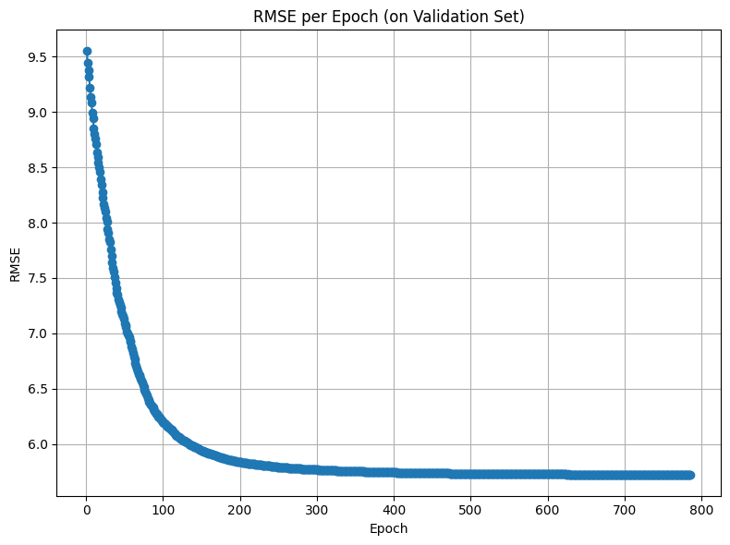

**Fig. 8. RMSE per Epoch on Validation Set**

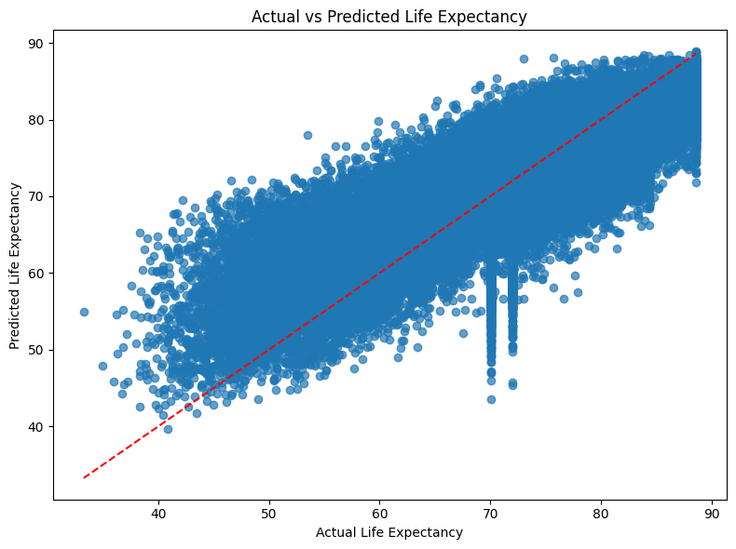

**Fig. 9. Actual vs. Predicted Life Expectancy**

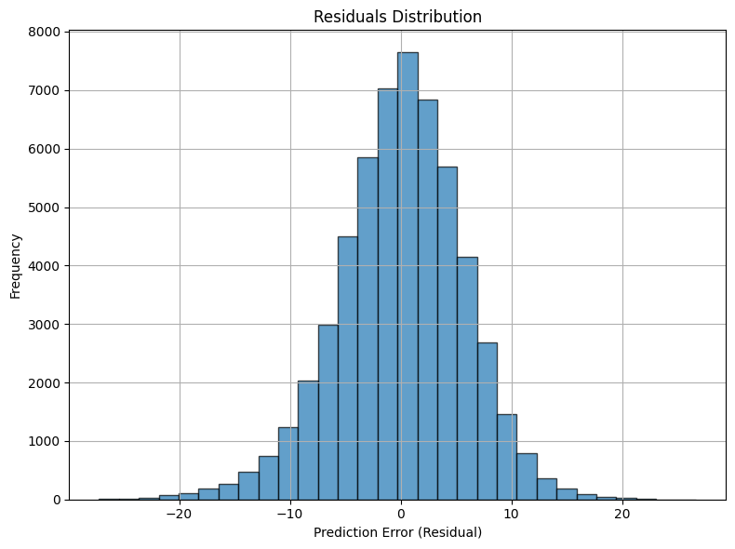

**Fig. 10. Residuals Distribution**

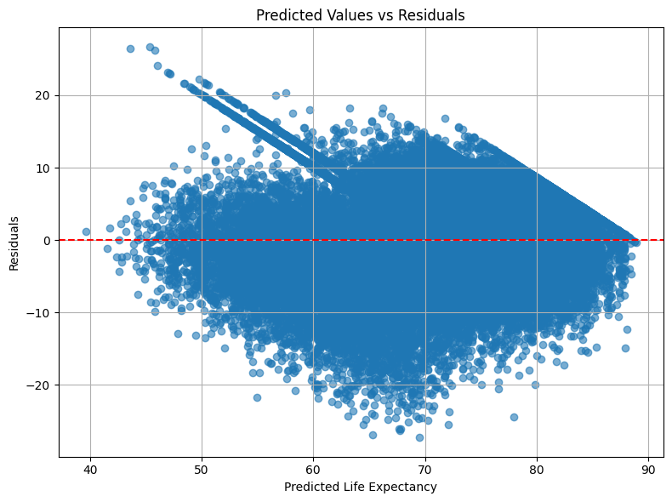

**Fig. 11. Predicted Values vs. Residuals**

# **7. Documenting Failed Experiences During the Study**

## 7.1. Synthetic Dataset Creation Using Averaged Data

Initially, the research aimed to create a synthetic dataset by merging averaged life expectancy data from WHO [34] with other averaged indicators such as smoking rates, sleep duration, and BMI from various sources. The next step involved using the CTGAN model to generate individual-level data from these merged averages.

However, this approach faced significant challenges:

* Averaged Data Limitations: Since the data represented averages at the country level, it was ineffective in capturing meaningful individual relationships between indicators (e.g., smoking reducing life expectancy).
* Indicator Relationships: The approach also failed to detect nuanced interactions between multiple indicators (such as smoking and BMI) due to the averaged nature of the data.
* Dataset Insufficiency: Building a comprehensive synthetic dataset required collecting numerous datasets for each indicator, making the approach impractical at this stage.
* Poor Initial Results: Early attempts, using limited datasets (only four indicators), resulted in poor predictions. There was little observable relationship between indicators and life expectancy beyond the inherent country-level averages.
* Introduction of Penalties: The introduction of penalty scores showed slight improvement but failed to produce robust relationships and realistic predictive capabilities. The results remained heavily biased toward averaged data points.
* Poor Model Performance: Experiments with multiple machine learning models consistently produced unsatisfactory results, with predictions limited to narrow ranges of life expectancy, as evidenced by visualization graphs.

Due to these compounded issues, the decision was made to abandon this synthetic averaged data approach and identify more suitable, realistic datasets for future analyses.

**You can review our implementation on GitHub at the following link:** [**https://github.com/mahersalman/life-expectancy/tree/main/Archive**](https://github.com/mahersalman/life-expectancy/tree/main/Archive)

## 

## 7.2. Deep Learning on Tabular Data

In an effort to leverage state-of-the-art architectures for tabular forecasting, we experimented with **SAINT** [35]. Our workflow included extensive hyperparameter sweeps (varying attention heads, embedding dimensions, learning rates, etc.) and protracted training runs—up to 20 epochs over several hours—yet the model consistently struggled to learn meaningful patterns from our synthetic life-expectancy dataset.

The residuals distribution (Fig 12) reveals a pronounced bias and heavy tails, indicating that SAINT’s errors are both large and skewed. Likewise, the Predicted vs. Actual scatter plot (Fig 13) shows most points collapsed around ~71 years rather than following the full 45–90 year range, demonstrating a failure to capture variance across the test set. Finally, the epoch-by-epoch training MSE log (Fig 14) illustrates that after an initial drop, mean squared error plateaus rapidly, with minimal improvement even after 20 epochs.

Despite repeated tuning, SAINT’s predictions remained plagued by high MSE and RMSE, failing to approximate the true variance in our labels. These negative results underscore that, for our particular tabular regime, conventional tree-based methods (e.g., XGBoost) or more specialized tabular-learning approaches may offer superior performance.

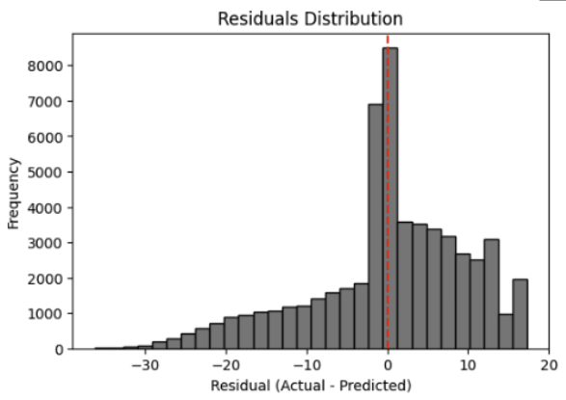

**Fig 12.** histogram of (Actual – Predicted) showing a pronounced bias and heavy tails.

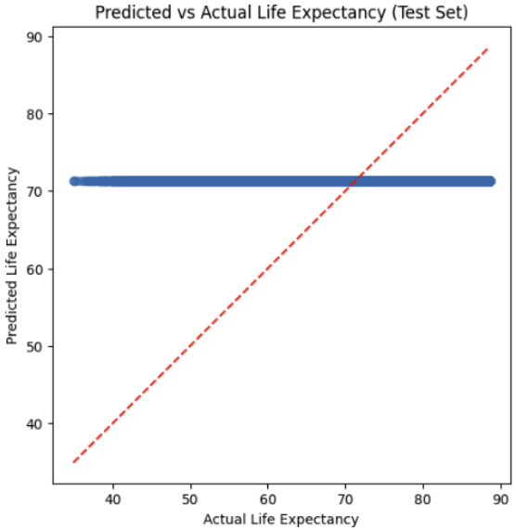

**Fig 13.** scatter plot on the test set, with most predictions collapsed around 71 years.

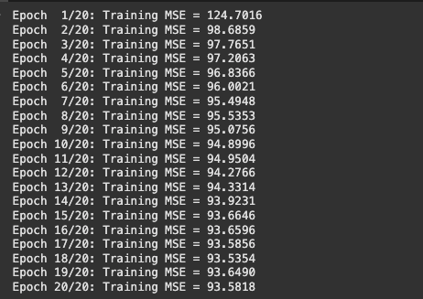

**Fig 14.** console output of mean squared error per epoch, illustrating minimal improvement after the first few rounds.

# 8. User Guide The system predicts individual life expectancy based on health-related indicators, using an XGBoost model trained on synthetic data.

**Explanation with Screenshots :**

The landing screen (**Fig 15)** features a clear title, a friendly health-themed illustration (cropped to reduce surrounding whitespace), a concise welcome blurb explaining the four input sections, four iconized tiles for each section, and a prominent “Get Started” button.



**Figure 15 – Home Page of the Life Expectancy Calculator**

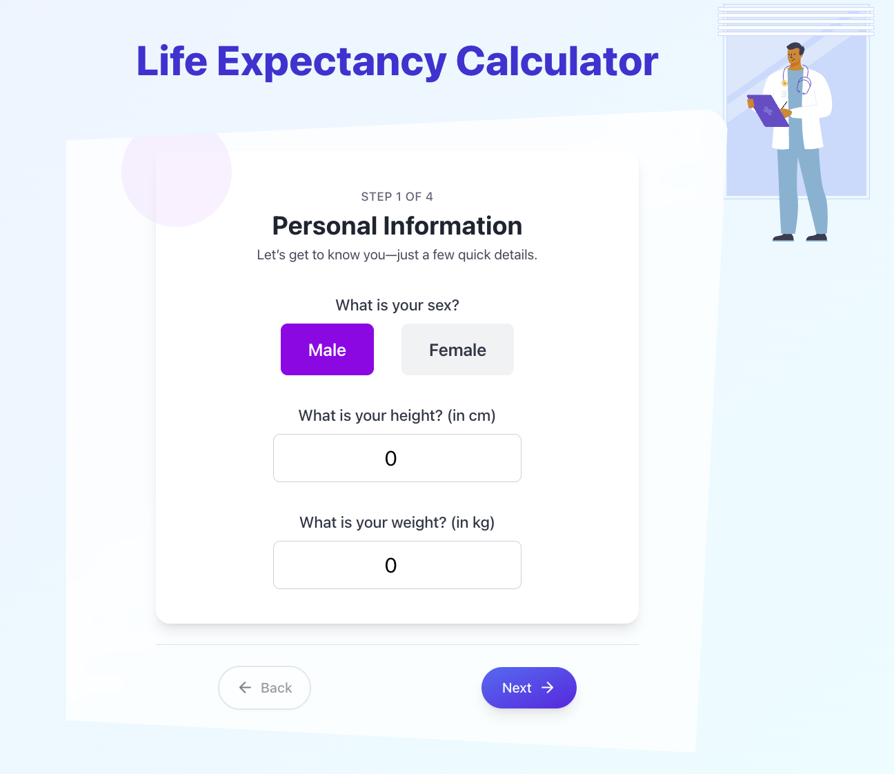

**Figure 16.1 – Personal Information (Step 1 of 4)**

Next, we have the form, which consists of four sections, starting with Personal Information (Fig. 16.1). On this screen, you’ll provide three basic data points that help tailor your life expectancy estimate:

1. Sex : Tap Male or Female to indicate your sex.
2. Height : In the “What is your height?” field, type your height in centimeters (e.g. “170”).
3. Weight : In the “What is your weight?” field, type your weight in kilograms (e.g. “65”).

Once all three fields are filled, press the Next button to move on to Step 2.

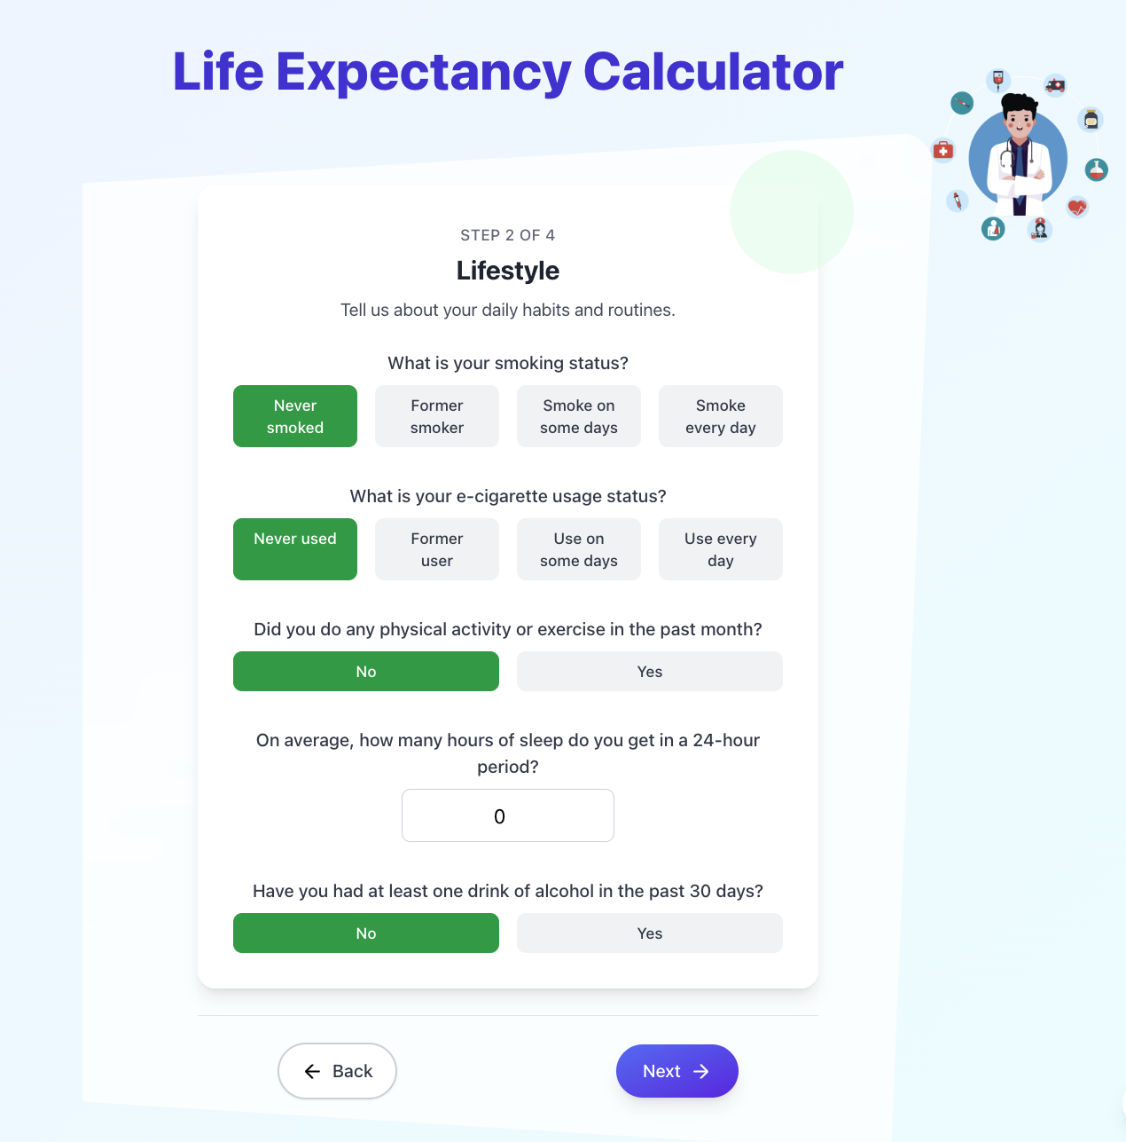

**Figure 16.2 – Lifestyle (Step 2 of 4)**

On this screen fig.16.2 you’ll report daily habits that affect your health:

1. **Smoking Status** : Tap one of the four options to describe your cigarette use  
    - Never smoked  
    - Former smoker  
    - Smoke on some days  
    - Smoke every day
2. **E-Cigarette Usage** :Select one of four to indicate your vaping history:  
    - Never used  
    - Former user  
    - Use on some days  
    - Use every day
3. **Physical Activity** : Choose Yes or No to tell us if you’ve exercised or done any physical activity in the past month.
4. **Sleep Hours** : In the numeric field, enter the average number of hours you sleep within a 24-hour period (for example, “7”).
5. **Alcohol Consumption** : Select Yes or No to indicate whether you’ve had at least one alcoholic drink in the past 30 days.

Once all answers are selected or entered, press Next to continue to the Medical History section—or tap Back to change your Personal Information.



**Figure 16.3 – Medical History (Step 3 of 4)**

On this screen fig.16.3 you’ll review a series of 15 yes/no questions about past diagnoses and health conditions (e.g. heart attack, stroke, asthma, diabetes, and more). Simply scroll through the list, tap Yes or No for each item, and then press Next when you’ve answered them all. If you need to change your previous responses, use the Back button.

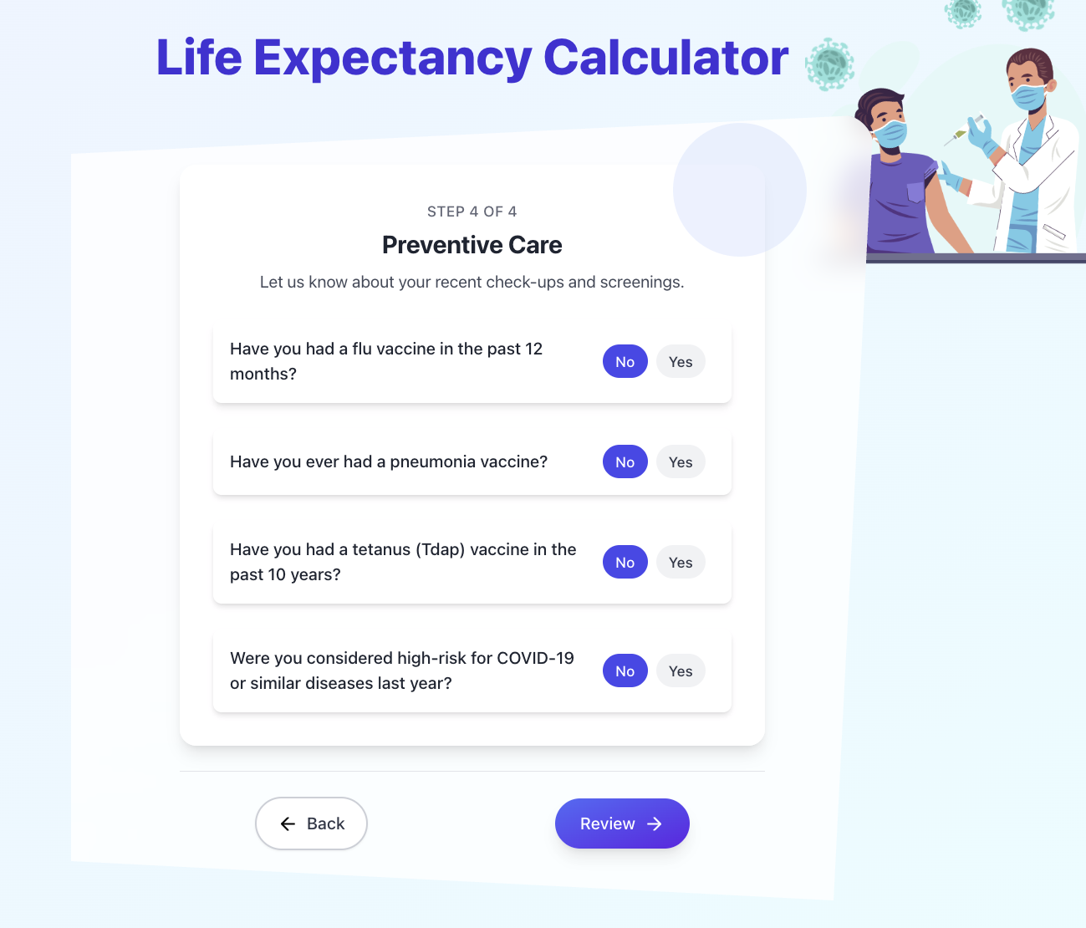

**Figure 16.4 – Medical History (Step 4 of 4)**

On this final section fig.16.4 you’ll answer four yes/no questions about recent vaccinations and risk status:

1. Flu Vaccine : Select Yes if you received a flu shot within the past 12 months.
2. Pneumonia Vaccine : Select Yes if you’ve ever had a pneumonia vaccine.
3. Tetanus (Tdap) Vaccine :Select Yes if you’ve had a tetanus booster in the last 10 years.
4. High-Risk Status :Select Yes if you were considered high-risk for COVID-19 or similar diseases during the last year.

When all four questions are answered, tap Review to see your summary before submitting. Use Back if you need to change any previous answers.

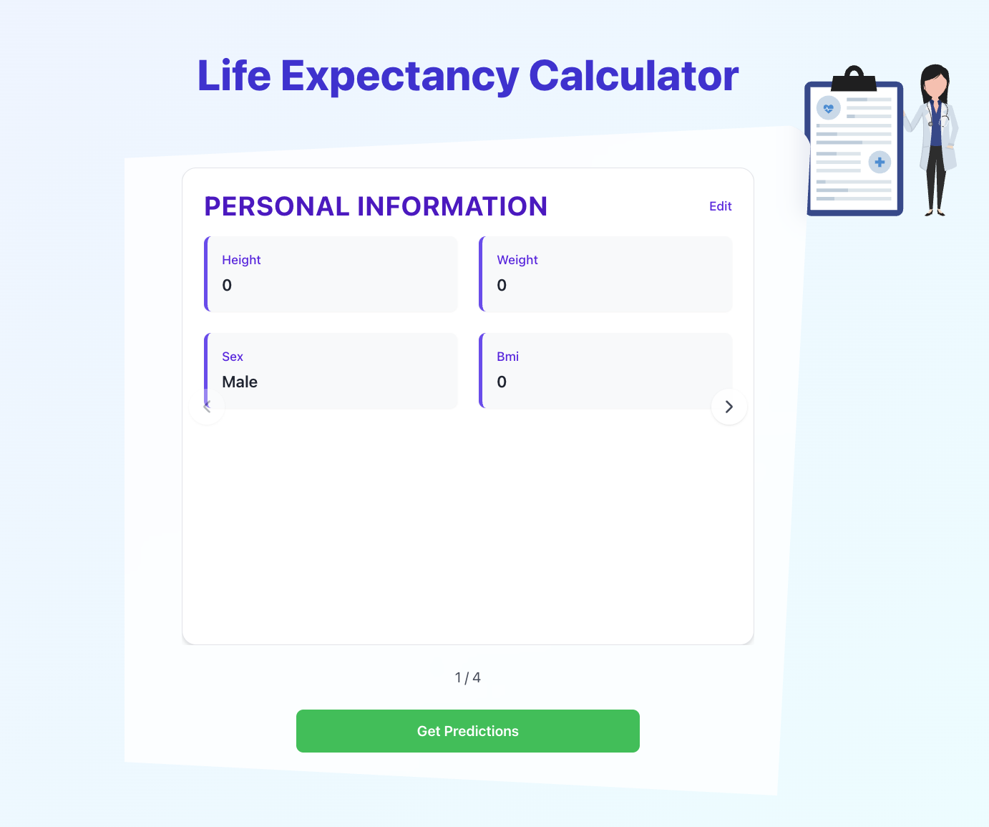

**Figure 17 – Review Form Details**

After completing all four steps, you’ll land on the Review screen fig.17 where you can verify every answer before getting your life-expectancy prediction:

1. Section Carousel  
   * At the top of the card you’ll see the current section title (e.g. “PERSONAL INFORMATION”).
   * A page indicator below shows “1 / 4” (or whichever section you’re viewing).
2. Navigate Between Sections  
   * Use the left and right arrow buttons at the sides of the card to scroll through each of the four summary panels.
3. Edit Any Section  
   * Click the Edit link in the top-right of the card to jump back directly to that section’s form and adjust your answers.
4. Submit for Prediction  
   * Once you’ve confirmed all data, press the large green Get Predictions button.
   * Your responses will be sent to our model, and you’ll immediately see your personalized life-expectancy estimate.

This review step ensures you have one last chance to correct typos or mis-clicks before generating your final result.

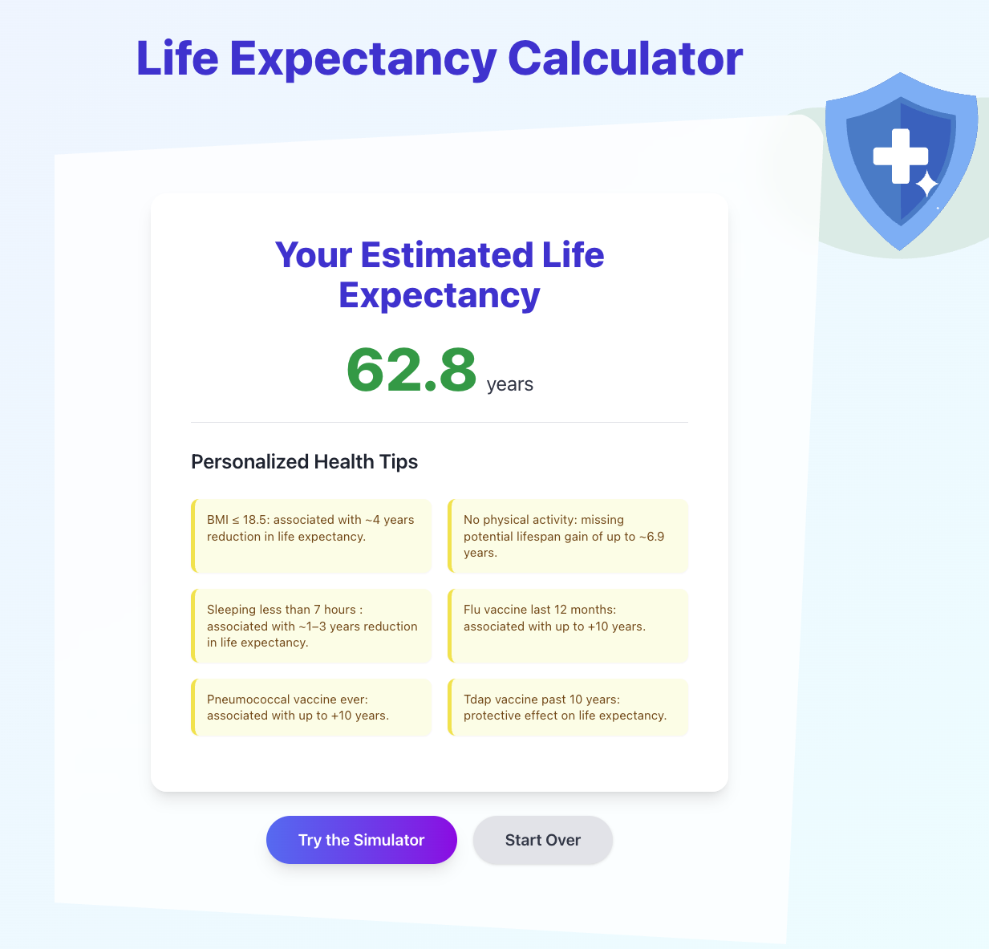

**Figure 18 – Result - Predicted Life Expectancy**

After you tap Get Predictions, our model may take 10–15 seconds to process your inputs. A loading indicator will appear during this time; please wait until the results card displays Fig.18..

### Your Estimated Life Expectancy

* At the center of the card you’ll see your personalized life-expectancy estimate in large green type (e.g. 62.8 years).

### Personalized Health Tips

* Below the estimate is a set of concise, color-coded tips showing which factors—such as BMI, sleep, exercise, and vaccinations—are associated with gains or losses in life expectancy.

### Next Actions

* Try the Simulator(Fig. 19): adjust any answer directly on this page to see how changes could increase your predicted lifespan.
* Start Over: clear all entries and return to Step 1 to run a completely new calculation.

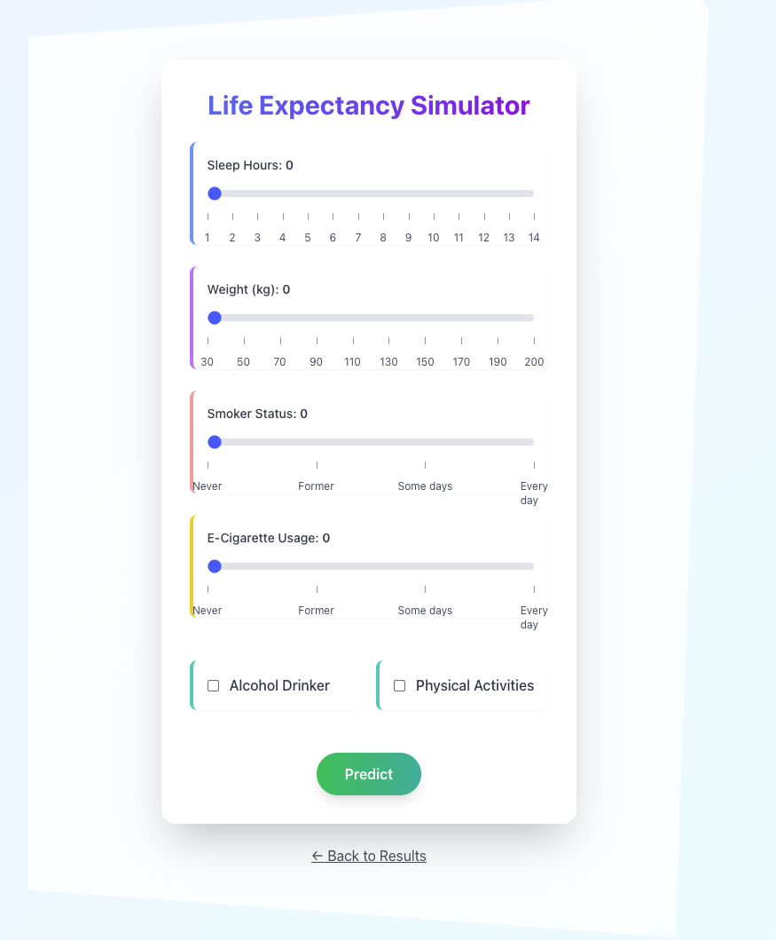

**Figure 19 – Life Expectancy Simulator**

After viewing your initial result, you can experiment with different values to see how changes in your habits and measurements affect your estimated lifespan:

1. Sleep Hours :Drag the slider to set your average nightly sleep (1–14 hours).
2. Weight (kg) : Use the slider to adjust your weight between 30 kg and 200 kg.
3. Smoker Status : Slide between four positions to simulate cigarette use.
4. E-Cigarette Usage : Slide between four positions to simulate e-cigarette use.
5. Alcohol Drinker : Check this box if you drink alcohol; uncheck to simulate quitting.
6. Physical Activities : Check this box if you exercise regularly; uncheck to simulate a more sedentary lifestyle.

When you’ve adjusted the sliders and checkboxes, tap Predict to recalculate your life-expectancy estimate instantly. This interactive tool helps you explore how small changes—like getting more sleep or quitting smoking—can boost your predicted lifespan.

# 9. Maintenance Guide

## 9.1 Environment

* **Backend:**
  + Python environment with dependencies: Flask, XGBoost, Pandas, NumPy, Scikit-learn.
  + AWS EC2 for deployment.
* **Frontend:**
  + Next.js framework with React, TypeScript, and Tailwind CSS.

## 9.2 Installation Instructions:

1. **Backend Setup:**
   * Clone the backend repository: (<https://github.com/mahersalman/life-expectancy/tree/main/ML-Server>)
   * Install dependencies with pip install -r requirements.txt.
   * Deploy Flask application locally (python app.py) or via AWS EC2 (ensure proper AWS setup and configurations).
   * Ensure .pkl files (model and scaler) are correctly placed in the Flask application's directory.
2. **Frontend Setup:**
   * Clone the frontend repository: <https://github.com/mahersalman/life-expectancy/tree/main/life-expectancy-app>
   * Navigate to the project directory and run npm install.
   * Launch application with npm run dev for local development or build for production deployment with npm run build.

**Note:**

* If your API is hosted on AWS EC2 (or any other remote server), update the destination URL in your vercel.json file to point at that host.
* If you’re running the server locally, set SERVER_URL to http://localhost:3000 (or whatever port you’ve configured).

## 9.3 Synthetic Data Generation & XGBoost Training

This part of the project is organized into two core modules—data generation and model training—each encapsulated in its own notebook for clarity and reproducibility:

1. **Synthetic Data Generation** The GenerateData.ipynb notebook (located in Data/) drives the creation of our individual‐level dataset. It ingests:  
   * **heart_2022_with_nans.csv**—the raw, person-level records containing missing entries
   * **xmart.csv**—country-year life-expectancy averages
2. Through a pipeline of imputation, encoding, normalization, and probabilistic sampling, this script rebuilds a fully synthetic cohort that mirrors real-world distributions. You can easily toggle which indicators to include or exclude—just update the indicator list at the top of the notebook and rerun.
3. **XGBoost Model Training** The Xgboost.ipynb notebook (under ML-Server/) handles everything from loading the synthetic data to exporting your final model:  
   * **Data Loading & Path Configuration** — Point the notebook at your local or cloud drive path.
   * **Hyperparameter Tuning** — Includes grid-search routines for tree count, depth, learning rate, and subsampling.
   * **Training & Evaluation** — Trains on the 70% split, validates on 15%, and tests on the remaining 15%, reporting RMSE, MAE, and R².
   * **Model Export** — Once satisfied with performance, save the fitted XGBoost object as a .pkl file and commit it to your repository for seamless integration with the Flask API.

Together, these notebooks form a reproducible pipeline: regenerate data as your indicators evolve, retrain XGBoost in minutes, and deploy directly to your backend.

## 9.4 Life Expectancy Next.js Website (Front-End)

This Next.js app provides the user interface for collecting inputs and displaying life-expectancy predictions. To get started locally:

npm install

npm run dev

Then point your browser to http://localhost:3000.

**Entry Point (src/app/page.tsx)**

This client-side component sets up the app’s full-screen gradient layout, animated header, and Lottie mascot, then renders all routes inside a clipped, semi-transparent card. It uses React Router to switch between:

* **/** → HomePage
* **/form** → UserForm
* **/review** → Review
* **/result** → Results
* **/simulator** → Simulator

### **Core Components**

* **src/components/HomePage.tsx:** A welcome/landing screen that introduces users to the tool.
* **src/components/UserForm.tsx :** Orchestrates the multi-step questionnaire, advances through each section, and submits the final payload.
* **Section-Specific Forms:**
  + **PersonalInfoForm.tsx** — captures sex, height and weight.
  + **LifestyleForm.tsx** — gathers smoking, exercise, sleep, alcohol details.
  + **MedicalHistoryForm.tsx** — records past conditions and functional limitations.
  + **PreventiveCareForm.tsx** — asks about vaccinations and risk screenings.
* **src/components/Review.tsx** & **ReviewCard.tsx:** Display a summary of entered answers and allow users to jump back and correct any step.
* **src/components/Results.tsx & DisplayTips.tsx :**Renders the life-expectancy estimate fetched from the backend alongside personalized health tips. After displaying the predicted LE value, it imports and uses the Tips.ts module to surface actionable advice tailored to the user’s input—highlighting factors that most influence their forecasted lifespan and suggesting ways to improve it.
* **src/components/Simulator:** a mini “what-if” panel with sliders (sleep, weight/BMI, smoking, e-cigs) and toggles (alcohol, exercise) that calls fetchResult(...) to recalc and display the new estimate inline.
* **Interactive Helpers: SliderWithLabelsV2.tsx**, **ToggleWithLabel.tsx**— custom inputs and mini-simulations.

### **Context Providers**

* **Form Context (src/context/FormContext.tsx):** Defines a React context and provider for formData and its updater, initialized from initialFormData. Components can call useFormContext() to read the current form state and call setFormData() to update it, ensuring user inputs stay synchronized across the entire app.
* **src/context/LottieContext.tsx :**Manages loading and playing of Lottie animations stored under src/Lottie/*.json.

### **Utility Modules**

* **Question Schema (src/utils/**[**Questions.ts**](http://questions.ts)**) :**Defines a Question type and four lists—personalInfoQuestions, lifestyleQuestions, medicalHistoryQuestions, preventiveCareQuestions—each entry specifying its name, label, question, type (number with optional min/max or radio with options).
* **Health Tips (src/utils/**[**Tips.ts**](http://tips.ts)**):** Exports a tips map where each form field key links to an array of conditions and messages. At results time, the app checks each condition against the user’s data and displays matching messages—e.g., low BMI warns of reduced LE, missing flu vaccine offers a +10-year benefit, daily smoking flags an ~8.8-year reduction, etc. This drives the personalized advice panel shown alongside predictions.
* **src/utils/**[**initialData.ts**](http://initialdata.ts)**:**  Supplies default values for all form fields on first render.
* **API Utility (src/utils/**[**fetchResult.ts**](http://fetchresult.ts)**):** Defines fetchResult(formData: FormData): Promise<number>, which sends a POST to /api/predict with the user’s inputs, handles non-OK responses by extracting error details, and returns the numeric prediction field from the JSON response.

# References:

[1] Lipesa, B. A., Okango, E., Omolo, B. O., & Omondi, E. O. (2023). An application of a supervised machine learning model for predicting life expectancy. *SN Applied Sciences, 5*, Article 189. <https://doi.org/10.1007/s42452-023-05404-w>

[2] Shwartz-Ziv, R., & Armon, A. (2021). Tabular data: Deep learning is not all you need. *arXiv.* <https://arxiv.org/pdf/2106.03253>

[3] Stokanović, S., Đukić, D., & Miljković, N. (2023). Robustness of XGBoost algorithm to missing features for binary classification of medical data. *IEEE Xplore.* <https://ieeexplore.ieee.org/document/10495929>

[4] Wang, H., Naghavi, M., Allen, C., Barber, R. M., Bhutta, Z. A., Carter, A., … & Murray, C. J. L. (2016). Global, regional, and national life expectancy, all-cause mortality, and cause-specific mortality for 249 causes of death, 1980–2015: A systematic analysis for the Global Burden of Disease Study 2015. *The Lancet, 388*(10053), 1459–1544. <https://doi.org/10.1016/S0140-6736(16)30175-1>

[5] O’Donovan, G., Petermann-Rocha, F., Ferrari, G., Lee, I.-M., Hamer, M., Stamatakis, E., Sarmiento, O. L., Ibáñez, A., & Lopez-Jaramillo, P. (2024). Associations of the ‘weekend warrior’ physical activity pattern with all-cause, cardiovascular disease and cancer mortality: The Mexico City Prospective Study. *British Journal of Sports Medicine, 58*(7), 359–367. <https://bjsm.bmj.com/content/58/7/359>

[6] Georgiev, V., Hadzhikoleva, S., & Hadzhikolev, E. (2024). Impact of global country indicators on life expectancy. *Contemporary Scientific and Industrial Research, 1*(1), Article 11. <https://doi.org/10.70862/CSIR.2024.0101-04>

[7] Chen, T., & Guestrin, C. (2016). XGBoost: A Scalable Tree Boosting System. Proceedings of the 22nd ACM SIGKDD International Conference on Knowledge Discovery and Data Mining. <https://dl.acm.org/doi/pdf/10.1145/2939672.2939785>

[8] Streppel, M. T., Boshuizen, H. C., Ocké, M. C., Kok, F. J., & Kromhout, D. (2007). Mortality and life expectancy in relation to long‐term cigarette, cigar and pipe smoking: The Zutphen Study. Tobacco Control, 16(2), 107–113. <https://pmc.ncbi.nlm.nih.gov/articles/PMC2598467/>

[9] Reimers, C. D., Knapp, G., & Reimers, A. K. (2012). Does Physical Activity Increase Life Expectancy? A Review of the Literature. Journal of Aging Research, 2012, Article ID 243958. <https://pmc.ncbi.nlm.nih.gov/articles/PMC3395188/>

[10] Stenholm, S., Head, J., Kivimäki, M., Magnusson Hanson, L. L., Pentti, J., Rod, N. H., Clark, A. J., Oksanen, T., Westerlund, H., & Vahtera, J. (2019). Sleep Duration and Sleep Disturbances as Predictors of Healthy and Chronic Disease‐Free Life Expectancy Between Ages 50 and 75: A Pooled Analysis of Three Cohorts. *J Gerontol A Biol Sci Med Sci*, *74*(2), 204–210. <https://pubmed.ncbi.nlm.nih.gov/29415200/>

[11] Korhonen, K., Moustgaard, H., Tarkiainen, L., Ostergren, O., Costa, G., Urhoj, S. K., & Martikainen, P. (2021). Contributions of specific causes of death by age to the shorter life expectancy in depression: A register-based observational study from Denmark, Finland, Sweden and Italy. Journal of Affective Disorders, 295, 831–838. <https://www.sciencedirect.com/science/article/pii/S0165032721008818>

[12] Turin, T. C., Tonelli, M., Manns, B. J., Ravani, P., Ahmed, S. B., & Hemmelgarn, B. R. (2012). Chronic kidney disease and life expectancy. Nephrology Dialysis Transplantation, 27(8), 3182–3186. <https://pubmed.ncbi.nlm.nih.gov/22442392/>

[13] Majer, I. M., Nusselder, W. J., Mackenbach, J. P., Klijs, B., & van Baal, P. H. M. (2011). Mortality risk associated with disability: A population-based record linkage study. *American Journal of Public Health, 101*(12), e9–e15. <https://pmc.ncbi.nlm.nih.gov/articles/PMC3222426/>

[14] Liu, Y.-T., Lee, J. H., Tsai, M. K., Wei, J. C.-C., Wen, C.-P., & et al. (2022). The effects of modest drinking on life expectancy and mortality risks: a population-based cohort study. Scientific Reports, 12, Article 7476. <https://www.nature.com/articles/s41598-022-11427-x>

[15] Seshasai, S. R. K., Kaptoge, S., Thompson, A., Di Angelantonio, E., Gao, P., Sarwar, N., Paul, D. S., Manson, J. E., Sattar, N., Kelishadi, R., Engström, G., Kandala, N. B., Mohan, V., Ratonwala, S., Patel, R. A., Gillum, R. F., Lewington, S., & Danesh, J.; Emerging Risk Factors Collaboration. (2011). Diabetes mellitus, fasting glucose, and risk of cause‐specific death. *New England Journal of Medicine*, *364*(9), 829–841. <https://pmc.ncbi.nlm.nih.gov/articles/PMC4109980/>

[16] Shavelle, R. M., Paculdo, D. R., Kush, S. J., Mannino, D. M., & Strauss, D. J. (2009). Life expectancy and years of life lost in chronic obstructive pulmonary disease: findings from the NHANES III Follow-up Study. International Journal of Chronic Obstructive Pulmonary Disease, 4, 137–148. <https://pmc.ncbi.nlm.nih.gov/articles/PMC2672796/>

[17] American Heart Association News. (2019, July 25). Here's how many years you could gain by keeping heart disease at bay. American Heart Association. <https://www.heart.org/en/news/2019/07/25/heres-how-many-years-you-could-gain-by-keeping-heart-disease-at-bay>

[18] Vandergriendt, C. (2024, March 12). Stroke Prognosis: Factors Affecting Life Expectancy and Outlook. Healthline. <https://www.healthline.com/health/stroke/stroke-prognosis#life-expectancy>

[19] Lardieri, A. (2018, October 31). Study: High and low BMI linked to increased risk of death from all major causes. U.S. News & World Report. <https://www.usnews.com/news/health-care-news/articles/2018-10-31/study-high-and-low-bmi-linked-to-increased-risk-of-death-from-all-major-causes>

[20] Heywood, A. L. (2023, May 4). How many people have asthma? Healthline. Medically reviewed by Avi Varma, MD, MPH, AAHIVS, FAAFP. <https://www.healthline.com/health/asthma/how-many-people-have-asthma#life-expectancy>

[21] WebMD. (2024, January). RA May Affect Your Life Expectancy. WebMD. <https://www.webmd.com/rheumatoid-arthritis/ra-life-expectancy>

[22] <https://medium.com/@senihberkay/boosting-methods-57b74300235b>

[23] <https://xgboost.readthedocs.io/en/stable/install.html>

[24] <https://medium.com/@stronganalytics/deep-learning-for-tabular-data-an-overview-3a742d72246b>

[25] <https://fastapi.tiangolo.com/>

[26] <https://www.kaggle.com/code/alexisbcook/xgboost>

[27] <https://nextjs.org/>

[28] <https://tailwindcss.com/>

[29] <https://react.dev/>

[30] <https://www.typescriptlang.org/>

[31] [What Really Drives Higher Life Expectancy.” Towards Data Science, 2021,](https://towardsdatascience.com/what-really-drives-higher-life-expectancy-e1c1ec22f6e1)

[32]<https://flask.palletsprojects.com/en/stable/>

[33]<https://www.cdc.gov/nchs/fastats/life-expectancy.htm>

[34] [Life Expectancy (WHO). Kaggle](https://www.kaggle.com/datasets/kumarajarshi/life-expectancy-who)

[35] SAINT: Improved neural networks for tabular data via row attention and contrastive pre-training. *arXiv.* <https://arxiv.org/pdf/2106.01342>