

## Pune Vidyarthi Griha’s

**College of Engineering and Technology, Pune**

**T.E. MINI PROJECT**

**(Computer Engineering)**

**Skill Development Laboratory**

**Semester I**

**[Academic Year 2018-19]**

|  |  |  |
| --- | --- | --- |
| **Sr.No.** | **Roll No.** | **Name** |
| 1 | 6034 | Praneet Avhad |
| 2 | 6028 | Mahesh Kamble |
| 3 | 6023 | Pranav Zagade |
| 4 | 7074 | Akshay Bhapkar |

**SYNOPSIS**

1. Group Id:- **13**
2. Title of the project:-

**CRIMINAL IDENTIFICATION AND DATABASE SYSTEM**

1. Problem statement: -

**Police Department often have a necessity to catch absconding criminals who can seriously affect public security they depend upon the traditional methods of surveillance.**

1. Abstract:-

We choose the topic for the project as “**Criminal Identification and Database System (CIDS)**” the one who helps the police. CIDS once started by the user he must first register himself to avail the benefits of the app. After this we have to select the user or police to register or login .The login and signup are different for police as well as user. The user has simple option as name, phone number, etc; The police register is different for each police-men , it is done according to zone wise and according to respective division and police station. After entering the details he has to press the REGISTER button, once done the user is registered with us successfully. Once registered he may login with the email id and password provided during the registration. He may reset the password by selecting the “FORGET PASSWORD” option. A reset email is sent to the respective email id by pressing on the link the password is resetted. After logging inside the app the navigation bar appears to the corner and in the Main Activity he may see the details of the criminals along with picture In the navigation bar various options such as Home, All Criminals, My Location, etc options are provided in it. Once he selects Home the details of the criminal are displayed on the screen where he may see the respected criminal’s record such as his crime, issued warrant, with respected police name and his mobile number. If user see a specific criminal, he has to press just ‘send’ button it will auto generate a link that will include the criminal’s longitude and latitude. And this link is send to the respected police under which criminal record exist. Also user can able to see criminals around his locality by just clicking three dots on the right side i.e.

He may see the criminals around specific region i.e. swargate, hadapsar, katraj etc. This is for user side. For police login, along with this police is able to add new criminals, update or delete specific criminal’s info.

1. Technical Key Words:-

* Class: A **class**, in the context of **Java**, is templates that are used to create objects, and to define object data types and methods.
* Object: A **Java object** is a combination of data and procedures working on the available data.
* Serializable: **Serialization** is a mechanism of converting the state of an object into a byte stream.
* Firebase Database: It is an object used to read the database i.e. real time database from the firebase.
* Firebase Auth: It is an object of Firebase used for the email authentication which in turn is used for the sign up and login.
* Database Reference: It is an object of Firebase used to write object in the real time database of Firebase.
* GeoCoder: A **GeoCoder** is either a piece of software or a service that implements a **geocoding** process. Used to get the location of a person.
* **Bundle**: Stores activity data that could be used to recreate activity or transfer to other activity.
* **OnCreate**: callback when activity is created.
* **OnDestroy:** callback when activity is destroyed.
* **OnPause:** callback when activity is paused.
* Implements:  **implements** mean you are using the elements of a **Java** Interface in your class.

1. Goals and Objectives:-

* To help police to find absconding criminals.
* Zone wise criminals
* Tracking and surveillance of criminal by google map location
* Detail Analysis to respective police station
* Real Time criminal status (Court case status)
* Building up mutual understanding and trust between citizen and police.

1. Introduction:-

PoliceMitra,24*7,Pratisaad are various apps provided by the play store. But all of them only provide the only specific information to user .Only static data is displayed whereas in Criminal Identification Database System real time data i.e. the latest updated information. It will give full information about the criminals, its cases, its police officer information in short . All the data can be easily accessed by any user at any time as just a necessary condition for using this app is internet connectivity. Police are able to add absconding criminals with ease. Also by adding, information of missing peoples in this app it will make easy to search missing peoples.

1. Literature Review:-

We are in the modern world, which involves lots of new technologies. Our Police Department is also modified to the great extent. By using lots of technologies, apps police work has been reduced. But inspite of that, it doesn’t show involvement of citizen. Normally citizens have fear in mind about police and its processes. So a good relation between user and police is must for real development our society. Due to all these reasons it was a need to bring into picture an app which has all the features. Hence an app of this type was created.

1. System Design and Implementation
   1. Architecture

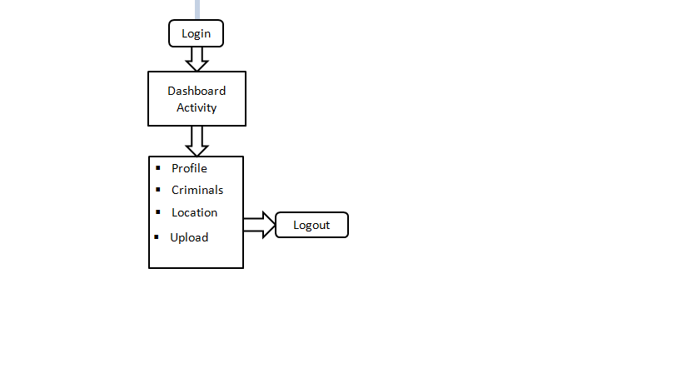

* 1. List the modules/Functionalities :-
* Google Map- It is used to get location of absconding criminal.
* Firebase Database-It is used to store details of user, criminals, police. Database can be accessed 24*7.
* Image upload-Police are able to upload and retrieve criminal images .
* Update/Delete-Police can update or delete respective criminal’s

Info at ease.

* Sorting of criminals through locality, zone wise.
* Create good interaction between user and police.

1. System requirements:-

A) Hardware requirements

* Laptop / Personal Computer with Intel Processor
* 200MB RAM
* Disk space for the android studio

B) Software requirements

* Windows or Linux Operating System
* Oracle Java SE JDK (Version 7 or above)
* Android Studio

11) Result:-

A) GUI

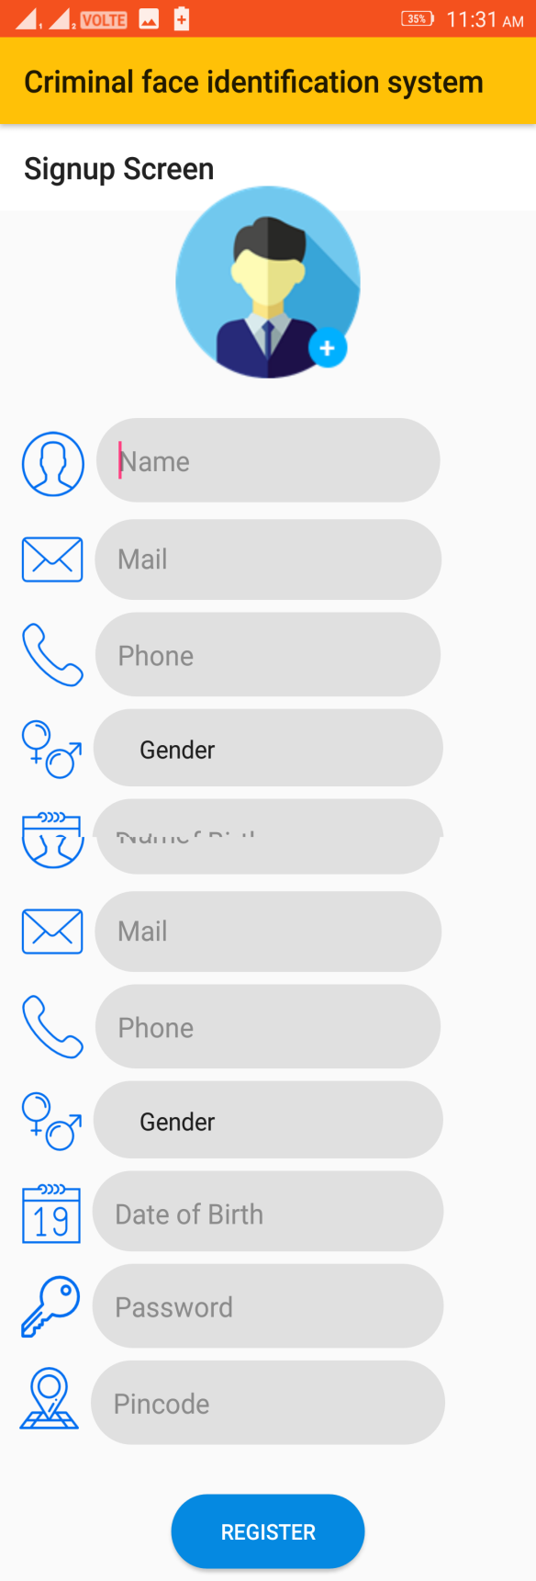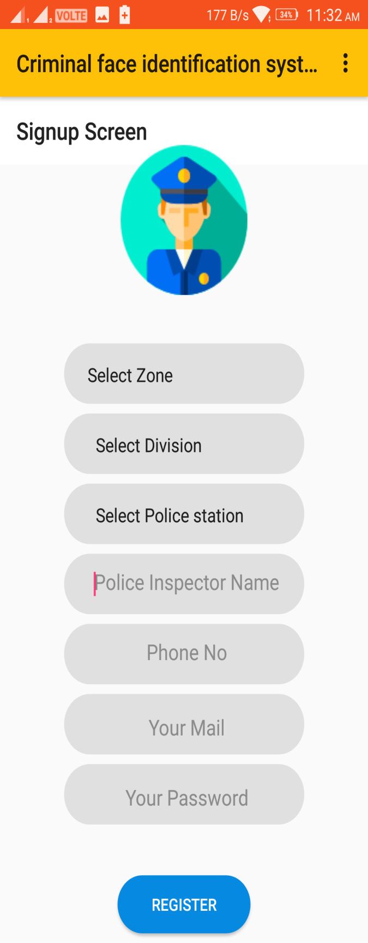

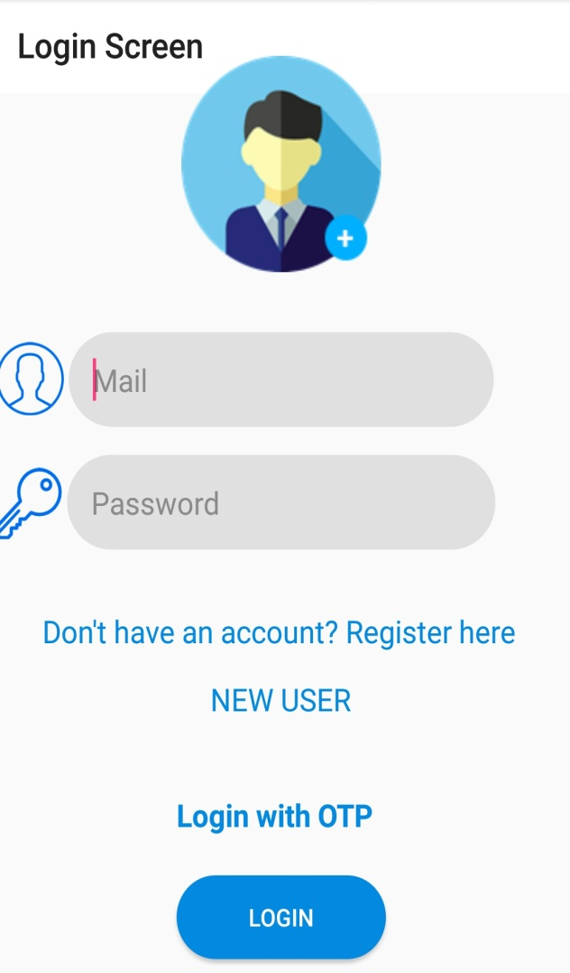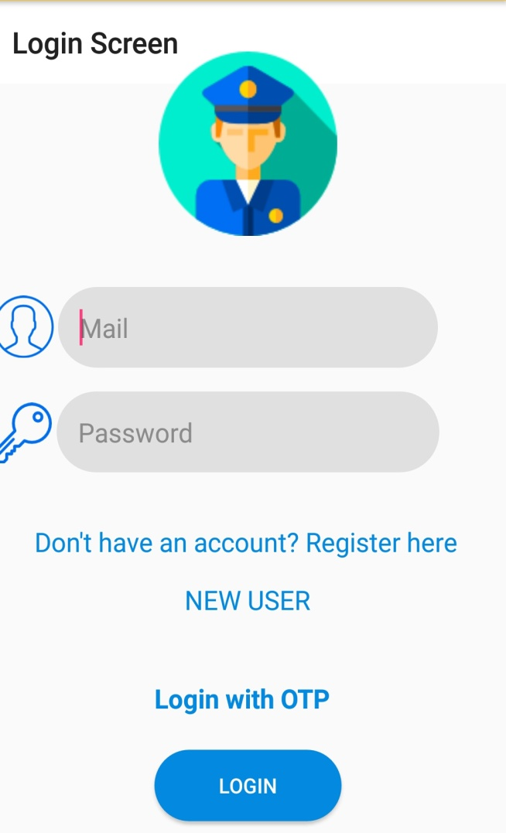

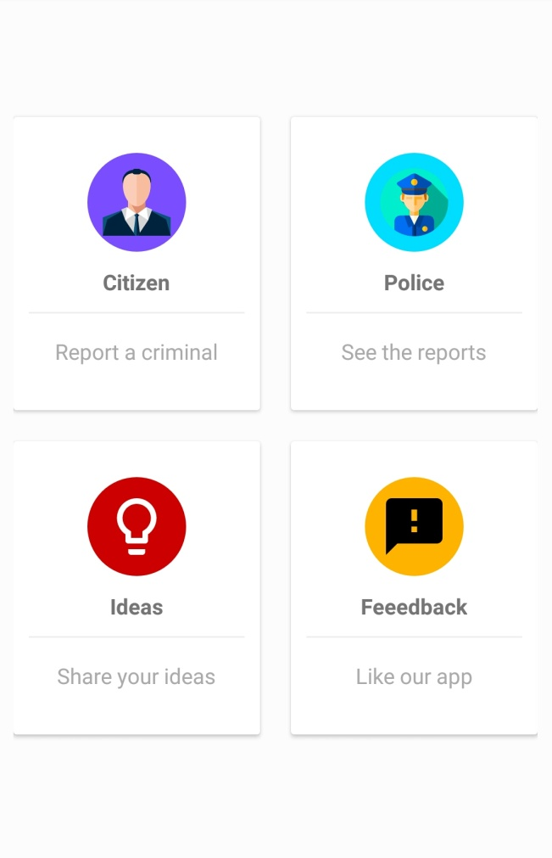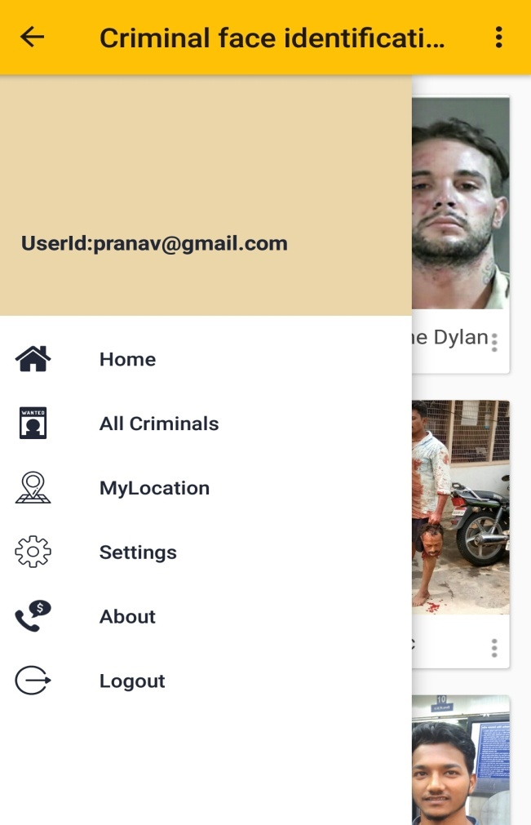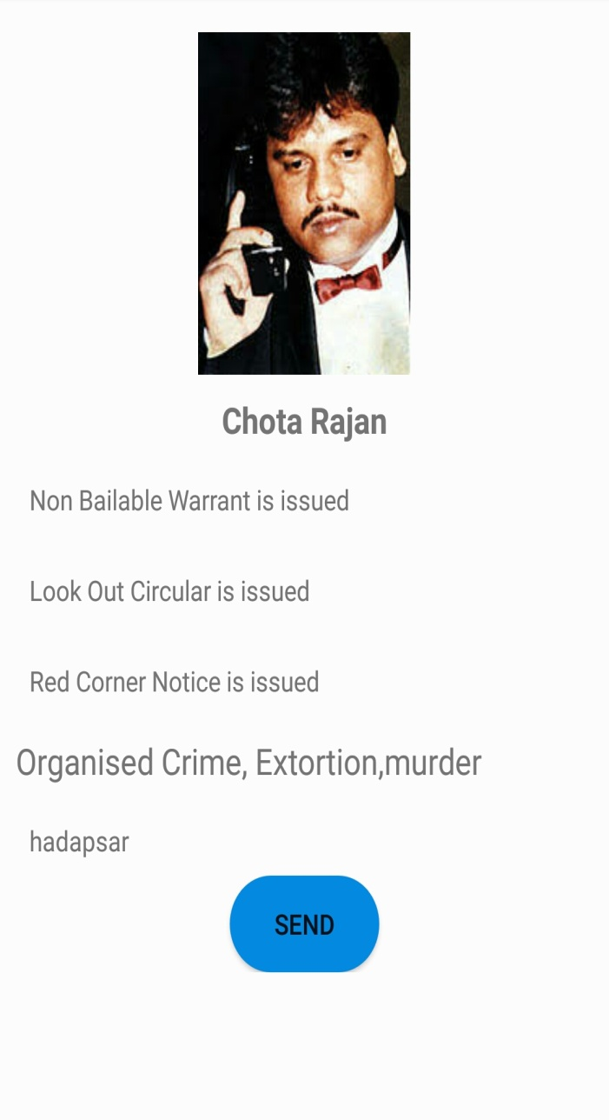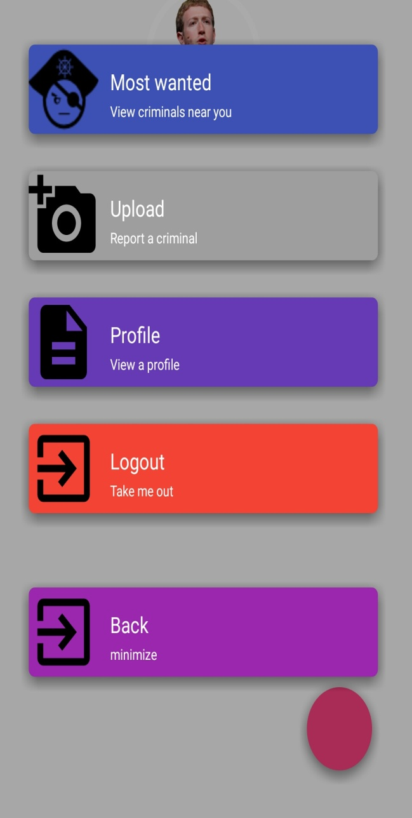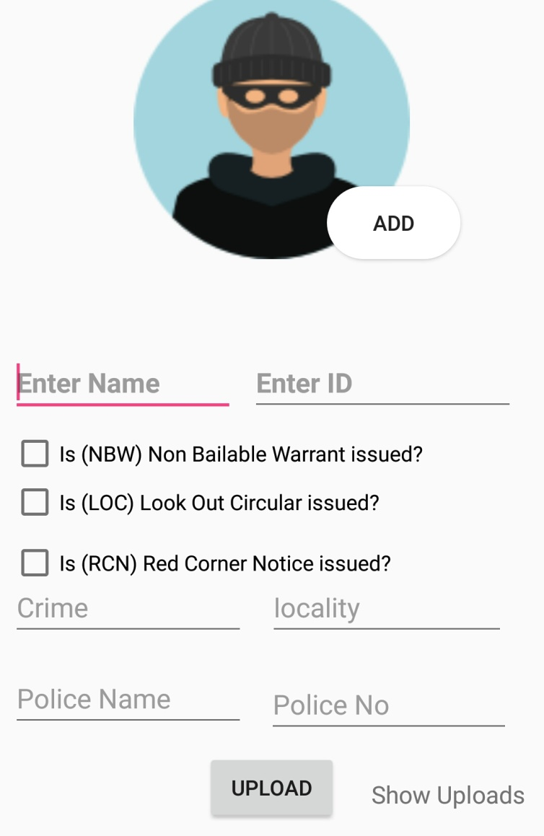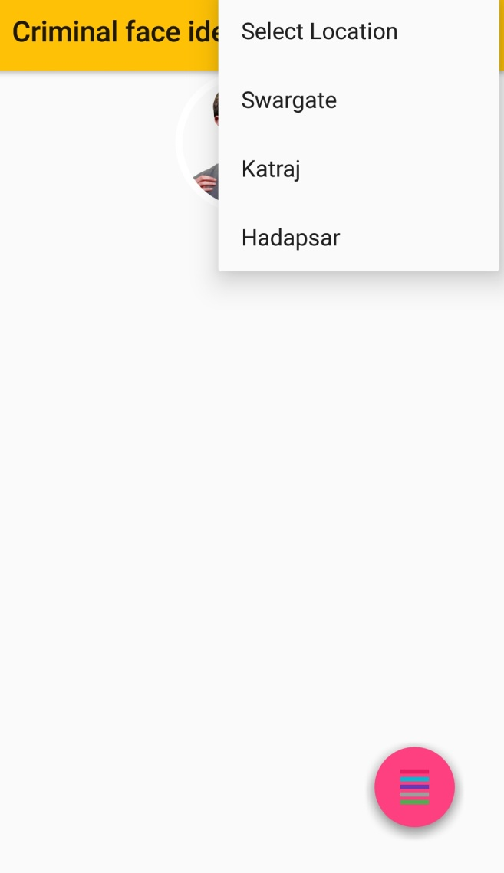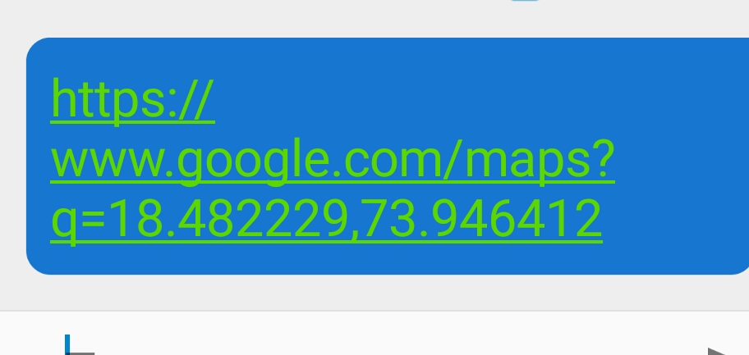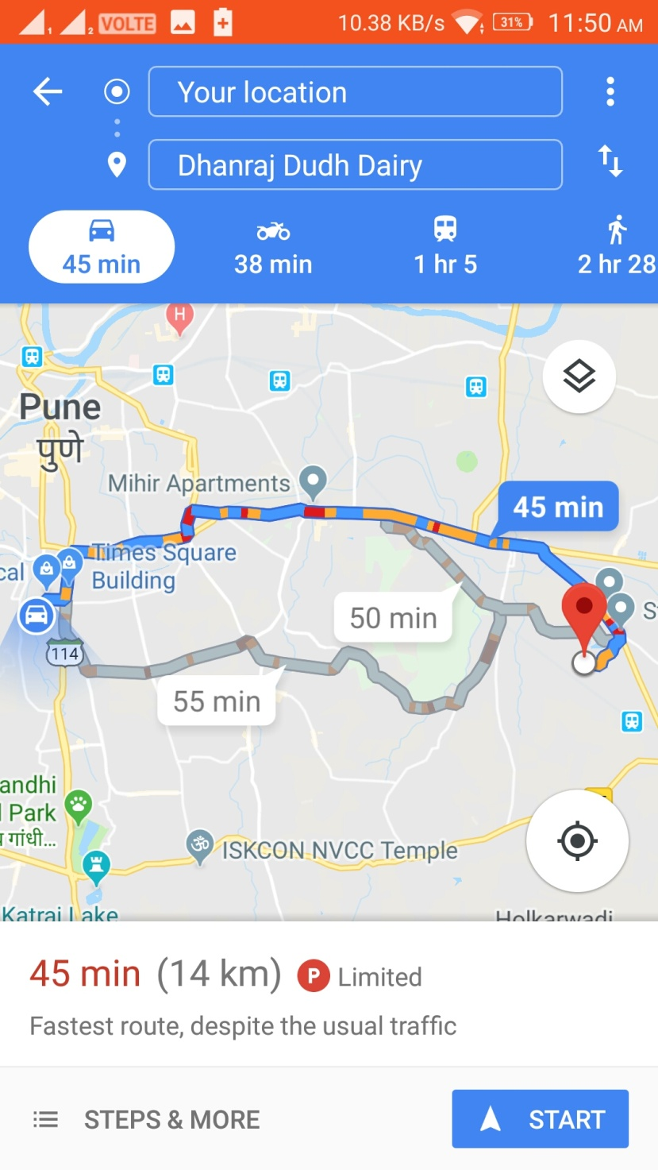

12) Conclusion:-

Helping others is what teaches us the way of Life. Project made us understand the meaning of partnership, team spirit, and various such values were studied by the means of the project. Project helped us to add a skill of the software known as Android Studio adds to our skill set. Various factors have to be considered while developing a project was known to us with the help of this. Most important MUTUAL UNDERSTANDING must be there between the team members was also known with the help of this. It is because of our GUIDE/SIR under their guide as well as inspiration we were able to build such a unique and good project so all due credits to them who helped us make such a successful project also thankful to the Insp. Krushna indulkar of the Dattawadi Poloce staion providing with such a relevant information which provided us a path toward the success under the dark times when needed. This app is a very helpful tool for most of the police. It has helped them in times of need. We all are very happy as to the app was quite a success and has helped in a very meaningful manner as expected. Though it has some pitfalls we will implement or remove them as soon as possible and make a better projects expected. Suggestion of the people will also considered.

13) References;

* [www.cctns.com](http://www.cctns.com) is used to collect information about Maharashtra police
* **http://developer.android.com/index.html**
* **http://www.androidsnippets.com/**
* **various online videos and documents are referred to know the widgets included in the project**
* **We also referred app ‘PRATISAAD’ of Maharashtra Police**
* **We have also visited the “Dattawadi Police Station” to know the working status of police department.**