Project Document: Centralized Video Playback System for Showroom TVs

Problem Statement :
Maruti Suzuki showrooms across multiple locations have TVs displaying promotional and informational videos.
Currently, there’s no centralized system to manage what each TV plays.
->Our goal is to build a central hub that decides, distributes, and monitors video playback across all showroom TVs, regardless of brand or OS.

Quick requirements summary :
1. centralized control : The central hub should decide which video plays on each TV, using TV-specific Ids(TV static IP)
2. Offline Resilience : in the process we have to make sure that whenever a TV get disconnected to central hub or internet, video must continue to play, that means we have to store a video or two atleast in local storage of TV.
3. Health Monitoring : deploying a tracking mechanism in the TV to get live status of the TV weather video is playing or not, what’s the storage status of TV.
4. Dashboard Visualization : An admin dashboard should show all TVs, their connectivity status, current video, and last-sync timestamp(whatever stats needed).

Our resources :
✅ Videos (named as SR-ID_TV-ID.mp4 or similar).
✅ Central Hub is basically a server — where videos are uploaded & control logic is running.
✅ Static IPs & Credentials for each showroom TV.
✅ Raspberry Pi Modules (confirmed by Mrityunjay Sir) connected to TVs via HDMI or USB.
- These can run Linux-based agents with Python.

System Architecture :
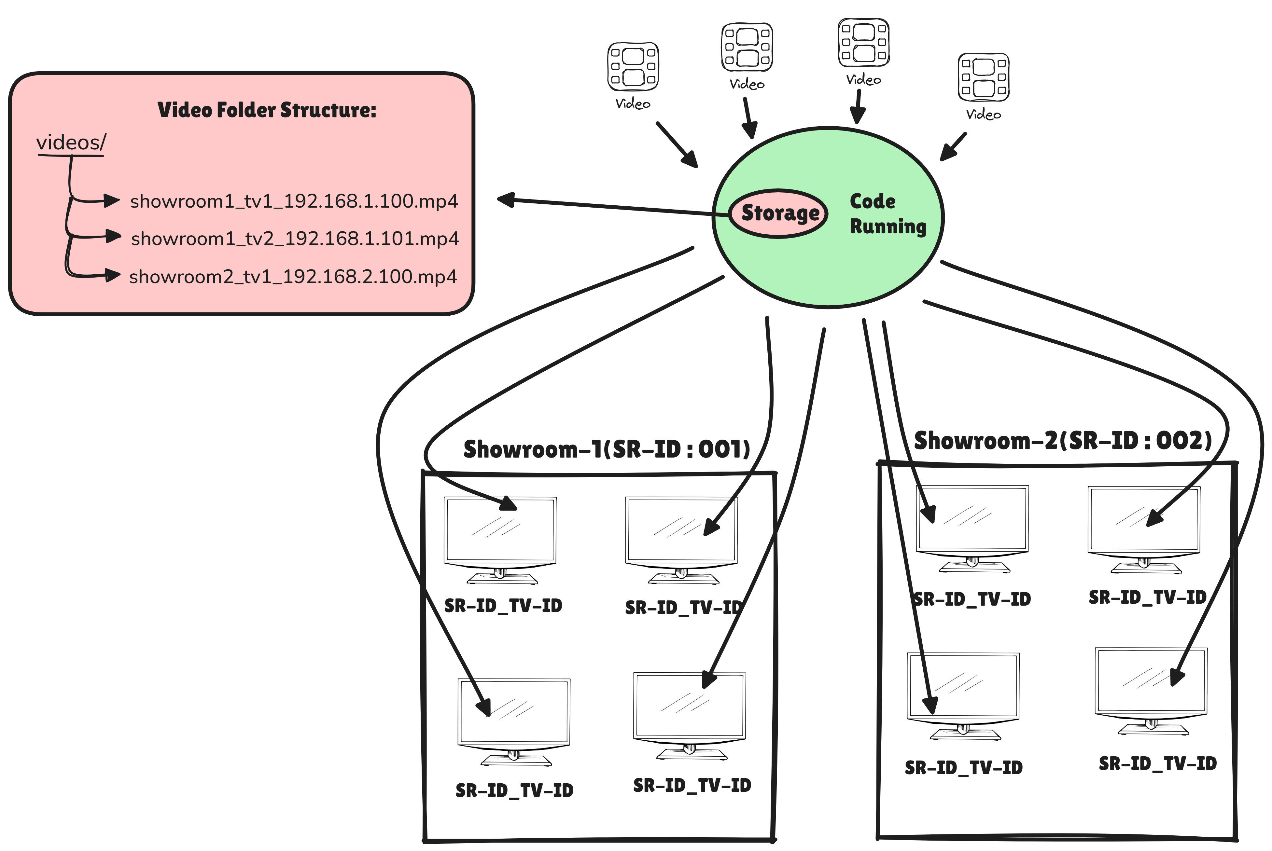
Central Hub Layer :

Video Management
- Hosts an upload folder (/videos), where new files are placed following a naming rule (SR-ID_TV-ID.mp4).
- Uses the Python watchdog library to detect when new videos appear.
- Maps each video to the correct showroom TV based on naming or a database table.
Content Distribution
- On detecting a new video, the hub automatically pushes it to the target TV/TV agent (Raspberry Pi / LibreELEC node) through:
  - POST method(HTTP POST) or MQTT topic publish or SFTP transfer
- The hub logs the dispatch status (success / failure / retry).
Tracking & Telemetry Reception
- Receives heartbeat(here depicts hearbeat of video) and tracking data from every TV/TV agent at regular intervals (e.g., every 30 seconds).
- Each report contains:
  - Current video name and timestamp position.
  - Playback state (playing / paused / stopped / error).
  - Free storage.
  - Last successful download and sync time.
- Data is stored in a monitoring database (PostgreSQL or MongoDB) for the dashboard.
- Alerts (email / SMS) can be triggered when a TV stops reporting or playback fails.
Dashboard API
- Exposes REST or WebSocket endpoints consumed by the dashboard frontend to show:
  - Online / offline status of all TVs.
  - Last reported video and health metrics.
  - Download / upload logs and errors.

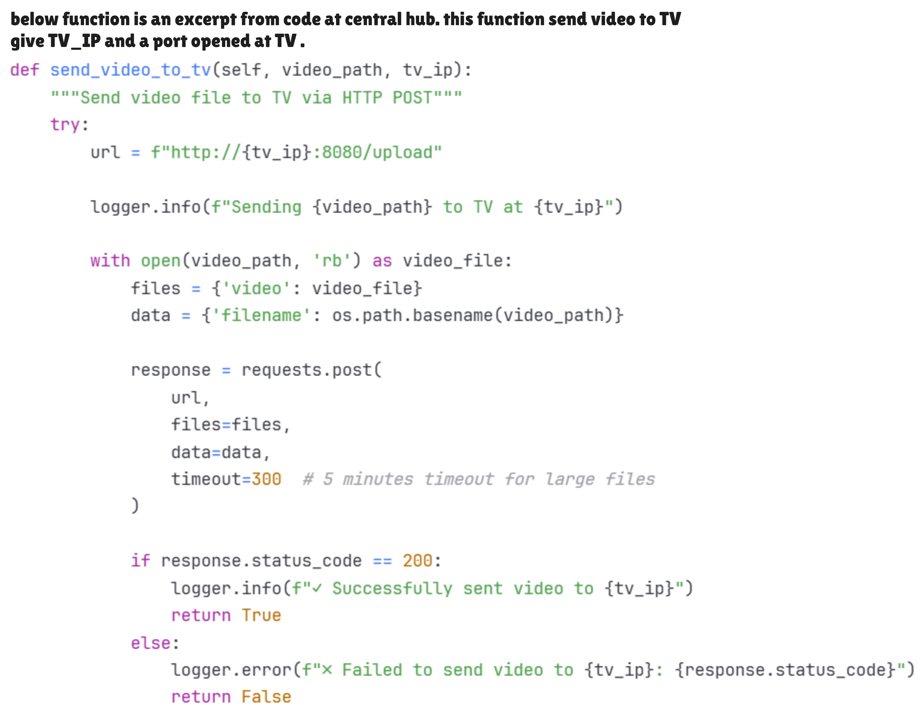
Python's watchdog library :
Watchdog is a Python library and set of shell utilities designed to monitor file system events. It provides a cross-platform API to detect changes in files and directories, such as creation, modification, deletion, and movement.

we can employ this library for detecting the changes in the folder for example whenever a new videos get uploaded to folder in the central hub it will detect these changes and run the functions in the script responsible for sending the video forward to TV.

Communication Layer :
Establish a persistent connection between Hub ↔ TV Modules via one of:

1. getting remote access of TV using static IP and credentials.
And then we can run a executable file on the TV remotely which will install media player and tracking mechanisms.
Detailed Exploration on this approach : link

2. using raspberi pi.
We can connect raspberry pi to the TV via HDMI port and run a python script on the module that starts the port & sunsequently recieves the videos from central hub and play the videos, and send the tracking data. We can also add storage device to module if TV does not have enough storage for holding video. Main idea is that we interact with module and module executes actions in the TV.

Edge Layer (running script on TV side)
task in this layer is to run executable(python scrip) or lightweight program on the TV side for :
- Plays assigned videos automatically,
- Tracks playback status and local storage health,
- Reports this information back to the central hub.

This step is technically the most challenging, because it depends on the operating system and developer access level of each TV model.

->Can We Run a Python Script Directly on TVs?
Short answer: No, not directly on most consumer Smart TVs.
Most Smart TV operating systems (LG webOS, Samsung Tizen, Roku OS, VIDAA, Panasonic My Home Screen, etc.) do not include a Python runtime environment and do not permit arbitrary code execution for security and stability reasons.
They only allow apps written using their official SDKs and app frameworks, which are sandboxed and distributed through their respective app stores.
Even though many of these systems are based on Linux kernels, they expose limited, proprietary user-space APIs—so we can’t treat them as normal Linux machines that accept python3 script.py.

->Smart TV OS Landscape

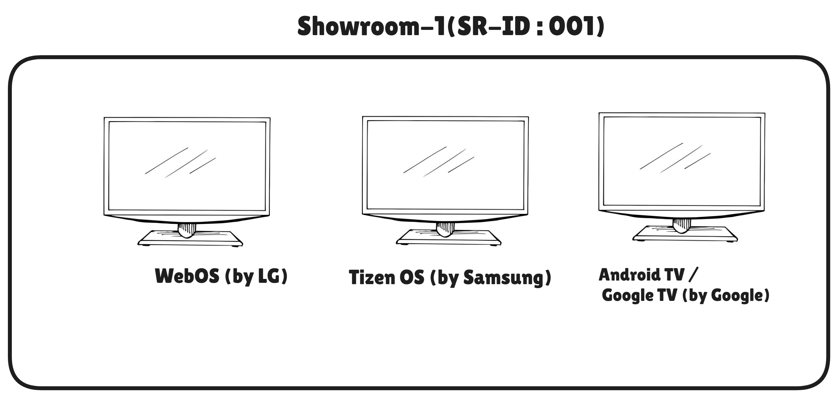

Brand | OS | Based on | App Store
LG | webOS | Linux | LG Content Store
Samsung | Tizen | Linux | Smart Hub
Sony / TCL / Xiaomi | Android TV / Google TV | Android | Play Store
Amazon / Onida | Fire TV OS | Android fork | Amazon Appstore
TCL / Hisense | Roku OS | Linux | Roku Store
Hisense / Toshiba | VIDAA OS | Linux | VIDAA Store
Panasonic | My Home Screen | Firefox OS | Panasonic Market

most of TV OS are based on Linux Kernal except few which are based on android or firefox or else.

They each have their own app model:
- LG webOS: HTML5/JavaScript apps (Enact), webOS JS services.
- Samsung Tizen: Web apps (JS) or .NET; media via AVPlay APIs.
- Roku OS: BrightScript / SceneGraph only.
- VIDAA / Panasonic: HTML5/JS-style apps with restricted APIs.
- Amazon Fire TV OS & Android TV / Google TV: Android apps (Java/Kotlin; C++ via NDK). You can sometimes sideload things like Termux/Python on Android TV, but it’s hacky, fragile, and not suitable for production.

Solutions :

Option 1 – Native App per TV Platform
We could build dedicated applications using each platform’s official SDK:
- webOS → Enact (HTML5 + JavaScript)
- Tizen → Web App (JS) or .NET App
- Android TV / Fire TV OS → Android App (Java/Kotlin / C++ NDK)
- Roku OS → BrightScript
- VIDAA / Panasonic → Restricted HTML5 apps
Each app would handle:
- Video playback via native media APIs,
- Local caching of media files,
- Periodic status reporting to the central hub.
However, this requires multiple codebases, vendor certifications, and store publishing, making it expensive and difficult to maintain at scale.

Option 2 – Using External Playback Device (Raspberry Pi + LibreELEC + Kodi + Python Add-on)
A more uniform and controllable solution is to use an external device connected via HDMI, such as:
- Raspberry Pi / Intel NUC / Android Box
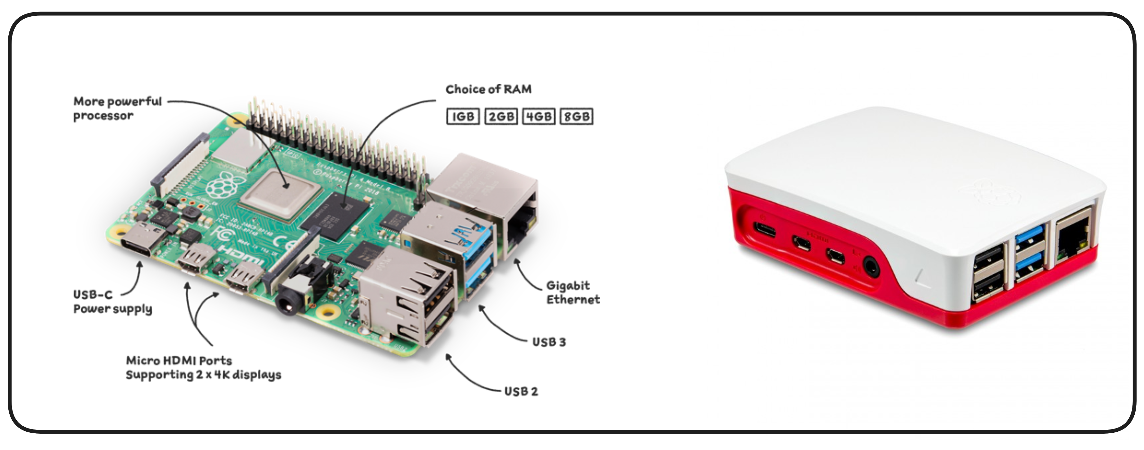

WHAT is LibreELEC & Kodi : Understanding LibreELEC & Kodi

Example setup:
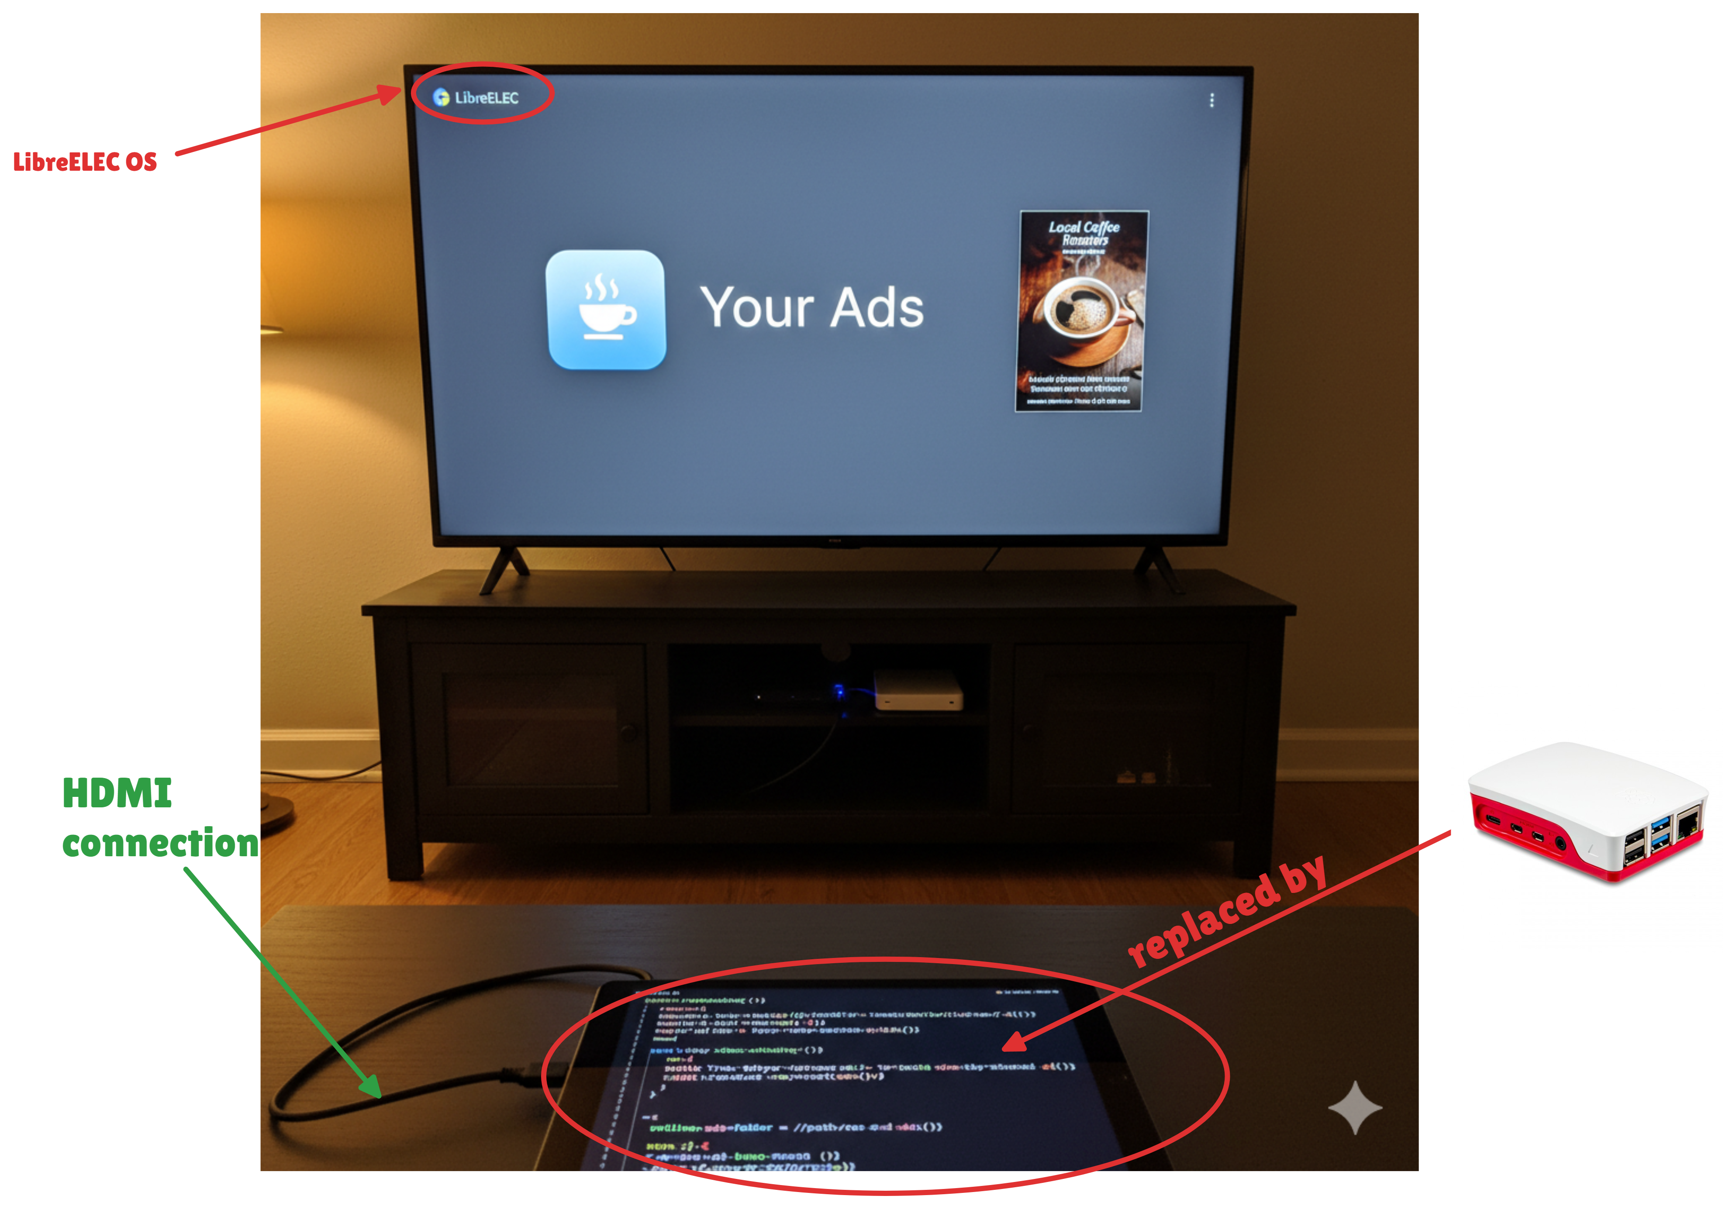

......Step 1 – Hardware Connection
- Connect Raspberry Pi to the TV via the HDMI port.
  - Power the Pi using a reliable 5 V / 3 A adapter.
  - Optionally connect a USB flash drive or micro-SD card (≥ 32 GB) for local caching.
- Connect the Pi to the internet (Ethernet preferred / Wi-Fi optional).
- Once powered on, the TV will detect HDMI input → select the Pi’s HDMI source as default display.

.......Step 2 – Install LibreELEC
- On a laptop, use the LibreELEC USB-SD Creator tool.
- Flash the LibreELEC OS image onto the Pi’s micro-SD card (model-specific build).
- Insert the card into the Pi → boot.
- On first boot:
  - Configure language, network, and hostname.
  - Enable SSH and Samba (SMB) in Settings → LibreELEC → Services.
This allows remote file transfer and remote debugging later.
LibreELEC boots directly into Kodi, the media-center interface.

....Step 3 – Enable Kodi Remote & Developer Interfaces
- In Kodi → Settings → Services → Control:
  - Enable “Allow remote control via HTTP” (default port 8080).
  - Enable “Allow remote control from applications on other systems.”
- Note the device IP address (e.g., 192.168.1.42); the central hub will use this for API calls or data push.

....Step 4 – Add the Python Environment (Kodi Add-on)
Kodi 19+ ships with Python 3 built in for add-ons.
Our playback-and-tracking logic will live inside a custom Kodi Add-on written in Python.

4.1 Add-on Folder Structure
plugin.video.showroomplayer/
│
├── addon.xml
├── icon.png
├── default.py # Main entry point
├── resources/
│ └── settings.xml
└── service.py # Background service

4.2 Key Files
- addon.xml – metadata & entry points.
- default.py – handles manual UI or playlist testing.
- service.py – auto-starts on boot, runs background loop.
Example addon.xml snippet:
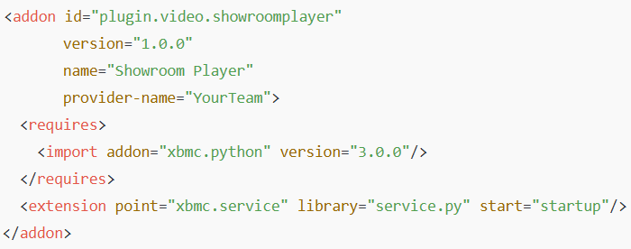

.....Step 5 – Core Functionalities Implemented in Python(these are Kodi add-ons)

5.1 Receiving and Updating Videos
- The add-on periodically polls the central hub API or subscribes to an MQTT topic like
videos/<SHOWROOM_ID>/<TV_ID>.
- On receiving a new video URL or file metadata:
  - Downloads it via requests or urllib.
  - Saves to local folder /storage/videos/.
  - Maintains a simple SQLite/JSON list of cached videos.
- Uses hashing or timestamps to avoid duplicate downloads.

5.2 Video Playback (using Kodi API)
Kodi exposes a JSON-RPC API and Python module xbmc.Player:
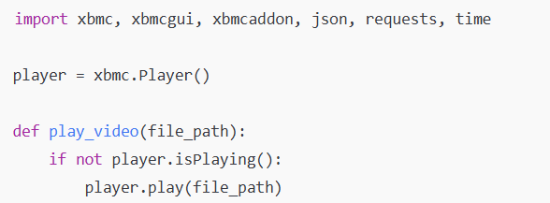
- The add-on auto-plays the next video when the current one ends.
- The playlist loops indefinitely to satisfy “always-on” showroom playback.
- On reboot, Kodi auto-starts and the add-on resumes playback.

5.3 Offline Resilience
- Videos are cached locally (/storage/videos).
- If the hub is unreachable, the service reads the local playlist and continues looping until connectivity returns.

5.4 Tracking and Telemetry
The script periodically collects and sends data such as:
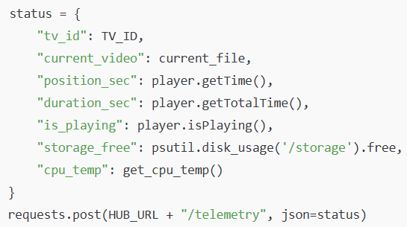
- Frequency: every 30 – 60 seconds.
- If offline, logs locally and retries later.

5.5 Auto-Start and Recovery
- service.py runs automatically at Kodi startup (declared in addon.xml).
- Even after power loss, LibreELEC → Kodi → service.py sequence restarts playback automatically.

Step 6 – Remote Management and Monitoring
- Central Hub Dashboard receives telemetry and displays:
  - Online/offline status, current video, free storage, last update time.
- Kodi Web API (port 8080) can also accept remote JSON-RPC commands for manual control:
  - /jsonrpc POST → {"method": "Player.Stop"}
  - /jsonrpc POST → {"method": "Player.Open", "params": {"file": "path"}}
- SSH/Samba provide maintenance access (logs, config edits).

Execution Flow Summary
Stage | Executed Where | Description
Hardware setup | On-site technician | Connect Pi → HDMI → TV; power on.
OS installation | Laptop → Pi SD card | Flash LibreELEC and boot.
Add-on deployment | Developer → via Samba/SSH | Copy plugin.video.showroomplayer folder to /storage/.kodi/addons/.
First boot | Kodi auto-launch | service.py starts, registers TV, requests playlist.
Normal operation | Pi (continuous) | Receives videos, plays them, caches offline, sends telemetry.
Monitoring | Central Hub | Displays status via dashboard & alerts.

Why This Works
- LibreELEC provides a minimal, read-only OS → fast boot & stability.
- Kodi handles all video decoding and fullscreen display.
- Python Add-on gives complete automation and communication with the hub.
- No dependence on the TV’s internal OS; works with any brand via HDMI.

Dashboard Design (High-Level)
below are a rough design how a dashboard might look like(obviously it will change as we progress in project building stage)

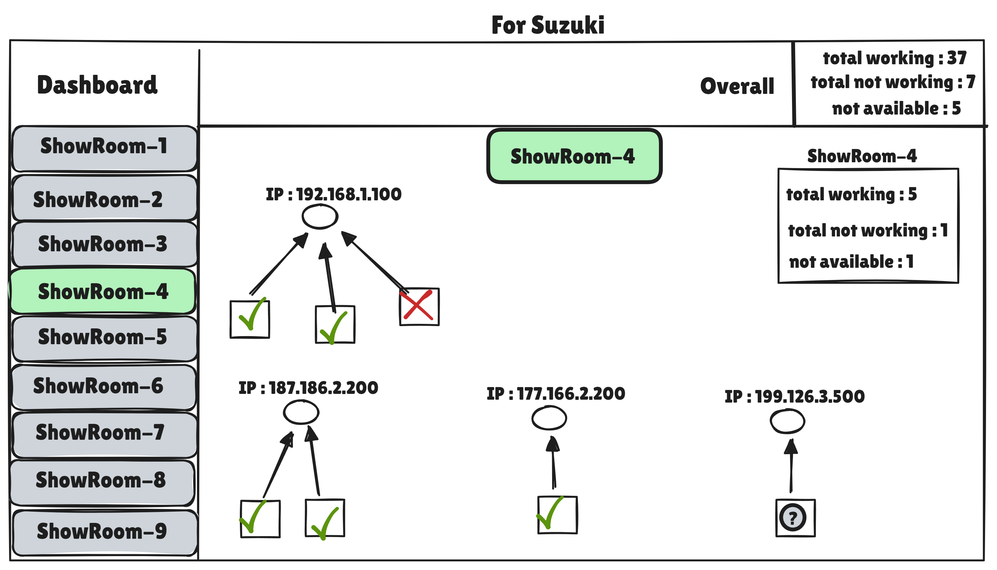
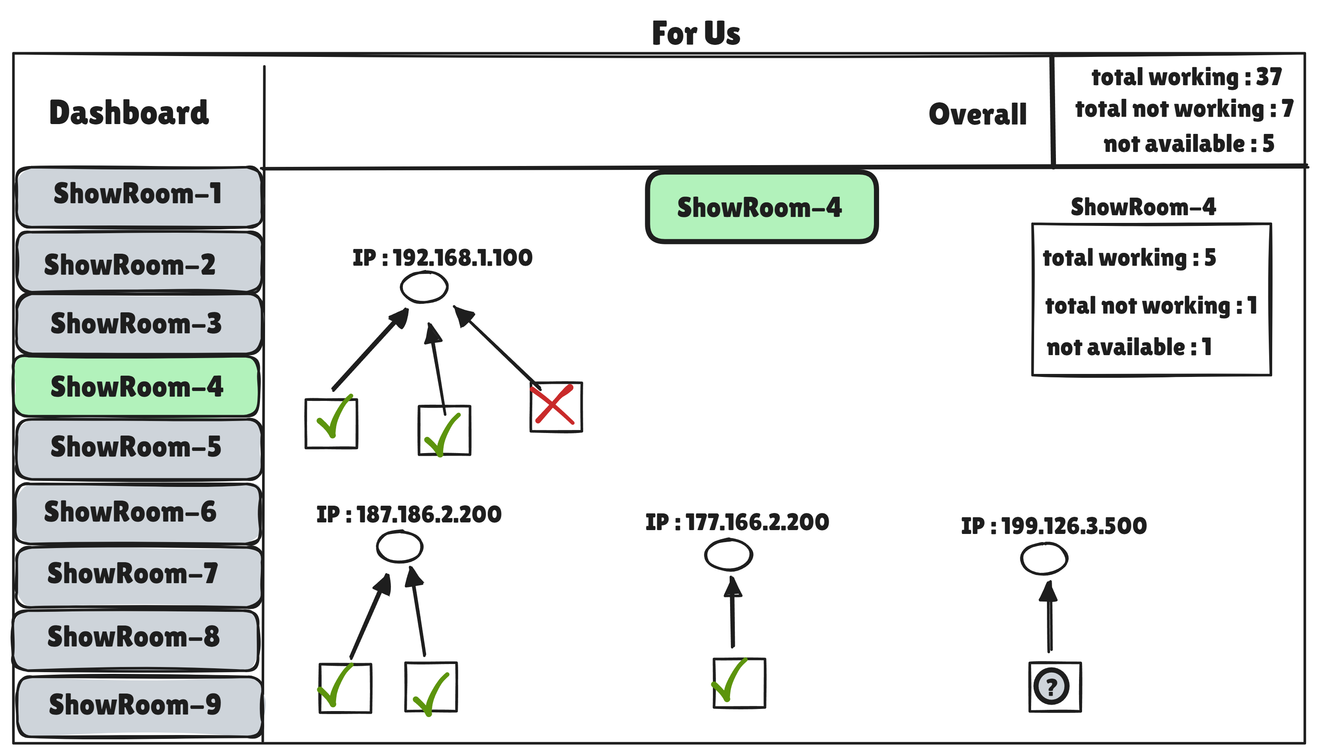

What “remote access via static IP” really requires
- Reachability:
  - The TV must be reachable from the hub (routable static public IP or a site-to-site VPN into the showroom LAN).
  - Correct ports opened on the store firewall (varies by OS tools below).
- Correct privilege mode on the TV:
  - You typically need Developer Mode (Android TV, webOS, Tizen, Roku) or an MDM/enterprise enrollment (Android/Fire TV).
  - Without this, you generally cannot sideload or control media playback programmatically.
- Right packaging:
  - You don’t “run an executable.” You install the platform’s app package (APK/IPK/TPK/ZIP) and start it with the vendor’s SDK tools or MDM.
- Security/operations:
  - Dev modes often timeout (e.g., webOS ~50 hours) and must be re-enabled on-device.
  - Certificates, pairing keys, and device profiles must be managed.
  - Brand updates can break side-loaded apps.

Feasibility by platform (and the exact how-to)

1) Android TV / Google TV (also Amazon Fire TV, similar via ADB)
Feasible and the most practical of the “remote access” options.
- What you need
  - Physical one-time setup: enable Developer options → USB debugging → ADB over network (or use USB once).
  - Network: TV must be reachable (VPN or public static with firewall rules).
  - Ports: ADB default 5555/TCP.
- What you can do
  - Install/update your APK remotely; start/stop your app; auto-start on boot; run a background service for playback/telemetry.
- Core commands (from your hub or a jump host)
adb connect <TV_IP>:5555
adb devices
adb install -r player.apk
adb shell pm grant com.your.app android.permission.WAKE_LOCK
adb shell am start -n com.your.app/.MainActivity
Auto-start: implement a BOOT_COMPLETED receiver in the app; optionally set device owner (via Android Enterprise/MDM like Esper, Scalefusion) for kiosk/autoplay and to block user interference.
- Pros: Strong control, robust APIs, decent tooling, MDM options for scale.
- Cons: Requires dev/MDM enrollment per TV; not all brands run Android TV.
Fire TV note: Also ADB-capable; enable ADB debugging in Developer Options. Install via adb install. Similar management story.

2) LG webOS
Possible but operationally fragile for production at scale.
- What you need
  - webOS Dev Mode app installed on each TV and activated (session typically expires ~50 hours → must be renewed on-device).
  - LG developer account and device pairing.
  - Tools: ares-setup-device, ares-install, ares-launch.
- What you can do
  - Install an IPK (web app: HTML/CSS/JS) that uses media playback APIs and a websocket/HTTP client for telemetry.
  - Launch/stop the app remotely while dev mode is active.
- Typical flow
ares-setup-device --add <tv_name> --host <TV_IP> --port 9922 --username prisoner --privatekey <key>
ares-install player.ipk --device <tv_name>
ares-launch com.your.app
- Cons: Dev mode renewal and certificate handling make this brittle; background services are limited. Great for pilots, not ideal for unattended nationwide rollout.

3) Samsung Tizen
Technically possible; also operationally heavy.
- What you need
  - Enable Developer Mode on the TV, create a device profile and certificate in Tizen Studio.
  - Tools: sdb (Samsung Debug Bridge), tizen CLI, or pkgcmd.
- What you can do
  - Install a TPK (web/native) that uses AVPlay APIs for video playback and report telemetry via HTTP/MQTT.
- Typical flow
sdb connect <TV_IP>:26101
tizen install -n player.tpk -t <device_name>
sdb shell # limited shell, not a general Linux shell
- Cons: Certs/profiles per fleet, dev mode persistence varies, upgrades can break provisioning. Better than webOS for some deployments, still complex.

4) Roku OS
You can sideload during a “developer mode” session, but it’s not meant for fleet ops.
- What you need
  - Enable developer mode via on-remote key sequence; set a password.
  - Upload a ZIP of your channel via the built-in dev web server.
- Limits
  - BrightScript only; limited background control; dev mode is not intended for permanent production. For large fleets you need a published channel and Roku business agreements.

5) VIDAA / Panasonic “My Home Screen”
Very limited for remote sideloading.
Usually web-style apps with restricted APIs; no stable remote shell; deployments tend to go via the vendor store or on-site provisioning. Treat as not feasible for headless remote installs at scale.

Why a generic “run an .exe” isn’t possible
- TVs don’t run Windows; they run Android, custom Linux, or specialized firmware.
- Each platform only executes its own app package type (APK/IPK/TPK/etc.) and enforces sandboxing.
- Remote shells (SSH) are not exposed on retail firmware.

Security & networking checklist (if we still choose this path)
- Never expose ADB/web dev ports to the public internet. Use site-to-site VPN from hub → showrooms.
- Firewall allowlist specific ports per OS tool (ADB 5555, Tizen 26101, webOS 9922, Roku dev web UI 80/8060 etc.).
- Rotate keys/certs, keep per-device credentials, audit logs.
- Lock to kiosk mode (Android Enterprise/MDM) to prevent user exit.
- Auto-recovery: your app must auto-start on boot, loop content offline, and re-sync when network returns.

Practical recommendation for this project
- For a heterogeneous TV fleet, relying on “remote access with static IP” is operationally risky (dev mode churn, certs, brand quirks).
- The most reliable, uniform approach is still:
  - Raspberry Pi (or Intel NUC) on every TV HDMI
  - LibreELEC + Kodi or Python VLC agent
  - Single, brand-agnostic deployment and a clean, testable control surface.
If you also have some Android TVs, you can add an Android TV app path for those sites (via ADB/MDM) to reduce hardware, but keep Pi/Kodi as the standard baseline.

If we want to proceed with “remote access” anyway—deployment playbooks

Android TV playbook (most feasible)
- One-time on each TV: enable Developer options + ADB over network (or enroll into an MDM).
- Network: ensure VPN; open TCP/5555 from hub → TV.
- From hub CI runner/jump host:
adb connect <ip>:5555 || exit 1
adb install -r player.apk
adb shell am start -n com.company.player/.MainActivity
adb shell settings put global stay_on_while_plugged_in 3
- App behavior:
  - Foreground player with MediaPlayer/ExoPlayer, auto-loop.
  - Background service for telemetry (HTTP/MQTT heartbeat).
  - Offline cache with a min of 2–3 videos; auto-resume after reboot.

webOS playbook (pilot only)
- Keep a spreadsheet of dev-mode expiry per device and a weekly on-site renewal rota.
- Package IPK; use ares-* CLI to push & launch; telemetry via your backend.
- Expect occasional breakage after TV firmware updates.

Tizen playbook (pilot/limited)
- Create and store device certs; automate sdb connect + tizen install from your hub.
- App uses AVPlay; telemetry via HTTP/MQTT; plan for cert rotation and dev-mode lifecycle.

Bottom line
- Yes, “remote access via static IP” is sometimes possible, but only within each vendor’s dev/MDM constraints and with their app package, not a generic executable.
- For reliable, scalable, and uniform control across brands, prioritize the Raspberry Pi + LibreELEC + Kodi approach as the primary architecture, and treat TV-native remote installs as opportunistic for Android/Fire TV sites where ADB/MDM is practical.

--------------------------------Development----------------------------------------

in this project task is to control all TV's in the maruti suzuki showrooms from a central hub. Central hub will send video to particular TV using TV IP for which the video is meant to be played. Central hub will also reacive the data from TV for example if video is being played or not, how much is the storage in the TV etc. each TV is basically a small computer either windows or android and each TV has unique Static IP and we have TV's IPs and credentials.

