CSE 5301 - Data Analysis and Modeling

Homework 2

Date of submission: 09/23

Time of submission: 5 pm

**Problems from Chapter 3**

3.7, 3.21, 3.22, 3.31, 3.36

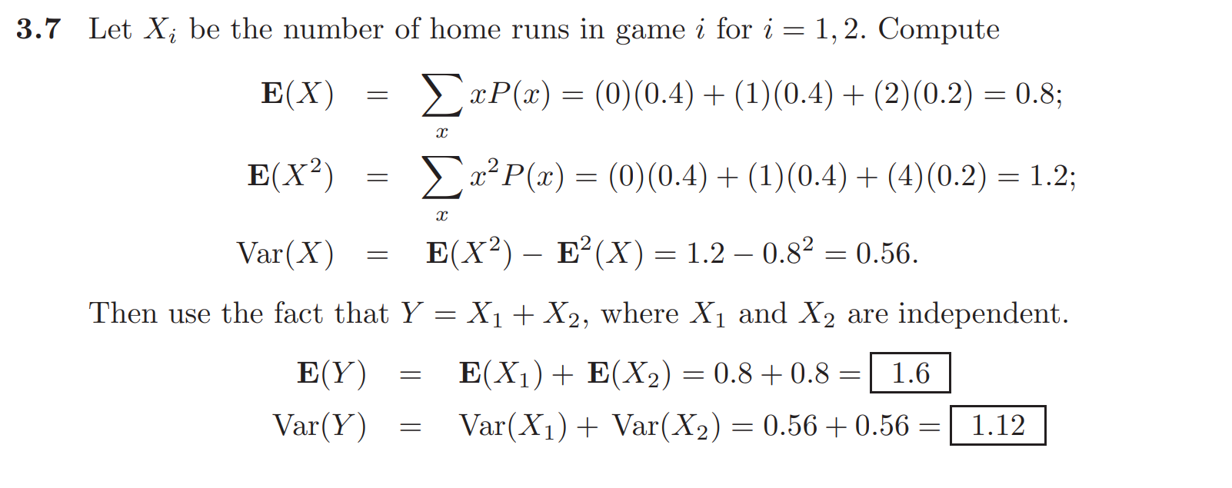

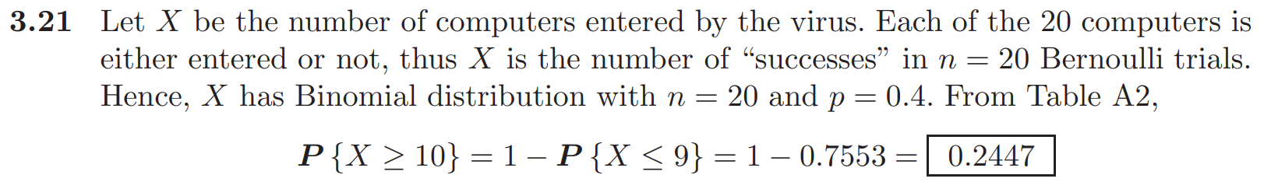

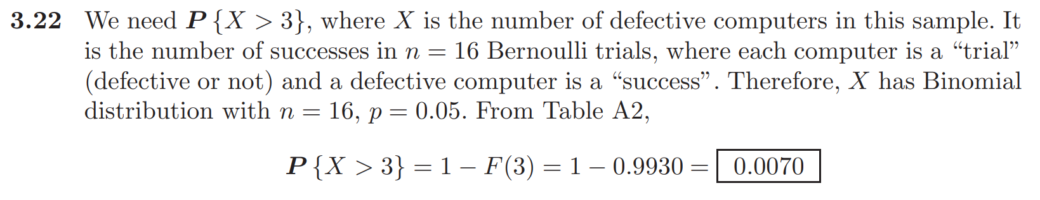

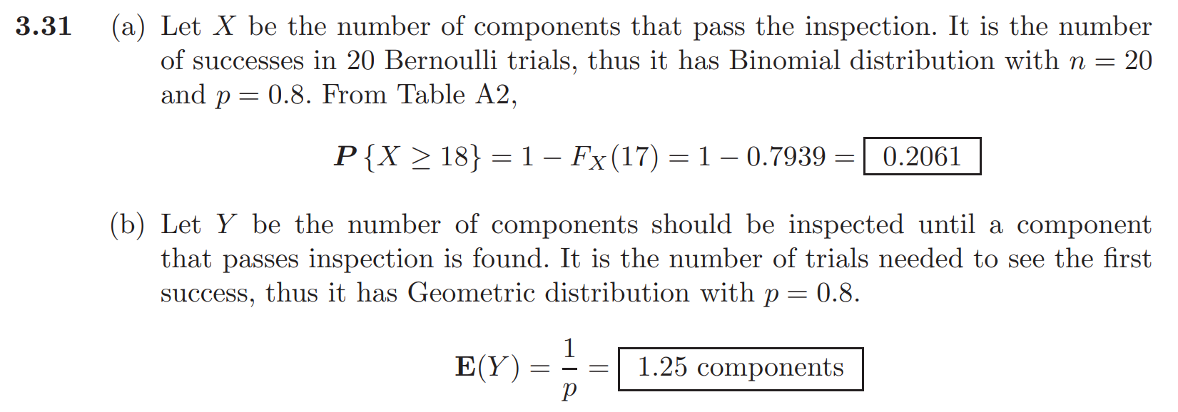

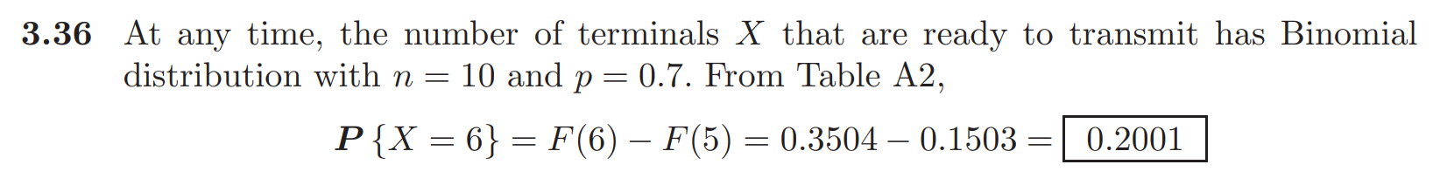

**Hypergeometric Distribution Problem**

To avoid detection at customs, a traveler places 6 narcotic tablets in a bottle containing 9 vitamin tablets that are similar in appearance. If the customs oﬃcial selects 3 of the tablets at random for analysis, what is the probability that the traveler will be arrested for illegal possession of narcotics?

