Multi-Assistant Voice Control
A Pluggable Voice Service for our IoT Application
High-Level & Low-Level Design (HLD / LLD)
Status: Draft for team review • Version 0.1

Contents

1. Purpose & Audience
This document describes how we add voice control to our IoT application — Alexa today, with Google Assistant and Siri planned next — as a single, pluggable service rather than three separate integrations.
It is written for the whole team, including members who are new to voice platforms. Section 2 explains the idea in plain language. Section 3 (HLD) shows the big-picture architecture. Section 4 shows what “pluggable” means in practice. Section 5 (LLD) follows one real voice command from start to finish. A glossary at the end defines every technical term used.

2. The Problem and the Idea

The problem
Every voice assistant speaks its own language. Alexa sends a request in one shape, Google in another, and Siri works differently again. If each assistant talked directly to our IoT app, we would build and maintain the same logic — “turn on the heater”, “set the temperature” — three separate times. Worse, any change Amazon, Google, or Apple makes to their format would ripple straight into our core application.

The idea
We put one service between the assistants and our app: the Voice Gateway. Each assistant connects to it through a small, replaceable piece called an adapter. Every adapter translates that assistant’s request into one shared internal format — the canonical command. Our IoT core only ever understands this single format; it never knows or cares which assistant the user actually spoke to.
The payoff: voice logic is written once. Adding Google or Siri later means writing one new adapter — not touching the core.

3. High-Level Design (HLD)
The system has three layers. Requests flow left to right; the spoken reply flows back the same way.
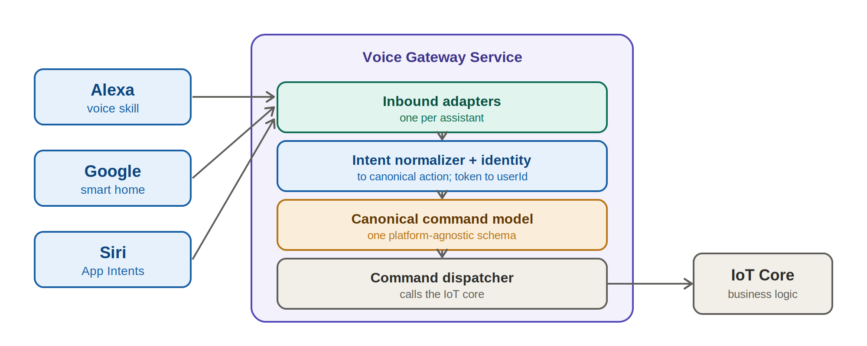
Figure 1 — High-level architecture: voice platforms feed the gateway, which hands a single clean command to the IoT core.

The three layers
1. Voice platforms (external). Alexa, Google, Siri. Owned by Amazon, Google, and Apple. They capture the user’s speech and send us a request in their own format.
2. Voice Gateway Service (ours — new). The subject of this document. It receives every request, translates it, forwards a clean command to the core, and turns the result back into the assistant’s reply.
3. IoT Core (ours — existing). Our current application and device-control logic. It receives canonical commands and acts on the real devices.

What each component does
Component | Layer | Responsibility
Voice platform | External | Captures the spoken request and sends it to us in its own format.
Inbound adapter | Gateway | One per assistant. Reads that assistant’s request and begins building a canonical command.
Intent normalizer | Gateway | Maps the assistant’s intent name to our fixed canonical action (e.g. SetTemperatureIntent → device.set_temperature).
Identity / account linking | Gateway | Converts the assistant’s user token into OUR internal user id.
Device resolver | Gateway | Turns a spoken device name (“living room thermostat”) into a real device id.
Canonical command model | Gateway | The single shared command format the whole system agrees on — the contract.
Command dispatcher | Gateway | Sends the canonical command to the IoT core and waits for the result.
Response formatter | Gateway | Turns the core’s result back into the assistant’s reply format (e.g. Alexa SSML).
IoT Core | Ours (existing) | Executes the command on the real device and returns a result.

4. How the Pluggable Service Works
“Pluggable” means each assistant is an independent, swappable part. The canonical layer and the IoT core form a stable centre that does not change when an assistant is added, updated, or removed.
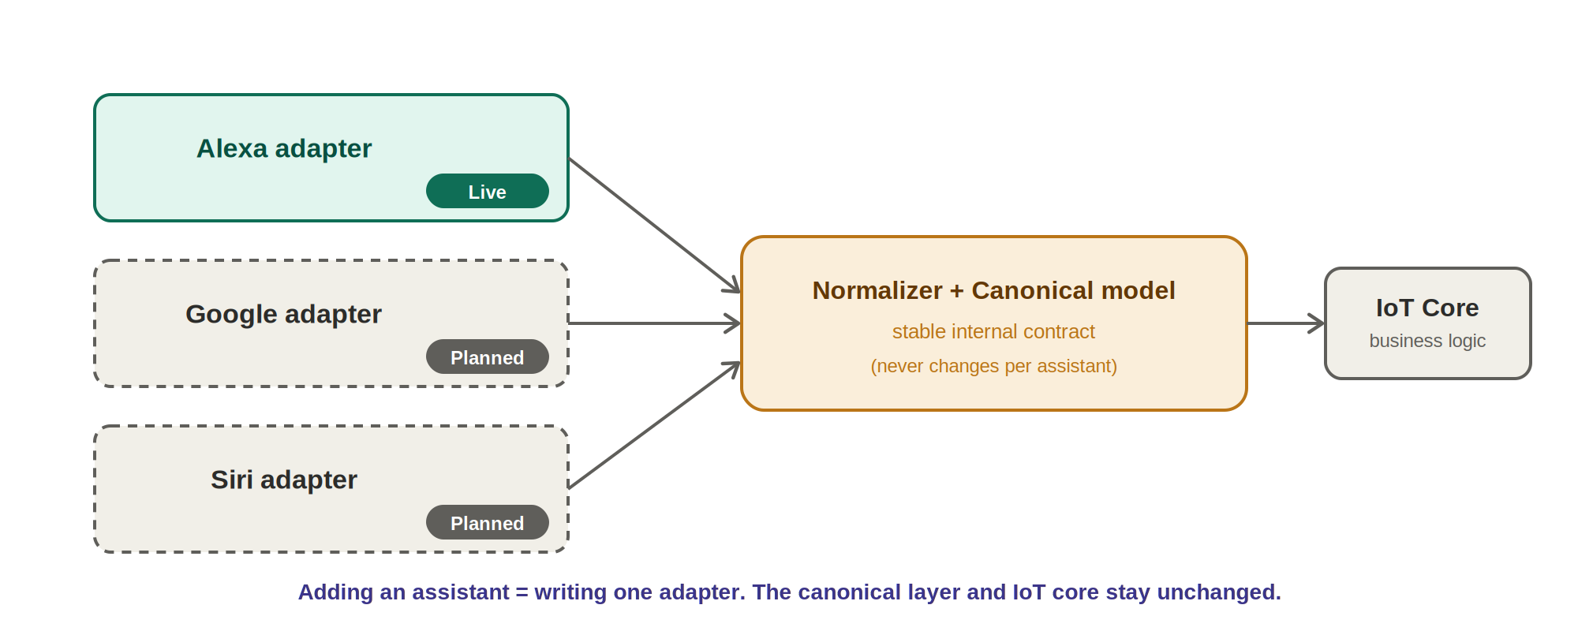
Figure 2 — Each assistant plugs in through its own adapter; the canonical layer and core stay fixed.

Adding a new assistant (e.g. Google)
- Write a Google adapter that reads Google’s request format.
- Map Google’s intents to our existing canonical actions (the vocabulary already exists).
- Add a Google response formatter for its reply format.
- Plug it in. The normalizer, canonical command model, and IoT core are untouched.
Stays the same: canonical command model, IoT core, all business logic. What’s new: one adapter + one response formatter.

5. Low-Level Design (LLD)
This section follows one command end to end: “Set the living room thermostat to 22 degrees.”
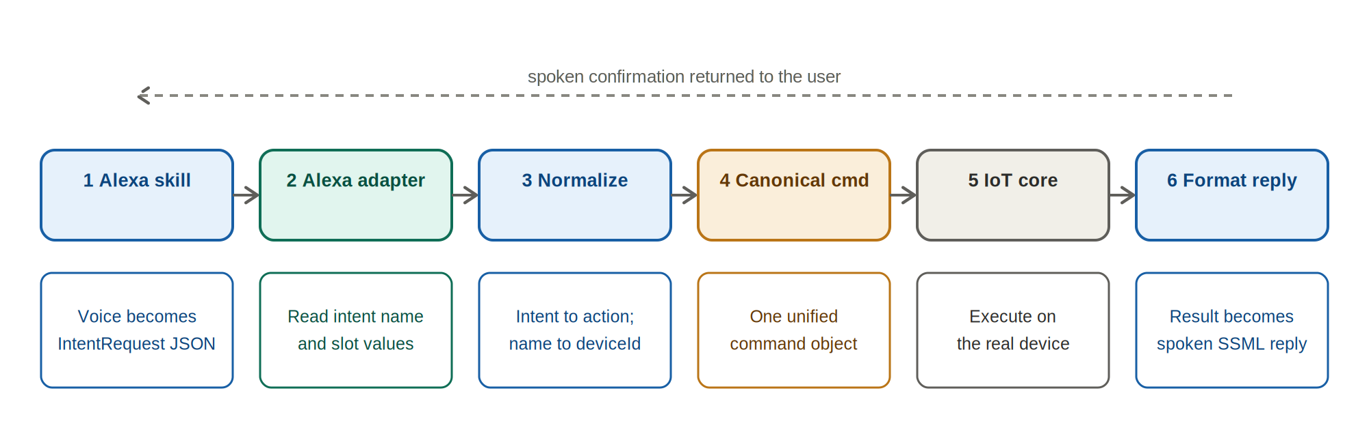
Figure 3 — The lifecycle of a single voice command, and what the data looks like at each stage.

Step by step
- Alexa skill — the user speaks; Alexa converts the speech into an IntentRequest (JSON) and calls our gateway. This skill is already built and deployed on AWS.
- Alexa adapter — reads the intent name (SetTemperatureIntent) and the slots (Device = “living room thermostat”, Temperature = “22”).
- Normalize + resolve — intent name → canonical action device.set_temperature; the account-linking token → our internal userId; the spoken device name → a real device id.
- Canonical command — everything above is assembled into one platform-agnostic object (see the contract below).
- IoT core — receives the canonical command, sets the thermostat, and returns a result.
- Response formatter — turns the result into an Alexa SSML reply (“Okay, setting the living room thermostat to 22 degrees”), which Alexa speaks aloud.

The canonical command — the contract
This is the single object every adapter produces and the IoT core consumes. It is the most important agreement in the design.
Field | Meaning | Example value
version | Schema version, so we can evolve it safely later | "1.0"
commandId | Unique id for this command (tracing + idempotency) | "b7e2-…"
correlationId | Follows the request across every log line | Alexa requestId
action | The fixed canonical verb | "device.set_temperature"
kind | control (write) or query (read) | "control"
actor.userId | OUR internal user id (not the platform’s) | "user_42"
target.spokenReference | What the user actually said | "living room thermostat"
target.deviceIds | The resolved real device id(s) | ["thermostat_lr"]
parameters | The action’s arguments | { value: 22, unit: "C" }
source.platform | Which assistant it came from | "alexa"

Worked example: Alexa request → canonical command
Each field of the canonical command has a clear source in the incoming Alexa request:
From the Alexa request | Becomes (canonical)
request.intent.name | action = "device.set_temperature"
slot Temperature = "22" | parameters.temperature.value = 22
slot Device = "living room thermostat" | target.spokenReference, then resolved to target.deviceIds
session.user.accessToken | resolved to actor.userId (your internal id)
request.requestId | correlationId
(gateway generates a new UUID) | commandId

Key design decisions & gotchas
- Internal user id, not the platform’s. Each assistant gives its own user token; the adapter converts it so the core never branches on which assistant a user came from.
- Device resolution lives in the gateway. The spoken name is matched to a device id from that user’s registry, once — not re-implemented per assistant.
- Units are not in the request. Alexa number slots carry no °C/°F; we infer from locale or the user’s saved preference and always hand the core an explicit unit.
- Siri is different. Alexa and Google are cloud-to-cloud (their servers call our gateway). Siri is mostly on-device (App Intents) or HomeKit, so its “adapter” may partly live in the iOS app. The canonical command still applies.
- Consider Matter. For standard smart-home devices, the Matter standard (backed by Amazon, Google, and Apple) can reduce how much we build per assistant. Worth evaluating before the Google/Siri work.

6. Glossary
Voice platform — Alexa, Google Assistant, or Siri — the system that listens to the user and sends us a request.
Skill / Action — The app you build on a voice platform. Alexa calls it a “skill”; Google calls it an “action”.
Intent — The user’s goal, named by the platform (e.g. SetTemperatureIntent).
Slot — A value inside an intent (e.g. the device name, or the temperature number).
Adapter — A small, replaceable piece that converts one assistant’s request into our canonical command, and the reply back.
Canonical command — Our single, shared, assistant-agnostic command format.
Normalizer — Maps each assistant’s intent names onto our fixed canonical actions.
Account linking — Connecting a user’s assistant account to their account in our system; gives us a token we resolve to our user id.
Device resolver — Turns a spoken device name into a real device id.
Dispatcher — Sends the canonical command to the IoT core.
Response formatter — Turns the core’s result into the reply format the assistant expects.
SSML — Speech Synthesis Markup Language — the format Alexa expects for spoken replies.
IoT core — Our existing application and device-control logic.
Matter — An industry smart-home standard supported by Amazon, Google, and Apple.

7. Next Steps
- Refactor the existing Alexa Lambda so its translation logic becomes “adapter #1” producing the canonical command.
- Define and freeze v1 of the canonical action vocabulary and command schema.
- Build the shared pieces once: identity / account-linking resolution, device resolver, and dispatcher.
- Add the Google adapter against the same canonical layer.
- Evaluate Matter and the Siri / App-Intents on-device path.

