**Forecasting**

**Example-Coca-Cola Dataset**

**Dataset having 42 records and 2 variables and its collected on Quarterly basis between year 1986 to 1996 and its free from missing values and outliers.**

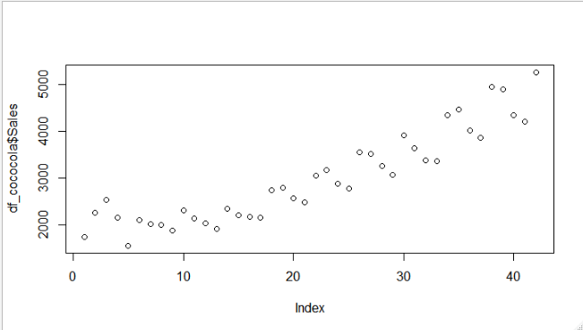**From the above plot, sales are gradually increasing from third cycle i.e. from record 9 which is representing a linear trend as well as the variation within the year is representing the cyclic variation in our data.**

**Data Preprocessing 🡺**

**Data is collected quarterly basis so creating 4 dummy variables for 4 quarters.**

**From the dataset first 30 records considered as train data and balance 12 records as test data.**

**Linear Trend with Record Number (RN) 🡺**

**Multiple R-squared: 0.7079, Adjusted R-squared: 0.6975**

**RMSE 🡺714.0144**

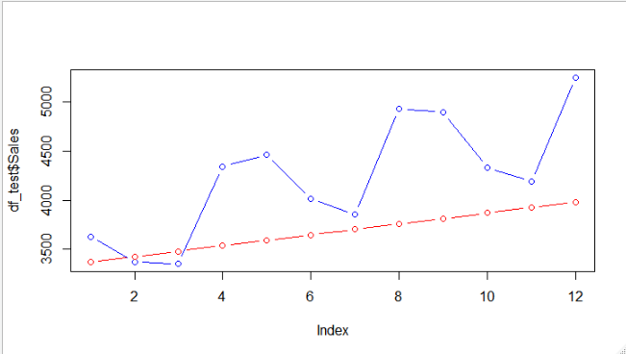

**In the above plot, red line is predicted values and blue line is actual values.**

**We unable to explain the cyclic variation due considering the data points 1 to 8 which is erratic nature. So, we will remove in future models.**

**Exponential Model Considering Only Record Numbers 🡺**

**Multiple R-squared: 0.7067, Adjusted R-squared: 0.6962**

**RMSE 🡺 552.2821**

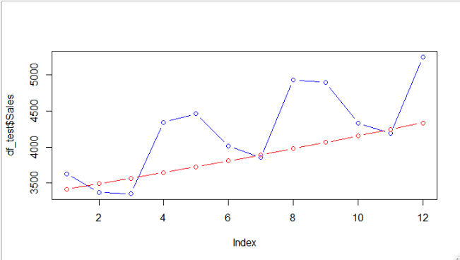

**Slightly increment in trend line as well as R^2 than previous model and lesser RMSE. So, we**

**can say that exponential model quite effective than previous linear model.**

**Additive Seasonality with Linear Trend 🡺**

**Multiple R-squared: 0.8457, Adjusted R-squared: 0.821**

**RMSE 🡺 637.9405**

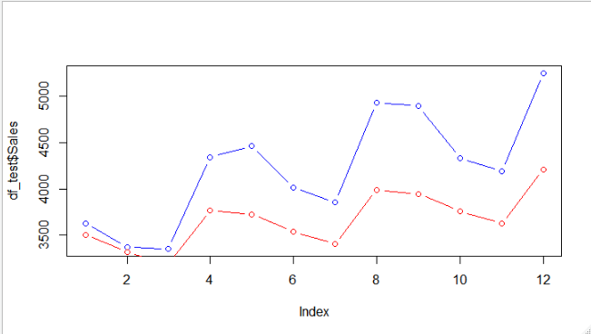

**In this model considered dummy variables of Quarters and rn variable to keep**

**linear tendency of prediction.**

**From this plot, we found similar pattern between predicted and actual values**

**but it is still widely separated from actual. So, we will take log of our target**

**variable.**

**Also, in this model R^2 increased but RMSE also increased which is not good for our model.**

**Multiplicative Seasonality Linear Trend 🡺**

**Multiple R-squared: 0.8586, Adjusted R-squared: 0.8359**

**RMSE 🡺 410.2497**

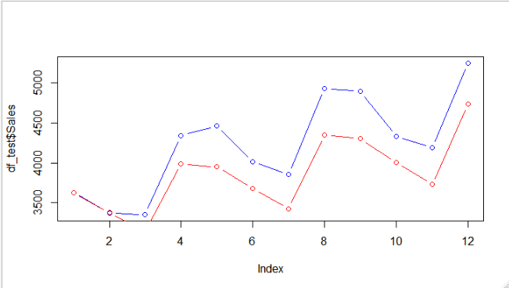

**In this plot gap between predicted and actual values is somewhat**

**Decreased and accuracy also improved than previous model.**

**Now we will remove erratic variation from our data to improve accuracy i.e. record 1 to 8 which have no definite pattern.**

**Multiplicative Seasonality Linear Trend with Removing Erratic**

**Components 🡺**

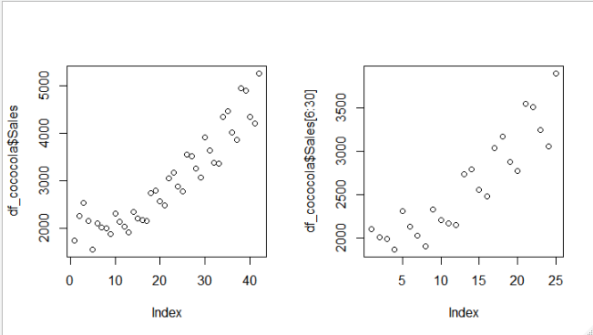



**In the above plot circled data points are neither cyclic nor in linear trend which**

**looks like random and erratic in nature, so I have removed it in my model.**

**Multiple R-squared: 0.9655, Adjusted R-squared: 0.9578**

**RMSE 🡺 146.4575**

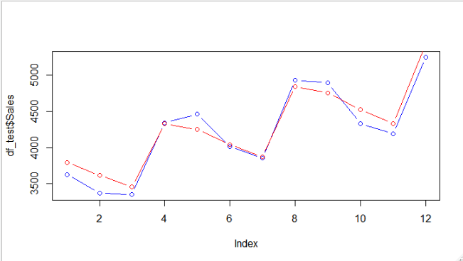

**Difference between predicted and actual values is negligible in this model.**

|  |  |  |
| --- | --- | --- |
| **Model** | **R^2** | **RMSE** |
| **Linear Trend** | **0.7079** | **714.0144** |
| **Exponential Model** | **0.7067** | **552.2821** |
| **Additive Seasonality with**  **Linear Trend** | **0.8457** | **637.9405** |
| **Multiplicative Seasonality with Linear Trend** | **0.8586** | **410.2497** |
| **Multiplicative Seasonality**  **Linear Trend with removing erratic components** | **0.9655** | **146.4575** |

**From the above information we can infer than Model 5 is our final**

**best model with high R^2 and least RMSE.**