Name: Gedala mahesh

Mail:maheshgedala043@gmail.com

Batch:125(10AM)

GitHUB: <https://github.com/mahesh043/vcube-task>

**Task on Creating multiple instance by using terraform**

* Creating multiple EC2 instances using Terraform can be done using various methods such as using count, for_each, or creating a module. Below are examples of how to create multiple EC2 instances using the count and for_each methods:

### Using count:

### The count parameter allows you to create multiple resources based on a single resource definition.

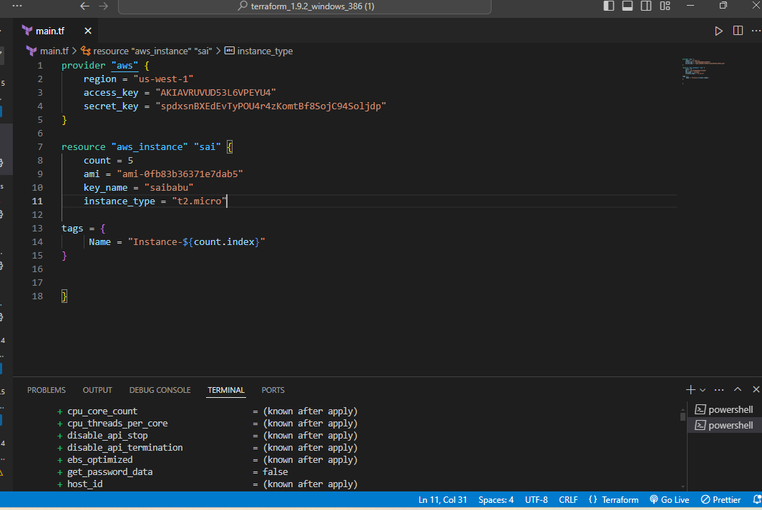

* The count parameter is set to 3, so Terraform will create three instances.
* The ${count.index} is used to give each instance a unique name.

**Enter the commands:**

* **Terraform init :**
* The terraform init command is used to initialize a working directory containing Terraform configuration files. It is the first command that needs to be run after writing a new Terraform configuration or cloning an existing one from version control. The initialization process performs several setup tasks that are essential for using Terraform.
* **Terraform validate:**
* The terraform validate command is used to validate the syntax and internal consistency of Terraform configuration files. It checks whether the configuration is syntactically correct and complies with the schema of the providers.
* **Terraform plan:**
* The terraform plan command is used to create an execution plan, showing what actions Terraform will take to achieve the desired state described in your configuration files. It does not make any changes to the infrastructure but helps you understand what Terraform will do when you apply the configuration.

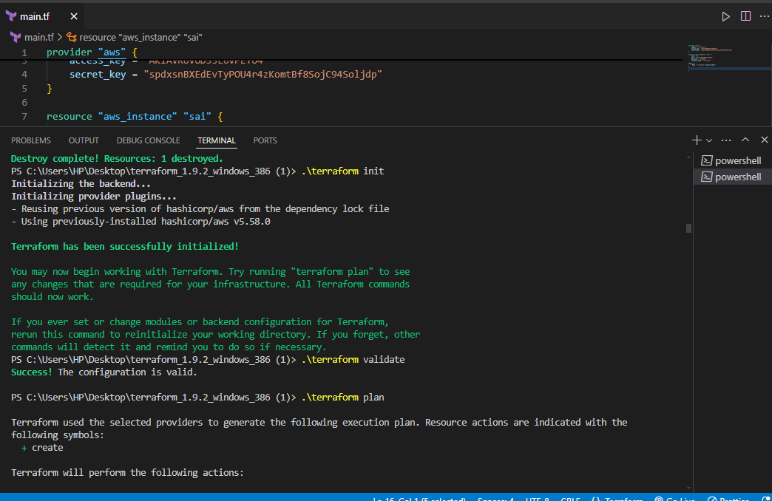

**Terraform apply:**

* Terraform apply is a critical Terraform command that takes your declared infrastructure configurations and applies them to your cloud provider, creating and managing the specified resources.

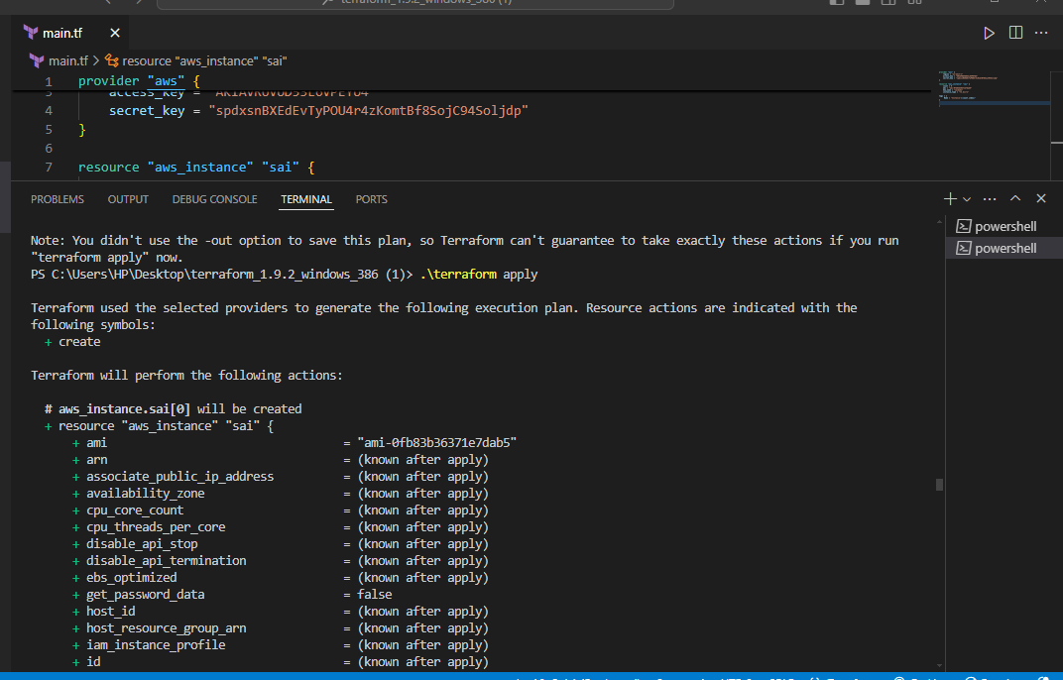

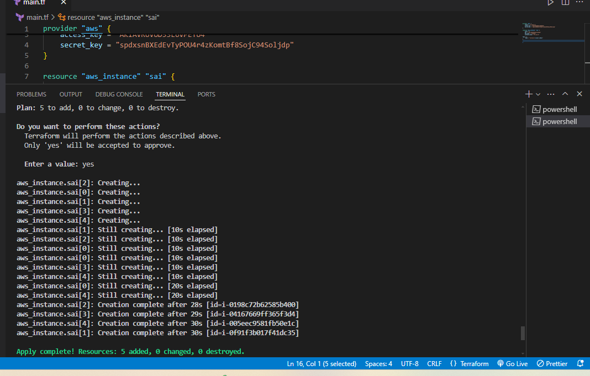

* Then create multiple instance.

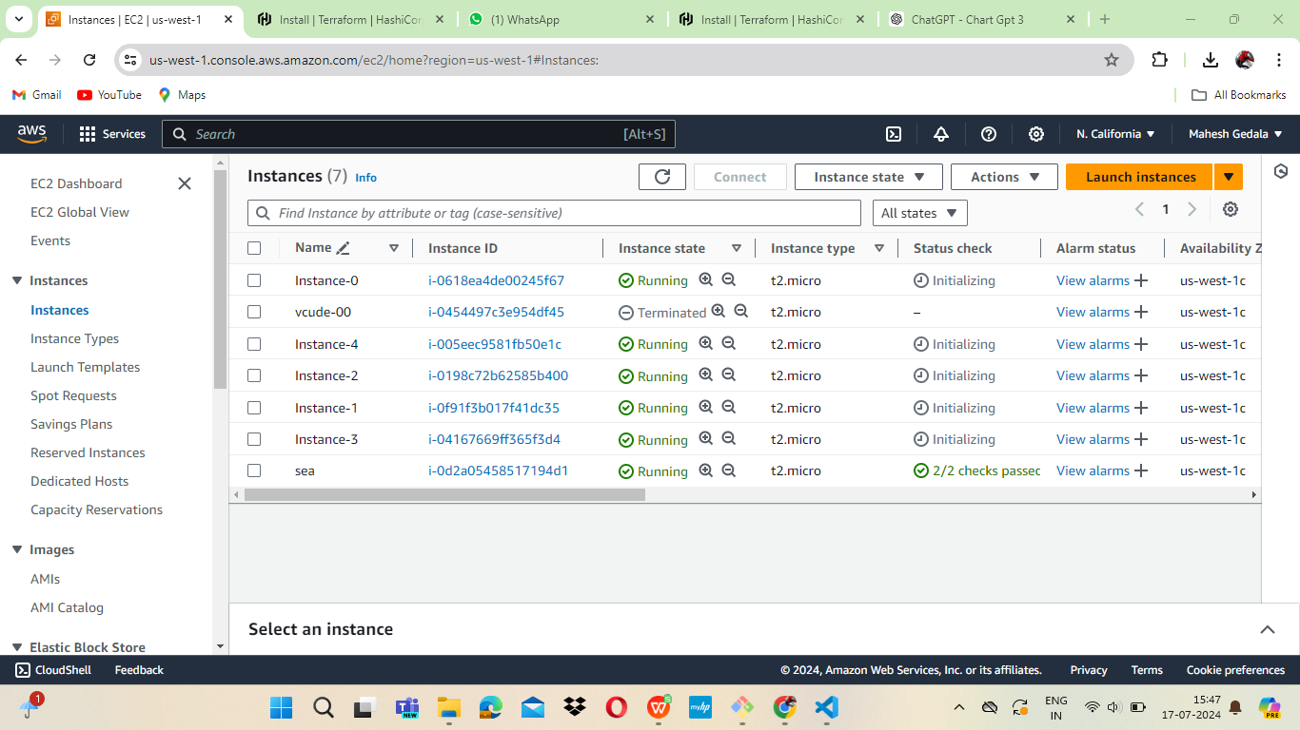

**Terraform distroy:**

Used to distroy (or) terminate the instances.

