Project Submission: End-to-End DevOps Pipeline for Brain-Tasks-App
Candidate Name: Mahesh Kumar S
Submission Date: April 5, 2026
AWS Region: ap-south-1
Project Repository: https://github.com/mahesh050695/brain-tasks-app

1. Project Overview
This project demonstrates the deployment of a React-based task management application to a production-ready environment using AWS EKS. The solution implements a full CI/CD pipeline using GitHub, AWS CodeBuild, Docker Hub as the image registry, and AWS EKS for orchestration.
Application Port: 3000
Deployment Strategy: Rolling Update

2. Architecture & Workflow
The infrastructure follows a standardized DevOps lifecycle:
- Version Control: Code managed in GitHub.
- CI/CD Pipeline: AWS CodePipeline/CodeBuild orchestrates the flow.
- Build & Registry: AWS CodeBuild creates the Docker image and pushes it to Docker Hub.
- Orchestration: AWS EKS pulls the image from Docker Hub and manages the application containers.
- Access: Application is exposed via an AWS LoadBalancer.

3. Dockerization & Docker Hub Registry
The application was dockerized using a Node.js base image. The image is stored in a public/private Docker Hub repository.
Screenshot : Docker Hub Repository
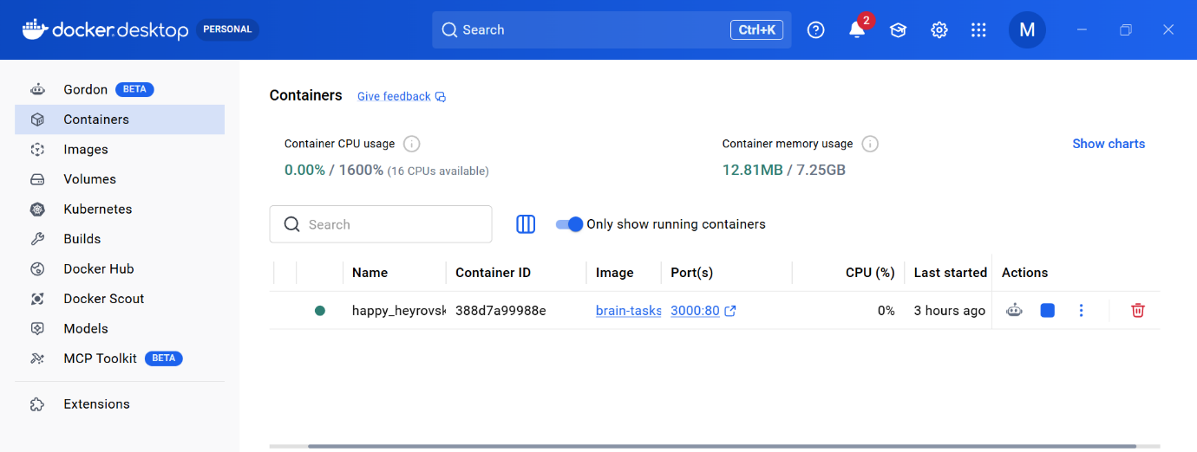

4. CI/CD Pipeline (CodeBuild)
The pipeline automates the build and deployment process. AWS CodeBuild is configured to log into Docker Hub, build the image, and update the Kubernetes deployment.
Screenshot 2: AWS CodePipeline/Build Dashboard (Showing the pipeline stages in 'Succeeded' state) 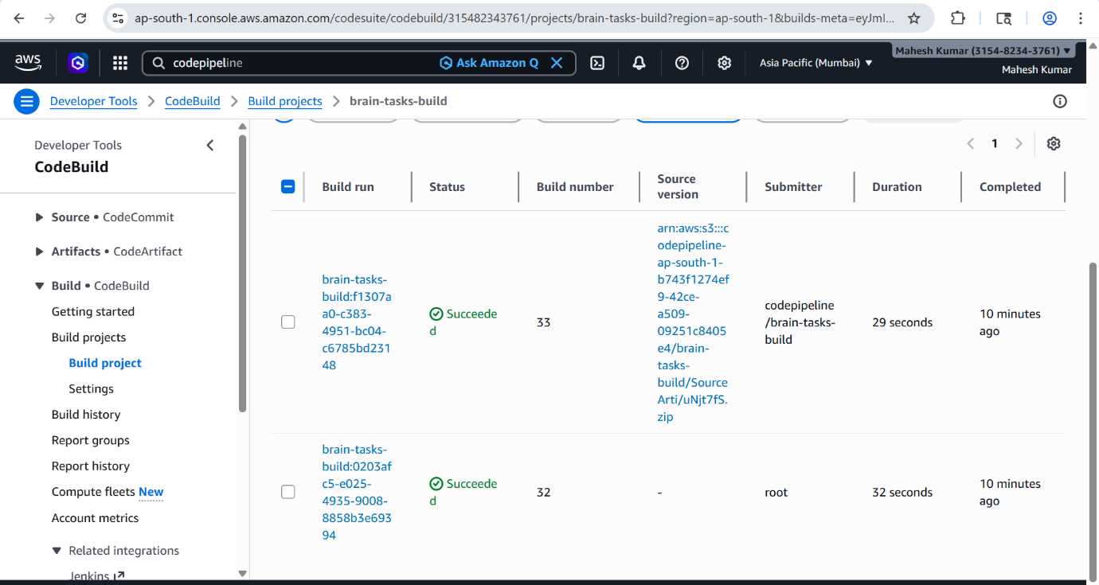

Screenshot 3: AWS CodeBuild Logs (Showing successful 'docker login', 'docker push', and 'kubectl apply' commands) 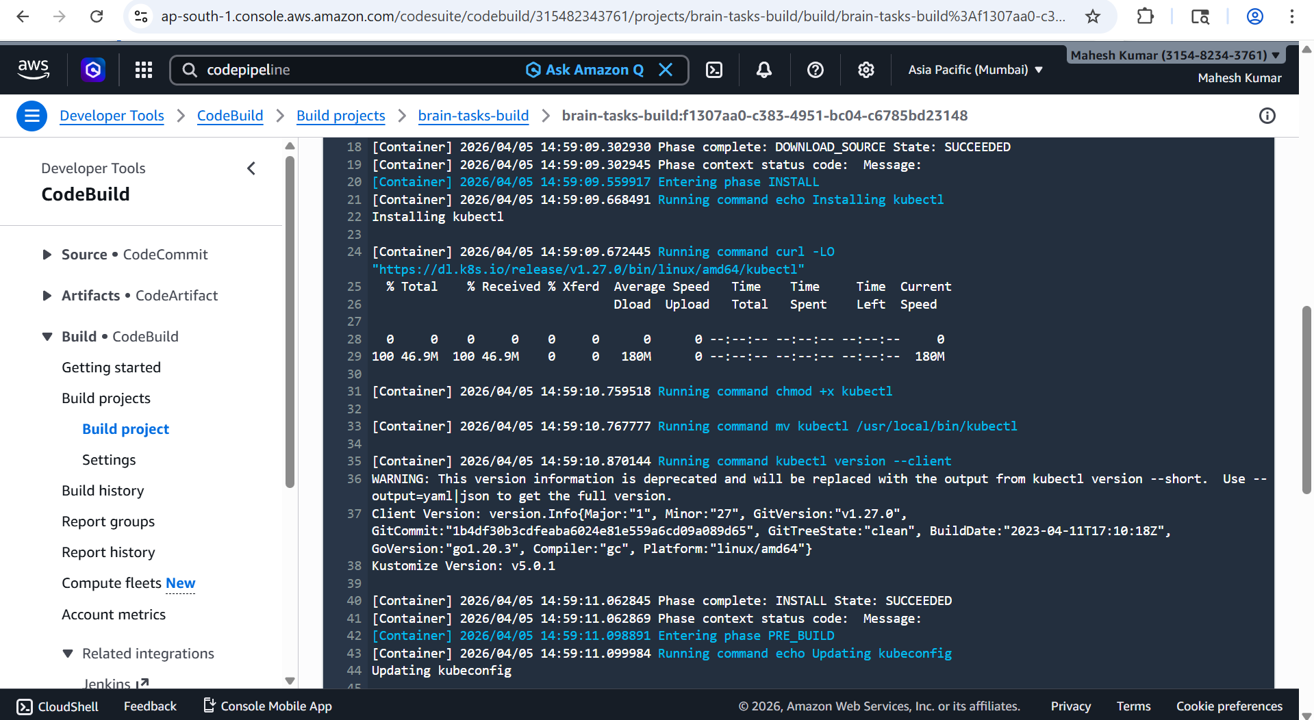

5. Kubernetes Cluster State (EKS)
The application is deployed on an EKS cluster named brain-tasks-cluster.
Screenshot 4: Cluster Resources (CLI) (Paste the terminal output showing kubectl get nodes,pods,svc) 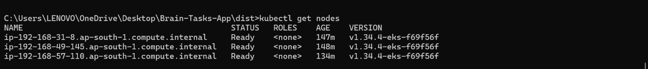
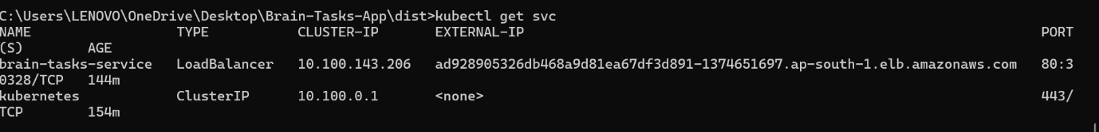

6. Monitoring & Logging
CloudWatch Logs track the health of the build process and ensure the application starts correctly.
Screenshot 5: CloudWatch Log Groups (Showing the logs for the Brain-Tasks-App build) 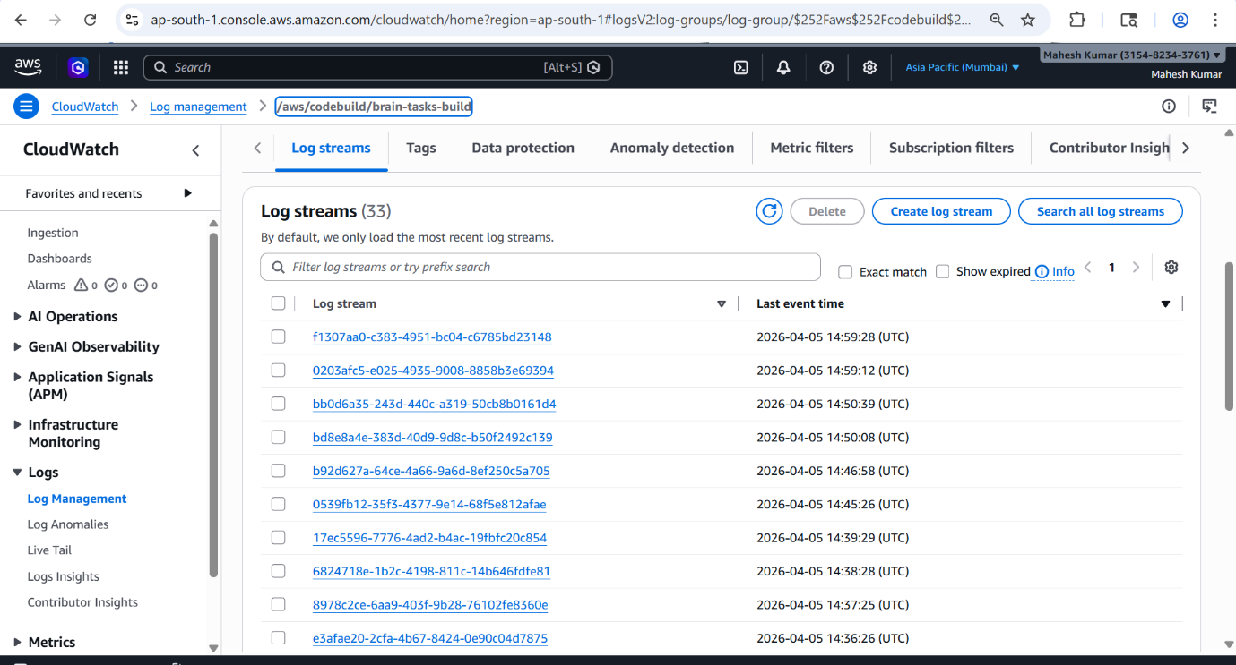

7. Live Application
The application is successfully running and accessible via the AWS LoadBalancer.
Application LoadBalancer URL: http://ad928905326db468a9d81ea67df3d891-1374651697.ap-south-1.elb.amazonaws.com/
Screenshot 6: Production Web Application (Showing the React UI in a browser window with the LoadBalancer URL visible) 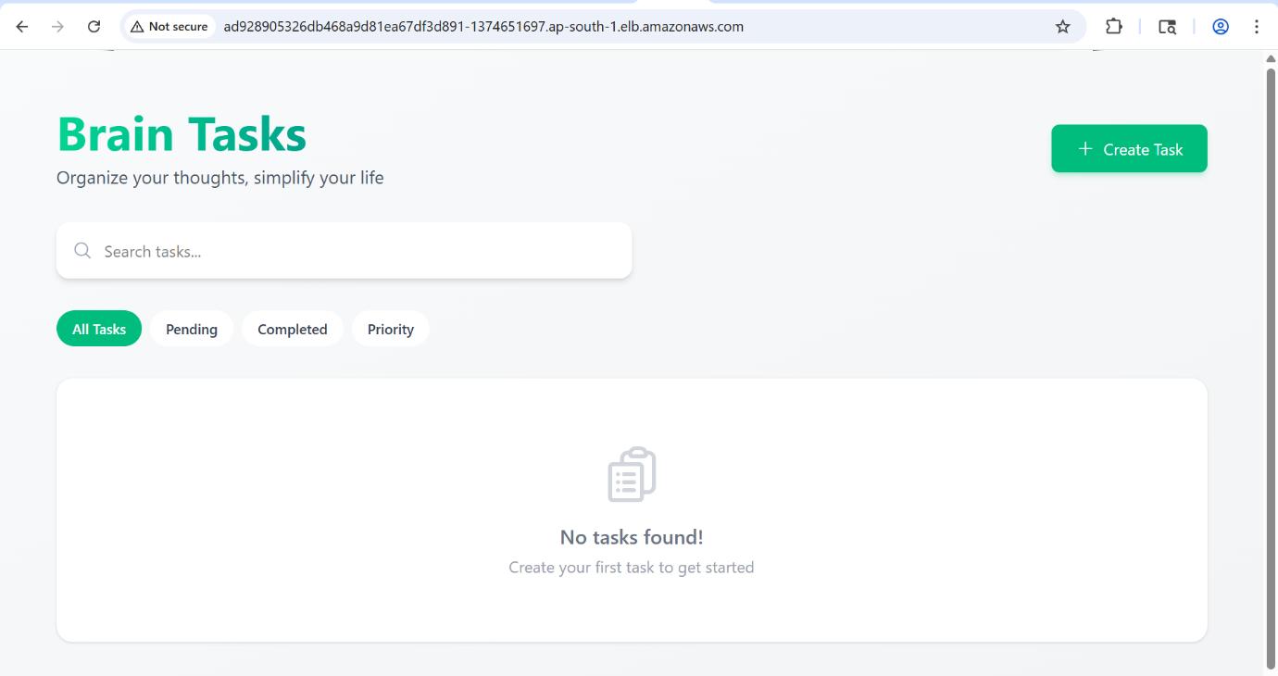

8. Local Execution
To test the image locally from Docker Hub:
Bash
# Pull from Docker Hub
docker pull mk5695/brain-tasks-app:latest

# Run the Container
docker run -p 3000:80 brain-tasks-app
Summary of Completion:
- GitHub Repository Pushed
- Dockerfile Created & Optimized
- Docker Hub Repository Configured
- EKS Cluster Provisioned & RBAC Configured
- CI/CD Pipeline Fully Operational
- Application Accessible via LoadBalancer ARN

