Html And Css

1. Html

The <!DOCTYPE html> declaration defines that this document is an HTML5 document

The <html> element is the root element of an HTML page

The <head> element contains meta information about the HTML page

The <title> element specifies a title for the HTML page (which is shown in the browser's title bar or in the page's tab)

The <body> element defines the document's body, and is a container for all the visible contents, such as headings, paragraphs, images, hyperlinks, tables, lists, etc.

The <h1> element defines a large heading

The <p> element defines a paragraph  
<pre> Defines pre-formatted text

1. Boxmodel  
   The CSS box model is essentially a box that wraps around every HTML element. It consists of: margins, borders, padding, and the actual content. The image below illustrates the box model

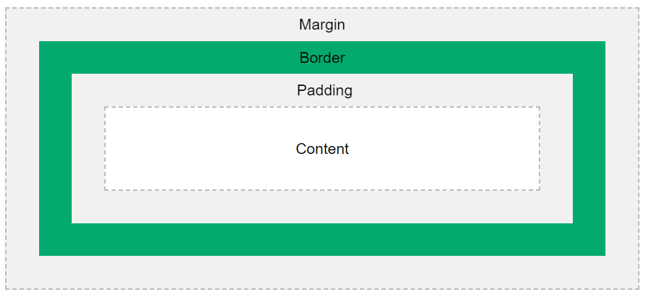

1. Diff b/w html and html5  
     
   HTML5 has many new syntactical features, including <audio>, <video> and <canvas> elements as well as integration of SVG content. With these new elements it will be very easy to integrate multimedia and graphical content to web without using flash and third party plugins.
2. CSS Position.

* static (default) - Static positioned elements are not affected by the top, bottom, left, and right properties.
* Relative - Setting the top, right, bottom, and left properties of a relatively-positioned element will cause it to be adjusted away from its normal position. Other content will not be adjusted to fit into any gap left by the element.
* Fixed - is positioned relative to the viewport, which means it always stays in the same place even if the page is scrolled. The top, right, bottom, and left properties are used to position the element.
* Absolute - is positioned relative to the nearest positioned ancestor (instead of positioned relative to the viewport, like fixed.
* Sticky - A sticky element toggles between relative and fixed,A sticky element toggles between relative and fixed

1. pseudo-classes

A pseudo-class is used to define a special state of an element.

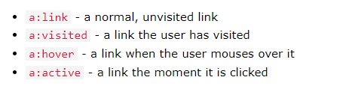

1. Pseudo-Elements

A CSS pseudo-element is used to style specified parts of an element.

::after, ::before, ::marker, ::selection, ::first-letter, ::first-line

1. What are Semantic Elements?

A semantic element clearly describes its meaning to both the browser and the developer.

* Examples of semantic elements: <form>, <table>, and <article> - Clearly defines its content.
* Examples of non-semantic elements: <div> and <span> - Tells nothing about its content.

1. Block-level Elements -> A block-level element always starts on a new line, and the browsers automatically add some space (a margin) before and after the element.

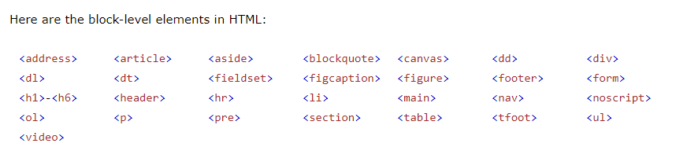

Inline -> An inline element does not start on a new line.

1. Different between html and xhtml.

* XHTML stands for Extensible HyperText Markup Language
* XHTML is a stricter, more XML-based version of HTML
* XHTML is HTML defined as an XML application
* XHTML is supported by all major browsers
* Html 1991 and xhtml 2000
* Sgml stanterd generalized markup language(html).
* .html,.htm and .xhtml,.xml,.html
* Not mandatory doctype (html)
* <br/>, <hr/>,<img> closing not mandatory.(html)
* Upper and lower case in html allow.
* <table width=”100%”> in xhtml.  
    
  HTML is Not Case Sensitive

HTML tags are not case sensitive: <P> means the same as <p>.  
The HTML standard does not require lowercase tags, but W3C recommends lowercase in HTML, and demands lowercase for stricter document types like XHTML.

1. Using I frame we can show one page inside another page.  
   <iframe src="demo_iframe.htm" height="200" width="300" title="Iframe Example"></iframe>
2. HTML Attributes  
    All HTML elements can have attributes
   1. Attributes provide additional information about elements
   2. Attributes are always specified in the start tag
   3. Attributes usually come in name/value pairs like: name="value"
   4. <a href="https://www.w3schools.com">Visit W3Schools</a>
   5. <img src="img_girl.jpg" alt="Girl with a jacket">
3. HTML Text Formatting  
     
   <b> - Bold text

<strong> - Important text

<i> - Italic text

<em> - Emphasized text

<mark> - Marked text

<small> - Smaller text

<del> - Deleted text

<ins> - Inserted text

<sub> - Subscript text

<sup> - Superscript text

1. HTML Quotation and Citation Elements

In this chapter we will go through the <blockquote>,<q>, <abbr>, <address>, <cite>, and <bdo> HTML elements.

1. Image Maps HTML  
   The HTML <map> tag defines an image map. An image map is an image with clickable areas. The areas are defined with one or more <area> tags.  
   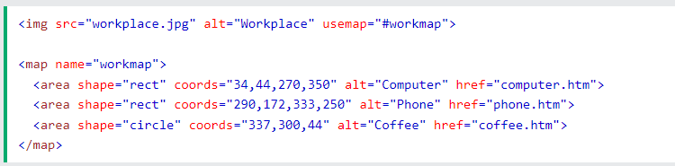  
   The HTML <picture> element allows you to display different pictures for different devices or screen sizes.  
   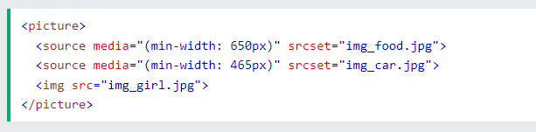
2. List   
   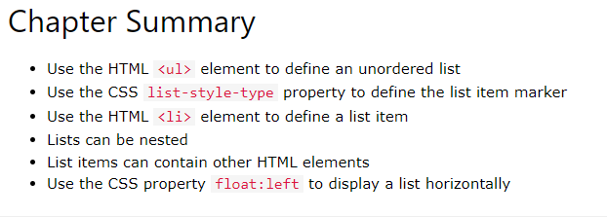

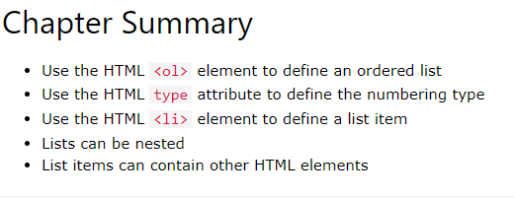

Start=”50” in order list

1. Setting The Viewport

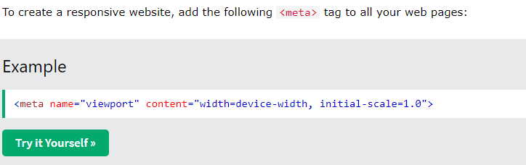

1. Using HTML Geolocation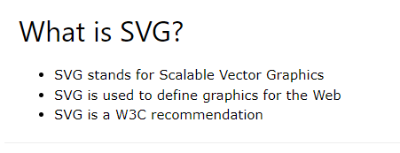

if (navigator.geolocation) {

navigator.geolocation.getCurrentPosition(showPosition);

} else {

x.innerHTML = "Geolocation is not supported by this browser.";

}

if (navigator.geolocation) {

navigator.geolocation.watchPosition(showPosition);

} else {

x.innerHTML = "Geolocation is not supported by this browser.";

}

1. CSS Simple Selectors

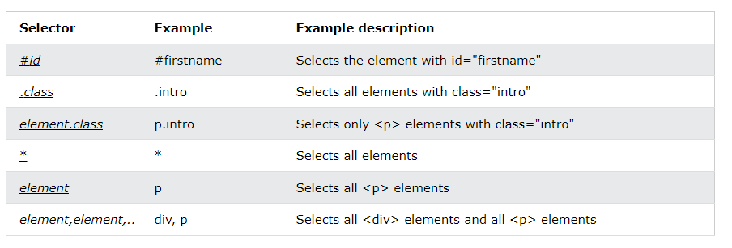

1. CSS Outline  
   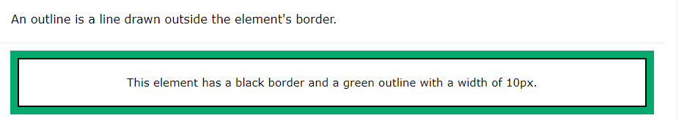

The outline-offset property adds space between an outline and the edge/border of an element. The space between an element and its outline is transparent.

1. CSS Combinators

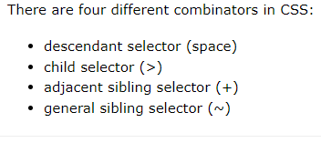

1. Specificity Hierarchy  
   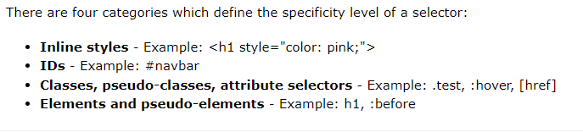
2. box-sizing

Defines how the width and height of an element are calculated: should they include padding and borders, or not.

1. /* On screens that are 992px or less, set the background color to blue */

@media screen and (max-width: 992px) {

body {

background-color: blue;

}

}

/* On screens that are 600px or less, set the background color to olive */

@media screen and (max-width: 600px) {

body {

background-color: olive;

}

}

1. Flex display

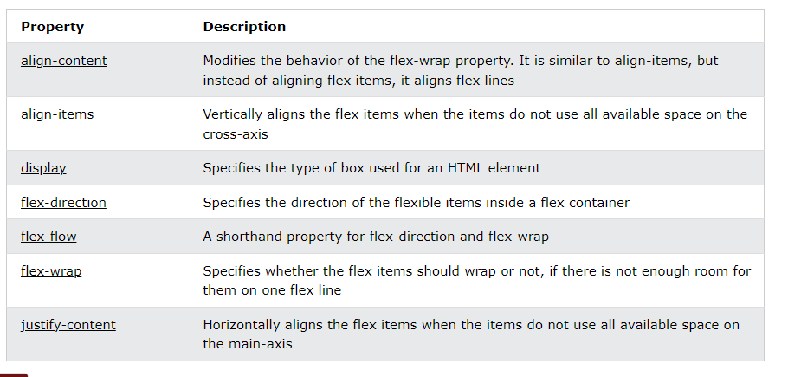

Display center  
