Site Based Compliance Training Report

Pernix Pty Ltd



Document Control History

|  |  |  |  |
| --- | --- | --- | --- |
| Version | Date Reviewed | Author | Reviewed By |
| 0.1 |  | Chandra Mahesh Boddu |  |
|  |  |  |  |
|  |  |  |  |
|  |  |  |  |
|  |  |  |  |

Amendment Record

|  |  |
| --- | --- |
| Version | Change Description |
|  |  |
|  |  |

Contents

Overview 1

Business Value 1

Technical Summary 1

Business Processes 1

Report 1

Filters/Slicer on Dashboard page 2

Drill through pages 4

1.1.1 Site based compliance – overall (Detail view): 4

1.1.2 Site based compliance – Critical (Detail view): 6

1.1.3 Corporate training compliance (Detail view): 8

Overview

Site Based Compliance Report will be utilised by asset/field supervisors and management, and administration support staff, along with the Health, Safety, Environment and Risk division and the People and Culture division to ensure that they can manage and meet Beach's training compliance requirements.

Business Value

The report saves time, effort and most importantly enables business to effectively track progress, identify problems and answer other questions about their project cost data.

Technical Summary

This report is primarily developed for the Organizational development department of Beach Energy. The report pulls data from a single Microsoft Excel data extract from a SharePoint Online location with the Beach Energy. The report is published to Power BI Online and is refreshed manually by the business SME.

Business Processes

Monthly/Manual report refresh process

1. Each month, data will be extracted from email and moved to SharePoint online automatically https://beachenergy.sharepoint.com/teams/DataAnalyticsCoP/Documentation/Forms/AllItems.aspx?FolderCTID=0x012000352486B612D40847B3542499194D9009&id=%2Fteams%2FDataAnalyticsCoP%2FDocumentation%2FData%20Integrations%2FData%20Capture%2FOrganisational%20Development%2FLMS%20Extracts%2FCurrent&viewid=78cedb9f%2D13df%2D4fee%2Db392%2Da361ef991351
2. The published dataset is then refreshed to display the new data.

Report

Source of data

The source data is coming from the excel spreadsheets which provided by the Learning Management System module within SAP SuccessFactors. The excel file that are used in report are given below:

* **LMS-Pros Training Matrix Custom (Admin)v**

Filters/Slicer on Dashboard page

Main dashboard page has three different categories:

* Site based compliance – overall
* Site based compliance – Critical
* Corporate Compliance Training

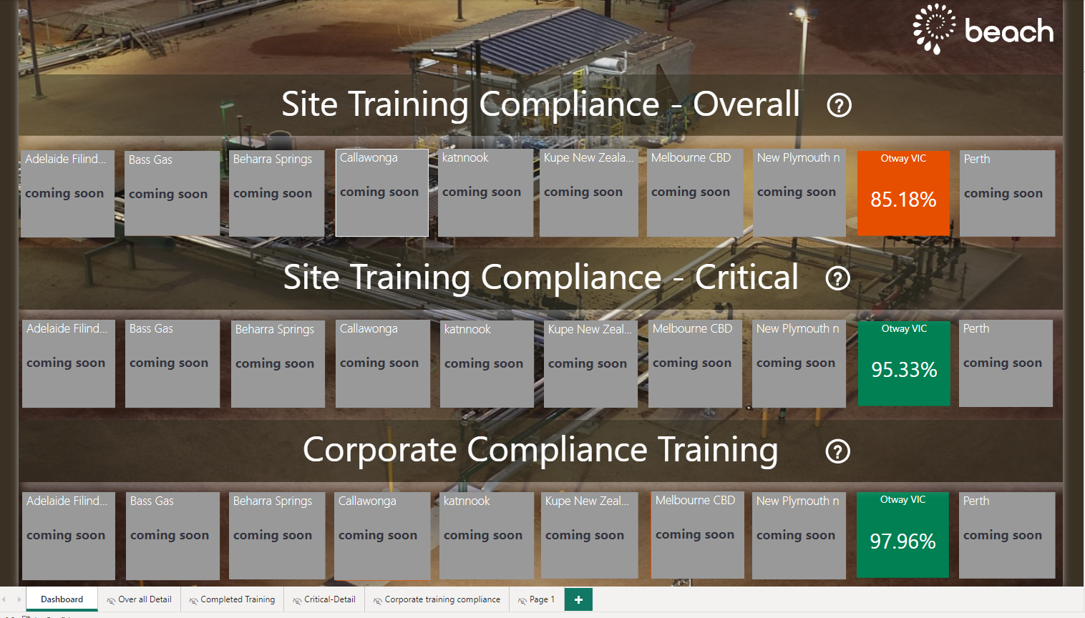

**Site based compliance – overall** **:** display data Requirement for ER and Fire & Gas Systems and critical operational systems Legal Certification Absence in danger Applied to a particular discipline/person, may not apply to everybody. Only those carrying out associated tasks. KPI > 85% Percentage is calculated on the number of completed items assigned/required against the non-completed/current items assigned.

**

Course Assignment Type is either Critical(CRIT) or Mandatory(MAND) AND Job location of that particular visual.

**Site based compliance – Critical** **:** display data Includes all critical and mandatory training required by site based staff. Percentage is calculated on the number of completed items assigned/required against the non-completed/current items assigned.

**Filters on this Visual**: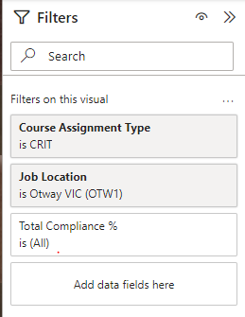

Course Assignment Type Critical(CRIT) AND Job location of that particular visual.

**Corporate Compliance Training** **:** display data Includes mandatory corporate compliance training items such as Workplace Ethics and Corporate Induction. Percentage is calculated on the number of completed items assigned/required against the non-completed/current items assigned.

**

Category1 is SYS or ONBOARD and Category2 is ONBOARD and Course Assignment Type is Mandatory(MAND) AND Job location of that particular visual.

Drill through pages

To get the detail of each Asset, we need to click on Asset for detail view.  
Detail views are described in three different pages for three different Categories (Site based compliance – overall, Site based compliance – Critical, Corporate Compliance Training)

* + 1. Site based compliance – overall (Detail view):

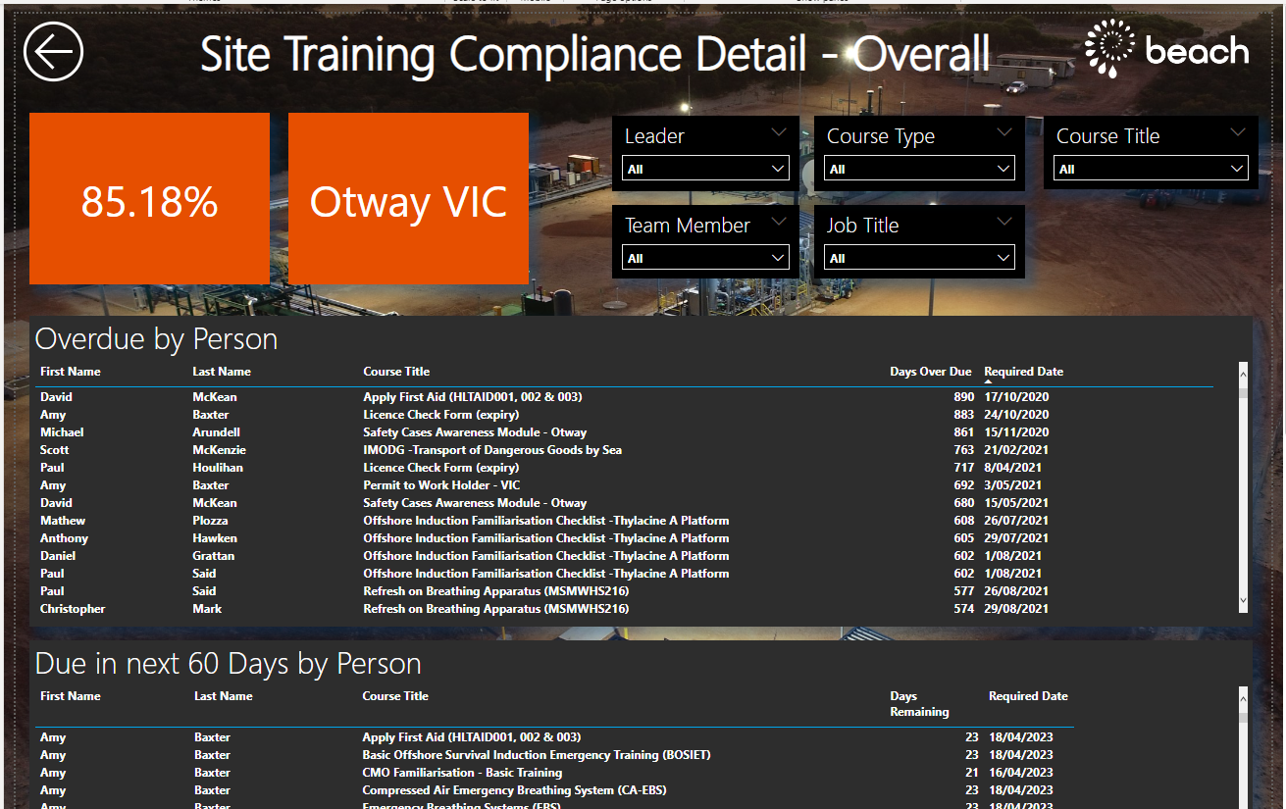

This page display three tables:

Overdue by Person: This tables shows ‘First Name’, ‘Last Name’, ‘Course Tittle’, ‘Days Over Due’, ‘Required Date’ columns.

Due in next 60 Days by Person: This tables shows ‘First Name’, ‘Last Name’, ‘Course Tittle’, ‘Days Remaining’, ‘Required Date’ columns. 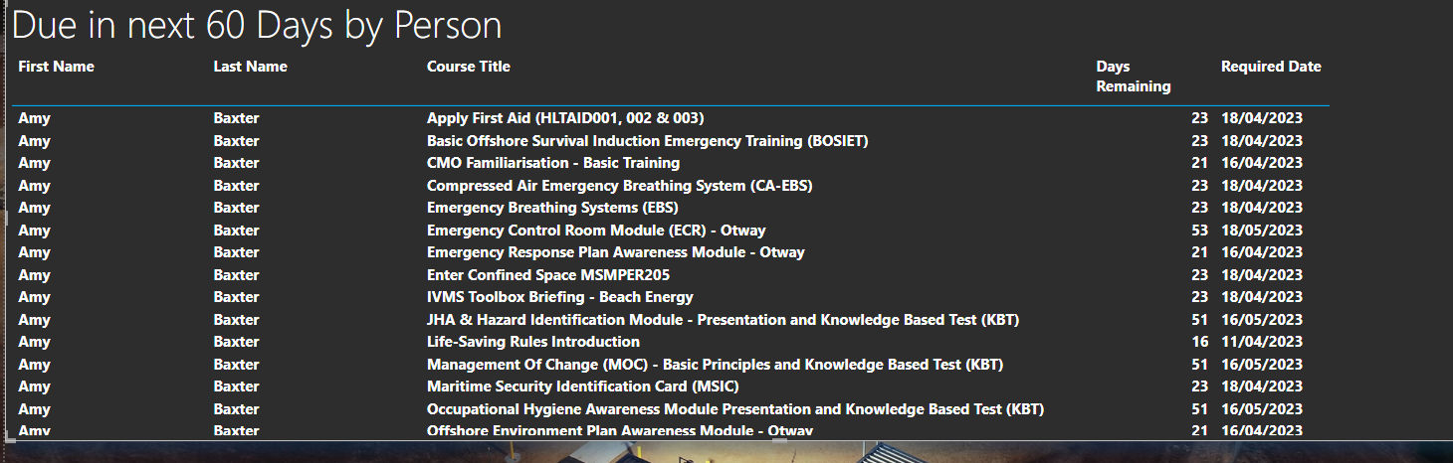

Completed Training: This tables shows ‘First Name’, ‘Last Name’, ‘Course Tittle’, ‘Completion Date’ columns. 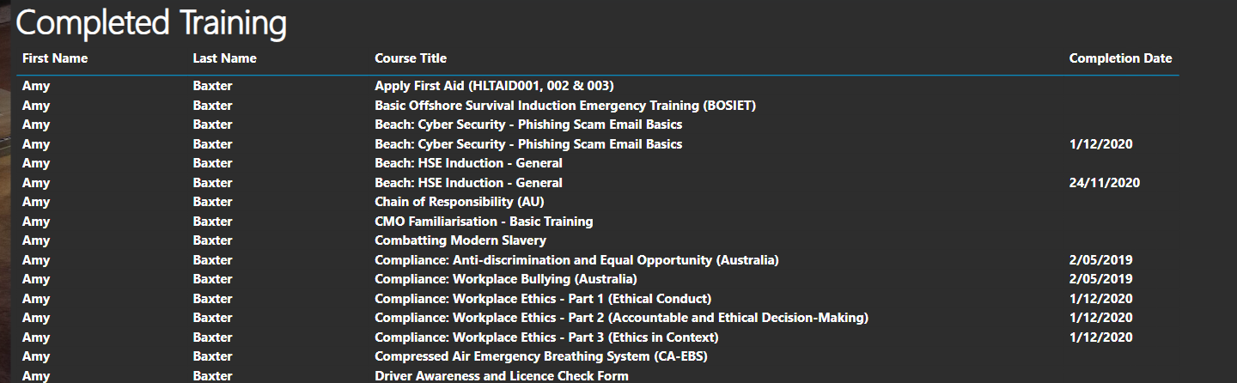

Course Assignment Type is either Critical(CRIT) or Mandatory(MAND) AND Job location of that particular visual.

* + 1. Site based compliance – Critical (Detail view):

This page display three tables:

Overdue by Person: This tables shows ‘First Name’, ‘Last Name’, ‘Course Tittle’, ‘Days Over Due’, ‘Required Date’ columns.

Due in next 60 Days by Person: This tables shows ‘First Name’, ‘Last Name’, ‘Course Tittle’, ‘Days Remaining’, ‘Required Date’ columns. 

Completed Training: This tables shows ‘First Name’, ‘Last Name’, ‘Course Tittle’, ‘Completion Date’ columns.

Course Assignment Type is Critical(CRIT) AND Job location of that particular visual.

* + 1. Corporate training compliance (Detail view):

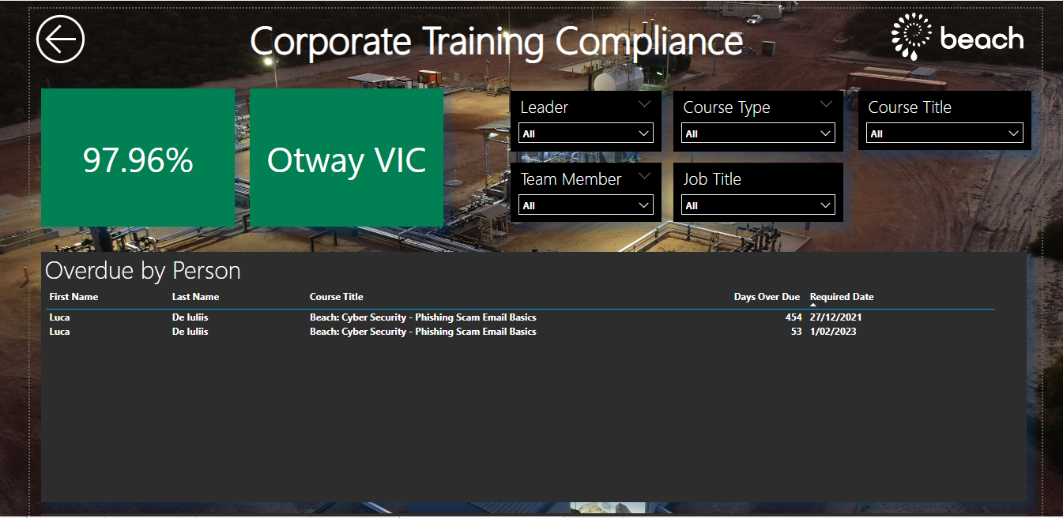

This page display three tables:

Overdue by Person: This tables shows ‘First Name’, ‘Last Name’, ‘Course Tittle’, ‘Days Over Due’, ‘Required Date’ columns.

Due in next 60 Days by Person: This tables shows ‘First Name’, ‘Last Name’, ‘Course Tittle’, ‘Days Remaining’, ‘Required Date’ columns.

Completed Training: This tables shows ‘First Name’, ‘Last Name’, ‘Course Tittle’, ‘Completion Date’ columns.

Category1 is SYS or ONBOARD and Category2 is ONBOARD and Course Assignment Type is Mandatory(MAND) AND Job location of that particular visual.

Bookmarks

Bookmarks are added in the report for all assets in all categories

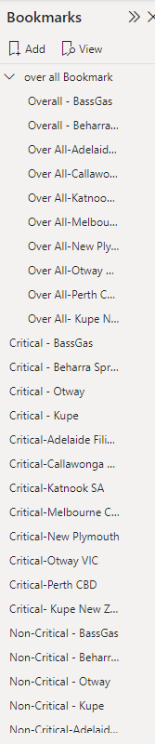

So it will be easy to update changes in bookmarks and it will be updated in detail view’s.